**Exploring Hematological Alterations in Canine Babesiosis: A comprehensive study**

**ABSTRACT**

The study was conducted to the dogs that were presented to state veterinary hospital, Agartala Tripura with a history of anorexia, fever, tick infestation, weakness and red colored urine. Present work was aimed to get an overview on the haematological changes in babesiosis infected dogs and for that, a total of50 dogs which were found to be positive for *Babesia gibsoni* infection wereincluded in the study*.*The diagnosis was done through microscopy by identifying *Babesia* *gibsoni* organisms in Giemsa-stained blood smears. Hematological analysis revealed a significant decline in hemoglobin, TEC, and PCV levels, suggestive of anemia. A notable reduction in platelet count was also observed indicating thrombocytopenia. However, total leukocyte count (TLC) and differential leukocyte count (DLC) remained within normal reference ranges which suggesting that babesiosis does not significantly alter these parameters. The findings in the present work provide valuable insights into the hematological impact of canine babesiosis, which can aid in correct diagnosis and timely management of the disease.

**Keywords** – Agartala, Anaemia, Babesiosis, Haematological changes, Thrombocytopenia.

## 1. INTRODUCTION

Dogs are susceptible to various harmful infections caused by blood-feeding ectoparasites such as fleas, ticks, sand flies, and mosquitoes. Among these, tick is considered as the most important ectoparasite as it serves as a vector for several hemoparasitic infections. Tick-borne hemoparasitic infections includes babesiosis, hepatozoosis, ehrlichiasis, and anaplasmosis, of which babesiosis is the most common and dangerous one. Though several species of *Babesia* is found to cause disease in canines but the two most common species affecting dogs are *Babesia canis* and *Babesia gibsoni* [1]. The brown dog tick, *Rhipicephalus sanguineus*, serves as the primary vector of babesiosis, while other ticks, including *Haemaphysalis* spp. and *Dermacentor* spp. may also contribute to its transmission [2]. Dogs acquire the infection when an infected tick feed and introduce sporozoites into its blood circulation. Parasitemia peaks within 4-6 weeks while clinical signs appearing 1-2 weeks after infection [3]. The acute phase of the disease presents with symptoms such as fever, lethargy, hemolytic anemia, and significant thrombocytopenia [3]. Dogs that recover from an acute infection become carriers of the pathogen, with parasitemia lasting for a minimum of 38 months [4]. In the chronic phase, symptoms like intermittent fever, lethargy, and weight loss appear, and the infection can remain in the body for years [5]. *Babesia gibsoni* infections typically cause mild parasitemia but can result in severe anemia. Acute infections are rare and mostly affect puppies, leading to rapid death, likely through maternal transmission. Diagnosing *B. gibsoni* infection can be done by blood smear examination. This method is relatively cheaper and can be done on field level. However, it can give false negative or positive result in subclinical or low parasitaemic cases. To overcome these limitations, serological as well as molecular techniques like IFA and ELISA and PCR can be useful for species identification, detecting low parasitemia levels and recognizing subclinical infections [6]. Haemotological changes in babesiosis include haemolytic anaemia, thrombocytopenia, anisocytosis, lymphopenia and neutrophilia [7][8][9]. However, there is no such report available in this aspect in Agartala, Tripura. Therefore, the present study was undertaken to know the hematological changes in dogs naturally infected with babesiosis in Agartala, Tripura, India.

## 2. MATERIALS AND METHODS

**2.1 Study area and selection of animals**

A total of 50 dogs of various age, breed and sex that were presented to the State veterinary hospital, Agartala, Tripura with a history of anorexia, fever, tick infestation, weakness and red colored urine and diagnosed positive for babesiasis were included for the study. Diagnosis was done based on presence of *Babesia* organism in Giemsa stained thin blood smear examination **(Fig. 1)**. A number of 10 apparently healthy dogs brought to the hospital for routine health checkup were included as control group. For haematological analysis, 2ml of blood samples were collected from the cephalic vein using sterile disposable syringe into vacutainers containing EDTA as anticoagulant. Hematological parameters such as haemoglobin, Total erythrocyte count (TEC), Packed cell volume (PCV), Total leucocytic count (TLC), differential leucocyte count and platelet count were estimated using standard methods [10].

**2.2 Statistical Analysis**

Results were expressed as means ± standard error. To know the significance effect, the estimated values of babesiosis affected dogs were compared with the healthy control group using unpaired t-test..

**3. Result and discussion**

The present study shows that there was a significant decrease (p<0.01) in the haemoglobin, TEC and PCV level compared to the healthy control dogs suggestive of anemia **(Table 1)**. These findings are in agreement with [11] and [12]. Blood smear examination shows anisocytosis and nucleated erythrocytes indicating regenerative anaemia. *Babesia* organism induce direct damage to the erythrocyte cell membrane might be the reason of decreased Hb and TEC level, which will subsequently increase osmotic fragility and cause intravascular hemolysis [13]. The development of methemoglobinemia as a result of oxidative stress, the induction of serum hemolytic proteins, the production of anti-erythrocyte membrane antibodies, the inhibition of erythrocyte 5'-nucleiosidase, and elevated macrophage erythrophagocytic activity are additional factors contributing to the anaemia [14]. The study also reveals a significantly decreased (p<0.01) platelet count in the infected animals compared to the healthy control dogs indicating thrombocytopenia **(Table 1)**, which is in accordance with [15]. The reason behind the thrombocytopenia observed in the present study might be because of immune-mediated platelet destruction and the emergence of disseminated intravascular coagulopathy or platelet sequestration in the spleen [16]. No significant change in the TLC count was observed in the dogs infected with babesiosis**(Table 1)**. However, differential leucocyte count shows mild changes which were statistically non-significant. These findings correlate with [17].

**Table 1. Comparison of haematological parameters of healthy control group vs babesiosis affected group**

|  |  |  |
| --- | --- | --- |
| **Parameters** | **Babesiosis affected dogs (n=50)** | **Healthy control group (n=10)** |
| Hb(g/dl) | 8.47±0.35** | 16.03±0.42 |
| TEC (x 106/mm3) | 4.48±0.16** | 7.46±0.16 |
| PCV(%) | 23.28±0.94** | 45±0.79 |
| TLC (x 103/mm3) | 12±0.47 | 12.61±0.61 |
| Neutrophil (%) | 62.22±0.45 | 63.10±0.34 |
| Lymphocyte(%) | 31.36±0.43 | 30.60±0.40 |
| Eosinophil(%) | 3.28±0.11 | 3.10±0.27 |
| Monocyte(%) | 3.14±0.11 | 3.20±0.20 |
| Total Platelet (x 103/µl) | 82.06±2.89** | 338.90±30.85 |

**\*\*p<0.01 (Highly significant)**

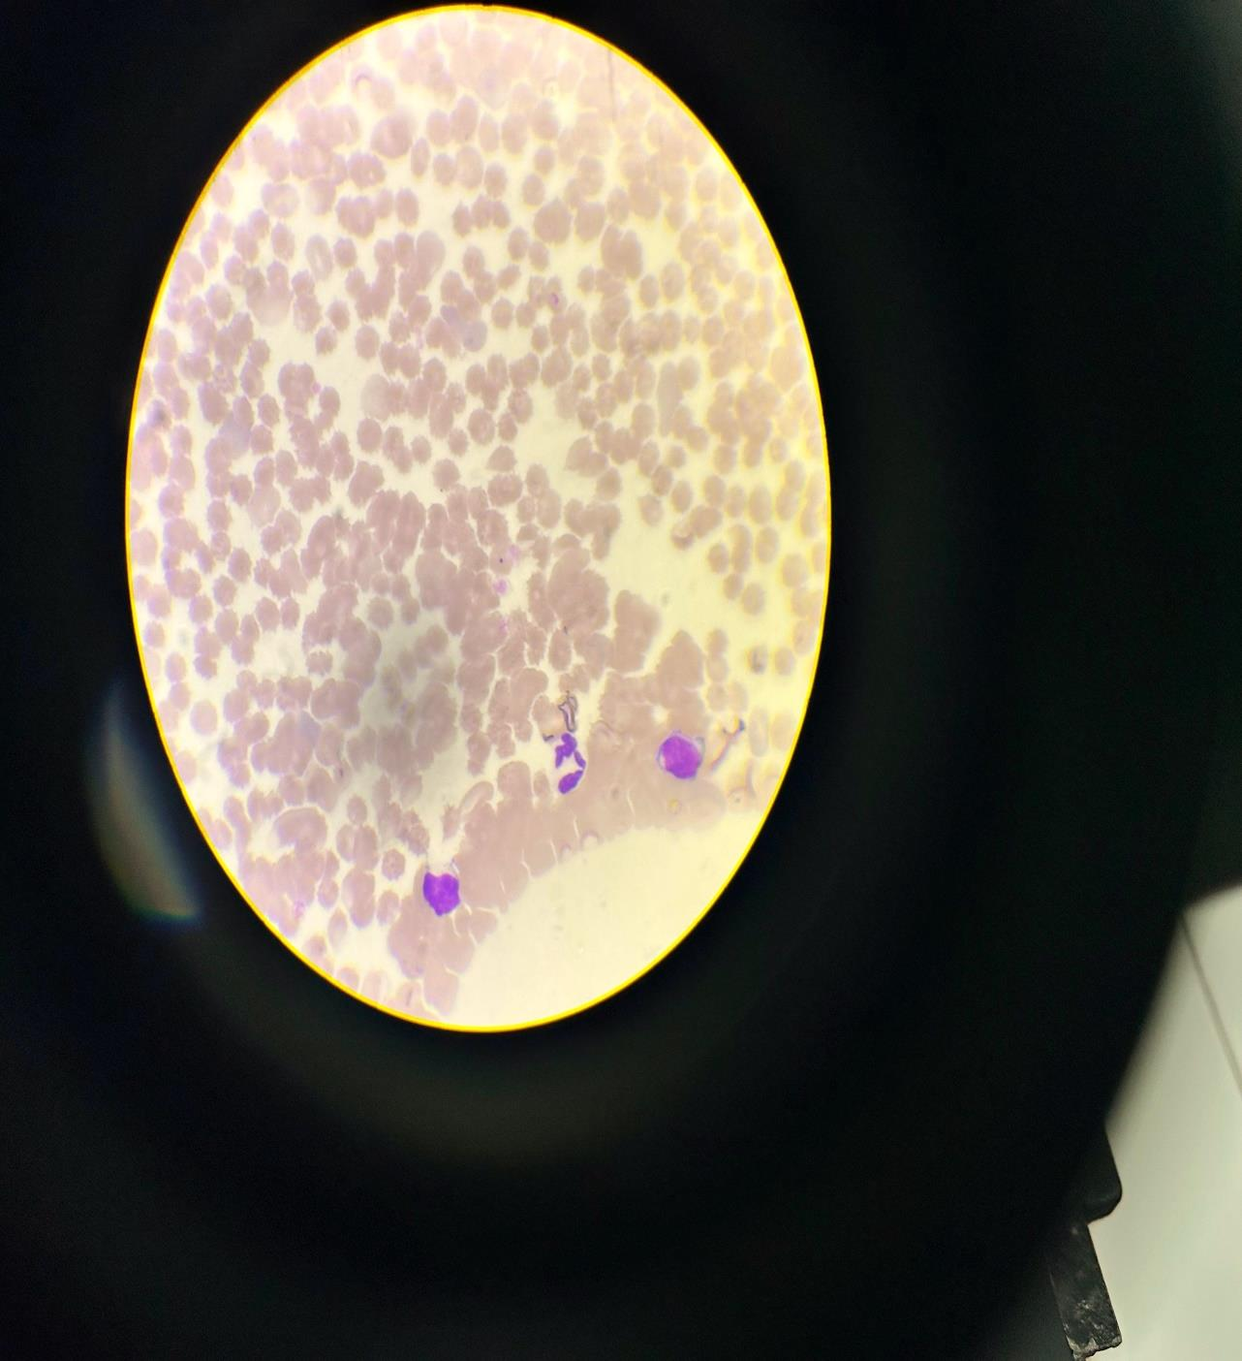

Fig. 1.  *Babesia* *gibsoni* in Giemsa stained thin blood smear

**4. Conclusion:**

Canine babesiosis is one of the most significant tick-borne diseases worldwide and responsible for causing severe illness in canines throughout the world. In the present study, a significant hematological alteration, particularly anemia and thrombocytopenia was observed in dogs naturally infested with babesiosis. The reduction in hemoglobin, TEC, and PCV levels highlights the destructive effects of *Babesia* *gibsoni* on erythrocytes, contributing to intravascular hemolysis and oxidative stress. Thrombocytopenia observed in infected dogs is likely due to immune-mediated platelet destruction or disseminated intravascular coagulopathy. Despite these alterations, total leucocyte count and differential leucocyte count remained within normal limits. These findings emphasize the importance of timely diagnosis and hematological monitoring in managing canine babesiosis, aiding in understanding the pathophysiology and also guiding therapeutic strategies.

**Reference**

1. Taboada, J., & Merchant, S. R. (1991). Babesiosis of companion animals and man. Veterinary Clinics of North America: Small Animal Practice, 21(1), 103-123.
2. Filipe, D. T., & Luciana, A. F. (2006). Canine babesiosis: A Brazilian persepective. Vet. Parasit, 141(3-4), 197-203.
3. Meinkoth, J. H., Kocan, A. A., Loud, S. D., & Lorenz, M. D. (2002). Clinical and hematologic effects of experimental infection of dogs with recently identified Babesia gibsoni-like isolates from Oklahoma. Journal of the American Veterinary Medical Association, 220(2), 185-189.
4. Farwell, G.E.; Le Grand, E.K.; Cobb, C. Clinical observations on Babesia gibsoni and Babesia canis infections in dogs. J. Am. Vet.Med. Assoc. 1982, 180, 507–511.
5. Groves, M.G.; Dennis, G.L. Babesia gibsoni: Field and laboratory studies of canine infections. Exp. Parasitol. 1972, 31, 153–159.
6. Brahma, J., Chandrasekaran, D., Jayathangaraj, M. G., Vairamuthu, S., & Soundararajan, C. (2019). Clinical, haemato-biochemical and molecular findings of babesiosis in dogs. International Journal of Current Microbiology and Applied Sciences, 8(1), 2127-2132.
7. Furlanello, T.F., Fiorio, M., Caldin, G., Lubas, L. and Solano G. 2005. Clinicopathological findings in naturally occurring cases of babesiosis caused by large form Babesia from dogs of Northern Italy. Vet. Parasitol. 134:77-85.
8. Lobetti R.G. (2006). Babesiosis. In: Infectious diseases of the dog and cat, 3rd ed., C.E. Greene (ed.). Philadelphia: W.B. Saunders.
9. Suarez M.L., Espino L., Goicoa A., Fidalgo L.E. and Santamarina G. (2001). Fatal Babesiagibsoni infection in a dog from Spain. Veterinary Record, 148, 819-820.
10. Jain NC. (1993). Examination of blood and bone marrow in Essentials of Veterinary Haematology Lea and Febiger. Philadelphia, 20(80):185-207.
11. Bilwal, A. K., Mandali, G. C., & Tandel, F. B. (2017). Clinicopathological alterations in naturally occurring Babesia gibsoni infection in dogs of Middle-South Gujarat, India. Veterinary World, 10(10), 1227.
12. Panda, C. (2015). Studies on incidence of Babesiosis in stray and pet dogs in and around Bhubaneswar (Doctoral dissertation, Orissa Univesrity of Agriculture and Technology; Bhubaneswar).
13. Sindhu, B. S., Shobhamani, B., Suresh, K., & Chengalva, V. (2020). Clinico-haematobiochemical alterations and Electrocardiograhy findings in Babesia infected dogs. Journal of Entomology and Zoology Studies, 8(5), 209-215.
14. Ayoob, A. L., Hackner, S. G., & Prittie, J. (2010). Clinical management of canine babesiosis. Journal of Veterinary Emergency and Critical Care, 20(1), 77-89.
15. Gonde, S. U. R. E. S. H., Chhabra, S., Singla, L. D., & Randhawa, C. S. (2017). Clinico-haemato-biochemical changes in naturally occurring canine babesiosis in Punjab, India. Malaysian Journal of Veterinary Research, 8(1), 37-44.
16. Boozer, A. L., & Macintire, D. K. (2003). Canine babesiosis. *Veterinary Clinics: Small Animal Practice*, 33(4), 885-904.
17. Yogeshpirya S, Sivakumar M, Saravanan M, Venkatesan M, Veeraselvam M, Jayalakshmi K et al. (2011). Clinical, haemato-biocheimical and ultrasonographical studies on naturally occurring Babesia gibsoni infection in dogs. *Journal of Entomology and Zoology Studies*, 6(1):1334-1337.