*Original Research Article*

Prevalence and Pathological Characteristics of Septic Eye Affections in Dogs: A Clinical Study

.

ABSTRACT

|  |
| --- |
| **Aims:** To study the prevalence and pathology associated with septic eye affections in dogs of Jabalpur region.  **Place and Duration of Study:** Veterinary Clinical Complex (VCC), College of Veterinary Science and A.H., Jabalpur and in private pet clinics of Jabalpur for period of seven months spanning from April 2024 to October 2024.  **Methodology:** A total of 992 dogs were screened for eye affections. Amongst these, clinically 153 dogs had various eye affections and were included in the study. Eye swabs were collected aseptically from dogs suspected of having eye infections for bacterial isolation, identification and antibiotic sensitivity test (AST). Bacterial cultures were also subjected for molecular confirmation of the bacterial species.  **Results:** Septic eye affections were observed in 70 dogs, with a prevalence of 45.75%. Male dogs (71.43%) and young dogs (up to 3 years) (44.28%) were more prone, with the Labrador Retriever breed most commonly affected, followed by non-descript breeds. A significant decrease in hemoglobin, packed cell volume, total erythrocyte count, monocytes and platelets was noted. The highest frequency of septic eye affections was recorded as conjunctivitis (35.71%). The most commonly isolated bacteria from septic eye affections were *Staphylococcus* spp. (57.69%), followed by *Escherichia coli* (11.53%). All *Staphylococcus* spp. and *E. coli* isolates tested positive for the genus-specific *16SrRNA* gene using species-specific primers in PCR. Gentamicin, Chloramphenicol Amikacin and Erythromycin exhibited the highest sensitivity against all gram-positive bacteria, whereas Amoxiclav, Tetracycline, and Norfloxacin showed the highest sensitivity against all gram-negative bacteria.  **Conclusion:** Conjunctivitis (35.71%) was found to be the most common septic eye affection and *Staphylococcus* spp. was highest among all the bacteria isolated from septic eye affections. |

*Keywords: Septic eye affections, Staphylococcus spp., Conjunctivitis, 16SrRNA*

1. INTRODUCTION

The eyes of a dog are essential for their ability to navigate the world, detect potential threats, locate food, and interact with their environment. A dog's vision plays a critical role in their overall health, well-being and behaviour. However, like humans, dogs are susceptible to various eye conditions, including septic affections—bacterial, viral, or fungal infections that can affect the eye's structures and lead to discomfort, impaired vision, and potentially more serious complications if left untreated.

Eye is very susceptible to infection by common microorganisms including bacteria, viruses, fungi and parasites. Bacterial eye infection in canine eye is a common problem which has been reported worldwide. Blepharitis, conjunctivitis, keratitis, keratoconjunctivitis, canaliculitis, cellulitis and endophthalmitis are the most obvious clinical features of bacterial eye infections include (Modarres et al., 1998). One of the most common signs of a septic eye infection in dogs is redness or inflammation of the conjunctiva and excessive tearing. The most common bacterial agents in ocular infections include *Staphylococcus* spp., *Streptococcus* spp., *Corynebacterium* spp., *Moraxella* spp., *Pseudomonas* spp., *Hemophilus* spp., *Neisseria* spp. and some enteric bacteria (Forbes et al., 2002). Microorganism of the normal flora can become potential pathogen if tissue damage occurs, or if host resistance to infection has decreased (Sushma, 2010). The choice of the drug could be based on the incidence of pathogens at the location and its probable sensitivity to the drug (Gelatt et al., 2000).

Early detection of eye infections, along with assessing bacterial susceptibility, is essential for successful intervention and improving the wellbeing of companion animals as eye sight is a vital aspect of well-being and plays a crucial role in helping companion animals maintain their independence and enjoy a high quality of life (Warren, 2004).

2. material and methods

During the study period of seven months spanning from April 2024 to October 2024, a total of 992 dogs were screened for eye affections at Veterinary Clinical Complex (VCC), College of Veterinary Science and A.H., Jabalpur and in private pet clinics of Jabalpur. Amongst these, clinically 153 dogs had various eye affections and were included in the study. Among the screened dogs, 70 cases of septic eye affections were identified and included for further analysis. Complete history of animals was obtained from the owners and all the information regarding age, sex, breed, significant clinical signs, behaviour and health status was recorded.

**2.1 Blood**

5ml blood was collected from cephalic vein of forelimb or the lateral saphenous vein of the hindlimb into sterilized test tubes with anticoagulant i.e. Ethylenediamine Tetra Acetic Acid (EDTA) for haematological examinations.

**2.2 Eye swabs**

Eye swabs were collected aseptically from dogs suspected of having eye infections for bacterial isolation, identification and antibiotic sensitivity test (AST). The lower eyelid was pulled away from the eyeball to expose the conjunctival sac. The tip of the swab was Inserted into the sac and firmly rub the inside of the eyelid to moisten the swab and the swab was gently removed to avoid contamination with the skin (Featherstone and Scurrell, 2015).

**2.3 Direct smear examination**

The direct smear prepared from the eye swab on microscopic slides were air dried and heat fixed for Gram’s staining method for demonstration of bacterial population under oil immersion (Quinn et al., 2002).

**2.4** **Isolation and identification of bacteria**

Each collected eye swab was put into a Brain heart infusion broth and was mixed thoroughly. Then it was incubated in incubator for 24 hours at 37ºC. A loopful inoculum was taken from Brain heart infusion broth and streaked on to Nutrient agar plate and incubated at 37°C for 24 hours. Colonies of the microorganism in Nutrient agar were identified by Gram’s staining. Gram positive bacteria were further inoculated in Mannitol salt agar and Blood agar whereas gram negative bacteria were inoculated in MacConkey agar and Eosin methylene agar. These inoculated plates were aerobically incubated at 37ºC and examined from 24 hrs up to five consecutive days for the presence of bacterial growth. The growth of microorganism was identified with the help of their cultural characteristics, morphologic features and gram’s differential staining. The suspected clinical isolates were further identified by using biochemical test (catalase, coagulase, oxidase, IMVIC and urease).

**2.5 Genotypic identification of *Staphylococcus* species and *E. coli***

All *Staphylococcus spp.* and *E. coli* isolates tested positive for the genus-specific *16SrRNA* gene using species-specific primers in PCR.

**2.5.1 PCR for detection of *16SrRNA* gene of *Staphylococcus* species**

**Table 1. Primer used for amplification *16SrRNA* gene of *Staphylococcus* species**

|  |  |  |  |
| --- | --- | --- | --- |
| **Primer** | **Primer sequence** | **Product size** | **Reference** |
| *16SrRNA*-F | GTG CCA GCA GCC GCG GTA A | 876 bp | **(Salisbury *et al.,* 1997**) |
| *16SrRNA*-R | AGA CCC GGG AAC GTA TTC AC |

**2.5.2 Primers used for amplification of *16SrRNA* gene of *E. coli***

**Table 2. Primer used for amplification *16SrRNA* gene of *E. coli***

|  |  |  |  |
| --- | --- | --- | --- |
| **Primer** | **Primer sequence** | **Product size** | **Reference** |
| *E. coli*  *16S rRNA* | F-TGGGAACGGCGAGTCGGAATAC | 1476bp | **(Shrivastava, 2016)** |
| R-GGCGCAGGGGATGAAACTCAAC |

3. results and discussion

**3.1 Prevalence and anatomical locations of septic eye affections**

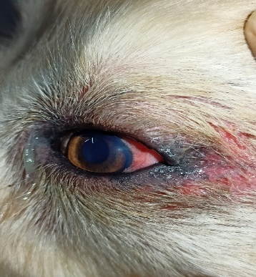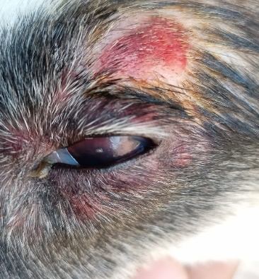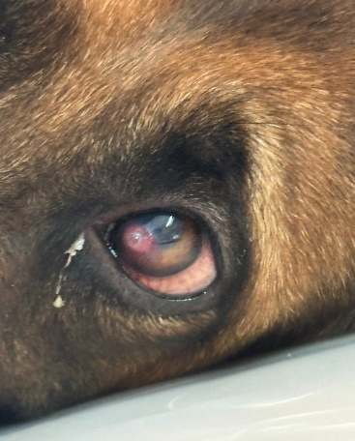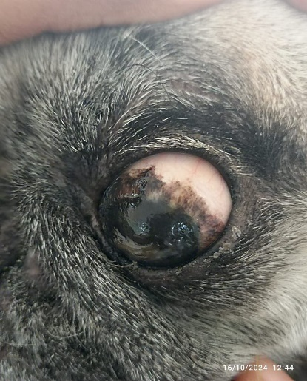 In the present study, overall prevalence of eye affections was recorded as 15.42 percent (153/992). Prevalence of septic eye affections was recorded as 45.75 percent. Septic eye affections include 35.71 percent (25) conjunctivitis (Figure 01), 25.71 percent (18) pigmented keratitis (Figure 02), 24.29 percent (17) corneal ulcers (Figure 03), 05.72 percent (04) uveitis, 04.29 percent (03) blepharitis (Figure 04), 02.86 percent (02) keratoconjunctivitis sicca and 01.42 percent (01) hypopyon was recorded in dogs. Anatomical locations of various septic eye affections were included 50.00 percent of (35/70) corneal affections, 38.57 percent (27/70) conjunctival affections, 04.29 percent (03/70) eyelid affections, 05.71 percent (04/70) uveal affections and 01.42 percent (01/70) orbital affections.

Fig 01: Conjunctivitis Fig 02: Pigmented Keratitis Fig 03: Corneal Ulcer Fig 04: Blepharitis

Al-Shuwaili (2024) recorded 38 percent of septic eye affections in dogs. Zajer and Szucs (1986) and Radhika (2021), also reported various septic eye affections in dogs as recorded in present study. Akinrinmade and Ogungbenro (2015) and Soundarya et al. (2020) noted that the most prevalent ocular disorders were conjunctivitis (30.30%) which aligns with our findings. Antonia et al. (2014) also noted various location of ophthalmic disorders and recorded 48.83 percent affections in cornea, followed by 14.93 percent affections in eyelids and 11.66 percent affections in conjunctiva.

**3.2 Demographic profile**

*3*.*2.1 Age and Gender wise distribution of septic eye affections in dogs*

A total of 70 dogs had septic eye affections of them 44.28 percent (31) dogs were up to 03 years of age, 30 percent (21) were from 03 to 06 years of age, 15.72 percent (11) were of 06 to 09 years of age and 10 percent (07) from 09 to 12 years of age. 71.43 percent (50) were male dogs and 28.57 percent (20) were female dogs. Generally younger age dogs are playful and often energetic thus they are more prone to various eye affections. Similarly, Joon et al. (2009), Akinrinmade and Ogungbenro (2015) and Kumar et al. (2018) observed various ocular affections in dogs younger than 05 years of age. The observed male predominance in septic eye affections could also reflect the general overrepresentation of male dogs in study populations. Earlier researchers Bacchini and Simonazzi (2005), Tamilmahan et al. (2013), Antonia et al. (2014) and Kumar et al. (2018) documented higher prevalence of eye affections in male dogs as compare to female dogs

*3*.*2.2 Breed wise distribution of septic and other eye affections in dogs wise*

Higher percent of septic eye affections was found in Labrador Retriever 21.4 percent (15) followed by non-descript 20 percent (14), Pug 17 percent (12), German Shepherd and Pomeranian 07.1 percent (05) each, Shih Tzu and Spitz 05.7 percent (04) each, Golden Retriever, Husky and Cross breed 03 percent (02) each and Beagle, Boxer, American Bully, Lhasa Apso and St. Bernard 01.4 percent (01) each. The maximum prevalence in these breeds is largely due to their numerical dominance in the population studied.

**3.3 Clinical examinations**

Dogs were examined clinically for various eye affections and the symptoms were recorded. Amongst, the total 70 dogs with septic eye affections, the dogs exhibited symptoms either individually or in combination. Specifically, 30 dogs had itching, irritation and frequent pawing, 02 dogs had dryness, 23 dogs showed congested eyes, 18 dogs had conjunctival edema, 12 dogs had mucopurulent discharge, 07 dogs had pale conjunctival mucous membrane, 06 dogs had photophobia and 13 dogs had ocular discharge. Four dogs had blepharospasm, 03 dogs had reduced or no vision, 08 dogs showed opacity and 01 dog was with mydriasis.

**3.4 Heamatological Examination**

In this study, a significant decrease in haemoglobin, total erythrocyte count, packed cell volume, monocyte and platelets were observed in dogs with septic eye affections as compare to control dogs where as other parameters showed non-significant difference. Haematological alterations indicated that the septic eye affections in dogs may lead to anaemia. It can be a consequence of septic infections and inflammation. Similarly, Nagraj (2011) recorded significant decrease in total leukocyte counts in dogs with keratoconjunctivitis. However, Grahn et al. (1998) and Martens (2007) recorded haematological parameters in various eye affections in dogs and found to be in normal range.

**3.5** **Bacterial isolation and identification**

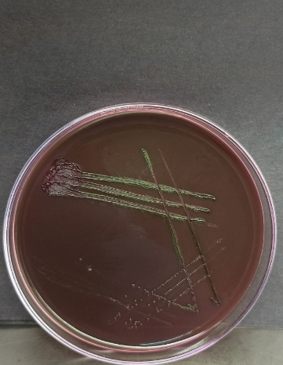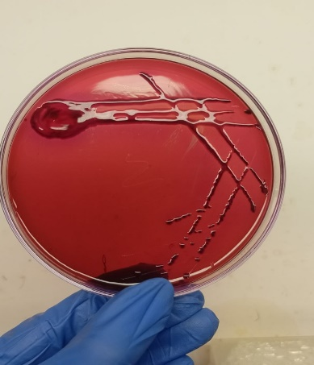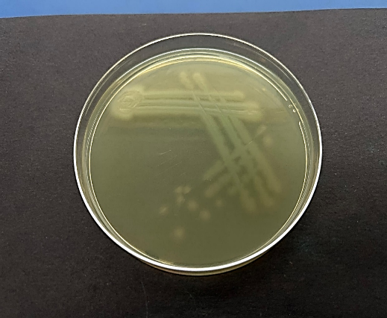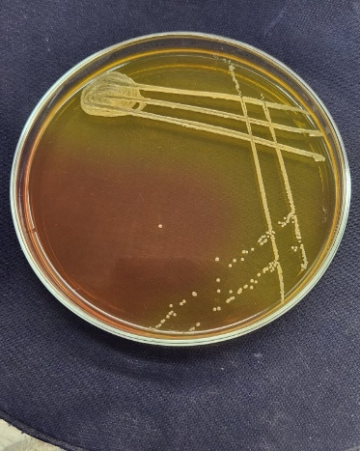In the present study the frequency of bacteria isolated was recorded as 57.69 percent (30) *Staphylococcus spp*. (Figure 05) followed by 11.53 percent (06) *E. coli (*Figure 06), 09.61 percent (05) *Bacillus spp.*, 05.77 percent (03) *Pseudomonas spp.* (Figure 07), 03.85 percent (02) *Streptococcus spp.*, 03.85 percent (02) *Corynebacterium spp.*, 03.85 percent (02). *Enterobacter spp.* and 03.85 percent (02) *Klebsiella spp*. (Figure 08). Bacterial spp. isolated from various septic eye affections is described in Table 03

Figure 06: Growth on EMB agar

showing green metallic sheen

colour colonies of *E. coli*.

Figure 05: Growth on Mannitol salt

agar showing yellowish colonies of

*Staphylococcus* spp

Figure 08: Growth on EMB

agar showing pink colour

mucoid colonies of *Klebsiella*

spp.

Figure 07: Growth on Cetrimide

agar showing yellowish green

colour colonies of *Pseudomonas*

spp.

**Table 3. Bacterial spp. isolated from various septic eye affections**

|  |  |  |  |  |  |  |
| --- | --- | --- | --- | --- | --- | --- |
| **Septic eye affections** | **No of cases** | **No of single isolates** | | | | **Mixed** |
| **Staph** | **Strepto** | **Pseudo** | ***E. coli*** |
| Conjunctivitis | 10 | 03 | - | - | 01 | *Staphylococcus* spp.+ *Klebsiella* spp.= 1  *Staphylococcus* spp.+ *Bacillus* spp.= 2  *Corynebacteria* spp.+ *Bacillus* spp.= 1  *Staphylococcus* spp. + *Streptococcus* spp. + *E. coli* = 1  *Staphylococcus* spp. *+ Enterobacter* spp.=1 |
| Corneal ulcers | 08 | 05 | - | - | 01 | *E. coli* + *Klebsiella* spp.= 1  *Staphylococcus* spp.+ *Corynebacteria* spp.=1 |
| Blepharitis | 03 | 01 | - | - | - | *Staphylococcus* spp. + *Enterobacter* spp.= 1  *Staphylococcus* spp.+ *Pseudomonas* spp.= 1 |
| Pigmented keratitis | 07 | 04 | - | - | 01 | *Staphylococcus* spp.+ *Bacillus* spp. + *E. coli* = 1  *Staphylococcus* spp. + *E. coli*=1 |
| Uveitis | 04 | 02 | - | - | - | *Staphylococcus* spp. + *Streptococcus* spp. *=* 1  *Staphylococcus* spp. + *Bacillus* spp.=1 |
| KCS | 02 | 01 | - | - | - | *Staphylococcus* spp. + *Pseudomonas* spp. = 1 |
| Hypopyon | 01 | 01 | - | - | - | - |
| **Total** | **35** | **17** | **00** | **01** | **02** | **15** |

Staphylococcus spp. was isolated predominantly from septic eye affections. This result of present study is in consistent with the findings of Sharma et al. (2019), Auten et al. (2020) and Guyonnet et al. (2020).

**3.6 Antibiotic sensitivity test**:

The sensitivity of gram-positive bacterial isolates and gram-negative isolates towards commonly used antibiotics was determined manually. (Table 01 and Table 02). Antibiotic sensitivity test revealed Gentamicin, Chloramphenicol, Amikacin and Erythromycin exhibited the highest sensitivity against all gram-positive bacteria, whereas Amoxiclav, Tetracycline and Norfloxacin showed the highest sensitivity against all gram-negative bacteria.

**Table 4. Antibiotic sensitivity test from isolates of gram-positive bacteria of septic eye affections**

|  |  |  |  |  |  |  |  |  |
| --- | --- | --- | --- | --- | --- | --- | --- | --- |
| **Antibiotics** | ***Staphylococcus* spp. (n=30)** | | ***Corynebacterium* spp. (n=02)** | | ***Streptococcus* spp. (n=02)** | | ***Bacillus* spp.**  **(n=05)** | |
| S (%) | R (%) | S (%) | R (%) | S (%) | R (%) | S (%) | R (%) |
| Amikacin | 86.67 | 12.33 | 100 | 00 | 100 | 00 | 60 | 40 |
| Clindamycin | 66.67 | 33.33 | 00 | 100 | 100 | 00 | 60 | 40 |
| Ampicillin | 63.33 | 36.67 | 50 | 100 | 00 | 100 | 40 | 60 |
| Erythromycin | 80.00 | 20.00 | 100 | 00 | 100 | 00 | 80 | 20 |
| Ciprofloxacin | 40 | 60 | 100 | 00 | 100 | 00 | 60 | 60 |
| Norfloxacin | 56.67 | 43.33 | 100 | 00 | 100 | 00 | 80 | 20 |
| Gentamicin | 96.67 | 03.33 | 100 | 00 | 100 | 00 | 80 | 20 |
| Meropenem | 66.67 | 33.33 | 100 | 00 | 50 | 50 | 60 | 40 |
| Levofloxacin | 56.67 | 43.33 | -- | -- | -- | -- | -- | -- |
| Kanamycin | 43.33 | 56.67 | -- | -- | -- | -- | -- | -- |
| Chloramphenicol | 100 | 00 | 100 | 00 | 100 | 00 | 80 | 20 |
| Tetracycline | 86.67 | 12.33 | 100 | 00 | -- | -- | 20 | 80 |

*\*S=Sensitive R=Resistant*

The antibiotic susceptibility profile of gram-positive isolates in the present study demonstrated high sensitivity to Chloramphenicol and Gentamicin. These results of study align with the findings of Prado et al. (2006), who reported that (80.7%) of the isolates were Gram-positive cocci and bacilli and these species were highly sensitive to Gentamicin and Chloramphenicol. However, the present study contradicts the observations of Lin and Peterson-Jones (2007) and Guyonnet et al. (2020) who found that *Staphylococcus* spp. isolates were resistant to Gentamicin.

**Table 5. Antibiotic sensitivity test from isolates of gram-negative bacteria of septic eye affections**

|  |  |  |  |  |  |  |  |  |
| --- | --- | --- | --- | --- | --- | --- | --- | --- |
| **Antibiotics** | ***Pseudomonas* spp. (n = 03)** | | ***Klebsiella* spp. (n = 02)** | | ***E. coli* (n = 06)** | | ***Enterobacter* spp.(n=02)** | |
| S (%) | R (%) | S (%) | R (%) | S (%) | R (%) | S (%) | R (%) |
| Amikacin | 66.66 | 33.34 | 100 | 00 | 66.67 | 33.33 | 50 | 50 |
| Ampicillin+ Sulbactam | 66.66 | 33.34 | 50 | 50 | 66.67 | 33.33 | 100 | 00 |
| Ampicillin | 66.66 | 33.34 | 00 | 100 | 16.67 | 83.33 | -- | -- |
| Cefepime | -- | -- | 100 | 0 | 50 | 50 | -- | -- |
| Ciprofloxacin | 00 | 100 | 50 | 50 | 50 | 50 | 50 | 50 |
| Norfloxacin | 66.66 | 33.34 | 100 | 00 | 66.67 | 33.33 | 100 | 00 |
| Gentamicin | 66.66 | 33.34 | 50 | 50 | 50 | 50 | 100 | 00 |
| Meropenem | -- | -- | 100 | 00 | 66.67 | 33.33 | -- | -- |
| Chloramphenicol | 00 | 100 | 50 | 50 | 33.33 | 66.67 | 100 | 00 |
| Amoxiclav | 66.66 | 33.34 | 100 | 00 | 83.33 | 16.67 | 100 | 00 |
| Levofloxacin | 00 | 100 | 100 | 00 | 50 | 50 | 50 | 50 |
| Tetracycline | 100 | 00 | 50 | 50 | 83.33 | 16.67 | 100 | 00 |

*\*S=Sensitive R=Resistant*

**3.7 Molecular confirmation**:

All phenotypically confirmed Staphylococcus spp. and E. coli isolates were genotypically tested for their respective genus-specific *16S rRNA* genes by PCR. Staphylococcus spp. showed a 876 bp band, while E. coli showed a 1476 bp band on 1% agarose gel. All isolates tested positive for their respective genes.

4. Conclusion

The overall prevalence of eye affections in dogs was found to be 15.42 percent. Out of these septic eye affections were found to be 45.75 percent. Male dogs were more affected with septic eye affections. Septic eye were more common in dogs up to 03 years age group. Conjunctivitis (35.71%) was found to be the most common septic eye affection and *Staphylococcus* spp. was highest among all the bacteria isolated from septic eye affections.

References

Modarres, S., Lasheii, A. and Oskoii, N.N. (1998). Bacterial etiologic agents of ocular infection in children in the Islamic Republic of Iran. Eastern Mediterranean Health Journal, 4(1): 44-49.

Forbes, B.A., Sahm, D.F. and Weissfeld, A.S. (2002). Bailley and Scott’s. Diagnostic Microbiology,11th Edn., Mosby., London, U.K., pp. 288-302.

Sushma, R. (2010). Studies on ocular diseases in dogs. M.V.Sc thesis (Veterinary Medicine), Karnataka Veterinary Animal and Fisheries Sciences University, Bidar.

Gelatt, K.N., Lippincott, Williams and Wilkins (2000). Essentials of Veterinary Ophthalmology, 3rd Edn., Philadelphia, pp 595. Warren, C. (2004). Phaco chop technique for cataract surgery in the dog. Veterinary Ophthalmology, 7(5): 348-351.

Featherstone, H. and Scurrell, E. (2015). Ocular sampling in the dog and cat. In Practice, 37(10): 510-539.

Quinn, P.J., Markey, B.K., Carter, M.E., Donnelly, W.C. and Leonard F.C. (2002). Veterinary Microbiology and Microbial Diseases, Blackwell Science, M.P.G. Books Limited, Bodmin, Great Britan, pp 33-34.

Salisbury, S.M., Lenda, M.D., Sabatini, M. and Spiegel, C.A. (1997). Identification of MRSA-S.aureus by multiplex polymerase chain reaction assay. Microbiology and Infectious Diseases, 107(1): 368-373.

Shrivastava, A. (2016). Studies on prevalence, characterization and inhibitory potential of herbs on extended spectrum beta lactamase E. coli in broilers. Ph.D thesis (Department of Veterinary Pharmacology and Toxicology), Nanaji Deshmukh Veterinary Science University, Jabalpur.

Al-Shuwaili, A.K.T. (2024). Study of bacterial isolates in eye infection cases of dogs. *Academic International Journal of Veterinary Medicine*, **2**(1): 10-16.

Zajer, J. and Szucs J. (1986). Eye diseases seen in dogs and cats at the Budapest veterinary school clinic. Magyar Allatorvosok Lapja, 41(2): 116–119.

Radhika, P. (2021). Studies on occurrence and diagnosis of ocular affections in dogs and management of superficial corneal ulcers M.V.Sc. thesis (Veterinary Medicine), Sri Venkateswara Veterinary University, Tirupati, Andra Pradesh, India.

Akinrinmade, J.F. and Ogungbenro, O.I. (2015). Incidence, diagnosis and management of eye affections in dogs. Sokoto Journal of Veterinary Sciences, 13(3): 9-13.

Saunders, L.Z. and Rubin, L.F. (1975). Ophthalmic Pathology of Animals. New York: Karger, pp 218-377.

Antonia, N.A., Narayanan., M.K., Anoop, S., Devanand, C.B., John, M.K.D. and Venugopal, K.S. (2014). Occurrence of ophthalmic disorders in dogs. Indian Journal of Veterinary Research, 23(2): 21-24.

Joon, Y.K., Hye, J.W. and Soon, W.J. (2009). A retrospective study of ulcerative keratitis in 32 dogs. International Journal of Applied Research in Veterinary Medicine, 7(1): 27–31.

Kumar, T., Punia, M., Agnihotri, D., Sindhu, N. and Jain, V.K. (2018). Incidence of ophthalmic affections in dogs – a short study. International Journal of Current Microbiology and Applied Sciences, 7(9): 1560–1565.

Bacchini, M. and Simonazzi, B. (2005). Ocular pathology in German Shepherd dogs: a retrospective study. Veterinary Ophthalmology, 25(1): 191-203.

Tamilmahan, P., Zama, M.M.S., Pathak, R., Muneeswaran, N.S. and Karthik, K. (2013). A retrospective study of ocular occurrences in domestic animals: 799 cases. Veterinary World, 6(5): 274-276.

Nagaraj, P. (2011). Clinical and diagnostic studies on certain ophthalmic conditions in dogs and their therapeutic management. PhD thesis (Veterinary Medicine), Sri Venkateswara Veterinary University, Tirupati, Andra Pradesh.

Grahn, B.H., Philibert, H., Cullen, C.L. and Houston, D.M. (1998). Multifocal retinopathy of Great Pyrenees dogs. Veterinary Ophthalmology, 1(4): 211-221.

Martens, A.L. (2007). Unusual presentation of an anterior uveal melanocytoma in a 3-year-old Poodle. Canadian Veterinary Journal, 48(1): 748–750.

Sharma, A., Gupta, A.K., Singh, M. and Dwivedi, D.K. (2019). Bacterial investigation and antibiogram in corneal ulcers in dogs. Journal of Animal Science, 9(1): 195–199.

Auten, C.R., Urbanz, J.L. and Dees, D.D. (2020). Comparison of bacterial culture results collected via direct corneal ulcer vs conjunctival fornix sampling in canine eyes with presumed bacterial ulcerative keratitis. Veterinary Ophthalmology, 23(1): 135-140.

Guyonnet, A., Desquilbet, L., Faure, J., Bourguet, A., Donzel, E. and Chahory, S. (2020). Outcome of medical therapy for keratomalacia in dogs. Journal of Small Animal Practice, 61(4): 253-258.

Lin, C.T. and Petersen-Jones, S.M. (2007). Antibiotic susceptibility of bacterial isolates from corneal ulcers of dogs in Taiwan. Journal of Small Animal Practice, 48(5): 271-274.