Case report

Split mouth de-epithelialisation techniques for gingival hyperpigmentation: A case report

Abstract:

Clinical melanin pigmentation is a significant aesthetic concern for many people, particularly Asians, even though it does not appear to be a medical issue or disease entity. These individuals can benefit greatly from aesthetic gingival depigmentation procedures. Using common surgical methods such as bur abrasion, electrosurgery, scalpel, and microneedling with ascorbic acid, this case report describes a split mouth de-epithelization treatment. Gingival hyperpigmentation was successfully treated with these methods. Even while we observed that electrosurgery and microneedling with ascorbic acid improved the effectiveness of our work and offered a neater, cleaner field, it still required a great deal of accuracy. On the other hand, bur-abrasion and scalpel de-epithelization were simple and technique-friendly, producing good outcomes and patient satisfaction. This case study also discusses the benefits and drawbacks of the several depigmentation methods that are currently available and restates that the scalpel method is still the most effective method.

Key-words: Ascorbic acid, Bur abrasion, Electrocautery unit, Gingival depigmentation, Microneedling, Scalpel

Introduction

In today's world, dental aesthetics have grown in importance. Both a pleasing gingival presentation and a healthy dental profile are necessary for a beautiful smile. The number and size of blood vessels, the thickness of the epithelium, the amount of keratinization, and the pigments present in the gingival epithelium all influence gingival depigmentation.1 The primary pigments that contribute to the normal colour of the oral mucosa are melanin, carotene, decreased haemoglobin, and oxyhaemoglobin. The most prevalent natural pigment that contributes to the gingiva's endogenous pigmentation is melanin, a brown pigment. Gingival hyperpigmentation results from an overabundance of melanin being deposited in the basal and supra-basal cell layers of the epithelium. Although complaints of black gums may be an aesthetic concern, especially if they are noticeable when speaking and smiling, clinical melanin pigmentation is entirely benign and does not present a medical issue.2 The anterior gingival segments have the most pigmentation compared to the posterior regions, and its distribution varies intraorally as well, with the connected gingiva and interdental papilla having the highest levels compared to the marginal gingiva.3 A periodontal plastic surgery procedure called gingival depigmentation involves reducing or eliminating gingival hyperpigmentation using a variety of methods. To achieve pigmentation-free gingiva, a variety of procedures have been employed, including gingivectomy, scalpel-assisted mucosal excision, abrasion techniques, free gingival grafts, chemical therapies employing caustic chemicals, electrosurgery, cryotherapy, and recently discovered lasers.4 The literature that is currently available indicates that there must be agreement on the most appropriate technique. Therefore, the purpose of this case study is to examine the clinical results of gingival depigmentation using bur abrasion, electrosurgery, microneedling with ascorbic acid, and a conventional scalpel.

Presentation of Case

The primary complaint of a twenty-five-year-old female patient who presented to the outpatient department of periodontology was "black" gums. There was no relevant medical history and upon intraoral examination, the gingiva was found to be highly pigmented, however was healthy, and inflammation-free. To rule out any surgical contraindications, a complete blood investigation was conducted. The patient provided a signed consent after being fully informed about the procedure. Four distinct depigmentation procedures were envisioned as part of a split mouth design that extended from the central incisor to the first premolar region. As a first step, the dental hygienist did supragingival scaling and gave instructions on oral hygiene. After scheduling the procedure, we carried it out aseptically and with 2% lignocaine (1:80,000 adrenaline) local anaesthesia infiltration.

Evaluation following surgery:

1. Pain: The Visual Analog Scale (VAS) was used to measure pain at baseline and on days four and seven following surgery.

2. During the procedure, bleeding was measured as "0 = no bleeding" was assigned to a clean, dry wound; "1 = oozing" to a wound that was bleeding slightly; and "2 = active bleeding" to a wound that was bleeding enough to fill the mouth.

3. Treatment duration: As soon as the procedure started and ended after all of the pigment had been removed from the treated area, the operation time was recorded in minutes.

4. The Dummett-Gupta Oral Pigmentation Index (DOPI) was used to measure gingival pigmentation both at baseline and seven days after surgery.

Quadrant one: Electrosurgery technique

The loop electrode was used to carry out the electrosurgical procedure. The current employed was a fully rectified combination of cutting and coagulating. Light brushstrokes were applied using the loop electrode. To prevent heat accumulation and tissue destruction, the tip was constantly kept in motion.

Quadrant two: Bur abrasion

The gingiva was depigmented using a rotating diamond bur, which was used with feather-light strokes without applying pressure. Because it could cause thermal stress and irreversible damage to the underlying tissue, it was not kept in at a single spot for an extended period of time. Because a small bur could result in tiny pits instead of surface abrasion, a medium-sized circular bur was employed.

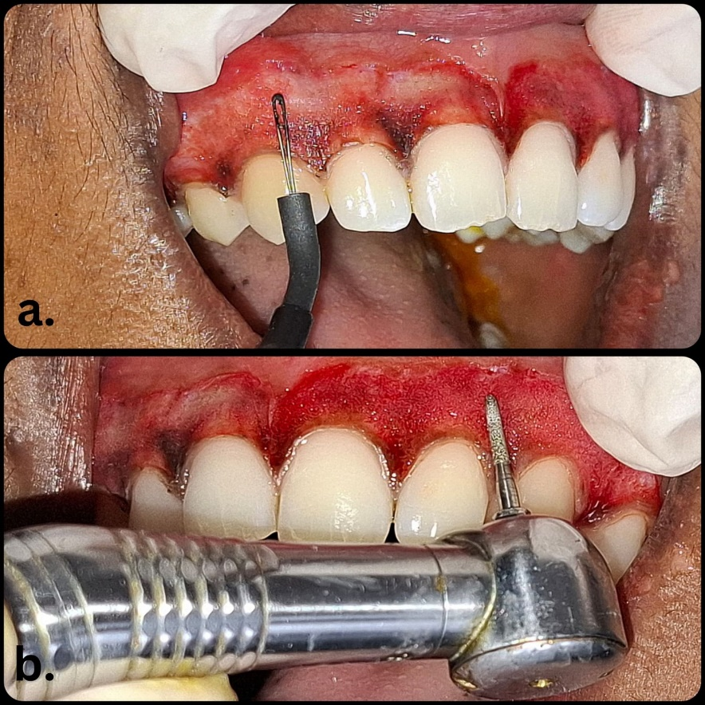

Figure 1- Gingival depigmentation using (a) Electrocautery unit and (b) Bur abrasion

Quadrant three: Conventional Scalpel Technique

A #15 scalpel blade was used to make two vertical incisions on the side that would be subjected to de-epithelialisation on both the distal and mesial sides of the pigmented area. A split-thickness flap was raised and eliminated, preserving the gingiva's natural structure. To stop the bleeding, sterile gauze soaked in saline was applied to the recipient's site.

Quadrant four: Microneedling with Ascorbic acid (AA) application

The microneedling technique involved intermittently applying a blood lancet to the gingival mucosa, 1.5 mm apical to the gingival margin. Once bleeding pinpoints were seen on all areas of pigmented gingiva, the gingival mucosa was irrigated with a saline solution, and the area was dried with sterile gauze. In a tiny glass dish, saline and topical AA powder (1000 mg/ml) were combined to create a paste. The gingival mucosa was treated with the mixture of slurry paste for ten minutes.

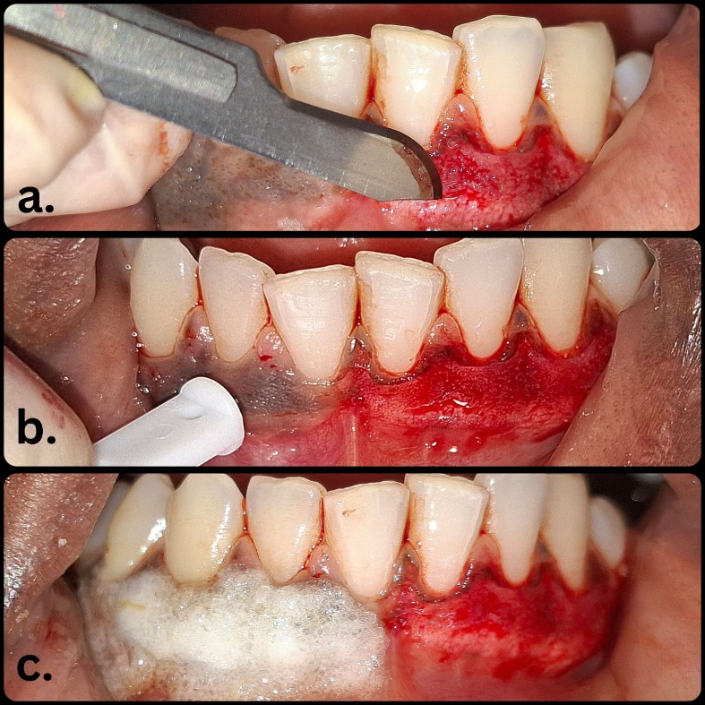

Figure 2- Gingival depigmentation using (a) Conventional scalpel technique and (b) Microneedling followed by (c) Ascorbic acid application

Coe-pak was placed over the surgical areas, the patient was prescribed Amoxicillin 500 mg, TD for 5 days and Aceclofenac–paracetamol combination BD for 3 days and post-operative instructions were given. The patient was reviewed at the end of one week. The healing process was uneventful, the patient did not report any discomfort and the DOPI score had improved to 1.

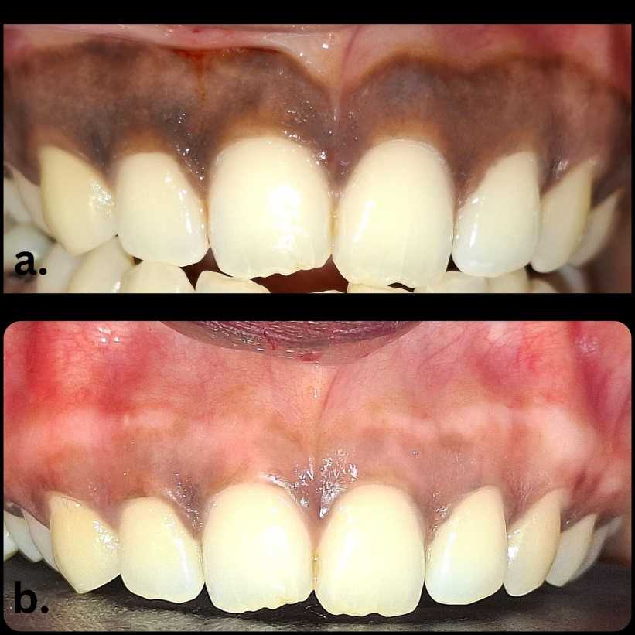

Figure 3- Maxillary arch gingival depigmentation (a) Pre-operative and (b) 7-days post-operative

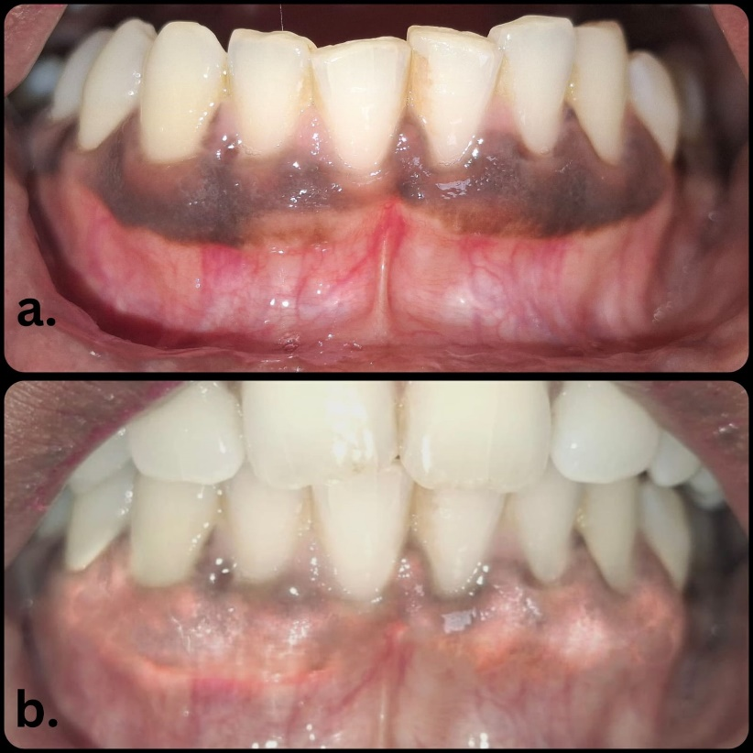

Figure 4- Mandibular arch gingival depigmentation (a) Pre-operative and (b) 7-days post-operative

Discussion

For many patients, gingival hyperpigmentation is a serious concern that frequently necessitates cosmetic surgery. The split-mouth design used in the current study is an excellent approach to assess the clinical significance of comparing the four depigmentation methods. It reduces the impact of many inter-subject variables, including age, facial complexion, etc., by comparing the methods inside a subject.5

In this report the patient demonstrated a deep blackish-brown pigmentation (DOPI 3) at baseline which improved to light brown-mild pigmentation (DOPI 1) at 7 days. The patient demonstrated more pain and discomfort in the electrosurgically treated site during the first 24h postoperatively (VAS Pain Score of 6) and the least pain and discomfort with bur abrasion (VAS Pain Score of 2).

Sites treated with bur abrasion and electrocautery unit were the least time consuming while that with conventional scalpel and microneedling with ascorbic acid application required the most time. During the surgery, a clean dry wound was maintained at all the sites except that with conventional scalpel where there was slight oozing blood observed.

In comparison to alternative methods, the traditional scalpel de-epithelization approach is straightforward, efficient, cost-effective, and has a quicker rate of healing. This method can be repeated if needed and doesn't require complex equipment. It might, however, result in more frequent and severe bleeding during or after operation.6

Known as collagen induction therapy, the microneedling (MN) technique is a non-surgical procedure that involves making repeated punctures in the skin. The MN enhances the permeability of the skin and blood flow into the epidermis by separating the cells rather than slicing through them to create microchannels. It has been established that AA is a water-soluble antioxidant and a necessary vitamin for the production of collagen. By reacting with the copper ions at the tyrosinase active site and preventing the enzyme's action, it reduces the synthesis of melanin and gets rid of hyperpigmented areas. The results of Mostafa et al., who applied topical AA powder mixed with saline to the gingiva and came to the conclusion that AA inhibited melanin pigmentation, were in line with our observations.7 But according to El-Mofty et al., intramucosal AA injections were superior and more effective for the same.8

Melanin cell migration from locally positioned cells is significantly slowed by electrosurgery. Therefore, even while cautery offers benefits including preventing bleeding and reducing patient discomfort, prolonged usage causes tissue damage and heat buildup.4

In order to remove any remaining re-pigmentation, bur abrasion is also a somewhat easy, affordable, safe, and non-aggressive procedure that is simple to use and may be easily repeated if needed. However, extra caution should be used to regulate the handpiece bur's speed and pressure in order to prevent unintended tissue abrasion or pitting.9 These results are in line with a study by Al Mokadem et al., which discovered that immediate coagulation during the use of a soft tissue trimmer decreases intraoperative bleeding and improves wound healing. The study also found that using a soft tissue trimmer could be a quick and promising procedure with little postoperative pain.10

Even if this patient experiences gingival re-pigmentation in the future, the same treatment might be carried out in the same area. Given the lack of equipment in developing countries, the scalpel surgical approach and the gingival abrasion technique are therefore strongly advised.

Conclusion

Growing aesthetic demands the removal of hyperpigmented areas to produce a smile that is confident and pleasant, which completely changes a person's personality. There are several methods available, each with pros and cons. However, patient affordability, professional knowledge, and personal preference should all play a role in the procedure selection. To guarantee long-term predictability and success, more information on comparable methodologies is needed.

References

1. Urmi D, Jasuma RJ, Deepak D, Vandana R. Comparison of patient perception on gingival depigmentation using scalpel and diode laser. J Dent Med Sci. 2013;11(4):33-8.
2. Kathariya R, Pradeep AR. Split mouth de-epithelization techniques for gingival depigmentation: A case series and review of literature. Journal of Indian Society of Periodontology. 2011 Apr 1;15(2):161-8.
3. Nagati RR, Ragul M, Al Qahtani NA, KS R. Clinical effectiveness of gingival depigmentation using conventional surgical scrapping and diode laser technique: a quasi experimental study. Global journal of health science. 2017;9(3):296-303.
4. Elavarasu S, Thangavelu A, Alex S. Comparative evaluation of depigmentation techniques in split-mouth design with electrocautery and laser. J Pharm Bioall Sci 2015;7:S786-90.
5. Sharath KS, Shah R, Thomas B, Madani SM, Shetty S. Gingival depigmentation: Case series for four different techniques. Journal of Health and Allied Sciences NU. 2013 Dec;3(04):132-6.
6. Mohan Kumar, P., Ravindra Reddy, N., Roopa, D., Sahitya, S., & Swamy, N. (2012). Aesthetic gingival depigmentation procedures: clinical and patient responses-A set of case reports. International Journal of Stomatology and Occlusal Medicine, 5, 28-37. <http://dx.doi.org/10.1007/s12548-011-0030-7>
7. Mostafa D, Alotaibi SM. A successful esthetic approach of gingival depigmentation using microneedling technique and ascorbic acid (Vitamin C). Case Reports in Dentistry. 2022;2022(1):3655543.
8. M. El-Mofty, S. Elkot, A. Ghoneim, D. Yossri, and O. M. Ezzatt, “Vitamin C mesotherapy versus topical application for gingival hyperpigmentation: a clinical and histopatholo gical study,” Clinical Oral Investigations, vol. 25, no. 12, pp. 6881–6889, 2021.
9. Sameer AM. Management of gingival Hyperpigmentation by surgical abrasion: Report of three cases. Saudi Dent J 2006;18:162-6.
10. Mikhail FF, El Menoufy H, El Kilani NS. Assessment of clinical outcomes and patient response to gingival depigmentation using a scalpel, ceramic bur, and diode laser 980 nm. Clinical Oral Investigations. 2023 Nov;27(11):6939-50.