**Analyzing Haller Cells through Cone Beam CT: Investigating Associations with Orbital Floor Dehiscence and Sinusitis**

**Abstract**

**Aims**: This study aims to analyze Haller cells (infraorbital ethmoid cells) through cone beam computed tomography (CBCT) to understand their association with orbital floor dehiscence and sinusitis.

**Place and Duration of Study**: A retrospective study was conducted at the Department of Oral Medicine and Radiology, Government Dental College, Chh. Sambhajinagar, from May 2024 to July 2024.

**Methodology**: CBCT images from 150 patients were obtained using the Carestream CS 9300 machine and analyzed with TROPHY DICOM 3D Imaging Dental software (Version 6.4.0.4). The evaluation was done on coronal sections with a slice thickness of 0.899 mm. Data was recorded in Microsoft Excel (2007/2013). Descriptive and frequency analyses were performed using SPSS version 21.0. The normality of the data was assessed with the Shapiro–Wilk test. Chi-square tests were used to analyze associations, and a p-value of <0.05 was considered statistically significant.

**Results**: The study included 150 participants, aged 16–62 years, with a mean age of 29.7 ± 9.16 years. Of the participants, 60% were female (90) and 40% were male (60). Haller cells were present in 42% and absent in 58%. The most common shapes of Haller cells were oval (28%), round (9.3%), irregular (2.7%), and triangular (1.3%). Sizes included large (5.3%), medium (20%), and small (14.7%). Bilateral presence was seen in 8%, unilateral in 34%, and absent in 58%. Maxillary sinusitis was present in 16.7% of participants with Haller cells, and orbital floor dehiscence was observed in 3.3%. Significant associations were found between Haller cells and maxillary sinusitis (Chi-square = 41.429, p < 0.001) and orbital floor dehiscence (Chi-square = 7.143, p = 0.012).

**Conclusion**: The study found a significant relationship between Haller cells and maxillary sinusitis and orbital floor dehiscence, highlighting the importance of identifying Haller cells in CBCT evaluations.

**Keywords**: CBCT, Haller cells, Sinusitis, Orbital Floor Dehiscence

**Introduction**

Haller cells are the anatomical variation in paranasal sinuses. Infraorbital ethmoid cells, also known as Haller’s cells (HC), are frequently cited as an incidental finding, without critical investigation into their possible role in the development of the obstruction and inflammation of the ethmoidal infundibulum which were named after anatomist Albert Von Haller, who first identified this ethmoidal pneumatization of orbital floor in 1765.(1,2,3,4,5,6)Haller cells are considered as an anterior extension of ethmoidal sinuses in to the orbital floor or superior aspect of maxillary sinus and they are located medial to the infraorbital canal and lateral to the nasolacrimal duct .These cells are also named as orbito‑ethmoidal cells or maxillo‑ethmoidal cells. Posterior extension of ethmoidal cells is rarely seen and should be differentiated from lateral extension of the posterior portion of the middle meatus.(2,3,5,6,7)Large sized Haller cells can cause compression of infundibulum of maxillary sinus which may block mucociliary flow, which will lead to disruption of transport and stagnation of fluid, which will produce favorable environment for bacterial growth which can further contribute to maxillary sinus diseases.(2,5)Haller cell position may lead to disruption of the normal pattern of mucocilliary flow that causes recurrent maxillary sinusitis.(3,11,12)Some studies showed a significant relationship between Haller cell size (>3 mm) and orbital floor dehiscence; nevertheless, there is no definite information on this matter.(3,7)Hence, In our study, we intend to evaluate the prevalence of Haller cells on cone beam computed tomography (CBCT) and its association with maxillary sinusitis and dehiscence of orbital floor.

**Materials and Methods**

A retrospective study was designed to analyze 150 CBCT scans of patients who visited the Department of Oral Medicine and Radiology for conditions such as temporomandibular joint disorders, orthodontic evaluation, dental implants, and other maxillofacial indications. Only scans that displayed the complete maxilla, from the alveolar bone to the orbit, were included. Patients aged 16 years and older were eligible for inclusion. Scans with artifacts or unclear visualization of the area of interest were excluded. Since no radiographic scans were taken specifically for this study, informed consent was not required.

The CBCT scans were acquired using a Carestream CS 9300 machine and evaluated with TROPHY DICOM 3D Imaging Dental Software (Version 6.4.0.4 CS 3D Imaging Software). The acquisition parameters included 8 mA (current), 85 kVp (voltage), 11.30 s (exposure time), 300 µm (voxel size), a 17 x 13.5 cm field of view (FOV), and a slice thickness of 0.3 mm. The software provided three-dimensional data to evaluate Haller cells using cone beam computed tomography, focusing on their associations with orbital floor dehiscence and sinusitis.

All scans were reviewed by two observers: the principal investigator (a) and an experienced Oral and Maxillofacial Radiologist (b) with a minimum of 20 years of expertise in evaluating CBCT scans. The coronal view was specifically examined for the presence of Haller cells. Both observers evaluated all sections for parameters such as age, gender, presence of Haller cells (including site, size, and number), maxillary sinusitis, and orbital floor dehiscence. The data was recorded in a Microsoft Excel sheet.

The study was approved by the institutional ethics committee.

**Parameters Measured**

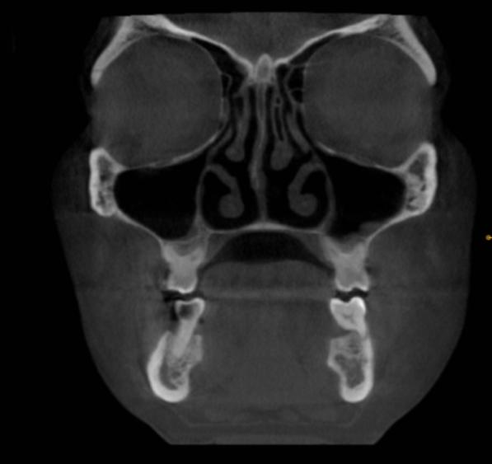

Fig. 1. Coronal cone beam CT shows the absence of Haller cells.

Haller cells are air-filled cavities located medially on the orbital floor. They are enclosed by the ethmoidal capsule, distinguishing them from the infraorbital recess of the maxillary sinus. Haller cells can vary in size and shape, be present unilaterally or bilaterally, and appear as single or multiple entities. Observations were made in the coronal section of CBCT scans, with a slice thickness of 800 µm. The maximum medio-lateral dimensions of the Haller cells were measured and categorized by size as small (<2 mm), medium (2–4 mm), or large (>4 mm).

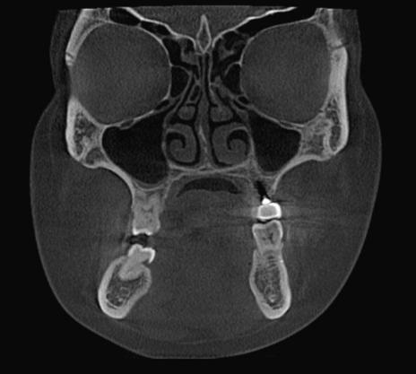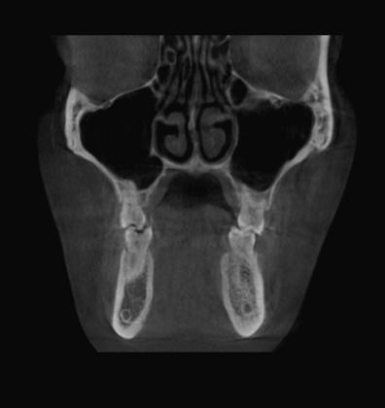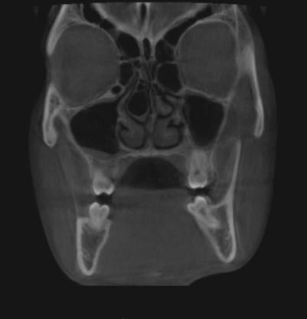

**Fig 2**.Coronal cone beam CT shows different shapes of Haller cells, (a) Small (b) Medium (c) Large

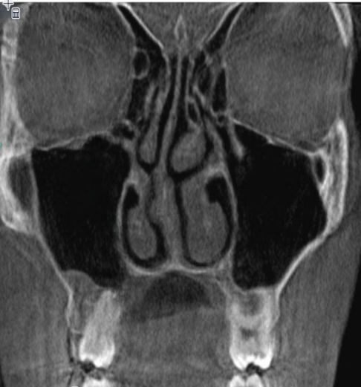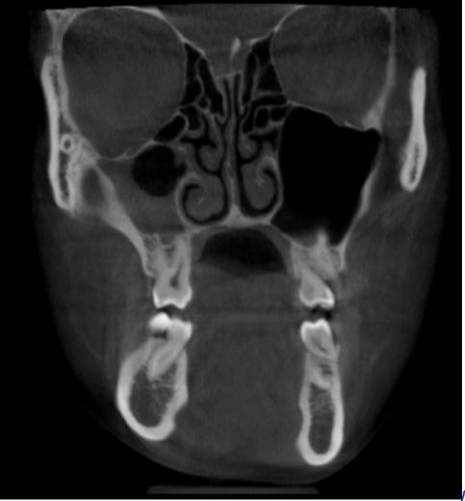

**Fig.3.**Haller cells present with maxillary sinusitis. **Fig.4.** Haller cells present with orbital floor dehiscence.

**Results**

The study comprised a total of 150 participants. The participants' ages ranged from a minimum of 16 years to a maximum of 62 years, encompassing a broad spectrum of adult age groups. The mean age of the participants was 29.7 years. Females constituted a larger portion of the sample, accounting for 60% (90 participants).

**Fig 5.** Pie chart depicts Frequency distribution of the study participants according to Gender

**Fig.6** Frequency distribution of the study participants according to presence or absence of Haller cells

A total of 87 patients, representing the majority, did not exhibit Haller cells. In contrast, 63 patients were found to have Haller cells, comprising a smaller portion of the study population (Fig. 6).

**Fig. 7.**Frequency distribution of the study participants according to Shape, Sites and Size of Haller cells

The chart (Fig. 7) shows that the majority of observations revealed the absence of Haller cells in 87 scans. Among the cases with Haller cells, oval-shaped cells were the most commonly observed, unilateral occurrences were more frequent, and medium-sized cells were the most prevalent.

|  |  |  |  |  |  |  |  |
| --- | --- | --- | --- | --- | --- | --- | --- |
|  | | **Haller cells present with maxillary sinusitis** | | **Total** | **Chi-square value** | **p value** | **Interpretation** |
| **No** | **Yes** |
| **Haller cells** | **Absent** | **87** | **0** | **87** | **41.429** | **0.001\*** | **Significant** |
| **Present** | **38** | **25** | **63** |
| **Total** | | **125** | **25** | **150** |

**Table no.1**.Association between presence or absence of Haller cells and maxillary sinusitis.

When Haller cells are present, 38 cases were recorded without maxillary sinusitis, and 25 cases were associated with maxillary sinusitis.

|  |  |  |  |  |  |  |  |
| --- | --- | --- | --- | --- | --- | --- | --- |
|  | | **Haller cells present with orbital floor dehiscence** | | **Total** | **Chi-square value** | **p value** | **Interpretation** |
| **No** | **Yes** |
| **Haller cells** | **Absent** | **87** | **0** | **87** | **7.143** | **0.012\*** | **Significant** |
| **Present** | **58** | **5** | **63** |
| **Total** | | **145** | **5** | **150** |

**Table no.2**.Association between presence or absence of Haller cells and orbital floor dehiscence

The chi-square test was used to analyze the association, with a chi-square value of 41.429.

The p-value is 0.001, which is marked as statistically significant (p < 0.05) and highly significant (p < 0.01).There is a statistically significant association between the presence of Haller cells and the occurrence of maxillary sinusitis. Specifically, individuals with Haller cells are more likely to have maxillary sinusitis compared to those without. Among individuals with Haller cells, 58 cases had no orbital floor dehiscence, and 5 cases exhibited orbital floor dehiscence.

**Discussion:**

Despite anatomical variations in the development of the nose and paranasal sinuses, Haller cells have been implicated in orofacial diseases [5]. In addition to their association with orofacial pain and sinusitis, Haller cells have been linked to symptoms such as nasal obstruction, impaired nasal breathing, headache, chronic cough, and pathologies like mucoceles cystic lesions containing mucoid secretions lined by pseudostratified columnar epithelium [9]. This study estimated the prevalence of Haller cells in CBCT images to be relatively high at approximately 42%. Previous studies have reported an extremely variable prevalence of Haller cells, ranging from 2% to 70.3%. For instance, Mathew et al. reported a prevalence of 60%, while Khojastepour et al. observed 68%, findings that closely align with our study. CBCT, as an advanced imaging modality, provides a slice thickness of 899 µm, enabling the detection of small, delicate bony structures, including Haller cells smaller than 1 mm [2]. The high percentage of Haller cells observed in this study underscores the sensitivity of CBCT in detecting these anatomical variations. This finding is statistically significant (p < 0.05) and consistent with several previous studies (2–4, 13).

In our study, Haller cells were evaluated based on parameters such as age, gender, site, number, size, and shape. The incidence of Haller cells was higher among younger individuals than older ones. Unilateral Haller cells (34%), medium-sized cells (20%), and oval-shaped cells (28%) were the most commonly observed variants. Notably, the prevalence of Haller cells showed no significant association with gender, a finding consistent with the studies of Raina et al. [7].

Haller cells were associated with maxillary sinusitis in 16.6% of cases and with orbital floor dehiscence in 3.3%. Moshfeghi et al. also highlighted the coexistence of Haller cells with orbital floor dehiscence [3]. The identification of Haller cells is crucial for rhinologists, particularly in cases of sinusitis where other significant findings are not evident during physical examination or endoscopy.  
Management of Haller cells can range from conservative measures to surgical intervention. When Haller cells are determined to be a contributing factor in maxillary sinusitis, medical therapy is usually the first line of treatment. However, if this approach proves unsuccessful, surgical procedures such as functional endoscopic sinus surgery or lateral rhinotomy may be necessary to relieve symptoms [2,12,13].  
The correlation between Haller cells and maxillary sinus pathologies highlights the need for further research involving larger sample sizes and more robust study designs, including longitudinal prospective studies.

### Conclusion

The presence and size of Haller cells were found to be associated with maxillary sinus pathology in this study. CBCT imaging, with its capability for three-dimensional evaluation, proved to be an effective tool for identifying Haller cells. A statistically significant (p < 0.05) association was observed, highlighting a positive relationship between Haller cells, maxillary sinusitis, and orbital floor dehiscence.

REFERENCES:

1)Caversaccio M, Boschung U, Mudry A. Historical review of Haller's cells. Ann Anat. 2011 May;193(3):185-90. doi: 10.1016/j.aanat.2011.02.006. Epub 2011 Mar 10. PMID: 21454060.

2) Kamdi, Pallavi; Nimma, Vijayalakshmi; Ramchandani, Amit; Ramaswami, Easwaran; Gogri, Ajas; Umarji, Hemant. Evaluation of haller cell on CBCT and its association with maxillary sinus pathologies. Journal of Indian Academy of Oral Medicine and Radiology 30(1):p 41-45, Jan–Mar 2018. | DOI: 10.4103/jiaomr.jiaomr_22_18

3) Moshfeghi M, Dehini H, Ghazizadeh Ahsaie M. Cone Beam CT Analysis of Haller Cells: Prevalence and Relationship with Orbital Floor Dehiscence. Int J Dent. 2023 Jan 31;2023:5200152. doi: 10.1155/2023/5200152. PMID: 36760838; PMCID: PMC9904925.

4) Mathew R, Omami G, Hand A, Fellows D, Lurie A. Cone beam CT analysis of Haller cells: prevalence and clinical significance. Dentomaxillofac Radiol. 2013;42(9):20130055. doi: 10.1259/dmfr.20130055. Epub 2013 Aug 23. PMID: 23975112; PMCID: PMC3828019.

5) Ahmad M, Khurana N, Jaberi J, Sampair C, Kuba RK. Prevalence of infraorbital ethmoid (Haller's) cells on panoramic radiographs. Oral Surg Oral Med Oral Pathol Oral Radiol Endod. 2006 May;101(5):658-61. doi: 10.1016/j.tripleo.2005.08.035. Epub 2006 Feb 28. PMID: 16632280.

6) Yesilova E, Bayrakdar IS. The Appearance of The Infraorbital Canal and Infraorbital Ethmoid (Haller's) Cells on Panoramic Radiography of Edentulous Patients. Biomed Res Int. 2018 Jul 8;2018:1293124. doi: 10.1155/2018/1293124. PMID: 30069460; PMCID: PMC6057392.

7) Wanamaker HH. Role of Haller's cell in headache and sinus disease: a case report. Otolaryngol Head Neck Surg. 1996 Feb;114(2):324-7. doi: 10.1016/S0194-59989670196-1. PMID: 8637763.

8) Sandhu R, Kheur MG, Lakha TA, Supriya M, Valentini P, Le B. Anatomic variations of the osteomeatal complex and its relationship to patency of the maxillary ostium: A retrospective evaluation of cone-beam computed tomography and its implications for sinus augmentation. J Indian Prosthodont Soc. 2020 Oct-Dec;20(4):371-377. doi: 10.4103/jips.jips_113_20. Epub 2020 Oct 8. PMID: 33487964; PMCID: PMC7814679.

9) Shetty, Shishir & Sura, Ali & Ahmed, Foud & Al-Bayati, Sura & Shakeel, Sk & Gandhiraj, Venkatesh. (2015). Haller' s Cells – a brief review. BALKAN Military Medical REVIEW. 18. 10.5455/bmmr.190880

10) Dhanasekaran, Balaji & Priya, K. & Srinivasan, Rajasekaran & K, Paventhan & Somu, Prabakaran & Navin, Namasivaya & C, Ramya. (2019). Prevalence of haller cells - A retrospective observational study at a tertiary health care centre. MedPulse International Journal of ENT. 12. 24-28. 10.26611/10161224.

11) S. Lerdlum and B. Vachiranubhap, “Prevalence of anatomic variation demonstrated on screening sinus computed tomography and clinical correlation,” Journal of the Medical Association of Tailand Chotmaihet thangphaet, vol. 88, no. 4, pp. S110–S115, 2005.

12) A. Leunig, “Anatomic variations of the sinuses; multiplanar CT-analysis in 641 patients,” Laryngo-Rhino-Otologie, vol. 87, no. 7, pp. 482–489, 2008

13) Yesilova E, Bayrakdar IS. The Appearance of The Infraorbital Canal and Infraorbital Ethmoid (Haller's) Cells on Panoramic Radiography of Edentulous Patients. Biomed Res Int. 2018 Jul 8;2018:1293124. doi: 10.1155/2018/1293124. PMID: 30069460; PMCID: PMC6057392.

14 ) Maillet M, Bowles WR, McClanahan SL, John MT, Ahmad M. Cone-beam computed tomography evaluation of maxillary sinusitis. J Endod. 2011 Jun;37(6):753-7. doi: 10.1016/j.joen.2011.02.032. Epub 2011 Apr 16. PMID: 21787483.

1. Ghosh, Debangshu & Baruah, Dilip & Goswmi, Subodh & Basu, Sumit. (2018). Lateral Rhinotomy for a Large, Infected Haller Cell Causing Proptosis. Philippine Journal of Otolaryngology-Head and Neck Surgery. 30. 4. 10.32412/pjohns.v30i1.389.