Original Research Article
Morphological variability and phytogeographic structures of Chrysophyllum albidum G. Don (Sapotaceae) in Benin

ABSTRACT
Chrysophyllum albidum is an agroforestry tree that provides enormous goods and services to local populations in West Africa. The unbridled use of organs the specy, causes its vulnerability, even its disappearance in certain regions, in Benin. The present study aims to evaluate the morphological diversity of populations of C. albidum in Benin, in order to differentiate individuals of the specy and target interesting morphotypes for its conservation. Nine (9) variables were used to evaluation of the phenotypic diversity of sixty (60) fruiting trees of the specy, selected in four (04) phytodistricts of Benin. To determine the inter and intra-population variability of the specy, the descriptive statistic was carried out on the quantitative morphology variables of trees by population, and for all populations. Analysis components of the variance were carried out on all the morphological descriptors, in order to study the part of the overall variability due to individuals, soil types and climatic conditions of phytodistricts. An Ascending Hierarchical Classification was performed to identify the different morphotypes of the specy. The results obtained reveal significant variability in certain morphological descriptors used, depending on the phytodistricts and soil groups. The descriptors based on the fruits and the leaves of trees of the specy are more discriminants than those the trunk and crown. Three (03) morphotypes of C. albidum were obtained in Benin. Chrysophyllum albidum’s plants of the phytodistricts Coastal and Plateau belong to the same phenotypic class while the trees of the phytodistricts Pobè and Valley of Ouémé each have a morphotype of the specy. Consisting of relatively short trees bearing longer and wider leaves and fruits, the morphotype of C. albidum from the phytodistrict Valley of Ouémé is better indicated for future selections. These various data found must be further supplemented by the molecular genetics characterization, for the definition of integrated and effective strategies.

Keywords: Benin, Chrysophyllum albidum, Morphological variability, Phytodistrict, West Africa.

- INTRODUCTION
Food security remains a major existential concern in this world exposed to the harmful effects of climate change and growing population (Kanazoe, 2017). To survive in the face of climate change which has profoundly reduced agricultural yields (Brou et al., 2005), rural communities particularly use to the plant genetic resources of fruit trees (Mbaye, 2011). These resources are increasingly essential in the areas of food security and development sustainable economy (FAO, 1996). Chrysophyllum albidum, one of the woody plants whose genetic resources have proven value for human well-being, are essential in West Africa. Almost all organs of C. albidum are exploited by the local populations of Benin. Its wood is used as energy wood and lumber, its fruits constitute a food very appreciated by its consumers, the bark, the roots and the leaves of trees of the species are used in the herbal medicine (Houessou et al., 2012). Aging, urbanization and the method of harvesting organs from C. albidum plants constitute the major factors in its disappearance in Benin (Alowanou-Kélé et al., 2023). It is therefore necessary to develop adequate strategies to conservation of the species, to prevent this disappearance (Agbo et al., 2018). Sustainable management and conservation of forest species requires the analysis of variability morphology of their plant material, to differentiate individuals, in order to identify the elite morphotypes to reproduce (Kouyaté and Van Damme, 2002; Houètchégnon, 2016). Among the numerous scientific studies carried out on the morphological variability of woody species useful to populations, we can cite among others, the work by Kouyaté (2005) and Agbo et al. (2018) on Detarium microcarpum, Fandohan et al. (2011) on Tamarindus indica, Gbèmavo et al. (2015) on Jatropha curcas Linn, Ewédjè et al. (2012) on Pentadesma butyracea, Ammari et al. (2016) on Celtis australis, Sourou Kuiga (2017) on Haematostaphis barteri. In each of these studies, the parameters morphological discriminants were identified and used to characterize the different morphotypes found.
From the results from research work on the phenotypic diversity of C. albidum in Benin, it appears that there is great variability at the level of several morphological descriptors of the organs of the specy (Dadégnon et al., 2014; Lougbégnon et al., 2016). However, these various works have unfortunately not taken into account the edaphic data, although the quality of the soil is essential for the good conservation of agroforestry species (Kouyaté, 2005). Fertile or suitable soil allows the growth of plants, to prevent desertification and land degradation (FAO, 2015). In consequently, the identification of soil types favorable to plant species with multiple uses like C. albidum, can ensure food security, and allow the ecosystem to fulfill its fundamental functions.
The main objective of this study is to evaluate, on a morphological level, the genetic diversity of Chrysophyllum albidum, in Benin. Specifically, it involved: (i) describe the morphological variability of C. albidum, (ii) analyze the influence of phytodistricts and soil types on this morphological variability, and (iii) to characterize the morphotypes of the species in Benin.

- MATERIAL AND METHODS
2.1. Study zone
This study took place in Benin in four (04) phytodistricts, which are distinguished from each other, by their biophysical characteristics and climate (table 1). These are the phytodistricts Coastal, Plateau, Pobè and Valley of Ouémé from the Guineo-Congolese zone, where Chrysophyllum albidum plants are present (figure 1).
Table 1: Biophysical characteristics of the phytodistricts of the study area (Gbèmavo et al., 2015).
Phytodistricts  of the area  of study | Percentage cor-responding to each of phyto-districts in the surface company of Benin | Diet rain | Rainfall | Main types  of soil | Main training  vegetables
Coastal | 1% | Bimodal | 900 à 1300 | Sandy + Hy-dromorphic & Halomorphic | Coastal forest and Mangrove
Plateau | 7% | Bimodal | 900 à 1100 | ferralitic without concretions | Semi- deciduous forest
Pobè | 2% | Bimodal | 1200 à 1300 | ferralitic without concretions | Semi- deciduous forest
Valley of Ouémé | 2% | Bimodal | 1100 à 1300 | Soil hydromorphic | Swamp and Semi-deciduous Forest deciduous.

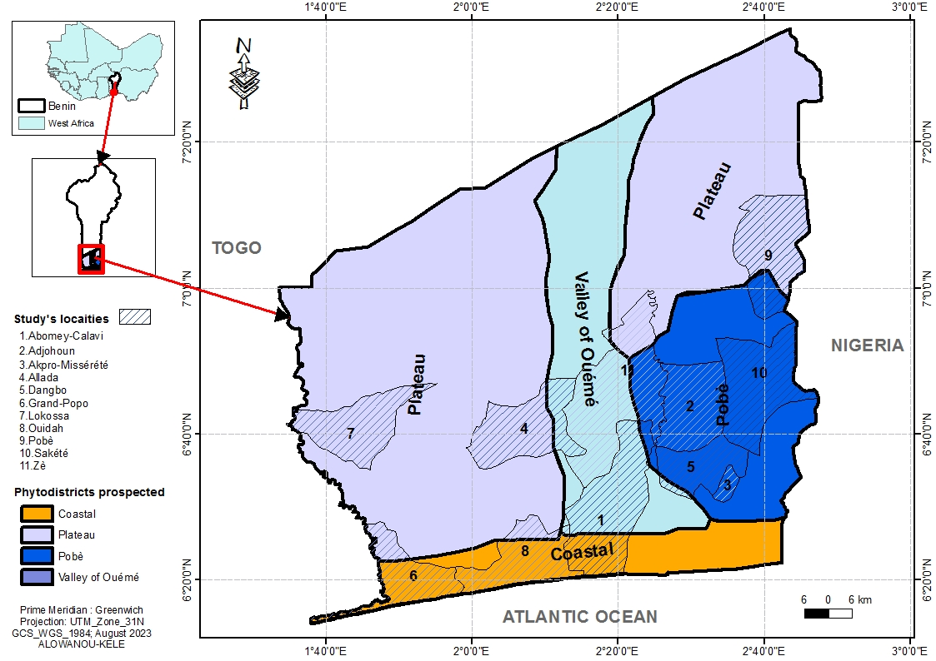

Figure 1: Map of prospected localities according to the phytodistricts of the study area (Alowanou-Kélé, 2023).
  - Collection of data
Following a spacing of at least 50 meters, sixty (60) fruiting trees of Chrysophyllum albidum, at a rate of fifteen (15) plants per phytodistrict, were selected and geo-referenced using a GPS (Geographical Positioning System). All of the individuals sampled in a phytodistrict was considered as a population at the same as those found on the same type of soil.
The morphological variability of C. albidum was evaluated using nine (09) descriptors inspired by the research work of several authors (Ouédraogo, 1995; Zitan, 1995; Agbo et al., 2018). These descriptors were measured on the trunk and crown, leaves and fruits of the trees retained. Morphological descriptors collected at the trunk and crown level are the diameter of the trunk at the height of a man's breast-breast (Dbh) expressed in centimeters (cm), the height of the first basal branching relative to the ground (Hpr) and the height of the plant (Hpl) each expressed in meter (m). The diameter of the trunk at the height of a man’s breast has was measured using a tailor's meter, while the variables Hpr and Hpl were taken using a penta decameter. At the leaf level, the morphological descriptors identified are the leaf length (Lfe), leaflet length (Lfo) and width leaflets (lfo). The variables Lfe, Lfo and lfo expressed in centimeter (cm) were measured using a 90 cm graduated ruler. Morphological descriptors considered at the level of fruits are the mass of the fruits (mfr) expressed in grams (g) using a balance precision, the length of the fruits (Lfr) and the width of the fruits (lfr) expressed in centimeters (cm) using a graduated ruler. Furthermore, to measure morphological parameters relating to leaves and fruits, it was collected from each of the selected trees, five (5) perfectly developed and unparasitized fresh leaves, and five (5) unparasitized fresh fruits.

  - Data analysis
The soil groups considered in this study (figure 2) were identified using the projection of the geographical coordinates of the plants of Chrysophyllum albidum on the base Harmonized World Soil Database (HWSD) version 1.21 (FAO/IIASA/ISRIC/ISS-CAS/JRC, 2012). Quantitative morphological data measured on the trunk and crown, leaves and fruits of the selected trees, were used to calculate the mean, standard error and coefficient of variation, in order to evaluate the inter- and intra-population variability of the specy. An analysis of the components of the variance was carried out on all the morphological descriptors considered in the four (4) populations of C. albidum, in order to study the part of the overall variability linked to individuals of the species, soil types and phytodistricts. From the coefficient of variation whose scale of interpretation was proposed by Ouédraogo (1995) and adopted by certain authors (Kouyaté et al., 2011; Sourou Kuiga, 2017; Agbo et al., 2018), the classification of variability was carried out the one hand, within and between the phytodistricts of origin of C. albidum, then on the other hand, within and between soil groups. According to this scale, the variation can be low (CV = 0 - 10%), medium (CV = 10 -15%), quite significant (CV = 15 - 44%) or even very important (CV > 44%). To test the variation of morphological descriptors within phytodistricts and across level of soil types, the recorded morphological variables were subjected to an Analysis of Variance (ANOVA). Likewise, all the morphological descriptors used were subjected to Ward's Ascending Hierarchical Classification (Euclidean distances on the averages of the characters studied), to identify the different morphotypes of the specy in Benin. All these analyzes were carried out with the statistical software R version 4.2.0 (R. Core Team, 2022).

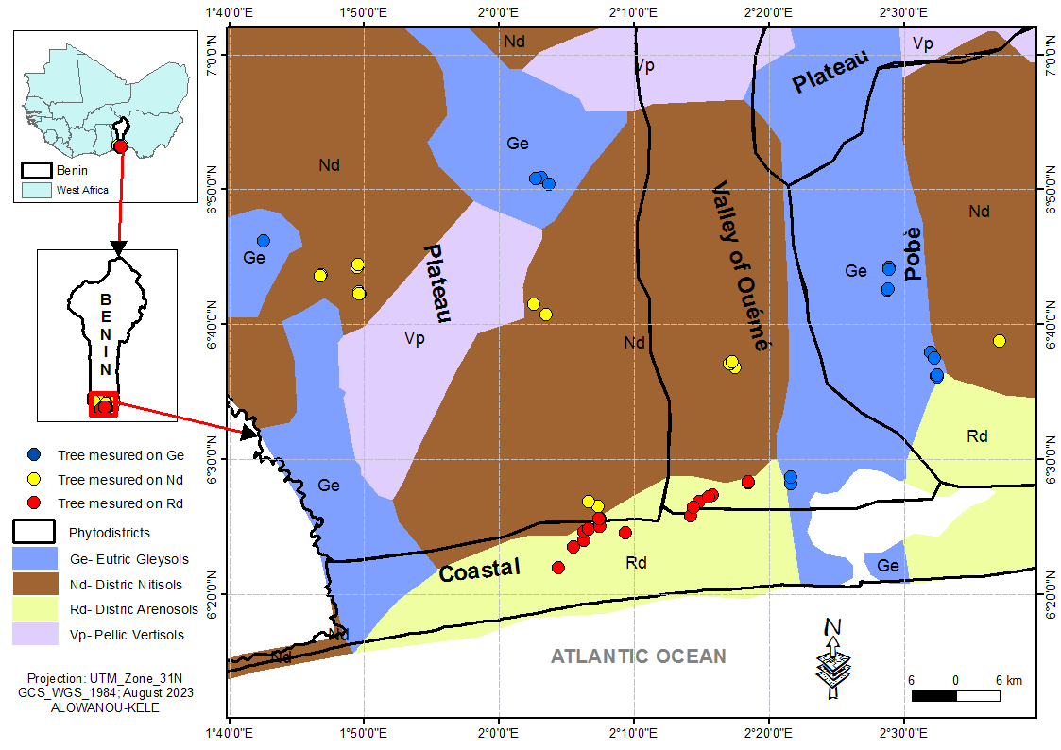
Figure 2: Identification map of the soil groups hosting the sampled Chrysophyllum albidum plants (Alowanou-Kélé, 2023).
- RESULTS

3.1. Variability of morphological descriptors of Chrysophyllum albidum

In Benin, the plants of C. albidum are found in the Guineo-Congolese, more precisely in the phytodistricts Coastal, Plateau, Pobè and Valley of Ouémé. Tables 2 and 3 presents respectively according to phytodistricts and soil types, variations of nine (9) descriptors quantitative morphological measured on the trunk and crown, leaves and fruits of C. albidum trees sampled.
    - Descriptors of the trunk and crown of C. albidum trees
The height of the feet (Hpl) of C. albidum inventoried varied from 8 to 33 m with a average of 20.07 (± 6.62) m. The height of the first basal branching relative to the ground (Hpr) is between 1.4 and 15 m with an average of 3.56 (± 3.22) m. However, alone the average Hpr of the plants of the specy located in the phytodistrict Pobè is less than that given by all the individuals of C. albidum considered (figure 3). The diameter of the trunk at the height of a man' breast-breast (Dbh) varied from 20 to 136.5 cm with an average of 53.54 (± 26.84) cm, slightly exceeded by the average Dbh of the specy' feet found in the phytodistricts Plateau and Pobè (figure 4). Intra-phytodistrict variability of the height of C. albidum plants was quite significant (15% < CV < 44%) in all the four (04) phytodistricts. Intra-phytodistrict variability of the height of the first basal branching in relation to the ground of the feet of the specy is very important (CV ˃ 44%) in all the phtytogeographical districts covered. The intra-phytodistrict variability of the diameter of the trunk at the height of a man' breast-breast of the C. albidum plants, is quite important (15% < CV < 44%) in the Coastal district and very important in the others phytogeographic districts (CV ˃ 44%) of the study environment.
The intra-type of soil variability of C. albidum plant height is quite significant (15% < CV < 44%) regardless of the soil group where the plants are found the specy. The intra-type of soil variation in the height of the first basal branching relative to the ground of the specy is quite important (15% < CV < 44%) on the Gleysols soil group, and is very significant (CV ˃ 44%) on Nitisols and Arenosols. Intra-type of soil variability of diameter of the trunk at the height of a man' breast-breast of C. albidum plants, is quite significant (15% < CV < 44%) on the Arenosols type of soils, and very important (CV ˃ 44%) on the Gleysols and Nitisols.
    - Leafs descriptors of C. albidum plants
The specy C. albidum has leaves whose length (Lfe) is between 29 and 70 cm with an average of 44.68 (± 10.16) cm, relatively lower than the averages of Lfe of plants of the specy in the Pobè and Valley of Ouémé districts (figure 5). There leaflet length (Lfo) varied from 14.73 to 33.93 cm with a mean of 22.39 (± 3.47) cm. Leaflet width (lfo) is between 5 and 11.16 cm with an average of 8.03 (± 1.23) cm. There intra-phytodistrict variability in C. albidum leaf length was quite significant (15% < CV < 44%) in all phytodistricts in the study area. Variability within phytodistricts leaflet length was quite significant in the Plateau (15% < CV < 44%), and moderately low (10% < CV < 15%) in the phytodistricts Coastal, Pobè and Valley of Ouémé. Intra-phytodistrict variability in leaflet width is low in the Plateau (0% < CV < 10%), moderately low in the Valley of Ouémé (10% < CV < 15%), and quite significant in the others districts of the study environment (15% < CV < 44%).
The intra-soil type variability of leaflet length (Lfo) and width of leaflets (lfo) is average (10% < CV < 15%) in C. albidum plants whatever the type of soil that shelters them. On the other hand, with regard to the length of the leaves (Lfe), this variation is quite significant (15% < CV < 44%) on each of the soil types in presence.

    - Fruit descriptors of C. albidum plants
The fruits of C. albidum have a length (Lfr) between 3.3 cm and 5.5 cm with an average of 4.61 (± 0.63) cm, lower than those the Lfr of the plants of the specy in the phytodistricts Coastal and Valley of Ouémé. Its width (lfr) varied from 2.3 to 4.6 cm with an average of 3.65 (± 0.64) cm, higher than those the lfr of the plants of the specy C. albidum in the phytodistricts Coastal, Plateau and Pobè. The fruits mass (mfr) of C. albidum in the study environment is between 23 g and 54 g with an average of 47.72 (±7.22) g, lower than those of the mfr of the specy located in the phytodistricts Coastal and Ouémé Valley (figure 6). Intra-phytodistrict variability in C. albidum fruit length is moderately low (10% < CV < 15%) in the phytodistricts Coastal, Pobè and Valley of Ouémé. The variation in fruit width is moderately low (10% < CV < 15%) within the populations of C. albidum sheltering the phytodistricts Pobè and Valley of Ouémé, and quite significant (15% < CV < 44%) in the phytodistricts Coastal and Plateau. The intra-phytodistrict variability of C. albidum fruit mass is moderately low (10% < CV < 15%) in the phytodistricts Plateau, and quite significant (15% < CV < 44%) in the phytodistricts Coastal, Pobè and Valley of Ouémé.
The intra-type of soil variability of fruit length of C. albidum plants is medium (10% < CV < 15%) on Gleysols, Nitisols and Arenosols. Intra-type of soil variability of width fruit of plants of the species is average (10% < CV < 15%) on Gleysols, and quite significant (15% < CV < 44%) on Nitisols and Arenosols. Furthermore, the variation of the fruit mass of individuals of the species is low (0% < CV < 10%) on Nitisols, average (10% < CV < 15%) on Regosols, and quite significant (15% < CV < 44%) on Gleysols.
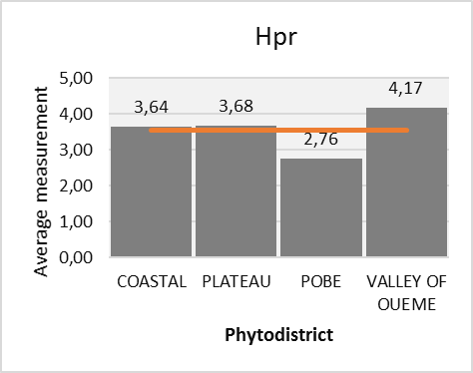
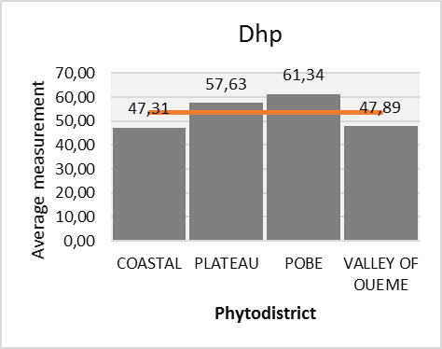
Figure 3 : Height of the first basal branching (Hpr) relative to the ground of C. albidum plants, depending on the phytodistricts.
Figure 4 : Trunk diameter at height man's chest (Dhp) of the feet of C. albidum, depending on the phytodistricts.

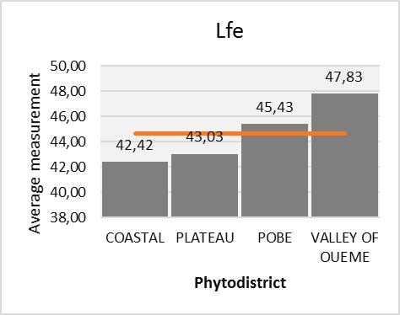
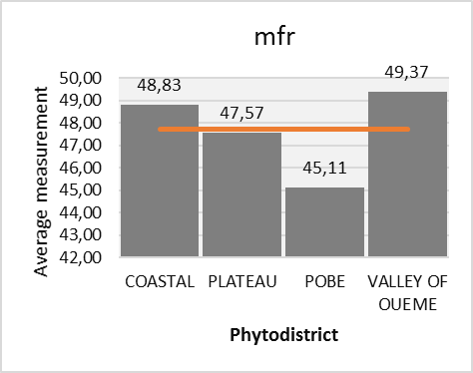
Figure 5 : Leaf length (Lfe) of feet of C. albidum, depending on the phytodistricts.

Figure 6 : Fruit mass (mfr) of trees of C. albidum, depending on the phytodistricts.

Table 2: Morphological description of quantitative variables of Chrysophyllum albidum, depending on the phytodistricts.
Phytodistricts | Parameter | Hpl (m) | Hpr (m) | Dhp (cm) | Lfo (cm) | lfo (cm) | Lfe (cm) | Lfr (cm) | lfr (cm) | mfr (g)
COASTAL | Average | 17.87 b | 3.64 a | 47.31 a | 21.36 bc | 7.83 b | 42.42 a | 4.64 ab | 3.61 ab | 48.83 a
COASTAL | SE | 5.97 | 3.89 | 17.42 | 3.08 | 1.19 | 6.92 | 0.59 | 0.65 | 8.05
COASTAL | CV (%) | 33.44 | 106.85 | 36.81 | 14.43 | 15.16 | 16.31 | 12.74 | 18.07 | 16.49
PLATEAU | Average | 20.4 ab | 3.68 a | 57.63 a | 23.47 ab | 7.96 ab | 43.03 a | 4.38 b | 3.53 ab | 47.57 a
PLATEAU | SE | 5.64 | 2.69 | 31.2 | 3.59 | 0.77 | 9.66 | 0.68 | 0.68 | 6.33
PLATEAU | CV (%) | 27.63 | 73.21 | 54.14 | 15.31 | 9.64 | 22.44 | 15.61 | 19.36 | 13.31
POBE | Average | 24.11 a | 2.76 a | 61.34 a | 20.26 c | 7.36 b | 45.43 a | 4.43 ab | 3.35 b | 45.11 a
POBE | SE | 6.77 | 2.32 | 28.59 | 2.92 | 1.21 | 13.59 | 0.53 | 0.42 | 6.77
POBE | CV (%) | 28.08 | 84.06 | 46.61 | 14.40 | 16.43 | 29.93 | 11.86 | 12.39 | 15.02
VALLEY OF OUEME | Average | 17.88 b | 4.17 a | 47.89 a | 24.49 a | 8.99 a | 47.83 a | 4.99 a | 4.09 a | 49.37 a
VALLEY OF OUEME | SE | 6.59 | 3.85 | 27.97 | 2.81 | 1.17 | 9.47 | 0.56 | 0.59 | 7.58
VALLEY OF OUEME | CV (%) | 36.83 | 92.36 | 58.42 | 11.49 | 12.99 | 19.80 | 11.29 | 14.53 | 15.35
Probability |  | 0.0259 * | 0.692ns | 0.386ns | 0.00168 ** | 0.00146 ** | 0.456ns | 0.0295 * | 0.00917 ** | 0.383ns
Minimum population |  | 8 | 1.4 | 20 | 14.73 | 5 | 29 | 3.3 | 2.3 | 23
Maximum population |  | 33 | 15 | 136.5 | 33.93 | 11.16 | 70 | 5.5 | 4.6 | 54
Average population |  | 20.07 | 3.56 | 53.54 | 22.39 | 8.03 | 44.68 | 4.61 | 3.65 | 47.72
SE population |  | 6.62 | 3.22 | 26.84 | 3.47 | 1.23 | 10.16 | 0.63 | 0.64 | 7.22
CV (%) |  | 32.99 | 90.42 | 50.13 | 15.50 | 15.27 | 22.75 | 13.59 | 17.62 | 15.14

CV: Coefficient of Variation; SE: Standard Error, *: Significant at the 5% threshold; **: Highly significant at the 1% level; ***: Very highly significant at the 0.1% level; ns: not significant.

Table 3: Morphological description of the quantitative variables of Chrysophyllum albidum, according to soil types.
Soil types | Parameter | Hpl (m) | Hpr (m) | Dhp (cm) | Lfo (cm) | lfo (cm) | Lfe (cm) | Lfr (cm) | lfr (cm) | mfr (g)
Ge - Gleysols | Average | 23.07 a | 2.24 b | 61.01 a | 20.24 b | 7.42 b | 42.62 a | 4.3 b | 3.3 b | 43.63 b
Ge - Gleysols | SE | 6.69 | 0.46 | 28,08 | 2.42 | 1.09 | 12.32 | 0.58 | 0.47 | 8.41
Ge - Gleysols | CV (%) | 29.01 | 20.41 | 46.02 | 11.94 | 14.68 | 28.91 | 13.58 | 14.15 | 19.28
Nd - Nitisols | Average | 19.24 ab | 5 a | 50.82 a | 24.5 a | 8.54 a | 45.74 a | 4.71 ab | 3.83 a | 49.76 a
Nd - Nitisols | SE | 7.24 | 3.95 | 33.04 | 3.28 | 1.16 | 8.24 | 0.6 | 0.62 | 3.65
Nd - Nitisols | CV (%) | 37.61 | 79.05 | 65.02 | 13.39 | 13.54 | 18.01 | 12.65 | 16.20 | 7.33
Rd - Arenosols | Average | 17.89 b | 3.45 ab | 48.8 a | 22.44 ab | 8.14 ab | 45.68 a | 4.83 a | 3.82 a | 49.77 a
Rd - Arenosols | SE | 4.87 | 3.52 | 16.32 | 3.36 | 1.21 | 9.71 | 0.6 | 0.7 | 7.18
Rd - Arenosols | CV (%) | 27.21 | 102.14 | 33.45 | 14.98 | 14.89 | 21.26 | 12.51 | 18.36 | 14.43
Probability |  | 0.0339 * | 0.0227 * | 0.309ns | 0.000231 *** | 0.0112 * | 0.548ns | 0.0184 * | 0.0104 * | 0.0063 *
Minimum population |  | 8 | 1.4 | 20 | 14.73 | 5 | 29 | 3.3 | 2.3 | 23
Maximum population |  | 33 | 15 | 136.5 | 33.93 | 11.16 | 70 | 5.5 | 4.6 | 54
Average population |  | 20.07 | 3.56 | 53.54 | 22.39 | 8.03 | 44.68 | 4.61 | 3.65 | 47.72
SE population |  | 6.62 | 3.22 | 26.84 | 3.47 | 1.23 | 10.16 | 0.63 | 0.64 | 7.22
CV (%) |  | 32.99 | 90.42 | 50.13 | 15.50 | 15.27 | 22.75 | 13.59 | 17.62 | 15.14

CV: Coefficient of Variation; SE: Standard Error; *: Significant at the 5% threshold; **: Highly significant at the 1% level; ***: Very highly significant at the 0.1% level; ns: not significant.

3.2. Impacts of phytodistricts and soil types on Chrysophyllum albidum variability
Leaflet length (Lfo), leaflet width (lfo) and fruit width (lfr) are the morphological descriptors of C. albidum that showed highly significant differences significant between phytogeographic districts (table 2) at the 1% threshold (P ˂ 0.01) according to the Student-Newman-Keuls test. Plant height of C. albidum (Hpl) and fruit length (Lfr) of trees of the species, showed inter-phytodistrict differences significant at the 5% level (P ˂ 0.05) according to the Student-Newman-Keuls test. In function phytogeographic districts, the morphological variables which best discriminate the populations of C. albidum, are leaflet length, leaflet width and width fruits. The leaf of C. albidum plants that was found in the phytodistrict Valley of Ouémé is on average longer and wider than those of the leaves of the feet which were found in the others phytodistricts (figure 7). The fruits of plants of C. albidum which were measured in the phytodistrict Valley of Ouémé are in average longer and wider than those of the feet sampled in the others phytodistricts (figure 7). Furthermore, the feet of the tree, found in the phytodistrict Pobè, are on average larger in size than those of others phytodistricts (figure 7).
Depending on the soil types, quantitative morphological variables such as the height of C. albidum plants (Hpl), the height of the first basal branching per relationship to the ground (Hpr), the width of the leaflets (lfo), the fruits length (Lfr) and the width of the fruits (lfr) showed significant inter-pedological differences (Table 3) at the threshold of 5% (P ˂ 0.05) according to the Student-Newman-Keuls test. On the other hand, the mass of the fruits of plants of the specy (mfr) showed highly significant inter-pedological differences at the threshold of 1% (P ˂ 0.01), and the length of the leaflets (Lfo) of the trees of the specy showed very highly significant differences between the soil types, at the threshold of 0.1% (P ˂ 0.001) according to the Student-Newman-Keuls test. Depending on the type pedological, the morphological variables which best discriminate the populations of C. albidum, are the length of the leaflets and the mass of the fruits of plants of the specy. The feet of the tree which were found on the Gleysols, are on average larger in size than those occupying the other soil groups (figure 8). The fruits of the plants of C. albidum which have been found on the Arenosols, are on average longer, and weigh more than those of the feet which were found on other soil types (figure 8). However, these fruits of plants of the species are wider on Nitisols than on Gleysols and Arenosols. Furthermore, the leaflets of the leaves of the plants of C. albidum which were measured on the Nitisols are on average longer than those of the leaves of the feet which were found on the others soil types (figure 8).
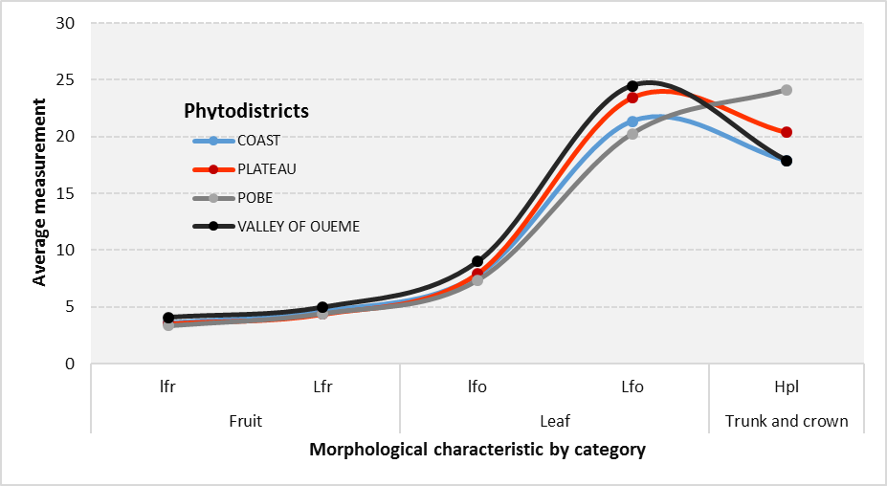
Figure 7 : Variation of the five (05) significant morphological descriptors (Hpl, Lfo, lfo, Lfr and lfr) of Chrysophyllum albidum, according to their averages and phytodistricts.

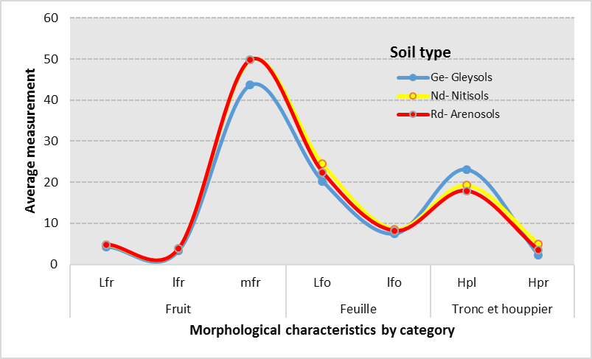
Figure 8 : Variation of the seven (07) significant morphological descriptors (Hpl, Hpr, Lfo, lfo, Lfr, lfr and mfr) of Chrysophyllum albidum, according to their averages and soil types.

  - Phytogeographic structures of Chrysophyllum albidum
Using the morphological descriptors of C. albidum considered, the Ascending Hierarchical Classification was carried out, and made it possible to highlight three (03) morphotypes at the 20% similarity threshold (figure 9).

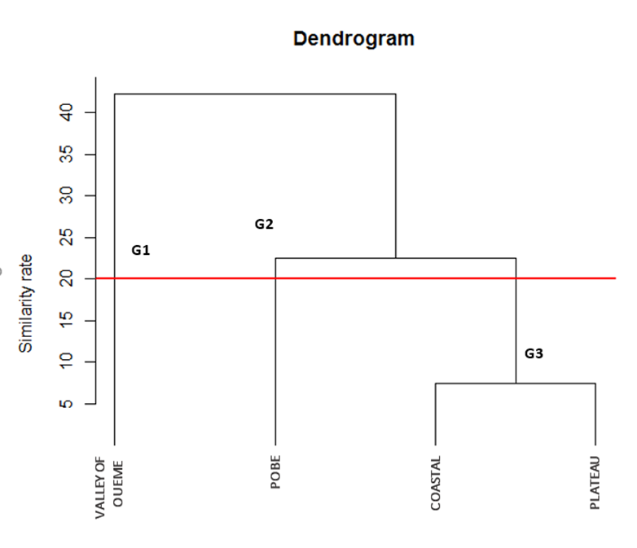

Figure 9 : Chrysophyllum albidum morphotypes from hierarchical classification ascending.

Group G1 consists of C. albidum plants from the phytodistrict Valley of Ouémé. This morphotype is characterized by short trees, bearing fruits longer, wider, heavier, and with longer and wider leaves. The group G2 is made up of C. albidum plants from the Pobè phytodistrict. This morphotype is characterized by larger trees, developing less long and wider leaves, and bearing lighter fruits of average length and width. The G3 group contains the C. albidum plants from the Coastal and Plateau phytodistricts. This class phenotypic is characterized by moderately tall individuals, presenting leaves moderately long and wide, bearing fruits of average mass, length and width.

- DISCUSSION
  - Morphological variability of Chrysophyllum albidum

Chrysophyllum albidum is a plant specy that provides multiple goods and services to local populations (Houessou et al., 2012; Lougbégnon et al., 2012). However, the importance of the resources of this specy for the local populations of Benin makes it vulnerable and even contributes to its disappearance (Alowanou-Kélé et al., 2023). With an index of 2.67, D. microcarpum was also considered a very vulnerable specy in the phytodistrict Zou, Benin (Agbo et al., 2017). The settings morphological plants of this very useful specy in Benin vary as well depending on phytogeographic provenances as well as soil types. The trees of shorter C. albidum produced longer and wider fruits and leaves, as had reported the results of the work of Dadégnon et al. (2014). These small feet, mainly come from the phytodistrict Valley of Ouémé, and seem very interesting for breeding programs for elite morphotypes of the specy for fruit production. Furthermore, in function of the phytogeographic districts of presence of individuals of C. albidum, the leaves of the specy are made highly polymorphic at the threshold of 1% by the length of the leaflets and leaflet width; the fruits of the specy are highly polymorphic at the threshold of 1%, and polymorphic at the threshold of 5% thanks respectively to their widths and their lengths; the trunk and crown of the specy are polymorphic at the threshold of 5% thanks to the height of its plants. Depending on the soil groups serving as support for individuals of C. albidum, the trunk and crown are made polymorphic at the threshold of 5% by the height of the plants of the specy and the height of the first basal branching relative to the ground; the leaves are made polymorphic at the threshold of 5% by the width of the leaflets, and very highly polymorphic at the threshold of 0.1% by leaflet length; the fruits are made polymorphic at the threshold of 5% by its length and width, and highly polymorphic at the threshold of 1% thanks to its mass. These variations observed at the level of certain morphological descriptors could be due to the characteristics of climatic and soil types, or to the reproductive biology of the plant (Agbo et al., 2018), or even genotypic factors (Sourou Kuiga, 2017). The relatively high variability recorded in the fruits of C. albidum, agree well with those obtained by Lougbégnon et al. (2016) on the same specy, Fandohan et al. (2010) on Tamarindus indica L., and Abasse et al. (2011) on Balanites aegyptiaca.
At the phytodistricts level, five (05) significant morphological descriptors have been identified, compared to seven (07) for soil types. Soil types therefore have a much greater influence on the variability of C. albidum plants in Benin. These results reinforce those revealed by the work of Agbo et al. (2018) where phytodistricts and soil groups equitably influence the variability of D. microcarpum. However, the variation in morphological descriptors remains much more significant in C. albidum than in D. microcarpum. This slight difference could be linked to the fact that D. microcarpum trees would have covered a larger part of the Beninese territory than C. albidum, and could thus allow a greater variation in climatic and edaphic conditions. The height of the first basal branching relative to the ground, the diameter of the trunk at height of a man's breast, the length of the leaf and the mass of the fruits, constitute the descriptors for which the C. albidum plants are morphologically similar, from phytodistrict to another. According to the work of Dadégnon et al. (2014), there is a large similarity between agro ecological zones, with regard to the total height of plants of C. albidum in Benin.

  - Influence of the environment on development and survival of the Chrysophyllum albidum plants in Benin
Ward's Ascending Hierarchical Classification indicates three (03) morphotypes or subpopulations of C. albidum in Benin. The plants of C. albidum from the phytodistricts Coastal and Plateau belong to the same phenotypic class, therefore are quite close morphologically from each other. The identified morphotypes present different characteristics, and depend on the districts Valley of Ouémé (G1), Pobè (G2) then Coastal and Plateau (G3). Despite the fact that all of these four (04) districts phytogeographical all belong to the Guineo-Congolese zone located between 6°25’N and 7°30’N, a difference is observed in these morphotypes. By deduction, from a sub-population of C. albidum to another, each phytodistrict presents characteristics that make it’s specified. Morphological variabilities are then mainly based on the condition’s environment and habitat (Assogbadjo et al., 2008). Larger trees found in the Pobè district, formed mainly of ferralitic soils without concretions (Gbèmavo et al., 2015), are due to the sufficient space available for the right development and survival of trees of the specy in this phytodistrict. Furthermore, the analyzes carried out in the present study revealed a significant intra- and inter-pedological difference at the level of six (6) morphological characters, then a significant intra- and inter-phytodistrict difference at the level of five (5), morphological characters. Consequently, soil types are essential in the morphological characterization of C. albidum to Benin. The Valley of Ouémé, with its numerous wetlands (Gbèmavo et al., 2015), constitutes one of the prediction territories of C. albidum, and is essential in the selection future of elite morphotypes for the sustainable management of genetic resources of C. albidum.
The multiple uses of C. albidum and the extensive urbanization in certain communes of Benin, dangerously threaten the survival and good development of the feet of the specy, through the ever-increasing reduction of its populations in habitats natural, and the observation in certain phytodistricts of less giant trees of the specy. Therefore, anthropogenic activities can negatively impact the presence of the specy.

- CONCLUSION
The present study made it possible to determine, based on the characteristics phytogeographic and pedological, the variability of certain morphological descriptors of
Chrysophyllum albidum. From the results obtained, it appears that the fruits and leaves of the
trees of the species are more polymorphic than the trunk and crown. Three (03) morphotypes
different phytogeographic structures have been identified in C. albidum in Benin. Thanks to its better-quality fruits, the elite morphotype formed from the C. albidum plants of phytodistrict Valley of Ouémé, is better indicated for future selections.

- REFERENCES
Abasse , T. , Weber C.J. , Katkore , B. , Boureima , M. , Larwanou , M. , Kalinganire , A. (2011). Morphological variation in Balanites aegyptiaca fruits and seeds within and among parkland agroforests in eastern Niger. Agroforest Syst 81 :57–66. DOI 10.1007/s10457-010-9323-x.
Goat, I.R., Missihoun, A.A., Vihotogbe, R., Assogbadjo, E.A., Ahanhanzo, C., Agbangla, C. (2017). Impacts of traditional uses on the vulnerability of Detarium microcarpum Guill. & Perr. (Caesalpiniaceae) in Zou phytogeographic district in Benin. International Journal of Biological and Chemical Sciences. 11(2): 730-743.
Goat, I.R., Missihoun, A.A., Great, R.A., Assogbadjo, E.A., Scent, C. (2018). Morphological variability of Detarium microcarpum Guill. & Perr. (Caesalpiniaceae) in Benin, West Africa. Asian Journal of Research in Agriculture and Forestry, 1(2): 1-12, 2018.
Alowanou-Kele, B., Missihoun, A.A., Agbo, R.I., Ewedje, E.-E.B.K., Yedomonhan, H. and Agbangla, C. (2023). Impacts of the Use of Chrysophyllum albidum G. Don on Its Vulnerability and Its Conservation in Benin. Annual Research & Review in Biology. 38, 11 (Dec. 2023), 1-1 DOI : https://doi.org/10.9734/arrb/2023/v38i1130613 .
Ammari , Y. , Zouaoui , R. , Abbasi , M. , Jebali , S. , Hamdi , S. (2016). Study of Dendrometric and Morphological Variability of Celtis Australis Located in Northern Tunisia. International Journal of Agricultural Innovations and Research, 5(3).
http://dx.doi.org/10.1037/0021-843X.112.2.202 Assogbadjo, A.E., Cocoa Glaze, R., Chadare, F.J., Thomson, L., Kyndt, T., Sinsin, B., Van Damme, P. (2008). Folk classification, perception and preferences of baobab products in West Africa : Consequences for species conservation and improvement. Econ. Bot. 62(1) (2008) 74–84.
Brou , Y.T. , Akindes , F. , Bigot , S. (2005). Climate variability in Côte d’Ivoire: between social perceptions and agricultural responses. Agricultural Notebooks, Vol.14(6):533-40.
Dadegnon , S. , Gbemavo , C , Ouinsavi , C , Sokpon , N. (2014). Morphological variation and ecological structure of Chrysophyllun albidum G. Don. International Journal of Plant & Soil Science. 5 : 25-3
Ewedje , E.B.K. , Parmentier , I. , Natta , A. , Ahanchéde , A. , Hardy , O.J. (2012), Morphological variability of the tallow tree, Pentadesma butyracea Sabine (Clusiaceae), in Benin. Gene Resour Crop Evol 59 : 625–633.
Fandohan , B. , Assogbadjo , A.E. , Cocoa Island , R. , Kyndt , T. , De Caluwe , E. , Codjia , J.T.C. , Sinsin , B. (2010). Women’s Traditional Knowledge, Use Value, and the Contribution of Tamarind (Tamarindus indica L.) to Rural Households’ Cash Income in Benin. Economic Botany, 64 : 248-259.

Fandohan , B. , Assogbadjo , E.A. , Kakaï , G.R. , Kyndt , T. , Sinsin , B. (2011). Quantitative morphological descriptors confirm traditionally classified morphotypes of Tamarindus indica L. fruits. Gene Resour Crop Evol, 58 : 299–309. DOI 10.1007/s10722-010-9575-3.
FAO (1996). Global Action Plan for the Conservation and Sustainable Use of Phytogenetic Resources for Food and Agriculture and the Leipzid Declaration. International Technical Conference on Phytogenetic Resources Leipzid, Germany 17-23 June 1997.
FAO, IIASA, ISRIC, ISSCAS, and JRC (2012). Harmonized World Soil Database (version 1.21), FAO and IIASA, Rome, Italy, and Laxenburg, Austria.
FAO (2015). Soils are fundamental to vegetation. 1st Conference on Afro-Mediterranean Soils: “Constraints and Potentials for Sustainable Management”, Marrakech 18 and 19 December 2015.
(2015). Morphological variability and conservation of morphotypes of Jatropha curcas Linn. (Euphoriaceae) in Benin. Journal of Agriculture and Environment for International Development , 109 ( 1 ): 55 – 69 .

Houessou , G. L. , Lougbegnon , O. T. , Gbesso , G. H. F. , Anagonou , S. E. L. , Sinsin , B. (2012). Ethnobotanical study of the African star apple (Chrysophyllum albidum G. Don). Journal of Ethnobiology and Ethnomedicine, 8:40.
Houetchegnon, O.T. (2016). Ethnobotanical, ecological and morphological studies of Prosopis africana (guill, perrott. and rich.) taubert in Benin and impacts of climatic changes on the species. Single Doctoral Thesis. Doctoral School of Agronomic and Water Sciences, University of Parakou, Benin. 159 p.
Kanazoe, A. (2017). The contribution of the rural center for incubation of agri-food technologies (CRITA) to the food security of Lebda households in Burkina Faso. Master's Memoir, Department of Philosophy and Psychology, University of Ouaga I Professor JOSEPH KI- ZERBO, Burkina Faso.
Kouyaté , A.M. , Van Damme , P. (2002). Morphological characters of Detarium microcarpum Guill. and Perr. in the south of Mali. Fruits, Vol. 57 : 231–238.
Kouyate, A.M. (2005). Ethnobotanical aspects and study of morphological, biochemical and phenological variability of Detarium microcarpum Guill. & Perr. In Mali. PhD thesis. Faculty of Bioscience Engineering, Ghent University, Belgium um. 190 p.
Kouyaté, A.M., Decalluwé, E., Guindo, F., Diawara, H., Diarra, I., N’diaye, I., Van Damme, P. (2011). Morphological variability of the baobab (Adansonia digitata L.) in Mali. Fruits, 66: 247-255.
Lougbégnon, O.T., Anagonou, L, Houessou, G.L., Gbesso, G.H.F., Sinsin, B. (2012). Socioeconomic importance of the organs (fruits, bark and roots) of the white star apple (Chrysophyllum albidum G. Don, 1831) on the Allada plateau. Ann. Univ. of Lomé, ser. Lett., Volume XXXI-1, 294: 157-165.

Lougbégnon, O.T., Houessou, L.G., Gbesso, G.H.F., Codjia, J.T.C. (2016). Eco-morphological variability of Chrysophyllum albidum G. Don fruits across phytogeographic districts of the Guinean zone in Benin. Bulletin of Agronomic Research of Benin (BRAB) - Special issue Agronomy, Society, Environment & Food Security - August 2016, 109-117. ISSN on paper (on hard copy): 1025-2355 and ISSN online (on line): 1840-7099.

Mbaye, A. (2011). Jatropha cultivation in Senegal: Between promoters' logic and farmers' skepticism. In: Collection of abstracts from the final workshop of the RIPIECSA program, Palais des congrès, Cotonou. Benin, 10p.

Ouédraogo, A.S. (1995). Parkia biglobosa (Fabaceae) in West Africa. Biosystematics and improvement. Thesis. Univ. Agron. Wagening. Inst. For. Nat. Res. IBN-DLO. Netherlands. 205 p.
Sourou Kuiga, N.B. (2017). Socio-economic importance and structural, morphological and genetic characterization of red plum (Haematostaphis barteri Hook F.) in Benin. Doctoral thesis in Agricultural Sciences from the University of Parakou, Benin. 143 p.
Zitan, L. (1995). Analysis of morphological characters for the evaluation of the genetic variability of cork oak (Quercus suber L.). 3rd cycle Agron mem. Inst. Agron. Vet. Hassan II. Morocco. 30-39.

