**Evaluation of the Effectiveness of 20% amino acid biostimulant with surfactant at Different Concentrations on the Growth and Yield of Groundnut**

ABSTRACT

A field trial was conducted during Kharif 2024 at Anurag University, Hyderabad, to evaluate the bioefficacy of a 20% amino acid formulation with surfactant on the growth and yield of groundnut (*Arachis hypogaea* L.). The formulation, designed to enhance nutrient absorption and stress tolerance, was applied as a foliar spray in varying concentrations (2 ml/l, 3 ml/l, 4 ml/l, and 5 ml/l) in addition to a control treatment and a recommended dose of fertilizers (RDF). Results demonstrated that the application of the 20% amino acid with surfactant at 3 ml/l (T4) significantly improved key growth parameters such as plant height, leaf area, root length, and dry matter accumulation. Yield components, including pod length, number of pods per plant, and pod weight, were also markedly enhanced at this concentration. Treatment T4 was identified as the most effective and economical concentration, offering comparable or superior results to higher dosages, highlighting its potential for cost-effective crop improvement. The study concluded that the 20% amino acid with surfactant formulation, particularly at 3 ml/l, provides a promising solution for enhancing groundnut productivity by improving nutrient uptake and supporting growth under stress conditions.

**Keywords:-** Amino acid, Biostimulants, Groundnut

**Introduction**

Groundnut (*Arachis hypogaea* L.), serves as a critical source of vegetable oil and protein, especially in tropical and subtropical regions, where it contributes significantly to both human diets and livestock feed. (Arya et al. 2016). The nutritive value of groundnut seeds is very high as it contains 40-50 percent of oil, 25-30 percent protein, 20 percent carbohydrates and 5 percent ash, some minerals as magnesium and calcium depending on the variety and agricultural treatments (Jani and Devani, 2020; Bakry et al. 2020).However, groundnut production faces several challenges, including nutrient deficiency, drought stress, and suboptimal management practices, all of which can reduce yield potential. To overcome these challenges and boost productivity, the adoption of biostimulants has emerged as an innovative approach in modern agriculture. Biostimulants are considered bioactive substances that are either inorganic or organic microorganisms that can increase crop performance when utilized in small quantities [La Bella, S. et al. 2021] as they can enhance both performance and growth as well as improve nutrient- and water-use efficiencies of different crops. Amino acids have a dual function as building blocks for proteins and as providers of organic nitrogen, which can alleviate the negative impacts of drought and salt stress [Abdelkader, M.M et al. 2021], and promote cell growth. They are vital in metabolite synthesis, growth, and development, and appropriate in plants because of their structure as protein units. Amino acid-based biostimulants, in particular, have garnered attention due to their capacity to regulate physiological processes, improve nutrient efficiency and enhance tolerance to abiotic stresses such as drought and salinity. (Vernieri et al. 2005)

The current field trial was designed to evaluate the bioefficacy of a 20% amino acid formulation with surfactant on groundnut during the Kharif 2024 season. Surfactants are known to improve the penetration and spread of foliar applications, making nutrients and biostimulants more readily available to plants.

**Materials and methods**

The study was conducted at the School of Agriculture, Anurag University, Hyderabad, during the Kharif 2024 season. The objective was to determine the optimal concentration of a 20% amino acid formulation with surfactant for enhancing groundnut growth and yield.

The experimental soil texture was sandy loamy and design was randomized block design (RBD) is implemented, comprising six treatments with four replications each. Seeds of groundnut were sown in the first week June. The recommended dose of fertilizers of 30 kg N/ha, 50 kg P2O5/ha and 40 kg K2O/ha were applied at the time of sowing. The normal cultural practices for groundnut were practiced as recommended. Sprinkler irrigation was applied as plants needed.

Treatments and Experimental Design

The treatments included a control recommended dose of fertilizers and five varying concentrations of the amino acid formulation with surfactant. Foliar applications were selected as the treatment method to ensure direct nutrient delivery to the aerial parts of the plant, promoting rapid absorption and immediate physiological effects. Applications targeted critical growth stages, particularly flowering and pod development, and were repeated at 15-day intervals to monitor sustained effects.

**Table 1: Treatment details**

|  |  |
| --- | --- |
| **Treatment Code** | **Treatment Description** |
| T1 | RDF only |
| T2 | RDF + 3 ml/l of 20% amino acid (Tata Bahaar) |
| T3 | RDF + 2 ml/l of 20% amino acid with surfactant |
| T4 | RDF + 3 ml/l of 20% amino acid with surfactant |
| T5 | RDF + 4 ml/l of 20% amino acid with surfactant |
| T6 | RDF + 5 ml/l of 20% amino acid with surfactant |

**RDF**: Recommended Dose of Fertilizers

**Data Collection**

A random sample of five plants was assigned for investigation in each plot. The data pertaining to morphology of vegetative growth and yield parameters were systematically recorded during key growth phases.

**Morphological characters of vegetative growth**

Plant height (cm), number of leaves/plant, number of branches/plant, dry weight (gm), leaf area (cm2), root length (cm).

**Yield and yield component characters.**

The assigned plants were taken for the each plot at harvest time (120 days from sowing date), data on seed yield characters were recorded follows: Pod Length (mm), Pod Weight (g), Pods Per plant, No. of Seeds Per Pod 100, Seed Weight(g), Harvest Index (%), Shelling Percentage.

**Statistical analysis**

Analysis of variance of randomized block design and Critical difference was performed accordingly.

**Results**

**Effect on growth parameters**

The data regarding growth attributes of groundnut presented in Table. 2indicate that groundnut crop raised under various treatments had a significant response on growth attributes. Among different treatments, Treatment T6 registered higher plant height (31.50 cm), number of branches (14.25/plant), number of leaves (316.00/plant), dry matter production (41.18 g/plant) average root length (23.90) and average leaf area (7.98 cm2), was found statistically at par with treatments T4, T5, and significantly superior over rest of the treatments.

**Table 2: Growth attributes of groundnut under different treatments in the bioefficacy field trial of 20% amino acid with surfactant**

|  |  |  |  |  |  |  |
| --- | --- | --- | --- | --- | --- | --- |
| **Treatment** | **Plant Height (cm)** | **No of Leaves** | **No of Branches** | **Dry weight – gm/plant** | **Root Length (cm)** | **Avg. Leaf area (cm2)** |
| **T1** | 25.775 | 250.0 | 13.0 | 32.30 | 21.35 | 3.61 |
| **T2** | 25.525 | 207.00 | 14.12 | 33.12 | 20.15 | 4.89 |
| **T3** | 25.800 | 315.00 | 15.34 | 35.21 | 21.10 | 4.76 |
| **T4** | 27.250 | 310.00 | 15.0 | 36.33 | 21.13 | 6.12 |
| **T5** | 29.125 | 318.50 | 13.75 | 39.50 | 22.25 | 7.05 |
| **T6** | 31.50 | 316.00 | 14.25 | 41.18 | 23.90 | 7.98 |
| **Sem** | **1.74** | **31.47** | **1.17** | **3.85** | **1.04** | **25.90** |
| **CD 5%** | **5.25** | **94.88** | **3.54** | **11.63** | **3.14** | **78.09** |

Amino acids in plants are implicated in primary and secondary metabolism, as well as a variety of cellular enzymatic activities as components of many enzymes. As a result, they could affect a variety of biochemical and physiological mechanisms, including plant vegetative growth, germination, fruit ripening, signaling and stimulation of defense systems versus abiotic and biotic stresses, osmo-regulation, reactive oxygen species inactivation, and as a nitrogen reserve source (Teixeira et al 2007).

Those amino acids have a significant impact on growth-related metabolic activities via enhancing the ability of water uptake and usage and as well as, preserving photosynthetic pigments, which were significantly induced higher levels of IAA contents which improve cell division and/or cell enlargement. The positive role of the utilized amino acids at a specific level in plants might be responsible for their promotional effect. They also regard as plant hormones like indole acetic acid as a source for nitrogen, carbon, energy, enzyme, co-enzymes as stated earlier (Goss, 1973; Ramadan et al. 2020). Moreover, Thom et al. (1981) stated that amino acids provide plant cells with an immediate source of nitrogen, which the cells typically consume faster than inorganic nitrogen. Amino acids play a crucial effect in plant and protein assimilation, which are crucial for cell formation and hence enhance fresh and dry matter (Fig.1) which reflected in increasing plant growth consequently plant productivity.

**Effect on Yield parameters**

A perusal of the mean data presented in Table 3 revealed that different concentration of 20 per cent amino acid with recommended dose of fertilizer practices had a significant impact on yield attributes of groundnut. The highest recording of Pod Length (35.78 mm), Pod Weight (2.50g), Pods Per plant (40), No. of Seeds Per Pod (2.5), 100 Seed Weight(23 g), Harvest Index (36 %), Shelling value (77 %) was observed in Treatment T6, it was found statistically at par with treatmentsT4, T5 and significantly superior over rest of the treatments.

**Table 3: Yield Attributes of Groundnut under Different Treatments in the Bioefficacy Field Trial of 20% Amino Acid with Surfactant**

|  |  |  |  |  |  |  |  |
| --- | --- | --- | --- | --- | --- | --- | --- |
| **Treatment** | **Pod Length (mm)** | **Pod Weight (g)** | **No. of Pods Per plant** | **No.of Seeds Per Pod** | **100 Seed Weight (g)** | **Harvest Index(%)** | **Shelling Percentage** |
| **T1** | 30.05 | 2.30 | 30 | 2.0 | 21.5 | 30 | 70 |
| **T2** | 32.20 | 2.35 | 32 | 2.1 | 21.8 | 32 | 72 |
| **T3** | 31.48 | 2.32 | 31 | 2.1 | 22.0 | 31 | 71 |
| **T4** | 33.63 | 2.40 | 35 | 2.3 | 22.5 | 34 | 74 |
| **T5** | 34.34 | 2.45 | 37 | 2.4 | 22.8 | 35 | 75 |
| **T6** | 35.78 | 2.50 | 40 | 2.5 | 23.0 | 36 | 77 |
| **S.Em** | 0.2 | 0.05 | 0.8 | 0.1 | 0.2 | 1.0 | 1.0 |
| **CD@5%** | 0.5 | 0.12 | 1.5 | 0.2 | 0.5 | 2.0 | 2.0 |

Amino acids treatments led to significant increases in different nutritional values of seed yield of groundnut. These increases in yield and its components of groundnut plants might be resulted from increased growth parameters, photosynthetic pigments contents thus reflecting on increased photosynthesis process resulting in increased transfer of photo-assimilates from leaves to seeds thus increased their weights which resulted in increased different yield components. Moreover, these increases could be due to increased endogenous growth regulators (as IAA). It is obvious that bioregulators tend to form sink mobilizing various nutrients, involved in biosynthesis new tissues in wheat plants and/or enhancing photosynthesis (Abd El-Hameid and Sadak, 2020).

**Conclusion**

The S.Em and CD values across growth and yield attributes showed that while there were some statistically significant differences between treatments, T4 consistently performed comparably to T5 and T6. Therefore, increasing the concentration to 4 ml/l or 5 ml/l did not result in proportional yield gains, making T4 the most efficient treatment. For farmers, this means that T4 offers an optimal concentration for maximizing groundnut productivity with minimal additional cost, making it the most economical treatment in the trial and its potential as a cost-effective solution for farmers to enhance groundnut yields under stress conditions while ensuring high profitability.

**References**

Abd El-Hameid, A.R. and Sadak, M.S., 2020. Impact of glutathione on enhancing sunflower growth and biochemical aspects and yield to alleviate salinity stress. *Biocatalysis and Agricultural Biotechnology*, vol. 29, pp. 101744.

Abdelkader, M.M.; Gaplaev, M.S.; Terekbaev, A.A.; Puchkov, M.Y. The influence of biostimulants on tomato plants cultivated under hydroponic systems. *Journal Horticulture Research,* **2021**, 29, 107–116.

Arya, S.S., Salve, A.R. and Chauhan, S., 2016. Peanuts as functional food: a review. *Journal of Food Science and Technology*, vol. 53, no. 1, pp. 31-41

Bakry, A.B., Sadak, M.S. and El-Monem, A.A.A., 2020. Physiological aspects of tyrosine and salicylic acid on morphological, yield and biochemical constituents of peanut plants. *Pakistan Journal of Biological Sciences*, vol. 23, no. 3, pp. 375-384.

Goss, J.A., 1973. Amino acid synthesis and metabolism. In: J.A. GOSS,ed. *Physiology of plants and their cells*. New York: Pergamon Press,202 p.

Jani, B.L. and Devani, B.M., 2020. Peanut protein: rich source as vegan protein. *Journal of Food Science and Nutrition*, vol. 6, pp. 059.

La Bella, S.; Consentino, B.B.; Rouphael, Y.; Ntatsi, G.; De Pasquale, C.; Iapichino, G.; Sabatino, L. Impact of Ecklonia maxima seaweed extract and Mo foliar treatments on biofrotification, spinach yield, quality and NUE. *Plants* **2021**, 10, 1139.

Ramadan, A.A.E.-M., Younis, A.E.-S.M., Bakry, B.A. and Elbassiouny, H.M.S. 2020. Biochemical and yield of flax in responses to some natural antioxidant substances under sandy soil conditions. *Asian Journal of Plant Sciences*, vol. 19, no. 3, pp. 261-272.

Thom, M., Maretzki, A., Komor, E. and Sakai, W.S., 1981. Nutrient uptake and accumulation by sugar cane cell culture in relation to growth cycle. *Plant Cell, Tissue and Organ Culture*, vol. 1, no.1, pp. 3-14.

Vernieri, P., Borghesi, E., Ferrante, A. and Magnani, G.,2005. Application of bio stimulants in floating system for improving rocket quality. *Journal of Food Agriculture and Environment*, vol. 3, pp. 86-88

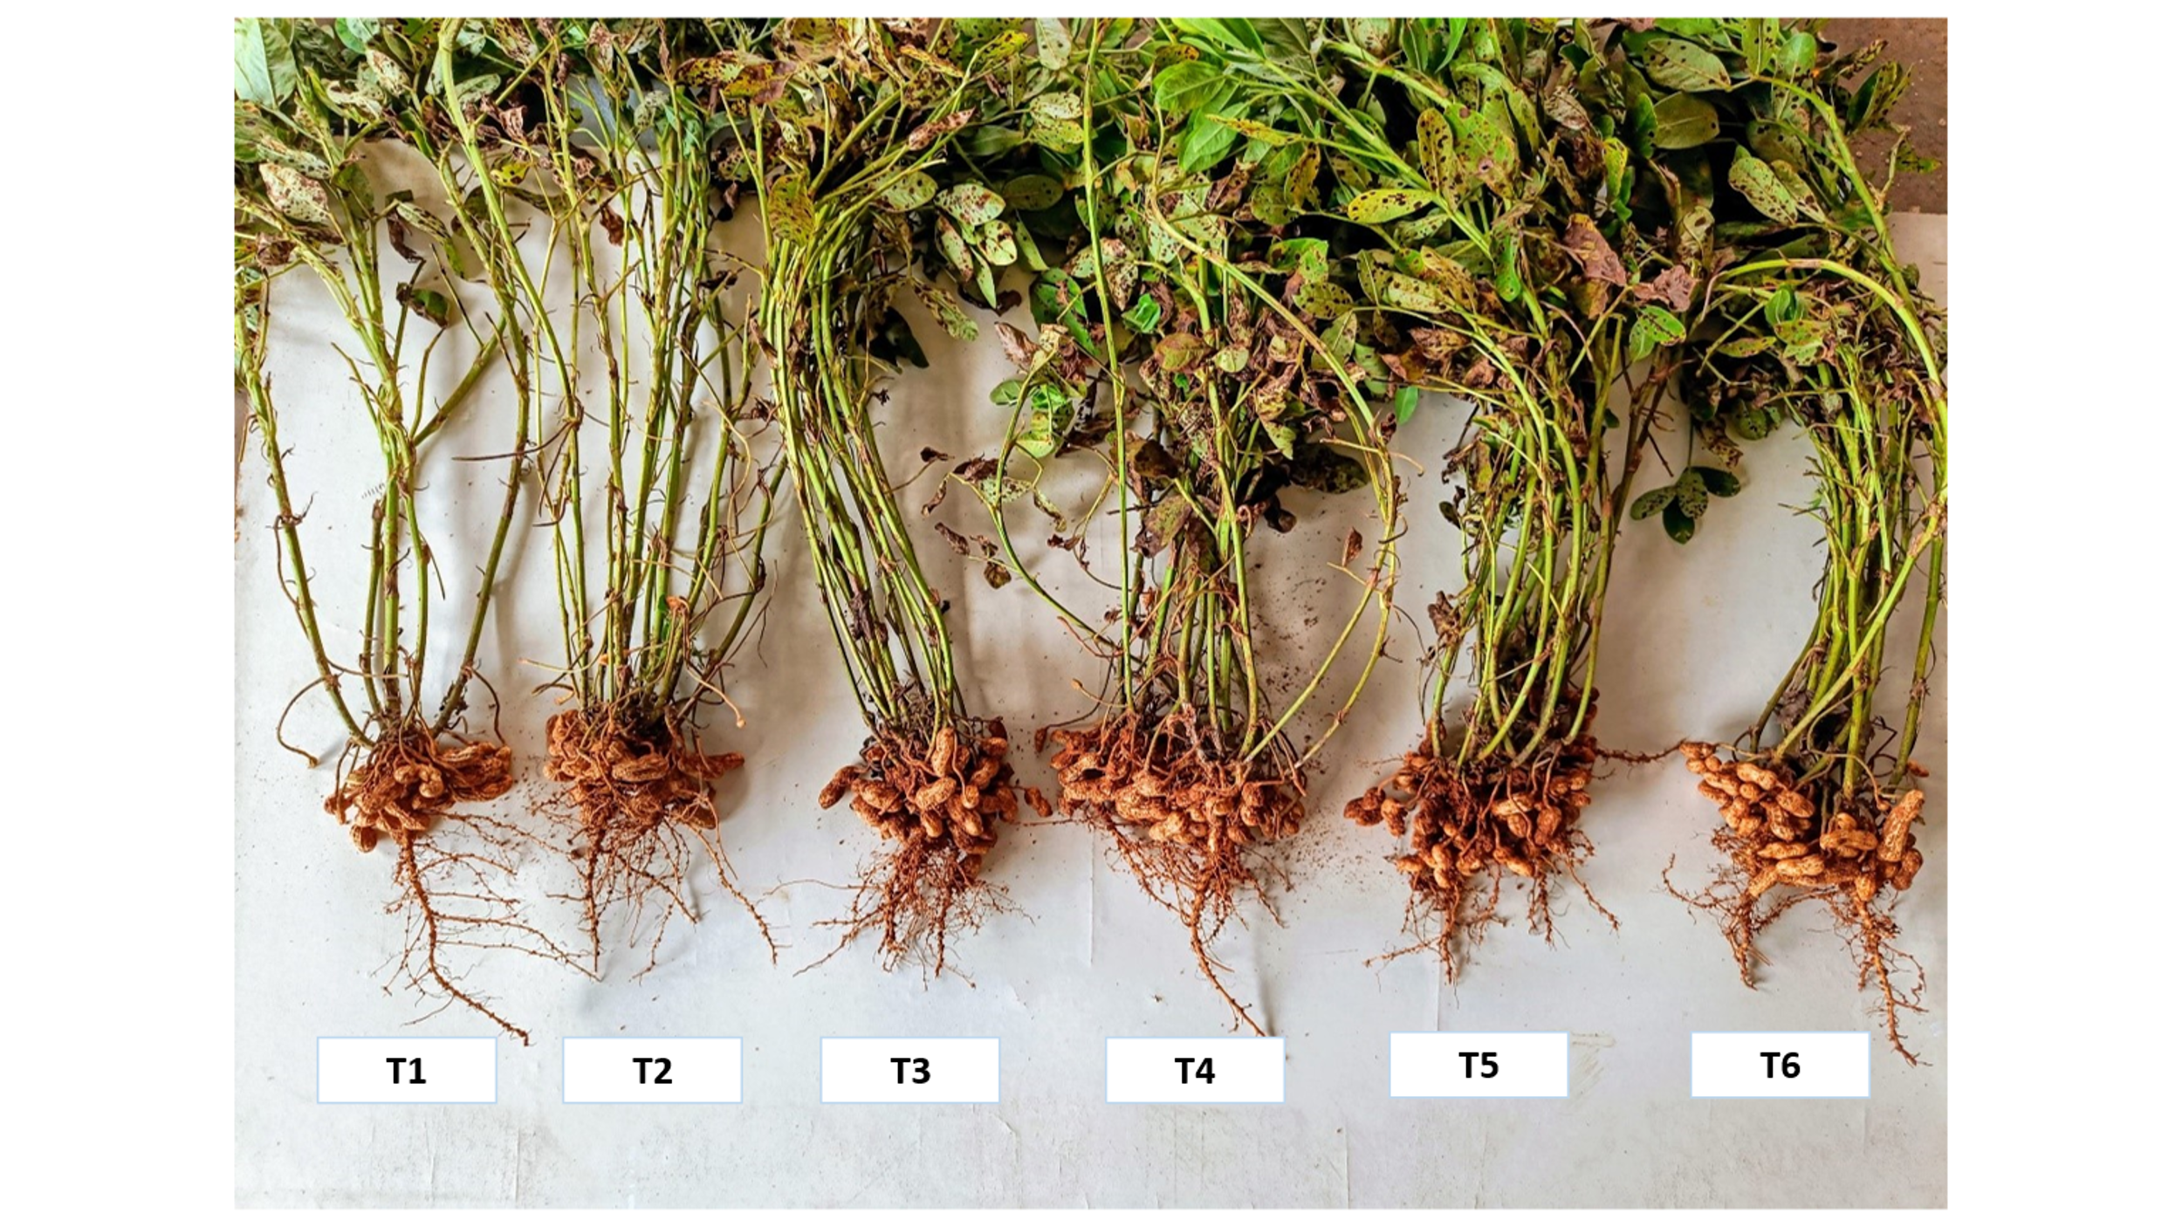

**Fig.1: Groundnut root growth and pod development**