*Original Research Article*

Assessing Water Spread Dynamics and Crop Diversification in Lower Palar Sub Basin Using Sentinel 1A (SAR) Data

.

ABSTRACT

|  |
| --- |
| Sentinel-1A Synthetic Aperture Radar (SAR) satellite is highly beneficial for continuously monitoring the evaluating changes in agricultural areas and water spread area assessment. Having reliable information about water availability is crucial for effective regional planning. Unfortunately, such information is often lacking, leading to incorrect planning decisions and potential overuse of water. By analyzing water spread dynamics using SAR satellite data at the tank level, farmers can access more accurate and timely information, aiding in crop planning locally and regionally and improving water management practices. Utilizing SAR satellite data to track water spread is essential for addressing these challenges and enhancing agricultural productivity. This approach allows stakeholders to make better decisions about water resource allocation, promoting sustainable agriculture and water conservation. This study focused on the water spread area in Lower Palar tanks by analyzing multi-temporal Sentinel-1A SAR data, linking it to rainfall and cropping pattern changes in and around the command areas. The years 2020-2023 showed increased water spread compared to 2018-2019, suggesting improved rainfall distribution and potential for year-round cropping using Northeast monsoon rainfall for subsequent seasons. The study applied Random Forest machine learning for crop classification across seasons, leveraging the algorithm's accuracy and efficient handling of large datasets to understand how water availability affects crop diversification in the Lower Palar Sub-Basin. |

*Keywords: Command areas, Irrigation requirement, Sentinel 1A, Tank water Spread*

1. INTRODUCTION

In India, agriculture holds significant importance in terms of its economic, employment, and food security implications. Accurate and timely data regarding crop production and land utilization are crucial for informed decision-making among various stakeholders in agriculture, including farmers, policymakers, marketers, financial institutions, and governmental bodies. This necessity becomes even more pronounced considering India's population is expected to surpass 1.62 billion by 2050, posing a formidable challenge for the sustainable management of land resources per capita (Bhumika et al., 2019). The mapping of irrigated areas within river basins plays a pivotal role in assessing water usage and ensuring food security, especially amid ongoing changes in land use driven by fluctuations in rainfall patterns, particularly noticeable in regions such as Tamil Nadu. The increasing reliance on irrigated agriculture, which accounts for over 70% of water withdrawals, faces escalating challenges due to global population growth, heightened food demands, and pressures stemming from climate change.

Efforts aimed at enhancing irrigation efficiency and potential, such as the implementation of initiatives like the Water Resources Consolidation Project (WRCP) and Command Area Development (CAD), are crucial (Hakeem et al., 2021). Satellite remote sensing emerges as a valuable tool for irrigation management, providing insights into inventory, performance, monitoring, viability, and environmental impacts. Integrating spatial information with conventional methods, aids in managing water scarcity and optimizing water use efficiency in irrigated agriculture. Techniques utilizing satellite imagery and data processing are particularly instrumental in mapping irrigated areas like tank ayacuts, facilitating the monitoring and evaluation of agricultural productivity and water management, thereby enhancing resource value and revenue generation (Premalatha and Rao, 1994). Understanding irrigation water demand and distribution across space and time is essential for effective irrigation planning and management to ensure efficient cropland use and food security.

Cropland mapping assumes significance in evaluating food and water security, especially in densely populated regions like South Asia, which hosts vast agricultural lands (Gumma et al., 2022). Despite challenges in obtaining reliable irrigation information, integrating spatial information with traditional methods remains valuable for managing water scarcity and enhancing water use efficiency in irrigated agriculture (Hakeem et al., 2021). The distribution of water in tanks directly influences cropping patterns in corresponding ayacuts. Satellite remote sensing not only aids in detecting water spread in tanks but also serves as a reliable method for acquiring crop acreage and production data. Advanced technologies coupled with satellite imagery empower farmers and policymakers to monitor and evaluate agricultural landscapes, identifying opportunities for diversification (Kamble et al., 2020). High-resolution remote sensing, enabled by satellite data, proves effective in mapping and conducting irrigation studies over vast areas within time constraints. Innovations in remote sensing and Geographic Information Systems (GIS) offer new ways of collecting, storing, and analyzing agricultural land parcel information. Techniques such as those employed by Shen et al. (2022) and Bioresita et al. (2019) demonstrate the precision and accuracy achievable through the fusion of Sentinel satellite data and advanced classification engines.

Addressing diverse cropping patterns is crucial for enhancing potential production and resilience to water scarcity. Machine learning techniques, utilizing multi-spectral and multi-temporal satellite images, are employed to develop accurate crop categorization models. From 2019 to 2024, the Centre for Water and Geospatial Studies at Tamil Nadu Agricultural University in Coimbatore, handled the TNIAM (Tamil Nadu Irrigated Agriculture Modernization) project (World Bank Mission Project). This project focused on leveraging Remote Sensing and GIS technologies for water resource monitoring and crop diversification in lower palar sub basin tanks. Throughout the project duration, significant outcomes were achieved, which are summarized below.

2. material and methods

**2.1 Study area**

The Lower Palar sub-basin extends from Longitude 79° 34' E to 80° 9' E and Latitude 12° 57' N to 12° 25' N (Figure 1) and covers an area of 1044.7 km2. The Lower Palar sub-basin overlaid on the districts of Kancheepuram and Chengalpattu with 243 tanks in the area. The average annual rainfall is around 1161 mm, and most of it is received during the northeast monsoon. The climate is variable, ranging from arid to semi-arid, with temperatures ranging from 20.9°C to 34.5°C. The general elevation of the region ranges from 60 to 240 m above mean sea level, with a gentle gradient from west to east. The small drainage in the basin's center contributes to the recharge of the various tanks. The registered ayacut area of the Lower Palar sub-basin is 27,850.1 ha. Rice is the primary crop grown throughout the area, followed by sugarcane crop. Groundnut is another significant crop primarily grown in areas with water scarcity or insufficient rainfall.

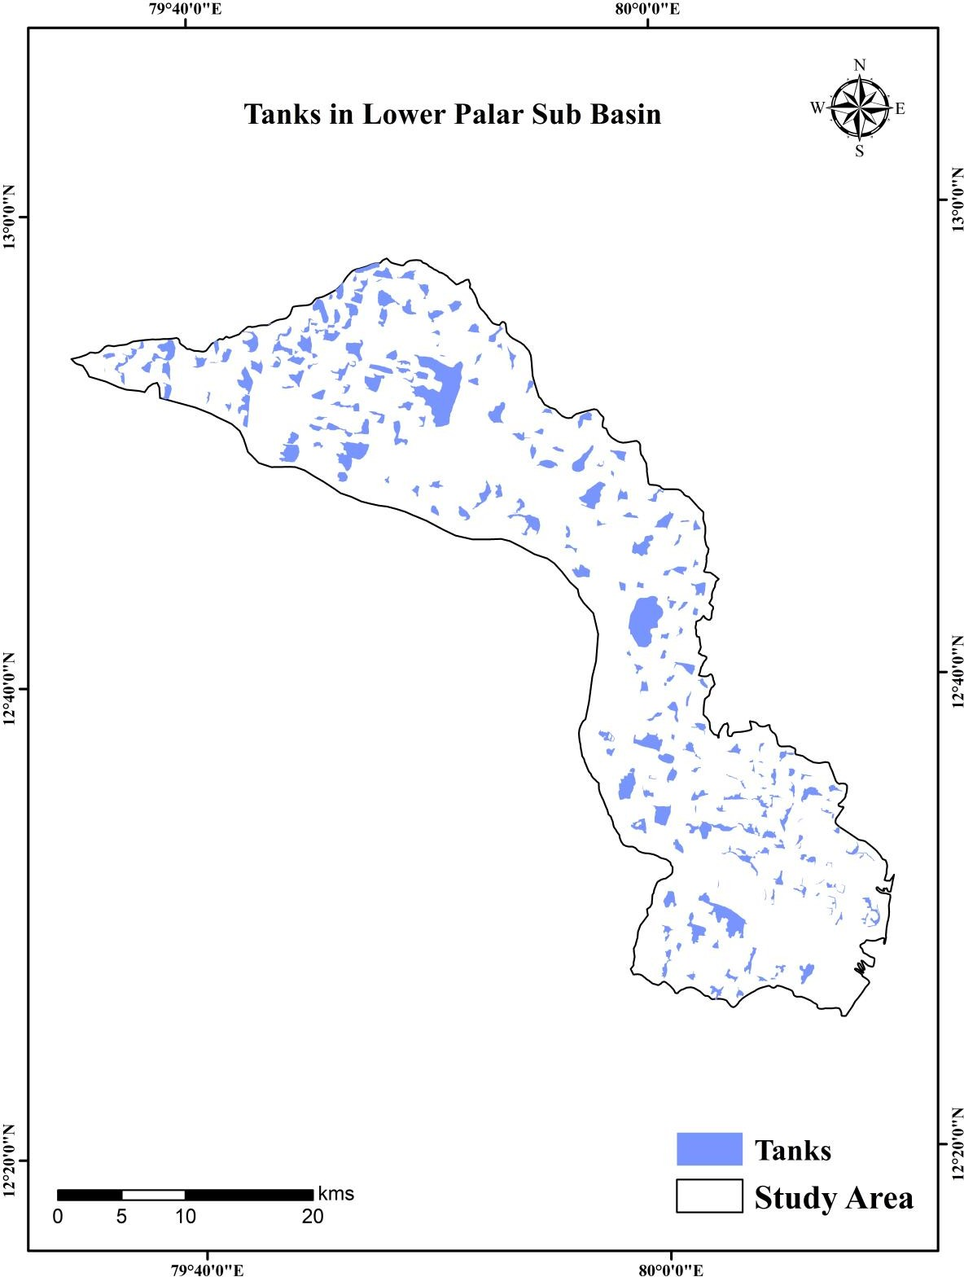

**Figure 1.** Lower Palar Sub-Basin tanks

**2.2 Water spread analysis**

**2.1.1 Sentinel 1A (SAR) Microwave Data**

The European Space Agency (ESA) launched Sentinel-1A in 2014 for its imaging radar mission, focused on Synthetic Aperture Radar (SAR) data collection. Operating at C-band with both H and V polarizations, it emphasizes the Interferometric Wide swath (IW) mode over land. Sentinel-1A prioritizes VV polarization for surface water detection (Liu, 2016; Clement et al., 2017). Information on the characteristics of Sentinel 1A's features is provided in Table 1. This study utilized Sentinel-1A C band GRD SAR data with 10m resolution, accessed through Google Earth Engine (Figure 2), for analyzing water spread within the Lower Palar sub-basin. Preprocessing techniques, similar to ESA's Sentinel 1A toolbox (ESA, 2023), included noise removal, calibration, and radiometric correction (Schuster et al., 2015).

1. Strip mosaicking merges frames into coherent strips, simplifying data management.
2. Co-registration aligns temporal images, adjusting pixel shifts using orbital data.
3. Time-series speckle filtering reduces noise across images.
4. Terrain geocoding, radiometric calibration, and normalization transform data into meaningful coordinates.
5. ANLD filtering enhances image quality, while atmospheric attenuation removal rectifies anomalies.
6. Sub-setting and SAR fuzzy thresholding enable targeted analysis and pixel classification, followed by zonal statistics for quantitative assessments, particularly in water spread area calculations.

**Table 1. Characteristics of Sentinel 1A (IW1-HR) Data**

|  |  |  |
| --- | --- | --- |
| **Parameters** | **Ground range (GRD)** | **Slant range (SLC)** |
| Pixel value | Magnitude detected | Complex |
| Coordinate system | Ground Range | Slant Range |
| Polarizations | Single (VV), Cross (VH) and Dual (VV+VH) | Single (VV), Cross (VH) and Dual (VV+VH) |
| Ground range coverage (km) | 251.8 | 251.8 |
| Radiometric resolution (dB) | 1.7 | - |
| Bits per Pixel | 16 | 16 I and 16 Q |
| Resolution (range x azimuth) (m) | 20.4 x 22.5 | 2.7 x 22.5 |
| Pixel spacing (range x azimuth) (m) | 10 x 10 | 2.3 x 14.1 |
| Incident angle | 32.9o | 32.9o |
| Number of Looks | 5 x 1 | 1 x 1 |
| Range look bandwidth (MHz) | 14.1 | 56.5 |
| Azimuth look bandwidth (Hz) | 315 | 315 |

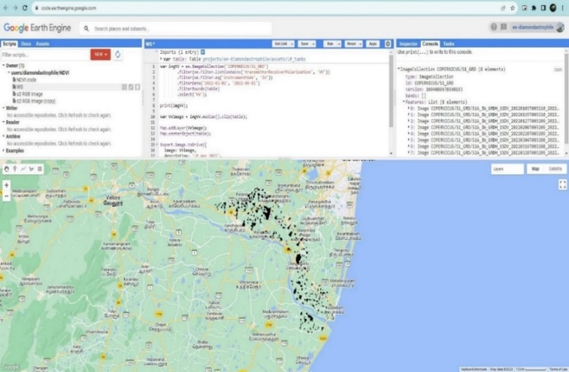

**Figure 2.** Satellite data download and processing in the GEE environment

**2.1.2 Drone Image Collection and Processing**

Using drones to capture imagery involves careful planning of flight paths tailored to specific goals. In this study, the objective was to create an extremely accurate elevation model with sub-centimeter precision, requiring images with resolutions finer than 3 cm. Both quadcopters and fixed-wing drones were used to capture orthoimages of tanks, which were then used to generate Digital Terrain Models (DTMs) for Lower Palar tanks. Fixed-wing drones were preferred for larger tanks due to their efficiency. Geotagged data from onboard receivers was embedded into images as EXIF information. The cameras were optimized to produce sharp imagery and accurate data, set in programmable mode with optimal settings such as shutter speed and exposure time. Overlapping images were taken along the flight path to create detailed point cloud data, with a recommended minimum front and side overlap of 60% to enhance matching accuracy. The Unmanned Aerial Vehicle (UAV) was equipped with an autopilot and high-precision GPS for navigation, and the onboard flight controller triggered the camera every 1-2 seconds. Flight paths were recorded using onboard GPS and synchronized with the camera before each flight. Figure 3 illustrates an exemplary flight path over the tank area.

|  |  |
| --- | --- |
|  |  |
| **Figure 3.** Flight Track over the study area | |

**2.1.3 Processing of images in Pix4D**

Drone images created an ortho-image and Digital Surface Model (DSM) for the tank, using Pix4D software for tasks like bundle block adjustment, point cloud generation, Orthomosaic creation, and filtering (Küng et al., 2011). Pix4D mapper, known for UAV photogrammetry, managed lightweight UAV photos well (Sona et al., 2014). This process generated cloud points, Orthoimages, and a Digital Elevation Model (DEM). Additional tie points made a Densified Point Cloud and a 3D Textured Mesh. Orthoimage correction fixed image perspective and terrain changes, aiding 3D model creation from 2D photos. Creating 3D models from 2D photos faces challenges due to the non-differentiable image generation process. Overcoming this requires more information, like corresponding image points in multiple views. Triangulating viewpoints reconstructs a 3D projection. Camera calibration and position are crucial, achieved through a projection matrix. The geometrical theory of Structure from Motion (SfM) computes projection matrices and 3D coordinates simultaneously using relevant points. DSM and Digital Terrain Model (DTM) development helps compute Volumes, Orthomosaics, and Reflectance Maps.

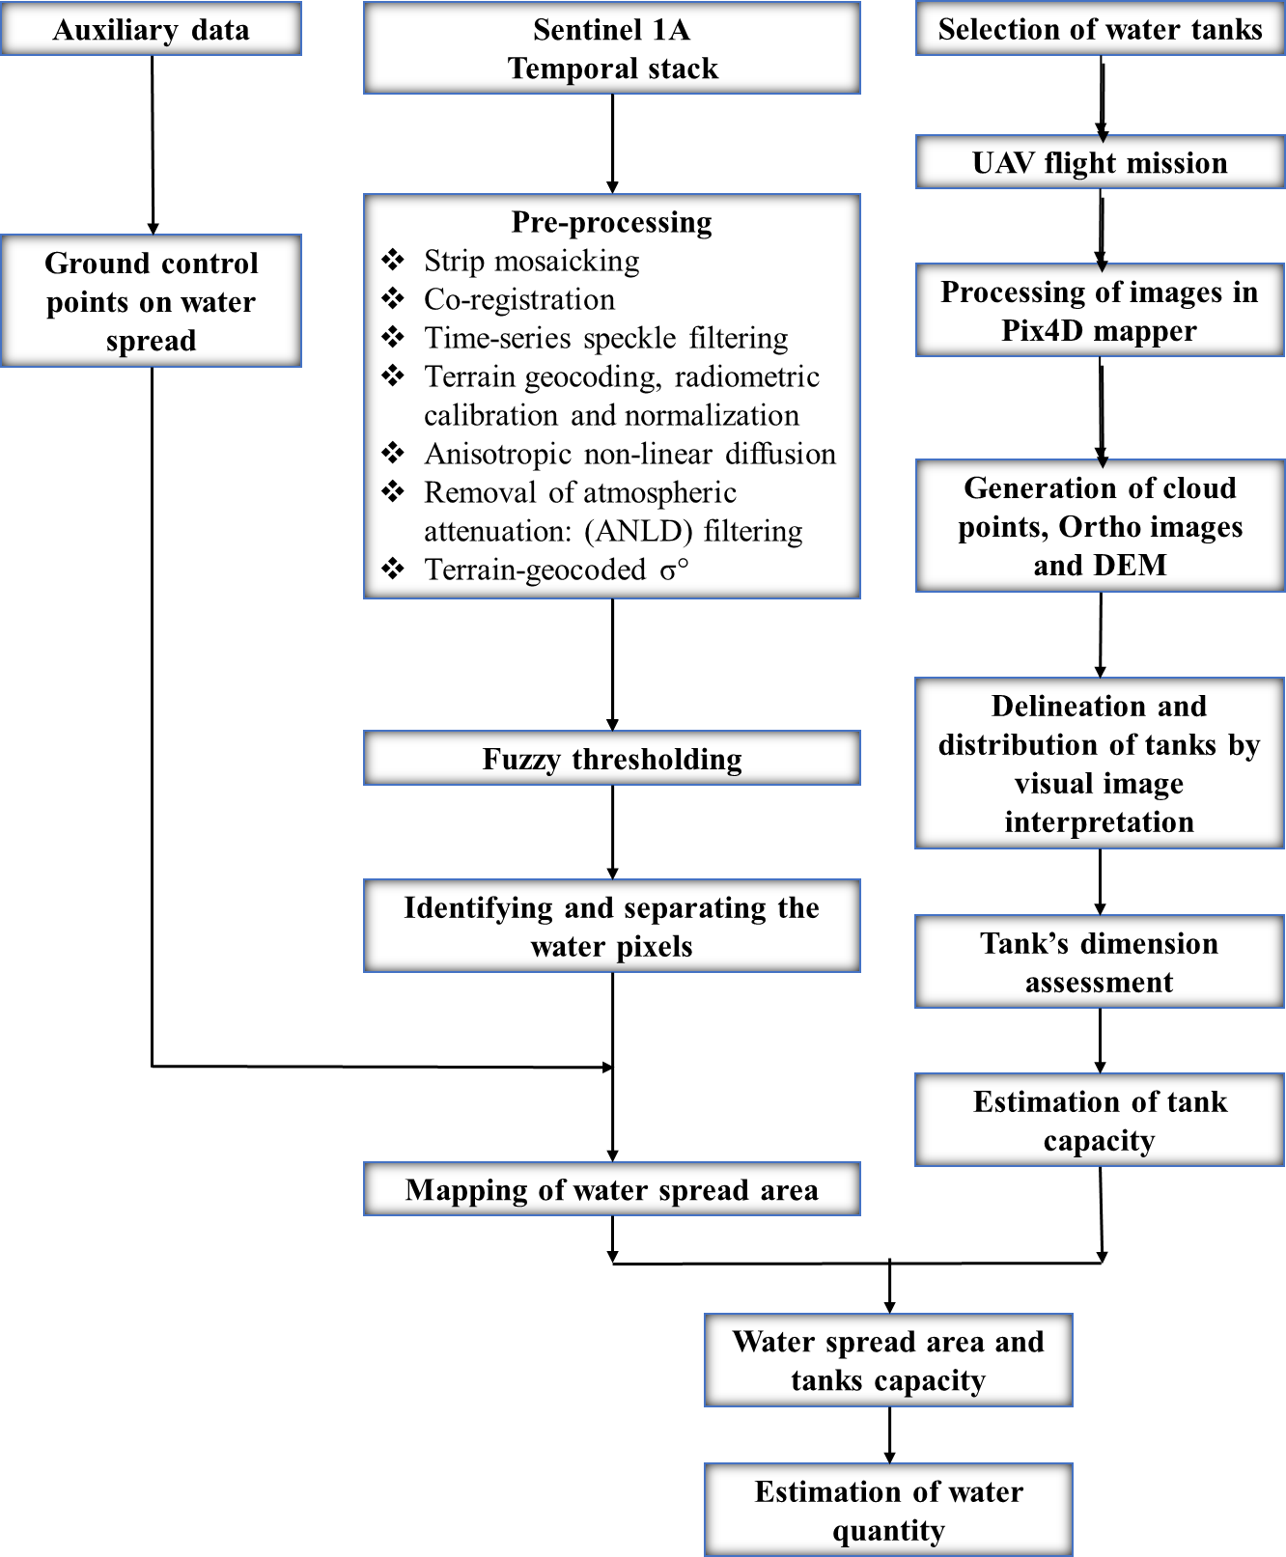

**Figure 4.** Methodology Overview for Water Spread Analysis

**2.1.4 Tank dimension assessment and estimation of water quantity**

The quantification of water in tanks was assessed using the customized tool developed by ArcGIS 10.6 software. The ‘Compute Water Depth’ tool was developed to create the water spread depth raster using DTM data generated from the Pix4D mapper and mask raster data of the water spread pixels (Figure 4). The volume will be generated as output in m3.

The volume (Vi) of each grid cell i is provided by:

Vi = Li x Wi x Hi

Where,

Li = the length of the cell; Wi = the width of the cell; Hi = the height of the cell

The Length (Li) and Width (Wi) equal the project's Ground Sample Distance (GSD).

Li =Wi = GSD

The Height (Hi) is given by

Hi = ZTi – ZBi

Where,

ZTi = the terrain altitude of each cell at the centre of the cell

ZBi = the base altitude of each cell at the centre of the cell

Therefore, the volume Vi of cell i is given by

Vi = GSD x GSD x (ZTi - ZBi)

The altitude of the 3D terrain corresponding to the centre of cell ‘i' is denoted by ZTi. The altitude of the base surface of the volume corresponding to the centre of cell ‘i' is denoted by ZBi.

**2.3 Crop classification**

**2.3.1 Sentinel 1A and Sentinel 2 data**

Crop diversification and classification for the *Kharif*, *Rabi*, and *Summer* seasons in the Lower Palar Subbasin were evaluated using high-resolution Sentinel 2 Optical satellite data, along with Sentinel 1A Synthetic Aperture Radar products. Sentinel 2 comprises 13 spectral bands, of which four bands (B2 490 nm, B3 560 nm, B4 665 nm, and B8 842 nm) with 10 m resolution were utilized. Composite images for *Kharif*, *Rabi*, and *Summer* seasons in 2018 and 2021 were obtained from the Google Earth Engine platform. The data underwent preprocessing steps like cloud filtering and atmospheric corrections *via* Python scripting for optimal Sentinel 2 imagery of the Lower Palar sub-basin.

**2.3.2 Generation of Land parcel Information and Ayacut Area**

The cadastral maps of villages in the Lower Palar sub-basin were acquired from the Department of Agriculture in Chengalpattu and Kancheepuram Districts, using large-scale (1:5000) cadastral maps. The process involved map mosaicking, georeferencing, digitization, and edge matching to delineate the tank ayacut area from the digitized cadastral maps, as outlined in Figure 5 of the methodology.

Tank ayacut maps, obtained from the Water Resources Department, were generated using digitized cadastral maps and tank water user association maps in ArcGIS 10.6, delineating major tank ayacut boundaries across the Lower Palar sub-basin. Ground truth surveys collected 1833 points across six seasons to validate crop and non-crop areas derived from satellite data, employing a random stratified sampling approach for training and validation in crop classification.

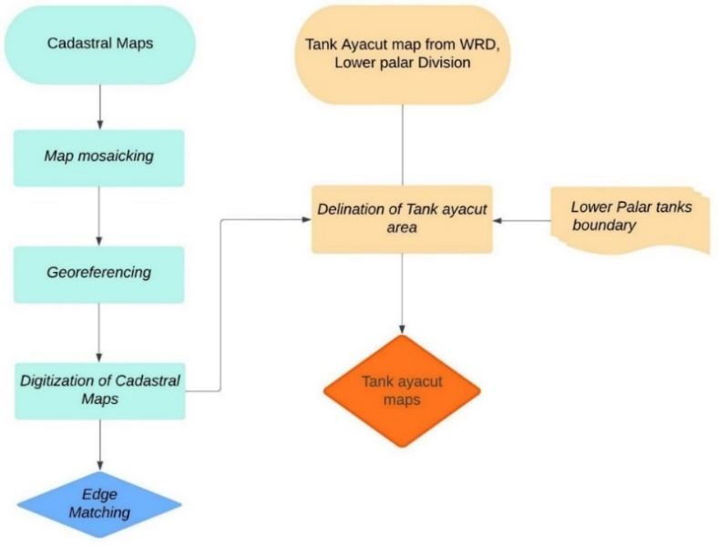

**Figure 5.** Methodology adopted for generation of cadastral maps and Tank Ayacut

**2.3.3 Crop Classification and Crop Diversification Assessment**

Pixel-based classification and the random forest machine learning algorithm were applied to pre-processed Sentinel 2 satellite data with 10m spatial resolution to identify major crop areas. Ground truth points from surveys were crucial for training classification modules to pinpoint major crops in the study area (Figure 6). Crop classification was performed for major crops across different seasons, and water spread in tanks was assessed during the *kharif, rabi,* and *summer* seasons of 2018 and 2021. These assessments correlated with crop area and crop variety in each season, informing the Crop Diversification Index analysis (Simpson, 1949). It considers species abundance and evenness, with values close to 1 indicating diverse cropping patterns and 0 indicating monoculture.

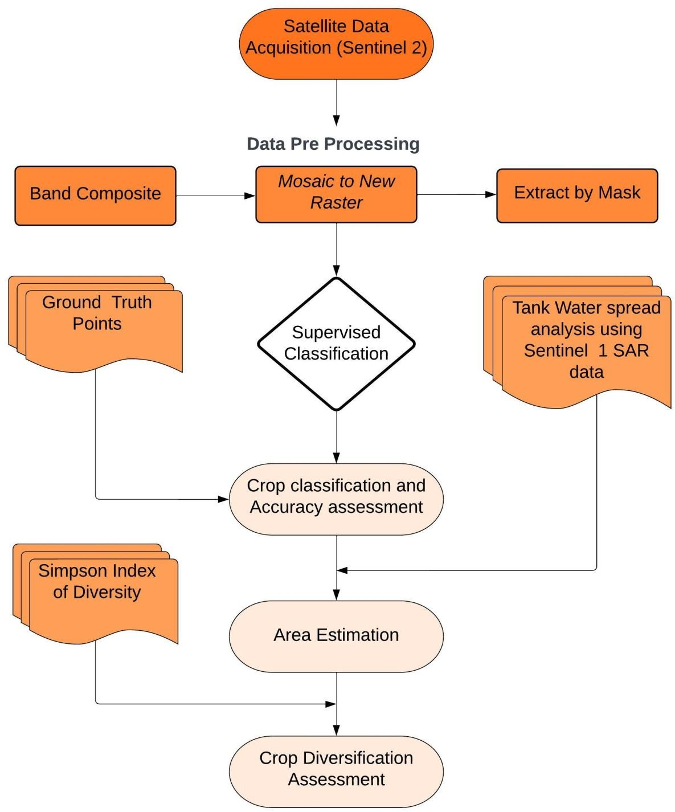

**Figure 6.** Crop classification and crop diversification assessment

3. results and discussion

3.1 Water Spread Assessment in Lower Palar Sub-Basin

The estimated water spread data for tanks in the Lower Palar sub-basin were presented in Tables 2 and 3. The monthly mean total water spread area in the Lower Palar basin ranges from 1489.0 to 3160.0 ha throughout the year, with higher cumulative totals observed from October to April. Conversely, May to September typically gets lower water spread areas. Peak water spread occurs in December, followed by January and February. In 2019-20, July had the minimum water spread area (460 ha), while December had the maximum (5211.8 ha), except for December 2019, where a lower area indicated a monsoon deficit.

The monthly mean total water spread volume ranges from 724.3 to 1185.7 million cubic meters (MCM) regardless of month or year, following a similar pattern to the water spread area, with higher volumes from October to April. Again, December stands out with the maximum volume, followed by January, April, and February. In 2019-20, July had the minimum volume (122.9 MCM), while December had the maximum (2117.6 MCM), except for December 2019 due to monsoon deficits. Due to the unavailability of a sentinel 1A satellite pass over Tamil Nadu during December 2023, water spread and volume were not assessed for that month.

**Table 2.** Month-wise cumulative water spread area (ha) analysis

|  |  |  |  |  |  |  |  |  |  |  |  |  |
| --- | --- | --- | --- | --- | --- | --- | --- | --- | --- | --- | --- | --- |
| **Year** | **Jan** | **Feb** | **Mar** | **April** | **May** | **June** | **July** | **Aug** | **Sep** | **Oct** | **Nov** | **Dec** |
| **2018-19** | 2170.3 | 1526.3 | 1598.7 | 1278.3 | 1064.4 | 1456.8 | 1187.5 | 1117.1 | 1232.9 | 1282.1 | 1019.6 | 1904.8 |
| **2019-20** | 1546.5 | 1534.5 | 1329.0 | 1357.4 | 924.3 | 926.8 | 460.0 | 1076.4 | 1492.2 | 1831.8 | 3103.5 | 5211.8 |
| **2020-21** | 3781.9 | 2313.5 | 2293.1 | 1811.8 | 1685.8 | 1216.7 | 2550.3 | 2450.9 | 1543.1 | 1822.1 | 3183.2 | 3891.4 |
| **2021-22** | 3304.0 | 3756.5 | 2786.8 | 3059.9 | 2098.3 | 1642.0 | 1890.0 | 1514.7 | 2108.0 | 2523.2 | 4775.1 | 3354.1 |
| **2022-23** | 4828.6 | 3026.6 | 3102.3 | 2807.7 | 2545.3 | 1610.6 | 1915.1 | 845.7 | 2073.7 | 1671.4 | 1343.1 | 4103.8 |
| **2023-24** | 3328.6 | 3570.9 | 2891.2 | 3012.4 | 2491.1 | 2081.0 | 1981.6 | 2081.5 | 2111.3 | 2924.4 | 2280.7 | N/A |
| **Maximum** | 4828.6 | 3756.5 | 3102.3 | 3059.9 | 2545.3 | 2081.0 | 2550.3 | 2450.9 | 2111.3 | 2924.4 | 4775.1 | 5211.8 |
| **Mean** | 3160.0 | 2621.4 | 2333.5 | 2221.2 | 1801.5 | 1489.0 | 1664.1 | 1514.4 | 1760.2 | 2009.2 | 2617.5 | 3077.7 |

**Table 3.** Month-wise cumulative water spread volume (MCM) analysis

|  |  |  |  |  |  |  |  |  |  |  |  |  |
| --- | --- | --- | --- | --- | --- | --- | --- | --- | --- | --- | --- | --- |
| **Year** | **Jan** | **Feb** | **Mar** | **April** | **May** | **June** | **July** | **Aug** | **Sep** | **Oct** | **Nov** | **Dec** |
| **2018-19** | 892.7 | 553.9 | 618.2 | 456.2 | 346.5 | 648.8 | 557.6 | 505.8 | 553.7 | 569.2 | 458.1 | 692.8 |
| **2019-20** | 560.1 | 640.7 | 609.7 | 556.8 | 248.0 | 299.5 | 122.9 | 340.2 | 468.6 | 677.7 | 1193.3 | 2117.6 |
| **2020-21** | 1476.0 | 761.1 | 882.9 | 834.2 | 742.1 | 307.8 | 1020.1 | 1017.2 | 671.2 | 640.3 | 1171.2 | 1162.8 |
| **2021-22** | 1169.6 | 1416.1 | 1075.7 | 1418.7 | 762.0 | 451.9 | 743.4 | 597.0 | 894.0 | 1134.9 | 1953.0 | 1219.2 |
| **2022-23** | 1909.1 | 1065.6 | 1244.9 | 1355.6 | 1205.1 | 829.4 | 926.6 | 314.1 | 840.6 | 677.7 | 419.2 | 1428.6 |
| **2023-24** | 1106.8 | 1328.6 | 1255.6 | 1430.3 | 1192.0 | 943.8 | 975.4 | 932.9 | 929.7 | 1304.6 | 955.0 | N/A |
| **Maximum** | 1909.1 | 1416.1 | 1255.6 | 1430.3 | 1205.1 | 943.8 | 1020.1 | 1017.2 | 929.7 | 1304.6 | 1953.0 | 2117.6 |
| **Mean** | 1185.7 | 961.0 | 947.8 | 1008.6 | 749.3 | 580.2 | 724.3 | 617.9 | 726.3 | 834.1 | 1025.0 | 1103.5 |

**3.1.1 Seasonal Water Spread Analysis**

The detailed cumulative seasonal total water spread and volume analysis was performed for the Lower Palar Subbasin from 2018 to 2024 (Table 4). The North East Monsoon reported a higher mean cumulative water spread area of 4798.1 ha, followed by summer (3961.9 ha) and South West Monsoon season (2852.7 ha), and the same pattern was observed in all the years. The maximum water spread was reported during North East Monsoon (6165.3 ha; 2021-22) followed by the Summer season (4787.0 ha; 2020-21) and South West Monsoon (3373.9 ha; 2023-24) respectively. The Mean and Maximum water spread volume follow the same pattern as the water spread area.

**Table 4.** Seasonal Cumulative water spread area and volume of Lower Palar subbasin

|  |  |  |  |  |  |  |
| --- | --- | --- | --- | --- | --- | --- |
| **Year** | **South West Monsoon** | | **North East Monsoon** | | ***Summer*** | |
| **Area (ha)** | **Volume (MCM)** | **Area (ha)** | **Volume (MCM)** | **Area (ha)** | **Volume (MCM)** |
| **2018-19** | 1987.9 | 192.7 | 2396.5 | 216.7 | 2318.6 | 228.1 |
| **2019-20** | 2169.2 | 202.6 | 5658.9 | 582.3 | 3530.3 | 383.3 |
| **2020-21** | 3310.8 | 355.4 | 5853.3 | 569.0 | 4787.0 | 481.3 |
| **2021-22** | 3035.2 | 325.1 | 6165.3 | 605.7 | 4652.0 | 489.9 |
| **2022-23** | 3238.9 | 326.1 | 5262.0 | 517.0 | 4521.5 | 443.9 |
| **2023-24** | 3373.9 | 333.5 | 3452.7 | 339.3 | N/A | N/A |
| **Maximum** | 3373.9 | 355.4 | 6165.3 | 605.7 | 4787.0 | 489.9 |
| **Mean** | 2852.7 | 289.2 | 4798.1 | 471.7 | 3961.9 | 405.3 |

**3.1.2 Tank Ayacuts in Lower Palar Sub Basin**

The digitized cadastral boundaries of Lower Palar sub-basin villages were used to delineate tank ayacut maps, obtained from the Public Works Department (PWD) – Water Resource Department (WRD). Challenges arose from including permanent features like settlements and greenery. 95 tank ayacuts were created and detailed in Table 5.

**Table 5.** Major tank ayacuts of Lower Palar sub-basin

|  |  |  |  |  |
| --- | --- | --- | --- | --- |
| **S.No** | **Tank Name** | **Village** | **Block** | **Area (ha)** |
| 1. | Oothukadu Peria Eri | Oothukadu | Kancheepuram | 512.9 |
| 2. | Enadur Tank | Enadur | Kancheepuram | 417.6 |
| 3. | Siruvakkam Big Tank | Siruvakkam | Kancheepuram | 396.8 |
| 4. | Singadivakkam Tank | Singadivakkam | Kancheepuram | 256.5 |
| 5. | Kooram Big Tank | Kooram | Kancheepuram | 254.5 |
| 6. | Nelvoy Tank | Nelvoy | Kancheepuram | 250.3 |
| 7. | Ullavur Peria Eri and Ullavur Chitheri | Ullavur | Kancheepuram | 244.8 |
| 8. | Konnerikuppam Tank | Konnerikuppam | Kancheepuram | 243.7 |
| 9. | Vedal Tank | Vedal | Kancheepuram | 198.7 |
| 10. | Thodur Tank | Thodur | Kancheepuram | 198.2 |
| 11. | Injambakkam Chitheri | Injambakkam | Kancheepuram | 187.6 |
| 13. | Kuthirambakkam Tank | Kuthirambakkam | Kancheepuram | 185.3 |
| 14. | Podavoor Melthangal | Podavoor | Kancheepuram | 181.8 |
| 15. | Vaiyavur Tank | Vaiyavur | Kancheepuram | 158.4 |
| 16. | Nathapettai Tank | Nathapettai | Kancheepuram | 151.4 |
| 17. | Sembarambakkam Tank | Sembarambakkam | Kancheepuram | 137.5 |
| 18. | Ariyaperumbakkam Tank Thangal | Ariyaperumbakkam | Kancheepuram | 115.9 |
| 19. | Thandalam Tank | Thandalam | Kancheepuram | 114.5 |
| 20. | Kaliyanur Peria Eri | Kaliyanur | Kancheepuram | 111.2 |
| 21. | Illuppapattu Mananthangal | Illuppapattu | Kancheepuram | 101.8 |
| 22. | Nirvalur Tank | Nirvalur | Kancheepuram | 100.7 |
| 23. | Sitiambakkam Tank | Sitiambakkam | Kancheepuram | 94.2 |
| 24. | Nathanallur Tank | Nathanallur | Kancheepuram | 88.7 |
| 25. | Siruvedal Tank | Siruvedal | Kancheepuram | 82.7 |
| 26. | Kovalavedu Tank | Kovalavedu | Kancheepuram | 82.1 |
| 27. | Peria Karumbur Malattu Thangal | Peria Karumbur | Kancheepuram | 77.6 |
| 28. | Athivakkam Vadaku Thangal | Athivakkam | Kancheepuram | 74.9 |
| 29. | Sinnivakkam Tank | Sinnivakkam | Kancheepuram | 71.4 |
| 30. | Alappakkam Tank | Alappakkam | Kancheepuram | 71.2 |
| 31. | Seeyati Tank | Seeyati | Kancheepuram | 64.8 |
| 32. | Palur Chitheri And Peria Eri | Palur | Chengalpattu | 259.8 |
| 33. | Villiambakkam Tank | Villiambakkam | Chengalpattu | 121.6 |
| 34. | Venbakkam Thangal and Guruvanmedu | Venbakkam & Guruvanmedu | Chengalpattu | 108.6 |
| 35. | Ozhalur Pudupakkam Hissa Tank | Ozhalur Pudupakkam | Chengalpattu | 61.4 |
| 36. | Settipunniyam Tank | Settipuniyam | Chengalpattu | 47.8 |
| 37. | Vallam Tank and Thenur Tank | Vallam, Thenur | Chengalpattu | 32.9 |
| 38. | Pandur Peria Eri | Pandur | Tirukalukundram | 189.6 |
| 39. | Veerapuram Tank & Thangal | Virapuram | Tirukalukundram | 148.0 |
| 40. | Vazhuvadur Tank | Vazhuvadur | Tirukalukundram | 143.5 |
| 41. | Perumbakkam Maduvu, Thangal | Vittilapuram | Tirukalukundram | 138.7 |
| 42. | Pattarai Kazhani Tank | Nerumbur | Tirukalukundram | 133.3 |
| 43. | Vitalapuram Tank | Vitalapuram | Tirukalukundram | 129.1 |
| 44. | Sooradimangalam Peria Eri | Mangalam | Tirukalukundram | 123.1 |
| 45. | Thathalur Big Tank | Thathalur | Tirukalukundram | 121.1 |
| 46. | Vayalur Tank | Voyalur | Tirukalukundram | 117.8 |
| 47. | Ayapakkam Periya and Chitheri | Ayapakkam | Tirukalukundram | 113.8 |
| 48. | Aminjikarai Tank and Thangal | Aminjikarai | Tirukalukundram | 108.5 |
| 49. | Vasuvasamuthiram Tank | Pudupatnam | Tirukalukundram | 105.2 |
| 50. | Muthigai Nallankuppam Chitheri | Muthigai Nallankuppam | Tirukalukundram | 104.1 |
| 51. | Nerumbur Peria Eri and Thangal | Nerumbur | Tirukalukundram | 103.6 |
| 52. | Edaiyur Peria Eri and Edaiyur thangal | Idaiyur | Tirukalukundram | 101.2 |
| 53. | Manapakkam Tank | Manapakkam | Tirukalukundram | 99.2 |
| 54. | Udhayambakkam Tank | Udhayambakkam | Tirukalukundram | 84.9 |
| 55. | Neikuppi Peria Eri | Neikuppi | Tirukalukundram | 84.5 |
| 56. | Nenmeli Peria Eri and Chitheri | Nemali | Tirukalukundram | 84.0 |
| 57. | Ponpadirkudam Tank | Ponpadirkudam | Tirukalukundram | 77.5 |
| 58. | Salur Tank | Salur | Tirukalukundram | 76.8 |
| 59. | Vellappanthal Tank | Vellappanthal | Tirukalukundram | 75.8 |
| 60. | Ayapakkam Kokorai Odai | Ayapakkam | Tirukalukundram | 75.7 |
| 61. | Thalambedu Tank | Thalambedu | Tirukalukundram | 75.7 |
| 62. | Bommarajapuram Tank | Nallathur | Tirukalukundram | 73.9 |
| 63. | Merkandai Tank | Merkandai | Tirukalukundram | 70.9 |
| 64. | Naduvakkarai Tank | Naduvakkarai | Tirukalukundram | 68.9 |
| 65. | Mullikolathur Mulleri | Mullikolathur | Tirukalukundram | 68.0 |
| 66. | Mudaiyur Peria Eri and Thangal | Mudaiyur | Tirukalukundram | 63.8 |
| 67. | Chitlambakkam Tank | Vittilapuram | Tirukalukundram | 63.0 |
| 68. | Echur Peria Eri | Echur | Tirukalukundram | 62.5 |
| 69. | Korapattu Tank | Korapattu | Tirukalukundram | 61.1 |
| 70. | Kondanganeri and Melperumalcheri Tank | Pudupatnam | Tirukalukundram | 60.9 |
| 71. | Patti Kadu Tank | Pattikadu | Tirukalukundram | 59.6 |
| 72. | Nallanpettral Peria Eri, Chitheri | Perumaleri | Tirukalukundram | 58.7 |
| 73. | Perumaleri tank | Perumaleri | Tirukalukundram | 57.3 |
| 74. | Soorakuppam Thangal & Peria Eri | Mangalam | Tirukalukundram | 53.7 |
| 75. | Narapakkam Tank | Narapakkam | Tirukalukundram | 53.4 |
| 76. | Thirumani Peria Eri | Tirumani | Tirukalukundram | 53.2 |
| 77. | Echangaranai Tank | Mangalam | Tirukalukundram | 53.1 |
| 78. | Karumarapakkam Periya Eri and Thangal | Mangalam | Tirukalukundram | 52.0 |
| 79. | Venpakkam Tank | Venbakkam | Tirukalukundram | 51.8 |
| 80. | Thunjam Tank | Thunjam | Tirukalukundram | 49.9 |
| 81. | Meyyur Tank | Meyyur | Tirukalukundram | 48.9 |
| 82. | Irumbuli Cheri Tank | Irumbuli Cheri | Tirukalukundram | 46.2 |
| 83. | Pulikundram Peria Eri and Chitheri | Pulikundram | Tirukalukundram | 45.7 |
| 84. | Kilavedu Tank | Kilvedu | Tirukalukundram | 41.5 |
| 85. | Kalkulam Tank | Kalkulam | Cheyyur | 171.4 |
| 86. | Pavinjur Tank | Pavinjur | Cheyyur | 113.7 |
| 87. | Neelamangalam Tank | Nilamangalam | Cheyyur | 99.0 |
| 88. | Kumarakuppam Tank | Thondamanallur | Cheyyur | 83.0 |
| 89. | Sivadi tank | Sivadi | Cheyyur | 62.5 |
| 90. | Uludamangalam tank | Uludamangalam | Cheyyur | 57.4 |
| 91. | Lathur Tank | Lattur | Cheyyur | 57.4 |
| 92. | Punnammai Tank | Punnamai | Cheyyur | 51.9 |
| 93. | Pachayambakkam Tank | Pachayambakkam | Cheyyur | 48.2 |
| 94. | Agaram Tank | Pavanjur | Cheyyur | 17.1 |
| 95. | Kalkulam Tank | Kalkulam | Cheyyur | 171.4 |

**3.2 Water Spread and Crop Diversification in Lower Palar Sub Basin**

**3.2.1 Water spread assessment during 2018 and 2021**

Water spread in the tanks of the Lower Palar sub-basin was examined across *Kharif*, *Rabi*, and *Summer* seasons in both 2018 and 2021, utilizing data from the multi-temporal Sentinel 1A Synthetic Aperture Radar. In *Kharif* 2018, 903.49 hectares of water spread were recorded across 262 tanks, with varying spread areas ranging from less than 0.01 ha to over 50 ha. The *Rabi* season saw an increase to 1124.09 ha of water spread, correlated with previous rainfall, and *Summer* recorded 1186.25 ha of water spread, also linked to preceding rainfall (Figure 7 and Table 6 and 7). In 2021, the *Rabi* season experienced the highest rainfall at 1530.9 mm, leading to increased water spread in the subsequent *Summer* season, reaching 2715.82 ha due to North East monsoon rains. The highest water spread across all six seasons was recorded in *Summer* 2021 at 2715.82 ha, significantly influenced by the previous season's rainfall of 1530.09 mm from the North East monsoon.

**Table 6.** Seasonal SoS, EoS and Cumulative Water Spread during 2018 and 2021

|  |  |  |  |  |  |  |  |
| --- | --- | --- | --- | --- | --- | --- | --- |
| **Particulars** | **Water Spread (ha)** | | | | | | |
| ***Kharif*,**  **2018** | ***Rabi*,**  **2018** | ***Summer*, 2018** | ***Kharif*,**  **2021** | ***Rabi*,**  **2021** | ***Summer*, 2021** |
| Start of the season (SoS) | 880.13 | 965.21 | 1360.37 | 1877.75 | 1327.87 | 3693.64 |
| End of the season (EoS) | 717.26 | 1342.02 | 895.17 | 1145.69 | 2826.36 | 2524.66 |
| Cumulative Water Spread | 903.49 | 1124.09 | 1186.25 | 1378.22 | 2391.58 | 2715.82 |

**Table 7.** Seasonal Water Spread assessment during 2018 and 2021

|  |  |  |  |  |  |  |  |  |  |  |  |  |  |
| --- | --- | --- | --- | --- | --- | --- | --- | --- | --- | --- | --- | --- | --- |
| **Water spread range (ha)** | ***Kharif*, 2018** | | ***Rabi*, 2018** | | ***Summer*, 2018** | | ***Kharif*, 2021** | | ***Rabi*, 2021** | | ***Summer*, 2021** | | |
| **Tank**  **(Nos.)** | **Tank**  **(%)** | **Tank**  **(Nos.)** | **Tank**  **(%)** | **Tank**  **(Nos.)** | **Tank**  **(%)** | **Tank**  **(Nos.)** | **Tank**  **(%)** | **Tank**  **(Nos.)** | **Tank**  **(%)** | **Tank**  **(Nos.)** | **Tank**  **(%)** |
| 0 | 30 | 11.45 | 43 | 16.41 | 29 | 11.07 | 44 | 16.79 | 20 | 7.63 | 23 | 8.78 |
| 0.01-10 | 224 | 85.5 | 208 | 79.39 | 222 | 84.73 | 197 | 75.19 | 197 | 75.19 | 183 | 69.85 |
| 10-25 | 4 | 1.53 | 6 | 2.29 | 5 | 1.91 | 12 | 4.58 | 28 | 10.69 | 36 | 13.74 |
| 25-50 | 0 | 0 | 1 | 0.38 | 2 | 0.76 | 4 | 1.53 | 11 | 4.2 | 14 | 5.34 |
| > 50 | 4 | 1.53 | 4 | 1.53 | 4 | 1.53 | 5 | 1.91 | 6 | 2.29 | 6 | 2.29 |
| Total | 262 | 100 | 262 | 100 | 262 | 100 | 262 | 100 | 262 | 100 | 262 | 100 |

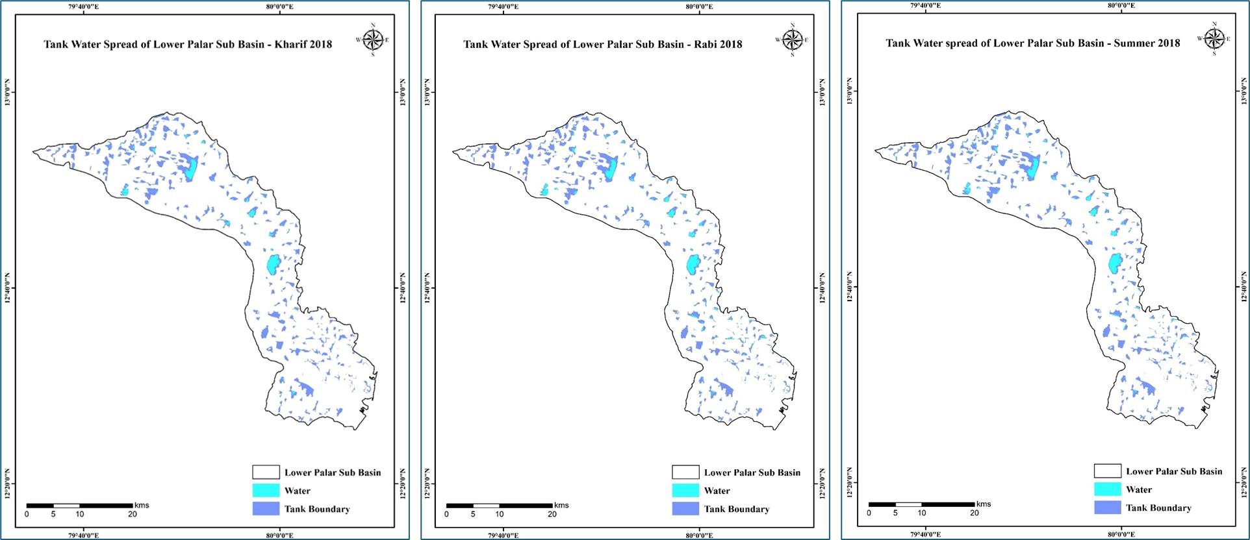

a. Kharif, Rabi and Summer 2018

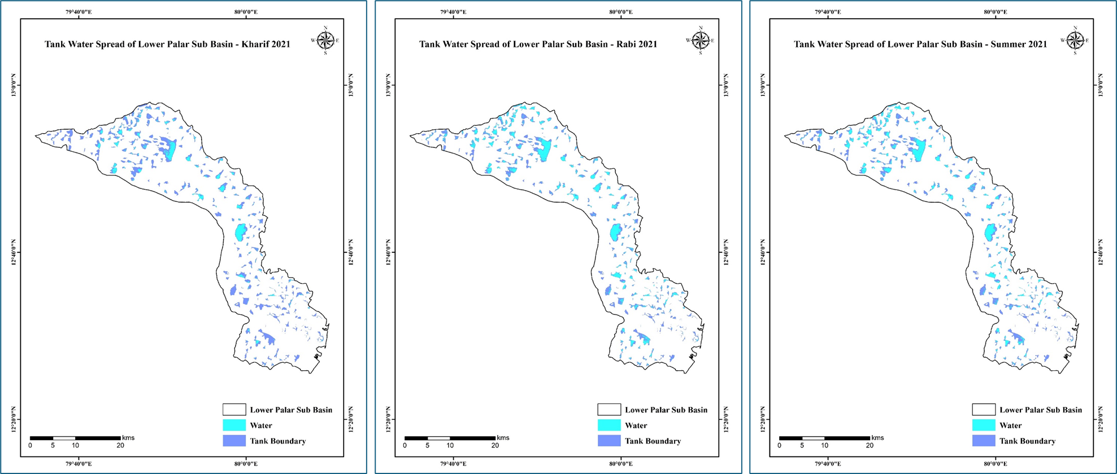

**b.** *Kharif, Rabi* and *Summer* 2021

**Figure 7 (a-b).** Seasonal Water Spread assessment in Lower Palar Sub Basin

**3.2.2** **Crop classification during 2018 and 2021**

The crop classifications were estimated among all three seasons of 2018 and 2021 (Table 8). Based on the results, the Paddy crop recorded the highest area of 24176.3 ha during *Rabi* season, followed by 15879.6 ha in *kharif* and 13606.5 ha in *summer*. Sugarcane crop recorded 4367.5 ha during *Kharif*, 4099.2 ha in *rabi* and 3325.5 ha in *summer*. Groundnut crop recorded 3254.6 ha, and watermelon occupies 2558.2 ha during *Summer*. In 2021, the paddy crop recorded the highest area of 29,973.7 ha during the *Rabi* season, followed by 26,450.0 ha in *Summer* and 24,809.7 ha in *Kharif*. Sugarcane crop recorded 4747.9 ha during *Summer*, 4099.2 ha in *Rabi* and 3578.6 ha in *Kharif*. Groundnut and watermelon crops recorded an area of 3254.6 and 6846.2 ha, respectively, during *Summer*.

**Table 8.** Crop classification classes for *Kharif, Rabi*, and *Summer* of 2018 and 2021

|  |  |  |  |  |  |  |
| --- | --- | --- | --- | --- | --- | --- |
| **Land Cover /Crop Class** | **Area (ha)** | | | | | |
| **2018** | | | **2021** | | |
| ***Kharif*** | ***Rabi*** | ***Summer*** | ***Kharif*** | ***Rabi*** | ***Summer*** |
| **Barren land** | 30286.3 | 29825.4 | 29987.2 | 25278.5 | 24864.3 | 24787.5 |
| **Casuarina** | 2033.8 | 1987.5 | 2023.5 | 998.6 | 1003.3 | 990.8 |
| **Coconut** | 903.3 | 921.2 | 962.6 | 1008.6 | 1106.8 | 1101.9 |
| **Fallow land** | 26962.9 | 18428.5 | 23257.2 | 19982.1 | 16416.2 | 8229.3 |
| **Forest** | 8947.3 | 8997.4 | 9002.3 | 8724.9 | 8802.7 | 8890.1 |
| **Groundnut** | - | - | 3254.6 | - | - | 3965.8 |
| **Mango** | 1989.3 | 1965.2 | 1967.6 | 2018.9 | 2010.6 | 2012.9 |
| **Paddy** | 15879.6 | 24176.3 | 13606.5 | 24809.7 | 29973.7 | 26450.0 |
| **Settlement** | 6220.1 | 6266.0 | 6426.3 | 7350.3 | 7389.2 | 7389.7 |
| **Sugarcane** | 4367.2 | 4099.2 | 3325.5 | 3578.6 | 3998.7 | 4747.9 |
| **Waterbody** | 6879.8 | 7803.5 | 8098.7 | 8633.6 | 8904.5 | 9057.9 |
| **Watermelon** | - | - | 2558.2 | 2086.3 | - | 6846.2 |
| **Total** | 104470.0 | 104470.0 | 104470.0 | 104470.0 | 104470.0 | 104470.0 |

Between 2018 and 2021, Paddy cultivation was prominent, notably with the largest cropping areas during *Rabi* 2021 (29,973.7 ha), *Summer* 2021 (26,450.0 ha), and *Rabi* 2018 (24,176.3 ha) (Table 9). Watermelon had a substantial area in *Summer* 2021 (6,846.2 ha), followed by sugarcane (4,747.9 ha). Sugarcane and casuarina crops persisted annually. Changes in mango and coconut plantations were observed between *Kharif* 2018 and *Summer* 2021, with varying areas. Barren land decreased from *Kharif* 2018 (30,286.3 ha) to *Summer* 2021 (24,787.5 ha), possibly influenced by increased rainfall in 2021. Urbanization led to conversions of barren land to settlements, notably in *Summer* 2021 (7389.7 ha).

**Table 9.** Seasonal cropping and Fallow land area (ha) of 2018 and 2021

|  |  |  |  |  |  |  |
| --- | --- | --- | --- | --- | --- | --- |
| **Class** | **2018** | | | **2021** | | |
| ***Kharif*** | ***Rabi*** | ***Summer*** | ***Kharif*** | ***Rabi*** | ***Summer*** |
| Groundnut | - | - | 3,254.6 | - | - | 3,965.8 |
| Paddy | 15,879.6 | 24,176.3 | 13,606.5 | 24,809.7 | 29,973.7 | 26,450.0 |
| Sugarcane | 4,367.5 | 4,099.2 | 3,325.5 | 3,578.6 | 3,998.7 | 4,747.9 |
| Watermelon | - | - | 2,558.2 | 2,086.3 | - | 6,846.2 |
| Fallow land | 26,962.9 | 18,428.5 | 23,257.2 | 19,982.1 | 16,416.2 | 8,229.3 |
| Cultivated area (ha) | 20,247.1 | 28,275.5 | 22,744.8 | 30,474.5 | 33,972.4 | 42,009.97 |

**3.2.3 Crop Diversity Index between 2018 and 2021**

Crop classification analysis included Paddy and Sugarcane areas in *Kharif, Rabi*, and *Summer* 2018, along with Paddy, Groundnut, Sugarcane, and Watermelon in *Summer*. These areas were crucial for calculating the Simpson Index of Diversity across the seasons (Table 10). The Simpson Index values were 0.34, 0.25, and 0.59 for *Kharif, Rabi,* and *Summer* 2018, and 0.32, 0.21, and 0.56 for *Kharif, Rabi*, and *Summer* 2021, respectively. This index ranges from 0 to 1, where lower values suggest monoculture or limited diversification, while higher values, around 0.5 and above, indicate a more diverse crop composition.

**Table 10.** Simpson Index of Diversity (SID) for *Kharif, Rabi* and *Summer*, 2018 and 2021

|  |  |  |  |  |  |  |
| --- | --- | --- | --- | --- | --- | --- |
| **Season** | **Water spread (ha)** | | | **Total cultivated area (N) (ha)** | **Fallow land (ha)** | **SID** |
| **Start of**  **season** | **End of**  **season** | **Seasonal**  **spread** |
| ***Kharif,* 2018** | 880.1 | 717.3 | 903.5 | 20,247.1 | 26,962.9 | 0.34 |
| ***Rabi,* 2018** | 965.2 | 1342.0 | 1124.1 | 28,275.5 | 18,428.5 | 0.25 |
| ***Summer,* 2018** | 1360.4 | 895.2 | 1186.3 | 22,744.8 | 23,257.2 | 0.59 |
| ***Kharif,* 2021** | 1877.8 | 1145.7 | 1378.2 | 30,474.5 | 19,982.1 | 0.32 |
| ***Rabi,* 2021** | 1327.9 | 2826.4 | 2391.6 | 33,972.4 | 16,416.2 | 0.21 |
| ***Summer,* 2021** | 3693.6 | 2524.7 | 2715.8 | 42,010.0 | 8,229.3 | 0.56 |

**4. Discussion**

**4.1 Water Spread assessment in Lower palar Sub-basin**

Using multi-temporal Sentinel 1A Synthetic Aperture Radar data, water spread in lower palar tanks were analyzed. This analysis focused on the sub-basin’s tanks, studying their water spread area to explore the link between water spread, rainfall, and changes in cropping area due to water availability, impacting crop diversification. Comparing years, 2020-2023 showed higher water spread areas and volumes than 2018-2019, indicating more uniform and better rainfall distribution during these later years.

The seasonal water spread in the tanks indicates the possibility of growing crops in all seasons, and rainfall received during the Northeast monsoon season has been carried forward for *Summer* season crops. The seasonal cumulative water spread area of the Lower Palar basin from 2018-19 to 2023 to 24 is presented in Figure 8. This analysis aimed to understand how water spread relates to rainfall, changes in cropping patterns due to water availability, and subsequent impacts on crop diversification. The Lower Palar sub-basin's tanks are interconnected based on their slope and terrain features, with a drainage pattern flowing west to east toward the coast. Factors such as slope, drainage networks, monsoon onset, and excess rainfall influence consistent water availability in these tanks.

Remote sensing, particularly using SAR data, has seen increased application in water body mapping and disaster monitoring, as seen in various studies like those conducted by Ovakoglou et al. (2021) and Prasad et al. (2018). In Lower Palar Subbasin, water spread during the Start of the Season (SoS) peaked in *Summer*, followed by *Rabi* and *Kharif* seasons. Conversely, at the end of the *Rabi* season (EoS), water spread was higher, ensuring adequate water for agriculture during *Summer*. Overall, cumulative water availability was highest in Summer, followed by *Rabi* and *Kharif* seasons, highlighting the importance of *Rabi* and *Summer* for the Lower Palar subbasin.

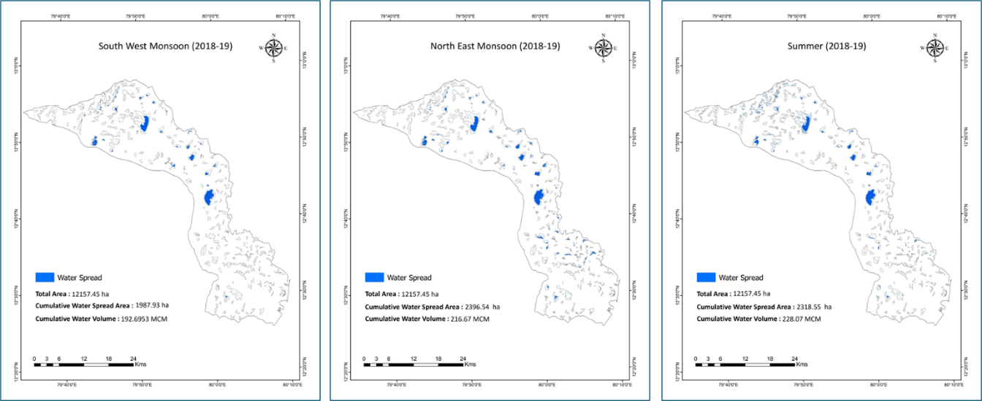

**a.** 2018-19

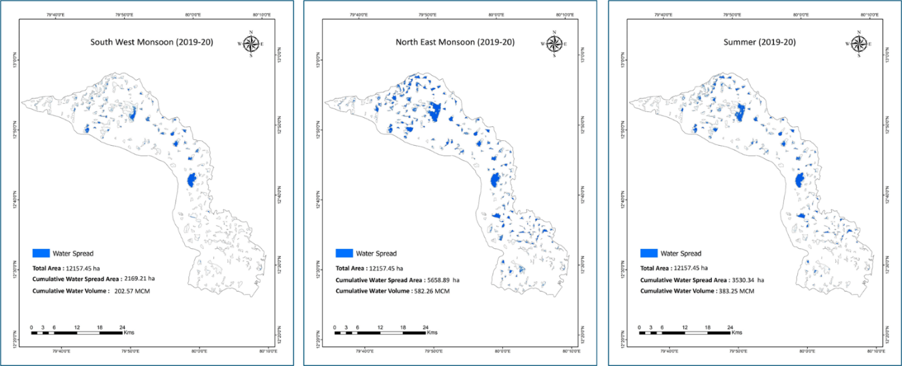

**b.** 2019-20

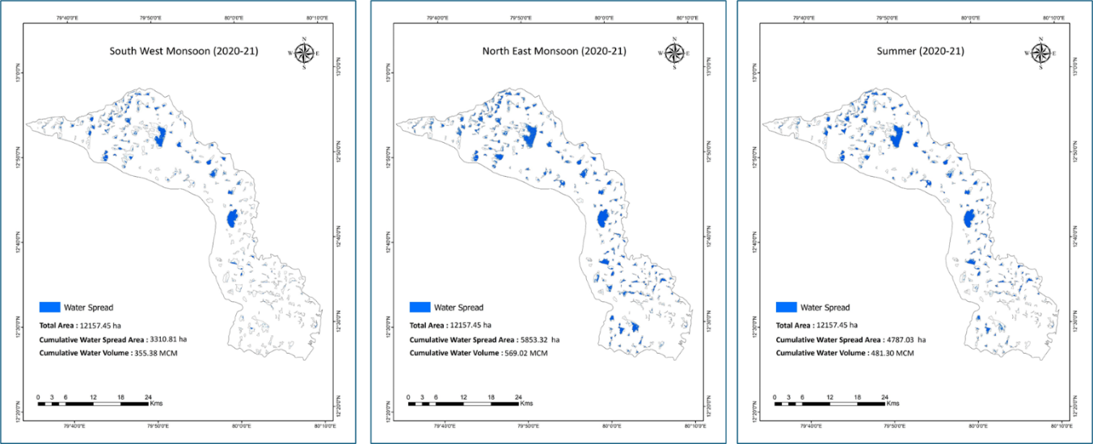

**c.** 2020-21

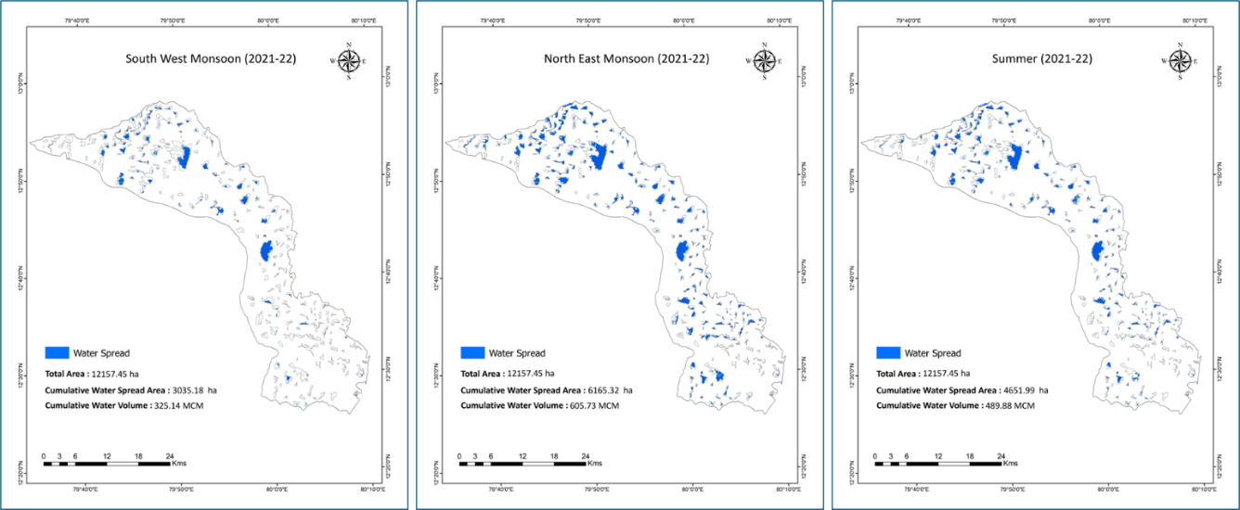

**d.** 2021-22

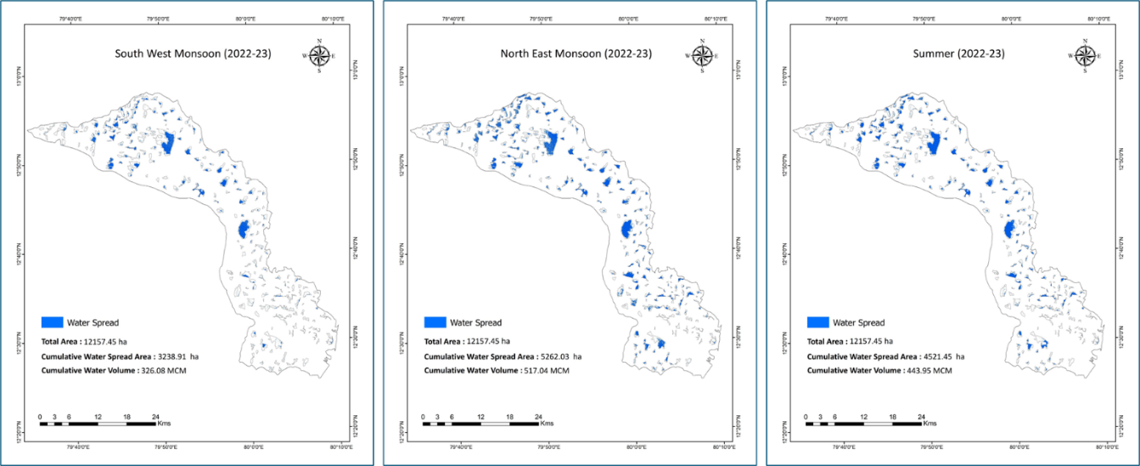

**e.** 2022-23

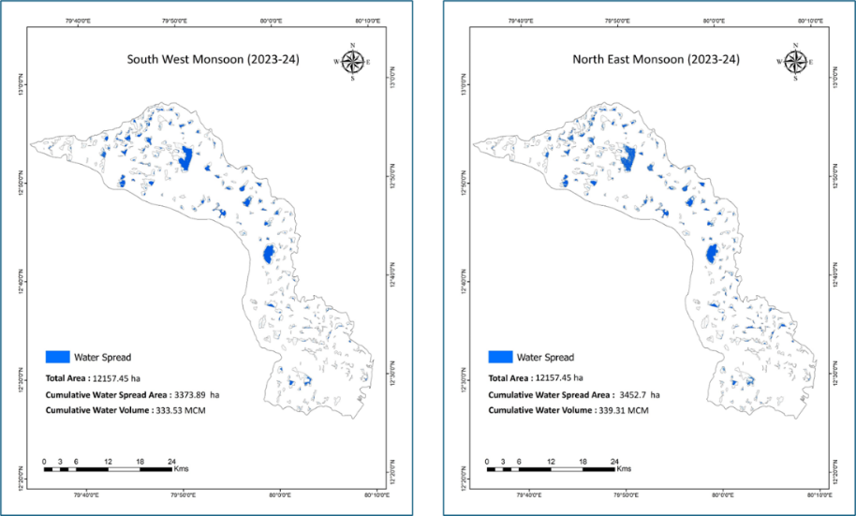

**f.** 2023-24

**Figure 8 (a-f).** Water Spread assessment in Lower Palar Subbasin

**4.2 Crop Diversification in Lower Palar Sub basin**

Remote sensing image classification, a key technique for extracting land cover details from satellite imagery, has seen extensive use. Studies by Ouattara et al. (2004), Borak (1999), and Casals-Carrasco et al. (2000) highlight various classification algorithms' effectiveness. The spectral attributes of significant crop and non-cropping regions were leveraged to identify the major crop cultivation areas, employing various machine-learning techniques supported by the ground truth data acquired during the survey.

This study employed Random Forest (RF) machine learning algorithms for crop classification in the study area (Figure 9 and 10) with a pixel-based classification approach across the *kharif*, *rabi* and *summer* seasons of 2018 and 2021, respectively. Crop discrimination using a pixel-based classification approach with an RF machine learning algorithm was done by Tatsumi *et al.* (2015) using Landsat 7 ETM+ satellite data. Similarly, crop discrimination using various optical remote sensing datasets used random forest classifiers (Piedelobo *et al.,* 2019; Conrad *et al.,* 2010; Turker and Ozdarici, 2011). It acquired good results by classifying various crop classes in different agricultural fields. The Random Forest algorithm, detailed by Kulkarni and Lowe (2016), was employed for multisource data classification, using ensemble methods like boosting and bagging. Random Forests, popular in land cover classification, offer high accuracy, handle large datasets efficiently, and save tree structures for future use, as demonstrated by Gislason et al. (2006) in multisource data classification studies.

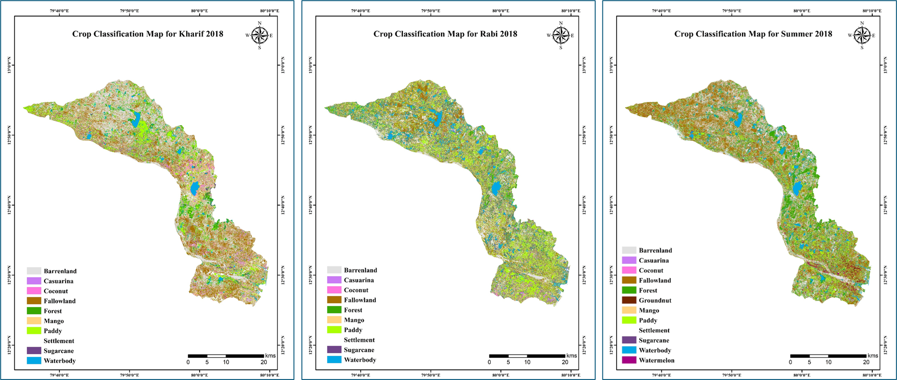

**a.** *Kharif, Rabi* and *Summer* during 2018

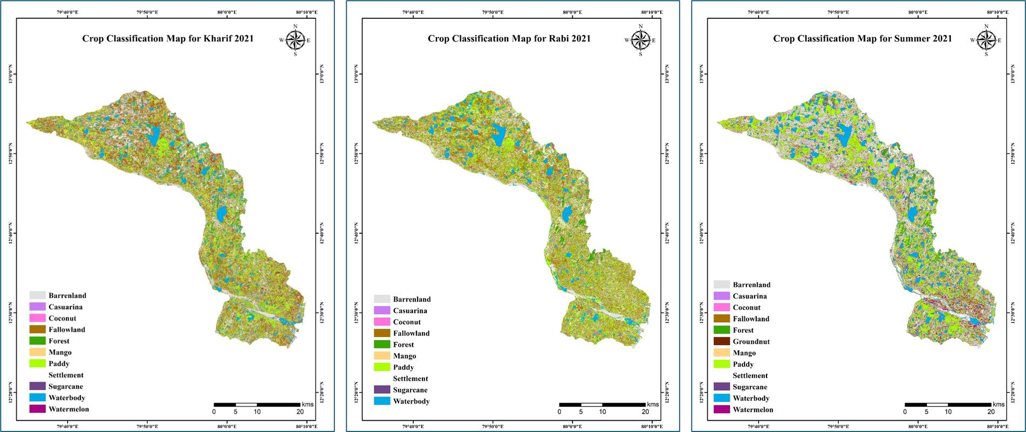

**b.** *Kharif, Rabi* and *Summer* during 2021

**Figure 9 (a-b).** Crop Classification derived from Sentinel 2 data

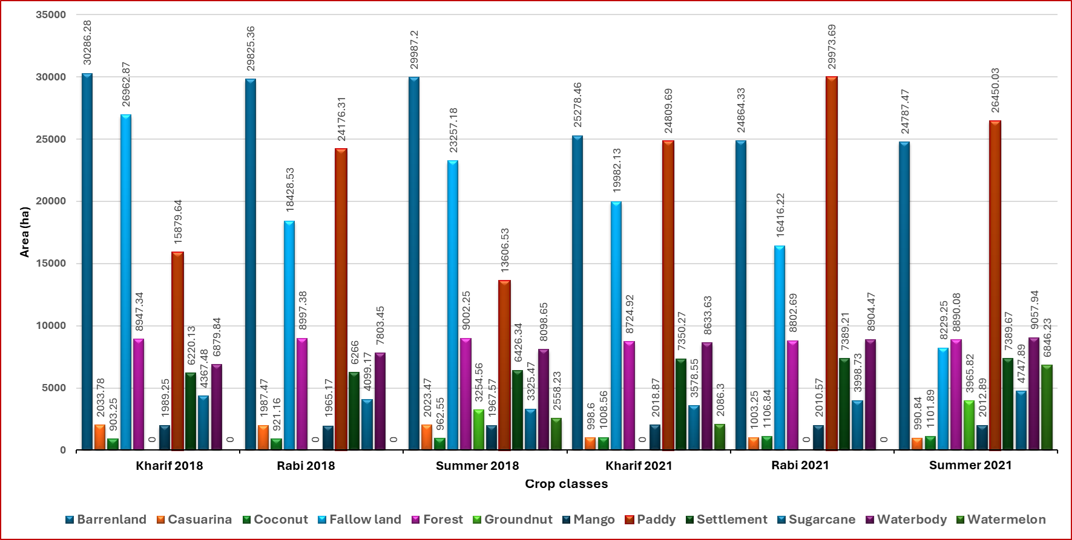

**Figure 10.** Comparison of Crop classes in Lower Palar subbasin for 2018 and 2021

**5. Conclusion**

The utilization of Sentinel-1A Synthetic Aperture Radar (SAR) satellite data presents significant potential for the continuous monitoring of tank water spread and assessing changes in agricultural landscapes. Proper maintenance of tanks throughout the year can contribute to an increased water spread area within these tanks, directly impacting groundwater levels in the region. Access to reliable information regarding water availability in tanks is crucial for effective regional planning. Unfortunately, such information is often scarce or unavailable, leading to erroneous planning decisions and the potential overuse of water from tanks. By assessing the dynamics of water spread at the tank level through the utilization of SAR satellite data, farmers can gain access to more accurate and timely information. This data can significantly aid in crop planning at both local and regional levels, facilitating better water management practices. Therefore, tracking the water spread area using Sentinel-1A SAR satellite data is essential for overcoming these challenges and improving agricultural productivity in the region. By leveraging satellite-based monitoring techniques, stakeholders can make more informed decisions regarding water resource allocation, leading to sustainable agricultural practices and enhanced water conservation efforts.

References

Bhumika, Kakadiya, Baulal M. Vadher, P. G. Agnihotri. (2019). Application of remote sensing and GIS in cropping pattern mapping: A Case Study of Olpad Taluka, Surat. *Emerging Research and Innovations in Civil Engineering*, 4, 343–348.

Bioresita, F., Puissant, A., Stumpf, A., & Malet, J. P. (2019). Fusion of Sentinel-1 and Sentinel-2 image time series for permanent and temporary surface water mapping. *International Journal of Remote Sensing*, 40(23), 9026-9049. https://doi.org/10.1080/01431161.2019.1597303

Borak, J. S. (1999). Feature selection and land cover classification of a MODIS‐like data set for a semiarid environment. *International Journal of Remote Sensing*, 20(5), 919‐938. https://doi.org/10.1080/014311699213778

Casals‐Carrasco, P., Kubo, S., & Madhavan, B. B. (2000). Application of spectral mixture analysis for terrain evaluation studies. *International Journal of Remote Sensing*, 21(16), 3039‐3055.

Clement, T., John, G., & Yin, F. (2017). Assessing the increase in background oil contamination levels in Alabama’s nearshore beach environment resulting from the Deepwater Horizon oil spill. In *Oil Spill Science and Technology (Second Edition)*, 851-888.

Conrad, C., Fritsch, S., Zeidler, J., Rücker, G., & Dech, S. (2010). Per‐field irrigated crop classification in arid Central Asia using SPOT and ASTER data. *Remote Sensing*, 2(4), 1035‐1056.

ESA. (2023). Sentinel Homepage. Available at <https://sentinel.esa.int/web/sentinel/home>.

Gislason, P. O., Benediktsson, J. A., & Sveinsson, J. R. (2006). Random forests for land cover classification. *Pattern Recognition Letters*, 27(4), 294‐300.

Gumma, M. K., Thenkabail, P. S., Panjala, P., Teluguntla, P., Yamano, T., & Mohammed, I. (2022). Multiple agricultural cropland products of South Asia developed using Landsat-8 30 m and MODIS 250 m data using machine learning on the Google Earth Engine (GEE) cloud and spectral matching techniques (SMTs) in support of food and water security. *GIScience & Remote Sensing*, 59(1), 1048-1077.

Hakeem, K. A., Raju, P. V., Sankar, E. S., & Jonna, S. (2021). Role of IRS-1C in Developing Remote Sensing Applications for Water Management in India. *Journal of the Indian Society of Remote Sensing*, 49(1), 151-160.

Kamble, S. S., Gunasekaran, A., & Gawankar, S. A. (2020). Achieving sustainable performance in a data-driven agriculture supply chain: A review for research and applications. *International Journal of Production Economics*, 219, 179-194.

Kulkarni, A. D., & Lowe, B. (2016). Random Forest Algorithm for Land Cover Classification. *Computer Science Faculty Publications and Presentations*, (Paper 1). <http://hdl.handle.net/10950/341>.

Küng, O., Strecha, C., Beyeler, A., Zufferey, J. C., Floreano, D., Fua, P., & Gervaix, F. (2011). The accuracy of automatic photogrammetric techniques on ultra-light UAV imagery.

Liu, C. (2016). Analysis of Sentinel-1 SAR data for mapping standing water in the Twente region. *M.Sc Thesis*, Faculty of Geo-Information Science and Earth Observation, University of Twente, Enschede, Netherlands.

Ouattara, T., Gwyn, Q. H. J., & Dubois, J. M. M. (2004). Evaluation of the runoff potential in high relief semi‐arid regions using remote sensing data: application to Bolivia. *International Journal of Remote Sensing*, 25(2), 423‐435.

Ovakoglou, G., Cherif, I., Alexandridis, T. K., Pantazi, X. E., Tamouridou, A. A., Moshou, D., & Mourelatos, S. (2021). Automatic detection of surface water bodies from Sentinel-1 images for effective mosquito larvae control. *Journal of Applied Remote Sensing*, 15(1), 014507-014507.

Piedelobo, L., Hernández‐López, D., Ballesteros, R., Chakhar, A., Del Pozo, S., González‐Aguilera, D., & Moreno, M. A. (2019). Scalable pixel‐based crop classification combining Sentinel‐2 and Landsat‐8 data time series: Case study of the Duero river basin. *Agricultural Systems*, 171, 36‐50.

Prasad, N. R. V., Garg, P. K., & Thakur, T. (2018). Role of SAR data in water body mapping and reservoir sedimentation assessment. *ISPRS Annals of the Photogrammetry, Remote Sensing and Spatial Information Sciences*, 15(4), 151-158.

Premalatha, M., & Rao, P. N. (1994). Crop acreage estimation using ERS-1 SAR data. *Journal of the Indian Society of Remote Sensing*, 22(3), 139-147.

Schuster, C., Schmidt, T., Conrad, C., Kleinschmit, B., & Förster, M. (2015). Grassland habitat mapping by intra-annual time series analysis–Comparison of RapidEye and TerraSAR-X satellite data. *International Journal of Applied Earth Observation and Geoinformation*, 34, 25-34.

Shen, G., Fu, W., Guo, H., & Liao, J. (2022). Water body mapping using long time series Sentinel-1 SAR data in Poyang Lake. *Water*, 14(12), 1902.

Simpson, E. H. (1949). Measurement of diversity. *Nature*, 163(4148), 688‐688.

Sona, G., Pinto, L., Pagliari, D., Passoni, D., & Gini, R. (2014). Experimental analysis of different software packages for orientation and digital surface modeling from UAV images. *Earth Science Informatics*, 7(2), 97-107.

Tatsumi, K., Yamashiki, Y., Torres, M. A. C., & Taipe, C. L. R. (2015). Crop classification of upland fields using Random forest of time‐series Landsat 7 ETM+ data. *Computers and Electronics in Agriculture*, 115, 171‐179.

Turker, M., & Ozdarici, A. (2011). Field‐based crop classification using SPOT4, SPOT5, IKONOS and QuickBird imagery for agricultural areas: a comparison study. *International Journal of Remote Sensing*, 32(24), 9735‐9768.

Abbreviations

|  |  |  |
| --- | --- | --- |
| dB | : | Decibels |
| DEM | : | Digital Elevation Model |
| DSM | : | Digital Surface Model |
| GIS | : | Geographic Information System |
| ha. | : | Hectare |
| viz., | : | Namely |
| % | : | Percentage |
| LAI | : | Leaf Area Indec |
| NRMSE | : | Normalized Root Mean Square Error |
| RMSE | : | Root Mean Square Error |
| SAR | : | Synthetic Aperture Radar |
| S1 | : | Sentinel 1 |
| S2 | : | Sentinel 2 |
| VH | : | Vertically Transmitted, Horizontally Received |
| VV | : | Vertically Transmitted, Vertically Received |
| UAV |  | Unmanned Aerial Vehicle |