**Climate Change: Why is CO2 Innocent and Humanity only an Accomplice of Nature?**

**Abstract**

The carbon dioxide (CO2) produced by human activities is now considered responsible for global warming which is expected to lead to dramatic climatic excesses in a few decades. This future comes from the reports published by the Intergovernmental Panel on Climate Change (IPCC), an international organization founded to exploit the fund of publications in climatology. IPCC's vision is often questioned, but criticism is generally dismissed as due to climate skepticism. This article is intended to present a summary of the essential steps of an approach initiated a few years ago to see where the fundamentals of hard sciences would lead in the area of ​​climate changes. Taking the role of a refrigerant in a refrigerator as model, it was first found that the IPCC mechanism can be replaced by an original mechanism based on heat, wherever it comes from, managed by water and its transitions between solid, liquid and gaseous physical forms. Then this alternative mechanism allowed accounting for variations in temperature and ocean level during a glacial cycle, a possibility considered as validating the role given to heat. The thermodynamics of ice melting was used to show a large imbalance in favor of heat during the last deglaciation, a quasi-equilibrium maintained by ice melt and evaporation during the first thousands years of the current Holocene interglacial plateau, and the return of excess heat at the origin of the currently observed ice disappearance. Finally, anthropogenic heat was introduced as heat related to humans and human activities. So far, anthropogenic heat supplements natural heat sources dominated by the Sun without exceeding the limits of temperature in force for the last 8,000 years. Excessive growth could contribute to accelerate the natural evolution of the climate that will sooner or later lead to a new glaciation. Today, only significant increases in the frequency and magnitude of climatic events are expected as long as the ice stock is sufficient. The interest of the energy transition carried out at a forced pace throughout the world must be reexamined in the light of the role given to heat. Keeping climate events within acceptable limits requires reducing anthropogenic heat production and not banning carbon energy in favor of electricity which, it should not be forgotten, also contributes to anthropogenic heat.

**Keywords**: global warming, anthropogenic heat, heat management, climate evolution, energetic transition, carbon dioxide, glacial cycle

**Introduction**

In the second half of the 20th century, a rapid increase in the average global temperature of the atmosphere, perceived as abnormal, or presented as such, led to the opening of an action against humanity for a responsibility popularized by the media and political channels, even going as far as the awarding of a Nobel Prize. The IPCC (Intergovernmental Panel on Climate Change) was created in 1988 with the mission of evaluating and exploiting the fund of publications in climatology to highlight the role of Humanity [1].

As early as 1990, the increase in temperature was linked to carbon dioxide (CO2) and water vapor atmospheric concentrations in relation to human activities since the beginning of the industrial era [2]. The accusation was based on a proposal by a 19th-century Swedish chemist, S. Arrhenius, who introduced a greenhouse effect (different from that described by modern physics) to justify the temperature of the atmosphere [3]. Today, the initial greenhouse effect is applied to CO2 alone by climatologists in their attempts to model and predict climate change [4]. The result is a radiative forcing said accumulated in oceans and source of global warming. The notion of anthropogenic overheating of the environment had thus found its reason for being, and an enemy to combat: the CO2 [20-23].

The initial mechanism, complemented and adjusted over the course of successive IPCC reports, is universally adopted but only by consensus [5]. Since experimental support is impossible due to the complexity of the involved phenomena, climatology relies on hypotheses and on average data which depend on reference periods often chosen according to needs. Despite these limitations, the annual growth of the CO2 concentration in the atmosphere is now considered indisputable source of global warming. Worrying evolutions are predicted within a few decades [6]. However, the global average temperature and sea level still vary relatively little. It is the ice that is disappearing.

More and more critics are raised that reject the roles given to CO2 and greenhouse effect [7-8]. Considered to be due to climate skepticism, critics are not taken into account by media and politicians for whom the strategy must be fight against CO2 production and implement an energy transition in favor of electricity and renewable energy resources recommended by the IPCC. Neglecting criticism may be due to the lack of openness that reigns in climatology, or to the caution of the medias and politicians with regard to the global nature of the consensus, or simply the absence of alternative mechanisms to oppose. In particular, there is no national or international conference or symposium to discuss knowledge and advances as is the case for the hard sciences. This is surprising in a field as complex as climate for which an interdisciplinary approach should be the rule. Indeed, the Earth is a closed system for all materials, including atmospheric gases. On another hand, it is an open system for electromagnetic waves received from space or emitted by the surface and the atmosphere of the planet, provided the atmosphere is transparent. In reality, the atmosphere is not transparent to all electromagnetic waves that make up solar irradiance. Once the waves penetrate the atmosphere, the science of interactions between waves and matters applies until radiative elimination becomes possible, that is, until the transparency of the atmosphere allows it. It is clear that environmental matter is not taken into account in the greenhouse effect, so I decided to introduce chemistry, physics and thermodynamics into the debates to see where this could lead [9]. This new approach quickly revealed weaknesses in the IPCC's argument.

**Some weaknesses in the consensual mechanism**

Currently, climate change is comparable to mysteries such as the origin of life or the existence of God. Either we believe in it, or we must fight against the established and manage to convince its authors of the presence of good reasons to contest it. Let us highlight some arguments against the established consensus.

At the end of the 19th century, Arrhenius had perceived that carbon dioxide and also water vapor contributed to the atmospheric temperature through a greenhouse effect. Retained in the first IPCC reports, the role of water vapor was dismissed to retain CO2 as the main greenhouse gas although water vapor is several times more efficient that CO2. In making this choice, climatologists and the IPCC have limited their logic to the following phenomena, namely: solar irradiance, atmospheric CO2 concentration, variations in temperature and level of the oceans, greenhouse effect involving infrared waves emitted by the surface heated by the Sun during the day, storage of the resulting radiative forcing in the oceans and radiative elimination towards space.

On another hand, it is surprising for someone familiar with hard sciences to see temperature discussed in terms of radiative fluxes only. Indeed, it is well known that temperature is related to interactions of heat with matter(s) according to its(their) thermal properties. Heat itself is related to the Brownian motion of molecules. The melting of ice, the evaporation of liquid water and the condensation of gaseous water are interphase transitions associated with reversible exchanges of matter and thermal energy. They are also exceptional means to manage heat and control temperature, which is impossible for greenhouse gases, especially CO2 which only exists in gaseous form in the atmosphere. Regarding evaporation, the IPCC AR6 states the following: "*it is virtually certain that evaporation will increase over the oceans*", without any link to thermodynamics.

As for the abandon of water vapor as greenhouse gas, the reason given by the IPCC to exclude it is a residence time that is much too short. This reason is unfounded because in spectroscopy, it is the concentration of molecules that must be taken into account, as taught for example by the Beer's law [10]. The concentration of the atmosphere in water vapor (humidity) is therefore an important determinant of the climate but only at temperatures above or close to 0°C, i.e. in the lower troposphere. On the contrary, CO2 is present throughout the atmosphere. A simple example can show the significance of the water vapor. In the Sahara, a desert where the atmosphere is generally dry and therefore transparent, the temperature, the result of local heat and matters interactions, changes very quickly from very high during the day to very low at night. Infrared radiation emitted by the warmed surface, and therefore the radiative elimination of the heat of the day, are not screened by water vapor and the surface cools rapidly. The greenhouse effect of CO2 cannot justify the nocturn fast cooling because this gas is present in the atmosphere of the Sahara day and night, and at night the greenhouse effect is said heating the atmosphere from the surface warmed during the day.

Finally, logic is flouted when it is said that the radiative forcing due to the greenhouse effect involving CO2 accumulates in the oceans while the Sun has been warming the Earth for billions of years without any accumulation of heat on Earth (on the human time scale). Overheating due to the accumulation of heat would have called into question the maintenance, or even the appearance, of life. In simple terms, the difference in fate between radiative forcing and solar contributions means that there are two kinds of heat on Earth that are distinguished by their effects and destinations, which is fundamentally contrary to modern physics in which heat is unique. In conclusion, it is impossible to believe in the scientific coherence of the culpability of anthropogenic CO2. These arguments against the consensus being ignored, the best means to support this doubt was generating a more credible alternative.

**Bases of another vision**

According to the previous comments, heat, water and its interphase equilibria were logical bases to replace the consensual CO2 and greenhouse effect [9].

Heat on Earth comes mostly from the solar irradiance composed of the total spectrum of electromagnetic waves. Among all these waves, only thermal infrared waves generate heat after absorption by intramolecular active vibrations of certain interatomic bonds in quantum energy harmony. The absorbed radiative energy is transformed into kinetic energy, a transfer faster than reemission. The gain in kinetic energy increases the Brownian motion of molecules that results in local heat rise. The excess heat then diffuses up to a new temperature equilibrium. Whether they come from the top of the atmosphere or from the surface, thermal infrared waves specific of greenhouse gas including CO2 and water vapor are soon totally absorbed. Therefore, they heat the zone where their absorption occurs, ozone in the stratosphere, CO2 in stratosphere and upper troposphere or close to the surface, water vapor in the low troposphere. However, thermal infrared waves with wavelength between 8 and 14 µm can reach the surface. This window of transparency allows radiative exchanges of corresponding waves emitted by the surface or received from space. Between 4 and 30 µm, thermal infrared waves outside the window are blocked as soon as water vapor is present in the atmosphere. Radiative elimination of heat by these waves is possible in a dry atmosphere or from above the clouds because water vapor concentration is very much decreased due to condensation (Fig. 1). As atmospheric moisture is an obstacle to the radiative emissions from the surface, a bypass process is necessary to move heat from the surface to the clouds above which condensation has significantly decreased the water vapor concentration to allow radiative elimination. In contrast to thermal infrared waves, the waves that composed visible light are not absorbed by the atmosphere and thus are not sources of heat.

Water is an exceptional chemical due to hydrogen bonds that associate molecules in ice and liquid water but not in water vapor. Its climate regulating role was illustrated using a refrigerator as an indirect model of the environment. Inside a refrigerator, the refrigerant, a volatile liquid trapped in the cooling circuit, evaporates to absorb heat and transfer it from the interior compartment to an external heat exchanger where the displaced heat is released by condensation. The back of a refrigerator is hot, as can easily be felt. The released heat is dispersed by convection into the ambient air and by conduction. Ice melt keeps the interior at the set temperature until the ice has disappeared enough for the internal temperature to rise and the thermostat to restart the cycle [11].

In the case of Earth, melting ice (terrestrial, floating, in the form of glaciers or as permafrost) absorbs heat wherever it comes from and tends to regulate the temperature as an ice cube does in a glass of water or the ice inside the refrigerator. This regulatory action of ice melting is complemented by the evaporation of water from surface water if this water is hotter than the atmosphere. The process is comparable to the sweating that keeps the temperature of the human body at 37°C. Less dense than air, the warm vapor formed by evaporation transports the heat absorbed at the surface to cold areas at altitude, as shown by the condensation that forms clouds (Fig. 1 center) [12].

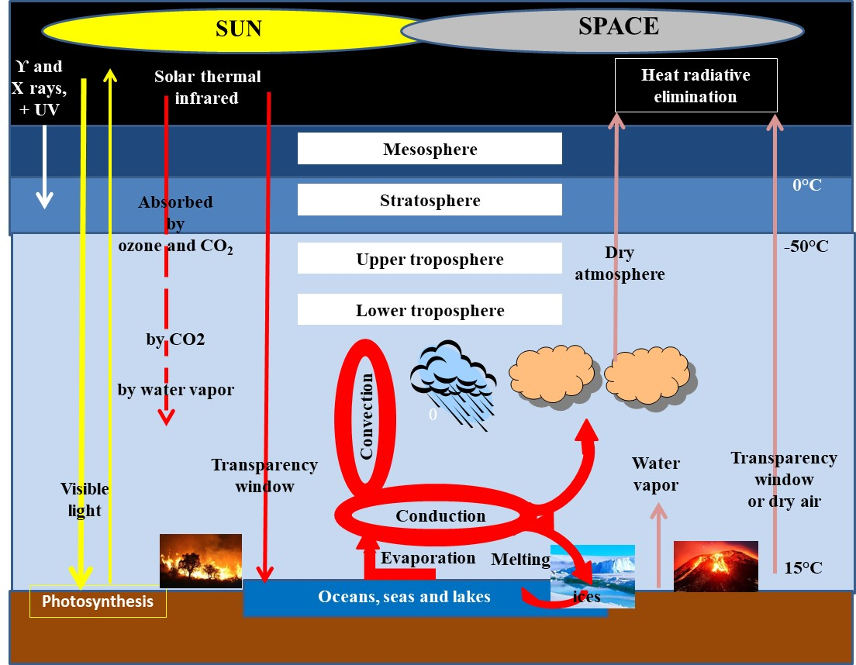

Figure 1: Schematic representation of the natural management of heat from natural sources (Sun, Volcanoes and forest fires) by the unique mechanism based on water and its reversible transitions ice ↔ water and water ↔ vapor [12].

In this mechanism, clouds are important because, like water vapor but for another reason, they minimize the heat coming from the Sun, except if the humidity is low. The result is then cooling of the surface, an effect rapidly felt when clouds start to fill the sky. On the other hand, clouds act as a thermal blanket for the heat below, but only for a short time as the surface gradually cools, the Sun being more or less obscured [13].

Controlled by ice melt and evaporation, the average temperature should remain constant as inside the refrigerator. However, on Earth, constancy is excluded by various factors that affect ideality. Let us mention the vastness of the planet unfavorable to the homogenization of the atmosphere, the chaotic distributions of heat at the origin of local climates, the seasons and the variations of solar inputs. Winds, hurricanes, tornadoes, air and ocean streams, convection in the air, and heat exchanges by conduction, are all means used by Nature in attempt to distribute and average thermal heterogeneities until radiative elimination to space is possible (Fig. 1 center). It is the case above the clouds. The convective transfer of heat from the surface to the zone where clouds form provides the means to bypass the obstacle of humidity to the radiative elimination.

If additional heat is injected into the atmosphere due to human activities, this surplus, called anthropogenic heat, is mixed with natural heat inputs and is no longer distinct in terms of management (compare Fig. 2 and Fig.1) [12].

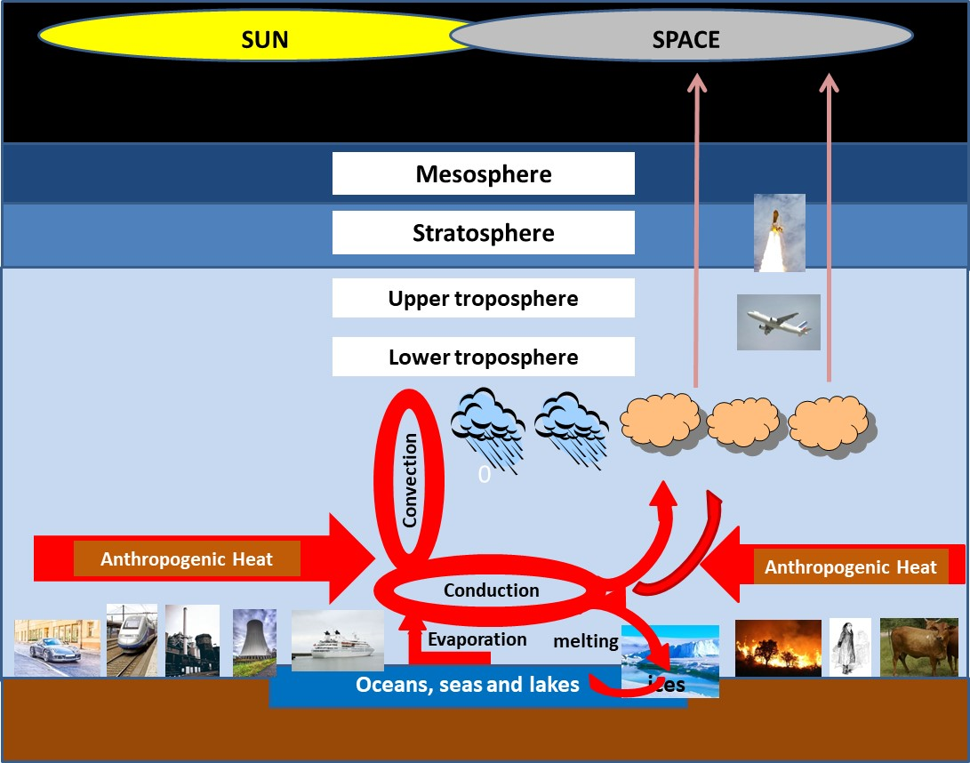

Figure 2: Schematic representation of changes in the water-based heat management system when anthropogenic heat is injected into the lower troposphere (compare with Fig. 1, with arsons instead of natural wildfires).

However, the consequences may be more clouds, more rains, less snow, more ice melting, and worsened climatic events such as flooding and drought if the added anthropogenic heat is large enough. It is interesting to note that planes flying high in the sky where humidity is absent generates hot CO2 and water vapor. The heat generated can be removed by irradiation into space. Therefore, in terms of heat, planes do not affect the surface climate in contrast to cars and other machines functioning producing heat at ground level. Planes may well be more ecological than cars but only quantitative comparative assessments can prove it (Fig. 2).

**Validation of the water-based mechanism**

In hard sciences, a novel mechanism must be supported experimentally or by convincing models, means not available for overly complex climatic phenomena. An indirect reference is therefore required. Glacial cycles provided an opportunity.

Figure 3 schematically represents climatic evolutions during a glacial cycle model of the one we are currently in. Let us begin the cycle at the level of maximum glaciation (at the bottom).

The absence of water vapor allows the Sun to heat the Earth without screening (Fig. 3 left). The ice melts quickly in about 10,000 years, while the temperature and the level of the oceans rise by about 10°C and 120 m, respectively [14].

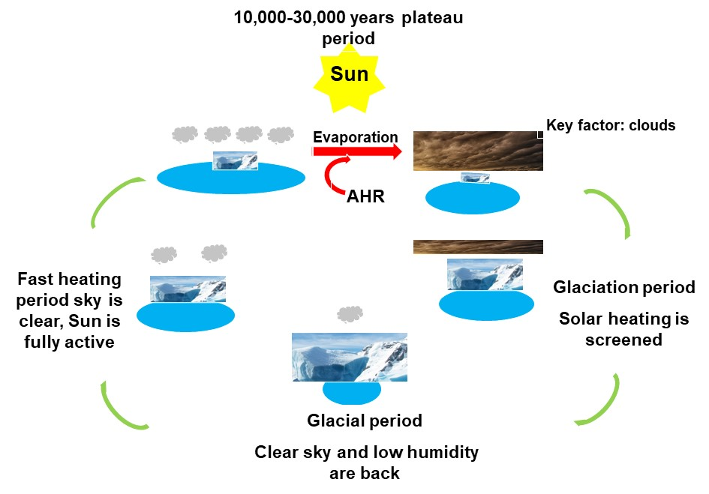

Figure 3: Schematic representation of the application of the water-based heat management to environmental changes during a deglaciation-glaciation period [14].

The concentration of the atmosphere in water vapor and the formation of clouds gradually increase up to the onset of an interglacial plateau (currently Holocene) during which the melting of ice and evaporation ensure stability at the cost of an evolution towards less and less ice and more and more evaporation and clouds (Fig. 2). When the screening of the Sun by the clouds becomes significant, the cooling on the surface allows the start of a new period of glaciation that closes the cycle at the end after about 150,000 years (Fig. 2 right).

Despite current alarmist warnings based on local meteorological observations, global temperatures are still within the limits of the Holocene reference (± 1°C) [15]. In terms of radiation, the energy on Earth is based on a balance between flux inputs and outputs. In terms of heat, a dynamic factor is added which teaches that, in a multistep system, the rate of evolution is conditioned by the slowest one. Radiative elimination, when transparency allows it, occurs at the speed of light while the transitions between water phases are comparatively extremely slow because they involve energy-dependent exchanges of matter. Slow elimination results in heat imbalance at the origin of aggravation of local effects such as rains, periods of flooding and drought, heat and cold, etc. which more or less compensate each other at the global level. At present, anthropogenic heat inputs have still not led to the overflow of the limits specific to the current Holocene period. It remains to be seen how long this acceptable situation can last because an interglacial plateau stands between about 10,000 to 20,000 years according to past glacial cycles, and an interglacial plateau can only lead to a new glaciation sooner or later [16]. Holocene counts already about 10,000 years.

As in the case of greenhouse and radiative forcing, the dependency of the global climate on a kinetic imbalance in heat inputs and outputs cannot be proved directly through experimentations. The best marker of heat imbalance in the environment is ice through melting and icing [17]. Therefore, the heat energy of ice melting was used to roughly estimate the thermal imbalance during deglaciation, during Holocene, and from a 23 years long period between 1994-2017 reported recently [18]. It was shown that heat imbalance was in the range of 1.7 ZJ/year during the deglaciation stage. In contrast, the heat imbalance during Holocene was in the 1 to 4 x 10-3 ZJ/year range a rate much smaller than during deglaciation. Today, the stability observed during the past of Holocene is broken. For the 1994-2017 period, ice imbalance was about 0.18 ZJ, a value signing a significant increase in heat to be managed. According to the water-based mechanism, the natural evolution should be sooner or later an inversion of the imbalance due to clouds screening of solar inputs and lately a new glaciation [17].

This finding allowed us to conclude that the mechanism of heat management by water advantageously replaces a greenhouse effect far from being able to account for the relative stability specific to interglacial plateaus. The reason for the return of the thermal imbalance remains open because it can be natural or natural + anthropogenic.

**The anthropogenic heat**

Anthropogenic heat is composed of [19]:

1. warm-blooded living organism, i.e. humans and domestic animals;

2. arsons that transform forest grown at ambient by photosynthesis, into heat;

3. residual waste heat during production and exploitation of energy regardless the source, meaning including electricity [14];

4. captures of solar thermal infrared waves by artificial materials that replace natural surfaces (buildings, roads, solar panels, etc.). Under the Sun, a grassy surface is colder than a concrete surface;

5. captures of solar radiation by equipment similar to greenhouses such as houses and towers with large bay windows, vehicle interiors, but also photovoltaic panels, thermal panels, solar water heaters, etc. This kind of heat capture is currently ignored;

6. municipal waste combustion.

The majority of these sources are growing worldwide but most cannot be estimated due to lack of information and data. Nevertheless, the growth of the anthropogenic heat is indisputable because between 1900 and today:

* 1. the world human population has approximately increased from 1.2 billion to 8 billion, that of cattle from 440 million to 1.55 billion, that of pigs from 200 million to 1 billion, and that of goats and sheep from 760 million to 1.32 billion, with a parallel increase in the standard of living and urbanization;
  2. the number of vehicles has increased from a few units to 1.48 billion, may be more;
  3. the number of nuclear power plants has increased from 0 to 410 with 59 under construction and 100 planned;
  4. the number of photovoltaic panels that heat the atmosphere by waste heat, by the capture of solar radiation directly and, for some, indirectly as greenhouses, has increased from 0 to an estimate of several tens of billions, at the minimum;
  5. incinerated municipal waste that counts now for 2.1 Gt in the world, etc.

**What could be the future**

Three scenarios are conceivable:

1. the ratio of anthropogenic heat inputs to dominant natural inputs remains negligible. The climate continues to fluctuate as it has since the stabilization of the Holocene 8,000 years ago. The temperature remains within average limits at the cost of melting ice, evaporation and slowly increasing cloud formation.
2. this ratio is no longer negligible and is increasing due to population growth and its activities. Holocene limits are still relatively respected but with aggravated climatic events, including increased disappearance of ice, more intense and frequent local rains, hurricanes, tornadoes, local droughts and floods, more clouds, etc., to manage the increase in heat due to anthropogenic inputs.
3. the ratio becomes so large that, sooner or later, the climatic events of ice melting, evaporation and heat distribution can no longer prevent a drift beyond the Holocene thermal limits signaling an evolution towards the next glaciation. This is not for now because the ice stock is still significant.

The challenge is to situate the current period with respect to one of these scenarios. The increase in the disappearance of ice over the years while the drifts in global temperature and sea level remain very low suggests that the second scenario is currently underway. Precisely imagining the future from observations of the distant past or even the present is impossible in the case of phenomena involving chaotic random evolutions. However, the disappearance of ice is undeniably worrying, but the invasion of submersible land is not for now according to scenario 2, this until scenario 3 takes over.

If the world continues to fight CO2 instead of minimizing anthropogenic heat sources, we may have a bitter awakening when the failure of the vast sums of money and resources committed becomes obvious. Inevitably, this failure will become evident one day.

As early as 1972, when the exhaustion of fossil resources was a prospect, Sico Manshfolt, former Vice-President for Agriculture of the European Commission, stressed in the “Manshfolt Letter 1972”: “*it is obvious that tomorrow’s society cannot be based on growth*”. Such an assertion must be taken into account today. The die has not been cast and the role given to CO2 is not set in stone. Where is the comparison that demonstrates the superiority of electricity over carbon-based energy in terms of anthropogenic heat production? Promoting contradictory and multidisciplinary discussions is essential because it is from them that solutions will come, not from yes-men.

**Conclusion**

The innocence of CO2 claimed by many scientists but generally rejected is now supported by the existence of an alternative mechanism based on heat management by water and its interphase equilibriums. The applicability of the new mechanism to glacial cycles gave it solidity and allowed to provide a new vision of the future. Anthropogenic heat suggests the worsening of a normality, the natural evolution. By its addition to the solar heat that has been heating the Earth for billions of years without overheating, anthropogenic heat could become an accelerator of the unfolding of time, that is to say as an accomplice of Nature in the way it manages heat on Earth. Since the followed strategy innocent the CO2, it is against the components of anthropogenic heat that a fight should be engaged to keep worsening of the climate acceptable. The interest in banning fossil fuels in favor of electricity must be examined in terms of anthropogenic heat assessments. This can lead to rethinking of equipment and devices.

For example, tiled roofs could be profitably replaced by vegetized terraces or thatched roofs; windows could be covered with thermoplastic films; vehicles and their power could be reduced regardless of the fuel type, large bay windows could be replaced by small windows, grass stabilized by a network of recycled plastic could replace asphalt and concrete parking and driveway surfaces, trees could be planted or replanted along roads to shade the solar heating of the artificial surface, etc. Even hydrogen from fossil carbon sources could be brought back into the spotlight as a viable energy source provided that a life cycle assessment including anthropogenic heat justifies it. Such an assessment should be carried out for any potentially beneficial solution to mitigate anthropogenic heat.

**Key points**

1. Hard sciences led to a mechanism based on heat, water and its interphase equilibria, validated as an alternative to the CO2-based consensus in force in climatology

2. The thermal imbalance that caused ice melt was very high during the last glaciation, very low after the beginning of the Holocene, and is increasing again at present

3. Anthropogenic heat is proteinic and the future should depend on its impact compared to that of the Sun and on solutions to limit the consequences

**References**

1. International Science Council (2018) The origins of the IPCC: How the world woke up to climate change, <https://council.science/blog/the-origins-of-the-ipcc-how-the-world-woke-up-to-climate-change/>
2. Houghton J. (2001) The science of global warming. *Interdisciplinary Science Reviews*. 26:247-257. <https://journals.sagepub.com/doi/abs/10.1179/isr.2001.26.4.247>
3. Arrhenius S. (1896) On the Influence of Carbonic Acid in the Air upon the Temperature of the Ground, *London, Edinburgh, and Dublin Philosophical Magazine and Journal of Science (fifth series*), 41: 237–275. <https://www.rsc.org/images/arrhenius1896_tcm18-173546.pdf>
4. [Pangburn](https://www.researchgate.net/profile/Dan-Pangburn?_sg%5B0%5D=HsVAaNFWQcaA9wE-0VFx0YzPyEjBpB4ypRt_MTDkZBH2W0OU0r6Kl1CSgiPlBVAPlqMZ_TM.hNULUJErSYjGUDQ43Rg_mUtCpYfXziNeZYXr8Kv4HWzs0WF4WRvoOzGhezoVYLRvCuHvGIwMx2M7s6xmvgdn7w&_sg%5B1%5D=AqC827wKCpK5w5lBOU3qPzrw0AHL_8SXn-IbLtLZVhiyC_tGc2MbgJFCuUvY43Tc9mtISi0.HGGLxs-Fkiz11WqQHlXrSVzv67VMqlNrHNu90SEBiVnnxhO5VhabsR_zUZSLlIA6Ycbv8UEgKGmaHXi2mDy4Kw&_tp=eyJjb250ZXh0Ijp7ImZpcnN0UGFnZSI6InB1YmxpY2F0aW9uIiwicGFnZSI6InB1YmxpY2F0aW9uIiwicG9zaXRpb24iOiJwYWdlSGVhZGVyIn19), D. (2021) Water vapor vs CO2 for planet warming (14), *ResearchGate.*

<https://www.researchgate.net/publication/338805648_>

1. IPCC (2024) The successive IPCC reports, (<https://www.ipcc.ch/reports/)>
2. Szulejko, J.E., Kumar, P., et al. (2016) Global warming projections to 2100 using simple CO2 greenhouse gas modeling and comments on CO2 climate sensitivity factor, *Atmospheric Pollution Research* <http://dx.doi.org/10.1016/j.apr.2016.08.002>
3. [Koonin](https://www.harvard.com/search/author/%22Koonin%2C%20Steven%20E.%22), S.E., Unsettled (Updated and Expanded Edition): What Climate Science Tells Us, What It Doesn't, and Why It Matters (Paperback)

<https://www.weforum.org/agenda/2020/09/climate-change-clouds-models-modeling-temperature-rises/>

1. Durkin, M., Nelson, T. (2023) Climate: The Movie. The Cold Truth, *YouTube*.

<https://www.youtube.com/watch?v=zmfRG8-RHEI>

1. Vert, M., (2019) La fonte des glaces : et si l'effet de serre du CO2 anthropique n'était pas la (seule) raison ? *Open Archive HAL CNRS*, <https://hal.science/hal-02362816v2>
2. Mayerhöfer, T.M., [Pahlow](https://pubmed.ncbi.nlm.nih.gov/?term=%22Pahlow%20S%22%5BAuthor%5D), S., [Popp](https://pubmed.ncbi.nlm.nih.gov/?term=%22Popp%20J%22%5BAuthor%5D), J. (2020) The Bouguer‐Beer‐Lambert Law: Shining Light on the Obscure, *Chemphyschem.*, 21:2029–2046.

<https://chemistry-europe.onlinelibrary.wiley.com/doi/10.1002/cphc.202000464>

1. Vert, M., (2021) Refrigerator as Model of How Earth's Water Manages Solar and Anthropogenic Heats and Controls Global Warming, *ESS Open Archive*, published on line. <https://essopenarchive.org/doi/full/10.1002/essoar.10507521.3>
2. Vert, M, (2022) A Different Vision of the Global Warming Based on Chemistry, Physics and Thermodynamics, *Intern. J. of Energy and Environ. Sci*., 7:74-79.

<https://sciencepublishinggroup.com/article/10.11648/j.ijees.20220705.11>

1. Ceppi, P., Williams, R. (2020) Clouds can tell us a lot about climate change - so why aren’t we paying attention to them? *World Economic Forum*,

<https://www.weforum.org/agenda/2020/09/climate-change-clouds-models-modeling-temperature-rises/>

1. Vert, M. (2023) Electricity in the context of a new vision of global warming in which anthropogenic heat and not CO2 is determinant, *Int. J. Plasma Environ. Sci. Technol*. 17 (2023) e02003 (9pp), <https://doi.org/10.34343/ijpest.2023.17.e02003>
2. Kaufman, D., McKay, N., Routson, C. *et al.* (2020) Holocene global mean surface temperature, a multi-method reconstruction approach. *Sci Data* **7**, 201. <https://doi.org/10.1038/s41597-020-0530-7>
3. Petit, J.R., Jouzel, J., Raynaud, D., Barkov, N.I., Barnola, J.M., Basile, I., et al., Climate and Atmospheric History of the Past 420,000 Years from the Vostok Ice Core, Antarctica, *Nature*, 399, 429-436, 1999. <http://dx.doi.org/10.1038/20859>.
4. Vert, M. (2024) The Earth's Imbalanced Heat Budget and its Relationship to Past, Present and Future Climate Change, *ESS Open Archive.*

[https://essopenarchive.org/users/539040/articles/838140](%20https:/essopenarchive.org/users/539040/articles/838140)

1. Slater T., Lawrence O.R., Otosaka I.N., Shepherd A., Gourmelen N., Jakob L., Tepes P., Gilbert L., Nienow P., (2021 Review article: Earth's ice imbalance, *The Cryosphere,* 15:33–246. <https://doi.org/10.5194/tc-15-233-2021>
2. Vert, M. (2024) Climat: le CO2 est Innocent et l'Humanité n'est que Complice de la Nature, *ResearchGate*, <https://www.researchgate.net/publication/380667789_>
3. Hurd CL, Gattuso JP, Boyd PW. Air‐sea carbon dioxide equilibrium: Will it be possible to use seaweeds for carbon removal offsets?. Journal of Phycology. 2024 Feb;60(1):4-14.
4. Matenda FR, Raihan A, Zhou H, Sibanda M. The influence of economic growth, fossil and renewable energy, technological innovation, and globalisation on carbon dioxide emissions in South Africa. Carbon Research. 2024 Dec;3(1):1-8.
5. Mishra H, Kumar KS, Pratibha K, Periyasamy C, Rao PS. Seaweeds Aid in Carbon Sequestration to Combat Global Warming: A Glimpse. Algae Mediated Bioremediation: Industrial Prospectives. 2024 Jun 4;2:505-20.
6. Borja-Patiño J, Robalino-López A, Mena-Nieto A. Breaking the unsustainable paradigm: exploring the relationship between energy consumption, economic development and carbon dioxide emissions in Ecuador. Sustainability Science. 2024 Mar;19(2):403-21.