**Original Research Article**

**Fourier Transform Infrared Spectroscopy (FTIR) Probing on Interactions of Proteins with Phenolic Compounds in the East African Highland Banana Pulp at Different Stages of Banana Juice Extraction**

**Abstract**

The ability of East African highlandbananas to produce juice is hypothesized to be attributed to the interactions of proteins and phenolic compounds during mechanical kneading of the banana pulps. The mechanism on how this occurs is still unclear though the involvements of their chemical functional groups have been mentioned. To evaluate the influence of proteins and phenolic compounds on juice recovery, this study analyzed and compared functional groups present in the pulp of intact fruit and at different stages of juice extraction. Fourier transform infrared spectroscopy (FTIR) analysis was performed to provide novel information on the changes of the functional groups in the pulp structure in response to banana juice production by mechanical blending. Amide I, amide II regions in FTIR spectra were used to study the structural changes of proteins as the result of protein-polyphenol interactions. FTIR analysis displayed that the mechanical blending led to the decrease of phenolic compounds and shift of protein regions (Amide I and II). Result suggests that, the reduction of the intensity of OH spectra is attributed to interaction of these groups, while the shift in the wavenumber of OH from 3300 to 2250 cm -1, may be attributed to the formation of hydrogen bonding. Moreover, the observed reduced intensity at amide I region at 1655.14 cm -1 could explain the same phenomena. Reduced intensity in the carbohydrate region (995.65 cm -1) of the spent pulp after juice recovery could be ascribed to the reduction of these components in the pulp as most of them were released in the juice product during extraction. The involvements of proteins and pectin with phenolic compounds were validated by the addition of adsorbent and enzyme (bentonite and pectinase) during juice extraction, as the result no juice was recovered, suggesting the chemical structures in protein and pectin were partly broken, hence no observed interactions. The observations suggest interactions between polyphenol, protein and pectic polysaccharides and that all three compounds may have an impact on banana juice release.

**Keywords:** FTIR spectroscopy, protein-pectin-polyphenol interaction, mechanical banana juice processing, banana juice

1. **Introduction**

East African Highland Bananas (EAHBs) are commonly cultivated in East Africa (Karamura, 1998). They are mainly utilised as staple foods, or for desserts and juice production (Gebre-Mariam, 1999). Banana is a highly perishable fruit due to a high moisture content, which makes it susceptible to post-harvest losses. Thus, processing bananas into value-added products like low viscosity juice is an interesting alternative to reduce these losses.

Low viscosity banana juice has traditionally been produced by kneading a mixture of ripe bananas and grass or fibres until juice oozes from the pulp. Research has been conducted to improve extraction efficiency and obtain clear banana juices during banana juice production (Kyamuhangire *et al.,* 2006; Kyamuhangire *et al.,* 1999). An improved method involves an extended blending of banana pulp without the addition of grass or fibre until juice separates from the pulp (Kibazohi *et al.,* 2017, Majaliwa et al 2019). Mechanical processing of banana juice utilises high tannin content EAHB bananas (Musa AAA-EA and ABB-EA). Kyamuhangire *et al.* (2002) used an electron microscope and observed higher tannin laticifers in juice-producing bananas than in non-juice producing bananas. Thus, the ability of banana to release juice is hypothesized to be linked to interactions between proteins and polyphenols, especially tannins (Kyamuhangire and Pehrson, 1999; Kyamuhangire *et al.,* 2002; Kibazohi *et al.,* 2017). Further, the involvement of polysaccharides (pectin) has also been reported (Kyamuhangire *et al.,* 2006). However, there is little information about the biochemical reactions of pulp components, and the potential involvement of their functional groups.

Polyphenols are secondary plant metabolites mostly found in fruits and vegetables (Tomás‐Barberán and Espín, 2001). Interactions of polyphenols with proteins have been demonstrated in many studies. Moreover, the degree of affinity of polyphenol to protein is governed by the type of polyphenol, size, and the nature of the protein, pH, ionic strength, and temperature (Siebert *et al.,* 1996; Ali *et al.,* 2012). Hydrogen and hydrophobic bonds have been reported to play an important role in the interactions (Sarni‐Manchado, and Cheynier, 2002), as the hydroxyl groups interact with the carbonyl groups of proteins (McManus *et al.,* 1981; Butler *et al.,* 1984; Siebert *et al.,* 1996; Richard *et al.,* 2006). These interactions lead to the formation of insoluble complexes which induce structural changes in tertiary and secondary protein structures (Ozdal *et al.,* 2013; Xie *et al.,* 2017; Czubinski and Dwiecki, 2017; Pessato *et al.,* 2018). It is implicit that the same phenomenon occurs during banana juice extraction; however, the contribution of the complex formation and its potential effect on banana juice release remains unclear. Moreover, previous researches on protein-polyphenol interactions have been conducted in the modal systems. Less is known, however, regarding their involvements and implications in the real processing environment.

Therefore, the understanding of structural changes of the banana pulp at different time intervals during juice extraction is vital for an improved understanding of the mechanism behind juice release. Moreover, bentonite and pectinase treatments may provide insight into the nature of interactions with and without the presence of pectins and proteins in the pulp, respectively. Bentonite can bind to proteins, by chelation or hydrogen bonding, through interactions with the polar terminal regions. This interaction is dependent on the pH value of the media and the isoelectric point (pI) of the protein (Blade and Boulton, 1988). Pectinase is used to break down high-molecular-weight pectins into monomer sugars (Jadaun, 2018). Fourier Transform Infrared Spectroscopy (FTIR) has been widely used to study interactions between polyphenols and proteins and for characterization of structural and conformational changes of proteins. It can be a valuable tool to enhance the understanding of how the physicochemical properties of the phenolic compounds or proteins may change after binding or complex formation, and their influence on juice release during processing (Zhang and Ma, 2013).

This study aims to explore and characterize the biochemical changes in proteins, polyphenols, and pectins in banana fruit pulp during mechanical juice extraction. To elucidate the underlying mechanism behind banana juice release, FTIR was employed to obtain detailed information on the molecular and conformational changes occurring during mechanical juice extraction.

**2.0** **Materials and Methods**

**2.1 Materials**

Pisang awak bananas (*Musa* ABB genotype), and cooking bananas (*Musa* AAA genotype) were purchased at the local market in Dar es Salaam city, Tanzania. The bananas were then transported to the Food Laboratory at the Department of Chemical and Mining Engineering, University of Dar es Salaam and stored at 28 - 32°C for 5 days. The ripening process was assessed following a colour chart (Fig.1.)

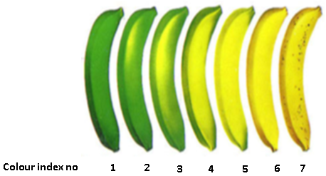

**Figure 1.** Categorization of different stages of ripeness in banana using a colour index (Sankhe, 2015).

**2.2 Reagents**

Pectinase (EC 3.2.1.15) from *Aspergillus niger* with an enzymatic activity 1.06 U per mg and aqueous bentonite powder were purchased from Sigma Aldrich, USA.

**2.3 Methods**

**2.3.1 Mechanical juice extraction**

Banana pulps of Pisang awak cultivar (about 800 g) were obtained from stage five of ripening (Fig. 1) were peeled and subjected to mechanical blending (Blixer 4 V.V., Robot Coupe, France) at a speed of 2500 rpm for 180 s (until the juice was released). Subsequently, pulp samples were collected at three different time intervals (60 s, 120 s, and 180 s) during blending for the lyophilisation process. Samples were lyophilised at 0.1 mbar and -78°C for 72 h to remove water interference during FTIR analysis (Kaddour *et al.,* 2008). Lyophilised pulps were ground into a fine powder using a mortar and pestle and then subjected to Fourier transform infrared spectroscopy (FTIR) analysis.

**2.3.2 Bentonite treatment of the banana pulp**

An aqueous bentonite suspension 5% (w/v) was prepared in deionised water (Moreno-Arribas and Polo, 2009). Bentonite was added to the banana pulp to bind the protein and prevent its interaction with polyphenols (Blade and Boulton 1988)**.** For each experiment, 500 g of fruit banana pulp was mixed with 100 mL pre-treated bentonite. The mixture was blended by using a mechanical blender (Blixer 4.V.V., Robot Coupe, France) at 2500 rpm for 240 s. After blending, the pulp was also collected and lyophilised at -78°C for 72 h. The lyophilised pulp was ground to a powder and subjected to FTIR measurements.

**2.3.3 Pectinase pre-treatment**

To study the relative role of the presence of pectins for the interactions, enzymatic depectinization was employed (Liu *et al.,* 2017; Zhai *et al.,* 2018). About 500 g banana pulp (chopped into small pieces) was mixed with 0.02 g of the pectinase enzyme (Nighojkar *et al.,* 2019). The mixture was stirred for 5 min and allowed to settle at room temperature (30°C) for 10 min and subjected to blending at 2500 rpm for 162 s in a blender (Blixer 4 V.V., Robot Coupe, France). The pectinase treatment was made as described by Majaliwa et al. (2019) but without adjustment of the of the banana pulp pH (4.5) since pectinase works well at pH 4 - 4.5 (Fleuri *et al.,* 2015). The obtained puree was lyophilised at 0.1 mbar and -78°C for 72 h and later subjected to FTIR analysis.

**2.4 FTIR spectrum acquisition**

Comparative analysis of functional groups (polyphenols, proteins, and pectins in the spent pulps with the control (intact fruit pulp) was done using FTIR (Bruker Optics GMBH vector, Germany). Spectra were collected at the wave range between 400 and 4000 per cm and the resolution of 4 per cm following the method described by Monteiro *et al.* (2014). Each sample was sprinkled on top of the FTIR crystal (3 mm2) and transmittance measured. The functional groups were detected based on their frequencies of vibration of the bonds within a molecule as a result of light absorption by the bonds. The analysis was done in duplicate for each sample, and the peak values were recorded. The spectral peaks were used to study if the chemical shifts could be associated with the interactions and provide information on the ability of phenolic compounds to bind proteins and pectins during banana juice extraction.

**3.0 Results and Discussion**

**3.1 FTIR characterization of protein-polyphenol interactions**

The bands considered to be the most interesting for the elucidation of protein-polyphenol interactions in the pulps were between 3300 - 2250 per cm and 1647-1545 per cm for polyphenols and proteins respectively. The FTIR spectra for the cooking cultivar (red line in Fig. 2) was compared with the juice-producing cultivar (blue line in Fig. 2). The characteristic band of the phenolic compounds in the juice-producing cultivar had higher intensity than in the cooking cultivar, suggesting higher content of tannins in the juice-producing cultivar than cooking cultivar. This is in line with the observations by Kyamuhangire *et al.* (2006) who compared banana cultivars using an electron microscope and reported a higher amount of tannin laticifers in the juice-producing cultivars then in cooking bananas. It is further suggesting that high tannin content is a determinant factor for juice release and provides evidence behind the failure of juice release from cooking banana when subjected to mechanical blending. The experimental IR spectra of banana pulps at different blending intervals during juice extraction are shown in Fig. 3, lines A-D, and the wavenumber values of the identified peaks are summarized in Table 1. The FTIR bands obtained at different blending time during juice extraction are based on sensitive band regions representing distinct stretching vibrations in functional groups that demonstrate the changes in the structures of phenolic compounds, proteins, and pectins. It is worth noting that the banana fruit pulp spectrum at intact stage (0 s) before juice extraction, characteristically had spectral peaks at 1750.35 per cm (Fig. 3-line A), corresponding to amide I. However, the absorption band (1750.35 per cm) disappeared at 180 s (Fig. 3-line D) of juice extraction, implying that the conformational changes of amide I bond was induced by the mechanical extraction. The interactions between para-OH, meta-OH, and COOH groups of phenolics with side chains of amino acids have been reported (Madhan et al., 2001). As shown in Fig. 3A-D, bands in the range between 3300.13 per cmand 3270.94 per cm were found in the pulp samples from all stages of juice extraction which might be attributed to the OH stretch of the phenolic compounds since lyophilisation process during sample preparation removes the OH groups from water in the fruit pulp (Kaddour *et al.,* 2008). The mechanical blending resulted in a significant shift of wavenumber and flattening of the curve in the OH region (Fig. 3, line A-D), from the intact fruit pulp (3270.94 per cm) to the point where the juice was recovered (3300.13 per cm). The observed decline in the intensity of the absorption band for the OH group and decline of wavenumber was probably due to the formation of hydrogen bonds and by interactions between NH groups in the peptide chain and the OH groups of phenolic compounds (Hassan *et al.,* 2013; Yang *et al.,* 2015). This agrees well with the *in vitro* study of Trnková *et al.* (2010), which showed a decrease in OH functional groups during interactions between bovine serum albumin and hydroxycinnamic acids.

**Table 1.** FTIR peak values (per cm) and functional groups of pulp collected at different time intervals of juice extraction.

|  |  |  |  |  |  |  |
| --- | --- | --- | --- | --- | --- | --- |
| Extraction time  (s) | Stretching  OH | C-H  stretching | | C=O bond  vibrations  of protein | C=C plane  Symmetric  stretching  of protein | C-O-C bond  stretching  vibration in  carbohydrate  (pectin) |
| 0 | 3300.13 | | 2875.20 | 1750.51 | 1655.14 | 995.65 |
| 60 | 3299.82 | | 2859.12 | 1743.07 | 1625.45 | 894.11 |
| 120 | 3296.46 | | 2835.53 | 1740.13 | 1630.09 | 887.34 |
| 180 | 3270.94 | | 2763.32 | 1725.84 | 1641.89 | 875.08 |

Determination of structural changes of protein have previously been described by evaluation of spectra regions of amide I and amide II in the region 1600 - 1700 per cmand 1480 -1575 per cm, respectively (Ng *et al.,* 2002; Capek et al., 2003; Ge *et al.,* 2006; Skotti *et al.,* 2014; Rodríguez-Torres., 2015). The presence of secondary structures of protein in these regions and hydrogen bonding environments enables the probing of the interaction of the protein with other macromolecules (Byler and Susi, 1986; Susi and Byler, 1983; Murayama and Tomida, 2004).Studies have shown that polyphenol-protein interactions through hydrogen bonds affect the secondary and tertiary structure of protein molecules resulting in an unfolding of the protein chain (Bandyopadhyay *et al.,* 2012).The amide I and II changes (C=O stretching) are reflected by extension of the band’s vibrations, and the shifting of the bands (Haris and Severcan, 1999; Bourassa *et al.,* 2013). Moreover, the amide I region has mostly been used to study secondary protein structures due to its high absorption sensitivity (Li *et al.,* 2006).

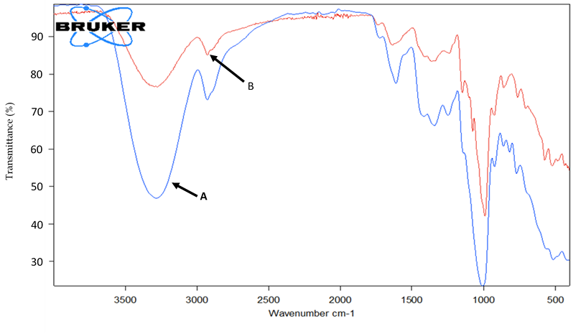

**Figure 2.** FTIR spectra for banana pulps. A-pulp of intact fruit of juice-producing cultivar, B-pulp of intact fruit of non-juice producing (cooking) cultivar.

In the present study, a wavenumber shift by 111.88 per cm was observed between the peak at 2875.20 per cm to 2763.32 per cm, suggesting asymmetric and symmetric CH2 stretching vibrations of proteins. Furthermore, there was a remarkable chemical shift of wavenumber at the amide I region from 1641.89 to 1655.14 per cm from 0 s to180 s of juice extraction, respectively. The shift of bands could be due to hydrophobic interactions between phenolic rings and hydrophobic pockets in proteins,resulting in a change of the secondary structures of the protein (Li *et al.,* 2004; Kanakis *et al.,* 2011; Mehanna *et al.,* 2014), and a transition of α-helix to β-sheet structure (Xu *et al.,* 2019). Similarly, Zhao *et al.* (2020) reported that the α-helix content of protein decreased during protein-polyphenol interactions.

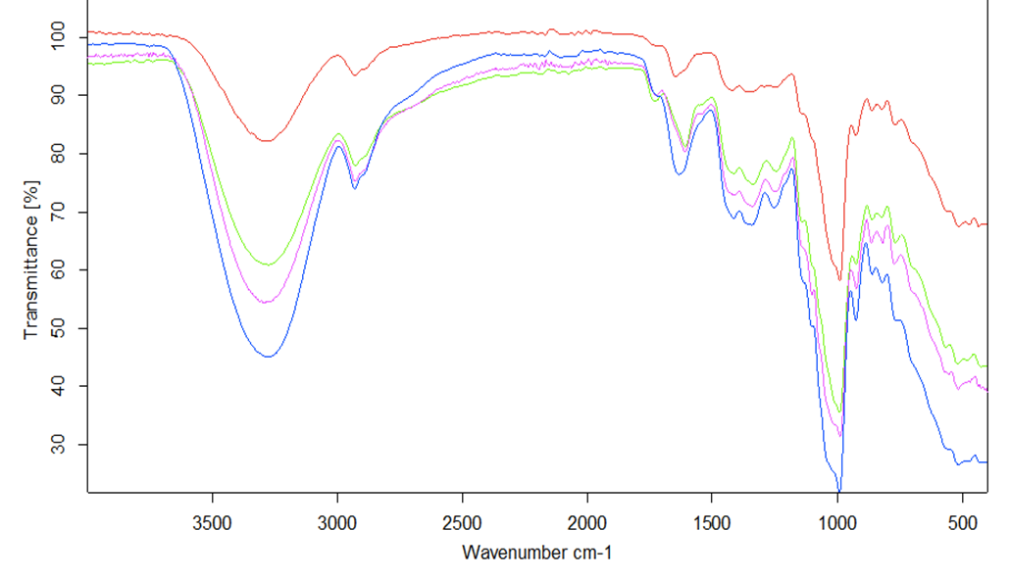

C-3296.46

D-3290.74

A-3300.13

B-3299.82

1641.89

1655.14

2763.32

2875.20

1750.35

995.65

**Figure 3.** FTIR spectra for banana pulps. A- Pulp of intact fruit, B- pulp (0 s), C- pulp (60 s), and D- pulp (180 s) of mechanical blending.

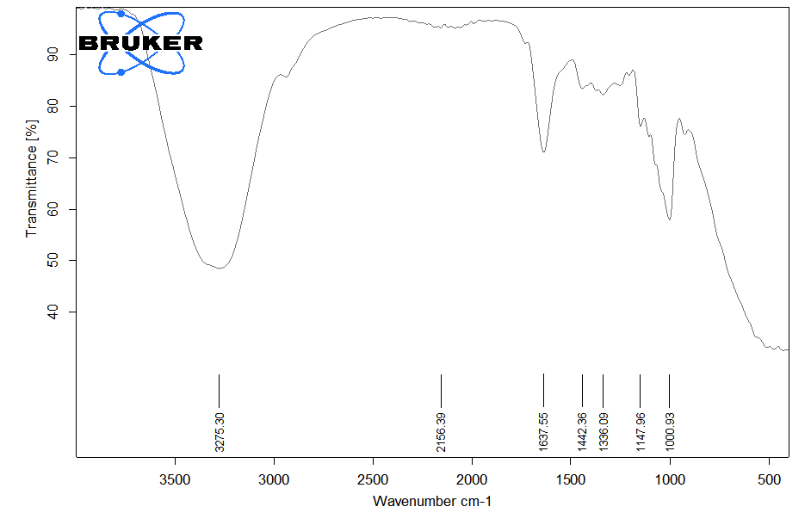

**Figure 4.** FTIR spectra of pectinase treated banana pulp

**3.2 FTIR characterization of pectin polysaccharides in the pulp**

Figure 3 shows the absorption spectra of pectins that are characterised by vibration modes of C-C, C-O stretching, and bending mode of C-H bonds in the region between 1250.11 and 875.08 per cm. The intense band occurring at 995.65 per cm at 0 s (line-A, Fig. 3) indicates a high amount of pectin (Mousia *et al.,* 2001; Capek 2003; Khoozani *et al.,* 2020). Thus, a significant reduction of the band intensity at 180 s (line-D in Fig. 3) is in line with the reduction of pectins in response to mechanical blending. This suggests the involvement of pectin in the release of juice from the banana pulp, as pectins interact with proteins and polyphenols. The interaction of polysaccharide by polyphenol and protein is mostly governed by hydrogen and hydrophobic bonds (Sow *et al.,* 2017; Zhu *et al.,* 2018).

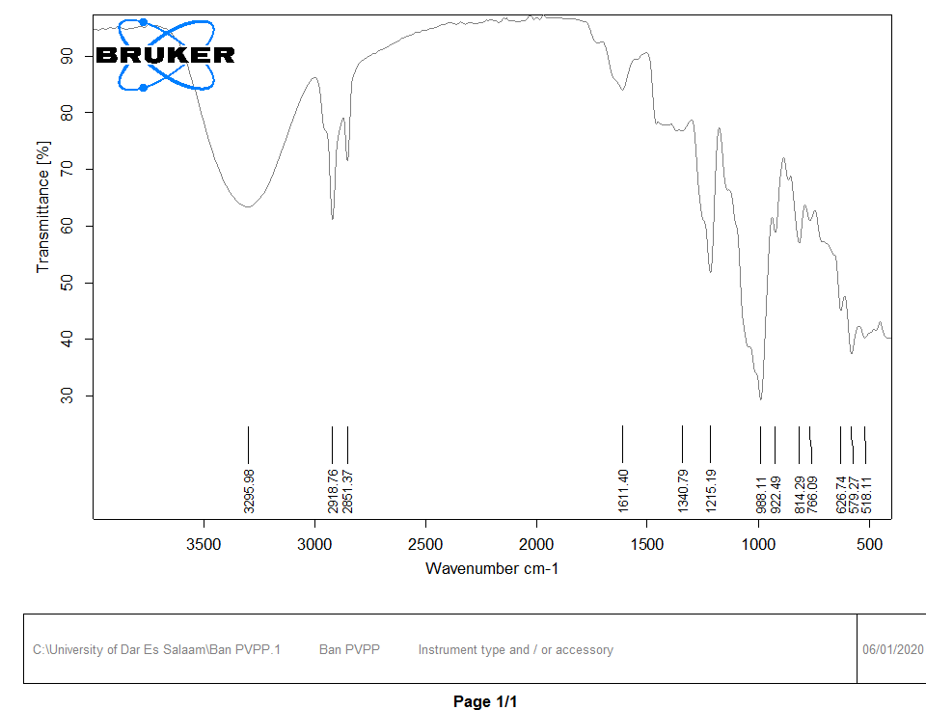

**Figure 5**. FTIR spectra of bentonite treated pulp

**3.3 Effect of bentonite treatments on pulp properties**

Figure 5 shows the FTIR analysis of bentonite treated pulps. Comparison between control (Fig. 3-line A) and the fruit pulp pre-treated with bentonite (Fig. 5) showed that the intensity of amide I peaks was reduced from 83 to 77%, respectively. The reduction of band intensities in the amide regions suggests a decrease of the amide groups and related to the bonding of these groups with bentonite (Chatjigakis *et al.,* 1998). Moreover, the failure of juice release after bentonite pre-treatment could be explained by the binding of proteins in the pulp to bentonite, and hence no interaction of proteins and phenolic compounds.

**3.4 Effect of pectinase treatments on pulp properties**

Identification of pectin in the FTIR spectra lies on the (C–OH) stretch vibrations and (C–O–C) vibrations, and the absorption peaks of different pectin polysaccharides are dependent on the adjacent groups attached to them. The transition of structural properties of pectin has been observed after treatment with pectinase (George *et al.,* 2014; Van Buggenhout *et al.,* 2009). These changes have been studied and reported to occur in the region between 900 and 2000 per cm of the FTIR spectra (Kalapathy and Proctor, 2001; Kačuráková *et al.,* 2000). The effect of pectinase on the banana pulp pectin in the present study is shown in Figure 4. The result indicates a drop of band intensity from 100% (Fig.3-line A) to 57% (Fig. 4), and a wavenumber shift from 995.65 to 1000.93 per cm, respectively. Further, the juice was not released after 10 min. of pectinase treatment. This might be due to the flocculation of pectin and protein due to pectin hydrolysis (Singh *et al.,* 2012), which suggests that pectin is involved in the formation of an insoluble complex.

**4.0 Conclusion**

The results of FTIR analysis provided a better picture regarding the chemical profile of the pulp in response to mechanical blending during low viscosity banana juice production. The blending process caused a reduction in the intensities of proteins, carbohydrate (pectin) and polyphenols functional groups. Thus, it is hypothesized that observed reductions were attributed to the protein-pectin-polyphenol interactions. Moreover, FTIR spectra disclosed the existence of interaction between protein, pectin and phenolic compounds and demonstrated that it was mainly contributed by hydrogen bonding. Furthermore, the influence of protein-pectin-polyphenol interaction on the conformational structures of the banana proteins was evidenced from the associated alterations in banana protein’s Amide I and II bands. Changes were detected in the protein secondary structure (Amide I), as well as the OH groups as the result of hydrogen bond formation. Further, it was obvious from the FTIR spectra that, pretreatment of fresh pulps with bentonite and pectinase gave rise to the decreased protein and pectin contents, as reflected by the decrease in their band’s intensities. The findings suggest that a combination of protein-pectin-polyphenol interactions, rather than only protein-polyphenol interactions, are involved in the formation of insoluble complexes and can play an important role in the release of low viscosity juice from the banana pulp. Further analyses using NMR is needed to confirm this hypothesis, and to decipher the properties of intrinsic and formed compounds during mechanical extraction of low viscosity banana juice, hence the biochemical involvements.

**REFERENCES**

1. Ali, H., Alli, I., Ismail, A., & Kermasha, S. (2012). Method development to identify protein-phenolic interactions. *Eurasian Journal of Analytical Chemistry*, *7*(3), 123-133.
2. Bandyopadhyay, P., Ghosh, A. K., & Ghosh, C. (2012). Recent developments on polyphenol–protein interactions: effects on tea and coffee taste, antioxidant properties and the digestive system*. Food & function*, 3(6), 592-605.
3. Blade, W. H., & Boulton, R. (1988). Adsorption of protein by bentonite in a model wine solution. *American Journal of Enology and Viticulture*, 39(3), 193-199.
4. Butler, L. G., Riedl, D. J., Lebryk, D. G., & Blytt, H. J. (1984). Interaction of proteins with sorghum tannin: mechanism, specificity and significance. *Journal of the American Oil Chemists’ Society*, *61*(5), 916-920.
5. Byler, D. M., & Susi, H. (1986). Examination of the secondary structure of proteins by deconvolved FTIR spectra. Biopolymers: *Original Research on Biomolecules*, 25(3), 469-487.
6. Capek, P., Hrıbalová, V., Švandová, E., Ebringerová, A., Sasinková, V., & Masarová, J. (2003). Characterisation of immunomodulatory polysaccharides from Salvia officinalis L. *International Journal of Biological Macromolecules*, 33(1-3), 113-119.
7. Chatjigakis, A. K., Pappas, C., Proxenia, N., Kalantzi, O., Rodis, P., & Polissiou, M. (1998). FT-IR spectroscopic determination of the degree of esterification of cell wall pectins from stored peaches and correlation to textural changes. *Carbohydrate Polymers*, 37(4), 395-408.
8. Czubinski, J., & Dwiecki, K. (2017). A review of methods used for investigation of protein–phenolic compound interactions. *International Journal of Food Science & Technology*, *52*(3), 573-585.
9. Fleuri, L. F., Delgado, C. H. O., Novelli, P. K., Pivetta, M. R., Do Prado, D. Z., & Simon, J. W. (2015). Enzymes in fruit juice and vegetable processing. In Enzymes in food and beverage processing (pp. 271-296). CRC Press.
10. Ge, D., Shi, W., Ren, L., Zhang, F., Zhang, X. and Zhang, Q. (2006) Variation Analysis of Affinity-Membrane Model Based on Freundlich Adsorption. *Journal of Chromatography*, 1114, 40-44.
11. Gebre-Mariam, S. (1999). Banana production and utilisation in Ethiopia. Ethiopian Agricultural Research Organization. Research Report no. 35, 2-3.
12. George, M., Mussone, P. G., & Bressler, D. C. (2014). Surface and thermal characterisation of natural fibres treated with enzymes. *Industrial Crops and Products*, 53, 365-373.
13. Haris, P. I., & Severcan, F. (1999). FTIR spectroscopic characterisation of protein structure in aqueous and non-aqueous media. *Journal of Molecular Catalysis B: Enzymatic*, 7(1-4), 207-221.
14. Hassan, Z.M.R., El Din, H.M.F., Ali, A.A., Mehanna, N.S.H. and El-Messery, T.M. (2013) Interaction of Some Low Molecular Weight Phenolics with Milk Proteins. *World Applied Sciences Journal*, 23, 182-187.
15. Jadaun, J. S. (2018). Pectinase: A Useful Tool in Fruit Processing Industries. *Nutr. Food Sci. Int. J*, *5*.
16. Kačuráková M, Capek P, Sasinková V et al (2000) FT-IR study of plant cell wall model compounds: pectic polysaccharides and hemicelluloses. *Carbohydr Polym* 43:195–203
17. Kaddour, A. A., Barron, C., Robert, P., & Cuq, B. (2008). Physico-chemical description of bread dough mixing using two-dimensional near-infrared correlation spectroscopy and moving-window two-dimensional correlation spectroscopy. Journal of Cereal Science, 48(1), 10-19.
18. Kalapathy, U. & Proctor, A. 2001. Effect of acid extraction and alcohol precipitation conditions on the yield and purity of soy hull pectin. *Food Chemistry* 73: 393-396.
19. Kanakis, C. D., Hasni, I., Bourassa, P., Tarantilis, P. A., Polissiou, M. G., & Tajmir-Riahi, H. A. (2011). Milk β-lactoglobulin complexes with tea polyphenols. Food Chemistry, 127(3), 1046-1055.
20. Karamura, E., Frison, E., Karamura, D. A., & Sharrock, S. (1998). Banana production systems in eastern and southern Africa. *Bananas and food security. INIBAP, Montpellier*, 401-412.
21. Khoozani, A. A., Birch, J., & Bekhit, A. E. D. A. (2020). Textural properties and characteristics of whole green banana flour produced by air-oven and freeze-drying processing. *Journal of Food Measurement and Characterization*, Vol? 1-10.
22. Kibazohi, O., Kyamuhangire, W., Kaunga, D. L., & Rokoni, C. (2017). Process improvement for mechanical extraction of low-viscosity clear banana juice. *Afr. J. Food Sci*, *11*, 291-295.
23. Kyamuhangire, W., & Pehrson, R. (1999). Conditions in banana ripening using the rack and pit traditional methods and their effect on juice extraction. *Journal of the Science of Food and Agriculture*, *79*(2), 347-352.
24. Kyamuhangire, W., Krekling, T., Reed, E., & Pehrson, R. (2006). The microstructure and tannin content of banana fruit and their likely influence on juice extraction*. Journal of the Science of Food and Agriculture*, 86(12), 1908-1915.
25. Kyamuhangire, W., Myhre, H., Sørensen, H. T., & Pehrson, R. (2002). Yield, characteristics and composition of banana juice extracted by the enzymatic and mechanical methods. *Journal of the Science of Food and Agriculture*, *82*(4), 478-482.
26. Li, H.; Liu, B.L.; Gao, L.Z.; Chen, H.L. Studies on bullfrog skin collagen. *Food Chem*. 2004, 84, 65–69.
27. Li, Y., He, W., Dong, Y., Sheng, F., & Hu, Z. (2006). Human serum albumin interaction with formononetin studied using fluorescence anisotropy, FT-IR spectroscopy, and molecular modeling methods. *Bioorganic & Medicinal Chemistry*, *14*(5), 1431-1436.
28. Liu, X., Jiang, Y., Yang, S., Meng, X., Song, X., & Wu, M. (2017). Effects of Pectinase Treatment on Pulping Properties and the Morphology and Structure of Bagasse Fiber. *BioResources*, 12(4), 7731-7743.
29. Madhan, B., Thanikaivelan, P., Subramanian, V., Raghava, R.J., Balachandran, U.N. and Ramasami, T. (2001) Molecular Mechanics and Dynamics Studies on the Interaction of Gallic Acid with Collagen-Like Peptides. *Chemical Physics Letters*, 346, 334-340.
30. Majaliwa, N., Kibazohi, O., & Alminger, M. (2019). Optimisation of process parameters for mechanical extraction of banana juice using response surface methodology. *Journal of food science and technology*, *56*(9), 4068-4075.
31. McManus, J. P., Davis, K. G., Lilley, T. H., & Haslam, E. (1981). The association of proteins with polyphenols. *Journal of the Chemical Society, Chemical Communications*, (7), 309b-311.
32. Mehanna, N. S., Hassan, Z. M. R., El-Din, H. M. F., Ali, A. A. E., Amarowicz, R., & El-Messery, T. M. (2014). Effect of interaction phenolic compounds with milk proteins on cell line. *Food and Nutrition Sciences,* 5(22), 2130.
33. Monteiro, S. N., Margem, F. M., Loiola, R. L., de Assis, F. S., & Oliveira, M. P. (2014). Characterisation of banana fibers functional groups by infrared spectroscopy. In Materials Science Forum (Vol. 775, pp. 250-254). Trans Tech Publications Ltd.
34. Moreno-Arribas, M. V., & Polo, M. C. (Eds.). (2009). *Wine chemistry and biochemistry* (Vol. 735). New York: Springer.
35. Mousia, Z., Farhat, I. A., Pearson, M., Chesters, M. A., & Mitchell, J. R. (2001). FTIR microspectroscopy study of composition fluctuations in extruded amylopectin–gelatin blends. *Biopolymers: Original Research on Biomolecules*, *62*(4), 208-218.
36. Murayama, K., & Tomida, M. (2004). Heat-induced secondary structure and conformation change of bovine serum albumin investigated by Fourier transform infrared spectroscopy. *Biochemistry*, 43(36), 11526-11532.
37. Ng, C., Losso, J.N., Marshall, W.E. and Rao, R.M. (2002) Freundlich Adsorption Isotherms of Agricultural By- Product-Based Powdered Activated Carbons in a Geosmin-Water System. *Bioresources Technology*, 85, 131-135.
38. Nighojkar, A., Patidar, M. K., & Nighojkar, S. (2019). Pectinases: Production and Applications for Fruit Juice Beverages. In Processing and Sustainability of Beverages (pp. 235-273). Woodhead Publishing.
39. Ozdal, T., Capanoglu, E., & Altay, F. (2013). A review on protein–phenolic interactions and associated changes. Food Research International, 51(2), 954-970.
40. Pessato, T. B., de Morais, F. P., de Carvalho, N. C., Figueira, A. C. M., Fernandes, L. G. R., Zollner, R. D. L., & Netto, F. M. (2018). Protein structure modification and allergenic properties of whey proteins upon interaction with tea and coffee phenolic compounds. *Journal of Functional Foods*, *51*, 121-129.
41. Richard, T., Lefeuvre, D., Descendit, A., Quideau, S., & Monti, J. P. (2006). Recognition characters in peptide–polyphenol complex formation. *Biochimica et Biophysica Acta* (BBA)-General Subjects, 1760(6), 951-958.
42. Rodríguez-Torres, A., Valladares-Cisneros, M., & Gonzalez-Rodríguez, J. (2015). Use of Salvia officinalis as green corrosion inhibitor for carbon steel in acidic media*. International Journal of Electrochemical Science,* 10, 4053-4067.
43. Sankhe, D. (2015). Ripeness inspection system for banana. *International Journal of Computer Applications*, 6, 0975-8887.
44. Sarni‐Manchado, P., & Cheynier, V. (2002). Study of non‐covalent complexation between catechin derivatives and peptides by electrospray ionization mass spectrometry. *Journal of mass spectrometry*, *37*(6), 609-616.
45. Siebert, K. J., Troukhanova, N. V., & Lynn, P. Y. (1996). Nature of polyphenol− protein interactions. *Journal of Agricultural and Food Chemistry*, 44(1), 80-85.
46. Singh, P., Hamid, B., Lone, M. A., Ranjan, K., Khan, A., Chaurse, V. K., & Sahay, S. (2012). Evaluation of pectinase activity from the psychrophilic fungal strain Truncatella angustata-BPF5 for use in wine industry. Journal of Endocytobiosis and Cell Research, 22, 57-61.
47. Skotti, E., Kountouri, S., Bouchagier, P., Tsitsigiannis, D. I., Polissiou, M., & Tarantilis, P. A. (2014). FTIR spectroscopic evaluation of changes in the cellular biochemical composition of the phytopathogenic fungus Alternaria alternata induced by extracts of some Greek medicinal and aromatic plants. Spectrochimica Acta Part A: Molecular and Biomolecular Spectroscopy, 127, 463-472.
48. Sow, L. C., Peh, Y. R., Pekerti, B. N., Fu, C., Bansal, N., & Yang, H. (2017). Nanostructural analysis and textural modification of tilapia fish gelatin affected by gellan and calcium chloride addition. LWT-*Food Science and Technology*, 85, 137-145.
49. Susi H, Byler DM. Protein structure by Fourier transform infrared spectroscopy: second derivative spectra. *Biochem Biophys Res Commun*.1983; 115:391–7.
50. Tomás‐Barberán, F. A., & Espín, J. C. (2001). Phenolic compounds and related enzymes as determinants of quality in fruits and vegetables. *Journal of the Science of Food and Agriculture*, 81(9), 853-876.
51. Trnková, L., Bousova, I., Kubicek, V. and Drsata, J. (2010) Binding of Naturally Occurring Hydroxycinnamic Acids to Bovine Serum Albumin. *Science and Research*, 2, 563-570.
52. Van Buggenhout, S., Sila, D. N., Duvetter, T., Van Loey, A., & Hendrickx, M. (2009). Pectins in processed fruits and vegetables: Part III—Texture engineering. Comprehensive *Reviews in Food Science and Food Safety,* 8(2), 105-117.
53. Xie, L., Wehling, R. L., Ciftci, O., & Zhang, Y. (2017). Formation of complexes between tannic acid with bovine serum albumin, egg ovalbumin and bovine beta-lactoglobulin. *Food Research International*, 102, 195–202.
54. Xu, H., Lu, Y., Zhang, T., Liu, K., Liu, L., He, Z., ... & Wu, X. (2019). Characterisation of binding interactions of anthraquinones and bovine β-lactoglobulin. *Food chemistry*, 281, 28-35.
55. Yang, H., Yang, S., Kong, J., Dong, A., & Yu, S. (2015). Obtaining information about protein secondary structures in aqueous solution using Fourier transform IR spectroscopy. *Nature protocols*, *10*(3), 382.
56. Zhai, X., Zhu, C., Li, Y., Zhang, Y., Duan, Z., & Yang, X. (2018). Optimisation for pectinase-assisted extraction of polysaccharides from pomegranate peel with chemical composition and antioxidant activity. *International Journal of Biological Macromolecules*, 109, 244-253.
57. Zhang, G., & Ma, Y. (2013). Mechanistic and conformational studies on the interaction of food dye amaranth with human serum albumin by multispectroscopic methods. *Food chemistry*, *136*(2), 442-449.
58. Zhao, Q., Yu, X., Zhou, C., Yagoub, A. E. A., & Ma, H. (2020). Effects of collagen and casein with phenolic compounds interactions on protein in vitro digestion and antioxidation. LWT, 124, 109192.
59. Zhu, F. (2018). Interactions between cell wall polysaccharides and polyphenols. *Critical reviews in food science and nutrition*, *58*(11), 1808-1831.