***Original Research Article***

**Process Optimization for the development of Little millet** *(Panicum sumatrense* **) based Functional Greek yoghurt enriched with WPC and its influence on sensory attributes**

**Abstract:**

The research project proposed was to develop functional Greek yoghurt utilizing little millet. The Greek yoghurt was prepared according to standard protocol. After being heated to 90˚ C for five minutes, the cow's milk was cooled to 45˚ C. Freeze-dried DVS Yoghurt culture was added at concentrations of 0.10, 0.20 and 0.30 per cent and the product was then incubated at 45˚C for 4 hours. Amongst them 0.30 % was best. The product was further de-wheyed and blended with different levels of little millet @ 3, 5, 7 per cent and WPC 2, 3 and 5%. The developed functional little millet based functional greek yoghurt was given for judges to adjudge the sensory attribute of the product based on 9-point hedonic scale .The best optimized product with 5% WPC and & 7 % little millet was selected.

Key words: Greek yoghurt, Little millet and Sensory attributes

**Introduction:**

India is the largest milk producer with 230.58 million tonnes in 2022-23 (BAHS,2023). About 46% of the milk produced is sold to consumers in rural regions or consumed by the producers themselves. Out of total milk production 7% of milk is converted into fermented dairy products. Fermented milk products were initially developed by nomadic Asian cattle breeders. These products are manufactured by following the fermentation of milk by a specific group of microorganisms, which lowers the pH and in each successive coagulation of milk proteins along with the microorganism which remains active as long as they do not experience heat treatment. Fermented milk products are well-known for their superior nutritional and health related properties including prevention of gastrointestinal infections, reduction of blood cholesterol levels and ant-mutagenic effects. In India, fermented products such as Dahi (curd), Mishti Doi (sweetened curd), Shrikhand, Lassi and Chhach or Mohi (buttermilk) (Dewan and Tamang, 2007).

The yoghurt is an excellent source of vital nutrients The folic acid in yoghurt and other other fermented dairy products gains more popularity. High protein yoghurts are consumed worldwide, with diversity in composition and denominations, depending on the place of origin. These strained yoghurts are best known as Greek-style yoghurts are characterised by protein content usually around 9% to 10%. Their creamy texture and their natural, nutritive and low-fat attributes have made them very popular in the past few years (Ramakrishna *et al*. 2024).

Little millet (*Panicum sumatrense*) is one of the important minor millets grown extensively in the tropics and a staple food for the low-income groups in some countries of the world. It is grown widely in India, Pakistan, Sri Lanka and Western Myanmar. By any nutritional parameter little millets are miles ahead of rice and wheat in terms of their mineral content compared to rice and wheat (Kundgol *et al.,* 2014). Little millet is comparable with other cereals such as rice and wheat as a source of protein, fat, carbohydrates and crude fibre apart from minerals, vitamins and is also rich source of antioxidants .Little millet has nutrient profile of carbohydrate (67.00 %), protein (7.7 %), fat (4.7 %), crude fibre (7.6 %), minerals (1.5 %) with 341 k cal of energy. Little millet comprises of lysine 110 mg/ g of N, tryptophan 60mg/ g of N, phenyl alanine 330 mg/ g of N, methionine 180 mg/ g of N, cystine 90 mg/ g of N, threonine 190 mg/ g of N, leusine 760mg/ g of N, isoleusine 370mg/ g of N, valine 350mg/ g of N (ICAR, Indian farming, 2016).Little Millet grains are highly nutritious with good quality protein, rich in minerals, dietary fiber, phyto- chemicals and vitamins. Photochemical help in slowing digestion process and this helps in controlling blood sugar level in condition of diabetes, bringing down cholesterol level by eliminating excess fat from Liver. If consumed regularly, it could help in overcoming mal nutrition, degenerative diseases and premature aging at bay (Mal and Tripathi, 2016).

A functional ingredient is a bioactive component that can be incorporated into multiple food manufacturing processes. It can come from a variety of sources, such as inorganic raw materials, microorganisms, aquatic sources, and other natural sources. Food processing waste is one of the sources of bioactive chemicals that help the food sector financially. Customers are commencing to gravitate towards functional foods more since they provide extra health advantages over traditional diets. Functional enhancement raises the nutritional value and market value of dairy products. One of the main and abundant functional by-products of the dairy industry, whey has several health advantages. Dried whey containing more than 25% protein is referred to as whey protein concentrate. The protein level of Whey Protein Concentrate, which varies from 25 to 90 percent, determines its chemical composition. Whey protein concentrate is an essential functional element that is necessary for human nutrition since it contains vital amino acids. It is one of the most well-liked and advantageous protein supplements that is simple to include into a diet, and it also have significant nutritional value. (Harinivenugopal *et al*., 2020).

Whey proteins have a higher concentration of key amino acids, including lysine, tryptophan, isoleucine, threonine, and others, which accounts for their higher nutritional value. The higher protein efficiency ratio (PER) of whey proteins (3.2) compared to casein (2.6) can be attributed to the higher concentration of sulfur-containing amino acids (cysteine and methionine) found in whey proteins. Whey proteins have a higher biological value (104) than casein (77). Blood pressure-raising angiotensin converting enzyme (ACE) inhibitory peptides have been found in beta-lactoglobulin and alpha-lactalbumin in whey proteins. Both its ability to lower cholesterol and raise glutathione levels is a sign that whey proteins have immune-boosting qualities. (Kumar *et al*., 2018).

**Materials and Methodology adopted:**

The following materials were used in this research study for the preparation of functional Greek yoghurt.

**Milk**

Fresh Cow milk was procured from Students Experimental Dairy Plant (SEDP) of Dairy Science College, Hebbal, Bengaluru.

**Whey Protein Concentrate**

Good quality Whey protein concentrate was procured from Nutrilac,DKSH India pvt ltd.

**Starter Culture**

Good quality of freeze dried starter culture was procured from Delvo DSL pvt Ltd, Netherlands.

**Sensory Test Analyzed By Panel of Judges Using 9-Point Hedonic Scale**

The panel of trained judges that was chosen assessed the generated study sample's sensory attributes, such as color and appearance, body and texture, flavor, and overall acceptability, using a 9-point hedonic scale. Statistical analysis was conducted using the output with the highest score .

**Statistical Analysis**

Using R software (R. version 4.0.3), the data collected for the research investigations was examined to evaluate the significant or non-significant effects of various treatments and trials obtained for the current study. The mean and critical difference was calculated.

**Methodology:** Fresh cow milk

(Fat-4.5 % & SNF- 9.0 %)

Heat treatment (90 ̊C/no hold)

Cooling to 45 ̊C

Addition of Whey Protein Concentrate (2%, 3% and **5%**)

Addition of 0.1, 0.20, and **0.30**% freeze dried DVS culture at 1:1

(*Streptococcus thermophilus* and *Lactobacillus bulgaricus*)

Incubation (45°C/ 4h)

De-wheying (cloth bag filtration at 4°C/overnight)

Addition of Little Millet (3, 5and **7%**)

Blending and Packaging in PET cups(100ml)

Cooling and storage (7±1°C)

**Results & discussion**

**Table 1: Effect of WPC as Functional ingredient on the sensory attributes of** **Greek yoghurt.**

|  |  |  |  |  |
| --- | --- | --- | --- | --- |
| **Functional ingredient-WPC (%)** | **Colour and appearance** | **Body and texture** | **Flavour** | **Overall**  **acceptability** |
| Control | 8.00c | 7.13c | 7.14b | 7.33c |
| 2 | 7.33b | 7.53b | 7.87ab | 7.73b |
| 3 | 8.00bc | 7.75ab | 7.50c | 8.00c |
| **5** | **8.50a** | **8.25a** | **8.00a** | **8.50a** |
| CD *(P=0.05*) | 0.60 | 0.47 | 0.54 | 0.55 |

**Figure 1: Effect of WPC as Functional ingredient on the sensory attributes of Greek yoghurt.**

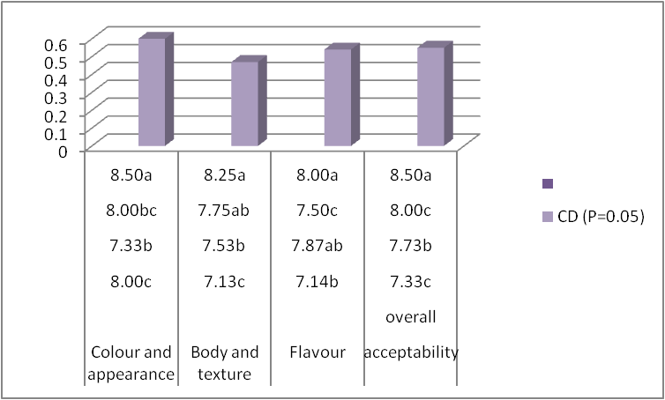

**Note:**

All the values are average of three trials

Similar superscripts indicate non - significance at the corresponding critical difference

Sensory analysis – 9-point hedonic scale

The sensory acceptance reflecting the effect of WPC is correlated in table 1 and figure1.The control sample's mean colour and appearance score was 7.17 8.00, compared to 7.33, 8.00, and 8.50 for treated samples that contained 2, 3 and 5 percent of WPC respectively. The functional Greek yoghurt with 5 percent WPC had a maximum score of 8.50, 8.25 , 8.00 and 8.50 for Colour and appearance, Body & texture, flavor and overall acceptability respectively. Statistical analysis indicated that WPC had a significant effect on the overall acceptability of functional Greek yoghurt. The result is complimenting with the work conducted by Brodzaiak *et al*. 2020 who emphasized that WPC ad positive influence on the product that possess excellent functional properties with respect to emulsifying, gelling and water binding capabilities that enhances the sensory acceptance of Greek yoghurt.

**Table 2: Effect of Little Millet as Functional ingredient on the sensory attributes of Greek yoghurt.**

|  |  |  |  |  |
| --- | --- | --- | --- | --- |
| **Functional ingredient-Little Millet (%)** | **Colour and appearance** | **Body and texture** | **Flavour** | **Overall**  **acceptability** |
| Control | 8.00c | 7.00c | 7.25b | 7.45c |
| 3 | 7.00b | 7.35b | 7.05ab | 7.70b |
| 5 | 8.02bc | 7.55ab | 7.50c | 8.05c |
| **7** | **8.50a** | **8.55a** | **8.09a** | **8.50a** |
| CD *(P=0.05*) | 0.60 | 0.47 | 0.54 | 0.55 |

**Figure 2: Effect of Little Millet as Functional ingredient on the sensory characteristics of Greek yoghurt.**

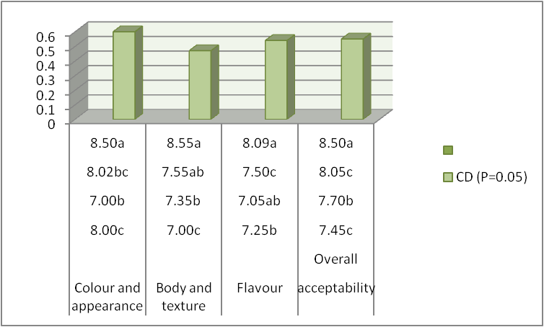

**Note:**

All the values are average of three trials

Similar superscripts indicate non - significance at the corresponding critical difference

Sensory analysis – 9-point hedonic scale

The sensory attributes relevant to the effect of little millet is correlated in table 2 and figure 2.The control sample's mean colour and appearance score was 8.00, 7.00, 7.25 and 7.45 compared to treated samples that contained 3, 5 and 7 percent of little millet respectively. The functional Greek yoghurt with 7 percent little had a maximum score of 8.50, 8.55, 8.09 and 8.50 for Colour and appearance, Body & texture, flavor and overall acceptability respectively. Statistical analysis indicated that little millet had a significant effect on the overall acceptability of functional Greek yoghurt. The result is in accordance with research study conducted by Sandy *et al* 2009 who insisted that little millet improvised the sensory attribute of the product due to its fibre content which binds the moisture content and gives good acceptability and mouth feel.

**Conclusion:**

Yoghurt and Greek Yoghurt are highly acclaimed healthy international product. The research study focused on value addition of the Greek yoghurt with nutraceutical ingredient WPC a versatile dairy ingredient and little millet which is a nutria-dense crop. Blending of these two ingredients in to Greek yoghurt is a novel ideology that can connect farmers, technology and consumers to relish super rich product.

**References:**

Brodzaiak, A., Krol, J Barlowska J, Teter A and Florek, M 2020. Changes in the physioco-chemical parameters of yoghurts with added whey protein in relation to the starter bacteria strains and storage time, *J.Anim*., **10**(8):1350-1355.

Dewan, S and Tamang,J P.,2007. Domiant lactic acid bacteria and their technological properties isolated from Himlayan ethic fermented milk products. *Antonie van Leeuwenhoek*, **92** (3):343-352.

Harinivenugopal, Jayaprakasha, H.M. and Arunkumar, H., 2020. Influence of Whey Protein Concentrate (WPC) – A Functional Ingredient on Rheological Attributes of Foxtail Millet Based RTE Food. *International Journal of Creative Research Thoughts*. **8**(6): 4186-4192.

Kanhed, M.I., Harinivenugopal, Arunkumar, H., Manjunatha, H. and BG, S., 2023.Formulation of WPC enriched ready to serve yoghurt smoothie. *International Research Journal of Modernization in Engineering Technology and Science.* **5**(5): 2582-5208

Kumar,R.,Chauhan, S., Shinde,G., Subramanyan, V and Nandanasabapathi, S., 2018.Whey Proteins: A potential ingrient for food industry-a rewiew, *Asian J Dairy Food Res*., **37** (4): 283-290.

Mal and Tripati., 2016.,Millets-The nutridence potent ehno medical grasses-A rewiew.World *Journal of Pharmaceutical Research*., **5** (2):495-520.

Mckinley, M. C. 2005. The nutrition and health benefits of yoghurt. *International journal of dairy technology*, **58**(1): 1-1.

Ramakrishnan, V., Harinivenugopal., Aruun Kumar H., Venkatesh M., Manjunath H and Pushpa B P., 2024.Effect of concentration of starter culture and incubation time on sensory attributes of RTE functional Greek Yoghurt. *J Sci.Res.Rep*., **30** (7):340-345.

Sandy,,K.K,Asgar S,Manorama and Chaudary P L,2009.Utilization of little Millet Flour in the for preparation of dairy products. Res.J.Sci.Technol,1 (2):71-73.

Vijay, L., Karthikeyan, N., Kumaresan, G. and Kathirvelan, C., 2022. Sensory properties of

functional Greek yoghurt incorporated with Moringa oleifera leaf powder. *The Pharma*

*Innovation Journal*, ***11***(4), pp.251-254.

**ANNEXURE**

**DAIRY SCIENCE COLLEGE, KVAFSU, BENGALURU-24**

**DEPARTMENT OF DAIRY TECHNOLOGY**

**Score card for Sensory Evaluation Using 9-Point Hedonic Scale**

**Name of the Judge: Date:**

You are requested to assess the product in terms of general acceptability on a 9-point hedonic scale score system.

**score system:**

Like extremely 9

Like very much 8

Like moderately 7

Like slightly 6

Neither like nor dislike 5

Dislike slightly 4

Dislike moderately 3

Dislike very much 2

Dislike extremely 1

|  |  |  |  |  |  |  |
| --- | --- | --- | --- | --- | --- | --- |
| **Sensory Characteristics** | **Sample Code** | | | | | |
|  |  |  |  |  |  |
| Color and Appearance |  |  |  |  |  |  |
| Body and Texture |  |  |  |  |  |  |
| Flavour |  |  |  |  |  |  |
| Overall Acceptability |  |  |  |  |  |  |

**Comments: Signature**