Sustainable Indoor Farming: Integrating IoT and Data-Driven Strategies to Optimize Hydroponic Crop Production

.

ABSTRACT

|  |
| --- |
| **Aim:** To discuss the integration of IoT and data-driven strategies into hydroponic crop production with the aim of optimizing the crop growth and yield as a sustainable indoor farming.  **Problem Statement:** Globally, reduction in the per capita land is becoming prevailing and persistent resulting from the quick rise in population, urbanization and industrialization. This is adversely affecting the quantity of food supply and also hindering the revenue generation from this route. Additionally, unforeseen change in weather and climate conditions, inadequate water management system and temperature rise is causing serious problems to food production.  **Significance of Study:** There is need to look critically into productive ways of handling the problems attached to food scarcity, part of which is the adoption of hydroponic farming in agricultural systems via which thee essential nutrients are given to the plants from the water which is carefully supplied and balanced to the plant roots.  **Methodology:** This review article was put together using published articles, research write-ups and relevant books in the area of hydroponic farming incorporated with IoT and data-driven techniques for sustainable indoor farming systems.  **Discussion:** Current researchers have revealed the potential of adopting hydroponics incorporated with IoT and data-driven system as innovative approaches to achieve sustainable agriculture and also address the problems emanating from food security. This article discusses the fundamental principles of hydroponic farming and its historical background. The ways through which the methodology can be achieved are discussed with emphasis on optimizing the farming methods in order to enhance the efficiency and sustainability of the process. This article identifies the challenges of the approach and called for the need for future research studies in this regard. This article examines the involvement of smart farming in hydroponics and states how it assists with crop monitoring, decision-making and predictive analytics. The benefits of IoT technologies for automated system of managing hydroponics and how data gathering in real-time controlled environment agriculture can be attained are highlighted.  **Conclusion:** In conclusion, it is imperative for both local and international farmers to adopt the IoT and data-driven hydroponic system to ensure ease of operation and also ascertain sustainable indoor farming is achievable. |

*Keywords: Sustainable Indoor Farming,* *Hydroponic Crop Production, Deep Water Culture; Wick System, Drip system*

1. INTRODUCTION

Decrease in the per capita land is being experienced globally as a result of speedy rise in urbanization, population and industrialization. An intolerable saturation level has been attained by the soil fertility because of the non-responsiveness of crop yield despite the increased fertilizers application [1]. Nonetheless, temperature rise, inadequate water management system and unexpected climate and weather conditions are causing serious havoc to food production via conventional means of agriculture. Therefore, there is need to improve agricultural production in the current situation in order to ascertain proper food supplies that will be sustainable to cover up for natural disasters occurrence and population rise. To tackle this menace and make the aforementioned objectives a reality, present agricultural systems now adopt hydroponic farming which involves plants growing without soil in nutrient-rich water-based solutions. The essential nutrients are received directly by the plants from the water which is cautiously supplied and balanced to the plant roots. This soil-less cultivation approach enables for exact control over water usage, plant nutrition, and environmental factors like humidity, temperature and lighting. This farming approach has a long and complex history that pre-exists the modern agricultural methods [2].

Historically, hydroponics started with ancient civilizations such as the Babylonians, who watered the legendary Hanging Gardens using advanced irrigation systems dated back around 600 BC. In a similar way, soil-less cultivation was documented by Egyptian hieroglyphs along the Nile while floating gardens also called chinampas was developed by Aztecs in the 10th and 11th centuries. The scientific basis of hydroponics advanced over centuries as early experiments conducted by Dioscorides and Theophrastus, who were Greek scientists, opened doors for soil-less gardening studies. Progressively in the 17th century, additional study into hydroponics was inspired by Sir Francis Bacon's investigation while the benefits of nutrients dissolved in water were stated in the late 1600s as discovered in John Woodward's experiments [3]. In the 19th century, the fundamental principles of plant nutrition were formalized by the Julius von Sachs’ nutrient solution formula while essential mineral elements identification was achieved via as Nicolas De Saussure’s study. All these were the subsequent breakthroughs. In 1924, the term “hydroponics" was formulated by Dr. William F. Gericke where large-scale crop production potential in the absence of soil was demonstrated experimentally. His controversial study led to the fundamental basis of modern hydroponic principles [4]. Fortunately, hydroponics approach was adopted during World War II in supplying food for soldiers in isolated areas. Large-scale hydroponic system was then implemented by the U.S. military on barren islands such as Ascension Island.

The accorded benefits of hydroponics include faster growth rates, the potential to grow plants in locations having restricted access to arable land, higher crop yields and effective resource exploitation. Utilizing this approach gives plants the opportunity to grow in a monitored environment in the absence of soil in a way that their roots are adopted in a nutrient-rich water solution. The objective is purposely to maximize the usage of space and establish a more productive and effective growing system. It is a sustainable and modernized technique of gardening which enables better control over plant yield and growth [5]. In smaller spaces, plants can flourish using hydroponics and can be cultivated round the year positioning it as an attractive alternative for indoor gardening and urban farming. It is imperative to know that the exact lighting, nutrients and water management conditions are the influencing factors for successful hydroponics for the maximization of plant health and growth. The potential of hydroponic farming in revolutionizing agriculture has offered it high acceptance despite the high cost of infrastructural facilities attached to it especially in urban regions and areas having restricted arable land [6].

The technological advancement has revealed the benefits of incorporating IoT (Internet of Things) and data-driven approaches in order to optimize hydroponic crop production for sustainable indoor farming. The incorporation of IoT technology has modernized hydroponics via offering of automation, better control and effective hydroponic management systems. Hydroponic is hoped to play vital roles on sustainable food production in the nearest future as technology is becoming more accessible and advanced [4]]. It is believed that this will tackle the lingering food security problems in a resource-limited world. IoT is becoming imperative to the computerization cycle especially in hydroponic systems automation [7]. Automation is attainable via a linkage between IoT and hydroponic system. The cloud database serves as the central point for the whole automation process which contains all the information regarding hydroponic system such as data from the water tank and crops.

Vital variables such as humidity, nutrient levels, light intensity, pH level, water level and temperature are monitored by the IoT sensors installed in the hydroponic arrangement. Figures 1 and 2 present TDS and pH sensors respectively [8]. Data is continuously collected by these sensors and sent to a central control system. Machine learning (ML) algorithms and data analytics are employed in analyzing the gathered data which assist in the identification of trends, patterns and potential cases in the hydroponic environment. With reference to this analysis, the nutrient supplied to the plants can be easily controlled and adjusted automatically using the IoT system. This will ascertain that nutrients are supplied to the plants at the appropriate time to influence optimizing their health and growth. Nonetheless, the climate around the growing surrounding can also be controlled with the aid of the IoT-enabled hydroponic systems via ventilation, humidity and temperature control to establish perfect growing conditions for the plants [9].

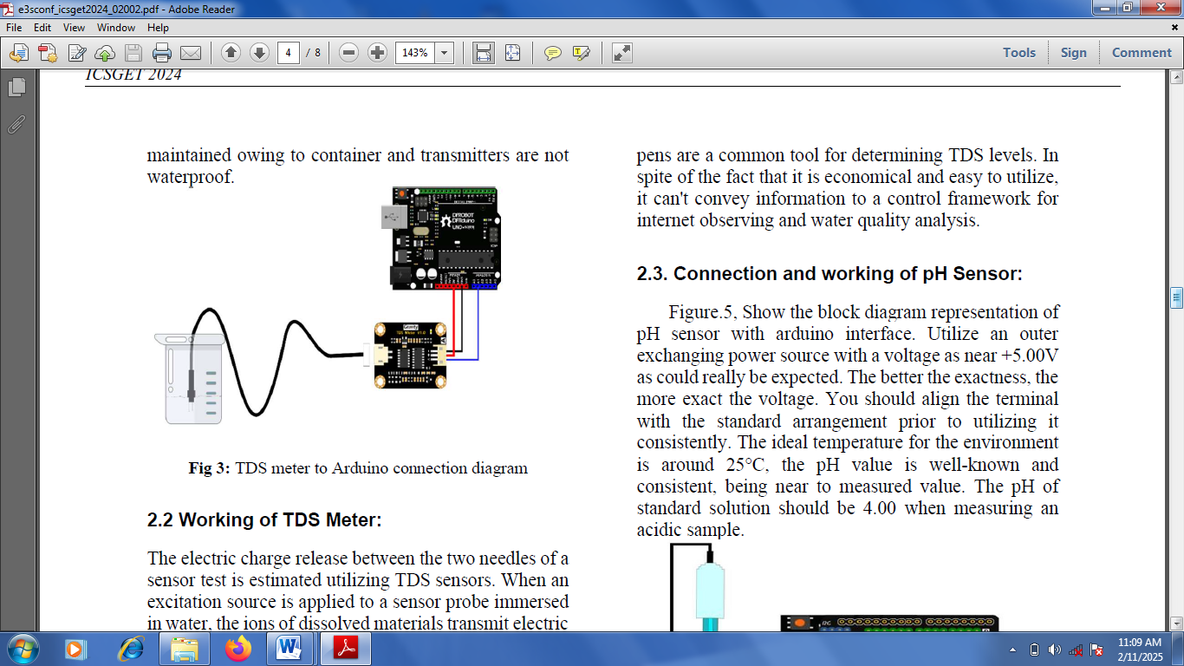

Figure 1: TDS measurement sensor

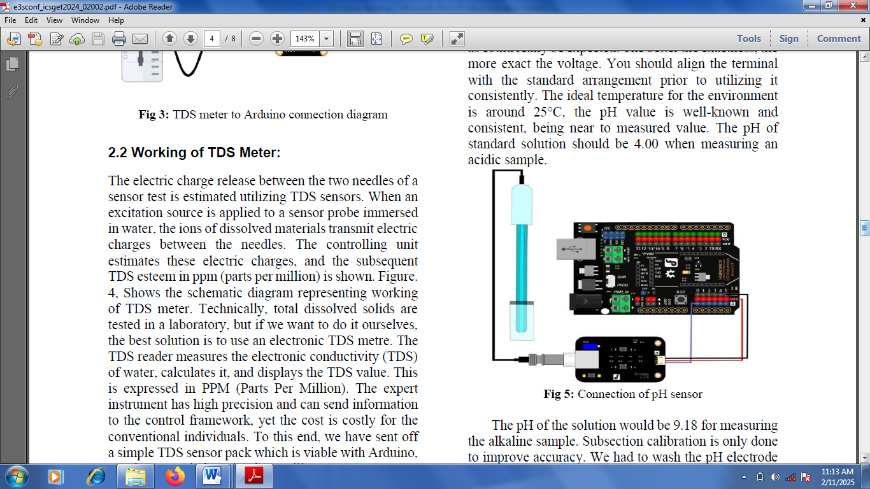

Figure 2: pH measurement sensor

Hydroponic farm can be remotely monitored by growers using IoT and data-driven strategies with the aid of computers or smartphones. The real-time data is being accessed, alerts on critical conditions are received and thus makes the system to be adjustable from anywhere while ensuring that ease of management and flexibility are provided. Also, the watering process can be automated by IoT to ensure sufficient water is received by the plants while reducing the wastage of water. The artificial lighting duration and intensity needed for the simulation of natural light cycles can be controlled using IoT for indoor arrangements while ensuring that optimal plant growth is promoted [10]. The historical data can be analyzed by ML algorithms for the prediction of crop yield and health potential in order to assist growers to maximize their farming practices and plan harvesting. Resource usages such as energy, nutrients and water are optimized by an IoT-based and data-driven hydroponic system resulting in cost and environmental impact reductions [11]. Also, the incorporation of this system with weather forecast data gives room for irrigation schedules control with reference to weather situations which further enhance the resource efficiency. Merging IoT technology with hydroponics provides substantial advantages which enable more automated, precise and data-driven farming practices. Higher yields can be achieved with the incorporation alongside lowered operational costs, excellent crop quality and a better sustainable technique to agriculture [12].

Data-driven and IoT incorporated hydroponics is a user-friendly approach which is easy to maintain and requires less power and water consumption. The automation components are integrated for proper control and monitoring of the hydroponic system to give effective outputs. Smart controllers are utilized in optimizing the required resources and managing the system. Energy-efficient LED is utilized for indoor farming situations during summer as a replacement to continuous air conditioning instead of implementing a climate monitoring system that regulates humidity and temperature within the hydroponic setup [13]. Other accorded benefits include the potential to design a delivery and nutrient solution mixing system which gives the plant the maximum growth it deserves via the provision of the adequate nutrients in the right proportion; reduction of the necessity for consistent replenishment and waste minimization via the utilization of a nutrient recycling system which is closed-loop based on design; remote management and monitoring of the hydroponic system using computers or smartphones via the creation of a user-friendly interface; and provision of real-time alerts and notifications for critical conditions. The practical model of hydroponic system is shown in Figure 3.

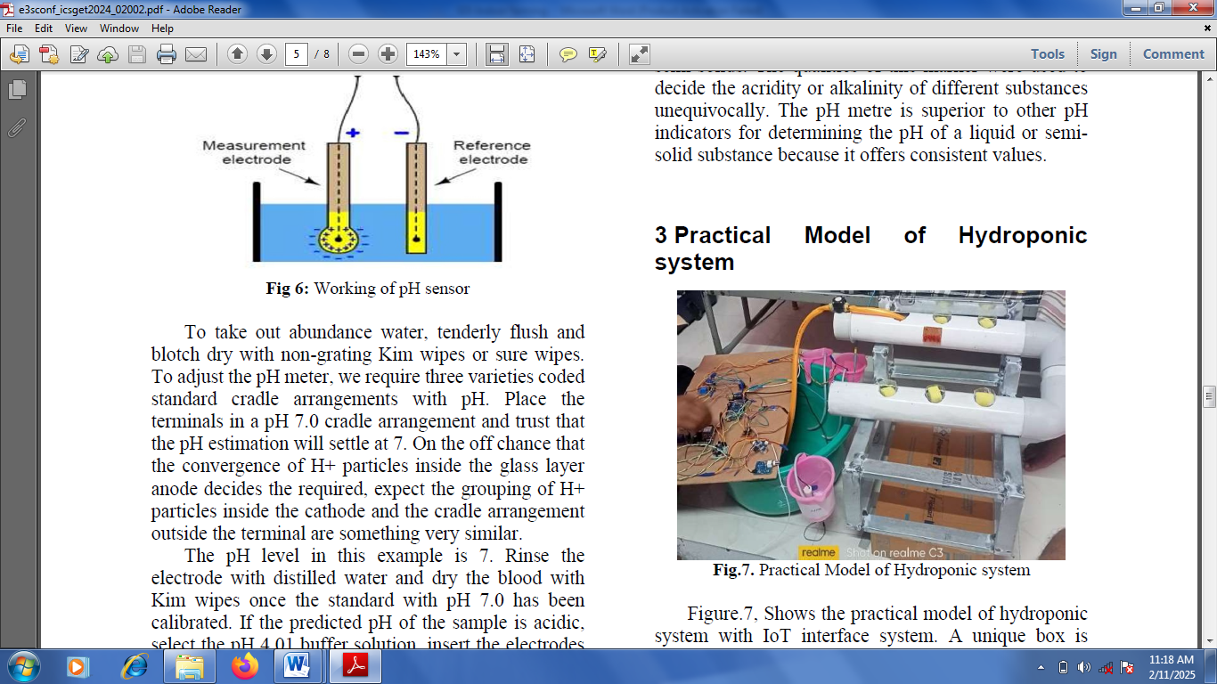

Figure 3: The practical model of hydroponic system

Prospectively, the data-driven and IoT incorporated hydroponics for a sustainable indoor farming via the optimization of the hydroponic crop production can be advanced and extended for large scale farming operations through the use of monitoring and centralized control systems to efficiently manage cases of multiple hydroponic units. There are different steps and procedures to take to achieve this. Instructional videos and guides should be provided to assist users in maintaining and setting up the systems effectively together with troubleshooting guides for general cases. The adoption of energy saving approaches and utilization of eco-friendly materials should be emphasized to ensure the environmental impact is drastically minimized. Effective recycling systems and irrigation techniques should be employed in promoting water conservation. Sharing of knowledge within users and community engagement should be encouraged to nurture a compassionate farming community [14]. Nonetheless, training sessions and workshops should be organized to enlighten people on the benefits of hydroponics. Additionally, it is imperative to provide a nutrient solution prepared in the right proportion of micro and macronutrients while equally giving consideration to oxygen concentration, pH and electrical conductivity in order to achieve optimal quality, yield and growth of crops in hydroponic systems. All the aforementioned points should be carefully considered by growers and researchers to avoid stress symptoms and improve crop performance in hydroponics. A reliable, sustainable, accessible and effective solution will surely be created for both large-scale and personal farming through the combination of sustainable practices and automation with hydroponics, even when the environmental situations are unfavourable [6].

Cases showing high significance of nutrient solution composition, oxygen concentration, pH and electrical conductivity on the quality, yield and growth of crops using hydroponic systems have been reported. Carmelo and tomato cultivars Torques yield have been found to be enhanced using cooper's nutrient solution by 21% and 32% respectively when observed in hydroponic systems [15]. Also, better vegetative yield and growth was observed in tomato cultivar Lucy using Cooper's solution than Plantain solution. The beta carotene content and pigment concentrations in tomato fruits were affected by the potassium concentration present in the nutrient solution under hydroponics. In order to achieve the desired fruit quality, it is vital to maintain the potassium concentrations appropriately. Nonetheless, excellent growth results were exhibited by cucumber seedlings when nurtured hydroponically using Hoagland solution in the presence of LED light. High photosynthetic activity, high biomass and healthy appearance were revealed. The same solution proved effective with qualitative improvements being exhibited by lettuce when compared with other different nutrient solutions under the same hydroponics environmental conditions. However, there is need to incorporate data-driven and IoT hydroponic systems for more user friendly and effective purposes [2].

In this article, the historical background of using hydroponic systems for farming purposes was discussed alongside with the fundamental principles, benefits and cases of its application in breeding crops for both personal and large scale farming. The need to incorporate data-driven and IoT into hydroponics to achieve a sustainable indoor farming and its optimization for crop production for both personal and large scale farming operations via using monitoring and centralized control systems was discussed in this paper. The introduction is presented in Section 1.0. The types of hydroponic systems and integration of IoT and data-driven strategies to optimize hydroponic crop production are presented in Sections 2.0 and 2.1 respectively. Section 3.0 discusses the design and development of smart hydroponics system while the challenges of the methodology for sustainable indoor farming are presented in Section 3.1. The conclusion is stated in Section 4.0.

2.0 Types of Hydroponic Systems

Different techniques via which oxygen, minerals and water can be delivered to plants are provided by hydroponic systems. A medium-like perlite is usually adopted by the flow system for periodic and stable pumping of nutrient solutions into trays for the plant to absorb them and in order to drain and recycle excess back into the reservoir. The various types of hydroponic systems are presented in Figure 4. These include the Nutrient Film Technique (NFT); Deep Water Culture (DWC); Wick System; Ebb and flow; Drip system and Aeroponics. In NFT, sloped channels are adopted for easy flow of the nutrient solution over the plant roots which stands as an ideal system for plants having large root systems. Plant roots are suspended in oxygenated nutrient-rich water with DWC. This made possible using an air pump which supplies the oxygen and thereby offer a low-maintenance arrangement. Materials like rockwool or perlite and nylon ropes are often used in Wick System to convey water and nutrients from the reservoir to the plants which makes the technique an economical one without the need for pumps [8]. In Drip Systems, nutrients are delivered via smaller tubes straight onto plants thereby making provision for those having little developed root systems. Aeroponics is a mist-based system in which plant roots receieved nutrient solutions via spraying in the absence of a medium. This is usually adopted for commercial purposes. Various kinds of plants and growing environments are caterred for with the existing different hydroponic techniques. Each of the methods possesses its own benefits for particular purposes [10].

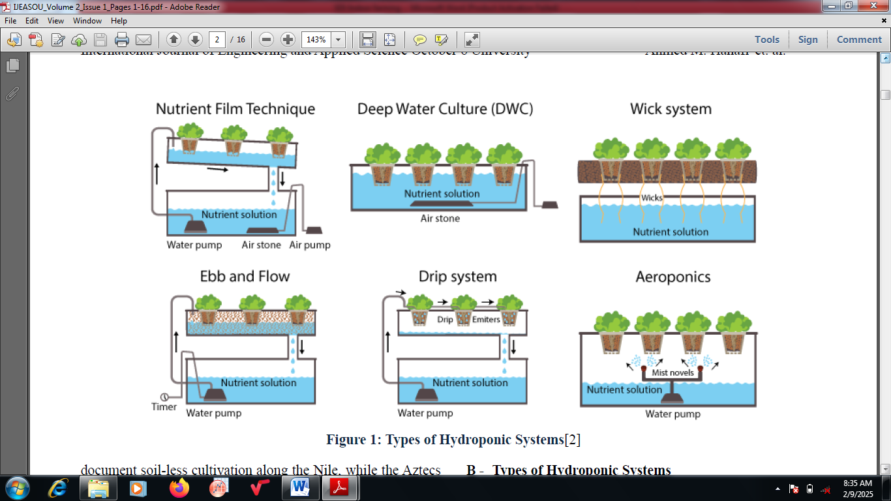

Figure 4: Types of Hydroponic Systems

2.1 IntegratiON of Internet of Things and Data-Driven Strategies to Optimize Hydroponic Crop Production

IoT is the network of actuators and wireless sensors which are buried in the earth to regulate and monitor different soil properties such as nutrients, moisture, pH levels and electrical conductivity. The protection of the sensitive electronics which are present in the wireless sensor nodes and reducing the wireless signal transmission loss are the principal challenges of incorporating IoT technology in hydroponic crop production. The characteristics of soil like humidity, temperature and pH are being sent to a smartphone over Bluetooth after proper monitoring [3]. The data then becomes accessible to the farmers to help them in the selection of fertilizers and crops. The incorporation of IoT technologies into Controlled Environment Agriculture (CEA) systems is a remarkable achievement and improvement in modern day agricultural practices. The efficiency and productivity of agricultural operations are increased through using IoT. To attain this, a network of interconnected devices are employed such as different actuators, sensors and communication systems [7].

Real-time data which allows the exact growing conditions regulation is recorded and given by the sensors through tracking of essential environmental variables such as CO2 levels, soil moisture, temperature, light intensity and humidity [12]. These parameters are modified by the automated watering systems and actuators such as temperature control units with reference to the sensor data to control and maintain the maximum situations for plant growth. Zigbee, Wi-Fi and LoRa protocols are adopted and utilized by connectivity solutions to ascertain uninterrupted communication between devices. The cloud computing data processing allows decision-making and real-time analysis. Among the numerous functions of IoT in Controlled Environment Agriculture include (1) optimization of water use with reference to the soil moisture levels through irrigation management; (2) modification of nutrient delivery in hydroponic systems through nutrient management; (3) pest and disease management that enables early discovery via sophisticated imaging and sensors; and (4) energy management [16]. Numerous advantages are linked to these applications such as enhanced crop yields, excellent resource management, better productivity and reduced labour costs. Despite these, there are some challenges that are needed to be addressed such as data security concerns, low technical reliability, expensive expenses and incorporation and integration problems. It is projected that present research and future IoT technological advancements such as those involving machine learning and artificial intelligence will improve the potential of IoT in Controlled Environment Agriculture and inspire additional sustainable and productive agricultural techniques. The incorporation of IoT and artificial intelligence in hydroponics is guaranteed to revolutionize the agricultural sector via the establishment of a more data-driven, sustainable and effective technique to food production [6].

3.0 construction of an Internet of Things-BASED hydroponics system: USING Nutrient Film Technique of hydroponics as a case study

Figure 5 presents a typical design and development of smart hydroponics system. Several key components are required for the construction of an IoT-based NFT hydroponics system [17-19]. These include:

* Growing/NFT Channels: Three channels having six separate holes placed at a distance of 15 cm from each centre point are components of the NFT hydroponics system in which the plants are situated. The channels are basically made up of nutrient solutions and water resistant materials or preferably food-grade PVC.
* Support Structure: Here, a sturdy support structure made from supporting rods are connected using clamp. Galvanized iron was used to make the rods. The well-situated NFT channels are made possible with the help of the supporting structure. For effective output, the supporting structure should have the potential to tolerate the nutrient solution, to resist plants weight and other system components.
* Reservoir and Pump: A pump that is submersible in nature having a power of 14W which have the capacity to pump water to 1.4 m height is utilized in circulating the nutrient solution from a reservoir tank (having the capacity of holding 30 L of nutrient solution) to the top of the NFT channels. This is recirculated continuously throughout the entire system. A constant flow of the nutrient solution by the pump should be guaranteed over the plant roots.
* Return System: A return system receives the extra nutrient solution supplied which has gone through the root zone at the end of the channels. The excess solution is then recycled back to the reservoir using the recirculated PVC pipes.
* Control System and Sensors: IoT incorporation requires sensors installation in monitoring different parameters such as electrical conductivity, humidity, temperature and pH. Data is transmitted to a control system via these sensors which could either be a central computer or a microcontroller. The data is processed by the control system which then prompts the necessary actions such as activation of the irrigation cycles or adjustment of the nutrient levels.
* Lighting System: A spectrum light with an artificial lighting system is installed in cases of low-light or indoor environments in order to make provision for the required spectrum and light intensity for maxima plant growth. The functionality, durability and maintenance ease should be prioritized in during the mechanical construction of an IoT-based NFT hydroponics system. It is vital to ensure secured connections, adequate sealing and circulation of appropriate nutrient to ensure a reliable and effective system is achieved.
* ESP32 microcontroller: This is utilized as a microcontroller in data storage and also aids Wi-Fi connection to the system from which the controlling and monitoring of sensor values is made feasible. The esp32 board is utilized to upload the data coming from EC, ultrasonic, humidity and temperature sensors to blynk application.
* Ultrasonic sensors: These are electronic devices which use emitted ultrasonic sound waves in evaluating the distance to a target and later convert the waves into electrical signals. They are often utilized to calculate the water level in the container. Nutrients are dispensed into the container as the water is 7cm away from the sensor.
* Electrical conductivity sensor: This is a device utilized in the evaluation of the electrical conductivity of a solution. They are usually utilized in aquaponics, hydroponics and other applications in which the exact monitoring of nutrient levels in water is vital.
* pH sensor: This is a device adopted in measuring the alkalinity or acidity of a solution by evaluating its pH value which is a measure of hydrogen ions concentration in a solution. It strongly indicates the alkalinity or acidity levels on a logarithmic scale ranging between 0 and 14. A pH value of 7 means neutrality while pH values of less than 7 shows acidity of a solution. Values more than 7 means the solution is alkaline in nature. A pH sensor is utilized in measuring the pH of nutrient solution in hydroponics.
* ESP8266 microcontroller: This is utilized as a microcontroller in data storage and also assists the system in connecting to the Wi-Fi via which controlling and monitoring of sensor values is made possible. The esp8266 board is utilized in uploading the pH sensor data to blynk application.
* 4-Channel relay module: This is a device which allows the multiple control of electrical circuits with aid of a microcontroller. The 4-Channel relay module is utilized in controlling the pH and nutrient dispenser pumps between the top and the bottom solutions.
* Nutrient pump: This is adopted in dispensing the nutrients into the principal container of the hydroponics system. These pumps are also helpful in dispensing the pH between the top and the bottom solutions into the container to ensure the pH is balanced.
* Blynk application: This is the general IoT platform that enables the easy creation of mobile applications in controlling and monitoring the connected devices. Blynk application is adopted in monitoring and controlling the nutrient dispensing, EC values and pH values in real time.

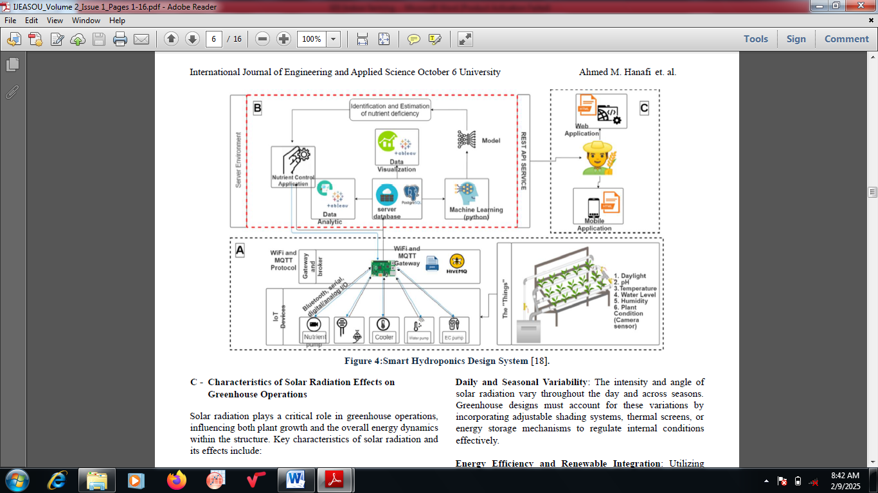

Figure 5: Design and Development of Smart Hydroponics System

3.1 challenges of using Iot and data-driven Hydroponic system for Sustainable Indoor Farming

The major challenges of using IoT and data-driven hydroponic system for sustainable indoor farming are stated here. The first is the water demand challenges. For example in Europe, It is evaluated that approximately, 3000 liters/person/day of water is often used for food production [20]. Water transportation from the source to the required location is usually tasking as some other components are required. The necessary nutrients required for different crops within the principal irrigation and hydroponic system is supplied through the water source. Another major existing challenge in hydroponic farming system is the required volume of land. Millions of hectares of natural land are being utilized for agricultural purpose making the system of farming very challenging [21]. It has severe harmful influence on biodiversity, herbal ecosystem and nature. Change in weather conditions is another challenging factor which influences hydroponic farming such as alteration in photo intensity, water supply and temperature which could hinder the crops growth and result in production yield loss. Every year, many crops produced via hydroponics are destroyed due to insufficient water supply resulting from doughtiness in some countries like the Midwest America [22]. Also, the high cost of computer components and gadgets required in making a suitable and effective IoT and data-driven system in hydroponic systems is another challenging task. Another accorded challenge is insufficient supply of energy required for plant growth inside a building. Hydroponic system being handled by IoT and data-driven technology utilizes both artificial and natural light as energy sources for photoperiodic and photosynthesis purposes by growing plants. Lastly, fossil fuels that are often needed for energy supply often contribute to environmental pollution via the release of pollutants into the atmosphere that are detrimental to human health [23].

4. Conclusion

The incorporation of IoT and data-driven technologies into hydroponics farming has innovative prospects. It allows farming systems to become more efficient, sustainable and flexible to cater for the increasing food security demands. A potent blend of controlled environment agriculture is established when IoT and real-time data driven are utilized for automated decision-making capabilities, resource optimization and predictive analytics. The accorded benefits of this approach include less environmental impact, increased crop yields, less resource consumption, sustainable food chain supply and ease of farming operation. The identified difficulties are data privacy concerns, high implementation costs and technological complexity. Data-driven and IoT-supported hydroponics exhibits a feasible pathway of achieving sustainable agriculture. There is need continuous research and innovative ideas to tackle the present problems of this approach and attain its full potential of this kind of farming system that is appearing complex to novice farmers.

References

1. Resh, H.M. (2016) Hydroponic Food Production: A Definitive Guidebook for the Advanced Home Gardener and the Commercial Hydroponic Grower; 19 April ,2016; CRC Press: Boca Raton, FL, USA, 2016; ISBN 1439878676.

2. Crisnapati, P.N.; Wardana, I.N.K.; Aryanto, I.K.A.A.; Hermawan, A. Hommons (2023) Hydroponic management and monitoring system for an IOT based NFT farm using web technology. In Proceedings of the 5th International Conference on Cyber and IT Service Management (CITSM), Denpasar, Indonesia, 8–10 August 2023; pp. 1–6.

3. Mehra, M.; Saxena, S.; Sankaranarayanan, S.; Tom, R.J.; Veeramanikandan, M. (2022) IoT based hydroponics system using Deep Neural Networks. Comput. Electron. Agric., 155, 473–486.

4. Maldonado, A.I.L.; Reyes, J.M.M.; Breceda, H.F.; Fuentes, H.R.; Contreras, J.A.V.; Maldonado, U.L. (2023) Automation and robotics used in hydroponic system. In Hydrocultural and Hydroponics Systems; Intech Open: London, UK.

5. Jin, X., Zhang, Y., & Liu, L. (2023). AI-Enhanced IoT Systems for Smart City Applications: A Comprehensive Review. Journal of Network and Computer Applications, 204, 103519.

6. Jones, L. J., & Martin, R. A. (2022). Optimizing Nutrient Delivery in Hydroponic Systems with IoT. Horticultural Technology, 32(6), 851-863.

7. Kalantari, F., Tahir, O. M., Joni, R. A., & Fatemi, E. (2021). A Review of Vertical Farming

Technology: A Guide for Implementation of Building Integrated Agriculture in Cities. Advanced Engineering Informatics, 47, 101233.

8. Khan, F.A., Kurklu, A., Ghafoor, A., Ali, Q., Umair, M., Shahzaib, (2018). A Review on

Hydroponic Greenhouse Cultivation for Sustainable Agriculture. Int. J. Agric. Environ. Food Sci., 2(2), 59-66.

9. Khan, R., Salah, K., Azzedin, M. (2022). Artificial Intelligence and IoT Integration for Smart City Applications: A Survey. Future Generation Computer Systems, 119, 357-370.

10. Lee, F. C., & Kumar, T. H. (2021). Energy Management in Smart Greenhouses with IoT.

Renewable Energy, 162, 1704-1715.

11. Lee, J., & Kim, S. (2023). Connectivity Solutions for IoT in Agriculture: A Comprehensive

Review. IoT Journal, 8(7), 123-145.

12. Lu J, Ehsani R, Shi Y, Abdulridha J, de Castro AI, Xu Y. Field detection of anthracnose crown rot in strawberry using spectroscopy technology. Comput Electron Agric 2017;135:289–99.

13. Mamatha, V., & Kavitha, J. C. (2023). Machine learning-based crop growth management in greenhouse environment using hydroponics farming techniques. Measurement: Sensors 25, 1-7.

14. Martin, R. D., & Smith, M. V. (2022). Actuation Systems in Agricultural IoT Applications.

Journal of Agricultural Engineering, 72(4), 45-59.

15. Musa, A., Hassan, M., Hamada, M., & Aliyu, F. (2022). Low-Power Deep Learning Model for Plant Disease Detection for Smart-Hydroponics Using Knowledge Distillation Techniques.

Journal of Low Power Electronics and Applications, 1-20.

16. Nguyen, C. T., & Chou, P. K. (2021). Automated Climate Control in Greenhouses Using IoT. Computers and Electronics in Agriculture, 181, 105931.

17. O'Brien, M. E. G., & Garcia, A. J. (2022). Precision Irrigation Systems with IoT: Efficiency and Water Conservation. Journal of Irrigation and Drainage Engineering, 148(9).

18. Rogers, H. J., & Thompson, K. E. (2023). IoT-Based Early Detection of Agricultural Pests and Diseases. Journal of Pest Science, 93(3), 1047-1060.

19. Singh, B. V., Ashutosh, Janbandhu, M. S., Satapathy, S. N., Das, H., Yadav, B.,... Singh, S. (2023). Hydroponics and Synergetic Technologies: A Deep Dive into Small and Medium-Scale Applications. International Journal of Plant & Soil Science, 32-41.

20. Wong, A. K. S., & Leung, H. M. (2021). IoT Sensors for Smart Agriculture: A Review. Sensors, 21(10), 3337.

21. Yang, R., Wu, Z., Fang, W., Zhang, H., Wang, W., Fu, L., Cui, Y. (2023). Detection of abnormal hydroponic lettuce leaves based on image processing and machine learning. Information Processing in Agriculture, 1-10.

22. Zhang, Y., & Liu, L. (2021). Edge and Cloud Computing for IoT-Based Smart Agriculture.

Future Generation Computer Systems, 114, 210-225.

23. Zhao, Y., Zhang, C., & Xu, Y. (2021). Integration of AI and IoT for Smart Agriculture: Challenges and Opportunities. IEEE Access, 9, 129512-129528.