Modeling of Giant Magnetoresistance (GMR): Simple, Advanced, and Complete Approaches- Application to Temperature Study

ABSTRACT
Aims: Today, giant magnetoresistors are used in a wide range of fields, from education to space and industrial applications. It is therefore necessary to develop different models for studying and implementing these components.
Study design: Giant magnetoresistance
Methodology: For this study, we have taken simple and advanced mathematical models from the literature. We then developed our CIP/CPP 2D model by solving the Boltzmann equations. Although this model is complex, it provides a detailed description of the operation of GMRs. To validate this model, we carried out a study of temperature dependence.
Results: As part of this study, we implement the different models in Matlab. The temperature study validate our 2D model.

Aims: Today, giant magnetoresistors are used in a wide range of fields, from education to space and industrial applications. It is therefore necessary to develop different models for studying and implementing these components.
Study design: Giant magnetoresistance
Methodology: For this study, we have taken simple and advanced mathematical models from the literature. We then developed our CIP/CPP 2D model by solving the Boltzmann equations. Although this model is complex, it provides a detailed description of the operation of GMRs. To validate this model, we carried out a study of temperature dependence.
Results: As part of this study, we implement the different models in Matlab. The temperature study validate our 2D model.

1. Introduction
Giant magnetoresistance (GMR) is a quantum phenomenon observed in multilayer structures composed of ferromagnetic and non-magnetic materials. Discovered in 1988 by Fert [1][3] and Grünberg [3][4], it revolutionized the field of data storage as well as spintronics, which exploits electron spin in addition to their charge [5].
In a GMR device, electrical resistance varies significantly depending on the relative orientation of the magnetic moments of the ferromagnetic layers. When these moments are aligned (parallel state, denoted as P), the resistance is minimal; when they are opposite (antiparallel state, denoted as AP), the resistance is maximal. A thorough understanding of this phenomenon is crucial not only for applications such as hard drive read heads and magnetic sensors [5] but also for optimizing the performance of spintronic devices [5].
This article presents a hierarchical approach to GMR modeling structured into three levels:
- A "simple" model based on the two-channel model.
- An "advanced" model inspired by the Valet-Fert theory, which introduces spin diffusion.
- A "comprehensive" model based on the numerical resolution of the Boltzmann equations, integrating spin diffusion effects and interface-specific boundary conditions in 1D and 2D.
We will detail the mathematical models of each approach, discuss their assumptions and limitations, and highlight the advantages and improvement prospects for quantitatively precise GMR modeling.

2. Simple Modeling of GMR

2.1 Mathematical Model
In this model, electronic transport is assumed to occur via two independent channels corresponding to majority and minority spin electrons. For each channel, conductivity is given by the classical relation [6]:
sigma_(±) = (e² * n_(±) * tau_(±)) / m*,
where:
- e is the elementary charge,
- n_(±) is the electronic density for the (+) or (-) channel,
- tau_(±) is the relaxation time for each channel,
- m* is the effective electron mass.
The resistance of each channel is inversely proportional to its conductivity, and the total resistance (when both channels are in parallel) is given by:
1/R_tot = 1/R_+ + 1/R_–
We also define the asymmetry coefficient as:
beta = (sigma_+ – sigma_–) / (sigma_+ + sigma_–).
By considering that the parallel state (P) corresponds to a configuration where the channels retain their intrinsic values, whereas the antiparallel state (AP) results in a modification (notably a reduction in relaxation time for one channel), a simplified analysis leads to the approximate relation [7]:
GMR = (R_AP – R_P) / R_P ≈ beta² / (1 – beta²).
This equation expresses the nonlinear dependence of the GMR ratio on the coefficient [8].

2.2 Results
The implementation of this model in MATLAB is presented in Figure 1. The figure shows the variation of normalized resistance (GMR effect) as a function of an external magnetic field ranging from -100 to 100 Oersted.
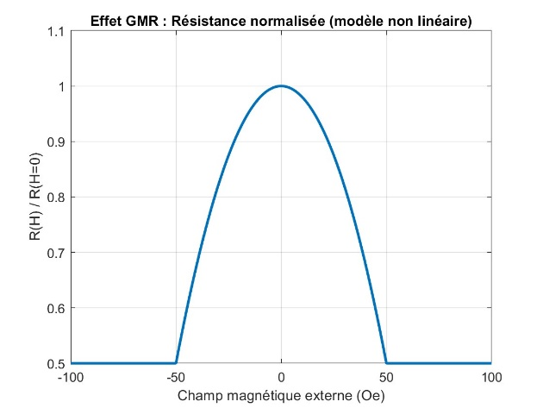
Fig. 1: Variation of normalized resistance (GMR effect) as a function of an external magnetic field ranging from -100 to 100 Oersted.

2.3 Discussion
This simple model presents several advantages:
- Simplicity and intuition: The analytical formulation allows for a quick understanding of how conduction imbalance between the two channels influences the GMR phenomenon.
- Starting point: It provides an initial framework for comparison with more elaborate models.
However, it is based on strong assumptions:
- The two channels are considered independent (except for minimal coupling represented by beta).
- The model does not account for boundary conditions at interfaces or temperature dependence.
- Nonlinear effects and magnetic hysteresis are ignored.
Despite these limitations, this model remains useful for qualitatively grasping the behavior of GMR and serving as a benchmark for more advanced approaches.
3. Advanced Modeling of GMR
3.1 Mathematical Model
To go beyond the simple description, the advanced model relies on the Valet-Fert theory [11], which describes spin diffusion in multilayer structures. In this framework, the spin-dependent chemical potential mu_sigma(x) (for sigma = + or -) satisfies a transport equation of the form:
(d²mu_sigma/dx²) = (mu_sigma – mu_(-sigma)) / (lambda_sigma)²,
where lambda_sigma is the spin diffusion length for the corresponding channel [12]. This model accounts for spin accumulation at interfaces and variations in effective relaxation times within the layers.
The resistance of a layer is given by [13]:
R_F = (rho_F * t_F) / lambda_F and R_N = (rho_N * t_N) / lambda_N,

where:
- rho_F and rho_N are the resistivities of the ferromagnetic and non-magnetic layers,
- t_F and t_N are their respective thicknesses.
Interfaces between layers introduce an additional resistance R_i, which translates into a potential jump at the interface [14]:
mu_sigma^(m) – mu_sigma^(n) = R_i^sigma * J_sigma,
where J_sigma is the current in the channel. This jump reflects the spin-dependent transmission at interfaces [15].
3.2 Results
The MATLAB implementation results of this model are presented in Figure 2. The figure illustrates the variation of normalized resistance (GMR effect) as a function of an external magnetic field ranging from -0.1 to 0.1 Tesla.
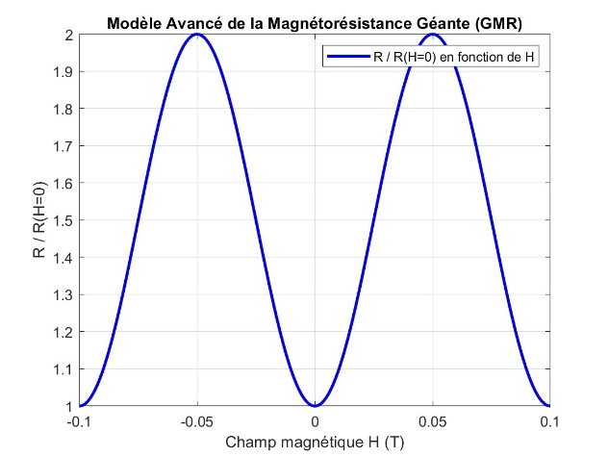
Fig. 2: Variation of normalized resistance (GMR effect) as a function of an external magnetic field ranging from -0.1 to 0.1 Tesla.
3.3 Discussion
The advanced model provides better agreement with experimental observations by integrating:
- The concept of spin diffusion length, essential for describing spin accumulation.
- A refined description of interface effects via R_i.
- Differentiation between diffusion in ferromagnetic and non-magnetic layers.
However, this approach remains generally limited to a 1D geometry (CPP configuration) and assumes a linear regime. Some effects, such as magnetic hysteresis or nonlinear parameter variations with temperature, are not yet integrated into this model.
4. Comprehensive Modeling with Boltzmann Equations
For a quantitatively precise description of the GMR phenomenon, it is necessary to start from the fundamental equations of kinetic theory and include spin diffusion effects as well as boundary conditions specific to interfaces. The approach is structured in multiple levels, presented below.
4.1 General Mathematical Model
For each spin channel (denoted σ, with σ = + for majority electrons and σ = - for minority electrons), the distribution function satisfies, under the relaxation time approximation, the linearized Boltzmann equation [16]:
v · ∇f₍σ₎(r, v) + e E · ∇₍v₎f₍σ₎(r, v) = − [ f₍σ₎(r, v) − f₀(ε) ] / τ₍σ₎ − [ f₍σ₎(r, v) − f₍−σ₎(r, v) ] / τ_sf
where:
- f₀(ε) is the equilibrium distribution (e.g., Fermi-Dirac distribution) [17],
- τ₍σ₎ is the relaxation time of the channel σ,
- τ_sf is the spin relaxation time, coupling both channels [18],
- E is the applied electric field,
- V represents electron velocity.
Linearizing around equilibrium, we write:
f₍σ₎(r, v) = f₀(ε) − (∂f₀/∂ε) · ψ₍σ₎(r, v)
where ψ₍σ₎(r, v) is the perturbation induced by the electric field [19]. By multiplying the Boltzmann equation by appropriate moments (e.g., 1 for density, or m·v for current) and integrating over velocity space, we obtain a system of diffusion equations for spin-dependent chemical potentials μ₍σ₎(r).
In a simplified two-dimensional version (r=(x,y)), the system is written as follows:
(1) σ(T) · (∂²μ₊/∂x² + ∂²μ₊/∂y²) = [ μ₊ − μ₋ ] / R_sf(T)
(2) σ(T) · (∂²μ₋/∂x² + ∂²μ₋/∂y²) = [ μ₋ − μ₊ ] / R_sf(T)
Here, σ(T) represents the effective conductivity (which may vary with temperature T), and R_sf​(T) is a parameter encompassing spin relaxation effects (related to τ_sf and the spin diffusion length) [20]. These equations describe the spatial distribution of chemical potentials for each channel in a homogeneous material subjected to an electric field.
4.2 CIP 1D Model
In the Current-In-Plane (CIP) 1D configuration, it is assumed that potential variation occurs only along a single direction (e.g., x). For each channel, the diffusion equation simplifies to:
(3) σ · (d²μ₍σ₎/dx²) = [ μ₍σ₎(x) − μ₍−σ₎(x) ] / R_sf
Typical boundary conditions for this model are:
- At (input edge): μ₊(0) = μ₋(0) = V₀.
- At x = L (output edge):
For the parallel configuration (P): μ₊(L) = μ₋(L) = 0.
For the antiparallel configuration (AP): and μ₊(L) = 0 et μ₋(L) = V₀.
By solving numerically (e.g., using finite differences) equation (3) with these boundary conditions, the distribution of potentials and is obtained. The current in each channel is given by Ohm’s local law:
J₍σ₎ = −σ · (dμ₍σ₎/dx)
The total current is the sum J_tot = J₊ + J₋, and the effective resistance is:
R_eff = V₀ / |J_tot|.
The GMR ratio is defined as:
GMR = (R_AP − R_P) / R_P
where R_P and R_AP are the effective resistances obtained for parallel and antiparallel configurations, respectively.

4.3 Results
The MATLAB implementation of the CIP model for GMR, based on the Boltzmann equation in the relaxation time approximation, is illustrated in Figures 3 and 4. This script presents a two-channel model for giant magnetoresistance (GMR) in a Current-In-Plane (CIP) configuration. It is assumed that the conductivity of each channel is given by
sigma = (e^2 n tau)/m*, and that the GMR effect results from a resistance change due to the variation of relaxation times in parallel (P) and antiparallel (AP) configurations.
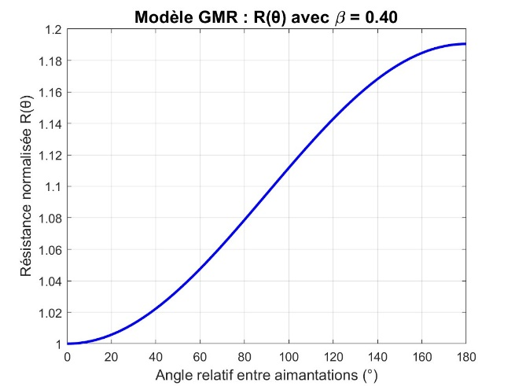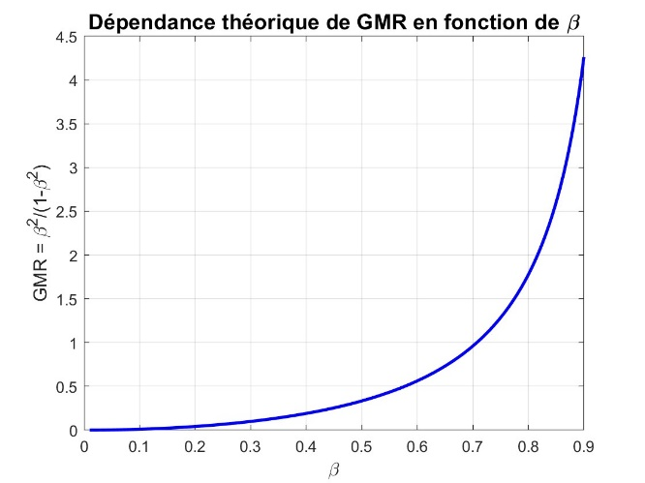
Fig. 3 (left): Normalized resistance variation Fig. 4 (right): GMR dependence as a function of β
as a function of the magnetization angle
for β=0.4\beta = 0.4β=0.4.
.

4.4 Mathematical Model for CIP and CPP (1D)
The primary difference between the CIP and CPP configurations lies in the main current direction and the boundary conditions:
- In the CIP (Current-In-Plane) configuration:
The electric field is generally considered homogeneous within the layer plane, with variations occurring along a single direction (e.g., x). The boundary conditions can be imposed similarly to the 1D model described above, or periodic conditions may be used to model continuity in the plane.
- In the CPP (Current-Perpendicular-to-Plane) configuration:
The current flows perpendicularly through the layers. In this case, the potentials primarily depend on x (or z, depending on the reference frame). The boundary conditions reflect the magnetic alignment of the layers, for example:
- À x = 0 (entrée) : μ₊(0) = μ₋(0) = V₀.
- À x = L (sortie) :
- – Pour l’état P : μ₊(L) = μ₋(L) = 0.
- – Pour l’état AP : μ₊(L) = 0 et μ₋(L) = V₀.
The difference in boundary conditions results in a modification of the potential distribution, leading to variations in current and effective resistance. This model enables a quantitative comparison of the effects of CIP and CPP geometries on the GMR ratio.

4.5 Results
To illustrate this section, a complete MATLAB implementation of the two-channel GMR model in CIP/CPP configurations, including a spin relaxation term (spin ↑ and ↓), was developed. This approach is derived from the Chapman-Enskog expansion of the Boltzmann equation. The script numerically solves the diffusion equations for the spin-dependent chemical potentials μ+​ and μ−​ over the domain [0, L] using finite difference methods. Two boundary condition configurations are considered: the parallel (P) and antiparallel (AP) states. Figure 5 presents the results of the variation of μ+​ and μ−​ in both configurations.
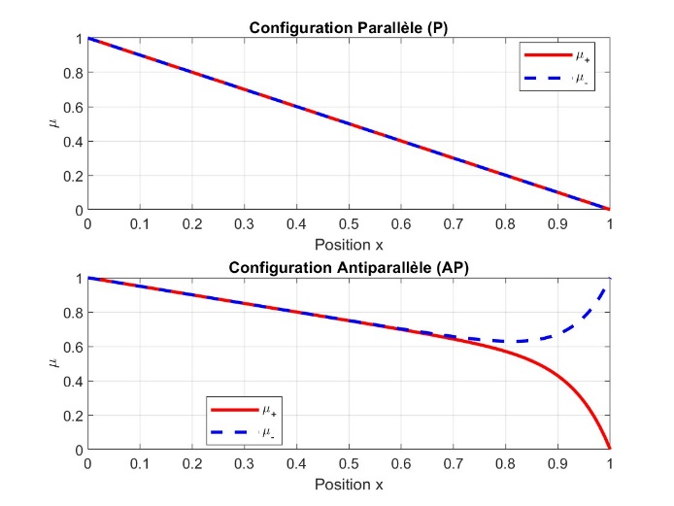
Fig. 5: Variation of μ+ and μ−​ in the parallel and antiparallel configurations.

4.6 Mathematical Model for CIP and CPP in 2D
The extension to two dimensions involves considering a spatial domain Ω defined by:
x ∈ [0, Lₓ] et y ∈ [0, L_y].
For each spin channel, the diffusion equation is written as follows:
(4) σ(T) · [ (∂²μ₍σ₎/∂x²) + (∂²μ₍σ₎/∂y²) ] = [ μ₍σ₎(x,y) − μ₍−σ₎(x,y) ] / R_sf(T)
The boundary conditions are imposed as follows:
- Input boundary (x=0x = 0x=0):
For all y in [0, Ly​], we impose: μ₊(0, y) = μ₋(0, y) = V₀.
- Output boundary (x=Lx):
  - For the parallel (P) state:
For all y, μ₊(Lₓ, y) = μ₋(Lₓ, y) = 0.
  - For the antiparallel (AP) state:
For all y, μ₊(Lₓ, y) = 0 et μ₋(Lₓ, y) = V₀.
- Lateral boundaries (y=0 and y=L_y​):
Neumann boundary conditions are imposed, meaning that the flux along y is zero:
∂μ₍σ₎/∂y (x, 0) = 0 et ∂μ₍σ₎/∂y (x, L_y) = 0.
By numerically solving equation (4) under these conditions, the spatial distributions μ₊(x,y) et μ₋(x,y) are obtained. The local current in each channel is given by:
J₍σ₎(x,y) = −σ(T) · ∇μ₍σ₎(x,y)
and by integrating over the transverse section (along y), the total current is determined. The effective resistance of the device is then calculated as:
R_eff = V₀ / |J_avg|
where J_avg is the average current over the considered section. Finally, the GMR ratio is defined as:
GMR = (R_AP − R_P) / R_P
This 2D model has the advantage of accounting for spatial variations in the plane, allowing the study of the impact of geometry and boundary conditions on the potential distribution and, by extension, on overall transport within the device.

4.7 Results
A result from the MATLAB implementation of the 2D GMR model in the CPP configuration is presented in Figure 6. This script is based on the finite difference solution of two coupled diffusion equations for the spin-dependent chemical potentials μ₊(x,y) and μ₋(x,y). The equation for each channel is:
sigma*(d²μ/dx² + d²μ/dy²) = (μ_σ - μ_{-σ})/R_sf,

with σ = + ou -, and R_sf ​ characterizing spin relaxation.
Two boundary condition configurations are considered: parallel (P) and antiparallel (AP).
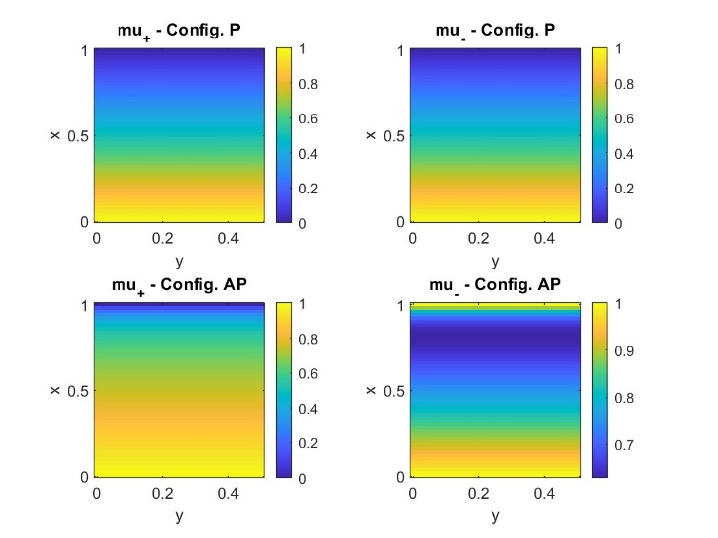
Fig. 6: Variation of the spin-dependent chemical potentials μ₊(x,y) and μ₋(x,y) for the parallel (P) and antiparallel (AP) configurations.

Discussion of Mathematical Models
The different approaches presented illustrate a progression in the modeling of GMR:
- Simple model (two-channel model):
This model provides an initial understanding of the phenomenon by directly linking the conduction imbalance (measured by the coefficient β) to the GMR ratio. It is analytical and intuitive but remains limited by simplifying assumptions (diffusive transport, absence of interface and temperature effects).
- Advanced model (Valet-Fert model):
By introducing the spin diffusion length and accounting for the resistance of layers and interfaces, this model refines the description of electronic transport. It captures spin accumulation at interfaces and explains why resistance varies significantly between P and AP states. However, it is generally restricted to a 1D description and does not explicitly address nonlinear effects or hysteresis.
- Comprehensive modeling with Boltzmann equations:
By solving the linearized version of the Boltzmann equations, a system of diffusion equations for the chemical potentials is obtained, which can be extended to both 1D and 2D geometries. This model quantitatively integrates spin diffusion effects, interface-specific boundary conditions (e.g., potential jumps proportional to interface resistance), and temperature dependence. The 2D approach is particularly relevant for modeling real devices, where the electric field and potential gradients vary in-plane (CIP configuration) or perpendicularly (CPP configuration). Although numerically more complex, this approach provides accurate predictions and is essential for optimizing spintronic device design.
Each level of modeling provides complementary insights. One of the main challenges is obtaining reliable physical parameters (relaxation times, resistivities, diffusion lengths, etc.) and validating models through comparison with experimental data. Furthermore, including temperature dependence opens the way for studying GMR evolution under various operational conditions.

6. Application to Temperature Study
The objective here is to understand how temperature variations between -150°C and 150°C affect the GMR ratio in the 2D model.
The temperature dependence is influenced by the material used and the electronic and magnetic interactions within the system. In general, experimental studies reveal two main trends:
- Exponential variation: Many experimental results suggest an exponential dependence, reflecting the fact that the spin effect decreases significantly with increasing thermal agitation.
- Linear variation in some materials: In systems with impurities or limited diffusion effects, a linear trend may be observed. This tendency is sometimes noticeable at moderate temperatures before a more rapid decay sets in.
Based on experimental studies conducted on magnetic multilayers such as Co/Cu or Fe/Cr, the exponential decay model is generally more suitable.
To account for this, temperature-dependent relations for key parameters, such as conductivity (σ), relaxation time, and R_sf​, are integrated into the model. The MATLAB implementation computes the variation of these parameters as a function of temperature and solves the 2D GMR model accordingly.
In this model, the diffusion equations for the spin-dependent chemical potentials μ+(x,y) and μ−​(x,y)) are solved using finite difference methods over a rectangular domain. The temperature influence T (expressed in Kelvin) is introduced through two scaling parameters that affect the conductivity σ and the spin relaxation parameter Rsf​. The reference temperature is set at Tref​=298K (25°C), with reference values σref​=1.0 and Rsf,ref=0.01 (arbitrary units), while the temperature coefficients are chosen as α=β=10−3 K⁻¹.
The model is solved for two boundary condition configurations:
- Parallel (P) configuration:
μ+(0,y)=μ−(0,y)=V0 et μ+(Lx,y)=μ−(Lx,y)=0
- Antiparallel (AP) configuration:
μ+(0,y)=μ−(0,y)=V0 ​ et μ+(Lx,y)=0 , μ−(Lx,y)=V0​.
The current is estimated from the gradient at x=0, and the effective resistance is defined as:
Reff​=V0​/∣J∣.
For each temperature, the GMR ratio is computed as:
GMR(T) = (R_AP(T) – R_P(T)) / R_P(T)
Figure 7 presents the results of this implementation. It is observed that the GMR effect increases by a factor of 3 between -150°C and 25°C. This demonstrates that GMR performance improves at lower temperatures, highlighting the potential of GMR-based technologies in cold environments.
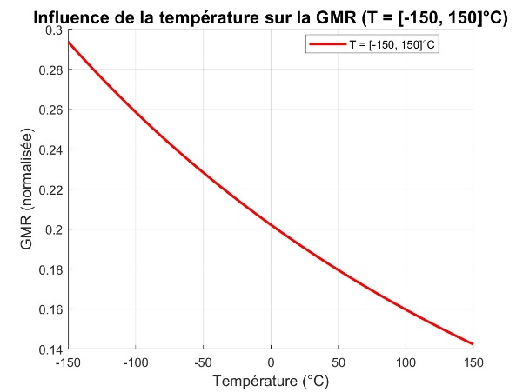
Fig. 7: Variation of the GMR effect between -150°C and 150°C.

7. Conclusion
This study has presented a hierarchical approach to modeling giant magnetoresistance (GMR), starting from a simple two-channel model to a comprehensive formulation based on the Boltzmann equation. The simple model provides an intuitive analytical relationship linking conduction imbalance (expressed by the coefficient β\betaβ) to the GMR ratio. The advanced model, based on Valet-Fert theory, incorporates spin diffusion and interfacial effects, improving agreement with experimental observations. Finally, the full 2D model offers a precise quantitative description of spin-dependent transport, accounting for specific boundary conditions and temperature dependence.
The temperature study has shown that the GMR effect is enhanced by a factor of 3 between -150°C and 25°C, demonstrating improved GMR performance at lower temperatures.
A deep understanding of spin-dependent transport, obtained through these models, is crucial for optimizing GMR-based devices. The comparison between theoretical predictions and experimental results is a key driver for advancing the design of magnetic sensors and non-volatile memory technologies. Future research could extend these approaches to 3D modeling, incorporate first-principles electronic structure calculations, and investigate nonlinear or hysteresis effects to further enhance the performance of spintronic technologies.
References
[1] Baibich, M. N., Broto, J. M., Fert, A., Van Dau, F. N., Petroff, F., Etienne, P., ... & Chazelas, J. (1988). Giant magnetoresistance of (001)Fe/(001)Cr magnetic superlattices. Physical Review Letters, 61(21), 2472.
[2] Binasch, G., Grünberg, P., Saurenbach, F., & Zinn, W. (1989). Enhanced magnetoresistance in layered magnetic structures with antiferromagnetic interlayer exchange. Physical Review B, 39(7), 4828.
[3] Fert, A., & Campbell, I. A. (1976). Two-current conduction in nickel. Physical Review Letters, 37(5), 303.
[4] Grünberg, P. (2001). From spinwaves to giant magnetoresistance (Nobel Lecture). Angewandte Chemie International Edition, 40(15), 2610-2618.
[5] Baibich, M. N., & Fert, A. (2003). Giant magnetoresistance: The discovery and the applications. Journal of Magnetism and Magnetic Materials, 262(1), 1-7.
[6] Camley, R. E., & Barnas, J. (1989). Theory of giant magnetoresistance effects in magnetic layered structures with antiferromagnetic coupling. Physical Review Letters, 63(6), 664.
[7] Levy, P. M., & Zhang, S. (1997). Resistivity due to domain wall scattering. Physical Review Letters, 79(25), 5110.
[8] Valet, T., & Fert, A. (1993). Theory of the perpendicular magnetoresistance in magnetic multilayers. Physical Review B, 48(10), 7099.
[9] Dieny, B., Speriosu, V. S., Parkin, S. S. P., Gurney, B. A., Wilhoit, D. R., & Mauri, D. (1991). Giant magnetoresistive in soft ferromagnetic multilayers. Physical Review B, 43(1), 1297.
[10] Barnas, J., Fuss, A., Camley, R. E., Grünberg, P., & Zinn, W. (1990). Novel magnetoresistance effect in layered magnetic structures: Theory and experiment. Physical Review B, 42(11), 8110.
[11] Valet, T., & Fert, A. (1993). Theory of the perpendicular magnetoresistance in magnetic multilayers. Physical Review B, 48(10), 7099.
[12] Rashba, E. I. (2002). Spin currents in thermodynamic equilibrium: The challenge of discerning transport currents. Physical Review B, 68(24), 241315.
[13] Zhang, S., Levy, P. M., & Fert, A. (2002). Mechanisms of spin-polarized current-driven magnetization switching. Physical Review Letters, 88(23), 236601.
[14] Stiles, M. D., & Zangwill, A. (2002). Anatomy of spin-transfer torque. Physical Review B, 66(1), 014407.
[15] Brataas, A., Nazarov, Y. V., & Bauer, G. E. W. (2000). Finite-element theory of transport in ferromagnet–normal metal systems. Physical Review Letters, 84(11), 2481.
[16] Ziman, J. M. (2001). Electrons and Phonons: The Theory of Transport Phenomena in Solids. Oxford University Press.
[17] Mahan, G. D. (2000). Many-Particle Physics. Springer Science & Business Media.
[18] Ashcroft, N. W., & Mermin, N. D. (1976). Solid State Physics. Holt, Rinehart and Winston.
[19] Kadanoff, L. P., & Baym, G. (1962). Quantum Statistical Mechanics: Green's Function Methods in Equilibrium and Nonequilibrium Problems. Benjamin-Cummings Publishing Company.
[20] Tsymbal, E. Y., & Pettifor, D. G. (2001). Perspectives of giant magnetoresistance. In Solid State Physics (Vol. 56, pp. 113-237). Academic Press.

