***Original Research Article***

**STABILITY ANALYSIS OF DIAPHRAGM WALLS FOR COASTAL PROTECTION WORKS IN THE NIGER DELTA BY FINITE ELEMENT STRESS-BASED METHOD.**

**ABSTRACT**

In this study, a 2D uncoupled transient seepage and load deformation analyses were carried out to determine the stability of the diaphragm wall in different soil stratigraphy in the Niger Delta using the finite element stress-based method. The finite element solutions are based on the Galerkin’s weighted residual method and the use of Lagrange isoparametric triangular or quadrilateral elements. Most coastal structures are founded on deep foundation with diaphragm walls for coastal protections (quay walls). Diaphragm walls serve the dual purpose of coastal protection and berthing of vessels. Transient seepage/sediment transport (flow boundary conditions) and stress-deformations (stress boundary conditions) are the major controlling factors in the stability analysis of diaphragm walls for coastal protection works. Representative soil stratigraphy along the coastline of the Niger Delta region were subjected to different stress and flow conditions modelled using a finite element method-based product Geostudio 2018R2V9.1 with several components for specific purposes. Uniform surcharge loads of 40KPa, 60Kpa, 80KPa, 100KPa and 120KPa were applied to the different case studies at varying dredge depths of 10m, 16m and 19m under transient seepage conditions. Stability factors for critical slip surfaces and local stability factor of each slice for both shallow and deep-seated failure modes of the diaphragm wall were determined. The results obtained showed that diaphragm walls embedded in Stiff to firm clay offered better resistance than those in sand or sand with clay intercalations for both shallow (10m) and deep-seated slip surface (19m) failure modes. The solutions obtained were in agreement with literature. Therefore, it is recommended that uncoupled/coupled transient seepage and stress-deformation analyses should be considered in the stability analysis and design of diaphragm walls for coastal protection works in the Niger Delta region.

**Keywords:** Finite Element, Stress-deformation, Transient Seepage, Sediment Transport, Stability Analysis, Geostudio, Diaphragm Walls, Coastal Protection, Niger Delta

**1. INTRODUCTION**

The activities of the oil/gas industries and transshipment of freight through waterways have increased the construction of coastal structures and ports along the shoreline of the Niger Delta region. Most coastal structures are founded on deep foundations with diaphragm walls for shoreline protections (quay walls). Diaphragm walls are embedded retaining walls that depend to a great extent or wholly on the earth passive resistance below dredge level and support systems [1]. The weak soils (Recent deposits) are along the coastline with high phreatic level, presence of compressible organic clays, peat and hydraulic fills exert large initial stresses [2]. The adverse coastal environmental conditions with repeated variation in water levels, currents, and wave impacts, results in saturated or unsaturated soil conditions with time-dependent flow and pore-water pressure fluctuations along shorelines. Transient seepage/sediment transport and externally applied loads/lateral earth pressures are the major controlling factors in the stability of diaphragm wall for coastal protection works in the Niger Delta. Simulation of seepage and sediments transport through soils (both saturated and unsaturated conditions) results in the computation of fluxes, pore-water pressures distributions and water velocity/pathway (migration of sediments) that are used as hydraulic boundary conditions in the stress deformation analysis, through which internal stresses distribution needed for detailed engineering stability analysis/design of diaphragm walls along the shorelines computed [3]. The alarming rates of failure of coastal protection works due to stability problems of diaphragm walls have been a major problem in the Niger Delta region affecting adjoining quay apron stacking areas and disruption of offshore productions/cargo transportation. For these reasons, stability analysis of diaphragm walls continues to be major geotechnical problems and are being investigated by many researchers.

[4] modelled the stability of sheet pile walls subjected to seepage flow by slip lines (method of stress characteristics) and finite elements method. [5] investigated the effect of steady state seepage flow and the stability of vertical sheet pile walls were considered in a cohesionless soil and stability evaluated in terms of the rotation about the anchor attachment. [6] studied the stability of diaphragm wall for deep excavation by using Plaxis 2D to determine the factors affecting stability. [7] conducted a numerical analysis of a 36m deep diaphragm wall using Geo5 and internal stresses and displacements were compared. [8] used closed form solution based on the principle of minimum potential energy to compute lateral displacement and internal force in diaphragm walls. [9] carried out different analysis /calculations on diaphragm wall using dependent pressures method and Plaxis software to determine internal forces.

Detailed engineering evaluations must be carried out to determine the transient seepage and stress-deformations conditions during the analysis/design phase before the construction of diaphragm wall for coastal protection works. The dependent variable solved for in a finite element solution of a seepage problem is the pressure head and of a load deformation problem is the displacements (deformations) at each nodal point in the finite element mesh [10,11]. For such complex stratigraphy (multi-layer saturated/unsaturated soils) with transient flow having varying boundary conditions and different stage construction processes involving incremental loading, analytical and general limit equilibrium methods (GLE) solutions are not possible rather high-power numerical methods (finite element stress-based method) provide the needed solutions. The finite element stress-based method captures the localized shear stress concentration, local factor of safety, soil-structure interaction problems and possible convergence problems with the general equilibrium methods [11]. Finite element method is very useful in finding solutions to differential equations that have no close form or analytical solutions [12,13].

In this paper, transient seepage in saturated-unsaturated soil conditions were considered and used as boundary conditions in the computation of the stresses needed for stability analysis of diaphragm walls for coastal protection works.

**2.** **METHODOLOGY**

**2.1 Study Area**

The area of the research is the Niger Delta region in the southern part of Nigeria bordering with the Atlantic Ocean, Figure 1. In Niger Delta region, diaphragm walls are used for shoreline protections such as in Nigerian Ports Authority berths (4, 5, 6, 9,10,11 and 12), West African Container Terminal berths (7 and 8) in Federal lighter Terminal and Federal Ocean Terminal Onne Rivers State and Nigerian Port Authority Warri in Delta State. The sites as shown in the goggle map are located in Onne, Eleme local government area of Rivers state Nigeria. They are accessible through the Federal Ocean Terminal junction and also through Ogu creek and Bonny River at the back side. Total area of the site in the Federal Lighter Terminal (FLT) is 26,250sqm comprising of berth 1-3 and 131,250sqm comprising of berth 1-15 in the Federal Ocean Terminal (FOT) of the Nigerian Ports Authority (NPA) Onne. Berths 1-3 in FLT and Berths 1- 11 in the FOT lie along the Ogu creek side while Berth 12-15 in FOT lie along the Bonny River side. The sites are approximately 10km from the Atlantic coast with the Federal Ocean Terminal actually located in an inlet, where tidal currents play a major role in water flow. The areas investigated falls within the tertiary Niger Delta which occurs at the south-central sedimentary basin of Nigeria bordering the Atlantic Ocean and extends from about 3º-9ºE and latitude 4º30’ - 5º20’N (from Berth 9-11).

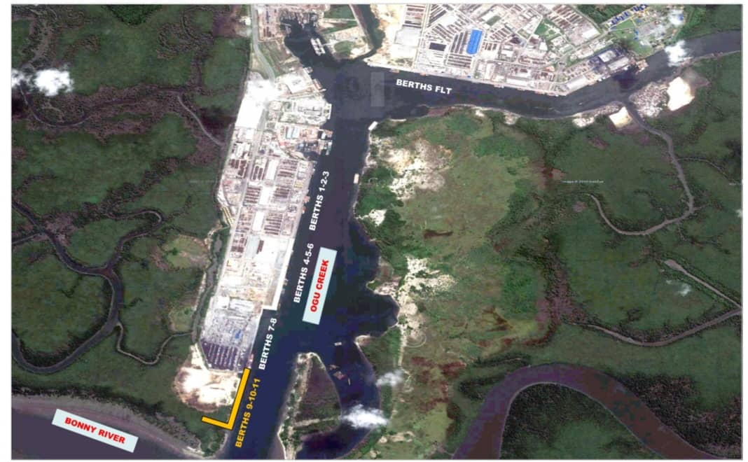

**Figure 1. Goggle maps of Onne study area**

**2.2 Sources of Data**

Relevant data used were obtained from standard codes of practice, authorities and reputable sources. Laboratory tests results on representative samples were also taken from these areas from Dutch Cone penetrometer tests (CPT) to refusal depths and various geotechnical boreholes to depth of 40 metres below existing ground level and Standard Penetration Tests, showed similar lithology (subsoil and groundwater conditions) which have been classified into 3 categories. All the tests were executed in accordance and compliance with the specifications contained in [14].

**2.2.1 Geotechnical Soil Stratigraphy & Properties, Boundary Conditions, Properties of Anchor Data for Geostudio Modelling.**

Table 1 shows the soil stratigraphy for the 3-Case study with a probe depth of 40m, as used for Geostudio Modelling.

**Table 1. Soil Stratigraphy for Geostudio Modelling**

|  |  |  |  |  |  |  |  |  |  |
| --- | --- | --- | --- | --- | --- | --- | --- | --- | --- |
| **Strata Unit** | **Case Study 1** | | | **Case Study 2** | | | **Case Study 3** | | |
|  | Description | Top level  (m) | Bottom level  (m) | Description | Top level  (m) | Bottom level  (m) | Description | Top level  (m) | Bottom level  (m) |
| Unit 1 | Hydraulic fill | +0.00 | -3.00 | Hydraulic fill | +0.00 | -1.50 | Hydraulic fill | +0.00 | -1.50 |
| Unit 2 | Hydraulic fill | -3.00 | -15.00 | Hydraulic fill | -1.50 | -10.00 | Hydraulic fill | -1.50 | -10.00 |
| Unit 3 | LSS to MDS | -15.00 | -19.00 | LSS to LS | -10.00 | -24.00 | LSS to LS | -10.00 | -24.00 |
| Unit 4 | Soft to Firm Clay | -19.00 | -24.00 | Firm to Stiff Clay | -24.00 | -40.00 | MDS to DS | -24.00 | -40.00 |
| Unit 5 | MDS to DS | -24.00 | -40.00 |  |  |  |  |  |  |

*\*Hydraulic fill: Loose Silty Sand to Loose Sand, LSS: Loose Silty Sand, MDS: Medium Dense Sand, DS: Dense Sand*

Preliminary dredging level of existing unit 1 and 2 (very soft to dark grey organic peaty Clay) to depth of -15m for case study 1, unit 1 and 2 to a depth of 10m for both case study 2 and 3 were assumed completed. Sandfill taken from riverbed with no selection likely in very loose state once discharged has been placed to +0.00m. The fill materials are granular (non-cohesive) soil materials with the same property as the loose silty sand and are allowed for compaction with the fill compaction requirements. This material is described as hydraulic fill. Table 2 shows the geotechnical properties of the soil as used in the Geostudio modelling**.**

**Table 2. Geotechnical Properties of Soil for Geostudio Modelling (SEEP/W-Seepage and SIGMA/W- Load-deformation).**

|  |  |  |  |  |  |  |  |
| --- | --- | --- | --- | --- | --- | --- | --- |
| **Parameter** | **Name/**  **Symbol** | **Unit** | **Hydraulic fill** | **LSS to MDS** | **Soft to Firm Clay** | **MDS to DS** | **Firm to Stiff Clay** |
| Material Model | Model | - | Mohr-Coulomb | Mohr –Coulomb | Mohr –Coulomb | Mohr –Coulomb | Mohr –Coulomb |
| Soil Unit Weight | γ | KN/M3 | 18.5 | 18.5 | 13.0 | 18.5 | 19.0 |
| Horizontal Conductivity | Kx | m/day | 0.60 | 0.60 | 8.64E-02 | 0.60 | 0.15 |
| Vertical Conductivity | Ky | m/day | 0.60 | 0.60 | 1.7E-05 | 0.60 | 0.15 |
| Saturated Water Content | ϴs | - | 0.41 | 0.41 | 0.65 | 0.41 | 0.55 |
| Compressibility | av | /KPa | 1.0E-6 | 1.0E-6 | 4.24E-4 | 1.0E-6 | 4.24E-4 |
| Residual Water Content | ϴr | - | 5.0E-5 | 5.0E-5 | 6.0E-6 | 1.0E-6 | 1.042E-5 |
| Young’s modulus | E | KN/M2 | 6.0E+04 | 6.0E+04 | 500.00 | 6.0E+04 | 1.2E+04 |
| Poisson’s ratio | Ѵ | - | 0.35 | 0.35 | 0.33 | 0.35 | 0.34 |
| Angle of soil shearing resistance | Ø | O | 30.00 | 30.00 | 0 | 30.00 | 28.00 |
| Cohesion | C | KN/M2 | 0 | 0 | 21 | 0 | 10.00 |

The boundary conditions used for SEEP/Wand SIGMA/W modelling, are as reported in Tables 3 and 4.

**Table 3. Boundary Conditions (BC) for SEEP/W modelling.**

|  |  |  |  |
| --- | --- | --- | --- |
| **Boundary Condition** | **Long Term Steady State** | | **Transient** |
| Name | Upstream | Downstream | Slow drawdown |
| Type | Hydraulic | Hydraulic | Hydraulic |
| Kind | Water total head | Water total head | Water total head |
| Constant | 38.5m | 38m | Not applicable |
| Function | Not applicable | Not applicable | (0hr,38m) and 24hrs,35.4m) |

**Table 4. Boundary Conditions (BC) for SIGMA/W modelling.**

|  |  |  |  |  |  |
| --- | --- | --- | --- | --- | --- |
| **Boundary Condition** | **Insitu Stress Condition** | | **Load deformation** | | |
| Name | Fixed X | Fixed X/Y | Lateral Unload | Uplift stress | Surcharge Load |
| Type | Stress/Strain | Stress/Strain | Stress/Strain | Stress/Strain | Stress/Strain |
| Kind | X-Displacement | X/Y Displacement | Hydrostatic Pressure | X-Y Stress | Normal/Tan. Stress |
| Constant | 0m | 0m | Unit wt./m Depth | X and Y Stress | Normal  (60KPa,80Kpa,100Kpa and 120KPa) |

The properties of the tie rods (Anchor system) as used in the load-deformation and finite element stress-based method are given in Table 5.

**Table 5. Properties of the Anchor for SIGMA modelling.**

|  |  |  |  |
| --- | --- | --- | --- |
| **Parameter** | **Name** | **Value** | **Unit** |
| Type of behaviour | Material type | Elastic | KN |
| Anchor spacing | Ls | 2.50 | m |
| Pre- axial force |  | -100 | KN |
| Area | M2 | 0.006 | M2 |
| Diameter |  | 0.0875 | m |
| Youngs modulus | E | 2.10E6 | KPa |

Properties of the diaphragm wall as used in the analysis are:

Top level = + 0.00m Elastic Modulus, E = 20E6kpa

Toe level = - 30.00m Unit bulk weight, γ = 25kN/m3

Length, L = 30m Area, A = 2.2m2/m

Thickness of wall =1100mm Net width of wall = 2000mm

Moment of Inertia, I = 3.24m4/m Allow for both Tension and Compression

**2.2.2 Waves, Current, Seismic Input, Levels and Ground Water Conditions**

Information on Tide levels at Onne Port are similar to Bonny town and are stated in Table 6 as obtained from Tidal predictions for Nigerian ports and River Channels [15].

**Table 6. Tidal Level for Geostudio modelling.**

|  |  |  |  |
| --- | --- | --- | --- |
| Description* | Tide Level (m) | Description* | Tide Level(m) |
| HAT | +2.70 | MSL | +1.50 |
| MHWS | +2.30 | LAT | +0.10 |
| MHWN | +1.90 |  |  |

\**HAT: Highest Astronomical Tide, MHWS Mean High Water Springs, MHWN: Mean High Water Neaps, MSL: Mean Sea Level, LAT: Lowest Astronomical Tide*

No seismic design is applicable to diaphragm walls design in the Niger Delta region hence, pseudo-static ground movement was not considered in the analysis. Finally, the existing ground water level at the site from geotechnical reports is 1.5m below existing ground level.

**2.3 Method of Data Analysis**

This is done using the finite element software Geostudio 2018R2V9.1. The point coordinates for the general geometry are (-30,0), (35,0), (-0.55,10), (0.55,10), (-30,16), (-0.55,16), (0.55,16), (36,16), (-30,24), (-0.55,21), (0.55,21), (35,21), (-30,24), (-0.55,33), (-30,37), (-0.55,37), (0.55,37), (35,37), (-30,40), (-0.55,40),(-0.55,40), (0.55,40), (35,40), (-30,28), (-0.55,28), (-30,26), (-0.55,26) and (35,40).

**2.3.1 Finite Element Stress-Based Analysis (SIGMA/W STRESS)**

The following were the key components for finite element stress-based analysis solutions:

1. Geometry and Meshing: Input data as given in Tables 1- 5 used and the entire discretized domain into 493 elements having an approximate global element size of 2.4m. The initial dredging depth at the seaside is -10m. Transient state seepage solutions considering slow water drawdown for duration of a day, 15-time steps with an exponential initial increment size of 0.05 days and spline data point function boundary conditions were obtained. Insitu stress state conditions and load deformation (incremental loading considering different stage construction stages) and solutions obtained. The stage construction considered are insitu state of stress condition (stage 1), install diaphragm wall and excavate top 3m (stage2), install upper anchors (stage 3), excavate another 4m (stage 4), install lower anchor (stage 5), Dredge last 3m, 6m or 9m for dredging depths of 10m, 16m and 19m respectively (stage 6) and Apply Surcharge loads of 40KPa,60KPa, 80KPa, 100KPa and 120KPa (stage 7).
2. The model for Stage 7 cloned, initial stress conditions obtained from it and pore water pressure conditions obtained from the transient seepage analysis considering all time steps. Entry & exit slip surface considered. Minimum slip surface depth of 0.1m and 30 number of slices used.
3. Material definitions: Elastic-plastic model (Mohr-Coulomb) material model used and basic unit weight, cohesion and angle of internal friction supplied and assigned.
4. Boundary conditions: The stresses from the parent analysis (Stage 7) used as initial stresses conditions for this analysis hence the boundary conditions of the parent analysis used and no new boundary conditions specified in the finite element stress- based analysis and solutions were obtained.

**2.3.1.1 Shallow Slip Failure Mode**

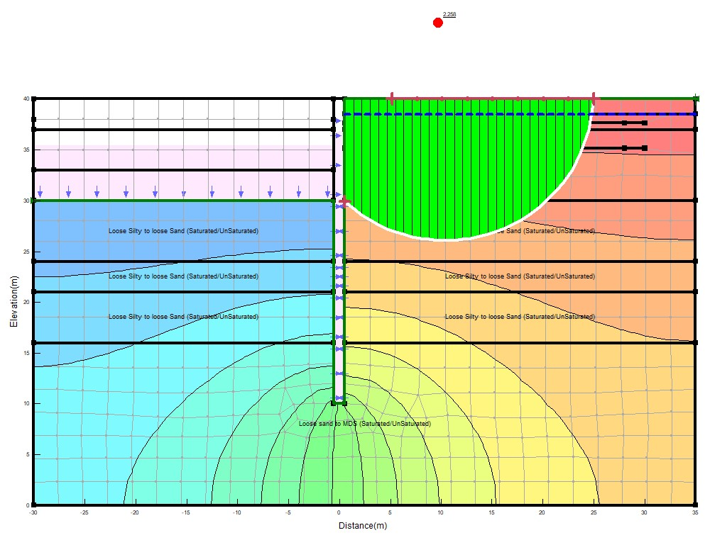Initial dredge depth of 10m considered for shallow slip failure and the entry and exit considered as range at the ground surface level of the landside and a single point at the dredge depth of 10m respectively. Passive wedge exists from the depth of 10m to the tip of the diaphragm wall (30m). The passive resistance from these passive earth pressures computed and modelled with a line load (constant X-force) or pile shear force acting at the depth of 10m as a boundary condition (constant X-force boundary condition). The SIGMA/W stress stability models for shallow failure mode as shown in Figure 2.

**Figure 2. Case study 3 Sigma/w stress finite element stability model for depth of Shallow failure mode (10m) and 60kpa surcharge load application.**

**2.3.1.2 Deep-Seated Failure Mode**

For the deep-seated failure mode, the slip surface passes below the diaphragm wall and no inclusion of the resistance force due to the passive wedge in the computations of the factor of Safety. The slip surface entry and exit considered a range indicated at the ground surface level of the landside and at the downstream line on the sea side respectively. The slip surface therefore starts from the upstream line level through the tip of the diaphragm wall to the downstream line level. The SIGMA/W stress stability models for deep-seated failure mode as shown in Figure 3.

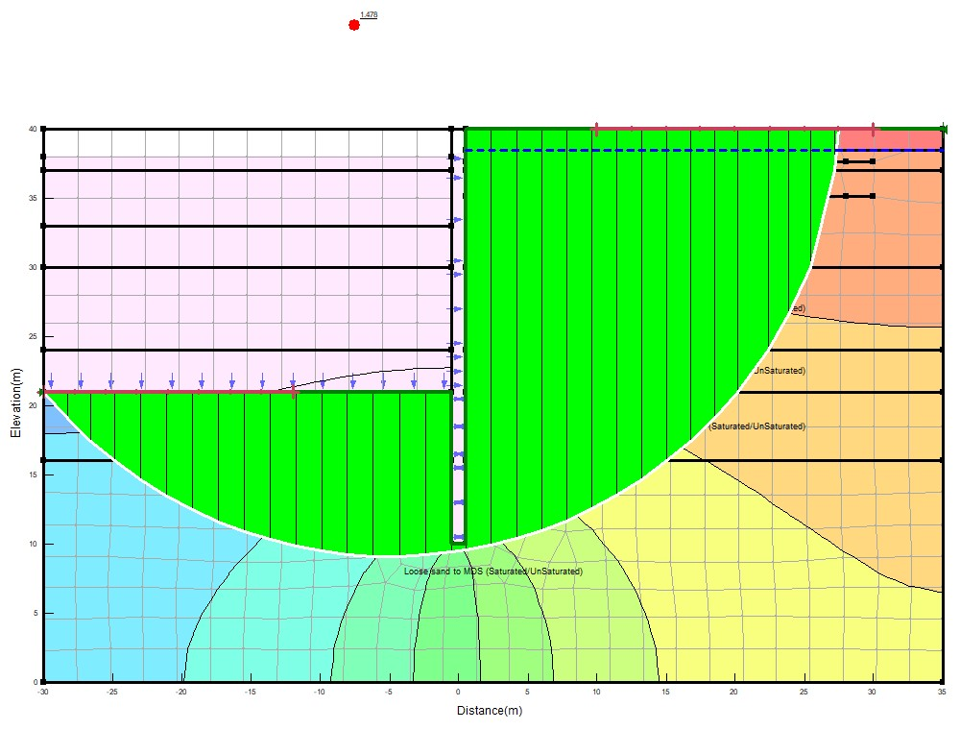

**Figure 3.** **Case study 3 Sigma/w stress finite element stability model for depth of Deep-Seated failure mode (19m) and 60kpa surcharge load application.**

**3. RESULTS AND DISCUSSION**

**3.1 Results**

**3.1.1 Stability Analysis Results**

The results of the stability factors for all time steps considering the distribution of pore water pressure from 0hr to 24hr computed for surcharge loads of 40kpa, 60kpa, 80kpa, 100kpa and 120kpa and dredging depths of 10m, 16m and 19m, for the critical slip surfaces versus time(hrs.) for the 3-case study shown in Tables 7 to 9.

**Table 7. Stability Factor versus Time for Case study 1 at dredge depth of 10m and different surcharge loads application.**

|  |  |  |  |  |  |
| --- | --- | --- | --- | --- | --- |
|  | 40KPa | 60KPa | 80KPa | 100KPa | 120KPa |
| Time (d) | Factor of Safety | Factor of Safety | Factor of Safety | Factor of Safety | Factor of Safety |
| 0 | 2.7533267 | 2.0506527 | 1.7667936 | 1.5350627 | 1.3446406 |
| 0.05 | 2.7541371 | 2.0511831 | 1.767206 | 1.5355207 | 1.3450179 |
| 0.10208333 | 2.7553729 | 2.0519922 | 1.7678348 | 1.5362176 | 1.3455922 |
| 0.15625 | 2.7567832 | 2.0529154 | 1.7685525 | 1.5370124 | 1.3462471 |
| 0.2125 | 2.7582816 | 2.0538963 | 1.7693149 | 1.5378565 | 1.3469427 |
| 0.27083333 | 2.7598437 | 2.0549189 | 1.7701098 | 1.5387365 | 1.3476678 |
| 0.33125 | 2.7614635 | 2.0559793 | 1.7709341 | 1.5396491 | 1.3484197 |
| 0.39444444 | 2.7631583 | 2.0570888 | 1.7717965 | 1.5406038 | 1.3492064 |
| 0.46041667 | 2.7649277 | 2.0582471 | 1.7726969 | 1.5416005 | 1.3500277 |
| 0.52847222 | 2.7667529 | 2.059442 | 1.7736257 | 1.5426287 | 1.350875 |
| 0.6 | 2.7686713 | 2.0606978 | 1.7746019 | 1.5437094 | 1.3517655 |
| 0.67361111 | 2.7706455 | 2.0619902 | 1.7756065 | 1.5448216 | 1.3526819 |
| 0.75069444 | 2.7727129 | 2.0633436 | 1.7766585 | 1.5459862 | 1.3536416 |
| 0.83055556 | 2.7748548 | 2.0647458 | 1.7777484 | 1.5471928 | 1.3546358 |
| 0.91388889 | 2.7770898 | 2.0662089 | 1.7788857 | 1.5484519 | 1.3556732 |
| 1 | 2.7793993 | 2.0677208 | 1.7800609 | 1.5497529 | 1.3567453 |

**Table 8. Stability Factor versus Time for Case study 2 at dredge depth of 10m and different surcharge loads application.**

|  |  |  |  |  |  |
| --- | --- | --- | --- | --- | --- |
|  | 40kPa | 60kPa | 80kPa | 100kPa | 120kPa |
| Time (d) | Factor of Safety | Factor of Safety | Factor of Safety | Factor of Safety | Factor of Safety |
| 0 | 3.0017815 | 2.436743 | 2.1115797 | 1.8962098 | 1.7365891 |
| 0.05 | 3.0020214 | 2.4369195 | 2.1117198 | 1.8963246 | 1.7366854 |
| 0.10208333 | 3.0025413 | 2.437302 | 2.1120234 | 1.8965735 | 1.736894 |
| 0.15625 | 3.0033067 | 2.4378651 | 2.1124703 | 1.8969399 | 1.7372011 |
| 0.2125 | 3.0042684 | 2.4385726 | 2.1130318 | 1.8974003 | 1.7375869 |
| 0.27083333 | 3.0053822 | 2.439392 | 2.1136821 | 1.8979335 | 1.7380337 |
| 0.33125 | 3.0066134 | 2.4402978 | 2.114401 | 1.8985229 | 1.7385277 |
| 0.39444444 | 3.0079523 | 2.4412828 | 2.1151828 | 1.8991638 | 1.7390648 |
| 0.46041667 | 3.0093823 | 2.4423349 | 2.1160177 | 1.8998484 | 1.7396385 |
| 0.52847222 | 3.010877 | 2.4434346 | 2.1168905 | 1.9005639 | 1.7402382 |
| 0.6 | 3.01246 | 2.4445992 | 2.1178148 | 1.9013217 | 1.7408732 |
| 0.67361111 | 3.0140958 | 2.4458027 | 2.1187699 | 1.9021048 | 1.7415295 |
| 0.75069444 | 3.0158128 | 2.4470659 | 2.1197724 | 1.9029267 | 1.7422184 |
| 0.83055556 | 3.0175939 | 2.4483762 | 2.1208124 | 1.9037793 | 1.7429329 |
| 0.91388889 | 3.0194535 | 2.4497443 | 2.1218982 | 1.9046696 | 1.743679 |
| 1 | 3.0213758 | 2.4511586 | 2.1230206 | 1.9055898 | 1.7444502 |

**Table 9. Stability Factor versus Time for Case study 3 at dredge depth of 10m and different surcharge loads application.**

|  |  |  |  |  |  |
| --- | --- | --- | --- | --- | --- |
|  | 40kPa | 60kPa | 80kPa | 100kPa | 120kPa |
| Time (d) | Factor of Safety | Factor of Safety | Factor of Safety | Factor of Safety | Factor of Safety |
| 0 | 2.3355022 | 2.2275901 | 2.1412642 | 1.9910102 | 1.7817293 |
| 0.05 | 2.3372258 | 2.2291163 | 2.1426341 | 1.9922575 | 1.7827657 |
| 0.10208333 | 2.3390313 | 2.230715 | 2.144069 | 1.9935638 | 1.7838513 |
| 0.15625 | 2.340909 | 2.2323777 | 2.1455613 | 1.9949224 | 1.7849802 |
| 0.2125 | 2.3428589 | 2.2341043 | 2.1471111 | 1.9963333 | 1.7861526 |
| 0.27083333 | 2.344881 | 2.2358949 | 2.1487182 | 1.9977964 | 1.7873685 |
| 0.33125 | 2.3469754 | 2.2377494 | 2.1503827 | 1.9993118 | 1.7886277 |
| 0.39444444 | 2.349166 | 2.2396892 | 2.1521238 | 2.0008968 | 1.7899448 |
| 0.46041667 | 2.351453 | 2.2417143 | 2.1539414 | 2.0025515 | 1.7913199 |
| 0.52847222 | 2.3538121 | 2.2438033 | 2.1558164 | 2.0042585 | 1.7927383 |
| 0.6 | 2.3562916 | 2.2459989 | 2.157787 | 2.0060525 | 1.7942292 |
| 0.67361111 | 2.3588434 | 2.2482584 | 2.1598151 | 2.0078989 | 1.7957634 |
| 0.75069444 | 2.3615155 | 2.2506245 | 2.1619388 | 2.0098323 | 1.79737 |
| 0.83055556 | 2.3642839 | 2.2530759 | 2.164139 | 2.0118353 | 1.7990346 |
| 0.91388889 | 2.3671726 | 2.2556339 | 2.166435 | 2.0139255 | 1.8007714 |
| 1 | 2.3701577 | 2.2582771 | 2.1688074 | 2.0160853 | 1.8025662 |

Variations of stability factors for each critical slip surface with time (hrs) for dredging depths of 10m, 16m and 19m for all time steps for the critical slip surfaces for the 3-case study displayed in Figures 4 - 6.

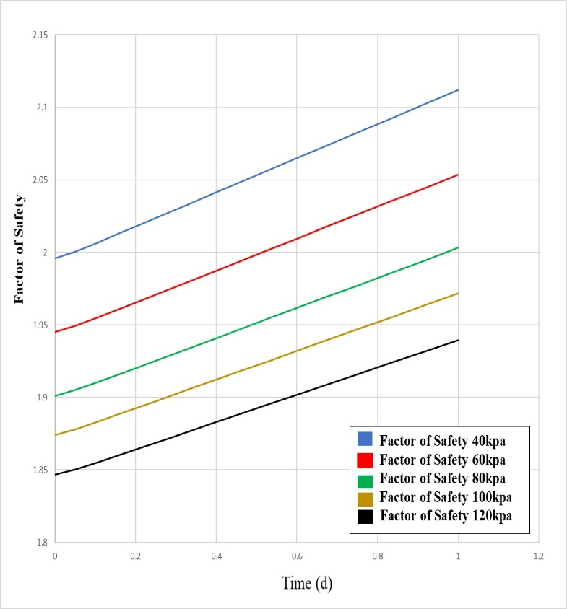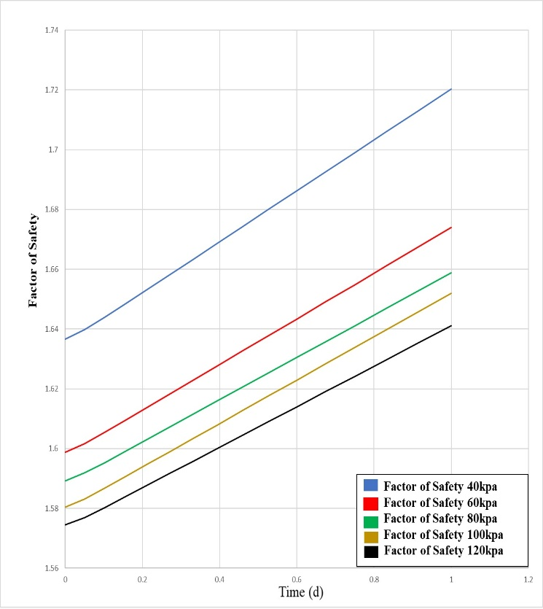**Figure 4. Factors of safety versus Time for Case study 1 at dredge depth of 16m and 19m with different surcharge load applications.**

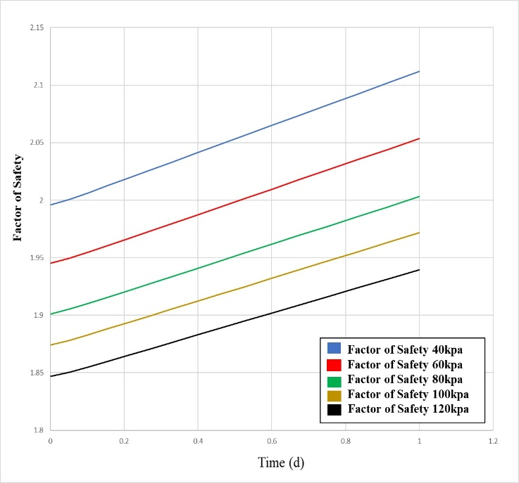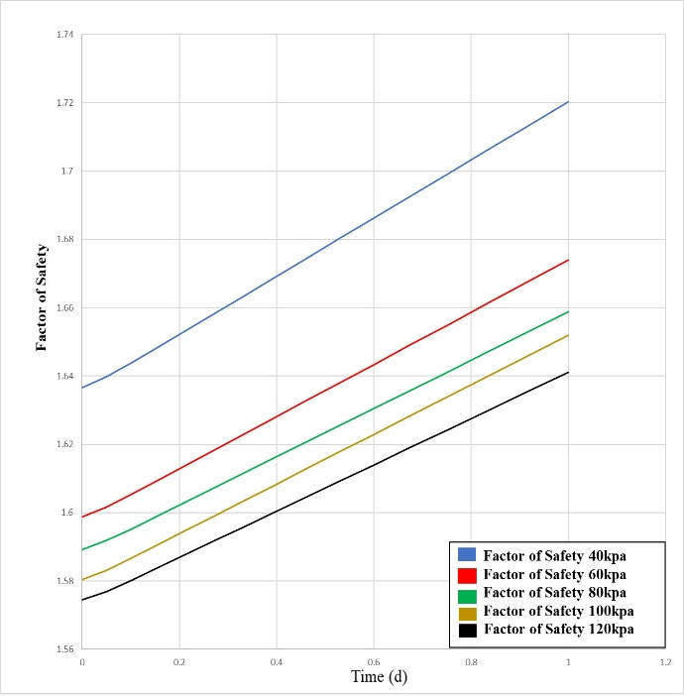

**Figure 5. Factors of safety versus Time for Case study 2 at dredge depth of 16m and 19m with different surcharge load applications.**

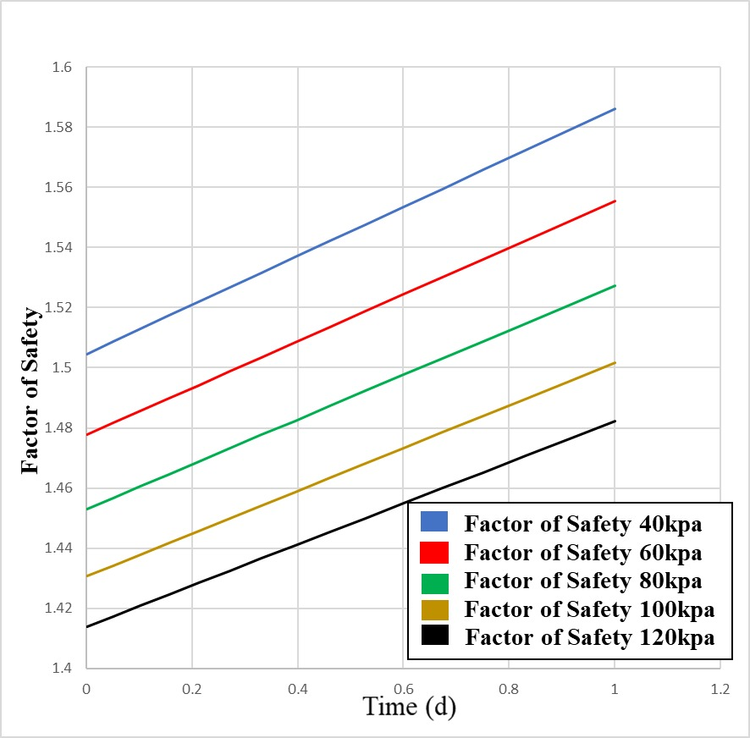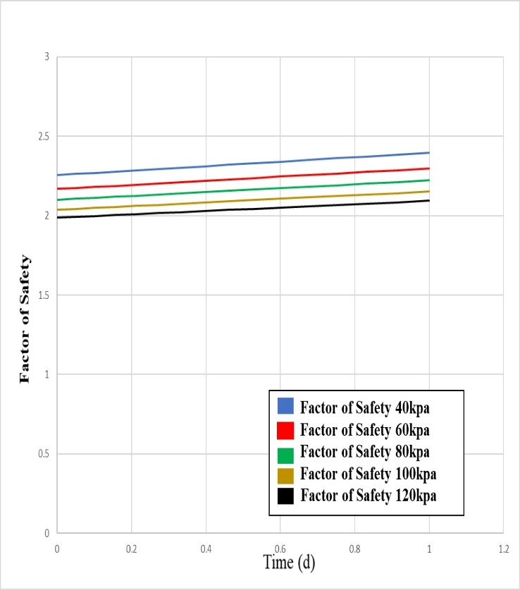 **Figure 6. Factors of safety versus Time for Case study 3 at dredge depth of 16m and 19m with different surcharge load applications.**

**3.2 Discussion**

**3.2.1 Shallow Slip Surface Failure Mode (10m Dredge Depth).**

i). For Case study 1 at dredge depth of 10m at 0day, factors of safety of 2.75 and 1.345 obtained for 40kpa and 120kpa surcharge loads applications. Also, case study 2 at same 10m dredge depth at 0 day, factors of safety of 3.00 and 1.737 obtained for 40kpa and 120kpa surcharge loads applications respectively and finally, for Case study 3 factors of safety of 2.34 and 1.781 respectively.

**3.2.2 Deep- Seated Slip Surface Failure Mode (19m Dredge Depth).**

i). For Case study 1 at dredge depth of 19m at 0day, factors of safety of 1.64 and 1.57 obtained for 40KPa and 120KPa surcharge loads applications. Also, for case study 2 at same 19m dredge depth at 0 day, factors of safety of 1.65 and 1.55 weobtained for 40kpa and 120kpa surcharge loads applications respectively. Finally, for Case study 3 factors of safety of 1.50 and 1.41 respectively obtained with same surcharge loads application. Therefore, on application of 40KPa to 120KPa surcharge loads at dredge depth of 19m, Case 2(diaphragm wall embedded in firm to stiff clay through loose to dense sand) showed highest values of the stability factor for surcharge loads between 40 to 60KPa. For all the 3-Case study, the stability factor decreases with increasing depth of dredging which is in agreement with literature [1,4,5 & 7].

**4. CONCLUSION AND RECOMMENDATION**

**4.1 Conclusion**

The following conclusions are made based on the results obtained:

1. The stability of Diaphragm wall has been shown to be dependent on the depth of embedment of the wall. Therefore, for Diaphragm wall for coastal protection works in Niger Delta with surcharge loads between 40kpa to 120kpa, the depth of embedment should be thoroughly evaluated using finite element stress-based stability analysis that will take care of seepage/sediment transport problems and excessive lateral pressures exerted on the wall.
2. Dredging must be monitored closely in diaphragm wall coastal protection works as such increases the disturbing moment and reduces resisting moments on the wall.
3. The results obtained showed that diaphragm walls embedded in Stiff to firm clay offered better resistance than those in sand or sand with clay intercalations for both shallow (10m) and deep-seated slip surface (19m) failure modes. Due to high seepage rates in sand, the depth of embedment must be increased to accommodate sediment transport resulting from scour actions leading to reduction in passive resistance in sand. Generally, for all the 3-Case study, the stability factor decreases with increasing depth of dredging.

**4.2 Recommendation**

For stability analysis of diaphragm wall for coastal protection works in the Niger Delta, coupled or uncoupled transient seepage/sediment transport and load deformation analyses should be considered. This will provide the realistic distributions of pore water pressures, fluxes (due changes in volumetric water content and hydraulic conductivity functions) and internal stresses (due to incremental load applications).

**REFERENCES**

[1] Brian, S., & Williams, P. (2001). Embedded Retaining Walls: Theory, Practice and Understanding. Perspective lecture of the 15th International Conference on Soil Mechanics and Geotechnical Engineering.

[2] Reijers, T.A. (2011). Stratigraphy and sedimentology of Niger Delta. Geologos, pp 133 – 162.

[3] Woessner, W.W., Hunt, R.J., & Anderson, M.P. (2015). Applied Groundwater Modelling – Simulation of flow and Advective Transport. 2nd Edition, Academic Press, Inc, San Diego, California.

[4] Veiskarami, M., & Zanj, A. (2014). Stability of sheet pile walls subjected to seepage flow by slips line and finite element. Geotechnique, 64. No 10, 759-755.

[5] Richart, F.E., & Schmertmann, J.H. (2011) The Effects of Seepage on the Stability of Sea Wall. Department of Civil Engineering, University of Florida.

[6] Suraya, S., Hamzah, M.H., Taib, M.A., Ramli, A.B., & Hasbollah, A.D. (2019). The stability of Diaphragm wall for deep excavation. International Journal of Advanced Trends in Computer, Science and Engineering (IJATCSE), Vol 8, No 1.6, 2019.

[7] Czajewska, M.M. (2014). Numerical analysis of a 36m deep diaphragm wall. Geotechnical Aspects of Underground Construction in Soft Ground-Korean Geotechnical Society, ISBN 978-1-138-02700-8.

[8] Qiang, O., Ling, Z., Minghua, Z., & Yixian, W. (2019). Lateral Displacement and Internal Force in Diaphragm Walls Based on Principle of Minimum Potential Energy. *International Journal of Geotechnics, American Society of Engineers.* ISSN 1532-3641

[9] Czajewska, M.M., & Lewandowska, A.S. (2007). Design of diaphragm wall according to EN 1997-1:2004 Eurocode 7. 18th French Congress of Soil mechanics.

[10] Department of the Army. Geotechnical Analysis by the Finite Element Method, Engineering Technical Letter (ETL), U.S Army Corps of Engineer, Washington, July 1995.

[11] Geo-Slope International (2017). Engineering Methodology for Seepage, Contaminants, Stress-deformation and Stability Modelling. Calgary, Alberta Canada.

[12] Zienkiewicz, O.C., & Taylor, R.L. (2000). The Finite Element Methods. 5th Edition, Butterworth – Heinemann Pulisher UK.

[13] Nwaogazie, I.L. (2019). Finite Element Modelling of Engineering Systems, 2nd Edition University of Port Harcourt Press Plc, Port Harcourt.

[14] British Standards Institutions: BS 1377-2 (2022), Methods of Test for Soils for Civil Engineering Purposes, Part 2: Classification Tests and Determination of Geotechnical Properties

[15] Nigerian Navy, (2016). Tidal Predictions for Nigerian Ports and River Channels.