**GRAIN-BORNE FUNGI ON FARMER SAVED SORGHUM (*Sorghum Bicolor* L.)**

**Abstract**

Sorghum (*Sorghum bicolor* (L.) Moench) is an under-utilized cereal crop grown mainly in arid and semi-arid lands (ASALs) with various uses as human food, fodder, feed, fuel and industrial use but its yield and quality is influenced factors during and after production. The aim of this study was to determine the occurrence of grain borne fungi on farmer saved sorghum cultivars at pre-and post-harvest value chain. Using direct-plating technique, four fungi genera and 12 species were identified in sampled sorghum grains from farmers and experimental plots. The influence of moisture content (MC) is crucial in growth and development on grain surfaces. Prevalent fungi isolated and identified from the grains were *Aspergillus* spp., *Fusarium* spp., *Penicillium* spp. and *Rhizopus* spp. An analysis using high performance liquid chromatography (HPLC) revealed that 30% of the tested samples revealed B1 and B2 strains of aflatoxin. The existence of mould on grains showed mycotoxin strains which result in deterioration of sorghum grains thus food insecurity among the small holder farmers.

**Key words**: Sorghum, sampling, grain, fungi, aflatoxin,

**Introduction**

Sorghum (*Sorghum bicolor* (L.) Moench) is an herbaceous cereal crop cultivated from seed (Ssepuuya et al., 2018) is an under-utilized crop and one of the most important cereal crops in ASALs (Muui, Muasya, & Kirubi, 2013). Globally, it is ranked fifth and second in Africa after maize (*Zea mays* L.) as the most significant cereal in terms of production (Ssepuuya et al., 2018). Due to its drought- tolerance and hardy characteristics its different cultivars are grown in the arid, sub-tropical and tropical regions, where harsh agro-ecological conditions prevail (Rao & Kumar, 2013). Sorghum is among the important staple cereals in the sub-Saharan Africa’s mainly the rural resource poor, source of food and income security for smallholder farmers (Ssepuuya et al., 2018). Sorghum has multiple uses as food, feed, fodder, fuel, industrial use as ethanol and beer production thus an important driver for economic development in the developing countries (Aruna & Visarada, 2019; Njuguna, Cheruiyot, Mwonga, & Rono, 2018). Food safety is a significant element of food security, thus ensuring that sorghum is safe for human and livestock consumption turn into a key concern (Boisrobert, 2010). The contamination of sorghum is mainly during the pre-and post-harvest handling that leads to grain losses thus food insecurity (Kange, Cheruiyot, Ogendo, Arama, & Sylvans, 2014).

Sorghum, like many cereal crops, is vulnerable to fungal proliferation during cultivation, and long the value chain such as harvest, storage and processing (Adebo, Kayitesi, & Njobeh, 2019). This colonisation with toxigenic fungi could be accompanied by the production of secondary metabolites including mycotoxins which is aggravated by the favourable tropical climate prevalent in Africa (Taye, Ayalew, Dejene, & Chala, 2018). Thus cereals have been identified as a major route of dietary exposure to mycotoxins, which is of global concern, especially when these mycotoxins are carried over to subsequent products derived from these cereals (Chala et al., 2014). Globally, mycotoxins belong to the *Aspergillus, Fusarium, and Penicillium* and spare a major concern for food safety in both the developing and developed countries in the world (Saeger, 2011). In Africa, mycotoxins are one of the five major food safety concerns (Ssepuuya et al., 2018) and the cereals are important sources of mycotoxins (Schrenk, 2012). The cereal grain consumption contributes on average, about half of the per capita kilocalorie intake (Gardner, 2013). Mycotoxins are toxic secondary fungal metabolites that cause mycotoxicosis, if ingested in large quantities over long period of time. While exposure to low mycotoxin concentrations has been associated with carcinogenic, mutagenic, teratogenic, immunotoxic and estrogenic activity in animals and humans (Ssepuuya et al., 2018). In cereal the main mycotoxins are aflatoxins, fumonisins, trichothecenes, OTA, Alternaria toxins and zearalenone (Adebo et al., 2019).

In Africa, addressing of the issues of mycotoxins contaminations and exposure to grain sorghum is a challenge and food safety is not a priority for the domestic population thus little effort in reduction of mycotoxins levels and its prevalence in cereals (Motarjemi, 2014). This can partly be attributed to lack of awareness, poverty, , inadequate poor storage practices and insufficient infrastructure to support the provision of safe food to the population (Ssepuuya et al., 2018). The compromised ability by many farmers to address mycotoxin contamination of common staple foods renders all actions related to the reduction and prevention of mycotoxin formation and contamination urgent and humanely necessary. A wealth of documented information already exists about the types, levels and prevalence, maximum limits and toxic threshold levels of mycotoxins in foods have been identified in foods (Ssepuuya et al., 2018). However, in the recent past there has been little or no study to determine the occurrence of mycotoxins producing fungi in sorghum grain cultivars at both pre-and post-harvest value chain.

**MATERIALS AND METHODS**

## Farm survey grain sampling and determination of moisture content (MC %)

A farm survey was conducted in Bondo, Kathonzweni, Kibwezi, Makueni, Njoro, Rongai, and Siaya sub-counties using a questionnaire. Sixty samples of were collected from the six sampling units. The samples were put in clean Khaki bags, brought to the mycological laboratory and kept at 5ºC till fungal analysis. The moisture content was estimated by drying triplicates of known weight of the samples (sorghum) at 105 °C for 24 h then cooled in a desiccator and re-weighed. The moisture content was expressed as the average percentage of the weight loss of the three replicates (Abdel-Hafez, Ismail, Hussein, & Abdel-Hameed, 2014; Magan & Lacey, 1985; J. Pitt & Hocking, 2009).

**Germination test**

The viability of sorghum grains was assessed through their ability to germinate. Whatman filter papers were placed inside the Petri-dishes (90 mm diameter), moisten the paper with water. Ten sorghum grains were put above the wet paper in each plate replicated thrice (incubated 30°C and the germination percentage (GP) was calculated as stated by using the following formula (Sater, Hafez, Hussein, & al-amery, 2017).

$$GP=\frac{Number of germinated seeds}{Total number of seed}×100$$

**Isolation and identification**

Direct plating technique adopted technique was used to isolate and enumerate fungi on sorghum grain (S. B. Mathur & Kongsdal, 2003; Ostry, Ruprich, Skarkova, Prochazkova, & Kubatova, 2001). The Czapek’s and Czapek’s supplemented with 40% sucrose  
 agar media incubated at 28ºC were used for isolation of fungi. Five grains from each sample were put on the surface of the isolation medium (J. I. Pitt et al., 1986). The plates were incubated at 25°C for 7 days and the developing fungi were isolated and identified mainly on the basis of their macro- and microscopic features following the keys (Booth, 1971; Leslie & Summerell, 2006; J. Pitt, 1979; J. Pitt & Hocking, 1986; Raper & Fennell, 1966).

**Screening for aflatoxin and assessment of aflatoxins by HPLC**

The ten isolates of *Aspergillus* *flavus*, that were isolated and identified in during this stud, were screened for their aflatoxin potential using the coconut agar medium (CAM) (shredded coconut, 100 g were homogenized for 5 min with 300 ml hot distilled water, then filtered and the volume was made up to 1000 ml with distilled water (pH 7), then 20 g agar was added thereafter sterilization). Fungal isolates were inoculated on CAM agar plates and incubated at 28ºC in the dark for 7 days. The cultures were observed for fluorescence under ultra violet (UV) light (365 nm). The positive inoculates were detected as blue fluorescence and an uninoculated plate was a reference (Davis, Iyer, & Diener, 1987). The determination of aflatoxin from ten fungal isolates, using silica-based HPLC columns bonded with C8 or C18 groups were used with mobile phases consisting of binary or ternary mixtures of polar solvents. In a reversed phase approach, the elution order of the aflatoxin strains as B1, B2, G1 and G2 (Sekar, Yumnam, & Karuppiah, 2008).

**RESULTS**

**Drying of sorghum grains and effects of moisture content**

A farm survey for the sorghum farmers and collection of samples for mycological analysis, the farmers cultivate the improved and landraces cultivars. In the survey, the landraces were preferred by farmers in Siaya, Ugunja, Bondo, Rongai and Kathonzweni areas than the improved varieties in Njoro and Kibwezi (Fig. 1). After harvesting the sorghum panicles, they are dried to the solar radiation and stored before being threshed (Fig. 2A & B). The moisture content (MC) in sampled sorghum grains from farmers’ storage facilities were from 10 - 11 % in Kathonzweni and Kibwezi (Fig.3), 10 - 13 % in Njoro and Rongai (Fig. 4), and 9 -12 % in Siaya, Ugunja and Bondo (Fig. 5). The MC was recorded higher in grain sorghum sampled at Njoro and Rongai. In terms of gender of the farmers who cultivate sorghum rom the sampled farmers, men were slightly higher than the women among the household heads (Fig. 3,4 & 5).The sorghum grain sampled at Egerton University and Koibatek experimental plots had 13-15 % MC (Fig. 6), this could have been attributed to the grains had not been dried on the sun as those sampled from the farmers.

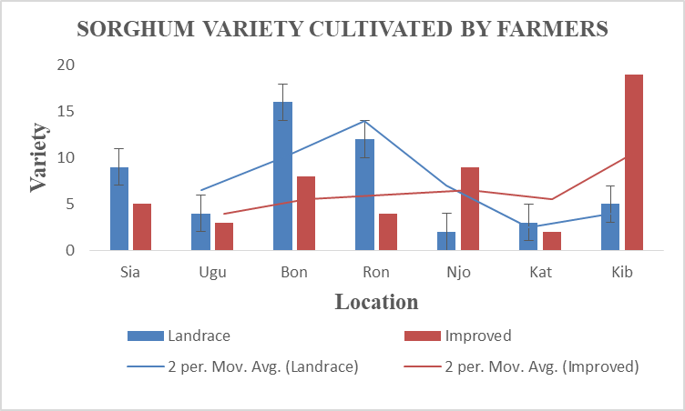

Fig. 1. Preference of sorghum cultivar (improved (I) and landrace (L)) farmers cultivate

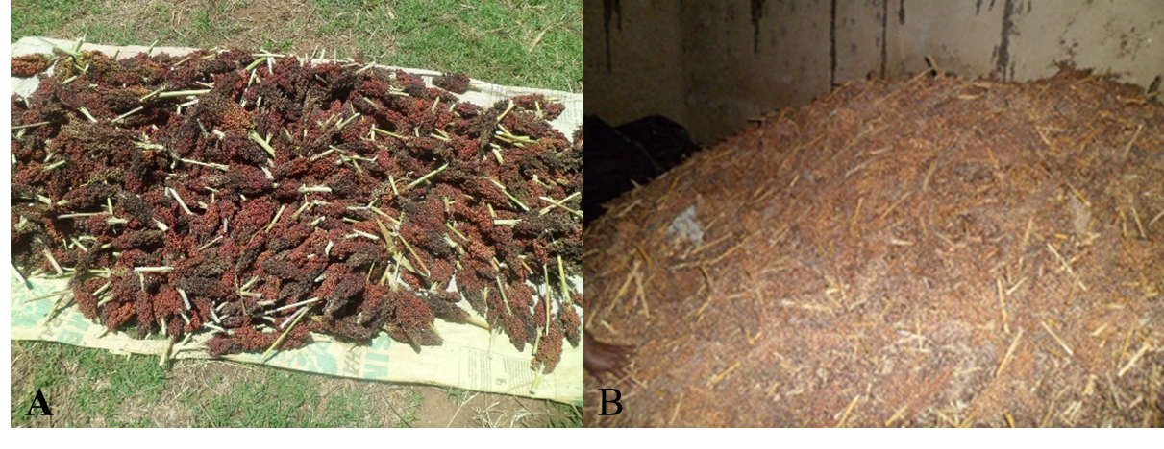

**Fig. 2**. Post-harvest handling of sorghum grain (A) sun drying of sorghum panicles and (B) storage on sorghum grain on panicles.

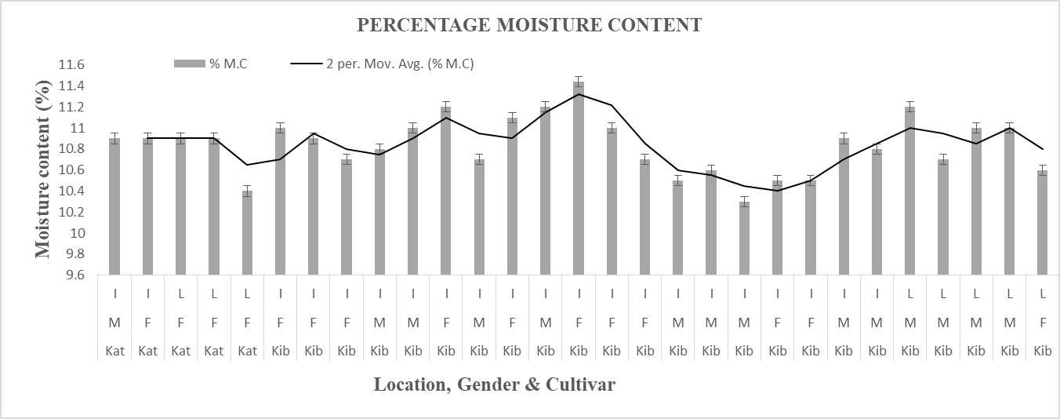

Fig. 3. Effects of sampling location on grain moisture content in relation to gender that cultivates sorghum and cultivar (I and L).

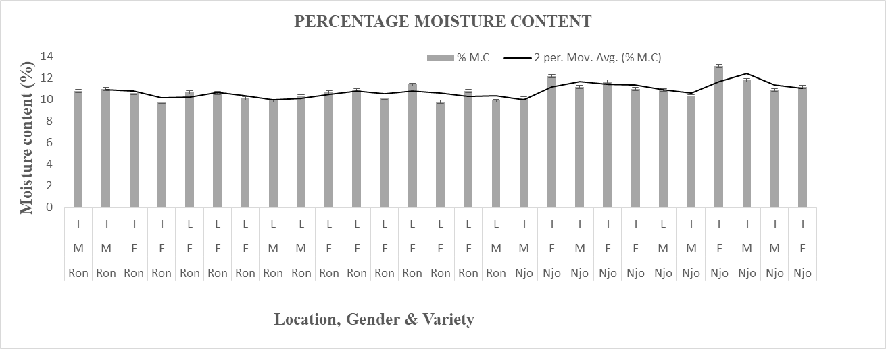

Fig. 4. Effects of sampling location on grain moisture content in relation to gender that cultivates sorghum and cultivar (I and L).

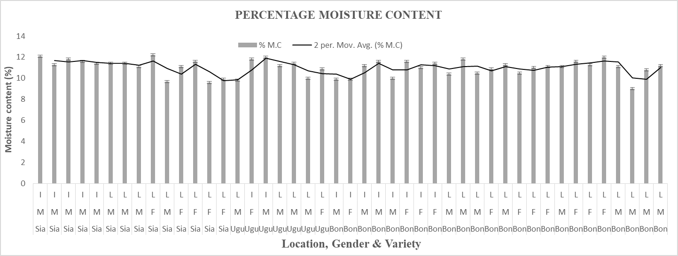

Fig. 5. Effects of sampling location on grain moisture content in relation to gender that cultivates sorghum and cultivar (I and L).

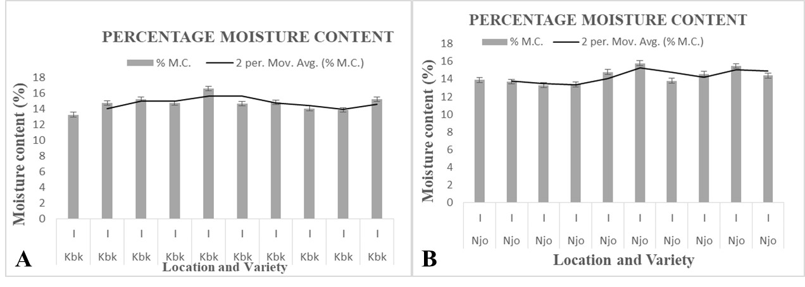

Fig. 6. Effects of moisture content on improved sorghum grain cultivar sampled at maturity phase from Koibatek and Egerton University experimental plots.

**Germinability of the sorghum grains**

The percentage of germination for a sample of 20 grains was ranging between 50–90%. The highest germinability was 90 % which were detected in samples from Kibwezi while lowest values of germinability were recorded in sorghum grain sample from Ugunja, Rongai and Njoro (Fig. 7).The germination percentage could be attributed to MC in sorghum grains which stimulate fungal growth. This is in agreement with the study on germinability of peanut seeds that declined with increasing MC (Moubasher, 1993) and in a recent study on fungi associated with sorghum and maize (Sater et al., 2017).

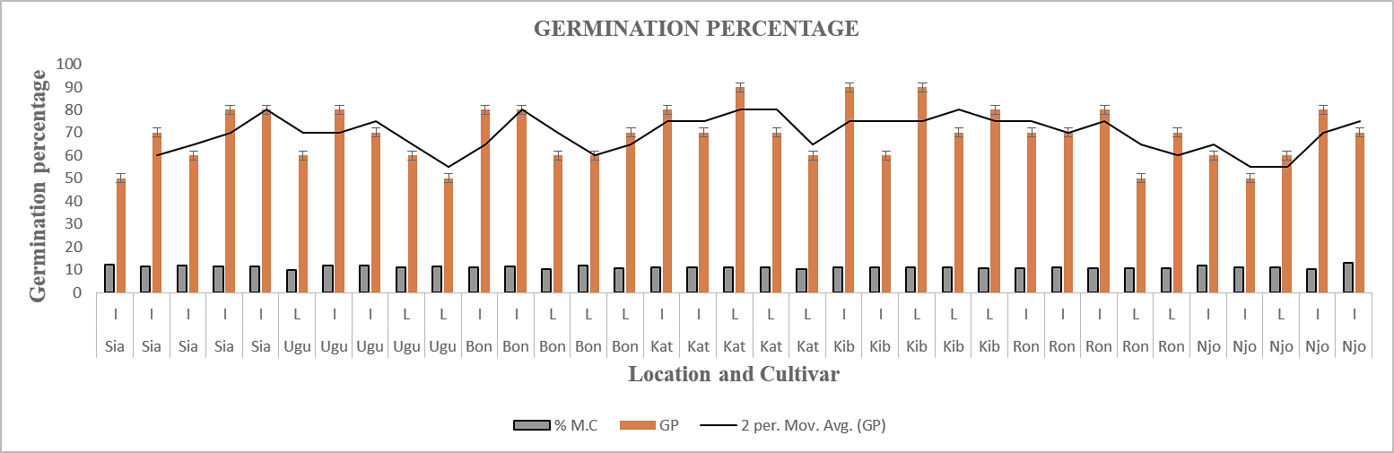

Fig. 7. Localities, percentage moisture content (%MC) and germination percentage (GP) of sorghum grain samples. Sia-Siaya, Ugu-Ugunja, Bon-Bondo, Kat-Kathonzweni, Kib-Kibwezi, Ron-Rongai, Njo-Njoro, I-improved, L-landrace

**The identification of fungi on grain**

Many of the grain sorghum samples were contaminated with fungi. However more Aspergillus and Fusarium species were isolated. The total number of genera and species on sorghum (4 genera and 12 species) were identified. In general, the agar media supported moderate to heavy sporulation in all the isolates of *Aspergillus* spp, *Fusarium* spp, and *Penicillium* spp. The ratio of macro conidia were more than the micro conidia. Least sporulation on agar medium was exhibited from the isolates of grain sorghum sampled from the Koibatek and Egerton University experimental plots compared to from farmers sampled grains (Fig. 8A & B). Only the *Aspergillus* spp were isolated from the grains were investigated for aflatoxin production.

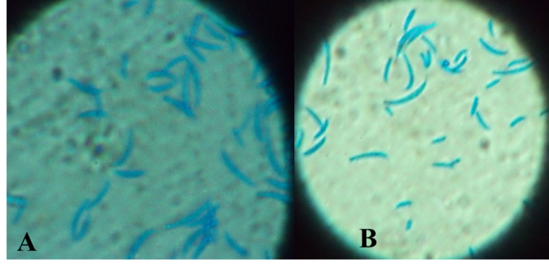

Fig. 8. The macro and micro conidia of an isolate (x100).

**Fungi isolated from sorghum grains**

Four genera and 12 species of fungi were recorded from the sorghum grains. *Aspergillus*, *Fusarium* and *Mucor* species were predominant than the *Penicillium*. *Aspergillus* and *Fusarium* had 5 species, *Penicillium* and *Mucor* had 1 spp. that were isolated. Mucor was isolated in all the sampled grains except in Kathonzweni (Table 1).

Table 1: Isolated fungi from the farmers sampled sorghum grains

|  |  |  |  |  |  |  |  |  |
| --- | --- | --- | --- | --- | --- | --- | --- | --- |
| S/NO | Fungi | Sia | Ugu | Bon | Ron | Njo | Kat | Kib |
|  | *Aspergillus flavus* Link | **+** | **+** | **+** | **-** | **+** | **+** | **-** |
|  | 1. *clavatus* Desmaziere | **+** | **-** | **-** | **+** | **-** | **₋** | **+** |
|  | *A. niger* Van Tieghem | **+** | **+** | **-** | **-** | **+** | **-** | **-** |
|  | *A. fumigatus* Fresenius | **-** | **-** | **-** | **-** | **-** | **-** | **+** |
|  | *A. terrreus* Thom | **₋** | **+** | **+** | **-** | **-** | **+** | **+** |
|  | *Fusarium moniliforme* Sheldon | **+** | **-** | **-** | **+** | **+** | **-** | **-** |
|  | *F. oxysporium* Shlecht | **-** | **-** | **+** | **-** | **+** | **+** | **-** |
|  | *F. verticillioides* (Saccardo) Nirenberg | **+** | **-** | **-** | **+** | **-** | **-** | **+** |
|  | *F. proliferatum* (Matsush.) Nirenberg | **-** | **+** | **-** | **+** | **-** | **-** | **-** |
|  | *F. solani* (Maartius) Saccardo | **-** | **-** | **+** | **-** | **+** | **-** | **-** |
|  | *Penicillium* Link | **-** | **+** |  | **+** | **-** | **-** | **+** |
|  | *Mucor* Fresenius | **+** | **+** | **+** | **+** | **+** | **-** | **+** |

**Key:** + = fungi present, - = fungi absent, Sia-Siaya, Ugu-Ugunja, Bon-Bondo, Ron-Rongai, Njo-Njoro Kat-Kathonzweni, Kib-Kibwezi,

**Fluorescence of *Aspergillus flavus* on coconut agar medium and aflatoxin using HPLC**

The ten isolates of *A. flavus* collected from sorghum grains were screened for their abilities to produce aflatoxin on coconut agar medium (CAM). The results revealed that 3 isolates were able to produce the fluorescence under ultra violet (UV) light (365 nm), this indicates the production of aflatoxin. The *A. flavus* strains showed fluorescence (+, ++) of aflatoxin production while others didn’t (-ve) (Table 2). The assessment of mycotoxins by HPLC, aflatoxin from the ten *A. flavus* isolates of sorghum grains was determined using high performance liquid chromatography (HPLC), 6 strains showed production of aflatoxin B1 and B2.

**Table 2: Fluorescence (365 nm) of Aspergillus flavus from sorghum grain on coconut agar medium**

|  |  |  |  |
| --- | --- | --- | --- |
| **S/NO** | **Fungal species** | **Strain No.** | **Fluorescence on CAM** |
|  | *Aspergillus flavus* | Sia5 | ++ |
|  | *A. flavus* | Kib13 | -ve |
|  | *A. flavus* | Ugu5 | -ve |
|  | *A. flavus* | Ron7 | -ve |
|  | *A. flavus* | Ron15 | -ve |
|  | *A. flavus* | Njo9 | -ve |
|  | *A. flavus* | Bon23 | -ve |
|  | *A. flavus* | Sia12 | -ve |
|  | *A. flavus* | Kat4 | + |
|  | *A. flavus* | Njo5 | ++ |

Fluorescence on CAM as: –ve: negative result, +: weak intensity, ++: moderate intensity

**Discussion**

The composition of fungi in cereal grains at pre-and post-harvest is an important phase towards the prediction of possible mycotoxin contamination thus, evasion of the harmful effects on yield and quality grain (Sater et al., 2017). Moisture content is one of the factors that influence fungal growth, development and production of secondary metabolite in many of the Agricultural produce thus loss of quality (Dar, Kamili, Nazir, Bandh, & Malik, 2014; Ezekiel et al., 2014; Moubasher, 1993). It has a significant role in enzyme production by the fungi (Dar et al., 2014). The results on MC is in agreement with the study on peanut seeds sample from Kenya and Uganda and maize from Kenya (Ismail, 2004; Wagacha, Mutegi, Christie, Karanja, & Kimani, 2013). The germinability was 50-90 % this may be due to the low moisture contents in sorghum grains which could have stimulated fungal growth this is in contrast with the results of germinability of peanut seeds that declined with raising the moisture content (Moubasher, 1993).

Our results shown that the seed borne fungi identified could be the main seed borne pathogen that affected the viability. This is in concurrence with the study on high frequency of occurrence of Mycoflora which affect the seed viability and germination (Tarp, Lange, & Kongsdal, 1987). The study on seed-borne Mycoflora of sorghum, pearl millet and groundnut (Girish, Rao, & Thakur, 2004; Oyekunle, Aiyelaagbe, & Fafunso, 2006). Post-harvest fungal infection, is one of the constraints for mass production of grains, poor seed germination and viability (Danish, Naqvi, & Mehret, 2013). The reduction in germination rate of sorghum and pearl millet was due to fungi such; *Aspergillus* spp., *Alternaria alternata*, *Fusarium equiseti,* *Rhizopus* spp., and *Curvularia lunata* which were present in or on seed surface (S. K. Mathur, Mathur, & Neergaard, 1975) .

The results showed that four genera and twelve species of fungi isolated from sorghum, the moisture content enhance in sorghum enhance fungal diversity and population. *Mucor* species was the least than the *Aspergillus*, *Fusarium* and *Mucor* species. This is in agreement with the previous study of stored sorghum grains (Kange et al., 2014) and on the farmers saved sorghum seeds (Abdulsalaam & Shenge, 2011). The *Rhizopus* species identified on grain sorghum in the current study concurred with previous finding on peanut (Ismail, El-Maali, Omran, & Nasser, 2016) and from maize and wheat but not peanut in Nigeria (Abriba et al., 2017) however it was in contrast with the study on maize from Egypt (Soliman, 2003).The results in our study corroborate with the finding of seed-borne fungal pathogens in cereals such as in pearl millet and sorghum are highly susceptible to diseases as they act as source of stored nutrients for fungi *Aspergillus*, *Penicillium* and *Rhizopus* spp (Dawson-Andoh, Lovell, & Kamdem, 2000; S. B. Mathur & Kongsdal, 2003; Singh, 1983).

The causes of varying presence and prevalence mycotoxins producing fungi in the sampled grains could not be thoroughly explained, this might be attributed to the possibility that sampled grains had better deterrent measures such as use of resistant cultivars like landraces, preventative agronomic practices such as use of fungicides, and suitable pre- and post-harvest handling practices (Lawley, Curtis, & Davis, 2008). Though, other factors such as agro varying ecological zones in the sampled areas which include the climatic conditions, agronomic practices, grain maturity and soil conditions that vary among ecological zones of the same country could have influenced the presence mycotoxins in the grains (Caballero, Finglas, & Toldrá, 2015). Consequently, although similar sampling strategy was used to collect the samples from all the regions, lack of clear documented information concerning agronomic and handling practices, level of maturity at harvesting, different agro ecological zones with their climatic conditions amidst the complex multi-factorial nature of the causes of grain mould contamination make it difficult to thoroughly expound on the cause of these differences.

The influence of the source and period of collection on mycotoxin of sorghum cannot be thoroughly explained due to other influencing factors like the environment and pre- and post-harvest handling conditions at the sources of samples (producer/ farmer) other tan drying /threshing others were not recorded during sample collection and transportation. The varieties corresponding to the diverse colours were not known, and the agronomic practices during sorghum cultivation. Thus, these observations can only be commonly be attributed to insufficient farming/agronomic and storage practices that possibly subjected sorghum grain to mycotoxins (Ssepuuya et al., 2018).

The fluorescence at 365 nm for the aflatoxin production results showed that 30% of total isolates tested (10) were able to produce aflatoxin this is concurrence with the results of aflatoxin on peanut, corn and wheat on wheat on the coconut agar media (Ismail et al., 2016). In the studies of characterization of aflatoxin producing *Aspergillus flavus* from food and feed samples (Fakruddin, Chowdhury, Hossain, & Ahmed, 2015). The studies on *A. flavus* and *A. tamarii* from Algerian wheat for aflatoxin production on CAM (Riba et al., 2010). The results showed that *A. flavus* isolates could produce aflatoxin BI, B2, GI, and G2 which concurs with previous studies on millet and sesame produced aflatoxin B (Ezekiel et al., 2014) and sorghum grain conditions on mycotoxin production (Kange, Cheruiyot, Ogendo, & Arama, 2015).

**Conclusion**

The mycotoxins from *Aspergillus* spp are of concern in sorghum growing areas with regard to prevalence, concentration should be frequently and routinely be determined as they are potential health risks from exposure to moulds on grain sorghum as food safety is concerned. The results indicate that there is a need to study, establish and implement a coherent pre-and post-harvest systems to ensure safety at all levels in the sorghum production chain. The use of farm survey results to deepen the understanding of sorghum consumption, human and livestock exposure to mycotoxins and implement programmes to improve the application of good agricultural practices in sorghum production and mitigation along the value chain through harvesting, transportation, storage, processing and distribution to the consumers.

**REFERENCES**

Abdel-Hafez, S., Ismail, M., Hussein, N., & Abdel-Hameed, N. A. (2014). Fusarium species and other fungi associated with some seeds and grains in Egypt, with 2 newly recorded Fusarium species. *Journal of Biology and Earth Sciences, 4*, 120-129.

Abdulsalaam, S., & Shenge, K. C. (2011). *Seed borne pathogens on farmer-saved sorghum (Sorghum bicolor L.) seeds*.

Abriba, C., Lennox, J. A., Asikong, B., Asitok, A., Ikpoh, I. S., Henshaw, E. E., & Eja, M. E. (2017). Isolation of aflatoxin producing species of Aspergillus from foodstuffs sold in calabar markets, Cross River State, Nigeria. *Journal of Microbiology and Biotechnology Research, 3*, 8-13.

Adebo, O., Kayitesi, E., & Njobeh, P. (2019). Reduction of Mycotoxins during Fermentation of Whole Grain Sorghum to Whole Grain Ting (a Southern African Food). *Toxins, 11*.

Aruna, C., & Visarada, K. B. R. S. (2019). Chapter 17 - Other Industrial Uses of Sorghum. In C. Aruna, K. B. R. S. Visarada, B. V. Bhat & V. A. Tonapi (Eds.), *Breeding Sorghum for Diverse End Uses* (pp. 271-292): Woodhead Publishing.

Boisrobert, C. (2010). *Ensuring global food safety : exploring global harmonization*.

Booth, C. (1971). *The genus Fusarium*.

Caballero, B., Finglas, P., & Toldrá, F. (2015). *Encyclopedia of food and health*.

Chala, A., Taye, W., Ayalew, A., Krska, R., Sulyok, M., & Logrieco, A. (2014). Multimycotoxin analysis of sorghum (Sorghum bicolor L. Moench) and finger millet (Eleusine coracana L. Garten) from Ethiopia. *Food Control, 45*, 29-35.

Danish, S., Naqvi, Y., & Mehret, S. (2013). *Identification of seed borne fungi on farmer saved sorghum (Sorghum bicolor L.), pearl millet (Pennisetum glaucum L.) and groundnut (Arachis hypogaea L.) seeds*.

Dar, G., Kamili, A., Nazir, R., Bandh, S. A., & Malik, T. A. (2014). *Biotechnological production of -amylases for industrial purposes: Do fungi have potential to produce -amylases?*

Davis, N. D., Iyer, S., & Diener, U. L. (1987). Improved method of screening for aflatoxin with a coconut agar medium. *Applied and environmental microbiology, 53 7*, 1593-1595.

Dawson-Andoh, B., Lovell, R., & Kamdem, D. (2000). Inhibitory and Compatibility Effects of Essential Oils on Sapstain and Biological Control Fungi. *Journal of Essential Oil Research, 12*, 509 - 515.

Ezekiel, C., Udom, I., Frisvad, J., Adetunji, M., Houbraken, J., Fapohunda, S., . . . Onashile, O. A. (2014). Assessment of aflatoxigenic Aspergillus and other fungi in millet and sesame from Plateau State, Nigeria. *Mycology, 5*, 16 - 22.

Fakruddin, M., Chowdhury, A., Hossain, M. N., & Ahmed, M. (2015). Characterization of aflatoxin producing Aspergillus flavus from food and feed samples. *SpringerPlus, 4*.

Gardner, B. (2013). *Global Food Futures: Feeding the World in 2050*.

Girish, A., Rao, V. P., & Thakur, R. (2004). Diversity of grain mold fungi on selected soghum genotypes. *Indian phytopathology, 57*, 84-87.

Ismail, M. (2004). Deterioration and spoilage of peanuts and desiccated coconuts from two sub-Saharan tropical East African countries due to the associated mycobiota and their degradative enzymes. *Mycopathologia, 150*, 67-84.

Ismail, M., El-Maali, N., Omran, G., & Nasser, N. M. (2016). Biodiversity of mycobiota in peanut seeds, corn and wheat grains with special reference to their aflatoxigenic ability. *The Journal of Microbiology, Biotechnology and Food Sciences, 05*, 314-319.

Kange, A., Cheruiyot, E., Ogendo, J., & Arama, P. (2015). Effect of sorghum (Sorghum bicolor L. Moench) grain conditions on occurrence of mycotoxin-producing fungi. *Agriculture & Food Security, 4*, 1-8.

Kange, A., Cheruiyot, E., Ogendo, J., Arama, P., & Sylvans, O. (2014). *Pre- and post harvest factors affecting sorghum production (Sorghum bicolor L. Moench) among smallholder farming communities*.

Lawley, R., Curtis, L., & Davis, J. (2008). *The Food Safety Hazard Guidebook*.

Leslie, J., & Summerell, B. (2006). *The Fusarium laboratory manual*.

Magan, N., & Lacey, J. (1985). Interactions between field, and storage fungi on wheat grain. *Transactions of The British Mycological Society, 85*, 29-37.

Mathur, S. B., & Kongsdal, O. (2003). *Common laboratory seed health testing methods for detecting fungi*.

Mathur, S. K., Mathur, S. B., & Neergaard, P. (1975). Detection of seed-borne fungi in sorghum and location of Fusarium moniliforme in the seed. *Seed Science and Technology, 3*, 683-690.

Motarjemi, Y. (2014). *Public Health Measures: Modern Approach to Food Safety Management: An Overview*.

Moubasher, A. (1993). *Soil fungi in Qatar and other Arab countries*.

Muui, C. W., Muasya, R., & Kirubi, D. (2013). Baseline Survey on Factors Affecting Sorghum Production and Use in Eastern Kenya. *African Journal of Food, Agriculture, Nutrition and Development, 13*, 7339-7342.

Njuguna, V., Cheruiyot, E., Mwonga, S., & Rono, J. (2018). Effect of genotype and environment on grain quality of sorghum (Sorghum bicolor L. Moench) lines evaluated in Kenya. *African Journal of Plant Science, 12*, 324-330. doi: 10.5897/AJPS2018.1642

Ostry, V., Ruprich, J., Skarkova, J., Prochazkova, I., & Kubatova, A. (2001). The system approach to the identification of aflatoxigenic fungi in foodstuffs and feedstuffs. *Mycotoxin Research, 17*(2), 178-182. doi: 10.1007/BF03036431

Oyekunle, M. A., Aiyelaagbe, O., & Fafunso, M. (2006). Evaluation of the antimicrobial activity of saponins extract of Sorghum Bicolor L. Moench. *African Journal of Biotechnology, 5*, 2405-2407.

Pitt, J. (1979). *The genus Penicillium and its teleomorphic states Eupenicillium and Talaromyces*.

Pitt, J., & Hocking, A. (1986). *Fungi and food spoilage*.

Pitt, J., & Hocking, A. (2009). *Comprar Fungi and Food Spoilage | Pitt, John I. | 9780387922065 | Springer*.

Pitt, J. I., Mossel, D. A. A., Beckers, H. J., de Boer, E., Dijkmann, K. E., Hartog, B. J., . . . Reichart, O. (1986). General Purpose Enumeration and Isolation Media. In A. D. King, J. I. Pitt, L. R. Beuchat & J. E. L. Corry (Eds.), *Methods for the Mycological Examination of Food* (pp. 63-126). Boston, MA: Springer US.

Rao, P. S., & Kumar, C. (2013). *Characterization of Improved Sweet Sorghum Cultivars.* Paper presented at the SpringerBriefs in Agriculture.

Raper, K., & Fennell, D. I. (1966). *The genus Aspergillus*.

Riba, A., Bouras, N., Mokrane, S., Mathieu, F., Lebrihi, A., & Sabaou, N. (2010). Aspergillus section Flavi and aflatoxins in Algerian wheat and derived products. *Food and chemical toxicology : an international journal published for the British Industrial Biological Research Association, 48 10*, 2772-2777.

Saeger, S. (2011). *Determining mycotoxins and mycotoxigenic fungi in food and feed*.

Sater, M., Hafez, S. I., Hussein, N., & al-amery, E. (2017). *Fungi Associated with Maize and Sorghum Grains and their Potential for Amylase and Aflatoxins Production*.

Schrenk, D. (2012). *Chemical contaminants and residues in food*.

Sekar, P., Yumnam, N., & Karuppiah, P. (2008). Screening and Characterization of Mycotoxin Producing Fungi from Dried Fruits and Grains. *Advanced Biotech*, 12-15.

Singh, D. (1983). Fungi associated with wheat seeds and their significance. *Seed research, 11*, 103-105.

Soliman, H. M. (2003). Mycoflora and Mycotoxins of Cereal Grains in Delta, Egypt. *Mycobiology, 31*, 183 - 190.

Ssepuuya, G., Van Poucke, C., Njumbe Ediage, E., Mulholland, C., Tritscher, A., Verger, P., . . . Saeger, S. (2018). Mycotoxin contamination of sorghum and its contribution to human dietary exposure in four sub-Saharan countries. *Food Additives & Contaminants: Part A, 35*. doi: 10.1080/19440049.2018.1461253

Tarp, G., Lange, L., & Kongsdal, O. (1987). Seed-borne pathogens of major food crops is Mozambique. *Seed Science and Technology, 15*, 793-810.

Taye, W., Ayalew, A., Dejene, M., & Chala, A. (2018). Fungal invasion and mycotoxin contamination of stored sorghum grain as influenced by threshing methods. *International Journal of Pest Management, 64*, 66 - 76.

Wagacha, J., Mutegi, C., Christie, M., Karanja, L., & Kimani, J. (2013). Changes in Fungal Population and Aflatoxin Levels and Assessment of Major Aflatoxin Types in Stored Peanuts (Arachis hypogaea Linnaeus). *Journal of Field Robotics, 2*, 10-23.