**Case report**

**BONE MARROW OXALOSIS: A rare case report**

**Abstract**

We present a case of medullary oxalosis in a patient with terminal chronic renal failure, whose diagnostic work-up was conducted in the Hematology laboratory following the identification of pancytopenia. A 32-year-old patient with a history of end-stage chronic renal failure for 6 years, undergoing chronic hemodialysis, also presents with underlying cardiopathy. The patient's illness history dates back to one month prior to admission, marked by the onset of a left hypochondrial swelling that impeded respiration, severe asthenia, and unquantified weight loss. Combined liver and kidney transplantation is an effective treatment for primary hyperoxaluria, as it replaces the deficient enzyme and provides a new pathway for oxalate excretion. Successful treatment can stabilize or even reverse systemic oxalosis, but the clearance of tissue crystals is slow; hence, early diagnosis and treatment are crucial to prevent irreversible organ damage. Recently, new treatment options, such as RNA interference therapy, have become available. Understanding the AGXT gene and advances in genetics have enabled prenatal diagnosis and genetic counseling, creating hope for a radical treatment through genetic engineering in the near future.

**Keywords: Genetic engineering, Medullary oxalosis, pancytopenia, bone marrow**

**INTRODUCTION :**

Medullary oxalosis is an autosomal recessive inherited metabolic disorder resulting from a deficiency of the hepatic enzyme alanine-glyoxylate aminotransferase (AGT) (1). This condition represents a form of systemic oxalosis characterized by the deposition of oxalate within the bone marrow (BM) [4,5]. Although rare, it can present with pancytopenia at advanced stages, accompanied by visceral involvement that may pose a significant risk to patient survival [6-8].

We present a case of medullary oxalosis in a patient with terminal chronic renal failure, whose diagnostic work-up was conducted in the Hematology laboratory following the identification of pancytopenia.

**CASE PRESENTATION :**

A 32-year-old patient with a history of end-stage chronic renal failure for 6 years, undergoing chronic hemodialysis, also presents with underlying cardiopathy. The patient's illness history dates back to one month prior to admission, marked by the onset of a left hypochondrial swelling that impeded respiration, severe asthenia, and unquantified weight loss. Clinical examination revealed splenomegaly extending 7 cm below the costal margin, without hepatomegaly. The hemogram showed pancytopenia with severe anemia (hemoglobin at 6.5 g/dL, normochromic normocytic), neutropenia (1285/mm³), and thrombocytopenia (40,000/mm³). The bone marrow aspirate was hypocellular, prompting a complementary bone marrow biopsy (BMB) that confirmed the presence of multiple oxalate crystal deposits within the marrow, accompanied by a foreign body giant cell reaction and no evidence of malignancy (Figure 1,2,3). Therapeutically, the management included addressing transfusion needs with per-dialysis transfusions.

**DISCUSSION:**

Medullary oxalosis is a rare manifestation of oxalosis, with an estimated incidence of less than 1 case per million inhabitants per year. In Morocco, only one case has been reported (2). There are few reports of bone marrow oxalosis associated with varying degrees of cytopenias, leukoerythroblastic reaction, and resistance to erythropoietin in the literature. The presence of calcium oxalate crystals in the bone marrow is a common finding in the course of primary hyperoxaluria. However, bone marrow failure and extramedullary hematopoiesis are rare complications. In this context, the combination of pancytopenia, splenomegaly, and a dry tap during bone marrow aspiration was highly suggestive of medullary oxalosis. Combined liver and kidney transplantation is an effective treatment for primary hyperoxaluria, as it replaces the deficient enzyme and provides a new pathway for oxalate excretion. Successful treatment can stabilize or even reverse systemic oxalosis, but the clearance of tissue crystals is slow; hence, early diagnosis and treatment are crucial to prevent irreversible organ damage. Recently, new treatment options, such as RNA interference therapy, have become available. These therapies are changing the management paradigm by reducing the severity of the disease and are likely to decrease the future need for liver transplantation and its associated morbidity (3).

**CONCLUSION :**

Pancytopenia associated with medullary oxalosis typically does not respond to stimulating agents and may necessitate repeated transfusions, leading to specific complications, as observed in this case. Understanding the AGXT gene and advances in genetics have enabled prenatal diagnosis and genetic counseling, creating hope for a radical treatment through genetic engineering in the near future.

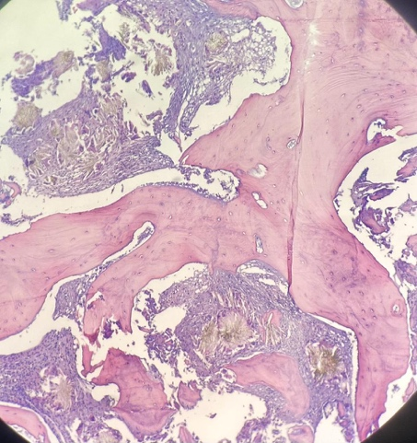

**FIGURE 1,2,3 :** Bone marrow biopsy : Multiple deposits of oxalate crystals within the marrow, accompanied by a foreign body giant cell reaction and no signs of malignancy.

**CONFLICTS OF INTEREST :**

**No conflicts of interest**

**PATIENT CONSENT :**

**The authors declare that they have obtained consent from the family of the patient discussed in the report.**

**REFERENCES :**

1. Singh P, Viehman JK, Mehta RA, et al. Clinical characterization of primary hyperoxaluria type 3 in comparison with types 1 and 2. Nephrol Dial Transplant. 2022;37:869–875. https://doi. org/10.1093/ndt/gfab027.
2. Hafsa Chahdi et al. The Pan African Medical Journal - ISSN 1937-8688
3. Groothoff JW, Metry E, Deesker L, et al. Clinical practice rec- ommendations for primary hyperoxaluria: an expert consensus statement from ERKNet and OxalEurope. Nat Rev Nephrol. 2023;19:194–211. https://doi.org/10.1038/s41581-022- 00661-1
4. Sahin GA, Acikalin MF, Yalcin AU. Erythropoietin resistance as a result of oxalosis in bone marrow. Clinical nephrology. 2005 May 1;63(5).
5. Bering JL, Wiedmeier‐Nutor JE, Sproat L, DiBaise JK. Bone marrow oxalosis with pancytopenia in a patient with short bowel syndrome: Report of a case and review of the literature. Journal of Parenteral and Enteral Nutrition. 2023 Jan;47(1):165-70.
6. Sharma S, Rao RN, Pani KC, Paul P. Bone marrow oxalosis: An unusual cause of cytopenia in end-stage renal disease; report of two cases. Indian Journal of Pathology and Microbiology. 2018 Apr 1;61(2):268-70.
7. Tapia G, Navarro JT, Navarro M. Leukoerythroblastic anemia due to oxalosis with extensive bone marrow involvement. American journal of hematology. 2008 Jun;83(6):515-6.
8. Breed A, Chesney R, Friedman A, Gilbert E, Langer L, Lattoraca R. Oxalosis-induced bone disease: a complication of transplantation and prolonged survival in primary hyperoxaluria. JBJS. 1981 Feb 1;63(2):310-6.