*Cotesia ruficrus*(Hymenoptera:Braconidae) Parasitizing *Beet* Armyworm, *Spodoptera exigua* (Lepidoptera : Noctuidae) larvae in Clover Fields in Egypt

Abstract

Clover, *Trifolium alexandrinum* L. is the key fodder winter crop, in Egypt, for feeding livestock, particularly with a sharp decline in meat and dairy product supplies. One of the important insect pests attacking clover is the beet armyworm, *Spodoptera exigua* Hubner (Lepidoptera: Noctuidae) which feeds upon clover stems and leaves, and in severe cases, it can defoliate the plants resulting in considerable foliage reduction. The current investigation was conducted at clover fields in Rasheed district, Beheira Governorate, during the 2020/2021 and 2021/2022 seasons, to monitor the population fluctuations of *S. exigua* as well as the fluctuations of the endo larval parasitoid, *Cotesia ruficrus* (Haliday) ( Hymenoptera: Braconidae) and its efficiency against *S. exigua* larvae. The first infestation by the beet armyworm was detected on November 1 with 28 - 30 larvae, and the highest pest densities were recorded in April and May. The parasitism of *S. exigua* larvae was remarkable from mid-March up to mid-May. The numbers of the parasitoid clutches were low during January, February and March, and were notably high during April and May. This study revealed that *C. ruficrus* attacked the larvae of *S. exigua* in clover fields, particularly during April and May, with overall parasitism of 14.41 - 17.86%. Thus, the parasitoid, *C. ruficrus* could be considered an efficient element in the integrated pest management of the beet armyworm, *S. exigua*.

**Key words:** *Cotesia ruficrus*, *Spdoptera exigua*, *Trifolium alexandrinum*.

# Introduction

Clover, *Trifolium alexandrinum* L., is the key fodder winter crop in Egypt for feeding livestock, particularly with a sharp decline in meat and dairy product supplies. This crop is highly significant as a multi-cut crop and an excellent soil-reclaiming crop because of its ability to fix the atmospheric nitrogen in its roots (Malaviya et al., 2005; Zayed et al., 2011; Roy *et al*., 2015).

Clover cultivations host a diverse fauna of insect pests and natural enemies. Since this crop is cut almost daily for animal feed, pesticide applications are heavily restricted. Accordingly, the populations of diversified natural enemies have become very high, and these enemies migrate clover moving to the following summer crops (Hervet *et al*., 2018). However, one of the most important insect pests attacking *T*. *alexandrinum* is the beet armyworm, *S. exigua* Hubner (Lepidoptera: Noctuidae). This insect feeds upon clover stems and leaves, and in severe cases, it can defoliate the plants resulting in considerable foliage reduction (Mardani *et al*., 2012, Hameed *et al*. 2016 and Cabello, 198). *S. exigua* poses a significant threat to early-sown clover (from late August to early September. During this duration, temperature is still relatively high in Egypt, which enhances the damage in clover plantations and may need chemical control, before offering the plants for livestock feeding.

Fortunately, the parasitoid, *Cotesia ruficrus* (Haliday) ( Hymenoptera: Braconidae) has proven to parasitise several economic insect pests as *S. exigua* ( Patil *et al.* 2016 and Mansour and Abou-El Kassem 2022). The wide host range of any parasitoid is desirable, to ensure the establishment of natural enemies in a wide range of zones (Hervet *et al*., 2022). Patil *et al*., (2016) recorded five insect pests as hosts of the endo larval gregarious parasitoid, *C. ruficrus*. These hosts were discerningly preferred as *Helicoverpa armigera*, (Hubner), *Mythimna separata* Walker, *Agrotis ipsilon* Hufnagel, *S. litura* Fab. and *S. exigua* Hubner. Gupta *et al*. (2019) surveyed *C. ruficrus* as one of the parasitoids of *S. frugiperda* in the maize fields. The larvae of the leaffolder, *Cnaphalocrocis medinalis* parsitoidized by *C. ruficrus* suffered reductions in of wet or dry weight, food consumption and fecal matter (Chen *et al.,* 2016). Mansour and Abou-ELkassem(2022) detected 21.48- 27.58 % *S. exigua* larval parasitism by *C. ruficrus* in sugar beet fields, depending on the date of sowing. *C. ruficrus* attacked the larvae of *S. frugiperda* infesting maize fields in India (Gupta *et al.,* 2019). The maximum number of parasitoid cocoons of *C. ruficrus* was obtained when the parasitoid was reared on the 4th larval instar of the tea looper, *Hyposidra talaca* (Walker) ( Lepidoptera: Geometridae ) with 65.2 cocoons, followed by 27.2 and 4.60 in thethird and second larval instars, respectively (Sarkara *et al.* 2020 and 2021). *S. exigua* (Patil *et al.* 2016 and Mansour and Abou-El kassem 2022). The wide host range of any parasitoid is desirable, to ensure the establishment of natural enemies in a wide range of zones (Hervet *et al*., 2022). Patil *et al*., (2016) recorded five insect pests as hosts of the endo larval gregarious parasitoid, *C. ruficrus*. These hosts were discerningly preferred as *H. armigera*, (Hubner), *Mythimna separata* Walker, *A. ipsilon* Hufnagel, *S. litura* Fab. and *S. exigua* Hubner. Gupta *et al*. (2019) surveyed *C. ruficrus* as one of the parasitoids of *S. frugiperda* in maize fields. The larvae of the leaffolder, *Cnaphalocrocis medinalis* parsitoidized by *C. ruficrus* suffered reductions in each wet or dry weight, food consumption and fecal matter (Chen *et al.,* 2016). Mansour and Abou-ELkassem(2022) detected 21.48- 27.58 % *S. exigua* larval parasitism by *C. ruficrus* in sugar beet fields, depending on the date of sowing. *C. ruficrus* attacked the larvae of *S. frugiperda* infesting maize fields in India (Gupta *et al.,* 2019). The maximum number of parasitoid cocoons of *C. ruficrus* was obtained when the parasitoid was reared on the 4th larval instar of the tea looper, *Hyposidra talaca* (Walker) ( Lepidoptera: Geometridae ) with 65.2 cocoons, followed by 27.2 and 4.60 in thethird and second larval instars, respectively (Sarkara *et al.* 2020 and 2021).

The objectives of the current study were to monitor the population fluctuations of the beet armyworm, *S. exigua* larvae, in clover fields, as well as the fluctuations of the endo larval parasitoid, *C. ruficrus*. In addition, the status of the parasitoid, and its emergence efficiency from cocoons was investigated.

# Materials and Methods

1. **Experimental Site**

This study was conducted at clover fields at Rasheed district, Beheira Governorate. Rasheed lies at the western branch of River Nile; about 50 km of Mediterranean seashore, with a latitude of 31.40 N and longitude of 30.41 E. Soil at the experimental site is fertile with 7.1pH and a good source of fresh irrigation water.

# Cultural Practices

The experimental area was prepared following the recommendations of Egypt's Ministry of Agriculture. Throughout the experimental period, all-normal agricultural procedures were adopted, but without any pesticidal treatments. On September 15, clover, *T. alexandrinum* L (Leguminosae) seeds (Helaly cultivar) were sown, in the 2020/2021 and 2021/2022 seasons.

1. **Population Fluctuations of *S. exigua***

The population fluctuations of *S. exigua* were monitored throughout the experimental period from beginning of November until end of May in both seasons of study. Biweekly samples (4m² of cut clover plants each) were examined to count the number of *S. exigua* larvae present in the clover vegetation. The collected larvae were kept for further investigation.

1. **Population Fluctuations of the Parasitoid, *C. ruficrus* (Haliday)**

The biweekly collected larvae of *S. exigua* were examined and those with any disease symptoms were excluded. The larvae were individually kept in glass containers and provided with clover plant pieces for feeding until they completed their larval stage. By monitoring the enclosed larvae, the clutches of the parasitoid could be observed; otherwise, the *S. exigua* pupaeare formed. By counting the clutches attached to *S. exigua* larvae, percentage of *S*. *exigua* parasitism were computed.

3. **Parasitism Status of *C. ruficrus***

Formed clutches of the parasitoid were examined to record the number of pupae per clutch. In addition, the clutches were kept individually in glass vials, and the emerging adult parasitoids were counted to calculate the percentage of *C. ruficrus* emergence throughout the period from early November up to late May.

# Results

1. **Population Fluctuations of *S. exigua* Larvae**

# 2020/2021 Season

In the first sample (Table 1) examined on November 1st, 28.00 larvae of *S. exigua* were detected in 4 m2 cut clover plants, which increased to 38.25 larvae/4 m2 two weeks later. By the beginning of December up to the beginning of February, the beet armyworm larvae decreased progressively and decreased from 26.75 to

10.50 larvae/4 m2 cut clover, respectively. However, the larval population steadily increased from 12.25 to 44.25 larvae / 4 m2 on March 15 and May 15, respectively.

# 2021/2022 Season

The population densities of *S. exigua* larvae (Table 1) ranged between

24.00 and 30.00/4 m2 cut clover through the period extending from November 1st up to January 1st. However, the highest densities were recorded in April and May, ranging between 26.00 and 43.25 larvae/4m2 cut clover plants.

1. **Population Fluctuations of *C. ruficrus***

Data presented in Table (2) shows that the parasitoid *C. ruficrus* (Fig 1) was low active from the beginning of November up to late March, except for a few individuals in some examinations. In the 2020/2021 season, the parasitism of *S. exigua* larvae was remarkable from mid-March (22.22%) up to

Mid-May (32.43 %). In addition, the parasitism was higher during April and May, ranging from 24.24 to 28.57%.

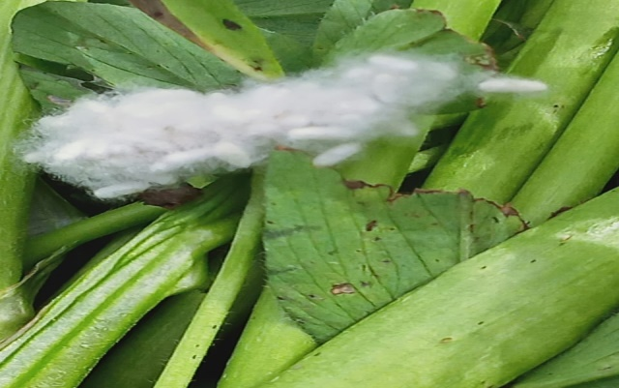

Fig (1): A clutch of *Cotesia ruficrus* parasitoid attached to clover stems

Table (1): Population dynamics of *Spodoptera exigua* larvae in clover fields, at Rasheed District, Beheira governorate

|  |  |  |
| --- | --- | --- |
| **Date of Examination** | **No. larvae / 4 m2** | |
| **2020/2021** | **2021/2022** |
| **Nov.1** | 28.00 | 30.00 |
| **Nov. 15** | 38.25 | 28.75 |
| **Dec. 1** | 26.75 | 28.50 |
| **Dec. 15** | 16.50 | 16.00 |
| **Jan. 1** | 14.00 | 24.50 |
| **Jan. 15** | 12.75 | 10.00 |
| **Feb.1** | 10.50 | 9.50 |
| **Feb. 15** | 0.00 | 0 |
| **Mar.1** | 0.00 | 0 |
| **Mar. 15** | 12.25 | 0 |
| **Apr.1** | 30.25 | 26.50 |
| **Apr 15** | 34.00 | 38.75 |
| **May. 1** | 42.50 | 32.00 |
| **May. 15** | 44.25 | 43.25 |

# Parasitism Status

**3.1. 2020/2021 Season**

Data presented in Table (3) show that number of the parasitoid clutches (Fig 2) was low during January, February and March (3-9 clutches/ 4 m2 cut clover plants). However, the number was notably higher during April and May with 17- 37 clutches/ 4 m2.

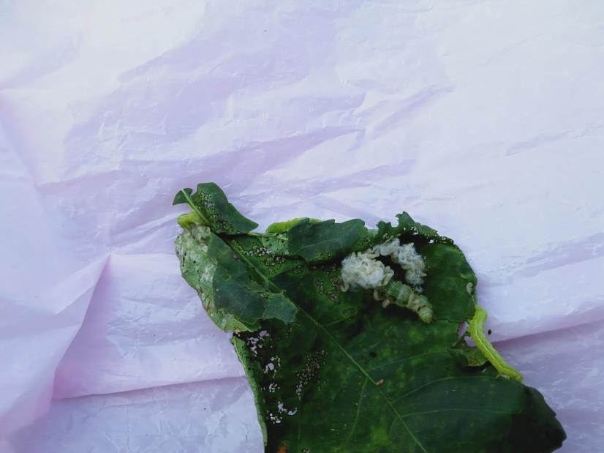Fig (2): A clutch of *Cotesia ruficrus* parasitoid showing gregarious pupae of the parasitoid emerging from *Spodoptera exigua* larva

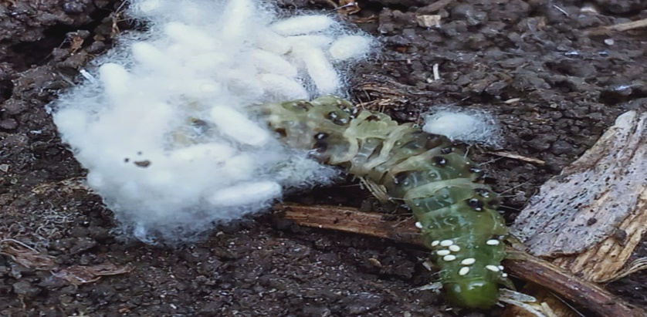

Table (2): Population dynamics of *Spodoptera exigua* parasitism by *Cotesia ruficrus* in clover fields, at Rasheed District, Beheira governorate (sample size is 4 m2 cut clover) clutches. Parasitoid emergence was almost the same in January, March and April (95.04-95.0)

|  |  |  |  |  |  |  |
| --- | --- | --- | --- | --- | --- | --- |
| **Date of sampling** | **2020/2021**  **Season** | | | **2021/2022**  **Season** | | |
| **No. incubated larvae** | **No. formed clutches** | **Parasitism**  **%** | **No. incubated larvae** | **No. formed clutches** | **Parasitism**  **%** |
| **Nov.1** | 25 | 0 | 0 | 20 | 0 | 0 |
| **Nov.15** | 30 | 0 | 0 | 25 | 0 | 0 |
| **Dec. 1** | 16 | 0 | 0 | 24 | 0 | 0 |
| **Dec. 15** | 16 | 0 | 0 | 14 | 0 | 0 |
| **Jan. 1** | 12 | 0 | 0 | 18 | 0 | 0 |
| **Jan. 15** | 10 | 3 | 30.00 | 4 | 0 | 0 |
| **Feb.1** | 10 | 2 | 20.00 | 2 | 1 | 50.00 |
| **Feb 15** | 0 | 0 | 0 | 0 | 0 | 0 |
| **Mar.1** | 0 | 0 | 0 | 0 | 0 | 0 |
| **Mar.15** | 9 | 2 | 22.22 | 0 | 0 | 0 |
| **Apr.1** | 21 | 6 | 28.57 | 26 | 7 | 26.92 |
| **Apr.15** | 26 | 8 | 30.77 | 35 | 9 | 25.71 |
| **May 1** | 40 | 12 | 30.77 | 28 | 8 | 28.57 |
| **May 15** | 37 | 12 | 32.43 | 33 | 8 | 24.24 |
| **Overall** | 252 | 45 | 17.86 | 229 | 33 | 14.41 |

**3.2. 2021/2022 Season**

Data of the second season (Table 4) is similar to those of the first one. Numbers of *C. ruficrus* clutches were low during January and February (2-9/4m2 cut

clover plants), increased to 5-12 clutches in March. The activity of the parasitoid was higher in April and May with 12-20 clutches/m2. The emergences of the parasitoid wasps were lower in the second season compared to those of the first one, with the lowest value in February (81.32 %), and highest in April (90.73 %).

**Table (3): *Spodoptera exigua* parasitism status, and activity of the parasitoid *Cotesia ruficrus* at clover fields, at Rasheed District, Beheira governorate 2020/2021**

|  |  |  |  |  |  |
| --- | --- | --- | --- | --- | --- |
| **Date of sampling** | | **No. of collected clutches** | **No. of parasitoid pupa** | **No. emerging parasitoids** | **Parasitoids emerging %** |
| **Month** | **Week** |
| **January** | **1st** | 4 | 188 | 180 | 95.74 |
| **2nd** | 6 | 240 | 230 | 95.83 |
| **Average** | | 5.00 | 214.00 | 205.00 | 95.81 |
| **February** | **1st** | 5 | 175 | 155 | 88.57 |
| **2nd** | 7 | 231 | 210 | 90.91 |
| **3rd** | 9 | 198 | 180 | 90.91 |
| **4th** | 5 | 85 | 80 | 94.12 |
| **Average** | | 6.50 | 172.25 | 156.25 | 91.13 |
| **March** | **1st** | 3 | 120 | 114 | 95.00 |
| **2nd** | 4 | 112 | 104 | 92.86 |
| **3rd** | 7 | 259 | 245 | 94.59 |
| **4th** | 6 | 264 | 258 | 97.72 |
| **Average** | | 5.00 | 188.75 | 180.25 | 95.04 |
| **April** | **1st** | 20 | 560 | 540 | 96.43 |
| **2nd** | 17 | 527 | 510 | 96.77 |
| **3rd** | 22 | 550 | 528 | 96.00 |
|  | **4th** | 25 | 875 | 805 | 92.00 |

|  |  |  |  |  |  |
| --- | --- | --- | --- | --- | --- |
| **Average** | | 21.00 | 628.00 | 595.75 | 95.30 |
| **May** | **1st** | 27 | 1700 | 1470 | 86.47 |
| **2nd** | 30 | 810 | 750 | 92.59 |
| 3rd | 37 | 911 | 812 | 89.13 |
| **Overall Average** | | 31.33 | 1140.33 | 1010.67 | 89.40 |

**Table (4): *Spodoptera exigua* parasitism status, and activity of the parasitoid *Cotesia ruficrus* at clover fields, at Rasheed District, Beheira governorate 2021/2022**

|  |  |  |  |  |  |
| --- | --- | --- | --- | --- | --- |
| **Date of sampling** | | **No. of collected clutches** | **No. of parasitoid pupa** | **No. emerging parasitoids** | **parasitoids emerging %** |
| **Manth** | **Week** |
| **January** | **1st** | 6 | 240 | 190 | 79.17 |
| **2nd** | 9 | 324 | 300 | 92.59 |
| **Average** | | 7.50 | 282.00 | 245.00 | 85.88 |
| **Febraury** | **1st** | 6 | 180 | 151 | 83.89 |
| **2nd** | 4 | 120 | 100 | 83.33 |
| **3rd** | 2 | 56 | 43 | 76.79 |
| **4th** | 3 | 48 | 39 | 81.25 |
| **Average** | | 3.75 | 101.00 | 83.25 | 81.32 |
| **March** | **1st** | 5 | 175 | 160 | 91.43 |
| **2nd** | 7 | 210 | 181 | 86.19 |
| **3rd** | 9 | 270 | 215 | 79.63 |
| **4th** | 12 | 480 | 360 | 75.00 |
| **Average** | | 8.25 | 283.75 | 229.00 | 83.00 |
| **April** | **1st** | 15 | 420 | 405 | 96.43 |
| **2nd** | 13 | 377 | 311 | 82.49 |
| **3rd** | 16 | 320 | 291 | 90.94 |

|  |  |  |  |  |  |
| --- | --- | --- | --- | --- | --- |
|  | **4th** | 20 | 720 | 670 | 93.06 |
| **Average** | | 16.00 | 459.25 | 419.25 | 90.73 |
| **May** | **1st** | 17 | 425 | 399 | 93.88 |
| **2nd** | 12 | 360 | 307 | 85.28 |
| **3rd** | 20 | 400 | 336 | 84.00 |
| **Overall Average** | | 16.33 | 395.00 | 347.33 | 87.72 |

# DISCUSSION

The Egyptian clover, *T. alexandrinum* L. (Leguminosae) is the most important forage crop in Egypt, it is rich in protein, and thus, is of high nutritional value for livestock. Furthermore, atmospheric nitrogen, fixed by *Azotobacter*, enriches the soil, particularly in newly reclaimed lands. Clover sown by late August up to early September is highly infested by the beet armyworm, *S. exigua*, due to the relatively high temperature during this period. Since the insect pest has built up resistance to several insecticides, it has become important to enhance the activity of natural enemies. Among the parasitoids efficient against this insect pest, is the endo larval parasitoid, *C. ruficrus* (Haliday) (Hymenoptera: Braconidae). In the current study, this parasitoid proved active against beet armyworm, *S. exigua*, fortunately, clover plantations are an ideal shelter for several natural enemies that move, by the end of clover season, to the neighboring summer fields. For the successful establishment of the parasitoids in new geographic zones, parasitoids need to find several suitable hosts that are of economic importance on cultivable plants (Hervet *et al*., 2018). Accordingly, Hearvet *et al*. (2022) considered *C. vanessae* (Hymenoptera: Braconidae) a successful parasitoid in North America, as it was reared on several noctuid pest species. Patil *et al* (2016) indicated that the main noctuid insect pests attacked by *C. ruficrus* are *H. armigera* (Hubner), *Mythimna separata* Walker, *A. ipsilon* (Hufnagel), *S. litura* Fab. and *S. exigua* (Hubner).

In the current study, *C. ruficrus* attacked the larvae of *S. exigua* in clover fields, particularly during April and May, with overall parasitism of 14.41 - 17.86

%. In the study of Mansour and Abou-El-Kassem (2023), the parasitism of *S. exigua* in sugar beet fields by *C. ruficrus* ranged from 21.48 to 34.33 %, with significant positive correlations between the population of the pest and parasitism level. In addition, Chen *et al*. (2016) indicated the efficient parasitism of *C*. *ruficrus* on leaf folder, *Cnaphalocrocis medinalis*, and the parasitism negatively affected all biological aspects of the host.

# REFERENCES

Cabello, T. (1989). Natural enemies of noctuid pests in alfalfa, corn, cotton and soybean crops in southern Spain. J. Appl. Entomol, 108:80-88.

Chen, Y[Chen](javascript:;), Y.; [X. G Liu](javascript:;), [J. Wang](javascript:;); [J. Zhao](javascript:;); [Z. X. Lu](javascript:;) and [Y. H. Liu](javascript:;) (2016). *Cotesia ruficrus*(Hymenoptera:Braconidae) parasitizing *Cnaphalocrocis medinalis* (Lepidoptera : Pyralidae):: Developmental Interactions and Food Utilization Efficiency of Hosts. Journal of Economic Entomology,109 (2): 588–593.

Gupta, A.,S.; R. Babu, and M. S. Kumar (2019). *Cotesia ruficrus* (Haliday, 1834) ( Hymenoptera: Braconidae) emerging as a common natural parasitoid of *S. frugiperida* (J.E.Smith) ( Lepidoptera : Noctuidae) in Indian maize fields. Journal of Biological Control,33(3): 193-196.

Hameed, A.; H. Karar, N. Muhammad and R. A. Kainth (2016). Varietal response to population fluctuation of insect pests, predators and pollinator fauna associated with berseem (*T. alexandrinum* L) crop. Pakistan J. Zool., 48(3),729-734.

Hervet, Y. A. D.; R. A. Larid and K. D. Floate (2022). Potential host range of *Cotesia vanessae* (Hymenoptera: Braconidae), a parasitoid new to North America and a possible biological control agent of noctuid pest species. Bulletin of Entomological Research, 113 (2). Published oniline by Cambridge Universit Press: 21 December, 2022.

Hervet, Y. A. D.; R. A. Larid and K. D. Floate (2018). Siblicidal behavior by larvae of the gregarious parasitoid, *Cotesia vanessae*. Journal of Hymenoptera Research, 67: 55-62.

Mansour, M. R. K. and A. B. Abou-Elkassem (2022). Ecological studies on *Spodoptera exigua* (Hubner) and its biological control by the novel parasitoid, *Cotesia ruficrus* (Haliday) (Hymenoptera: Braconidae) on sugar beet. Middle East Journal of Agriculture Research, 11(4): 1193-1200.

Mardani, M.; T. G. Nouri; G. B. Naseri and M. Hassanpour (2012). Life history studies of the beet armyworm, *Spodoptera exigua* (Hübner) (Lepidoptera: Noctuidae) on 10 corn hybrids J. Entomol. Res. Soc., 14(3): 09-18.

Malaviya, D. R.; A. K Roy; P. Kaushal; B.Kumar and A. Tiwari (2005). Development and characterization of interspecific hybrids of *Trifolium alexandrinum* x *T. apertum* using embryo rescue. Plant Breed, 123: 536-542.

Patil, S. S.; C. Kamble and T. V. Sathe (2016). Biocontrol potential of *Cotesia ruficrus* Hal. (Hymenoptera : Braconidae) against different lepidopterous pests. Biolife Journal, 4(2): 343-346.

Roy, D. C.; M. Ray; N. K Tudu and C. K. Kundu (2012). Impact of phosphate solubilizing bacteria and phosphorus application on forage yield and quality of berseem in west Bengal. IJAEB, 8(2):315-321.

Sarkara, S. S.; A. Babua; K. Chakrabortyb; B. Dekaa and S. Royc (2021). Seasonal abundance of *Cotesia ruficrus* ( Hymenopera: Braconidae) and its host tea looper, *Hyposidra talaca* (Lepidoptera: Geometridae) in tea ecosystem. International Journal of Pest Management, 69 (4): 332-345.

Sarkar,S, A. Babu; K. Chakraborty and B. dcka (2020). Biology and life history of *Cotesia ruficrus* (Hymenoptera: Braconidae) a potential parasitoid of *Hyposidra talaca* (Lepidoptera: Geometridae) larvae, a major tea pest. J. Biopest, 13 (1): 79-84.

Zayed, E. M.; E. M. R. Metwali; A. F. Khafaga, and M. M. Azab (2011). Field performance of commercial Egyptian clover (*Trifolium alexandrinum* L*.*)cultivars under high temperature condition. Range Mgmt. and Agroforestry, 32 (2): 87-91