IMPLEMENTATION OF DIRECT HEALTH FACILITY FUNDING IN PRIMARY HEALTHCARE FACILITIES IN PLATEAU STATE: SUGGESTIONS AND RECOMMENDATIONS

Abstract
The study investigated the suggestions and recommendations on how to improve the implementation of the Direct Health Facility Funding in Primary Healthcare Facilities in Plateau State. The population for this study therefore was made up of 974 healthcare centres in Plateau State, out of which 851 are primary health care centres with a population of 1702 administrators and 25,111 staff. Through the ballot system, a sample of 265 administrators and 377 staff were selected, giving a total sample size of 642 respondents. The results from the qualitative and quantitative analysis both revealed that there is a need to ensure prompt disbursement of funds, adequate training for staff on Direct Health Facility Funding administration and strict supervision of how funds are utilized in the primary healthcare facilities. Phasing out of the current fund disbursement modality and replacement with a more dependable and effective mechanism is recommended. Accordingly, for purposes of ensuring proper usage by facility management committees and medical staff, the Ministry of Health should provide primary healthcare facilities policy instructions on how to handle government health funding. This can be done by setting up a monitoring committee of management staff of primary health facilities, community leaders and staff of the ministry of health. In addition, more training should be provided to administrators of primary health facilities to train them adequately on Direct Health Facility Funding Administration.
Keywords: Direct Health Facility Funding, Adequate Training Programmes, Disbursement of Funds and Primary Healthcare Facilities

1.1 Introduction
The Direct Health Facility Funding (DHFF) was established as a novel direct financing transfer to health facilities and dispensaries in accordance with a ministerial order contained in Legal Notice No. 401. The legal notice states that the funds are derived from the state, contributions from development partners or grants, earnings from cost-sharing, and any funds generated by the fund's operations. Now kept in the MOPHS, the fund is meant to support the operations of all public dispensaries and medical centers. That is, setting aside money to carry out the Annual Operational Plan (AOP) of each facility, which covers curative, promotional, and preventative services at different levels.
Public Expenditure Tracking Survey (PETS) (2007) assert that, district levels only got 67% of the allocations made by Authorities to Incur Expenditure (AIE), and AIEs were frequently delayed. Access to funds by peripheral facilities was also hampered by the District Treasuries' bureaucratic and liquidity issues, according to the poll. According to the report, the district levels used the majority of these monies, leaving the periphery institutions with little to no operating capital. The ability of healthcare facilities to cover operating expenses and acquire necessary resources was significantly diminished by the elimination of cost sharing. Furthermore, it seemed that relationships with communities were being weakened by facility-level resource limitations and a lack of transparency regarding the user fee levels (Opwora, Kabare & Molyneux, 2021).
With assistance from the Danish International Development Agency (DANIDA), the Ministry of Health chose to pilot a novel direct facility funding (DFF) system for rural health facilities in order to alleviate the financial constraints in these facilities. As long as the District Medical Officer of Health (DMOH) could guarantee proper supervision by trained personnel, all MOH facilities were eligible to receive funding. The DHFF is a revolving fund that gives tier two and three primary healthcare facilities direct cash transfers. Depending on their medical needs, the fund's use is prioritized by the regional communities, who are represented by the Committees for Facility Management. In order to enable communities to take charge of their own health, the fund guarantees their active involvement in facility management committees that set priorities. In addition, maintaining the health facilities is one of the most crucial prerequisites for delivering efficient, equitable, and inclusive healthcare services (Mwangi, 2013).
The DHFF's main goal is to provide operational funding to health clinics and dispensaries right at the point of use. Approximately 50% of the allocated money for Level 2 and Level 3 facilities, respectively, were able to get to these facilities prior to the implementation of this policy. Numerous factors contributed to this, such as the inability to adhere to government accounting procedures, the lack of quarterly allocations, the Ministry of Health's financial problems, and delays in obtaining funds from the Ministry of Finance or the Ministry of Health. A study by Kiplagat (2015) on the factors influencing Kenyans' choice of health insurance was carried out at Kenyatta National Hospital with an emphasis on senior managers. According to research, Kenya has created a distinctive healthcare system that has generated exceptional health results per dollar invested, all while adhering to the principles of affordability and personal accountability. Despite significant government subsidies, research indicates that Kenyan healthcare funding is still heavily reliant on personal income levels. Also, there is little coverage for costly outpatient procedures, and the government subsidies and NHIF, the main medical care tools, are strongly skewed toward inpatient care.
The direct government funding model requires training for the Health Facility Committees and the facility staff. Health centers ' notice boards and blackboards that show accounting and facility usage to the public, as well as committee members, intended to give local communities the authority to keep an eye on how facilities spend their funds. According to the direct government funding policy, health institutions that receive program benefits must have a Health Facility Committee (HFC) chosen from the local population in the catchment area. The committee's responsibilities include managing and operating the facility, representing community interests, facilitating community feedback, putting community decisions into action, and mobilizing community resources. Program execution within the Local Government Area is the responsibility of the Local Government Health Management Teams, while at the state level, the State Health Management Teams are in charge. As a prerequisite for the distribution of funding, the local government's health services officer has the responsibility of overseeing everything, including approving work plans. It is projected that HFCs will participate in the planning and use of the funds at the facility level and create work plans that include quarterly budgets for each expense item and a justification for their use (Aga Khan Health Services, 2005).
Similar to other third-world nations, Nigeria has undergone health financing reforms in an effort to enhance the performance of its health system. Cost-sharing was introduced in 2003, and Community Health Funds (CHF) were introduced in 2006, as part of the health finance changes. Primary healthcare plays a vital role in ensuring the well-being of a population and serves as the foundation of a Nigeria’s healthcare system. Adequate funding is essential to deliver efficient and effective primary healthcare services. This research seeks to address the existing challenges in the healthcare system and identify potential solutions that can improve access and quality of healthcare services.
2.1 Literature Review
A study on health financing and health care performance in Tokyo, Japan, was carried out by Hyun, Nishizawa, and Yoshino (2015). The outcome of the study stated that one of the main factors influencing a nation's citizens' health is how it funds its healthcare system. In addition to the organizational structure for health service delivery, choosing a suitable and effective finance strategy or methods is crucial, if a nation is to meet its national health goal of universal access to healthcare.
In Japan, health care is paid for by tax money, out-of-pocket expenses, donations, and social and community health insurance. Nonetheless, Japan still has difficulties in establishing a viable system for financing health care. The National basic Health Care Development Fund, which was suggested as a way to increase the amount of resources allocated to basic health care, was one of the various financing strategies that were explored in the study. To tackle the issues that have undermined Japan's public health care funding, the study's conclusion called for Japan to investigate and fortify other health system mechanisms, move away from out-of-pocket payments, enhance evidence-based planning, and expedite the National Health Bill's implementation whenever it becomes law.
Tanzania implemented Direct Health Facility Financing in 2017–2018 to enable medical facilities to buy medications and associated supplies from the top supplier in the event that the Medical Store Department (MSD) notifies them that they are out of stock. The DHFF is being implemented at the primary level across the country, and by guaranteeing the availability of necessary medical supplies, it is anticipated that it will address the issues of subpar services, shortages of medications and medical equipment, and low provider morale. According to Kapologwe, Kalolo and Kibusi (2019), DHFF is the direct delivery of government or outside funding to the medical facility in order to cover its operational needs. According to guidelines for its execution, every primary level health institutions must have an account where money may be put and the funds must be supplied with the allowed budget. According to studies by Ndomba and Maluka (2021), the Tanzanian government implemented health insurance programs to improve the affordability of medical care in both public and private healthcare institutions, hence expanding access to healthcare. However, additional issues have emerged as a result of the expansion of health insurance, such as a greater burden for the already limited number of healthcare professionals, which has a negative impact on their morale and enrollment in health insurance programs. Implementing DHFF to enable health facilities to buy medications and other pharmaceutical products from MSD and other suppliers was one way to solve the problem. The objective is to raise the standard of healthcare services offered at the facilities, as this directly affects people's propensity to sign up for health insurance plans.
Kajuni and Mpenzi (2021) indicated that the implementation of the DHFF policy has made it possible for healthcare facilities to budget and plan in accordance with their needs. The purchasing of medical supplies is left to the discretion of the healthcare facilities. To help with strategic planning and resource allocation, the Tanzanian government developed PlanRep, an online planning and budgeting tool, in addition to deploying DHFF and FFARS. In addition, the rules for Health Facilities Planning and Comprehensive Council Health Planning (CCHP) were created to make it easier to allocate resources, including medical supplies. The changes are expected to give providers more control over how they access and use resources, and they will also increase the involvement of health facility governing committees and healthcare professionals in the planning and funding of inputs like medical supplies that are vital to providing high-quality healthcare (Kajuni & Mpenzi, 2021). Lodeinstein (2017) noted that health funding mechanisms that ensure adequate financial resources are available and resources are used efficiently are fundamental to achieving UHC's stated goals. Any health system striving to attain UHC must have access to basic health commodities. In order to accelerate UHC, robust health systems are recommended (Waweru & Toda, 2023).
According to Israel (2021), DHFF drastically changed the responsibilities and interactions between various players in the PHC manufacturing process, moving financial authority from LGAs to PHC facilities. In order to participate in planning, budgeting, and implementation activities that were traditionally handled by LGAs, DHFF required facility involvement. Today, PHC facilities facilitate the incorporation of community goals in facility planning and budgeting while taking the lead in planning, budgeting, and plan implementation—with money under their control. Through DHFF, PHC providers are now managing their own business and LGAs are taking on a supervisory role, rather than merely carrying out LGA directives in a passive manner. Better budget execution and more timely and thorough reports are the results of these roles adjustments, which have also improved facilities' ability to report and execute their budgets. These improvements have improved PHC facilities' relationships with LGAs.
3.1 Research Methodology
The study adopted the pragmatism research philosophy and descriptive cross-sectional design. The population for this study therefore was made up of staff and management of primary health care facilities in centres in Plateau State. There are a total of 974 healthcare centres in Plateau State, out of which 851 are primary health care centres with a population of 1702 administrators (chairmen and secretaries) and 25,111 staff. The sample of this study was drawn from the population of the study using Krejcie and Morgan technique. This provided a sample of 265 administrators and 377 staff giving a total sample size of 642 respondents. Through the ballot system, a sample of 265 administrators and 377 staff were selected, giving a total sample size of 642 respondents. Data was collected using interviews and questionnaires.
4.1 Data Analysis and Discussions
This section is based on data analysis and discussions of findings as guided by the qualitative and quantitative data collected for the study.
4.2 Data Analysis
The analysis of data was based on qualitative and quantitative analyses. The analysis of data was guided by various statements/questions in line with the research question and underlying objective.
4.2.1 Qualitative Analysis
The qualitative analysis was aimed at providing answers to the following research question:
What are the suggestions and recommendations for improving the implementation of Direct Health Facility Funding in Primary Healthcare Facilities in Plateau State?
In order to answer this research question, a thematic analysis of the responses collected from the interview was carried out and three themes were identified namely: prompt disbursement of funds, more training and strict supervision of how funds are utilised.
4.2.1.1. Prompt Disbursement of Funds:
One of the themes that emerged from the analysis of the research question on the suggestions and recommendations for improving the implementation of Direct Health Facility Funding in Primary Healthcare Facilities in Plateau State was prompt disbursement of Funds. 86% of the respondents interviewed mentioned the need for funds to be promptly disbursed. To further buttress this point, one of the officers in charge of one of the primary healthcare facilities in Plateau State who was interviewed on the 7th of November, 2024 has this to say
“one of the major challenges affecting primary healthcare facilities with the introduction of DHFF is lack of prompt disbursement of funds. Funds required for smooth-running of the facilities are not disbursed on time hence, I am suggesting therefore that funds should be disbursed early to enable the management of the facilities to carry out their responsibilities on time”.
To corroborate this point, one of the respondents who was interviewed on the 8th of November, 2024 has this to say:
“when funds are not disbursed on time, it affects the performance of the facility and its ability to give quality service to the community, hence there is need to ensure prompt disbursement of funds to enable the facilities to carry out their responsibilities effectively”.
To corroborate this account, one of the deputy officers in charge of the primary health facilities in Plateau who was interviewed on the 8th of November, 2024 made the following assertions:
“the delay in the disbursement of funds often hinders the proper functioning of health facilities because funds are necessary pre-requisite for proper functioning of the facilities. When there is a delay, it stagnates everything hence there is need for funds to be disbursed early to ensure smooth operation of the facilities”.
4.2.1.2 More Adequate Training Programmes
In carrying out the thematic analysis of responses to the research question, one of the themes that emerged is the need for more training programmes. 70% of the respondents interviewed attested to the need for more training programmes to enhance the standard of implementation of the Direct Health Facility Funding. To explain this point further, one of the respondents who was interviewed on 8th of November, 2024 made the following assertions:
“the quality of training given to some of the facilities staff on DHFF is inadequate hence the programme is not properly functional in those facilities. It is therefore suggested that proper training should be provided for all staff involved the DHFF management process”.
An officer in charge of one of the primary health facilities who was interviewed on the 8th of November, 2024 corroborated he above account by saying:

“training is an essential part of DHFF implementation hence the quality of training giving to the administrative staff of the primary health facilities should be improved to ensure effective implementation of the programme in those facilities”.

To further buttress this point, another respondent who was interviewed on 9th of November, 2024 made the following assertions:
“One of the major constraints militating against the effectiveness of the DHFF is poor training. The staff of the primary healthcare facilities were not properly trained for the take-off of the DHFF hence there is need to properly train all the staff involved in the administration of the DHFF for the programme to function effectively”
4.2.1.3 Supervision of How Funds are Utilised
One of the major themes that emerged during thematic analysis of interview responses collected on suggestions and recommendations for improving the implementation of Direct Health Facility Funding in Primary Healthcare Facilities in Plateau State us proper supervision of how funds are utilised 85% of the respondents mentioned the need for proper supervision of how the funds allocated to the primary healthcare facilities are expended. To buttress this point further, one of the respondents who was interviewed on the 9th of November, 2024 made the following assertions:
“in some facilities, the basic funds are not often completely utilised for the purposes they meant for hence, there is need for strict supervision on how these funds are expended by the authorities of the primary healthcare centres in Plateau State”
Another respondent who was interviewed on the 9th of November corroborated this account by making the following assertions:
“there is need for strict supervision of the funds from the DHFF because there has been cases of financial misappropriation by the management of some primary health care facilities. Committees need to be setup to supervise how these funds are expended”

Furthermore, one of the principal officers of the primary healthcare facilities in Jos in made the following recommendations:
“the government in conjunction with NGOs sponsoring the DHFF should setup committees to supervised how funds disburse to each facility are expended for better accountability and transparency”.
4.2.2 Quantitative Analysis
The quantitative analysis was based on descriptive analysis. The descriptive analysis was guided by the following research question:
What are the suggestions and recommendations for improving the implementation of Direct Health Facility Funding in Primary Healthcare Facilities in Plateau State?
Based on the above question, several sub-questions were formulated and analyzed based on data collected.
Q 1: What suggestions do you have for improving the implementation of Basic Health Care Funding in your facility?
The study investigated the suggestions provided by the respondents for improving the implementation of basic health care funding, the results are documented in Figure 1.
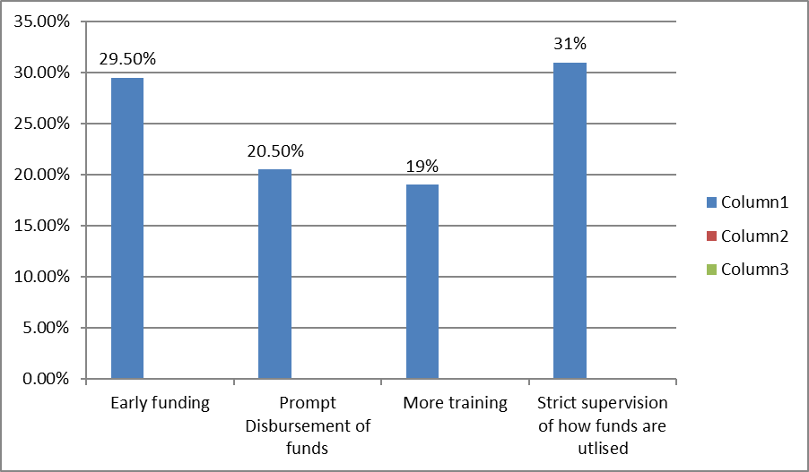
Figure 1: Suggestions do You Have for Improving the Implementation of Basic Health Care Funding
Figure 1 shows the suggestion for improving the standard of implementation of Basic Health Care Funding (DHFF) in primary healthcare facilities in Plateau State. 29.5% suggested early funding as a way of improving the implementation basic healthcare facility funding, 20.5% suggested prompt disbursement of funds as a way of improving the standard of implementation of DHFF, 19% suggested more adequate training for staff of primary healthcare facilities as a way of improving the standard of implementation of DHFF in primary healthcare facilities in Plateau State while 31% of the respondents suggested strict supervision of how funds are utilised by facility management as a way of improving the standard of implementation of DHFF in primary healthcare facilities in Plateau State.
Q2. Do you have any additional comments on how Basic Health Care Funding (DHFF) could better impact maternal and child health, immunization, or malaria control?
Responses from the above question were analyzed and the findings presented in Figure 2.
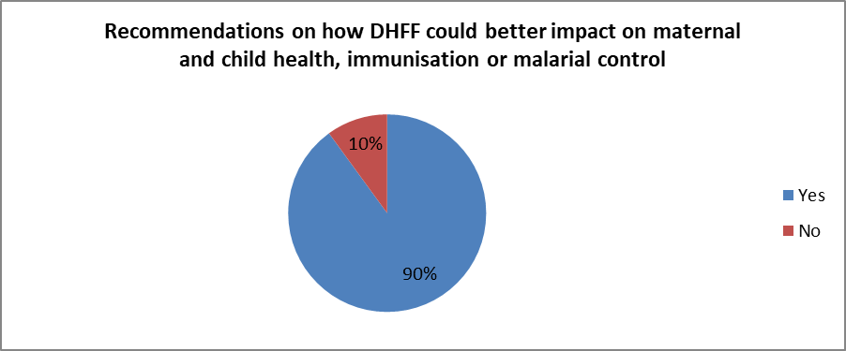
Figure 2: Showing Responses on Whether There are Recommendations on How DHFF Could Better Impact on Maternal and Child Health, Immunisation or Malarial Control.
Figure 2 shows that 90% of the respondents said yes, they have additional recommendations on how DHFF could better impact on maternal and child health, immunisation or malarial control while 10% of the respondents said no.
Q3. If yes, what are the recommendations?
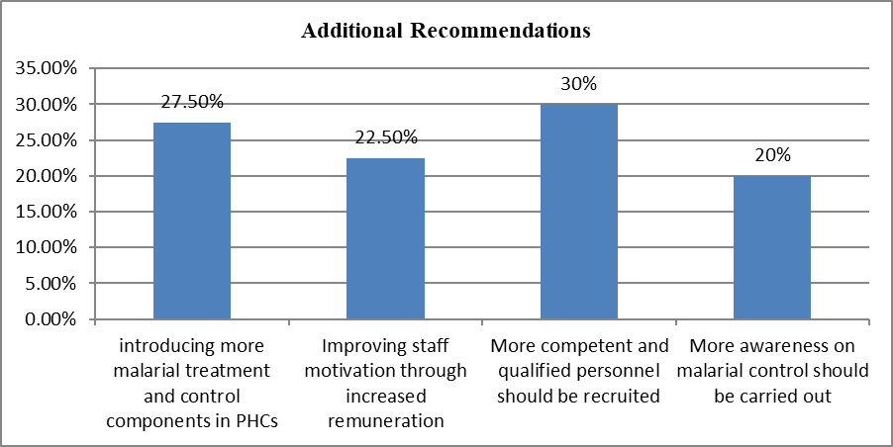
Figure 3: Additional Recommendations on How DHFF Could Better Impact on Maternal and Child Health, Immunisation or Malarial Control
Figure 3 shows the additional recommendations by the respondents on how DHFF could better impact on maternal and child health, immunisation or malarial control. 27.5% of the recommendations suggested introducing more malarial treatment and control componenet in PHCs. 22.5% of the respondents suggested improving staff motivation through increased motivation, 30% of the respondents suggested recruiting more competent and qualified personnel in PHCs while 20% suggested more awareness on malarial control, immunisation, maternal and child health.
4.3 Discussions of Findings
The study investigated the suggestions and recommendations on how to improve the implementation of the Direct Health Facility Funding in Primary Healthcare Facilities in Plateau State. To answer the research question, both qualitative and quantitative data were collected and analysed. The results from the thematic analysis of qualitative data collected revealed that the suggestions and recommendations made towards improving the standard of implementation of DHFF programme in primary health facilities in Plateau State include prompt disbursement of funds, initiation of more training programmes and strict supervision of how funds are utilized in the primary healthcare facilities.

The findings from the thematic analysis of data revealed that one of the major challenges affecting primary healthcare facilities with the introduction of DHFF is lack of prompt disbursement of funds. Funds required for smooth-running of the facilities are not disbursed on time hence, it was therefore suggested that funds should be disbursed early to enable the management of the facilities to carry out their responsibilities on time. This finding is in agreement with the recommendations of Dulak and Dupre (2018) who recommended early disbursement of funds to the healthcare facilities to enable them carry out their functions effectively.

The results of the thematic analysis also revealed that initiation of more training programmes in the primary healthcare facilities in Plateau State will improve the standard of DHFF implementation. The result of the study revealed that the quality of training given to some of the facilities staff on DHFF is inadequate hence the programme is not properly functional in those facilities. It is therefore suggested that proper training should be provided for all staff involved the DHFF implementation and management process in primary healthcare facilities in Plateau State. This finding is in agreement with the recommendations by Nielson and Randall (2023) who recommended intensive training to financial and administrative staff of health facilities on DHFF administration.
The results of the study further suggested strict supervision of how funds are utilized in the primary healthcare facilities as a measure to improving the standard of DHFF implementation in primary healthcare facilities in Plateau State. It was discovered from the findings of the study that in some of the primary healthcare facilities, the basic funds are not often completely utilised for the purposes they are meant for, hence, there is need for strict supervision on how these funds are expended by the authorities of the primary healthcare centres in Plateau State. This finding is in agreement with the recommendations by Sekwat (2023) who recommended that independent committees comprising of community members, sponsor agencies, government officials and facility management should be constituted to supervise the administration and utilization of the basic funds allocated to health facilities.
The quantitative analysis of data collected on the research question indicated that the following recommendations were proffered in a bid to improve the standard of DHFF implementation in primary healthcare facilities in Plateau State; early disbursement of funds to the facilities, adequate training for staff on DHFF administration and strict supervision of how funds disbursed to health facilities are utilized. This finding is in conformity with the recommendations by Tsofa, Goodman and Gilson (2019) who recommended early funding and appropriate fund utilization as top prerogative for improving the administration of DHFF in health facilities.
5.1 Conclusion and Recommendations
The implementation of Direct Health Facility Funding is aimed at improving the quality and efficiency of health services while mobilizing health workers as well as stakeholders across community levels towards improved delivery of health services. The current method utilized for disbursement of funds to primary health centres by government is inefficient as it is characterized by delays, hence slowing timely distribution of funds. It is recommended that the current modality being used in disbursement of funds should be phased out and subsequently replaced with a more efficient and reliable system.
Policy guidelines should be provided by the Ministry of Health with regards to the distribution and management of government funds in primary health facilities to be adhered to by facility management committees and health workers. A committee should be setup comprising of management staff of primary health facilities, community leaders and staff of the ministry of health to monitor how funds disbursed to primary health facilities are expended. More training should be provided to administrators of primary health facilities to train them adequately on Direct Health Facility Funding Administration. This will go a long way to enhance the effectiveness of the DHFF programme in primary healthcare facilities.
REFERENCES
Aga Khan Health Services, (2005). Direct facility funding as a response to user fee reduction: implementation and perceived impact among Kenyan health centers and dispensaries. Health Policy Plan 25(5):406-18.
Dulak, D. R. & Dupre, M. S. (2018). World Health Report 2017: A step towards evidence- based health policy. Lancet. 3(57):16-19.
Hyun, R. Y. Nishizawa, Z. A, & Yoshino, W. A. (2015). E. Evaluating community participation: a comparison of participatory approaches in the planning and implementation of new primary health care services in Northern Australia. International Journal of Health Planning Management, 2(3),20-29
Israel, J. D. (2021). Knowledge and utilization of Referral System among Health Care Workers in selected primary Health Care Centres in Oyo State, Nigeria. Journal of Community Medical Primary Health Care. 2(1), 65–75
Kajuni, B. D. & Mpenzi, K. P. (2021). Financial risk protection and universal health coverage: evidence and measurement challenges. PLoS Med. 1(3), 90-100
Kiplagat, W. B. (2015). The effects of performance incentives on the utilization and quality of maternal and child care in Burundi. Social Science and Medical Studies. 2(2), 123- 129.
Kapologwe, A. R., Kalolo, N.T. & Kibusi, S. R. (2019). The effects of performance-based financing on the use and quality of health care in Burundi: an impact evaluation. Lancet,2(2), 381-391.
Lodeinstein, D. S. (2017). Crowding out or no crowding out? A Self-Determination Theory approach to health worker motivation in performance-based financing. Social Science and Medical Research Journal, 6(9), 119-129.
Mwangi, B. A. (2023). Political economy and history: making sense of health financing in Sub-Saharan Africa. Journal of International Development, 5(3):297–309.
Ndomba K. A. & Maluka, M. A. (2021). Health sector reform and the interpretation of policy context. Health Policy, 1(2), 29-39.
Nielson, V. A. & Randall, R. D. (2023). Ethical Perspective: Five Unacceptable Trade-offs on the Path to Universal Health Coverage. International Journal of Health Policy Management, 2(2), 12-21.
Opwora, W. A., Kabare, H. R. & Molyneux, R. F. (2021). Demand and supply analysis for maternal and child health services at the primary healthcare level in Nigeria. BMC Health Service Research, 4(5), 200-215.
Sekwat, G. T. (2023). Tracking health commodity inventory and notifying stock levels via mobile devices: a mixed methods systematic review. Cochrane Database of Systematic Reviews, 11(2), 122-132.
Tsofa, G. S., Goodman, J. H. & Gilson, S. T. (2019). Assessing the quality of published genetic association studies in meta-analyses: the quality of genetic studies (Q-Genie) tool. BMC Genetic, 1(6), 50-54. https://doi.org/10.1186/s12863-015-0211-2
Waweru, V. B. & Toda, S. T. (2023). Performance-based financing toolkit. Washington, DC: World Bank Press

