**Minireview Article**

**Unraveling the Mechanisms of Hearing Loss in Lassa Fever: A Pathophysiological and Clinical Perspective**

***Abstract***

*Lassa fever is a viral hemorrhagic illness endemic to West Africa that poses a significant public health burden. One of its most debilitating complications is sensorineural hearing loss (SNHL), which affects up to 30% of survivors, regardless of the severity of its acute phase. The pathophysiological mechanisms underlying hearing loss in Lassa fever are not yet fully understood. In this review, we explore four potential mechanisms: direct viral damage to cochlear structures, immune-mediated cochleitis, cochlear neuritis, and vascular compromise. The neurotropic properties of Lassa fever may allow it to directly invade cochlear structures or trigger immune responses that damage auditory tissues. Cochlear inflammation and ischemic damage due to systemic inflammatory response and vascular dysfunction in Lassa fever also contribute to hearing loss. Despite these insights, gaps remain in understanding the exact mechanisms, and further studies are needed to elucidate the molecular and immune profiles associated with hearing loss in Lassa fever. Clinically, early detection and intervention, including routine auditory assessments and timely treatment, are crucial to improve the quality of life for survivors. Further research is needed to develop targeted therapies and implement public health measures to address this neglected complication in endemic regions.*

***Keywords:*** *Lassa fever, sensorineural hearing loss, pathophysiology, cochlear damage, immune-mediated cochleitis, cochlear neuritis, vascular compromise, public health, hearing loss management, endemic diseases.*

**Introduction**

Lassa fever is a viral hemorrhagic illness caused by the Lassa virus, endemic to West Africa and continues to pose significant public health challenges. The World Health Organization estimates that approximately 100,000 - 300,000 infections occur annually, with 5,000 deaths, primarily in Nigeria, Sierra Leone, Guinea, Benin, Ghana, Mali and Liberia [1,2]. Beyond its systemic manifestations, Lassa fever is increasingly associated with sensorineural hearing loss (SNHL), which affects up to 30% of survivors [3,4]. This complication often develops irrespective of the disease severity, suggesting a unique pathogenesis that warrants further exploration [18-20].

Despite its prevalence, the pathophysiological mechanisms underlying hearing loss in Lassa fever remain poorly understood. By integrating insights from related viral infections and focusing on the specific characteristics of Lassa fever, we aim to shed light on the mechanisms of hearing loss, identify research gaps, and propose actionable strategies to improve the diagnosis and management of this neglected complication [15-17].

Furthermore, understanding the mechanisms of hearing loss in Lassa fever could provide valuable insights that may be applicable to other viral infections, offering a broader impact on public health.

**Potential Mechanisms of Hearing Loss in Lassa Fever**

1. **Direct Viral Damage to Cochlear Structures**

The Lassa virus is a member of the Arenaviridae family which exhibits neurotropic properties that may enable it to directly invade and damage cochlear structures. Similar to mumps and rubella viruses, which are established causes of SNHL, the Lassa virus may exert cytotoxic effects on hair cells and spiral ganglion neurons within the cochlea [5,6,7].

Animal studies have demonstrated that arenaviruses can infect sensory and neural tissues, leading to cellular degeneration [8]. Specifically, cytopathic effects on the organ of Corti may disrupt auditory signal transmission, resulting in varying degrees of hearing loss. Molecular studies identifying viral RNA or antigens in cochlear tissues of Lassa fever survivors are critical to substantiate this mechanism. However, the difficulty in establishing direct causality between viral infection and cochlear damage remains a major challenge.

1. **Immune-Mediated Injury to the Inner Ear**

The immune response to Lassa virus infection may inadvertently damage cochlear structures, a phenomenon referred to as "immune-mediated cochleitis." This occurs when inflammatory cytokines such as tumor necrosis factor-alpha (TNF-α) and interleukin-1 beta (IL-1β) target cochlear tissues [9,10]. Furthermore, molecular mimicry between viral antigens and cochlear proteins could trigger autoimmune responses, similar to those observed in autoimmune inner ear disease.

Evidence from hemorrhagic fevers like Ebola supports the role of immune-mediated damage in auditory complications [11,12]. However, more research is needed to identify specific cytokine profiles and immune markers that are linked to hearing loss in Lassa fever survivors. Future research should investigate cytokine profiles and immune markers in Lassa fever survivors to identify specific pathways contributing to hearing loss.

1. **Neuritis of the Cochlear Nerve**

Cochlear neuritis, or inflammation of the auditory nerve, may also play a role in hearing loss among Lassa fever survivors. Viral infections such as herpes zoster oticus (Ramsay Hunt syndrome) and cytomegalovirus have been shown to cause auditory neuropathy through direct viral invasion or immune-mediated inflammation [13].

In Lassa fever, neuritis could arise due to viral replication within neural tissues or as a result of systemic inflammation. This inflammation disrupts the conduction of auditory signals, leading to hearing loss, tinnitus, and other auditory processing disorders. However, there is limited evidence of direct viral invasion of cochlear nerves in Lassa fever, and more advanced imaging techniques such as MRI could help elucidate the extent of cochlear nerve inflammation. Studies using advanced imaging techniques (e.g., MRI) to detect cochlear nerve inflammation in Lassa fever survivors are urgently needed.

1. **Cochlear Inflammation and Vascular Compromise**

The Lassa virus induces systemic inflammation and endothelial dysfunction, which may impair the cochlea’s vascular supply. The cochlea's high metabolic demand and reliance on robust blood flow make it particularly vulnerable to ischemic damage [14]. Vascular compromise in Lassa fever may lead to hypoxia-induced injury of cochlear hair cells and neurons. Given the potential for ischemic damage, experimental models assessing cochlear blood flow in Lassa fever may offer critical insights into the vascular mechanisms involved.

Fig. 1 below illustrates the summary of the four potential mechanisms of hearing loss in Lassa fever survivors

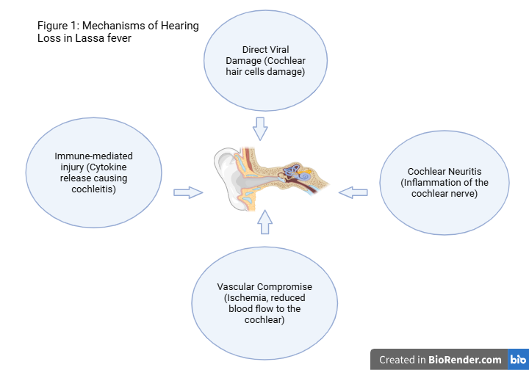

Fig. 1 illustrating mechanisms of Hearing Loss in Lassa

**Clinical and Research Implications**

**Clinical Implications**

Hearing loss in Lassa fever survivors has profound implications for communication, quality of life, and socioeconomic well-being. To address this, clinicians in endemic regions should incorporate routine auditory assessments into the management of Lassa fever survivors. Diagnostic tools such as audiometry, otoacoustic emissions (OAEs), and tympanometry are essential for early detection, particularly for children who are survivors and management should follow depending on severity of hearing loss as illustrated in Fig. 2.

However, due to limited resources in endemic regions, the implementation of these diagnostic tools faces significant barriers. Interventions such as hearing aids, cochlear implants, and auditory rehabilitation programs should be made accessible, particularly in resource-limited settings. Additionally, public health campaigns should raise awareness about hearing loss as a potential complication of Lassa fever to encourage early evaluation and treatment (Fig. 2). However, efforts to develop a vaccine for Lassa fever are particularly promising, offering the potential to prevent not only the acute illness but also its long term complications, such as hearing loss [4]. This may drastically reduce the disease burden and offer a long term preventive strategy for individuals in endemic regions.

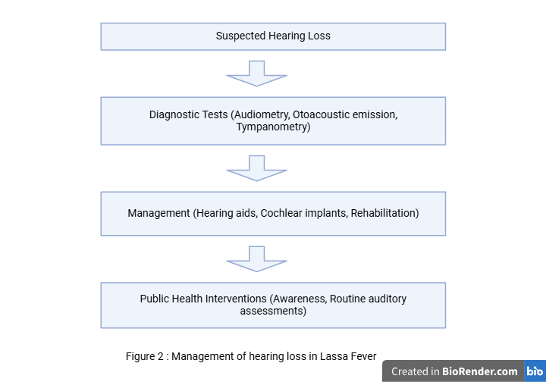

Fig. 2 illustrating the management of hearing loss in Lassa Fever

**Research Implications**

Understanding the mechanisms of hearing loss in Lassa fever is critical for developing targeted therapies. Key areas for future research include:

1. **Antiviral Therapies:** Investigating the efficacy of timely treatment with Ribavirin in preventing auditory complications.
2. **Anti-inflammatory Agents:** Exploring the potential of corticosteroids and immunomodulators in reducing cochlear inflammation.
3. **Pathophysiological Studies:** Conducting experimental and histopathological studies to characterize cochlear and neural changes.
4. **Epidemiological Studies:** Quantifying the burden of hearing loss in Lassa fever survivors to inform public health interventions.

Furthermore, investigating genetic susceptibility to hearing loss in Lassa fever survivors may identify high-risk populations and help tailor interventions accordingly. Interdisciplinary collaboration between audiologists, virologists, and public health experts is essential for advancing research in this area.

**Conclusion**

Hearing loss is a significant yet under-researched complication of Lassa fever with profound implications for survivors. We highlight four plausible mechanisms: direct viral damage, immune-mediated injury, neuritis, and vascular compromise that may contribute to this condition. Efforts toward the development of a Lassa fever vaccine may help the prevention of such complication. Meanwhile, by exploring these mechanisms and addressing research gaps, we can develop more effective interventions to mitigate hearing loss in Lassa fever survivors while vaccine development progresses. By prioritizing these areas of study, researchers, clinicians, and policymakers can improve the long-term outcomes of Lassa fever survivors, particularly in endemic regions where the disease disproportionately affects vulnerable populations.

**Declaration**

**Ethics approval and consent to participate**

Not applicable

**Consent for publication**

Not applicable

**Availability of data and materials**

The authors confirm that the data supporting the findings of this study will be made available upon reasonable request

**References**

1. WHO. Lassa fever fact sheet. 2024. Retrieved <https://www.who.int/news-room/fact-sheets/detail/lassa-fever.> Accessed January 26, 2025
2. Mateer, E. J., Huang, C., Shehu, N. Y., & Paessler, S. (2018). Lassa fever-induced sensorineural hearing loss: A neglected public health and social burden. *PLoS neglected tropical diseases*, *12*(2), e0006187. <https://doi.org/10.1371/journal.pntd.0006187>
3. Chime, E. , Chime, P. and Nwosu, J. (2022) Hearing Loss in Lassa Fever: A Systematic Review. *Open Journal of Preventive Medicine*, **12**, 239-247. doi: [10.4236/ojpm.2022.1211018](https://doi.org/10.4236/ojpm.2022.1211018).
4. Sulymon A. Saka, Qudus O. Lawal, Osahon Otaigbe et al. Lassa Fever Survivors: Long-Term Health Effects and Chronic Sequelae – A Scoping Review, 08 January 2025, PREPRINT (Version 1) available at Research Square [https://doi.org/10.21203/rs.3.rs-5624590/v1]
5. Yun, N. E., & Walker, D. H. (2012). Pathogenesis of Lassa fever. *Viruses*, *4*(10), 2031–2048. <https://doi.org/10.3390/v4102031>
6. Capra, D., DosSantos, M. F., Sanz, C. K., Acosta Filha, L. G., Nunes, P., Heringer, M., Ximenes-da-Silva, A., Pessoa, L., de Mattos Coelho-Aguiar, J., da Fonseca, A. C. C., Mendes, C. B., da Rocha, L. S., Devalle, S., Niemeyer Soares Filho, P., & Moura-Neto, V. (2023). Pathophysiology and mechanisms of hearing impairment related to neonatal infection diseases. *Frontiers in microbiology*, *14*, 1162554. <https://doi.org/10.3389/fmicb.2023.1162554>
7. Rubin, S., Eckhaus, M., Rennick, L. J., Bamford, C. G., & Duprex, W. P. (2015). Molecular biology, pathogenesis and pathology of mumps virus. *The Journal of pathology*, *235*(2), 242–252. <https://doi.org/10.1002/path.4445>
8. Murphy, H. L., & Ly, H. (2021). Pathogenicity and virulence mechanisms of Lassa virus and its animal modeling, diagnostic, prophylactic, and therapeutic developments. *Virulence*, *12*(1), 2989–3014. <https://doi.org/10.1080/21505594.2021.2000290>
9. Chen, X., Fu, Y. Y., & Zhang, T. Y. (2019). Role of viral infection in sudden hearing loss. *The Journal of international medical research*, *47*(7), 2865–2872. <https://doi.org/10.1177/0300060519847860>
10. Ciorba, A., Corazzi, V., Bianchini, C., Aimoni, C., Pelucchi, S., Skarżyński, P. H., & Hatzopoulos, S. (2018). Autoimmune inner ear disease (AIED): A diagnostic challenge. *International journal of immunopathology and pharmacology*, *32*, 2058738418808680. <https://doi.org/10.1177/2058738418808680>
11. Messaoudi, I., & Basler, C. F. (2015). Immunological features underlying viral hemorrhagic fevers. *Current opinion in immunology*, *36*, 38–46. <https://doi.org/10.1016/j.coi.2015.06.003>
12. Ficenec, S. C., Schieffelin, J. S., & Emmett, S. D. (2019). A Review of Hearing Loss Associated with Zika, Ebola, and Lassa Fever. *The American journal of tropical medicine and hygiene*, *101*(3), 484–490. <https://doi.org/10.4269/ajtmh.18-0934>
13. Shi, X., Liu, X., & Sun, Y. (2023). The Pathogenesis of Cytomegalovirus and Other Viruses Associated with Hearing Loss: Recent Updates. *Viruses*, *15*(6), 1385. <https://doi.org/10.3390/v15061385>
14. Tabuchi, K., Nishimura, B., Tanaka, S., Hayashi, K., Hirose, Y., & Hara, A. (2010). Ischemia-reperfusion injury of the cochlea: pharmacological strategies for cochlear protection and implications of glutamate and reactive oxygen species. *Current neuropharmacology*, *8*(2), 128–134. <https://doi.org/10.2174/157015910791233123>
15. Okokhere PO, Ibekwe TS, Akpede GO. Sensorineural hearing loss in Lassa fever: two case reports. Journal of Medical Case Reports. 2009 Dec;3:1-3.
16. Ibekwe TS, Okokhere PO, Asogun D, Blackie FF, Nwegbu MM, Wahab KW, Omilabu SA, Akpede GO. Early-onset sensorineural hearing loss in Lassa fever. European Archives of Oto-Rhino-Laryngology. 2011 Feb;268:197-201.
17. Liao BS, Byl FM, Adour KK. Audiometric comparison of Lassa fever hearing loss and idiopathic sudden hearing loss: evidence for viral cause. Otolaryngology–Head and Neck Surgery. 1992 Mar;106(3):226-9.
18. Ficenec SC, Percak J, Arguello S, Bays A, Goba A, Gbakie M, Shaffer JG, Emmett SD, Schieffelin JS, Bausch D. Lassa fever induced hearing loss: the neglected disability of hemorrhagic fever. International Journal of Infectious Diseases. 2020 Nov 1;100:82-7.
19. Mateer EJ, Huang C, Shehu NY, Paessler S. Lassa fever–induced sensorineural hearing loss: A neglected public health and social burden. PLoS neglected tropical diseases. 2018 Feb 22;12(2):e0006187.
20. Cashman KA, Wilkinson ER, Zeng X, Cardile AP, Facemire PR, Bell TM, Bearss JJ, Shaia CI, Schmaljohn CS. Immune-mediated systemic vasculitis as the proposed cause of sudden-onset sensorineural hearing loss following Lassa virus exposure in cynomolgus macaques. MBio. 2018 Nov 7;9(5):10-128.