**Case report**

**HAILEY-HAILEY DISEASE: A CASE REPORT ON A RARE CHRONIC BLISTERING DISORDER**

**ABSTRACT:**

Hailey-Hailey disease (HHD) is a rare autosomal dominant disorder of the skin, marked by recurrent blistering and erosions. Due to its resemblance to other dermatologic conditions, it is often misdiagnosed. A 74-year-old male with a five-year history of recurring skin lesions presented with pus-filled and crusted lesions affecting his limbs, lower back, and chest. He also had a family history of similar skin conditions and was diagnosed with type 2 diabetes mellitus. Histopathological analysis confirmed the diagnosis of HHD. The patient was treated with corticosteroids, tetracycline antibiotics, antihistamines, and diabetes management, with careful monitoring of his blood sugar levels. Following treatment, the patient showed significant improvement. This case underscores the importance of early diagnosis and individualized management, particularly in patients with comorbidities. Further research is needed to refine treatment approaches for HHD.

***Keywords:***

*Hailey-Hailey disease, Autosomal dominant disorder, ATP2C1 gene, Acantholysis*.

**INTRODUCTION:**

Hailey-Hailey disease (HHD) also referred as familial benign chronic pemphigus or familial benign pemphigus, was first detailed by the Hailey brothers in 1939 (Konstantinou et al., 2023). This uncommon **genetic disorder inherited in an autosomal manner,**arises from mutations in the ATP2C1 gene, leading to calcium dysregulation, which affects epidermal desmosomes and results in suprabasilar acantholysis (Arora et al., 2016). It is characterized by blisters and erosions commonly affecting the neck, armpits, skin folds, and genitals which recurs with remitting and relapsing episodes (Nair et al., 2020). HHD is estimated to affect 1 in 50,000 people, with both genders being equally impacted (Chiaravalloti et al., 2014). It is recommended that HHD be diagnosed based on clinical presentation, lesion location, family history, and The hallmark of HHD is acantholysis, which appears as a "dilapidated brick wall" in histopathological findings, paired with dyskeratosis, which manifests as spherical bodies and pimples. However, because of a lack of understanding and awareness of this rare ailment and its similarities to other dermatological conditions, HHD is frequently misdiagnosed (Patel et al., 2019 Rodriguez-Gutierrez et al., 2024). According to Ben Lagha et al. (2020), common treatment options include the use of topical and systemic medicines as well as procedural treatments including laser and surgery.   
This report provides a thorough clinical summary of a patient with Hailey-Haley disease, including information on their presentation, method of diagnosis, methods of treatment, and long-term care.

**CASE PRESENTATION:**

A 74 year old male presented to DVL department with complaints of pus filled lesions, raw areas, crusted lesions over both upper and lower limbs, lower back, chest. (Fig.1) History of similar complaints since 5 years. He had family history of similar complaints in mother and grandfather. History of T2DM since 5 years on regular treatment with either Tab. Metformin 500 mg or Inj. Insulin according to blood sugar levels on that day as said by physician. The first episode was 5 years back initially presented on lower limbs, visited outside hospital healed completely on treatment. Again the condition get relapsing with similar lesions with itching and bruising slowly spreading from lower limbs to upper limbs, and then to lower back and chest and he get temporarily relieved from symptoms on treatment with a corticosteroid, cephalosporin antibiotic, topical creams and antihistamines. Now presented with similar complaints again. Physician examined the lesions, which shows lesions of size ranging from 2x3cm to 3x3cm, erosions present over dorsum of right hand and advised laboratory tests. Readings of Complete Blood Picture, Liver Function Test, Complete Urine Examination, Renal Function Test, Sr. Electrolytes are with in normal references. As he is diabetic blood sugar levels are noted as follows – PPBS: 436 mg/dl; FBS: 211 mg/dl; HBA1C: 8.7 %. Based on the complaints and cutaneous examination raised a differential diagnosis of Hailey Hailey disease, bullous pemphigoid, dermatitis herpetiformis.

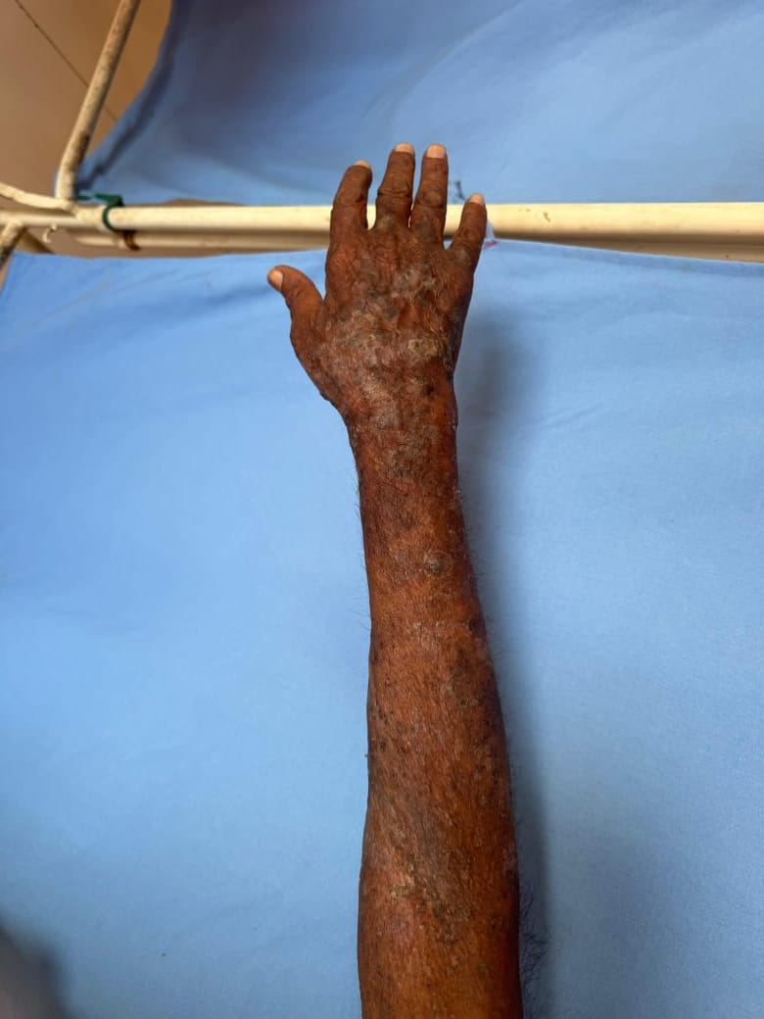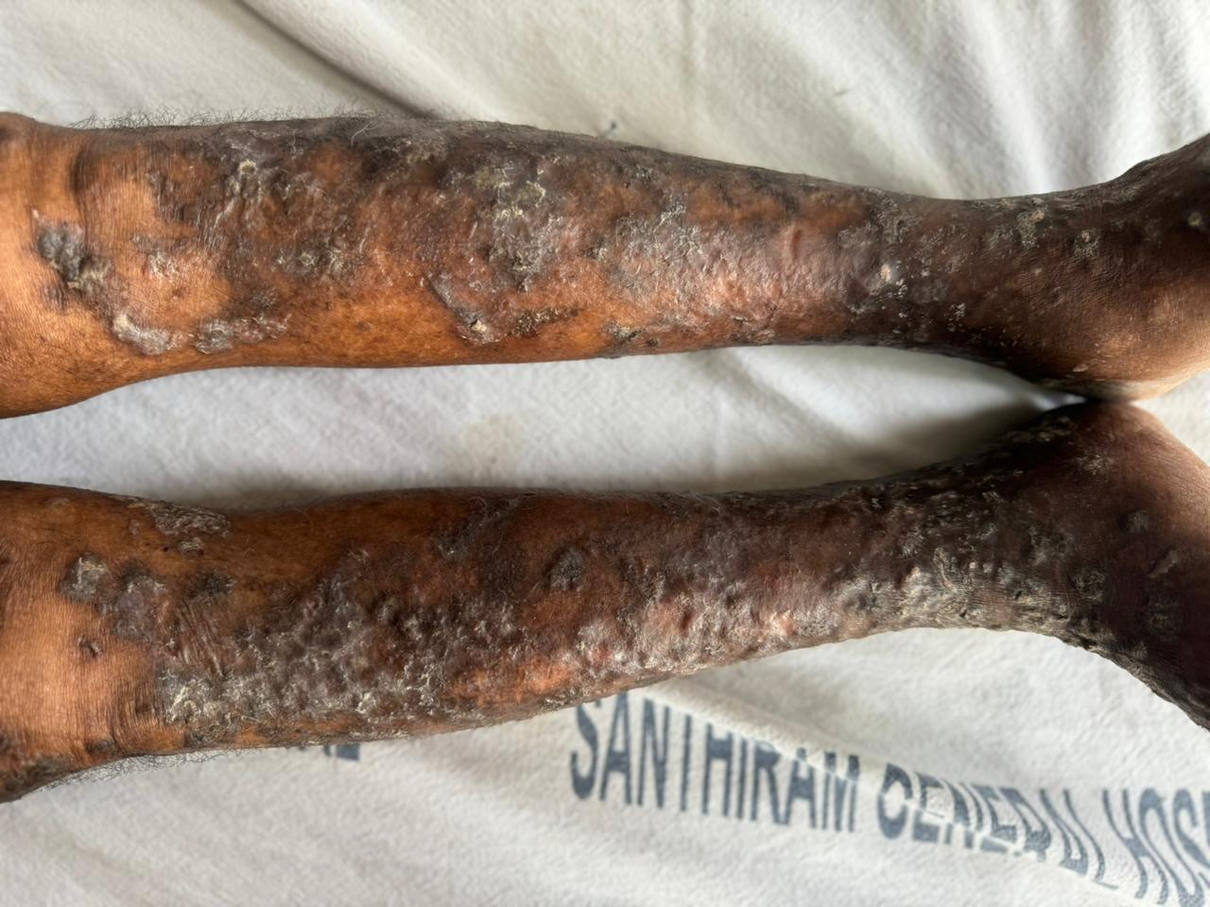

**Fig.1 raw areas and crusted lesions over lower limbs and upper limbs**

However histopathology report shows intraepidermal acantholytic blistering dermatitis with numerous incompletely acantholytic cells seen within the blister cavity. The epidermis is hyperplastic and shows a suprabasal acantholytic blister at places with tombstone pattern. Incomplete acantholysis extends to the hyperplastic epidermis where it is seen to involve more than half of its thickness which confirmed the diagnosis as Hailey Hailey disease characterised by acantholysis.(Fig. 2)

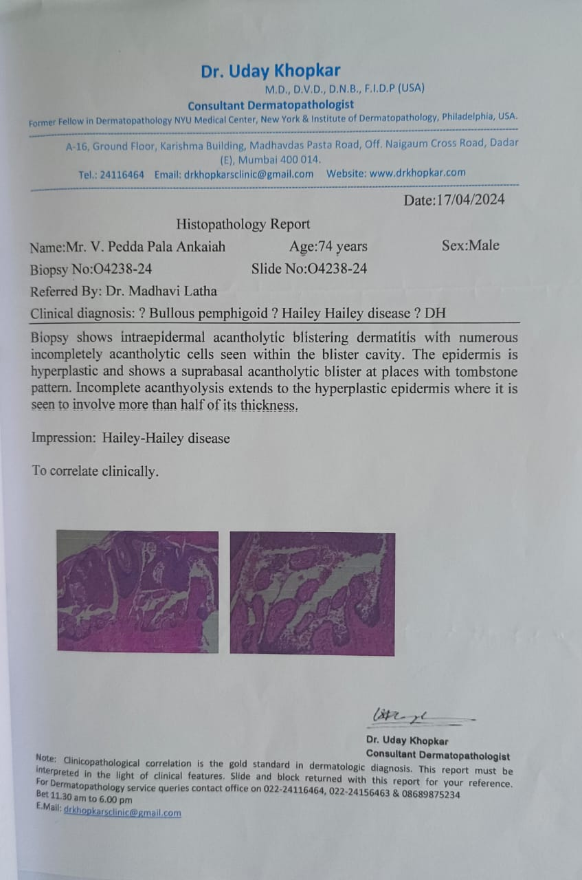

**Fig. 2 Acantholytic cells seen within the blister cavity**

Now he is treating with a corticosteroid (dexamethasone), tetracycline antibiotic, antihistamines, topical antibiotics, antidiabetics and supplements.

**DISCUSSION:**

Hailey Hailey disease is a rare autosomal dominant blistering disorder characterized by recurrent vesicular and erosive lesions at intertriginous sites, caused by loss of function in ATP2C1 gene which encodes Ca2+/Mn2+ ATPase which is responsible for calcium homeostasis in the Golgi apparatus. Disrupted calcium levels affect keratinocyte adhesion leading to acantholysis (Yamaga et al., 2022 Dai y et al., 2021) characterized by red scaly lesions or a fluid filled blister ruptures easily and becomes macerated or crusted frequently affects in skin folds of armpits, groin, neck and white lines that run the length of finge nails aggravated by sunlight, heat, sweating and friction (Nair et al., 2020 Prateek K et al., 2016), Diagnosis of HHD can be made clinically, with a follow-up confirmation using skin histopathology (Konstantinou et al., 2023). Recent research has aimed to determine characteristic dermoscopic patterns of HHD. Although molecular testing for ATP2C1 gene mutations is not routinely conducted, can be useful in complicated cases (Porro et al., 2024). There is no definitive treatment option for HHD can be manageable by using topical and oral antimicrobials like gentamicin, clindamycin and tetracyclines. Corticosteroids like dexamethasone and betamethasone. Calcineurin inhibitors like tacrolimus, pimecrolimus. And Retinoids like etretinate. Other immunosuppresants like methotrexate and thalidomide are also benefited. Laser and light therapy is also a possible treatment (Arora et al., 2016).

In this case he presented with lesions in upper and lower limbs, lower back and chest which are uncommon. Due to recurrent episodes since 5years, cephalosporin antibiotic replaced with tetracycline for better management. As he is diabetic and on steroid therapy meticulous monitoring of blood sugar levels is essential and diabetic treatment was adjusted according to GRBS sliding scale.

**CONCLUSION:**

Early diagnosis of HHD is significant for better disease management. Personalised treatment plans should be considered, especially in patients with comorbidities, to minimize

complications and optimize therapeutic outcomes. Further research is essential to develop more effective therapies and management strategies.

**ETHICAL APPROVAL:**

As per international standard / university standards written ethcal approval has been collected and preserved by the authors.

**REFERENCES:**

1. Konstantinou MP, Krasagakis K. Benign Familial Pemphigus (Hailey-Hailey Disease) [Updated 2023 Aug 14]. In: StatPearls [Internet]. Treasure Island (FL): StatPearls Publishing; 2025 Jan-. Available from: <https://www.ncbi.nlm.nih.gov/books/NBK585136/>
2. Arora, H., Bray, F. N., Cervantes, J., & Falto Aizpurua, L. A. (2016). Management of familial benign chronic pemphigus. *Clinical, cosmetic and investigational dermatology*, *9*, 281–290. <https://doi.org/10.2147/CCID.S89483>
3. NAIR, ANJALY & JOSEPH, SIBY & R, LAKSHMI & KURIAN, SUNU. (2020). HAILEY-HAILEY DISEASE – A CASE REPORT. Asian Journal of Pharmaceutical and Clinical Research. 4-5. 10.22159/ajpcr.2020.v13i9.38690.
4. Chiaravalloti, A., & Payette, M. (2014). Hailey-Hailey disease and review of management. *Journal of drugs in dermatology : JDD*, *13*(10), 1254–1257
5. Patel, V. M., Rubins, S., Schwartz, R. A., Septe, M., & Rubins, A. (2019). Hailey-Hailey disease: a diagnostic challenge. *Cutis*, *103*(3), 157–159
6. Rodríguez-Gutiérrez, J. S., Tirado-Motel, A., Sarabia-Esquerra, J. L., Urtuzuástegui-Gastelum, A. S., & Germán-Rentería, Á. A. (2024). Enfermedad de Hailey-Hailey: reporte de un caso [Hailey-Hailey disease: A case report]. *Revista medica del Instituto Mexicano del Seguro Social*, *62*(1), 1–5. <https://doi.org/10.5281/zenodo.10278169>
7. Ben Lagha, I.,Ashack, K. & Khachemoune, A. Hailey-Hailey Disease: An Update Review with a Focus on Treatment Data. Am J Clin Dermatol 21, 49-68 (2020). https://doi.org/10.1007/s40257-019-00477-z
8. Yamaga M, Miyauchi T, Peh JT, Itamoto S, Mai Y, Iwata H, Nomura T and Ujiie H (2022) Case report: Difference in outcomes between two cases of Hailey-Hailey disease treated with apremilast. Front. Genet. 13:884359. doi: 10.3389/fgene.2022.884359
9. Dai Y, Yu L, Wang Y, Gao M, Wang P. Case Report: A Case of Hailey-Hailey Disease Mimicking Condyloma Acuminatum and a Novel Splice-Site Mutation of ATP2C1 Gene. Front Genet. 2021 Dec 14;12:777630. doi: 10.3389/fgene.2021.777630. PMID: 34970303; PMCID: PMC8712934
10. Prateek K, Banwarilal MR, Chaudhary SS, Garg M. Hailey Hailey disease-a rare case report. Int J Res Dermatol 2016;2:36-9
11. Porro, A. M., Arai Seque, C., Miyamoto, D., Vanderlei Medeiros da Nóbrega, D., Simões E Silva Enokihara, M. M., & Giuli Santi, C. (2024). Hailey-Hailey disease: clinical, diagnostic and therapeutic update. *Anais brasileiros de dermatologia*, *99*(5), 651–661. <https://doi.org/10.1016/j.abd.2023.12.003>