Implementation Of The Design Thinking Method In The Design And Development Of The Company Profile Website For BEM Faculty Of MIPA Udayana University

.
ABSTRACT

Aims: Here This study aims to implement the Design Thinking methodology in the development of the company profile website for BEM Faculty of MIPA, Udayana University. The primary objective is to enhance user experience by addressing usability issues and improving the website's accessibility, navigation, and overall functionality.
Study design: This research adopts a user-centered design approach, utilizing the Design Thinking framework, which consists of five phases: Empathize, Define, Ideate, Prototype, and Test.
Place and Duration of Study: This study was conducted at the Faculty of Mathematics and Natural Sciences, Udayana University, over a period of five months.
Methodology: The research began with a preliminary usability evaluation using the System Usability Scale (SUS), where the existing website received a score of 51.75 (ranked D), indicating significant usability issues. User feedback was collected through surveys, interviews, and literature studies to identify pain points related to navigation, design, and content accessibility. Based on these insights, the website was redesigned using Design Thinking principles, emphasizing an intuitive interface, clear information hierarchy, and interactive features. The newly developed prototype was then tested for usability improvements.
Results: The implementation of Design Thinking led to significant enhancements in user satisfaction and website efficiency. The SUS score improved from 51.75 to 88.967, reflecting a substantial increase in usability and user-friendliness. Additionally, efficiency tests showed a 28.36% improvement, indicating that users required fewer clicks to complete essential tasks. These results demonstrate that the new website design is more intuitive, aesthetically pleasing, and aligned with user expectations compared to the previous version.
Conclusion: The application of Design Thinking in website development successfully improved the usability and functionality of the BEM Faculty of MIPA company profile website. By adopting a user-centered approach, the redesigned website effectively addresses user needs, enhances accessibility, and provides a better overall experience. Future research may explore further refinements and the integration of advanced features to maintain long-term user engagement.

Keywords: Design Thinking; User-Centered Design; User Experience (UX); System Usability Scale (SUS); Website Usability.

1. INTRODUCTION

The rapid advancement of information technology, particularly in the digital era, has significantly impacted various aspects of life, including the field of education. As a student organization at the faculty level, BEM Faculty of MIPA, Udayana University, must adapt to these technological changes to remain relevant and accessible to students, faculty members, and the public. One essential adaptation is the development of a company profile website, which serves as a platform to introduce, document, and disseminate information about the organization. A well-designed website acts as an official identity, reflecting the organization’s values, vision, and mission while ensuring efficient communication with stakeholders.

However, a preliminary usability assessment using the System Usability Scale (SUS) revealed that the existing company profile website of BEM Faculty of MIPA received a score of 51.75, placing it in the F ranking category, which indicates poor usability. Users encountered several challenges, including unintuitive navigation, difficulty in finding information, and an unappealing visual design that hindered engagement. Additionally, certain interactive features, such as news updates, were either non-functional or difficult to access, further reducing the website’s effectiveness in serving its purpose. These issues highlight the need for a comprehensive and user-focused redesign.

To address these challenges, this study applies the Design Thinking methodology, a user-centered design approach that prioritizes users' needs, pain points, and expectations in the development process. Design Thinking consists of five phases: Empathize, Define, Ideate, Prototype, and Test, which guide the systematic improvement of the website based on real user feedback. Through surveys, interviews, and usability testing, this research aims to create a more intuitive, accessible, and aesthetically pleasing website that enhances user experience and engagement.

The primary objective of this study is to analyze and implement an improved website design that effectively addresses usability issues and optimizes the navigation structure. By leveraging the Design Thinking framework, this research seeks to increase user satisfaction, as measured through an improved SUS score and efficiency metrics. The results of this study are expected to provide valuable insights into the impact of user-centered design principles on website usability and functionality in the context of student organizations.

2. methodology

This study applies the Design Thinking method, a problem-solving approach that focuses on understanding users' needs and perspectives while reframing problems from their point of view. This approach fosters the creation of innovative ideas that lead to effective and user-centered solutions. By emphasizing user experience, Design Thinking ensures that the resulting design helps users achieve their goals efficiently. The methodology consists of five key stages: Empathize, Define, Ideate, Prototype, and Test.
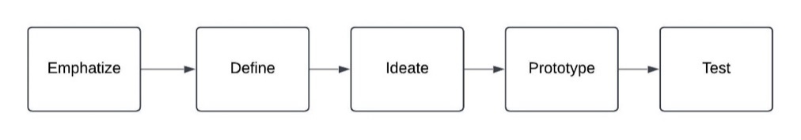
Fig. 1. Design Thinking process

2.1 Empathize

The Empathize stage in the Design Thinking method was conducted through interviews, surveys, and structured Q&A sessions to gain an in-depth understanding of user needs. This study focused on active students of the Faculty of Mathematics and Natural Sciences at Udayana University in Bali as the research subjects. The sample was selected using simple random sampling, involving six respondents representing the study programs of Chemistry, Physics, Biology, Mathematics, Pharmacy, and Informatics. This approach ensures a diverse range of perspectives, leading to a website design that aligns with users' needs and expectations.

Table 1. Empathize Interview Questions

Code | Questions
Q1 | Full Name
Q2 | Gender
Q3 | Age
Q4 | Study Program
Q5 | What type of device do you use most often? (e.g., smartphone/tablet/desktop)
Q6 | How often do you use digital devices to search for information?
Q7 | How often do you visit bemfmipaunud.com?
Q8 | How is your experience using the BEM Faculty of Mathematics and Natural Sciences Udayana University company profile website? Please describe what you like and dislike!
Q9 | What features would you like to have on the BEM Faculty of Mathematics and Natural Sciences Udayana University company profile website?

2.2 Define

The Define stage in the Design Thinking method aims to clearly define the problem based on insights gathered during the Empathize stage. At this stage, the primary user needs are specifically formulated as a foundation for designing an effective solution. The key activities include identifying pain points and formulating how-might-we statements.

Pain points refer to the main challenges or obstacles faced by users, which are identified to develop targeted and efficient solutions. How-might-we statements are derived from these pain points to foster a creative problem-solving mindset during the ideation process. This approach translates user problems from the previous stage into innovative statements, guiding the design of solutions that best align with user needs.

2.3 Ideate

The Ideate stage in the Design Thinking method focuses on developing creative ideas and solutions that address the How-Might-We statements from the Define stage. This process begins with an intensive brainstorming session to generate as many potential solution ideas as possible.

Afterward, these ideas are organized using an affinity diagram, which groups them based on common themes or conceptual similarities. This diagram helps identify patterns and key focus areas, serving as a foundation for refining and structuring more effective solutions.
2.1 Prototype

The Prototype stage in the Design Thinking method is the fourth step, focusing on creating an initial system model based on insights from previous stages. At this stage, the Design System, Wireframe, and High-Fidelity Prototype are developed to provide a preliminary visualization of the system.

The prototype serves as an interactive and visual representation of the system, designed to identify errors or shortcomings early in the process. By using prototypes, developers can evaluate the design without investing excessive time or resources into complex, untested elements. This stage is crucial for testing the feasibility of the design, validating user needs, and ensuring that the proposed solution aligns with the project’s primary objectives before proceeding to final implementation.

2.1 Test

The Test stage is the final step in the Design Thinking method, where the previously developed prototype is evaluated. The primary goal of this stage is to gather user feedback and responses, which are crucial for refining and improving the proposed solution.

In this testing phase, two methods are utilized: System Usability Scale (SUS) and Click Efficiency Test. SUS is a widely used method for measuring the usability of a system based on user-subjective evaluations. Meanwhile, the Click Efficiency Test assesses navigation efficiency by calculating the number of clicks required to complete specific tasks within the system. These evaluation methods help ensure that the final product meets user expectations and functions effectively.

Table 2. System Usability Scale Interview Questions

Code | Questions
Q1 | How comfortable are you using this website?
Q2 | How difficult is it for you to understand how this website works?
Q3 | How appealing do you find the website's design?
Q4 | How difficult is it to find the information you need on this website?
Q5 | How clear are the menu and navigation on this website?
Q6 | How often do you feel confused while using this website?
Q7 | How consistent are the appearance and functionality across all pages of this website?
Q8 | How satisfied are you with the website's loading speed?
Q9 | How easy is it for you to complete tasks on this website?
Q10 | How likely are you to recommend this website to others?

3. results and discussion

3.1 Result

The implementation of Design Thinking in developing the BEM FMIPA Universitas Udayana company profile website resulted in significant usability improvements, as shown in Table 3 and Table 4. Table 3 presents the System Usability Scale (SUS) comparison, where the score increased from 51.75 to 88.96, indicating a transition from a "poor" to an "excellent" usability rating. Additionally, Table 4 displays the results of the Click Efficiency Test, which showed a 28.36% increase in efficiency, demonstrating that users required fewer clicks to complete key tasks.
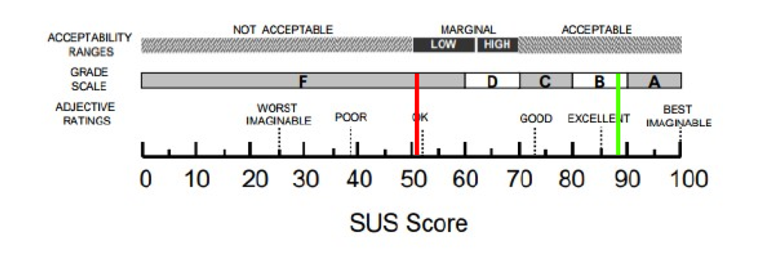
Fig. 2. SUS Metrics

There is a significant increase of 71.90% in the SUS Score between the old and new website versions, as shown in Fig. 2. And Table 3, The red bar represents the old website, while the green bar represents the new website, highlighting a substantial improvement in usability and user experience.

Table 3. System Usability Scale Score Comparation

SUS SCORE
Num | Old Website | New Website | Increase (%)
1 | 51.75 | 88.96 | 71.90%
Table 4. Click Efficiency Test Result

No | Task | Average Amout Of Click |  | Increase (%)
 |  | Old Website | New Website
1 | Open Lastest Article | 2 | 1.1 | 45%
2 | Searching for information about vision, mission, and Members | 2.1 | 1.03 | 50.95%
3 | Submitting aspirations | - | 2 | -
4 | Searching for specific news articles | 3.3 | 2.2 | 33.33%
5 | Downloading attachments | 4.7 | 3 | 36.17%
6 | Logging in | 2 | 2 | 0%
7 | Updating advertisements | 4.7 | 4.03 | 14.26%
8 | Updating announcements | - | 2 | -
9 | Managing aspirations | - | 2 | -
10 | Adding articles | 9 | 7 | 22.22%
11 | Deleting articles | 4 | 3 | 25%
Total Efficiency |  |  |  | 28.36%

3.2 Discussions

The significant increase in the SUS Score from 51.75 to 88.96, as shown in Table 3, indicates a major improvement in the usability of the new website. According to industry benchmarks, a score above 80 is considered excellent, suggesting that the redesign successfully addressed key user pain points. This aligns with previous studies emphasizing the role of user-centered design in enhancing system usability.
Furthermore, the Click Efficiency Test results in Table 4 show a 28.36% improvement, demonstrating that users required fewer clicks to complete essential tasks. This suggests that enhancements in website navigation, such as optimized menu structures and clearer information architecture, led to a more intuitive user experience. Prior research highlights that reducing cognitive load through effective interface design significantly impacts task completion time and user satisfaction.

4. Conclusion

The application of Design Thinking in developing the BEM Faculty of MIPA Udayana University company profile website has led to significant improvements in usability and user experience. The System Usability Scale (SUS) score increased from 51.75 to 88.96, reflecting a transition from a poor to an excellent usability rating. Additionally, the Click Efficiency Test demonstrated a 28.36% increase in efficiency, indicating that users could complete tasks more quickly and with fewer interactions.

These results highlight the effectiveness of a user-centered design approach in optimizing website functionality and navigation. By addressing key pain points identified during the Empathize and Define stages, the redesigned website successfully enhances accessibility, efficiency, and overall user satisfaction. Future improvements could focus on expanding website features, incorporating accessibility enhancements, and conducting long-term usability testing to ensure continuous optimization.

disclaimer (artificial intelligence)

The authors affirm that no generative AI technologies, such as Large Language Models (e.g., ChatGPT, Copilot) or text-to-image generators, were used during the writing or editing of this manuscript. All content has been independently developed and reviewed by the authors to ensure originality and academic integrity.

COMPETING INTERESTS

The authors have declared that no competing interests exist.

COMPETING INTERESTS DISCLAIMER:
Authors have declared that they have no known competing financial interests OR non-financial interests OR personal relationships that could have appeared to influence the work reported in this paper.

References

Adha, I. A., Voutama, A., & Ridha, A. A. (2023). UI/UX design of Ogan Lopian Diskominfo Purwakarta application using design thinking method. JOISIE Journal of Information System and Informatics Engineering, 7(1), 55-70.
Barnum, C. M. (2020). Usability Testing Essentials: Ready, Set...Test! Elsevier. https://doi.org/10.1016/B978-0-12-816942-1.01001-7
Hasugian, P. S. (2018). Website design as a promotional and information media. Journal of Informatic Pelita Nusantara, 3(1), 82-86.
Karnawan, G. (2021). Implementation of user experience using design thinking method on Cleanstic application prototype. Jurnal Teknoinfo, 15(1), 61-66. https://doi.org/10.33365/jti.v15i1.540
Lewis, J. R. (2018). The System Usability Scale: Past, present, and future. International Journal of Human-Computer Interaction, 34(7), 577-590. https://doi.org/10.1080/10447318.2018.1455307
Sunarya, L., Radiyanto, R., & Susanti, E. (2013). Enriching company profile as supporting information and promotion media at Perguruan Tinggi Raharja. CCIT Journal, 7(1), 77-93. https://doi.org/10.33050/ccit.v7i1.172

