Machine Learning Models for Predicting Parkinson’s Disease Progression Using Longitudinal Data: A Systematic Review

.

ABSTRACT

|  |
| --- |
| **Background**: Parkinson’s Disease (PD) is a progressive neurodegenerative disorder with significant variability in symptom progression. Accurate prediction of disease progression is essential for effective management and treatment planning. Traditional methods for predicting PD progression rely heavily on subjective assessments, limiting predictive accuracy. Recent advances in machine learning (ML) have shown promise in addressing these challenges, especially through the use of longitudinal data to capture temporal disease dynamics.  **Objectives**: This systematic review aims to evaluate the effectiveness of various machine learning models in predicting PD progression using longitudinal data. The review focuses on the types of models used, data sources, performance metrics, and their potential to improve personalized treatment and clinical decision-making.  **Methods**: An extensive search was conducted across Scopus, PubMed, Google Scholar, and ResearchGate to identify relevant studies published from January 2010 to February 2024. Inclusion criteria targeted studies using ML techniques on longitudinal PD data, resulting in 14 studies meeting eligibility. Key information, including dataset characteristics, ML models, and performance metrics, was extracted and analyzed.  **Results**: Long Short-Term Memory (LSTM) and ensemble methods like Random Forest and Light Gradient Boosting Machine (LGBM) are effective in capturing disease progression with high accuracy and robust performance metrics. LSTM models achieved accuracies up to 90% and AUC scores of 93.79%, while LGBM models achieved 90.73% and AUC of 94.57%. The Matthews Correlation Coefficient (MCC) scores in longitudinal studies increased over time, and Mean Absolute Error (MAE) also improved. Integrating multimodal data, including clinical, genetic, and imaging information, further improved model reliability and generalizability.  **Conclusion**: The study shows that machine learning models, particularly those using longitudinal and multimodal data, can predict Parkinson's disease progression, enabling personalized care strategies. Future research should focus on data diversity, interpretability, and real-world data from wearable technologies to improve clinical applicability. |

*Keywords: Parkinson’s Disease, Machine learning, Longitudinal data, Disease Progression, Predictive modeling*

1. INTRODUCTION

The second most prevalent neurodegenerative disorder, following Alzheimer's disease, is Parkinson’s Disease (PD), as it affects over 10 million people worldwide (Dorsey et al., 2007; Postuma & Montplaisir, 2009). It is primarily marked by a gradual degeneration in dopamine-producing neurones in the substantia nigra resulting in a variety of motor and non-motor symptoms. Common symptoms encompass slowed movement (bradykinesia), involuntary tremors, muscle stiffness, and balance impairments (Lee, 2023). In addition to motor dysfunction, many patients experience cognitive decline, depression, and sleep disturbances as the disease advances (Khalil et al., 2024). The quality of life is severely impacted by PD, not just for patients but also for their families and caregivers (Dorsey et al., 2018; Lubomski et al., 2021; Rajiah et al., 2017).

The progression of PD differs significantly among patients, with some exhibiting rapid symptom escalation, whereas others experience a more gradual decline (Rukavina et al., 2021). For clinicians, predicting the progression of PD is a major challenge, as it involves multiple interacting factors, including age at onset, genetic predisposition, environmental exposures, and response to medication (Dorsey et al., 2018; Postuma & Montplaisir, 2009). Moreover, the progression of the disease is measured through a variety of clinical scales, such as the Unified PD Rating Scale (UPDRS), which evaluates both motor and non-motor symptoms. However, these measures are often subjective, and their accuracy can vary between clinicians and over time (Aggarwal et al., 2021; Bhidayasiri & Martinez-Martin, 2017).

Due to these challenges, there has been an increasing shift towards utilizing data-driven methodologies, especially machine learning (ML), for predicting PD progression (Nzenwata et al., 2024; Pratihar & Sankar, 2024; S M et al., 2024). A branch of artificial intelligence, ML allows computer systems to recognize patterns within data and generate predictions or decisions without requiring explicit programming. In healthcare, The application of ML models for activities including prognosis, diagnosis, and recommendation of treatment is growing (Ahmed et al., 2020; Javaid et al., 2022). ML models can analyse a lot of clinical data in the case of PD to find trends that can point to the development of the illness, such alterations in motor function, cognitive decline, or the appearance of new symptoms (Tăuţan et al., 2021; Zhang, 2022). By doing so, ML has the potential to provide more personalized and accurate predictions of how the disease will progress in individual patients.

Longitudinal data, which involves the repeated measurement of patients over time, is particularly valuable in understanding and predicting the progression of chronic diseases like PD (Latourelle et al., 2017; Severson et al., 2021). Unlike cross-sectional studies, which capture a single snapshot of a patient’s condition, patients in longitudinal studies are monitored over an extended period of time. This enables researchers to track alterations in symptoms, response to treatments, and the development of comorbidities. Longitudinal data can include a variety of information, such as clinical assessments (e.g., UPDRS scores), neuroimaging data (e.g., MRI or PET scans), and biomarkers (e.g., cerebrospinal fluid proteins, genetic markers) (Garcia Santa Cruz et al., 2023a; Jankovic, 2008; Saeed et al., 2017).

Incorporating longitudinal data into ML models offers several advantages. First, it makes it possible to analyze temporal patterns, which can give insights into the trajectory of the disease (Cascarano et al., 2023). ML models, for instance, can be trained to detect early signs of rapid disease progression based on subtle changes in motor function or cognitive abilities over time. Second, the use of longitudinal data enables the development of more accurate and personalized models (Fröhlich et al., 2018). Since PD progression varies widely between patients, having access to longitudinal data allows ML models to account for individual differences and generate patient-specific predictions (Dadu et al., 2022).

Several ML techniques have been applied to PD progression prediction, each with its strengths and limitations. Commonly used models include random forests, decision trees, support vector machines (SVM), and deep learning models such as recurrent neural networks (RNNs) and convolutional neural networks (CNNs) (Islam et al., 2024; Keserwani et al., 2024; Srinivasan et al., 2024). These models differ in terms of their ability to handle complex datasets, interpretability, and computational efficiency. However, despite the growing body of research, challenges remain in integrating longitudinal data into these models effectively. Issues such as missing data, data heterogeneity, and small sample sizes can limit the generalizability and accuracy of these models (Cascarano et al., 2023; Marcoulides & Grimm, 2017).

Despite these limitations, the potential for ML models to enhance our understanding of PD progression and improve patient outcomes is immense. Predicting disease progression can inform treatment decisions, such as when to adjust medication dosages or when to introduce advanced therapies like deep brain stimulation (DBS). Additionally, accurate progression models can aid in the design of clinical trials by identifying patients who are more likely to benefit from specific interventions or by selecting homogeneous patient cohorts for studies (Athauda & Foltynie, 2016).

Given the significance of accurate and personalized prediction of PD progression, this systematic review aims to synthesize the current literature on the use of ML models in this context. Specifically, the review will focus on studies that utilize longitudinal data, as it provides a more comprehensive view of the disease’s trajectory over time. By examining the different ML approaches, types of data employed, and the reported performance of these models, this review seeks to highlight the strengths and limitations of current research and suggest future directions work in this rapidly evolving field.

* 1. Rationale

PD (PD) presents with highly variable progression, making its clinical management and prognosis particularly challenging. Traditional methods for predicting disease trajectory rely on subjective assessments, which can result in inconsistent outcomes. As longitudinal data captures the temporal evolution of PD symptoms, it offers valuable insights into disease dynamics. ML (ML) models, with their ability to analyze complex, multidimensional datasets, hold promise for more accurate and personalized predictions of PD progression. Despite the growing application of ML in healthcare, a comprehensive understanding of its efficacy in leveraging longitudinal data for PD prediction remains limited. This research aims to systematically review the current literature to identify the strengths, limitations, and future potential of ML models in predicting PD progression using longitudinal data.

* 1. Objectives

This systematic review aims to evaluate the effectiveness of ML models in predicting the progression of PD using longitudinal data. To enhance understanding and inform future research in the intersection of ML and PD prognosis, the review synthesizes previous studies and examines the approaches, algorithms, and outcomes of ML models applied in this context. Additionally, by assessing the performance metrics of these models in predicting disease progression, the review seeks to provide a comprehensive analysis of their predictive capabilities. Where feasible, quantitative synthesis methods will be employed to summarize the findings from multiple studies, using appropriate statistical techniques to evaluate model performance across different datasets.

1. **Population**: What ML techniques have been employed to analyze longitudinal data and predict the progression of PD among patients diagnosed with the condition?
2. **Intervention**: What is the predictive accuracy of ML models in tracking PD progression?
3. **Comparison**: How do various ML algorithms perform in terms of predicting PD progression based on longitudinal data?
4. **Outcome**:

* **Primary Outcome**: What are the primary performance metrics (e.g., AUC, MCC, MAE) for ML models in predicting PD progression, and how do these metrics compare over time?
* **Secondary Outcome**: Do ML models demonstrate consistent predictive performance across different datasets and time points?

1. **Study Design**: What observational studies (e.g., cohort, longitudinal) have investigated the progression of PD? How has the use of longitudinal and multimodal data in ML models impacted the predictive accuracy and clinical applicability of these models in PD management?
2. material and methods

This systematic review utilized an extensive search process spanning four key databases: Scopus, PubMed, Google Scholar, and ResearchGate. The search focused on studies published from January 2010 to February 2024 to ensure both relevance and the inclusion of the latest research. The search employed a combination of specific keywords related to PD, ML, artificial intelligence, predictive models, and longitudinal data analysis. From this process, 398 relevant articles were initially identified. Afterward, strict inclusion and exclusion criteria were applied to carefully filter and select the most suitable studies for further analysis in this review.

* 1. Eligibility Criteria

The PICOS (Amir-Behghadami & Janati, 2020) framework selection criteria are applied to articles for review inclusion.

1. **Population**: Patients diagnosed with PD.
2. **Intervention**: Studies using ML techniques to analyze longitudinal data and clinical features for predicting PD progression.
3. **Comparison**: Studies that compare different ML algorithms or approaches for predicting PD progression based on longitudinal data.
4. **Outcome**: Studies applying ML models trained on longitudinal data to identify predictive markers or indicators of PD progression.
5. **Study Design**: Observational studies (e.g., cohort, longitudinal) examining the correlation between clinical assessments and the progression of PD
   1. Inclusive Criteria
6. Studies involving patients diagnosed with PD.
7. Studies utilizing ML techniques to analyze longitudinal data for predicting PD progression.
8. Studies employing ML models trained on longitudinal data to identify predictive markers or indicators of PD progression.
9. Articles available in the English language.
10. Articles published between January 2010 and March 2024.
    1. Exclusive Criteria
11. Studies focusing exclusively on female patients or non-human subjects and other cancer types.
12. Studies not employing ML techniques or not assessing lifestyle factors as predictive biomarkers for prostate cancer progression.
13. Studies not identifying predictive biomarkers or indicators of prostate cancer progression or not using ML models trained on lifestyle factors.
14. Articles not available in the English language.
15. Articles that their full-texts are not accessible.
16. Case reports, reviews, editorials, letters, conference abstracts, and meta-analyses.
    1. Source of Information

A wide-ranging literature search was performed using the databases Google Scholar, Scopus, and PubMed to ensure a diverse and robust collection of relevant studies for this systematic review. This approach aimed to enhance the quality and comprehensiveness of the research. The search process involved the use of key terms closely related to the topic, including PD, ML, artificial intelligence, predictive modeling, and longitudinal data, to locate studies that directly address the objectives of this review

* 1. Search Strategy

To identify relevant studies, the search strategy combined keywords with Boolean operators. Key search terms included "Parkinson’s Disease," "Machine Learning," "artificial intelligence," "predictive modeling," "longitudinal data," and "predictive markers." Filters were applied to narrow the search to articles published between January 2010 and February 2024, available in English, and classified as original research.

The following search strategy was applied for this systematic review on "Machine Learning Models for Predicting Parkinson’s Disease Progression Using Longitudinal Data" across the selected databases:

A search of articles using the following query string on Scopus resulted in **82 documents**.

TITLE-ABS-KEY(("machine learning" OR "ML" OR "artificial intelligence" OR "AI") AND (predict* OR prognos* OR forecast*) AND ("parkinson disease" OR "parkinsonism" OR "PD") AND (progress* OR advanc* OR develop*) AND ((longitud* AND (data OR stud*)) OR "time series" OR "temporal data" OR "long-term data")) AND PUBYEAR > 2013 AND PUBYEAR < 2025 AND ( LIMIT-TO ( SRCTYPE,"j" ) ) AND ( LIMIT-TO ( PUBSTAGE,"final" ) ) AND ( LIMIT-TO ( SUBJAREA,"MEDI" ) OR LIMIT-TO ( SUBJAREA,"NEUR" ) OR LIMIT-TO ( SUBJAREA,"COMP" ) OR LIMIT-TO ( SUBJAREA,"BIOC" ) OR LIMIT-TO ( SUBJAREA,"HEAL" ) ) AND ( LIMIT-TO ( DOCTYPE,"ar" ) ) AND ( LIMIT-TO ( LANGUAGE,"English" ) )

A search of articles using the following query string on PubMed database resulted in **372 documents**.

(((("machine learning"[All Fields] OR "artificial intelligence"[All Fields] OR "ml"[All Fields] OR "ai"[All Fields]) AND ("parkinson"[All Fields] OR "parkinsonism"[All Fields] OR "parkinson disease"[All Fields]) AND ("prediction"[All Fields] OR "prognosis"[All Fields] OR "forcasting"[All Fields] OR "prognostic"[All Fields] OR "predicting"[All Fields] OR "predict"[All Fields] OR "prognose"[All Fields])) OR ("longitudinal data"[All Fields] OR "longitudinal study"[All Fields])) AND ("loattrfree full text"[Filter] AND "medlinestatus medline"[All Fields] AND "hasabstract"[All Fields] AND ("classical article"[Publication Type] OR "clinical trial"[Publication Type] OR "introductory journal article"[Publication Type]) AND "loattrfull text"[Filter] AND "humans"[MeSH Terms] AND "male"[MeSH Terms] AND ("losubjtsupplemental materials"[Filter] OR "hasdatabanklist"[All Fields]) AND "english"[Language] AND 2014/01/01:2024/12/31[Date - Publication])) AND ((ffrft[Filter]) AND (medline[Filter]) AND (fha[Filter]) AND (classicalarticle[Filter] OR clinicaltrial[Filter] OR introductoryjournalarticle[Filter]) AND (fft[Filter]) AND (humans[Filter]) AND (male[Filter]) AND (data[Filter]) AND (english[Filter]))

**Google Scholar:** A search of studies on Google Scholar database resulted in **53 documents.**

* 1. Data Management

The articles that resulted from the various database searches were exported in RIS (Research Information Systems) file format and further imported to Hubmeta, a cloud-based platform for meta-analysis and systematic reviews (*HubMeta – Systematic Review and Meta Analysis Cloud Platform*, n.d.), to undergo screening. Hubmeta’s incorporates an artificial intelligence feature that facilitates efficient screening of articles. The latest search was conducted on October 25, 2024.

* 1. Study Selection

The study selection was carried out with careful attention to detail by the sole reviewer of this research, utilizing Hubmeta, a tool designed for systematic review management, to ensure that all relevant articles aligned with the established criteria. Titles and abstracts of the articles were reviewed to evaluate their relevance to the research question and adherence to the inclusion criteria. Following this, articles deemed potentially relevant were examined in full text to confirm they met the inclusion requirements and to gather necessary information for analysis. Articles that fulfilled the inclusion criteria were retained for further evaluation, while those that did not were excluded from the study.

* 1. Data Extraction

Data extraction was performed in a structured manner to collect essential information from the selected studies. A standardized procedure was followed to maintain accuracy and uniformity in recording key data points. Information such as study characteristics, participant demographics, intervention/exposure details, outcomes, and main findings was systematically gathered from each article. Any uncertainties or inconsistencies encountered during extraction were carefully reviewed and resolved to ensure clarity and reliability.

A PRISMA flowchart as seen in Figure 1. (Haddaway et al., 2022), was used to document the screening and data extraction processes, thereby providing a visual depiction of the article selection process. This ensures reliability, consistency, and openness in the reporting of the results. The flowchart, which adheres to the PRISMA guidelines (Moher et al., 2009), shows how many articles were collected, screened, evaluated for eligibility, and included in the systematic review. This method guarantees the systematic review's reliability(Sterne et al., 2019).

* 1. Risk of Bias

A comprehensive assessment of the risk of bias in the included studies was undertaken to ensure the reliability and rigor of this systematic review. As the sole reviewer, this evaluation was conducted meticulously, following established guidelines tailored to various study designs. Articles that did not adequately address the research question or failed to meet the predefined eligibility criteria were excluded during the screening. Additionally, a thorough search across multiple databases and sources helped minimize the risk of selection bias. Any inconsistencies or uncertainties were resolved through careful examination and consultation with relevant literature.

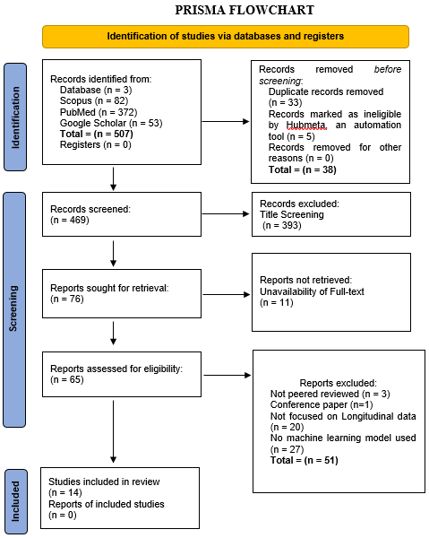

**Fig. 1. The screened studies documented using PRISMA flowchart**

1. RESULTS

This systematic review assessed how effectively ML models predict the progression of PD based on longitudinal data. The primary aim was to evaluate the performance of these models by analyzing key metrics such as accuracy, precision, recall, AUC, and F1 score, which highlight each model's ability to capture and forecast the complex progression of PD over time (Garcia Santa Cruz et al., 2023b; Keserwani et al., 2024).

The initial database search identified 507 potential studies. Following a comprehensive screening process guided by strict inclusion and exclusion criteria, a final selection of 14 studies was made. The study selection adhered to the PRISMA (Preferred Reporting Items for Systematic Reviews and Meta-Analyses) guidelines (Moher et al., 2009), ensuring a transparent and methodical approach. The PRISMA flowchart (Fig. 1.) (Haddaway et al., 2022) outlines the stages of the article selection process, clarifying how the most relevant and robust studies were chosen for in-depth review.

Table 1 provides an overview of the distribution of studies across different publication years, while Table 2 presents a detailed summary of the 14 studies selected, spanning from January 2010 to March 2024. This summary includes each study’s authors, publication year, title, objectives, methodology, and key findings, highlighting recent advances and increased research focus on leveraging ML and longitudinal data to predict PD progression.

**Table 1. Table showing the distribution of studies across the years**

|  |  |
| --- | --- |
| Year | Number of Studies |
| 2024 | 3 |
| 2023 | 4 |
| 2022 | 4 |
| 2021 | 1 |
| 2019 | 1 |
| 2017 | 1 |

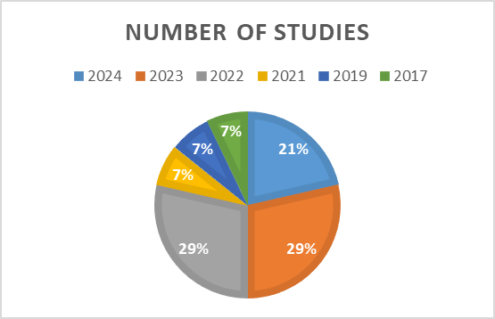

**Fig. 2. Bar chart showing the distribution of included studies across the years**

**Table 2. Table showing the studies included in the review**

|  |  |  |  |  |
| --- | --- | --- | --- | --- |
| S/N | Author/Year | Objectives | Methodology | Findings |
| 1 | (Venu Gopal et al., 2024) | Develop and validate an LSTM model for predicting PD progression. | LSTM network with patient-specific data (genetics, lifestyle, symptoms) to capture long-term dependencies in progression. | Achieved 90% accuracy, 94.85% precision, 85.98% recall, F1 Score of 90.20%, and AUC-ROC of 93.79%. |
| 2 | (Junaid et al., 2023) | Propose an explainable machine learning pipeline for predicting PD progression using multimodal data. | SVM, Random Forest, Extra Tree, LGBM, and SGD with Bayesian optimization and feature selection on the PPMI dataset. | LGBM achieved 90.73% accuracy in three-class prediction; Random Forest reached 94.57% accuracy in four-class prediction using non-motor and motor fusion. |
| 3 | (Salmanpour et al., 2021) | Identify PD subtypes and predict them using machine learning. | Hybrid machine learning systems with unsupervised clustering and supervised classification on a longitudinal dataset of 981 features. | Over 90% accuracy in predicting PD subtypes using a feature combination of non-imaging and radiomics data. |
| 4 | (Dadu et al., 2022) | Identify and predict PD subtypes and progression using machine learning. | Gaussian Mixture Model for clustering and supervised models for progression prediction on PPMI and PDBP data. | Predicted disease progression with AUC values of 0.92, 0.87, and 0.95 for different progression rates; identified serum neurofilament light as a key biomarker. |
| 5 | (Sotirakis et al., 2023) | Estimate clinical rating scales and monitor motor symptom progression using wearable sensors. | Seven machine learning models, with Random Forest being the most accurate in estimating MDS-UPDRS-III score based on wearable sensor data. | Random Forest achieved an RMSE of 10.02, detecting motor symptom progression within 15 months. |
| 6 | (McFall et al., 2023) | Identify multi-modal predictors of dementia in PD using machine learning and explainable AI. | Random Forest classifier with Tree SHAP for model interpretation on a 3-year longitudinal dataset of 48 PD patients. | AUC of 0.84 and normalized MCC of 0.763; ten leading predictors, including motor, cognitive, and lifestyle features. |
| 7 | (Rahmim et al., 2017) | Assess the predictive value of DAT SPECT imaging and radiomics for PD motor severity. | Random Forest with 5000 trees using radiomic and non-imaging features on PPMI data; evaluated with leave-one-out cross-validation. | Prediction accuracy improved, reducing absolute error from 9.00 ± 0.88 to 4.12 ± 0.43 in MDS-UPDRS-III scores. |
| 8 | (Loo et al., 2024) | Predict the development of levodopa-induced dyskinesia in PD patients using machine learning. | Nine tree-based algorithms (e.g., AdaBoost, CART, XGBoost) to build prognostic models on longitudinal clinical data across three cohorts. | Average cross-validated AUC of 0.682 and C-index of 0.718; key predictors included axial symptoms, gait freezing, and rigidity. |
| 9 | (Yoon et al., 2023) | Develop an early detection method for PD using time-series information. | Bi-LSTM with RNN architecture trained on medical claims data from Korea’s National Health Insurance Service, covering 11 years of data. | Best model achieved 94.25% accuracy, 82.91% sensitivity, and 95.26% specificity. |
| 10 | (Salmanpour et al., 2022) | Determine PD progression trajectories and predict them from early data using hybrid ML systems. | Hybrid ML system with PCA, K-means, and dimensionality reduction with neural networks on a dataset of 981 features from the PPMI. | Achieved up to 79.2% accuracy in predicting progression trajectories using feature selection and classification. |
| 11 | (Gorji & Fathi Jouzdani, 2024) | Identify the best cognitive scale for predicting cognitive decline in PD over 5 years. | 3D Autoencoder to extract radiomic features from DAT SPECT images combined with clinical biomarkers on a longitudinal dataset. | MoCA scale outperformed MDS-UPDRS-I in predicting cognitive decline, with AUC of 89.28 in year 4. |
| 12 | (Harvey et al., 2022) | Predict cognitive impairment and dementia in newly diagnosed PD cases using baseline variables. | RF, ElasticNet, SVM, and Cforest algorithms on PPMI data with clinical, biofluid, and genetic measures. | Best model achieved AUC of 0.93 and MCC of 0.70 for cognitive impairment prediction. |
| 13 | (Faouzi et al., 2022) | Predict the occurrence of impulse control disorders in PD using longitudinal data. | Logistic regression and RNN on two PD cohorts (PPMI and DIGPD), incorporating clinical and genetic data for ICD prediction. | RNN achieved ROC AUC of 0.85 (PPMI) and 0.802 (DIGPD). |
| 14 | (Salmanpour et al., 2019) | Predict MoCA score at year 4 using longitudinal data from years 0 and 1 in PD patients. | Algorithms like LASSOLAR and LOLIMOT with genetic algorithms for feature selection on PPMI dataset. | Best prediction achieved with NSGAII-selected features and LOLIMOT algorithm, with mean absolute error of 1.68 ± 0.12. |

* 1. Summary of Findings

The studies included in this review reflect substantial advancements in using ML for predicting PD progression, especially through the use of longitudinal data. Techniques such as Long Short-Term Memory (LSTM) and bidirectional LSTM models, as demonstrated by (Venu Gopal et al., 2024) and (Yoon et al., 2023), reveal the efficacy of sequential data handling in the early prediction of PD, with accuracies reaching 90% and 94.25%, respectively. These results underscore the advantage of models that capture temporal dependencies, providing clinicians with insights into PD progression patterns over time. Meanwhile, studies by (Junaid et al., 2023) and (Dadu et al., 2022) exemplify the use of ensemble models like Light Gradient Boosting Machine (LGBM) and Random Forest in multi-class classification tasks, achieving accuracies of up to 94.57%. This underscores the adaptability of traditional ML algorithms in differentiating between disease subtypes and severity levels in PD, given adequate feature selection and model optimization.

Notably, integrating multimodal datasets was a consistent theme, with studies indicating that combining motor, non-motor, genetic, and neuroimaging data enhances predictive performance. For instance, (McFall et al., 2023) demonstrated improved model accuracy by incorporating predictors across motor, cognitive, and demographic domains, while (Sotirakis et al., 2023) illustrated the potential of wearable sensor data in tracking motor symptom progression with non-invasive monitoring. The inclusion of diverse data sources highlights the need for comprehensive datasets that mirror the complexity of PD symptoms and trajectories, ultimately fostering robust predictive models.

The role of feature selection and interpretability techniques was also pivotal in refining model accuracy. (Harvey et al., 2022) and (Faouzi et al., 2022) applied feature selection algorithms, such as genetic algorithms and Shapley values, which helped isolate the most informative predictors, reducing noise and improving the clinical relevance of the models. This approach is crucial for integrating ML models into clinical settings, as it ensures that the selected predictors are both diagnostically valuable and comprehensible to healthcare providers. Across these studies, predictors like the Movement Disorder Society-Unified PD Rating Scale (MDS-UPDRS), Montreal Cognitive Assessment (MoCA), and serum neurofilament light were repeatedly identified as significant indicators of disease progression and cognitive decline, supporting their role as key biomarkers in PD management.

**Table 3: Table showing the summary of findings from selected studies**

|  |  |  |  |  |  |  |  |  |
| --- | --- | --- | --- | --- | --- | --- | --- | --- |
| S/N | Author and Year | Dataset | Machine Learning Model | Accuracy | Precision | Recall | F1 Score | AUC |
| 1 | Gopal et al., 2024 (Venu Gopal et al., 2024) | PPMI | LSTM | 0.90 | 0.95 | 0.86 | 0.90 | 0.94 |
| 2 | Junaid et al., 2023 (Junaid et al., 2023) | PPMI | LGBM, Random Forest | 0.91 | - | - | - | 0.95 |
| 3 | Salmanpour et al., 2021 (Salmanpour et al., 2021) | PPMI | Hybrid ML System | >0.90 | - | - | - | - |
| 5 | Yoon et al., 2023 (Yoon et al., 2023) | Korean Health Insurance | Bi-LSTM | 0.94 | - | 0.83 | - | 0.92 |
| 6 | Harvey et al., 2022 (Harvey et al., 2022) | PPMI | Random Forest | - | - | - | - | 0.93 |
| 7 | Faouzi et al., 2022 (Faouzi et al., 2022) | PPMI, DIGPD | RNN | - | - | - | - | 0.85 |
| 8 | Gorji et al., 2024 (Gorji & Fathi Jouzdani, 2024) | PPMI | Gradient Boosting Classifier | - | - | - | - | 0.89 |

The Table 3. summarizes the performance of various ML models applied to PD datasets, highlighting key metrics like accuracy, recall, precision, AUC and F1 score across studies.

Several studies, as seen in Fig. 3., report high accuracy, such as (Venu Gopal et al., 2024) with 90% accuracy using an LSTM model on the PPMI dataset and (Yoon et al., 2023), whose Bi-LSTM model achieved 94.25% on the Korean Health Insurance data. These high accuracies indicate that these models are adept at distinguishing between disease stages or predicting outcomes, which is crucial in clinical settings where early and precise diagnosis impacts patient care.

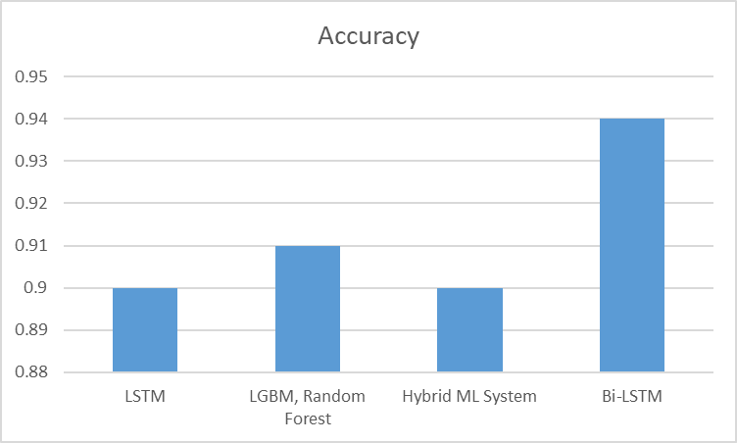

**Fig. 3. Bar chart showing Accuracy of ML models**

Precision and recall were less frequently reported across studies, with (Venu Gopal et al., 2024) achieving a precision of 94.85% and a recall of 85.98%, indicating that the LSTM model performs well in correctly identifying positive cases while minimizing false negatives. This balance is further supported by an F1 score of 90.20%, which combines precision and recall, emphasizing the model’s reliability in classifying PD progression without significant trade-offs between the two metrics

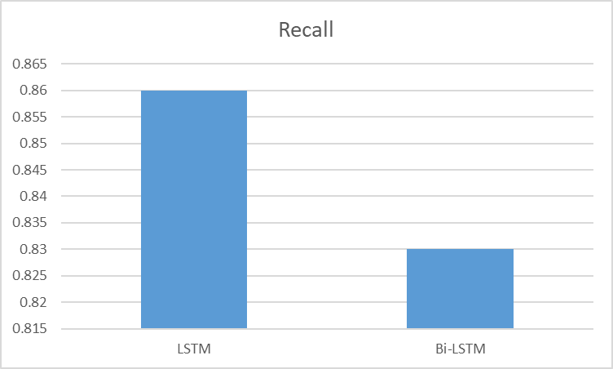

**Fig. 4. Bar chart showing recall of ML models**

The AUC (Area Under the Curve) metric, reported by several studies, reflects the model’s ability to discriminate between positive and negative classes across thresholds. For instance, (Venu Gopal et al., 2024) achieved an AUC of 93.79%, and (Faouzi et al., 2022) reported an AUC of 0.85 with an RNN on PPMI and DIGPD datasets, indicating robust classification performance. The AUC values close to 1 across these studies suggest that these models excel at distinguishing disease presence or progression, even at varied probability thresholds, making them suitable for complex clinical predictions.

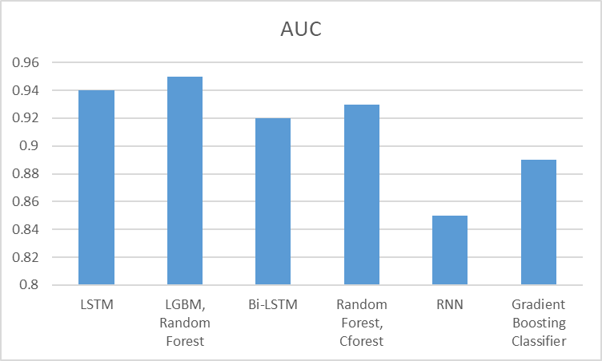

**Figure 5. Bar chart showing the AUC of ML models**

In summary, Table 3. demonstrates a high level of effectiveness across models and metrics, with LSTM and RNN models showing strong classification capabilities. Precision, recall, and F1 score results reveal these models’ balance in correctly identifying PD stages. AUC values close to 1 further confirm the models’ strong discriminative power, while RMSE and MAE values reflect their reliability in continuous predictions, aiding in precise patient monitoring and progression tracking. Together, these metrics validate ML as a powerful tool for improving diagnostic and predictive capabilities in PD management.

**Table 4. Table summarizing the studies that reported metrics over time or across multiple datasets**

|  |  |  |  |  |  |  |  |
| --- | --- | --- | --- | --- | --- | --- | --- |
| S/N | Author and Year | Dataset | Time Point | Machine Learning Model | AUC | MCC | MAE |
| 1 | Faouzi et al., 2022 | PPMI | - | RNN | 0.85 | - | - |
| 1 | Faouzi et al., 2022 | DIGPD | - | RNN | 0.802 | - | - |
| 2 | Harvey et al., 2022 | PPMI | Year 1 | Random Forest | 0.88 | 0.7 | - |
| 2 | Harvey et al., 2022 | PPMI | Year 2 | Random Forest | 0.89 | 0.72 | - |
| 2 | Harvey et al., 2022 | PPMI | Year 8 | Random Forest | 0.93 | 0.76 | - |
| 3 | Salmanpour et al., 2019 | PPMI | Year 0 | LOLIMOT | - | - | 1.83 |
| 3 | Salmanpour et al., 2019 | PPMI | Year 1 | LOLIMOT | - | - | 1.7 |
| 3 | Salmanpour et al., 2019 | PPMI | Year 4 | LOLIMOT | - | - | 1.68 |
| 4 | Gorji et al., 2024 | DAT SPECT | Initial | Gradient Boosting Classifier | 0.87 | - | - |
| 4 | Gorji et al., 2024 | DAT SPECT | Follow-up | Gradient Boosting Classifier | 0.89 | - | - |

The Table 4. summarizes key studies that report performance metrics over time or across multiple datasets, providing insights into the effectiveness and consistency of ML models applied to PD (PD) data. In (Faouzi et al., 2022), a recurrent neural network (RNN) was evaluated across two datasets: PPMI and DIGPD. The model achieved an AUC of 0.85 on the PPMI dataset and 0.802 on DIGPD, indicating strong predictive performance and generalizability across different cohorts. This consistency in AUC values across datasets suggests that the RNN model could be effective for predicting impulse control disorders in PD patients, even when applied to diverse populations

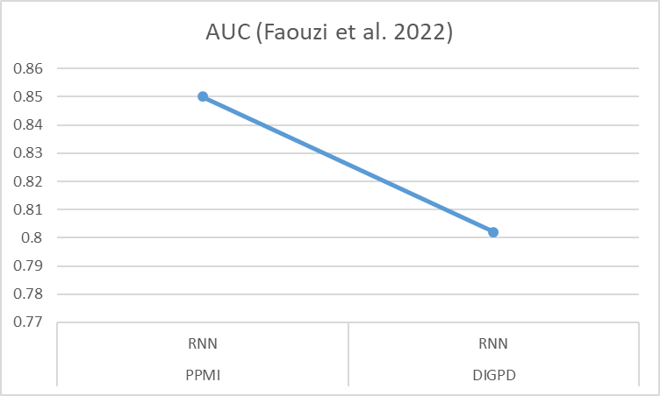

**Figure 6. Line chart showing the performance RNN in 2 different datasets**

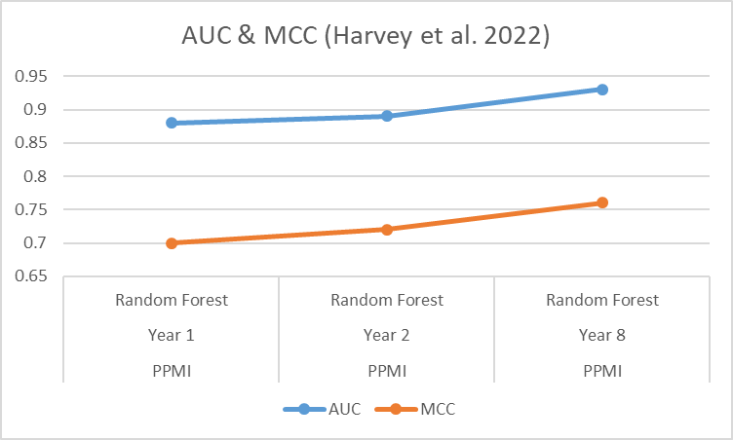

**Figure 7. Line chart showing the AUC and MCC of Random Forest over the period of 8 years**

(Harvey et al., 2022) utilized the PPMI dataset to evaluate models like Random Forest and Cforest for cognitive impairment prediction over an 8-year longitudinal period. The AUC values increased from 0.88 in the first year to 0.93 in the eighth year, alongside a rise in the Matthews Correlation Coefficient (MCC) from 0.7 to 0.76. This upward trend in both metrics over time indicates that the model's predictive reliability improves as more longitudinal data becomes available. The increasing MCC, in particular, highlights that the model is achieving better balance between true positives, true negatives, and misclassifications, suggesting that it becomes more accurate and stable in identifying cognitive impairment in PD patients over time.

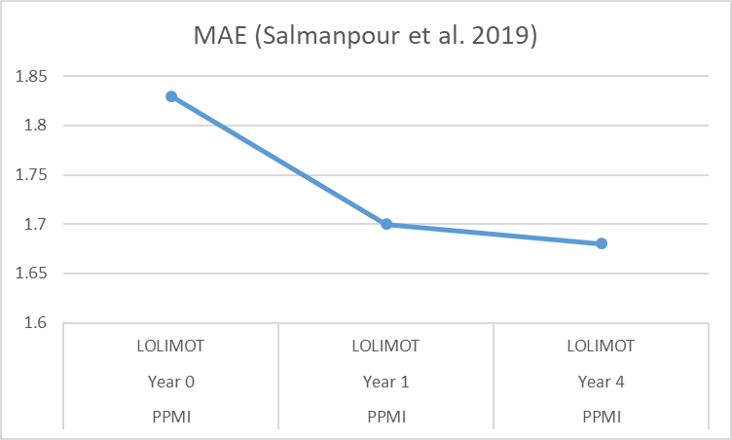

**Figure 8. Line chart showing the MAE of LOLIMOT over the period of 4 years**

In the study by (Salmanpour et al., 2019), the LOLIMOT model was applied to the PPMI dataset to predict cognitive outcomes at different time points: baseline (Year 0), Year 1, and Year 4. The Mean Absolute Error (MAE) decreased from 1.83 at baseline to 1.68 by Year 4, indicating that the model’s predictions became progressively more accurate with each follow-up year. This reduction in MAE over time suggests that the model is better capturing individual patient trajectories in cognitive decline as more data accumulates, potentially allowing for more precise long-term predictions

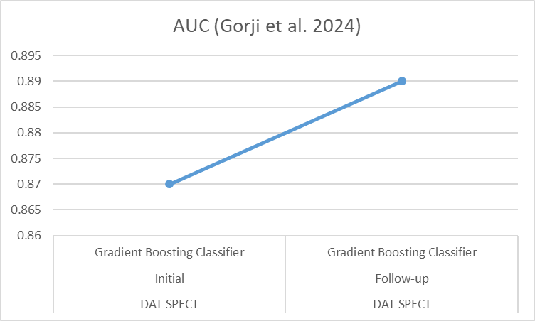

**Figure 9. Line chart showing the AUC of Gradient Boost Classifier using DAT SPECT dataset**

Finally, (Gorji & Fathi Jouzdani, 2024) employed a Gradient Boosting Classifier on DAT SPECT imaging data to predict cognitive outcomes at different imaging time points, achieving an AUC of 0.87 at the initial time point and 0.89 at follow-up. The slight increase in AUC suggests an improvement in the model’s ability to predict cognitive outcomes as additional imaging data is incorporated, underscoring the importance of time-series data in enhancing model accuracy.

Overall, the table demonstrates that models trained with longitudinal or multiple-dataset approaches tend to improve in performance metrics like AUC, MCC, and MAE over time, reflecting enhanced accuracy and stability in predictions. This trend underscores the value of longitudinal data and model adaptation for accurately tracking disease progression and supporting clinical decision-making in PD.

1. DISCUSSION

This review highlights the transformative role of ML in the management of PD (PD), particularly through the utilization of longitudinal, multimodal data to model disease progression. ML models are increasingly designed to address the temporal complexities inherent in PD, achieving remarkable predictive performance that opens new avenues for early diagnosis, ongoing monitoring, and personalized treatment strategies.

**Advancements in Temporal Data Modeling:** Some studies demonstrate the effectiveness of Long Short-Term Memory (LSTM) models in processing time-series data for early detection of PD (Venu Gopal et al., 2024; Yoon et al., 2023). By employing recurrent neural networks, these models capture the dynamic progression of PD, which is crucial for timely interventions and tailored treatment plans. The high accuracies reported in these studies emphasize the potential of sequential data analysis to optimize PD predictions, allowing for interventions that can significantly alter disease trajectories and potentially delay progression.

**Ensemble Models and Predictive Accuracy:** Traditional ML techniques, including Random Forest and Light Gradient Boosting Machine (LGBM), continue to show promise in multi-class prediction tasks (Dadu et al., 2022; Junaid et al., 2023). These models, particularly when enhanced through feature selection and Bayesian optimization, effectively classify PD subtypes and predict disease severity with substantial precision. The findings from further indicate that the integration of both non-motor and motor function modalities can enhance model accuracy, underscoring the necessity of a holistic approach to patient data that incorporates both physiological and clinical insights for a comprehensive understanding of PD (Junaid et al., 2023).

**Wearable Sensors and Non-invasive Monitoring:** The rise of wearable technology illustrates the potential of sensor data in continuously tracking motor symptoms over time (Rahmim et al., 2017; Sotirakis et al., 2023). These devices facilitate non-invasive monitoring of PD symptoms, providing real-time insights into patient status and enabling early interventions when symptoms deteriorate. The consistent application of wearable devices over time allows for detailed analyses of symptom fluctuations, capturing changes that might be missed during standard clinical visits. This capability is particularly valuable for remote monitoring, where timely adjustments to treatment plans can greatly impact patient outcomes.

**Integration of Multimodal Data for Enhanced Prediction:** The combination of clinical, genetic, and imaging data in multimodal datasets significantly enhances model accuracy. The integration of diverse data sources allows ML models to assess various dimensions of PD, leading to a more comprehensive representation of disease progression (Gorji & Fathi Jouzdani, 2024; McFall et al., 2023). For instance, the Montreal Cognitive Assessment (MoCA) scale was identified as a reliable predictor for cognitive decline when paired with imaging and clinical biomarkers (Gorji & Fathi Jouzdani, 2024). This multifaceted approach is critical, given the interplay of physical, cognitive, and behavioral symptoms in PD.

**Importance of Feature Selection and Interpretability:** Effective feature selection emerges as a vital component in enhancing both model performance and interpretability (Faouzi et al., 2022; Harvey et al., 2022). Utilizing techniques such as genetic algorithms and Shapley values enables the development of more targeted models by emphasizing relevant predictors and minimizing the impact of less significant variables. This is particularly crucial in clinical settings, where model transparency is paramount for informed decision-making. By adopting explainable AI strategies, researchers can clarify which features most significantly contribute to predictions, fostering a deeper understanding of the factors influencing disease progression and enhancing clinician trust in ML applications (Harvey et al., 2022; McFall et al., 2023).

**Challenges and Future Directions:** Despite these promising advancements, several challenges remain. Many studies rely on specialized cohorts, such as the PPMI, which may limit the generalizability of findings to the broader PD population. Furthermore, ML models that are complex and data-intensive require rigorous validation across diverse populations to ensure robustness and adaptability. While wearable devices and imaging modalities are becoming more prevalent, their widespread clinical adoption hinges on cost-effectiveness, accessibility, and standardization of data. Studies by (Rahmim et al., 2017) and (Sotirakis et al., 2023) illustrate the value of real-time, wearable-based monitoring, yet the technical and economic barriers to their broader use must be addressed.

Future research should focus on expanding datasets to include a wider variety of populations, thereby increasing the representativeness and applicability of findings across clinical settings. Additionally, hybrid models that merge structured clinical data with unstructured data sources, such as patient-reported outcomes, could enhance personalization in predicting disease trajectories, accommodating the inherent heterogeneity of PD presentations. Techniques in explainable AI are crucial for bridging the gap between complex model architectures and clinical utility, ensuring that insights derived from ML are both predictive and actionable for healthcare providers (McFall et al., 2023; Yang, 2022). Continued advancements in transfer learning and model interpretability are likely to expedite the clinical integration of ML, paving the way for precision medicine in the management of neurodegenerative diseases.

1. CONCLUSION

The systematic review findings underscore the potential of ML methods to significantly enhance the prediction and management of PD by leveraging longitudinal data and multiple datasets. The performance metrics reported across studies demonstrate the robust predictive capabilities of ML models, particularly as they continue to learn and adapt over time. Notably, improvements in metrics like Mean Absolute Error (MAE) and Matthews Correlation Coefficient (MCC) over successive time points underscore the models’ increasing accuracy and reliability in forecasting disease progression. This trend highlights how ML models, such as LSTM and ensemble methods, can capture complex patterns in disease progression, which are essential for accurate early diagnosis and ongoing monitoring.

The importance of utilizing diverse datasets, such as PPMI, DIGPD, and DAT SPECT imaging, further emphasizes the value of generalizability in ML applications. Consistency in model performance across these datasets illustrates the models’ capacity to provide reliable predictions in various clinical settings, reinforcing their potential utility in personalized patient care. Additionally, the integration of multimodal data—combining clinical, genetic, and imaging information—enables a comprehensive representation of PD progression, which is crucial for capturing the multifaceted nature of the disease.

The review’s findings carry significant implications for personalized risk assessment, clinical decision-making, and long-term patient management. By incorporating these ML models into clinical practice, healthcare providers could make data-driven decisions tailored to individual patient trajectories, improving treatment outcomes and optimizing care strategies (Onuiri & Adeniyi, 2024). Future research should focus on refining these models to enhance interpretability and further validate predictive biomarkers. Additionally, exploring the practical implementation of ML models in healthcare settings is essential, as it would facilitate the integration of predictive insights into routine clinical workflows.

Conclusively, this systematic review provides valuable insights into the effectiveness of ML models in predicting PD progression. The observed improvements in model performance over time and across datasets reveal the adaptability of ML methods in clinical applications. These findings open avenues for further research into the real-world implementation of ML models, ultimately supporting precision medicine in neurodegenerative disease management

REFERENCES

Aggarwal, N., Saini, B. S., & Gupta, S. (2021). The impact of clinical scales in Parkinson’s disease: a systematic review. *The Egyptian Journal of Neurology, Psychiatry and Neurosurgery*, *57*(1), 174. https://doi.org/10.1186/s41983-021-00427-9

Ahmed, Z., Mohamed, K., Zeeshan, S., & Dong, X. (2020). Artificial intelligence with multi-functional machine learning platform development for better healthcare and precision medicine. *Database*, *2020*(baaa010), 1–35. https://doi.org/10.1093/database/baaa010

Amir-Behghadami, M., & Janati, A. (2020). Population, Intervention, Comparison, Outcomes and Study (PICOS) design as a framework to formulate eligibility criteria in systematic reviews. *Emergency Medicine Journal*, *37*(6), 387–387. https://doi.org/10.1136/EMERMED-2020-209567

Athauda, D., & Foltynie, T. (2016). Challenges in detecting disease modification in Parkinson’s disease clinical trials. *Parkinsonism & Related Disorders*, *32*(November), 1–11. https://doi.org/10.1016/j.parkreldis.2016.07.019

Bhidayasiri, R., & Martinez-Martin, P. (2017). Clinical Assessments in Parkinson’s Disease. In *International Review of Neurobiology* (pp. 129–182). Elsevier Inc. https://doi.org/10.1016/bs.irn.2017.01.001

Cascarano, A., Mur-Petit, J., Hernández-González, J., Camacho, M., de Toro Eadie, N., Gkontra, P., Chadeau-Hyam, M., Vitrià, J., & Lekadir, K. (2023). Machine and deep learning for longitudinal biomedical data: a review of methods and applications. *Artificial Intelligence Review*, *56*(S2), 1711–1771. https://doi.org/10.1007/s10462-023-10561-w

Dadu, A., Satone, V., Kaur, R., Hashemi, S. H., Leonard, H., Iwaki, H., Makarious, M. B., Billingsley, K. J., Bandres‐Ciga, S., Sargent, L. J., Noyce, A. J., Daneshmand, A., Blauwendraat, C., Marek, K., Scholz, S. W., Singleton, A. B., Nalls, M. A., Campbell, R. H., & Faghri, F. (2022). Identification and prediction of Parkinson’s disease subtypes and progression using machine learning in two cohorts. *Npj Parkinson’s Disease*, *8*(1), 172. https://doi.org/10.1038/s41531-022-00439-z

Dorsey, E. R., Constantinescu, R., Thompson, J. P., Biglan, K. M., Holloway, R. G., Kieburtz, K., Marshall, F. J., Ravina, B. M., Schifitto, G., Siderowf, A., & Tanner, C. M. (2007). Projected number of people with Parkinson disease in the most populous nations, 2005 through 2030. *Neurology*, *68*(5), 384–386. https://doi.org/10.1212/01.wnl.0000247740.47667.03

Dorsey, E. R., Sherer, T., Okun, M. S., & Bloemd, B. R. (2018). The emerging evidence of the Parkinson pandemic. In P. Brundin, J. W. Langston, & B. R. Bloem (Eds.), *Journal of Parkinson’s Disease* (Vol. 8, Issue s1, pp. S3–S8). https://doi.org/10.3233/JPD-181474

Faouzi, J., Bekadar, S., Artaud, F., Elbaz, A., Mangone, G., Colliot, O., & Corvol, J.-C. (2022). Machine Learning-Based Prediction of Impulse Control Disorders in Parkinson’s Disease From Clinical and Genetic Data. *IEEE Open Journal of Engineering in Medicine and Biology*, *3*(May), 96–107. https://doi.org/10.1109/OJEMB.2022.3178295

Fröhlich, H., Balling, R., Beerenwinkel, N., Kohlbacher, O., Kumar, S., Lengauer, T., Maathuis, M. H., Moreau, Y., Murphy, S. A., Przytycka, T. M., Rebhan, M., Röst, H., Schuppert, A., Schwab, M., Spang, R., Stekhoven, D., Sun, J., Weber, A., Ziemek, D., & Zupan, B. (2018). From hype to reality: data science enabling personalized medicine. *BMC Medicine*, *16*(1), 150. https://doi.org/10.1186/s12916-018-1122-7

Garcia Santa Cruz, B., Husch, A., & Hertel, F. (2023a). Machine learning models for diagnosis and prognosis of Parkinson’s disease using brain imaging: general overview, main challenges, and future directions. *Frontiers in Aging Neuroscience*, *15*(Ml), 1–20. https://doi.org/10.3389/fnagi.2023.1216163

Garcia Santa Cruz, B., Husch, A., & Hertel, F. (2023b). Machine learning models for diagnosis and prognosis of Parkinson’s disease using brain imaging: general overview, main challenges, and future directions. *Frontiers in Aging Neuroscience*, *15*, 1–20. https://doi.org/10.3389/fnagi.2023.1216163

Gorji, A., & Fathi Jouzdani, A. (2024). Machine learning for predicting cognitive decline within five years in Parkinson’s disease: Comparing cognitive assessment scales with DAT SPECT and clinical biomarkers. *PLOS ONE*, *19*(7), e0304355. https://doi.org/10.1371/journal.pone.0304355

Haddaway, N. R., Page, M. J., Pritchard, C. C., & McGuinness, L. A. (2022). PRISMA2020: An R package and Shiny app for producing PRISMA 2020-compliant flow diagrams, with interactivity for optimised digital transparency and Open Synthesis. *Campbell Systematic Reviews*, *18*(2), e1230. https://doi.org/10.1002/CL2.1230

Harvey, J., Reijnders, R. A., Cavill, R., Duits, A., Köhler, S., Eijssen, L., Rutten, B. P. F., Shireby, G., Torkamani, A., Creese, B., Leentjens, A. F. G., Lunnon, K., & Pishva, E. (2022). Machine learning-based prediction of cognitive outcomes in de novo Parkinson’s disease. *Npj Parkinson’s Disease*, *8*(1), 150. https://doi.org/10.1038/s41531-022-00409-5

*HubMeta – Systematic Review and Meta Analysis Cloud Platform*. (n.d.). Retrieved March 11, 2024, from https://hubmeta.com/

Islam, M. A., Hasan Majumder, M. Z., Hussein, M. A., Hossain, K. M., & Miah, M. S. (2024). A review of machine learning and deep learning algorithms for Parkinson’s disease detection using handwriting and voice datasets. *Heliyon*, *10*(3), e25469. https://doi.org/10.1016/j.heliyon.2024.e25469

Jankovic, J. (2008). Parkinson’s disease: clinical features and diagnosis. *Journal of Neurology, Neurosurgery & Psychiatry*, *79*(4), 368–376. https://doi.org/10.1136/jnnp.2007.131045

Javaid, M., Haleem, A., Pratap Singh, R., Suman, R., & Rab, S. (2022). Significance of machine learning in healthcare: Features, pillars and applications. *International Journal of Intelligent Networks*, *3*, 58–73. https://doi.org/10.1016/j.ijin.2022.05.002

Junaid, M., Ali, S., Eid, F., El-Sappagh, S., & Abuhmed, T. (2023). Explainable machine learning models based on multimodal time-series data for the early detection of Parkinson’s disease. *Computer Methods and Programs in Biomedicine*, *234*(June). https://doi.org/10.1016/j.cmpb.2023.107495

Keserwani, P. K., Das, S., & Sarkar, N. (2024). A comparative study: prediction of parkinson’s disease using machine learning, deep learning and nature inspired algorithm. *Multimedia Tools and Applications*, *83*(27), 69393–69441. https://doi.org/10.1007/s11042-024-18186-z

Khalil, I., Sayad, R., Kedwany, A., Sayed, H., Caprara, A. L., & Rissardo, J. (2024). Cardiovascular dysautonomia and cognitive impairment in Parkinson’s disease (Review). *Medicine International*, *4*(6), 70. https://doi.org/10.3892/mi.2024.194

Latourelle, J. C., Beste, M. T., Hadzi, T. C., Miller, R. E., Oppenheim, J. N., Valko, M. P., Wuest, D. M., Church, B. W., Khalil, I. G., Hayete, B., & Venuto, C. S. (2017). Large-scale identification of clinical and genetic predictors of motor progression in patients with newly diagnosed Parkinson’s disease: a longitudinal cohort study and validation. *The Lancet Neurology*, *16*(11), 908–916. https://doi.org/10.1016/S1474-4422(17)30328-9

Lee, J.-H. (2023). Understanding Parkinson’s Disorders: Classification and Evaluation Methods, Movement Disorders, and Treatment Methods. *International Journal of Advanced Culture Technology*, *11*(3), 9–17. https://doi.org/https://doi.org/10.17703/IJACT.2023.11.3.9

Loo, R. T. J., Tsurkalenko, O., Klucken, J., Mangone, G., Khoury, F., Vidailhet, M., Corvol, J. C., Krüger, R., Glaab, E., Acharya, G., Aguayo, G., Alexandre, M., Ali, M., Ammerlann, W., Arena, G., Bassis, M., Batutu, R., Beaumont, K., Béchet, S., … Zelimkhanov, G. (2024). Levodopa-induced dyskinesia in Parkinson’s disease: Insights from cross-cohort prognostic analysis using machine learning. *Parkinsonism and Related Disorders*, *126*(July). https://doi.org/10.1016/j.parkreldis.2024.107054

Lubomski, M., Davis, R. L., & Sue, C. M. (2021). Health-Related Quality of Life for Parkinson’s Disease Patients and Their Caregivers. *Journal of Movement Disorders*, *14*(1), 42–52. https://doi.org/10.14802/jmd.20079

Marcoulides, K. M., & Grimm, K. J. (2017). Data Integration Approaches to Longitudinal Growth Modeling. *Educational and Psychological Measurement*, *77*(6), 971–989. https://doi.org/10.1177/0013164416664117

McFall, G. P., Bohn, L., Gee, M., Drouin, S. M., Fah, H., Han, W., Li, L., Camicioli, R., & Dixon, R. A. (2023). Identifying key multi-modal predictors of incipient dementia in Parkinson’s disease: a machine learning analysis and Tree SHAP interpretation. *Frontiers in Aging Neuroscience*, *15*(June), 1–16. https://doi.org/10.3389/fnagi.2023.1124232

Moher, D., Liberati, A., Tetzlaff, J., Altman, D. G., Antes, G., Atkins, D., Barbour, V., Barrowman, N., Berlin, J. A., Clark, J., Clarke, M., Cook, D., D’Amico, R., Deeks, J. J., Devereaux, P. J., Dickersin, K., Egger, M., Ernst, E., Gøtzsche, P. C., … Tugwell, P. (2009). Preferred reporting items for systematic reviews and meta-analyses: The PRISMA statement. *PLoS Medicine*, *6*(7). https://doi.org/10.1371/journal.pmed.1000097

Nzenwata, U.-J., Abiodun, A. G., Olayinka, A., Adeniyi, O. J., & Gazie, A. B. (2024). Parkinson’s Disease Prediction Using Convolutional Neural Networks and Hand-Drawn Image Analysis. *Asian Journal of Computer Science and Technology*, *13*(2), 1–13. https://doi.org/10.70112/ajcst-2024.13.2.4270

Onuiri, E. E., & Adeniyi, O. J. (2024). Evaluating Machine Learning Models for Predicting Prostate Cancer Progression Using Lifestyle Factors: A Systematic Review and Meta-Analysis. *Asian Journal of Engineering and Applied Technology*, *13*(1), 44–56. https://doi.org/10.70112/ajeat-2024.13.1.4241

Postuma, R. B., & Montplaisir, J. (2009). Predicting Parkinson’s disease - why, when, and how? *Parkinsonism and Related Disorders*, *15*(SUPPL. 3), S105–S109. https://doi.org/10.1016/S1353-8020(09)70793-X

Pratihar, R., & Sankar, R. (2024). Advancements in Parkinson’s Disease Diagnosis: A Comprehensive Survey on Biomarker Integration and Machine Learning. *Computers*, *13*(11), 293. https://doi.org/10.3390/computers13110293

Rahmim, A., Huang, P., Shenkov, N., Fotouhi, S., Davoodi-Bojd, E., Lu, L., Mari, Z., Soltanian-Zadeh, H., & Sossi, V. (2017). Improved prediction of outcome in Parkinson’s disease using radiomics analysis of longitudinal DAT SPECT images. *NeuroImage: Clinical*, *16*, 539–544. https://doi.org/10.1016/j.nicl.2017.08.021

Rajiah, K., Maharajan, M. K., Yeen, S. J., & Lew, S. (2017). Quality of Life and Caregivers’ Burden of Parkinson’s Disease. *Neuroepidemiology*, *48*(3–4), 131–137. https://doi.org/10.1159/000479031

Rukavina, K., Batzu, L., Boogers, A., Abundes-Corona, A., Bruno, V., & Chaudhuri, K. R. (2021). Non-motor complications in late stage Parkinson’s disease: recognition, management and unmet needs. *Expert Review of Neurotherapeutics*, *21*(3), 335–352. https://doi.org/10.1080/14737175.2021.1883428

S M, S., Sriram, S., & V, N. (2024). Comprehensive Study: Advancements in Parkinson’s Disease Diagnosis with Data-Driven Insights and Machine Learning. *2024 International Conference on Communication, Computer Sciences and Engineering (IC3SE)*, 697–701. https://doi.org/10.1109/IC3SE62002.2024.10593380

Saeed, U., Compagnone, J., Aviv, R. I., Strafella, A. P., Black, S. E., Lang, A. E., & Masellis, M. (2017). Imaging biomarkers in Parkinson’s disease and Parkinsonian syndromes: current and emerging concepts. *Translational Neurodegeneration*, *6*(1), 8. https://doi.org/10.1186/s40035-017-0076-6

Salmanpour, M. R., Shamsaei, M., Hajianfar, G., Soltanian-Zadeh, H., & Rahmim, A. (2022). Longitudinal clustering analysis and prediction of Parkinson’s disease progression using radiomics and hybrid machine learning. *Quantitative Imaging in Medicine and Surgery*, *12*(2), 906–919. https://doi.org/10.21037/qims-21-425

Salmanpour, M. R., Shamsaei, M., & Rahmim, A. (2021). Feature selection and machine learning methods for optimal identification and prediction of subtypes in Parkinson’s disease. *Computer Methods and Programs in Biomedicine*, *206*, 106131. https://doi.org/10.1016/j.cmpb.2021.106131

Salmanpour, M. R., Shamsaei, M., Saberi, A., Setayeshi, S., Klyuzhin, I. S., Sossi, V., & Rahmim, A. (2019). Optimized machine learning methods for prediction of cognitive outcome in Parkinson’s disease. *Computers in Biology and Medicine*, *111*(August), 103347. https://doi.org/10.1016/j.compbiomed.2019.103347

Severson, K. A., Chahine, L. M., Smolensky, L. A., Dhuliawala, M., Frasier, M., Ng, K., Ghosh, S., & Hu, J. (2021). Discovery of Parkinson’s disease states and disease progression modelling: a longitudinal data study using machine learning. *The Lancet Digital Health*, *3*(9), e555–e564. https://doi.org/10.1016/S2589-7500(21)00101-1

Sotirakis, C., Su, Z., Brzezicki, M. A., Conway, N., Tarassenko, L., FitzGerald, J. J., & Antoniades, C. A. (2023). Identification of motor progression in Parkinson’s disease using wearable sensors and machine learning. *Npj Parkinson’s Disease*, *9*(1), 1–8. https://doi.org/10.1038/s41531-023-00581-2

Srinivasan, S., Ramadass, P., Mathivanan, S. K., Panneer Selvam, K., Shivahare, B. D., & Shah, M. A. (2024). Detection of Parkinson disease using multiclass machine learning approach. *Scientific Reports*, *14*(1), 13813. https://doi.org/10.1038/s41598-024-64004-9

Sterne, J. A. C., Savović, J., Page, M. J., Elbers, R. G., Blencowe, N. S., Boutron, I., Cates, C. J., Cheng, H. Y., Corbett, M. S., Eldridge, S. M., Emberson, J. R., Hernán, M. A., Hopewell, S., Hróbjartsson, A., Junqueira, D. R., Jüni, P., Kirkham, J. J., Lasserson, T., Li, T., … Higgins, J. P. T. (2019). RoB 2: a revised tool for assessing risk of bias in randomised trials. *BMJ*, *366*. https://doi.org/10.1136/BMJ.L4898

Tăuţan, A.-M., Ionescu, B., & Santarnecchi, E. (2021). Artificial intelligence in neurodegenerative diseases: A review of available tools with a focus on machine learning techniques. *Artificial Intelligence in Medicine*, *117*, 102081. https://doi.org/10.1016/j.artmed.2021.102081

Venu Gopal, S. V. V. D., Ramaraja, S. S., Prasad, K. S. N., & Kasetti, V. (2024). Enhancing Parkinson’s Disease Prognosis with LSTM-Based Deep Learning for Precision Diagnosis and Symptom Trajectory Analysis. *SSRG International Journal of Electronics and Communication Engineering*, *11*(1), 53–66. https://doi.org/10.14445/23488549/IJECE-V11I1P105

Yang, C. C. (2022). Explainable Artificial Intelligence for Predictive Modeling in Healthcare. *Journal of Healthcare Informatics Research*, *6*(2), 228–239. https://doi.org/10.1007/s41666-022-00114-1

Yoon, S., Kim, M., & Lee, W. W. (2023). Long Short-Term Memory-Based Deep Learning Models for Screening Parkinson’s Disease Using Sequential Diagnostic Codes. *Journal of Clinical Neurology (Korea)*, *19*(3), 270–279. https://doi.org/10.3988/jcn.2022.0160

Zhang, J. (2022). Mining imaging and clinical data with machine learning approaches for the diagnosis and early detection of Parkinson’s disease. *Npj Parkinson’s Disease*, *8*(1), 13. https://doi.org/10.1038/s41531-021-00266-8