**EXPONENTIAL-GAMMA- RAYLEIGH DISTRIBUTION THEORY**

**ABSTRACT**

**The use of traditional probability models to forecast real-world events is causing growing dissatisfaction among scholars. One of the motives could be that the tail characteristics and goodness of fit metrics have a constraining tendency. Subsequently, there has been a significant increase in the generalisation of well-known probability distributions in recent years. This study focussed on the development of a family of continuous probability distribution from the extension of EG distribution. This is achieved by modifying the newly generated continuous Exponential-Gamma-X family of distributions. Explicit expressions for the probability density function cumulative distribution function, moments, and moment generating function, characteristics function of the EGRD distribution are derived. Various statistical properties, including the coefficient of variation, Also, the study are focussed on the estimation of the proposed model using the technique of maximum likelihood estimation.**

**Keywords: *Exponential Gamma-X, Statistical properties, Maximum Likelihood Estimation***

**INTRODUCTION**

Several researchers have generated new adaptable distributions from existing distributions using various modification techniques to increase their flexibility in modeling data. These adaptable distributions are created by adding extra parameters to the baseline distribution with generators or combining two distributions (Ali, *et al*., 2021). These modified distributions can model data sets efficiently and in most cases, provide the best fit to data sets. When applied because they have more parameters and are more adaptable than their baseline distributions. Introducing an extra parameter to an existing distribution has proven beneficial in studying tail properties and improving the goodness of fit of the compound distribution. Recent emerging data of interest exhibit non-normal characteristics such as high or moderate skewness and high kurtosis, which existing distributions cannot accurately model. As a result, researchers are attempting to develop models that account for the limitations of these distributions. So, in this study, we aim to develop a model that might efficiently fit such data. This purpose is achieved by adding an extra parameter using generators or by the existing models; therefore, in this study, we intend to develop a new probability distribution called the Exponential-Gamma-Rayleigh distribution by using the pdf of the new Exponential-Gamma-X distributions developed by Adewusi, *et al*., (2019).

Methods

In this study, we proposed and explored a new generalization of the Exponential-Gamma and Rayleigh distributions using the T-X method.

**Theorem 1:** Let $X$ be continuous independent random variable such that; $X \sim RD(x,σ)$ follows an Rayleigh distribution and, let  and  be the probability density function and cumulative distribution function of Rayleigh distribution given as:

 (1)

and (2)

Similarly, Adewusi, *et al*., (2019), defined a generalized T-X family of Exponential-Gamma-X distribution as:

 (3)

where in (3) is the PDF of Exponential-Gamma-X family of distribution,  and  are the pdf and the survival function of the baseline distribution.

Inserting (1) and (2) into (3) above, then probability density function, pdf of the Exponential-Gamma-Rayleigh distribution is given as:

 (4)

For convenient computation, let

 then,

 (5)

is the PDF of the new EGRD. The distribution has three parameters namely: $α$ (Shape), $θ$ (scale) and (location) .

**B Statistical properties**

In this section, the statistical properties of EGRD, particularly the first four moments, variance, and coefficient of variation, moment generating function, characteristic function, skewness, and kurtosis are obtained.

C Moment

**Theorem 2:** If  is a random variable distributed as an EGRD,having parameters $θ,α, ,$ then the $r^{th}$ non-central moment of X is given by:

 (6)

**Proof:**

 (7)

 (8)

Let  then, (8) reduces to:

 (9)

Since , based on gamma function, then

 (10)

Substituting r =1, 2, 3 and 4 in equation (10 ) we obtain the first (mean), second, third and the fourth moments by for EGRD: we obtain the variance by the association



Mean =  (11)

 (12)

 (13)

 (14)

 (15)

Then the 3rd and the 4th moment is given as:

 (16)

 respectively (17)

D. Moment generating function

**Theorem 3:** If  is a continuous random variable distributed as an EGRD, then the moment generating function is given as 

 (18)

 (19)

Let, then  so that (19) is reduced to

 (20)

 (21)

E. **Characteristic Function (CF)**

**Theorem 5:** If is a random variable distributed as an EGRD, then the characteristics function  is defined as 

**Proof:**

 (22)

 (23)

Let, then  so that (3.16) is reduced to

 (24)

 (25)

F. **Coefficient of Variation (C.V)** is a standardized measure of dispersion of a probability distribution and is given as:

 (26)

 (27)



**G. Skewness and Kurtosis**

**Skewness**is a measure of the asymmetry of the probability distribution of a real-valued random variable about its mean and is given as:

 (29)



**Kurtosis** is a descriptor of the shape of a probability distribution and is given as;

 (31)

(32)

 (33)

**Cumulative Distribution Function (CDF)**

The cumulative distribution function of a random variable *X* evaluated at *x* is the probability that *X* will take a value less than or equal to *x* and is defined as;

 (34)

**Theorem 6**: If $X$ is a continuous random variable from the Exponential-Exponential distribution, the cumulative density function (CDF) is defined by

 (35)

**Proof:**

  (36)

let   then  so (3.19) is reduced to:

 (37)

,   (38)

PDF

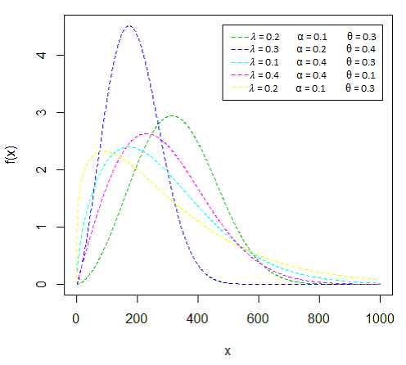

***Fig 1. PDF plots of EGRD***

CDF

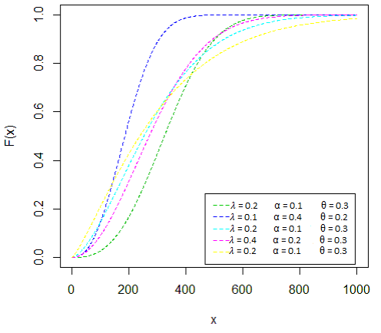

***Fig 2. CDF plots for EGRD***

From figure 1 The plot reveals various possible shapes of the EGR density function, including (approximately) symmetric, skewed, and unimodal were produced. It can be seen that the tail of the distribution is longer and shorter on both right side and left side for different combinations of the values of the parameters. This demonstrates the great flexibility of the EGR distribution, which makes it suitable for various real data and CDF plot shown in Figure 2 that EGRD starts from zero on the y axis and tend to 1 on x axis , which is an indication that the EGRD is a valid distribution because it satisfies the basic property of a valid probability distribution which states that the probability of any event is greater than or equal to zero and the sum of the cumulative probabilities of events is equal to one

1. **Reliability Function**

The reliability function also known as survival function is a function that measures the likelihood that a patient, device, or other object of interest will survive beyond a specific time range and is defined as:

 (39)

whereis the cumulative distribution function of *X,* substituting,

 (40)

1. **Hazard Function**

The **hazard function** also called theforce of mortality*,*instantaneous failure rate*,*instantaneous death rate, or age-specific failure rate is the instantaneous risk that the event of interest happens, within a very narrow time frame and is defined as;

 (41)

where  and are pdf and survival function of EGRD then,

 (42)



K. **THE MAXIMUM LIKELIHOOD ESTIMATOR**

**Theorem 7:** Let  be a random sample of size n from Exponential-Gamma- Rayleigh distribution (EGRD) with pdf

 (44)

By taking the natural logarithm of (44), the log-likelihood function is obtained as;

 (45)

Therefore, the MLE which maximizes (3.35) must satisfy the following normal equations;

 (46)

 (47)

 (48)

Differentiating equation (45) with respect to $α ,$ λ and $θ$ give the maximum likelihood estimates of the model parameters that generate the solution of the nonlinear system of equations. The parameters can be estimated numerically by solving (46), (47), and (48), while solving it analytically is very cumbersome and tasking. The numerical solution can also be obtained directly using some data sets in Python but there are other programming laguages that could do the work.

**CONCLUSION**

A new extension of the T-X family of the Exponential-Gamma-X distribution named Exponential-Gamma-Rayleigh distribution comprising three parameters has been developed and studied. We explored and generated several expressions for distribution theory and properties including the first four moment, moment generating function, characteristics function cumulative distribution function skewness, kurtosis and the maximum likelihood estimation approach was use to estimate the parameters of the distribution.

**REFERENCES**

Adewusi, O. A., Ayeni, T. M., and Ogunwale, O. D. (2019). On The Exponential- Gamma-X Mixed Distribution. *International Journal of Research and Innovation in Applied Science*, 4 (11),139-141.

Ali T. M., Mayssa J. M., Muna, D. S., and Rabha W. I. (2021). The inverse exponential Rayleigh distribution and related concepts. *Italian Journal of Pure And Applied Mathematics, 47(2), 852–861.*