Systematic Review

Gait Analysis of Children with Developmental Dysplasia of The Hip Under 2 Years-old After Closed Reduction: a Systematic Review

.
ABSTRACT

Introduction: Developmental dysplasia of the hip (DDH) is a common orthopedic condition affecting hip joint development, leading to potential dislocation. While early diagnosis is crucial, treatment typically involves harness therapy or surgical intervention. Despite advancements, postoperative gait abnormalities persist. Aims: Our study aims to explore the relationship between surgically corrected DDH, postoperative gait deviations, and functional outcomes. We hypothesize specific gait abnormalities will correlate with surgical procedure type, radiological findings, and overall functional outcomes. This study aims to provide insights into optimizing surgical decision-making and improving outcomes in hip surgery for DDH. Methods: Two reviewers conducted comprehensive searches independently across databases including PubMed, Embase, Cochrane Library, and Web of Science from inception to May 2024. The included studies underwent bias assessment using the RoB 2 and ROBINS-I tools. The evidence was evaluated using the GRADE approach. Results. Out of 169 initially identified articles, one study met the inclusion criteria after screening. This study involved 203 patients (406 lower limbs) with a mean age of 20.09 months, consisting of 165 females and 38 males. Of these, 143 patients (70.4%) were treated with abduction braces, 32 (15.7%) had surgical hip reduction followed by casting and brace treatment, and 28 (13.7%) were treated for other diagnoses. Evaluated with the ROBINS-I tool, the study had a moderate risk of bias. Gait analysis using the Wee Glasgow Gait Index (WeeGGI) showed a mean score of 6.44 ± 3.84, with a high correlation (r = 0.93) indicating a significant impact of DDH on gait. Significant correlations were found for the right (r = 0.97) and left (r = 0.25) lower limbs. No radiological outcomes or complications were reported. Conclusion: The included study showed notable gait deviations, emphazing the need for more rigorous research. Future studies should include larger sample sizes, standardized outcome measures, and detailed reporting to better understand the effectiveness of DDH treatments.

Keywords: developmental dysplasia of the hip, gait analysis, ddh, systematic review

1. INTRODUCTION

Developmental dysplasia of the hip (DDH) is a complex orthopedic condition characterized by a spectrum of abnormal developmental changes affecting the hip joint. These changes can lead to acetabular dysplasia, hip subluxation, and potentially hip dislocation, primarily due to factors such as capsular laxity and mechanical instabilities. DDH is recognized as one of the most common musculoskeletal disorders observed in newborns, with an incidence rate of approximately 1 in 100 for dysplasia and 1 in 1000 for hip dislocation. However, it's important to note that the prevalence of DDH can vary significantly across different regions and populations, with reported incidence rates ranging from 1 in 1000 to as high as 34 in 1000.^{1–3}
Several studies have highlighted the impact of DDH on various aspects of musculoskeletal function, including gait patterns. For example, a study by Vascilcova et al.⁴ demonstrated a substantial effect of DDH on the gait patterns of participants, particularly in populations such as Saudi Arabia. Understanding these effects is crucial for developing effective management strategies and improving patient outcomes. Various risk factors have been associated with the development of DDH, including female gender, a family history of hip dysplasia, being a firstborn child, and conditions such as oligohydramnios during pregnancy. Early diagnosis of DDH, ideally before the age of 6 months, is considered critical for successful management. The primary treatment approach for DDH involves the use of a harness, which is considered the gold standard for managing mild to moderate cases. In cases of delayed diagnosis or ineffective harness treatment, surgical interventions such as closed or open reduction with or without pelvic osteotomy may be necessary to correct hip morphology and restore joint function.^{5–7}
Despite advancements in surgical techniques and rehabilitation protocols for DDH, postoperative gait abnormalities remain a common concern. Studies, including research by Lee et al., have indicated that patients treated for unilateral DDH may exhibit compromised balance control strategies and altered body mechanics during gait, particularly in terms of frontal plane stance and sagittal plane swing. However, it's worth noting that while gait analysis is a standard method for objectively evaluating walking function post-surgery, its application in the context of DDH is relatively limited compared to other orthopedic conditions. Current research in DDH primarily focuses on assessing outcomes through clinical examinations, radiological evaluations, and functional parameters. For instance, Jamil et al. conducted a study evaluating functional outcomes based on clinical and radiological assessments. Additionally, some studies have utilized visual analysis techniques to assess gait in participants with DDH, highlighting the diverse approaches used by physiotherapists in evaluating gait deviations.^{8–11}
With these considerations, our study aims to further explore the relationship between surgically corrected DDH by using closed reduction, postoperative gait deviations, and overall functional outcomes. We hypothesize that patients undergoing closed reduction for DDH will exhibit specific gait abnormalities post-surgery, which may correlate with the type of surgical procedure performed, radiological findings, and functional outcomes. Thus, this study exhibits a systematic review the gait analysis of closed reduction for DDH children under 2 years-old.

2. material and methods

METHODS
Two reviewers conducted comprehensive searches independently across databases including PubMed, Embase, Cochrane Library, and Web of Science from inception to May 2024 according to Preferred Reporting Items for Systematic Reviews and Meta-Analyses (PRISMA) 2020 guidelines¹² and Cochrane's handbook for systematic reviews of interventions.¹³ The included studies underwent bias assessment using the RoB 2 and ROBINS-I tools. The evidence was evaluated using the GRADE approach. Our study protocol was registered with PROSPERO under the registration number CRD 42024545806 (citation).

Eligibility criteria
We included studies of closed reduction or surgical treatment in hip correction for DDH that assessed gait analysis (spatial parameters: speed, cadence, step width, step length, and stride length; temporal parameters: swing phase duration, swing phase per gait cycle, single support phase duration, single support phase per gait cycle, midstance duration, and midstance per gait cycle), radiological outcomes (change in acetabular index) and complications (femoral head avascular necroses (AVN) rate). Moreover, the clinical studies involving DDH patient under 2-years old treated by closed reduction with or without percutaneous adductor tenotomy were included. Randomized controlled trials (RCT) and quasi-RCT/Controlled clinical trials (CCT), cohort/longitudinal comparative studies, and case-control studies were included. Publication dates were not restricted in this study. We examined all published English-language articles that were accessible in full text for analysis. However, we excluded studies dealing with DDH treated by conservative treatment, subluxation of the hip and other types of hip disorder such as septic arthritis, legg-calve-perthes disease, slipped capital femoral epiphysis (SCFE). In addition, studies involving other types of surgical technique of hip surgery such as Salter Innominate osteotomy, Pemberton osteotomy, and shelf acetabuloplasty were excluded. We also excluded case series, case reports, reviews, systematic reviews, meta-analyses, editorials, letters, book chapters, study protocols, non-clinical/pre-clinical studies (in vitro, cadavers, animals) and conference abstracts that did not include full reports.

Electronic search
A systematic search of the electronic literature was carried out by the authors in the following databases:
- MEDLINE (PubMed): 1993 to present (27th May 2024)
- Embase (Ovid): 1980 to present (27th May 2024)
- CENTRAL (Cochrane Library): from inception to present (27th May 2024)
- Web of Science: 1993 to present (27th May 2024)
Our search was performed using both free text (title/abstract/keywords) in all databases and subject headings in MEDLINE (MeSH) and Embase (Emtree). A comprehensive list of keywords and search strategies was provided in the Appendix in order to provide detailed information concerning keywords and search strategies. We derived our search strategy by applying the appropriate Boolean operators ("AND","OR","NOT") to queries based on the PICO concept (Populations, Intervention, Comparison, Outcome). The concept keywords were added by "AND" and the connected keywords by "OR". A study population comprised RC tears patients who had undergone RC surgery. For the purpose of collecting the largest amount of relevant literature possible, we employed extensive word variations, truncations (*), and phrase searching (""). The balance between sensitivity and specificity was maintained. Several common keywords regarding to hip surgery were also included in the keywords. Additionally, common terms associated with open reduction were incorporated into the search strategy.

Study selection and data extraction
We transferred the references to Rayyan¹⁴ for identification of duplicates, following which two independent reviewers (... and ...) screened them based on their titles and abstracts using Rayyan¹⁴. Articles meeting our inclusion criteria were labeled as "included" for full-text review, while those not meeting the criteria were labeled as "excluded". Any uncertain studies were labeled as "maybe" and discussed further. The reviewers then conducted a comprehensive examination to determine whether the potentially eligible studies fulfilled the inclusion criteria. In cases of discrepancies during the selection process, a third reviewer (...) resolved them. Additionally, all references were checked for any potential additional relevant studies. Figure 1 illustrates our workflow as per PRISMA 2020 guidelines.¹²

We conducted standardized data extraction using Microsoft Excel software (Microsoft Corporation, USA). Information gathered included author details, publication year, country of origin, study design, evidence level, patient count, demographic details (age and gender), surgical techniques employed, methods of outcome assessment, rehabilitation protocols, duration of follow-up, gait analysis, change in acetabular index, and femoral head AVN rate.

Risk of bias assessment
We evaluated randomized controlled trials (RCTs) utilizing the Cochrane Risk of Bias (RoB) 2 tool. ¹⁵ For non-RCTs, we employed the Risk Of Bias In Non-Randomized Studies of Intervention (ROBINS-I) tool.¹⁶ The bias assessment summary was presented using the Risk-of-Bias Visualization (Robvis) tool.¹⁷ A rigorous meta-analysis was conducted, including only studies with moderate or superior bias. Funnel plots and Egger’s tests were intended for cases with at least ten studies included; otherwise, they lacked adequate power to objectively detect reporting bias.¹⁸

Synthesis of results
The primary outcome measure involved evaluating gait analysis in spatial parameters and temporal parameters. Continuous data were presented as mean difference (MD) with a 95% confidence interval (CI), while dichotomous data were expressed as odds ratio (OR). All data analyses were conducted using Microsoft Excel software version 16.64 from The Microsoft, USA.

3. results and discussion

Study selection
We retrieved 169 articles from four databases using our search strategies after removing 46 duplicate articles by checking title and abstract resemblance by using Rayyan¹⁴. Four studies were reviewed for full-text article evaluation after removing 165 articles based on title and abstract screening. Three studies^{9,23,24} were discarded because one study²⁴ utilized the closed reduction technique, however the outcomes evaluation were not gait analysis; one study⁹ combined the open reduction and closed reduction in the population; and one study²³ included the various surgical technique varying from open reduction to combined osteotomy. We provided in Figure 1 the standard flowchart based on PRISMA method¹² containing the selection process information of one study²⁵ for systematic review.
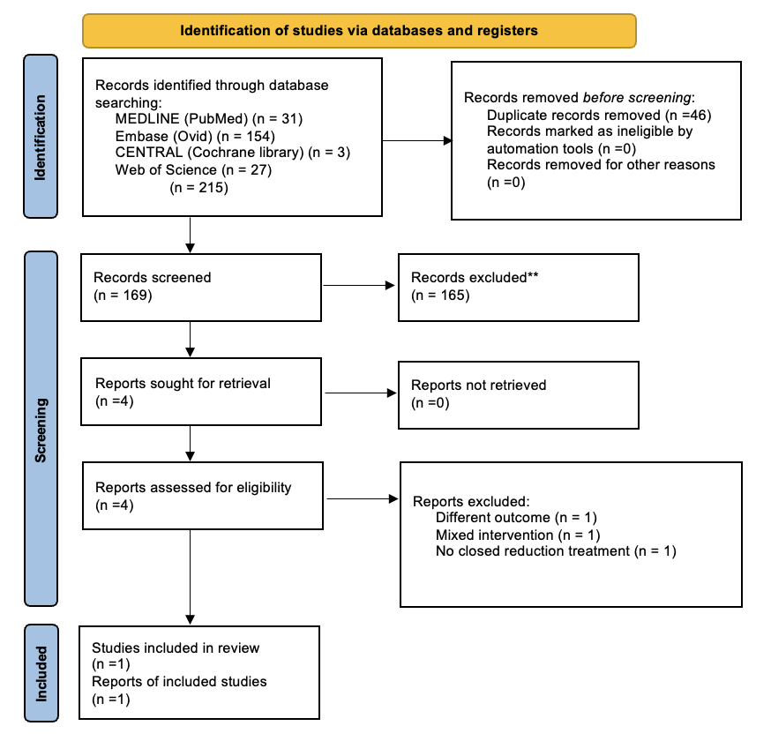
Figure 1. Flow diagram for finding the included study by PRISMA flow chart

Study characteristics
After a thorough literature searches through four databases, one study²⁵ met our inclusion criteria. A total of 203 patients (406 lower limbs) were involved in the included study. The mean age was 20.09 months (11-132 months), and the gender distribution was 165 females and 38 males. From the 203 patients, 143 patients (70.4%) were treated conservatively only with abduction braces, 32 patients (15.7%) were presented following surgical hip reduction and with casting and were referred for abduction braces after cast removal, and the remaining 28 children (13.7%) who were seen for brace treatment with another diagnosis.

Risk of bias within individual studies
We assessed the included study using the ROBINS-I tool.¹⁶ From the evaluation, the moderate risk of bias was indicated (Figure 2) due to confounding bias, selection bias, and outcome measurement bias. This study did not provide complete characteristic of sample giving it the potential risk of confounding bias. Furthermore, the selection sample from the population was not provided in the text. The method and procedure of outcome measurement were not described clearly whether the outcome measurement was performed by single evaluator or more than one evaluator. The standard tools for measuring the outcome were not explained. Thus, we classified this study²⁵ as moderate risk of bias based on ROBINS-I tool assessment.¹⁶

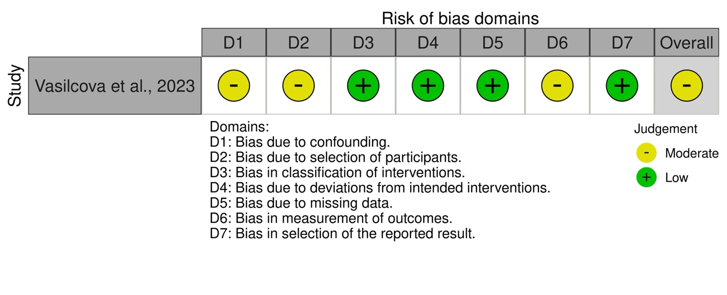
Figure 2. Visualization of risk of bias assessment using ROBINS-I tool

Qualitative synthesis
We assessed the primary outcome by measuring gait analysis. From the included study, the gait analysis of were assessed using The Wee Glasgow Gait Index (WeeGGI) index for the gait analysis. The mean WeGGI index was 6.44 ± 3.84, and the correlation for general gait analysis was r = 0.93, presenting very high impact of DDH on gait. Significant correlation was found between the right r = 0.97 and left r = 0.25 lower limbs. The study did not provide any radiological outcome or complication.

The systematic review has highlighted the significant impact of Developmental Dysplasia of the Hip (DDH) on gait and foot posture in pediatric patients following conservative treatment. It was observed that there were notable differences in foot posture between children treated conservatively and those who underwent surgical intervention for DDH. Correcting the pathology in the hip is critical as it affects the gait and foot posture of the opposite leg due to the compensatory shift in body weight to alleviate the burden on the affected hip and foot. Previous studies have indicated that untreated children with DDH tend to start walking slightly later than their healthy counterparts, with an average delay of 2-3 months, although this delay does not usually extend beyond the typical age range for walking onset. Dunn's study estimated that 20% of children with undiagnosed and untreated DDH may not begin walking until 18 months of age. Kamath and Bennet's research showed that children not treated for DDH began walking at an average age of 13 months, which is approximately one month later than healthy children. Conversely, Zgoda et al. found that abduction brace treatment did not adversely affect gross development, although there was a statistically significant but minimal three-week delay in walking onset.
Gait analysis has emerged as a vital assessment tool for DDH patients, with visual gait analysis now included as an outcome measure for all DDH patients. Reduced hip range of motion during various activities is a common finding. Larnert et al. identified associations between hip dislocation and pelvic obliquity, windswept deformity, and scoliosis, although our study did not find significant differences in coronal mid-stance pelvic obliquity. Additionally, Gijon-Nogueron et al. reported significant differences in foot posture index (FPI) scores across different countries, with the Saudi population in our study having a higher mean FPI compared to the averages reported in their study. These insights into average FPI scores help clinicians inform parents about what is considered normal at various ages, which is particularly useful in clinical practice. After this project, the FPI-6 was incorporated into the pediatric physiotherapy outcome measures at KASCH.
The timing of diagnosis and treatment significantly impacts the outcomes for children with DDH. Wenger et al. found that the likelihood of high dislocations increases with delayed diagnosis, underscoring the importance of early intervention to reduce the risk of avascular necrosis (AVN) of the femoral head. Our study observed only one case of AVN, which eventually resolved. The variability in presentations and treatment approaches within Saudi Arabia complicates treatment decisions and outcomes. Mulpuri et al. highlighted discrepancies in surgical management based on the age at initial treatment, with conservative treatment through splinting often being the first approach. However, the results regarding the effectiveness of different types of splints are inconsistent. The study emphasizes the importance of rehabilitation in DDH management, as evidenced by literature spanning decades. Key limitations of the study include a lack of probabilistic sampling and variability in the experience levels of physiotherapists assessing gait and foot posture, which could affect the consistency of the analysis.
The study also identified gait deviations in the surgically corrected DDH patients compared to the control group, justifying the use of comparable demographic characteristics as a baseline for healthy gait. Although postoperative gait comparison with healthy children may not be ideal, intra-patient comparisons were not feasible as surgeries were performed before or at walking age. The study found no significant differences in spatial gait parameters between DDH and control groups, aligning with previous findings by Ömeroğlu et al. and studies on total hip arthroplasty (THA) patients. However, kinematic parameters revealed increased hip internal rotation during walking in the affected hip, likely due to abnormal proximal femoral morphology and increased femoral neck anteversion, as shown by Passmore et al. Reduced hip adduction during walking was noted, possibly due to adductor muscle weakness post-surgery. Strengthening the hip adductor muscles and addressing hip abductor muscle weakness were recommended to restore normal hip motion and improve pelvic stability.
Temporal gait parameters indicated that DDH-affected hips had shorter stance durations and longer swing phases, suggesting early offloading to avoid discomfort. This finding was consistent with Chang et al.'s and Nie et al.'s observations in similar patient populations. Increased midstance duration in DDH-affected limbs could be due to weak hip abductor muscles. The study's strength lies in its multivariate regression analysis of risk factors influencing DDH correction outcomes, identifying weight, height, and surgical factors as significant predictors of gait and radiological outcomes. However, the retrospective nature and small sample size of the study limit the generalizability of the findings. Future research with larger populations and standardized surgical approaches is needed for more accurate results. Follow-up gait analysis post-rehabilitation could also provide valuable insights. Despite these limitations, the study demonstrates that gait analysis using inertial motion sensors can detect subtle changes not evident in routine physical examinations, highlighting the importance of thorough and continued assessment in DDH management.

4. Conclusion

The study highlighted significant gait abnormalities, underscoring the importance of conducting more thorough research. Future investigations should focus on larger sample sizes, standardized assessment methods, and comprehensive reporting to gain deeper insights into the effectiveness of DDH treatments.

References

- Loder RT, Shafer C. The demographics of developmental hip dysplasia in the Midwestern United States (Indiana). J Child Orthop. 2015;9(1):93-98. doi:10.1007/s11832-015-0636-1
- Al-Essa RS, Aljahdali FH, Alkhilaiwi RM, Philip W, Jawadi AH, Khoshhal KI. Diagnosis and treatment of developmental dysplasia of the hip: A current practice of paediatric orthopaedic surgeons. J Orthop Surg. 2017;25(2):1-7. doi:10.1177/2309499017717197
- Pollet V, Percy V, Prior HJ. Relative Risk and Incidence for Developmental Dysplasia of the Hip. J Pediatr. 2017;181:202-207. doi:10.1016/j.jpeds.2016.10.017
- Vasilcová V, Alharthi M, Alamri N, Jawadi AH, Zvonař M. Pilot study- Effect of Developmental Dysplasia of the Hip on the Gait and Feet Posture . 292.
- Jain DR, Patel DS. Developmental dysplasia of hip – An overview. Int J Orthop Sci. 2017;3(4a):42-49. doi:10.22271/ortho.2017.v3.i4a.10
- Zamborsky R, Kokavec M, Harsanyi S, Attia D, Danisovic L. Developmental Dysplasia of Hip: Perspectives in Genetic Screening. Med Sci (Basel, Switzerland). 2019;7(4):1-8. doi:10.3390/medsci7040059
- Agostiniani R, Atti G, Bonforte S, et al. Recommendations for early diagnosis of Developmental Dysplasia of the Hip (DDH): Working group intersociety consensus document. Ital J Pediatr. 2020;46(1):1-7. doi:10.1186/s13052-020-00908-2
- Czubak J, Kowalik K, Kawalec A, Kwiatkowska M. Dega pelvic osteotomy: Indications, results and complications. J Child Orthop. 2018;12(4):342-348. doi:10.1302/1863-2548.12.180091
- Lee WC, Chen TY, Hung LW, Wang TM, Chang CH, Lu TW. Increased Loading Rates During Gait Correlate With Morphology of Unaffected Hip in Juveniles With Treated Developmental Hip Dysplasia. Front Bioeng Biotechnol. 2021;9(July):1-10. doi:10.3389/fbioe.2021.704266
- Pirker W, Katzenschlager R. Gait disorders in adults and the elderly: A clinical guide. Wien Klin Wochenschr. 2017;129(3-4):81-95. doi:10.1007/s00508-016-1096-4
- Chang CF, Wang TM, Wang JH, Huang SC, Lu TW. Residual gait deviations in adolescents treated during infancy for unilateral developmental dysplasia of the hip using Pemberton’s osteotomy. Gait Posture. 2012;35(4):561-566. doi:10.1016/j.gaitpost.2011.11.024
- Page MJ, McKenzie JE, Bossuyt PM, et al. The PRISMA 2020 statement: An updated guideline for reporting systematic reviews. BMJ. 2021;372. doi:10.1136/bmj.n71
- Higgins J, Thomas J, Chandler J, et al. Cochrane Handbook for Systematic Reviews of Interventions version 6.3 (updated February 2022). Cochrane. Published online 2022. www.training.cochrane.org/handbook
- Ouzzani M, Hammady H, Fedorowicz Z, Elmagarmid A. Rayyan-a web and mobile app for systematic reviews. Syst Rev. 2016;5(1):1-10. doi:10.1186/s13643-016-0384-4
- Sterne JAC, Savović J, Page MJ, et al. RoB 2: A revised tool for assessing risk of bias in randomised trials. BMJ. 2019;366:1-8. doi:10.1136/bmj.l4898
- Sterne JA, Hernán MA, Reeves BC, et al. ROBINS-I: A tool for assessing risk of bias in non-randomised studies of interventions. BMJ. 2016;355:4-10. doi:10.1136/bmj.i4919
- McGuinness LA, Higgins JPT. Risk-of-bias VISualization (robvis): An R package and Shiny web app for visualizing risk-of-bias assessments. Res Synth Methods. 2021;12(1):55-61. doi:10.1002/jrsm.1411
- Page M, Higgins J, Sterne J, et al. Chapter 13: Assessing risk of bias due to missing results in a synthesis. In: Cochrane Handbook for Systematic Reviews of Interventions Version 6.3 (Updated February 2022). ; 2022. doi:10.1109/ISIT.2017.8006970
- Deeks J, Higgins J, Altman D. Chapter 10: Analysing data and undertaking metaanalyses. In: Cochrane Handbook for Systematic Reviews of Interventions Version 6.3 (Updated February 2022). ; 2022. www.training.cochrane.org/handbook
- Schünemann H, Higgins J, Vist G, et al. Chapter 14: Completing ‘summary of findings’ tables and grading the certainty of the evidence. In: Cochrane Handbook for Systematic Reviews of Interventions Version 6.3 (Updated February 2022). ; 2022. www.training.cochrane.org/handbook
- Schünemann H, Vist G, Higgins J, et al. Chapter 15: Interpreting results and drawing conclusions. In: Cochrane Handbook for Systematic Reviews of Interventions Version 6.3 (Updated February 2022). ; 2022.
- Schünemann H, Brożek J, Guyatt G, Oxman A. GRADE Handbook. Grading of Recommendations, Assessment, Development and Evaluation (GRADE) Working Group; 2013.
- Aslam F, Jamil K, Htwe O, et al. Postsurgical Analysis of Gait, Radiological, and Functional Outcomes in Children with Developmental Dysplasia of the Hip. Sensors. 2023;23(7):1-10. doi:10.3390/s23073386
- Leeprakobboon D, Kaewpornsawan K, Eamsobhana P. Four-point molding: A new cast molding technique for closed reduction treatment of developmental dysplasia of the hip. J Med Assoc Thail. 2014;97:S29-S33.
- Vasilcova V, AlHarthi M, Jawadi AH, Zvonař M. The Use of Visual Analysis for Gait and Foot Posture in Children with Developmental Dysplasia of the Hip. Diagnostics. 2023;13(5):1-9. doi:10.3390/diagnostics13050973

APPENDIX

Search strategies and keywords

EMBASE (Ovid) – search date 27th May 2024
No. | Search | Result
1 | exp hip dysplasia/ | 8328
2 | exp congenital hip dislocation/ | 3599
3 | ("Developmental dysplasia" or "Dysplasia hip" or "congenital hip dislocation*" or "congenital dislocation" or "developmental  3  displacement" or "Developmental dysplasia of the hip" or DDH).ti,ab, kw. | 6574
4 | 1 or 2 | 11578
5 | 4 or 3 | 13491
6 | exp conservative treatment/ | 730480
7 | ("closed reduction" or "DDH surgery" or Conservative or Surg* or treatment).ti,ab,kw. | 9497219
8 | 6 or 7 | 9915767
9 | exp gait/ | 70690
10 | ("gait analysis" or "analysis of gait" or "spatial parameter*" or Speed or Cadence or "Step width" or "Step length" or "stride length" or "temporal parameters" or "swing phase duration" or "swing phase" or "single support" or "phase duration" or Midstance or  "visual analysis").ti,ab, kw. | 294125
11 | 9 or 10 | 336805
12 | 5 and 8 and 11 | 154

MEDLINE (PubMed) – search date 27th May 2024
No. | Search | Result
#1 | "Developmental dysplasia"[Title/Abstract] OR “Dysplasia hip”[Title/Abstract] OR “congenital hip dislocation[Title/Abstract] OR “congenital dislocation”[Title/Abstract] OR “developmental displacement”[Title/Abstract] OR “Developmental dysplasia of the hip”[Title/Abstract] OR DDH[Title/Abstract] | 7,276
#2 | (Developmental Dysplasia of the Hip[MeSH Terms]) OR  (Hip Dislocation, Congenital [MeSH Terms]) | 8,751
#3 | #1 OR #2 | 11,788
#4 | "closed reduction" [Title/Abstract] OR "DDH surgery"  [Title/Abstract] OR Conservative[Title/Abstract] OR Surg*  [Title/Abstract] OR treatment[Title/Abstract] | 7,207,021
#5 | Conservative treatment[MeSH Terms] | 5,280
#6 | #4 OR #5 | 7,207,666
#7 | "gait analysis" [Title/Abstract] OR "analysis of gait" [Title/Abstract] OR "spatial parameter*" [Title/Abstract] OR Speed [Title/Abstract] OR Cadence[Title/Abstract] OR "Step width" [Title/Abstract] OR "Step length" [Title/Abstract] OR "stride length" [Title/Abstract] OR "temporal parameters" [Title/Abstract] OR "swing phase"[Title/Abstract] OR "single support"[Title/Abstract] OR “phase duration”[Title/Abstract] OR “Midstance”[Title/Abstract] OR “visual analysis”[Title/Abstract] | 250,616
#8 | Gait analysis [MeSH Terms] | 1,572
#9 | #7 OR #8 | 250,964
#10 | #3 AND #6 AND #9 | 31

CENTRAL (Cochrane Library)- search date 27th March 2024
No. | Search | Result
#1 | (Developmental NEXT dysplasia):ti, ab,kw OR (Dysplasia NEXT hip):ti, ab,kw OR (congenital NEXT hip NEXT dislocation*):ti,ab,kw OR (congenital NEXT dislocation):ti, ab,kw OR (developmental NEXT displacement):ti,ab,kw | 213
#2 | (Developmental NEXT dysplasia NEXT of NEXT the NEXT hip):ti, ab,kw OR (DDH):ti,ab,kw | 198
#3 | MeSH descriptor: [Developmental Dysplasia of the Hip] explode all trees | 155
#4 | MeSH descriptor: [Hip Dislocation, Congenital] explode all trees | 145
#5 | #1 OR #2 | 243
#6 | #3 OR #4 | 155
#7 | #5 OR #6 | 307
#8 | (closed NEXT reduction):ti, ab,kw OR (DDH NEXT surgery):ti,ab,kw OR (Conservative):ti,ab,kw OR (Surg*):ti, ab,kw OR (treatment):ti, ab, kw | 1147956
#9 | MeSH descriptor: [Conservative Treatment] explode all trees | 352
#10 | #8 OR #9 | 1147956
#11 | (gait NEXT analysis):ti,ab,kw OR (analysis NEXT of NEXT gait):ti,ab,kw OR (spatial NEXT parameter*):i,ab,kw OR (Speed):ti, ab,kw OR (Cadence):ti,ab,kw | 24210
#12 | (Step NEXT width):ti,ab,kw OR (Step NEXT length):ti, ab,kw OR (stride NEXT length):ti,ab,kw OR (temporal NEXT parameters):ti, ab, kw OR (swing NEXT phase NEXT duration):ti,ab,kw | 1975
#13 | (Step NEXT width):ti,ab,kw OR (Step NEXT length):ti, ab,kw OR (stride NEXT length):ti,ab,kw OR (temporal NEXT parameters):ti, ab, kw OR (swing NEXT phase NEXT duration):ti,ab,kw | 921
#14 | MeSH descriptor: [Gait Analysis] explode all trees | 76
#15 | #11 OR #12 OR #13 | 24311
#16 | #14 OR #15 | 25311
#17 | #7 AND #10 AND #16 | 3

Web of Science – search date 27th May 2024
TOPIC: ("Developmental dysplasia" OR "Dysplasia hip" OR "congenital hip dislocation*» OR "congenital dislocation" OR "developmental displacement" OR "Developmental dysplasia of the hip" OR DDH) AND
TOPIC: ("closed reduction" OR "DDH surgery" OR Conservative OR Surg* OR treatment) AND
TOPIC: ("gait analysis" OR "analysis of gait" OR "spatial parameter*» OR Speed OR Cadence OR "Step width" OR "Step length" OR "stride length" OR "temporal parameters" OR "swing phase duration" OR "swing phase" OR "single support" OR "phase duration" OR Midstance OR "visual analysis") AND
Review Article (Exclude – Document Types) and Open Access
Results: 27

