**Building Environmental Resilience to Climate Change: Mitigation and Adaptation in Yobe State, Nigeria**

**ABSTRACT**

|  |
| --- |
| Climate change poses significant challenges to environmental sustainability, particularly in vulnerable regions like Yobe State, Nigeria, which faces increasing temperatures, erratic rainfall, desertification, and prolonged droughts. The study examined building environmental resilience to climate change in Yobe State, Nigeria, that assessed mitigation and adaptation strategies over a period of one year (January, 2024 – January, 2025). The research employed both quantitative and qualitative methods and gathered data on the current state of environmental resilience in the area. The quantitative methods involved the use of descriptive statistics such as mean and standard deviation and determined co-efficient of variation (C.V) that ascertained how rainfall fluctuated in the area over the years while the qualitative employed in-depth interviews, focus group discussion, reviewed of literatures and field investigations. The results of rainfall anomaly and variability showed highest co-efficient of variation of 37.40% and 35.20% from 1984-1993 respectively are evidences of the manifestation of climate change in Yobe State. The findings further revealed mitigation strategies involves sustainable agricultural practices, afforestation and reforestation, improved transportation and renewable energy initiatives. Concurrently, adaptation includes enhancing water management systems, community-based early warning systems, ecosystem restoration, insurance and financial assistance. The study recommends keying into Climate Resilience Framework (CRF), addressing both mitigation and adaptation, can enhance environmental resilience, provides valuable insights for policymakers, researchers, and other stakeholders in the development of sustainable and adaptive solutions to climate change in Yobe State and beyond. |

***Keywords:*** *Climate change, resilience, mitigation, adaptation, environment, rainfall*

**1 INTRODUCTION**

Climate change is one of the global environmental problems that have over the years been receiving significant attention because of it devastating effects on virtually every variable of the environment. Haider (2019) revealed that profound changes such as temperature raise; variation of rainfall patterns; increase in sea level and flooding; desertification; devaluation of land; severe weather; water pollution and decline in species diversity have continued to occur on our planet, ascribed to climate change. The effects might have started many years ago which gradually over the years resulted to various changes being felt globally and will continue to have impacts on the ecosystem unless deliberate efforts and strategies are put in place to check mate the various factors that cause change in climate of an area; especially the ones caused by multifarious activities of man (Mshelia et al,. 2023; Elisha et al., 2017; Olaniyi et al., 2019).

Similarly, the International Energy Agency (IEA, 2009) posited the view that, if no action against climate change is taken, global warming could reach an increase of about 0.6°C and by 2100 the global average surface air warming is approximately expected to be between 1.8°C and 4.0°C with likely average range 1.1°C to 6.4°C) on earth (IEA, 2009) and cause devastating consequences on Earth. It is no longer news that today that all over the globe, species of plant and animals are becoming extinct at a rate of at least 1,000 times faster than the background extinction rate. Similarly, investigations by IAE (2009); IPCC (2013) showed that rainfall variations have been on increase, producing large runoffs and flooding in many places in Nigeria while its absence in other places is leading to drought and low precipitation related cases. Additionally, arable land is being reduced by 1-10km per annum in the northern part of Nigeria as a result of desert encroachment and drought; evidence of climate change (Mshelia et al., 2020, Kalele et al., 2021; Centre for Climate Change and Environmental Research, 2020, Cavatassi et al., 2011). Bukar and Abba (2022) and Mustapha et al., (2012) opined that environmental shift due to climate change contributed significantly to depletion of vegetal resources such as plant species that are of medicinal, culinary and commercial values, for instance the Adansonia digitata (baobab tree) being locally used by farming communities ie rarely seen productively close to settlement.

In Nigeria, Northern Yobe State in particular is located in the Sahel Savanna which makes it vulnerable to antics of oscillation and climate change; with indicators in temperature raise; variation of rainfall patterns; increase in sea level and flooding; desertification; devaluation of land; severe weather; water pollution and decline in species diversity (Mshelia et al., 2020). The region is also peculiar to bush burning, fuelwood excavation, drought and desertification which adversely affect nature, human and organisms (Kalu et al., 2014; Ahmed et al., 2024); having its toll on subsistence farmers that virtually depend on rainfall for cultivation of crops and irrigation farming as the major sources of income and means of livelihood (Majeed and Kruse (2017). Kehinde et al., (2021) on the other hand assessed varying forms of temperature in Yobe State as a proof of climate change and the result showed that there were an increase trends in monthly and annual positive temperature anomalies that ranged between 0.2°C - 4.0°C in some months and years and drew inference that the State has experienced differences in climate changes within the period of 60 years.

Furthermore, the multifarious activities of human such as bush burning, fuelwood and fossil fuels dated back since 1800s have been some of the most prominent and visible causes of the shift in weather patterns called climate change. The changes have resulted to the release of substantial greenhouse gas such as carbon dioxide and methane into the air and perform as wrapped blanket around the earth causing global warming being that it trapped the heat from the sun (Mshelia et al., 2020, IPCC, 2021). Other actions that aid the emission of methane are agricultural practices, gas and oil operations (UNEP, 2024). The climate changes have devastating consequences on Earth, which overtime drew the attention of the world for the need to have resilient approaches to curtail the effects through mitigation and adaptation. It is on this basis that the study examined climate changes in Yobe State with the view to building environmental resilience to the climate change that is bound to keep on occurring in the region focusing on mitigation and adaptation strategies in invigorating the capacity of living systems such as human beings and the ecosystems including the non- living system to cope and hold out against climate change as reported by Bill (2018).

**1.1 Theoretical Climate Change Resilience Framework**

The study keys into the Climate Resilience Framework (CRF) which is a coherent, logical and systems-based approach to climate change resilience in cities. The goal of the CFR is to have toughened and secured networks that is competent of taking care of emerging climate issues, immediate and slow, direct and indirect as well as unseen effects of climate change and environmental hazards. The CRF came into view from the beginning of resilience building activities in the Asian Cities Climate Change Resilience Network (ACCCRN) and also advocated by USA (Thompson, 2022) and the need to put activities into a conceptual context for dissemination and replication (CCCER, 2020). The CRF has proven helpful for cities working with numerous multi-stakeholders and sectors: academics, non-academics, private, governmental and non-governmental organisation when trying to address issues of climate change, uncertainty, and planning. The framework was used by BRAC for building climate change resilience which could be employed in Nigeria to build resilience for climate change to set the course of action in vulnerable and affected areas. It is also helpful in risk identification, and acts, respond to climate change hazards or shocks as communities respond to exposure and vulnerability through development, adaptation and mitigation as shown in Figure 1.

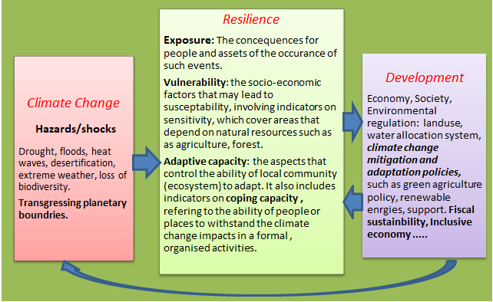

Figure 1: Building a blocks of open climate resilient development summarising a theoretical framework

Source: Thompson et al., (2022) Modified by Authors (2025)

**2 MATERIAL AND METHODS**

**2.1 Study Area**

Yobe State, located in northeastern Nigeria, is situated between latitude 120 00'N - 130 30'N and longitude 100 30'E - 120 30'E of the Equator and the Greenwich Meridian respectively (see Figure. 2). It amasses a land cover of about 47,153Km2 and has 17 Local Government Areas (LGA). The 2024 estimated population is 2,321,339 at growth rate of 2.6% base on the 2006 census. Yobe State located within the Sudano-Sahelian region, West Africa shares boundary with Borno State to the East, Niger Republic to the North, Jigawa State to the Southwest, also located to the South is Gombe State and to the Southeast is Bauchi State . Yobe State shares an international boundary with Niger Republic to the North of 323km (Bukar and Abba, 2022).

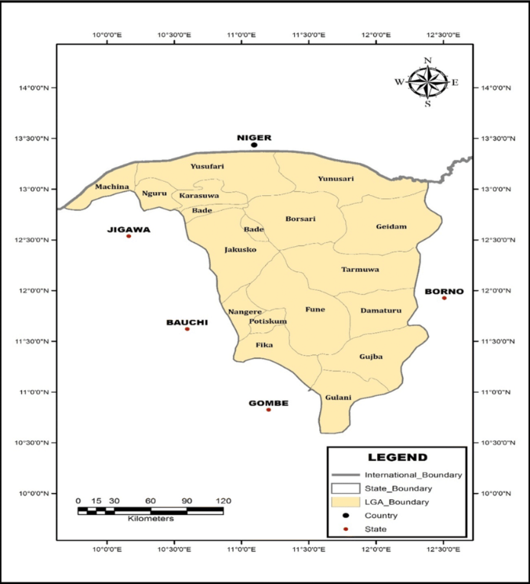Figure. 2: Map of Yobe State

Source: GIS Lab. FUGA, (2025)

Yobe State is an agrarian state despite being located in the Sudano-Sahelian vegetation zone. Majority of the people in the area depend on rain fed agricultural practice. This is being complemented by irrigation along River Yobe in Nguru, Gashua, Geidam, and other rural settlement that have river tributaries. The southern Yobe is made up of relatively dense vegetation and rainfall of about 713mm compared to the northern part that has stunted trees, shrubs, short grasses of the Gambian types and mostly the xerophytes plants. Rainfall duration falls within 3 – 4 months with some places in north recording less, attributed to climate change (Ejeh et al., 2025). Additionally, Kehinde et al., (2021) reported 350C as mean annual temperature of Yobe State. Yobe State has as other States in Nigeria including the Federal Capita Territory (Bashir et al., 2021) over the years seen up rise in population which in turn placed pressure on environmental resources and resulted to quest for urbanization, poor agricultural practices, over grazing, bush burning and fuelwood excavation. These activities triggered climate change and consequently decrease in vegetation and give room for desert encroachment (Ahmed et al., 2024).

**2.2 Methods**

In order to achieve the aim of this study, the study adopted quantitative approach. The quantitative methods involve the use of descriptive statistics such as mean and standard deviation. The mean and the standard deviation were employed to determine the co-efficient of variation (C.V) with a view to ascertaining how the rainfall fluctuates in the area over the years.

The formula for calculating the C.V is:

S.D/Xi ×100 where:

S.D=Standard Deviation

Xi = Long-term Mean

In order to also determine the variation and fluctuation of the rainfall during period in Yobe State, the study also used Rainfall Anomaly Index (RAI) in accordance with Katz and Glantz (1986). The index is most commonly used for regional climate change to examine the changes that might have taken place in the rainfall distribution over the years. The index has also been found to be effective for rainfall variability in Niger basin area (Babatolu, 1998).

The RAI was calculated for the individual station using the following equation:

Xij= Fij-ri/S.D

Where:

Xij = rainfall departure for jth year;

rij = the year’s rainfall total at station I;

ri = the mean of station i’s total for the base period;

SD = the standard deviation of station i’s totals for the base period;

All these analyses were done with the aid of Excel. The results were presented in table and charts for better understanding.

The research design further used mixed-methods approach that involved the combination of both. Data were collected through extensive existing literature reviews on climate change, environmental resilience, mitigation and adaptation. In-depth interviews and focus group discussion with key informants to collect more detailed and exquisite information were also employed. More still; observations and field visits were conducted and assessed the environmental conditions and resilience-building efforts in Yobe State.

**3 RESULT AND DISCUSSION**

**3.1 Evidence of Climate Change in Yobe State**

The result in Table 1 describes the rainfall for Yobe State for the period 1984-2024. The analysis contains the mean decadal rainfall, the decadal standard deviation and the co-efficient of variation (C.V) for each decade. The result reveals that the period 1984-1993 recorded the lowest mean rainfall of 341.87mm and 616.31mm for Nguru and Potiskum respectively. On the other hand, the period 1994-2003 recorded the highest mean rainfall during the entire period under review. The lowest mean rainfall recorded during 1984-1993 is attributed to the 1980s drought of varied magnitudes across the Nigeria. On the contrary, the highest mean rainfall recorded in the area during 1994-2003 may not be unconnected with the fact there was a recovery from the droughts from the tail end of 1990s upward.

Table 1: Rainfall Variability for Nguru and Potiskum, Yobe State (1984-2024)

|  |
| --- |
| Decade Nguru Mean Potiskum Nguru Std Potiskum Nguru C.V Potiskum  (mm) Mean (mm) Std (mm) (%) CV (%) |
| 1984-1993 341.87 616.31 94.99 217.00 27.78 35.20  1994-2003 538.35 712.26 201.34 136.77 37.40 19.20  2004-2013 470.41 676.07 129.34 46.72 27.49 6.91  2014-2024 524.39 668.62 118.17 145.25 22.53 21.72 |

Source: Author's Field Work, (2025)

The result in Table 1 equally reveals that the annual rainfall was stable and not fluctuating during the period 2014-2024 around Nguru and during 2004-2013 in Potiskum with the lowest C.V of 22.53% and 6.91% respectively. On the other hand, the annual rainfall was not stable and fluctuating during 1994-2003 and around Potiskum during 1984-1993 with the highest C.V of 37.40% and 35.20% respectively. It is very crucial to note that the higher the rainfall variability the more confused people will be. It attracts a lots of uncertainties in sectors such as agriculture, hydrology, ecology, etc. that are much concern about rainfall.

The results in Figures 3 and 4 depict the rainfall anomalies for Nguru and Potiskum over the period 1984-2024 in Yobe State. The years with negative anomalies are the years in which the annual rainfall fell below the long-term mean while the years with positive anomalies are the years in which the annual rainfall were above the long-term mean.

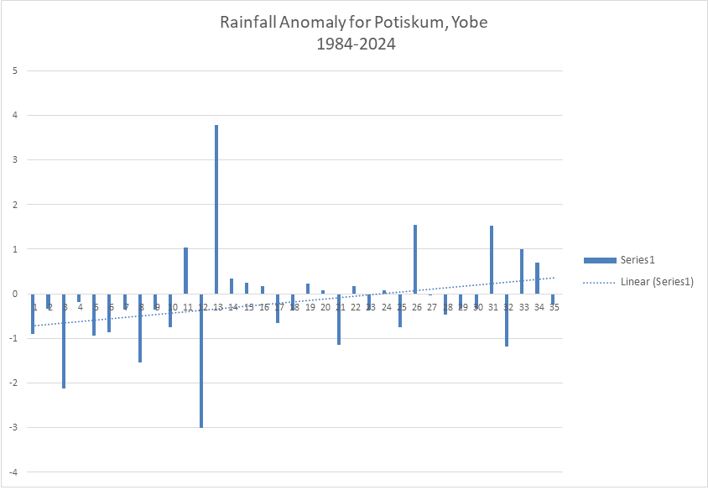

Figure 3: Annual Rainfall Fluctuation in Nguru, Yobe State (1984-2024).

Source: Author’s Field Survey (2025)

The former is more pronounced between 1984 and 2000 while the latter was rampant from the year 2000 upward. The upward trend in the negative rainfall anomaly in the area is a strong indication of dryness and droughts over the years. This implies that the annual rainfall fluctuates around the long-term mean and the annual rainfall of majority of the years fell below the average. The results of rainfall anomaly and variability are evidences of the manifestation of Climate change in Yobe State and these findings are in tandem with the study of Ifabiyi (2013) stresses that Rainfall fluctuations in the Sudano-Sahelian Ecological Zone (SSEZ) show diverse spatial and temporal patterns of occurrence, probably due to local influence The most important finding is the spatial patterns in which there were the above average rainfall of the 1960s and the below average of the 1970s and 1980s in this region.

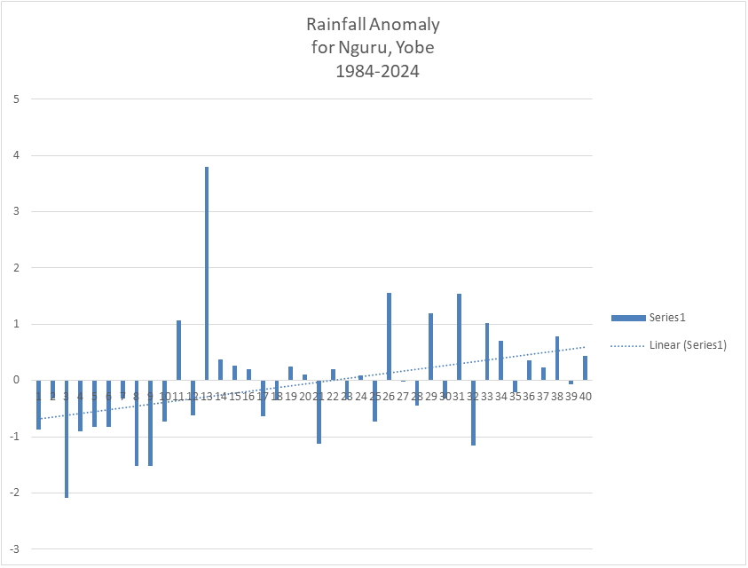

Figure 4: Annual Rainfall Fluctuation in Potiskum, Yobe State (1984-2024)

Source: Author’s Field Survey (2025)

The wet years are more striking than the dry ones; positive departures of 30 to 40 percent are common, while departures in the dry years rarely reach 30 percent. Trend in annual rainfall over the Sudano-Sahelian Ecological Zone of Nigeria indicated that there has been an overall increase in the annual rainfall for the entire period under study with a recession in 1970s and 1980s due to the well-researched drought of 1972/73 and 1980s in the Zone. Many studies in the Sudano-Sahelian Ecological Zone of West Africa in general, and Nigeria in particular, have established a general trend in rainfall towards aridity at the drought years as also pointed out by earlier studies such as (Powel et al., 1999a; Nicholson, 2001; Dami, 2008; Odekunle et al., 2008).

**3.3 Building Environmental Resilience Measures**

Building environmental resilience to mitigate and be able to adapt to the shocks of change in climate in Yobe State, Nigeria and the world at large requires the consideration of some measures basic such as the agricultural practices, water management, afforestation, environmental friendly energy, and waste management among other for efficient results against the exposures and vulnerabilities (Butu et al., 2022).

**3.4 Mitigation Strategies**

Mitigation strategies are geared towards reducing the emission greenhouse gas and the sequestration of carbon. These strategies include:

**3.4 1. Sustainable Agricultural Practices**

Agricultural practices in Yobe State are basically crude and subsistence, involving the use of local implements and application of unregularised chemicals which are detrimental to the soil and air quality and contribute to climate change in the region. It is therefore, imperative to embrace climate-resilient agriculture. The investigation showed that Yobe State Socio-Economic Reform Agenda (YOSERA-IV) 2016-2020 is of the view that about 80% of the population of the State is into agriculture. The location of most part of the State in semi-arid and arid zone placed it at disadvantaged in terms of sufficient rainfall but yet they mostly depend on rain fed for the cultivation of crops such as millet, rice, sorghums (Yobe State Environmental and Climate Change Action Project (YOECCAP, 2024). This calls for the use of drought-resistant and different crop varieties.

The use of drought-resistant and diverse crop varieties, farmers can ensure food security and better utilize available resources. This could include traditional grains, legumes, and improved varieties of millet and sorghum that are more resilient to dry conditions. This finding is in agreement with the study conducted by Dagona et al., (2024) on the climate change effect among smallholder farmers in Bade Area of Yobe State in Nigeria. The interviews pointed out that the cereals, mostly traditional variety are less resistance to drought and that vegetables in the area are mostly cultivated by means of irrigation mostly along the River Yobe. In view of these, it pertinent to encourage Agroecology such as intercropping, crop rotation, use of organic manure (animal dung, poultry waste) in place of the chemically inclined fertilizers in the region. Agroecology is also environmentally friendly when properly practiced, for it increases the soil fertility, reduces emissions and the concentrations of chemicals (Nitrate, Nitite, Phosphorous, and Potassium) and pesticides which have the potentials to contaminate water.

An interview with one Mallam Modu, a farmer at Jajimaji, acknowledged change in climate of the area over the years but has no idea of climate smart crops such as the Millet; Sorghum for the Smallholder Agriculture Transformation (SOSAT) apart from the traditional Gwagwar millet (see Figures 5 and 6). However, Mallam Mustapha of Nguru town reported that he was introduced to the SOSAT millet four years ago. Though, at first he was reluctant to plant it but gave it a trial and it paid off. He got almost twice of what he used to get on a small farmland and since then has not looked back. This in conformity with the investigations done by Food and Agriculture Organization (FAO 2019) where they reported that one Ali Shehu of Potiskum who harvested 550 kg/ha. of the local Gwagwar millet variety in three cropping seasons and 900 kg/ha. of the SOSAT millet cultivar. This gives a mean yield variation of 350 kg/ha at 65% increase. The climate smart crops enhance productivity, grow within a short time and reduce dependence on water for a long period since the area experience short period of rainfall.

The findings further revealed that the improved variety of millet (SOSAT) intercropped with sorghum and cowpea on the same land and another land with only cowpea. The result showed an increased rate of 64% when intercropped with sorghum and 88% when it was intercropped with cowpea only (FAO, 2019). This is a vivid indication of how climate-smart options such as the use of intercropping of enhanced cereals (millet and sorghum) with legumes (cowpea) could improve crop productivity and diversification which substantially increases the farmers’ income.

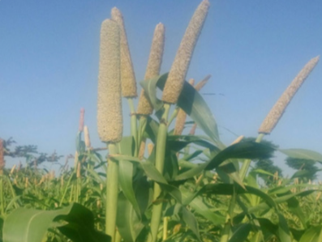 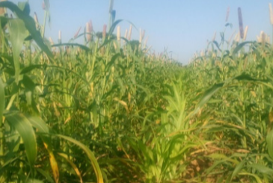Figure 5: SOSAT Millet Figure 6: Gwagwar Millet

FAO (2019) FAO (2019)

**3.4.2 Reforestation and Afforestation**

The activities of man such as deforestation, over grazing and fuelwood excavation have greatly depleted vegetal resources in the region. The study discovered that the fuelwood excavators do not only cut down mature live trees but also young and premature ones with no conscious to regenerate through replanting. In combating climate change, it is significant to plant trees for they have the ability to use the carbon dioxide (CO2) in the atmosphere during photosynthesis and absorb it. The process reduces the amount of greenhouse gases, improve biodiversity conservation, soil structure and fertility as well as influence hydrological cycle as ascribed by Dadile et al., (2023) who examined afforestation projects in some selected areas in Yobe State.

Afforestation and reforestation enables communities in Yobe State to better adapt to climate variability, such as droughts and floods, which are becoming more frequent and intense due to climate change. The Yobe State Government comprehended the significance of afforestation, collaborated through communities’ initiative and planted about 200 trees in the local government councils on World Environment Day in 2024. Similarly, Save the Children International (SCI) in 2024 also inaugurated a 1,000-tree planting campaign across 10 schools in Yobe State (see Figure 7). Additionally, Erezih, (2020) reported that Yobe State Climate Change Action Plan launched a five-year project in which the government was to raise and planted 40 million trees across 100,000 hectares across the State (see Figure 8). Farauta et al., (2011) and Geidam et al., (2022) who examined climate change and adaptation measures in Northern Nigeria: empirical situation and policy implications and afforestation programmes in Nigeria respectively corroborated this point.

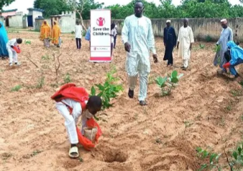 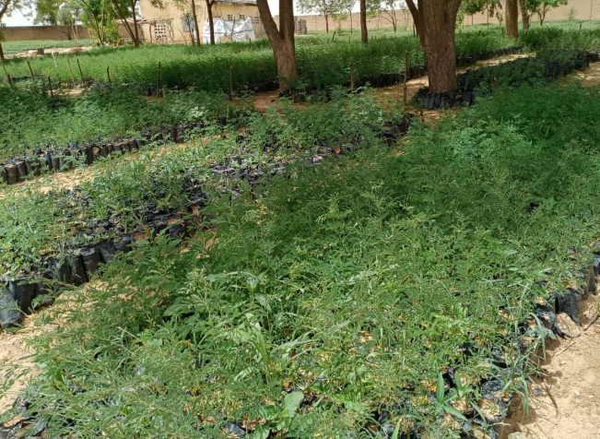

Figure 7: SCI Tree Planting Initiative Figure 8: Nangere Nursery Seedlings

Source: SCI (2024) Source: SCI (2020)

**3.4.3 Renewable Energy Development**

Over 80% of the households rely on fuelwood in Yobe as the first option for cooking and heating reported that the dependence on vegetal resource as the primary source of energy in the region is linked to the increase in poverty level index (Dadile et al.2023; Ahmed et al. 2024). Yobe State Environmental and Climate Change Action Project (2024) posited that about 72% of the population lives below the poverty line and that makes it difficult to use the renewed energy. The reliance on fossil fuels in energy production has further exacerbates desertification, water scarcity, and extreme weather events which are climate change indicators. Therefore, renewable energy development such as solar energy and biogas production in the State are important towards building climate resilience. Solar energy in households, schools and healthcare facilities will reduce reliance on fossil fuels.

The interview with the elite communities mostly staff of the Federal and State tertiary institutions showed that the use of solar photovoltaic systems as in the case of FUGA and wind (see Figure 9 and 10) to generate electricity and converting the biomass to energy can reduce dependence on fossil fuels which in turn reduce greenhouse gas emission (CO₂, CH₄, O₃, Nitrous Oxide (N₂O) and ChloroFlouro Carbon CFCs).

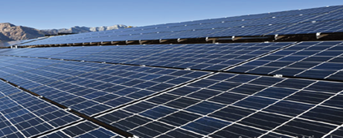 

Figure 9: FUGA Solar Plant Figure 10: Wind Energy

Source: Field Survey (2025)

**3.4.4 Waste Management**

The study showed that there are no sanitary landfills in Yobe State and wastewater treatment plant. Wastes of different types are indiscriminately being disposed at open dumpsites in the major towns. The wastes therefore decomposes anaerobically mostly at the dumpsites and produce methane which is potent greenhouse gas and contributes to climate change. This finding is in agreement with the work of Mshelia et al., (2021) who also reported indiscriminate disposal of wastewater which affects environmental quality in Gashua town, Yobe State.

It is in this regard that integrated municipal waste management is an important aspect of mitigation measures in climate through building of modern landfills that will be able to enclosed methane for energy use or alternatively converting it to sanitary landfills to reduce the methane emissions as also observed by Mshelia et al, (2020). Others are proper management of wastes to mitigate climate change is composting, application of the principle of 3Rs which deals with robust recycling process to reduce materials taken to landfill, reducing volume of wastes as well as the emission from the decomposition of the wastes. In addition, communities participation in clean-up initiatives, sustainable waste collection system, engaging private practice partnership (PPP) in waste management, policy and infrastructure development and agricultural waste management by converting the wastes to bioenergy, reducing waste and providing sustainable energy sources while sequestering carbon mitigate climate change.

**3.4.5 Improved Transportation**

Improved transportation systems play a crucial role in enhancing environmental resilience to climate change. Enhanced roads connectivity to rural areas of the region for ease access to market, healthcare and educational facilities as well as farmlands reduce time and mechanical workload of vehicle. It further enables movement of goods and service to enhance food security under extreme weather conditions. Similarly, efficient transport system opens up remote areas which encourage development, economic growth, job creation and encourage investment in renewable energy for transport, or incentives for adopting greener technologies. Good roads and infrastructure prevent traffic congestion and reduce burning of fossil gas. It in this regard that Mshelia et al (2019) were of the view that poor transport system increases global warming through the burning of the fossil hydrocarbons which has negative effects on the environment.

Discussion with Dr. Ejeh L.U. a climatologist, Federal University Gashua and Dr, Babagana Boso of Yobe State University showed that constructing resilient roads, bridges, rail infrastructure and green infrastructure such as permeable pavements (see Figure 11) as well as stormwater management systems that can withstand climate change effects like flood, wind, desert encroachment, erosion, rainfall runoff, thereby improving both transport functionality and environmental health. They also encouraged the use of luxury buses or trams, light train, cycling and pedestrian pathway to reduce over dependence on fossil fuel.

****

Figure 11: Green Infrastructure and Luxury Bus

Google Picture and Field Work (2025 & 2020)

**3.5 Adaptation Measures**

This centred on enhancing the capacity of communities and ecosystems to cope with the impacts of climate change. In Yobe State, these measures include:

**3.5.1 Water Resource Management**

Various responses from the investigation on water resources management for building environmental resilience to climate change called for holistic approach through the implementation of integrated water resources management (IWRM) in Yobe to deal with factors connected to water resources such as land use, and human activities as well as incorporating different stakeholders and local communities in water management decisions; to plan, manage, develop policies for sustainable water use and environmental protection (see Plate). IWRM is significant framework for water security suitable for dryland areas like Yobe State to curtail and at the same time adapt to the impacts of climate change (Stringer, 2021; Un Waters, 2023).

Reviewed literature such as Stringer, 2021; UNEP, 2009; Un Waters, 2023 and interviews with Water managers and community heads show that water management involves building of small scale dams and reservoirs such as sand dam (ephemeral Sand River) to collect water during the rainy season, use of modern technology and developing rainwater harvesting system to provide water to communities in the face of drought or during the dry season (see Figure 12).

|  |  |
| --- | --- |
| |  | | --- | | C:\Users\USER\Documents\oCam\Capture_2025_01_20_20_31_11_663.png | |

Figure 12: Components of an enabling environment for water security in drylands under climate change, drawing on relevant IWRM

Others are: the cultivation of water-efficient crops, introduction of drip irrigation system and practice of conservation and management for sustainability in all localities through the employment of technology such as satellite to monitor efficient water resources and predictive analytics for drought management. Study by Butu et al., (2022) similarly advocated the implementation of IWRM for mitigation and adaptation of the vulnerability of climate variability. IWRM enhances resilience to climate change, ensuring that communities adapt to the changing climate while protecting and sustainably using their water resources.

**3.5.2 Disaster Risk Reduction (DRR)**

Approaches to DRR in Yobe State requires adequate identification of vulnerable areas through the usage of GIS to comprehensively map the prompt climate risk areas and bring it to fore for the right mitigation measures to be employed. Similarly, the study discovered the need for community awareness campaign about climate risks which many of the people residing in rural settlements are unaware of. The knowledge of the environmental effects is also significant in guiding the communities to climate-resilient agriculture and embrace water management Mshelia (2024). DRR also involves the building of climate resilient infrastructure; homes that can withstand extreme weather climate conditions and good drainage system, provision of funds, good policies on climate change and improved landuse practice in Yobe state.

**3.5.3 Ecosystem Restoration**

Ecosystem restoration in the face of climate change is a better way of building environmental resilience. This statement was widely accepted by scholars, communities and stakeholders in Yobe State. It is more concern with protecting, restoring and managing natural ecosystems such as the savannas, wetlands and the forests that form the biodiversity and agricultural activities. They are ways to care for the ecosystem which is essential for livelihood, sustainable environmental development and maintenance of lives in the environment. It is therefore imperative to restore degraded habitat and soil as well as receded water. This can be done through the provision of ecosystem services like pollination, pest control and nutrient cycling, cover cropping and planting of economic trees to improve the soil structure, nutrients, reduce desertification, flooding, erosion and help in water retention in the soil. It is also pertinent to engage in community education along with achievable framework as also suggested by Marhiagbe et al., (2020) who reviewed the status of biodiversity conservation in Nigeria.

**3.5.4 Community Engagement and Education**

Community education and engagement are indispensable tools for enhancing environmental resilience to the variability of climate in Yobe State, which is characterized by its vulnerability to the indicators: desert encroachment, flooding, and changing agricultural conditions. Findings showed that many people in the rural areas do not have idea of climate change. Some relate it to depletion of some vegetation and animals, change in patterns of rainfall and appearance of sand dunes in their communities. It is therefore, of relevance to educate the people in the area on climate change and it effects. This agrees with the saying that “an informed person or community is more resilient in the face of challenges and changes”. It helps in understanding of the local contexts, cultural practices, and economic conditions for effective climate action. A sustainable development that is based on the pattern of life in is widely acceptable and gives room for efficient collaborations by all stakeholders for adaptation to climate change effects as advocated by building Nigeria’s response to climate change (BNRCC, 2011).

**3.5.5 Insurance, Inclusive Development and financial tools**

The study showed that little has been done in the aspect of insurance provision to meliorate the impact of climate change in the (Elum and Momoh 2017; Federal Ministry of Environment, 2014). Farmers need to be insured against possible climate hazards as well as included in developmental policies by encouraging the private insurance firms through policies that would encourage public-private partnerships (Federal Ministry of Environment, 2014). Access to credit, provided by microfinance institutions, government, grants and incentives are going to help the farmers, peasants and the communities to be financial stable is sacrosanct to adapt to climate changes and also posited by Abraham and Fonta, 2018. The low income communities are more hit by climate change effects because building climate resilience requires adequate fund for it is virtually not possible for adaptationstrategy to be successful without ensuring that the vulnerabilitycommunities have the financial, technical, andinstitutional resource they need to adapt as equally viewed by Bill (2018).

**4. CONCLUSION**

Yobe State located in the Northeast of Nigeria is being faced with notable effects of climate change that necessitates building resilience. Building environmental resilience to climate change is a measure to get ready, accept, respond and maneuver the impacts of climate change by putting in place strategies to the measures against the vulnerability to the climate-inclined hazards such as drought, extreme temperature, and desert encroachment among others. The study investigated mitigation and adaptation strategies to building environmental resilience to climate change in Yobe State and discovered that measures such as biodiversity, conservation of water and soil, sustainable agricultural practices, sequestering carbon, restoring ecosystems, and providing socio-economic benefits through afforestation and reforestation. Others are the preservations of the wetlands, water management, renewable energy, improved transportation system, disaster risk management and community education and engagement as well as collaborative efforts among government, local communities, NGOs, and international organizations will be crucial for the success of these initiatives are significant strategies for building environmental resilience to climate change not only in Yobe State but in all vulnerable environment.

**DISCLAIMER (ARTIFICIAL INTELLIGENCE)**

Authors declare that no generative AI technologies such as ChatGPT, COPILOT among others and text-to-image generators have been employed in course of the doing this research.

**REFERENCES**

Abraham, T. W. and Fonta, W. M. (2018). Climate change and financing adaptation by farmers in

Northern Nigeria. *Financial Innovation,* 4(11). <https://link.springer.com/article/10.1186/s40854-018-0094-0>

Ahmed, H. A., Jajere, I. A., Mshelia, S. S. and M. Suleiman, Productivity and Utilization of Fuelwood

Resources in the Southern Part of Yobe State, Nigeria. *International Journal of Interdisciplinary Research and Innovations.* 12(2):26-37. DOI: <https://doi.org/10.5281/zenodo.11144493>

Babatolu, J.S. Temidayo, A. R. and Bukola, O. O. (2014). Variability of trends of daily heavy rainfall events over Niger River Basin Development Area in Niger. American Journal of Atmospheric and Climatic Science.3(1):1 – 7. DOI: 10.4236/ajcc.2014.31001

Bashir, O. A., Reigns, A., Ogar, P. U. and Mshelia, S.S. (2021). Population dynamics to urban spaces

needs in one of Africa’s largest Cities: Abuja, the Federal Capital City of Nigeria. Iconic Research and Engineering Journals 4(10):124 – 130.

Bill, K. (2018). What is Climate Resilience? Environment, Science IMPAKTER Limited Company number:

10806931. Impakter publishing 2515-9569 (Printed) and 2515-9577 (online – Website).

BNRCC (Building Nigeria’s Response to Climate Change). (2011). *National adaptation strategy and plan*

*of action on climate change for Nigeria* (NASPA-CCN). Prepared for the Federal Ministry of Environment Special Climate Change Unit. <http://csdevnet.org/wp-content/uploads/national-adaptation-strategy-and-plan-of-action.pdf>

Bukar, S. M., and Abba, H. M. (2022). Vegetation Structure and Diversity in Northern Yobe, Nigeria.

*Asian Journal of Plant Biology*, 4(1):36–42. <https://doi.org/10.54987/ajpb.v4i1.702>

Butu, H., M., Okeke, C., U., and Okereke, C. (2022). Climate Change Adaptation in Nigeria: Strategies,

Initiatives, and Practices. Working Paper No. 3. APRI: Berlin, Germany. www.afripoli.org | [www.apri.africa](http://www.apri.africa)

Cavatassi, R., Lipper, L., and Narloch, U. (2011). Modern variety adoption and risk management in

drought prone areas: Insights from the sorghum farmers of eastern Ethiopia. climate change Science 311, 1917–21. doi:10.1111/j.1468- 2346.2007.00678.x

Centre for Climate Change and Environmental Research (2020). Good Practices on Climate Change

Adaptation and Mitigation. *Climate Change Programme*. Web: http://www.brac.net/program/climate-changeprogramme/ Copyright © 2020 BRAC.

Dadile, A. M., Y. Ibrahim, Y., Adam, L. I. and I. A. Jajere. I. A. (2023). Assessment of Afforestation

Projects and Trees Volumes in Some of the Four Local Government Areas of Northern Part of Yobe State, *Nigeria Journal of Global Ecology and Environment*. 17(4):1-7.

Dagona, A. M. Dala, A. and Hassan, A. (2024) Effects of Climate Change among Smallholder Farmers

in Bade Local Government Area of Yobe State, Nigeria. *Dutse Journal of Pure and Applied Sciences.* 10 (1b): 55-66.

Ejeh. L. U., Mshelia, S. S. and Elisha, I. (2025). An Analysis of Water Security Impediments in the

Drylands Region of Nigeria: A Review of Yobe State, Nigeria. *International Journal of Scientific Research in Multidisciplinary Studies* 11(1): 86-94.

Elisha, I., Sawa, B. A. and Lawrence, E. U. (2017). Evidence of climate change and adaptation strategies

among grain farmers in Sokoto State, Nigeria. *IOSR Journal of Environmental Science, Toxicology and Food Technology*, 11(3): 1-7.

Elum, Z. A. and Momodu, A. S. (2017). Climate change mitigation and renewable energy for sustainable

development in Nigeria: A discourse approach. *Renewable and Sustainable Energy Reviews* 76, 72–80. <http://dx.doi.org/10.1016/j.rser.2017.03.040>

Erezih, O. R. (2020). AFR100 Focal Point, Nigeria: 40 million trees for Nigeria's Yobe State.

[AFR100Sec@nepad.org](mailto:AFR100Sec@nepad.org). Article link: <https://afr100.org/content/40-million-trees-nigerias-yobe-state>).

FAO. (2019). Climate-Smart Agriculture in Yobe state of Nigeria: Food and Agriculture Organization of the

United Nations (FAO).

Farauta, B. K., Egbule, C. L., Idrisa, Y. L. and Agu, V. C. (2011). Climate Change and Adaptation

Measures in Northern Nigeria: Empirical Situation and Policy Implications. African Technology Policy Studies Network WORKING PAPER SERIES | No. 62 ISBN: 978-9966-030-17-7.

Federal Ministry of Environment (2014). United Nations Climate Change Nigeria. National Communication

(NC). NC 2. 2014. <https://unfccc.int/sites/default/files/resource/nganc2.pdf>

Geidam, A. A., & Mohamad, L. Z. (2022). Factors Effecting Afforestation Program in Nigeria: Building a

Conceptual Framework. *International Journal of Academic Research in Business and Social Sciences*. 12(12): 1444 – 1452.

Haider, H. (2019). *Climate change in Nigeria: Impacts and responses.* K4D Helpdesk Report 675.

Brighton, UK: Institute of Development Studies.

Ifabiyi, I. P. (2013). Rainfall Trends in the Sudano-Sahelian Ecological Zone of Nigeria.  *Earth Science Research*, 2 (2), 1-9.

IPCC (2021): Climate change 2021: the physical Science Basis. Contribution of working group 1

to the Sixth Assesment Report of the intergovernmental panel on climate change (masson-Delmotte), V.P, Zhai. A. Pirani . S.L. Connors, C.

IPCC, (2013): “Climate Change Synthesis Report. Contribution of Working Groups I, II and III to the Fourth Assessment Report of the Intergovernmental Panel on Climate Change” [Core Writing Team, Pachauri, R.K and Reisinger, A. (eds.)]. IPCC, Geneva, Switzerland..

International Energy Association IEA (2009). World energy outlook 2009. International Energy

Association (IEA), Paris. ISBN 9789264061309

Kalele, D. N., Ogara, W. O., Oludhe, C., Onono, J. O. (2021). Climate change impacts and relevance of

smallholder farmers’ response in arid and semi-arid lands in Kenya. Scientific African Vol. 12. https://doi.org/10.1016/j.sciaf.2021.e00814

Kalu, C., Edet, D. I. and Chukwuenye, C. E. (2014). Assessment of afforestation and reforestation efforts

by Forestry Department, Ministry of Environment, Imo State. *Journal of Research in Forestry, Wildlife and Environmental*. *6(2): ISBN: 2141 – 1778.*

Katz, R. W. and Glantz, M. H. (1986). The anatomy of rainfall index. Weath, Rev., 114: 764-771.

Kehinde. O. M., L. Bulama and Umar, A. A. (2021). Changing Patterns of Temperature in Yobe State,

North-Eastern Nigeria: An Evidence of Climate Change. *Asian Journal of Geographical Research.*  4(1): 52-72.

Majeed, A. R. and Kruse, S. (2017) The adaptive capacity of smallholder farmers to climate change in the

Northern Region of Ghana. *Climate Risk Management* 17: 104–122 http://dx.doi.org/10.1016/j.crm.2017.06.001

Marhiagbe, O., Egboduku, W. O. and Nwankwo, B. J. (2020). A review of the biodiversity conservation

status of Nigeria. *Journal of Wildlife and Biodiversity.* 4 (1):73-83. DOI: 10.22120/jwb.2019.115501.1096. (<http://jwb.araku.ac.ir/>)

Mshelia, S. S. (2024). Assessment of Wastewater Management in Kano Metropolis, Kano State, Nigeria.

*International Journal for Research Trends in Social Sciences & Humanities*. Vol.2(1): 1-18.

Mshelia, S. S. and Bulama, L. (2023). Concentration and Comparison of Groundwater Quality in Kano

Metropolis, Nigeria, *Brit. Journal of Environmental Sciences*, 11(2): 23-35.

Mshelia, S. S., Mbaya, Y. A. and Emmanuel, G. (2020). Municipal Solid Waste Management Practices in

Tarauni Local Government Area, Kano State, Nigeria”. *International Journal of Geography and Environmental Management.* 6 (3): 1-12. [www.iiardpub.org](http://www.iiardpub.org)

Mshelia, S. S., Makarfi, Y. B. and Abdullahi, H. (2019). Evaluation of the Effects of Traffic Congestion on

the Socio - Economic Activities in Kano Metropolis, Kano State, Nigeria. *Lapai Journal of Science and Technology.* 5(1):96 – 112.

Mshelia, S. S., Ogar, P. U., Reigns, A. and Oyetunji, A. B. (2020). Environmental and Health Effects of

Climate Change in Kaduna Metropolis. *International Journal of Advanced Academic Research (Sciences, Technology and Engineering*). Vol. 6(12): 100 – 113. [www.ijaar.org](http://www.ijaar.org).

Mshelia, S. S., Uba, I. A., Emmanuel, G. and Mbaya, Y. A. (2021). Evaluation of the Impacts of Wastewater on Environmental Quality in Gashua, Bade Local Government Area, Yobe State, Nigeria. *International Journal of Advanced Academic Research*. 7(8): 40-53.

Mustapha, S. B., Undiandeye, U. C. and Gwary, M. M. (2012). The role of extension in agricultural

adaptation to climate change in the Sahelian zone of Nigeria. *Journal of Environment and Earth Science.* 2(6), www.iiste.org

Nicholson, S. E. (2001). The Nature of rainfall fluctuations in subtropical West Africa. Monthly weather

period, 108 (4), 473-487. h<ttp://dx.doi.org/10.1175/1520-0>493(1980)108<0473:TNORFI>2.0.CO;2

Odekunle, O. T., Andrew, O., & Aremu, O. S. (2008). Towards a Wetter Sudano-Sahelian Ecological

Zone in the Twenty-First Century Nigeria. Weather, 63(3), 66-70. http://dx.doi.org/10.1002/wea.172

Olaniyi, O.A.; Olutimehin, I. O.; Funmilayo, O.A. (2019). Review of Climate Change and its effect on

Nigeria Ecosystem. *International Journal of Rural Development, Environment and Health Research.* 3(3): 92–100. Doi:10.22161/ijreh.3.3.3.

Powel, S., Casey, T., Folland, C., Colman, A., & Mehta, V. (1999a). Decadal Modulation of the Impact of

ENSO on Australia. Climate Dynamics, 15, 319-324. http://dx.doi.org/10.1007/s003820050284

Stringer, L. C., Mirzabaev A, Benjamninsen TA. Haris. RMB, Jafari M, Lissner and Cristina, T-Von.

(2021). Climate change impacts on water security in global drylands One Earth, Science Direct, Elsevier Inc. 851 – 864. <https://doi.org/10.1016/j.oneear.2021.05.010>

Thompson, J., Halifax, H., Need, Z., Norris, C., and Royer, D., (2022). Climate Change: Enhancing

Federal Resilience (GAO-22-106061). Government Accountability Office. 5 <https://www.whitehouse.gov/wp-content/uploads/2023/04/PCAST_Extreme-Weather-Report_April2023.pdf>

UNEP (2024). Environmental Programme: Emissions Gap Report in October, 2024. www.Unep.org/resources/emissions-gap-report-2024.

UNEP (2009). Integrated Water Resources Management in Action. WWAP , DHI Water Policy, UNEP-DHI Centre for Water and Environment.

UN-Waters (2023). Sustainable Development Goals (SDG) 6 Synthesis Report.) (<https://www.unwater.org/publications/sdg-6synthesis-report>)

Yobe State Environmental and Climate Change Action Project (2024). Project Appraisal Report,

Environment and Agriculture, Ministry of Environment, Federal Republic of Nigeria in Collaboration with African Development Bank