**YOUTH PREFERENCES OF FORTIFIED PRODUCTS IN LUCKNOW CITY: EXPLORING CONSUMPTION PATTERN AND BARRIERS**

ABSTRACT

Food fortification brings forth an inexpensive and scalable solution that can reach vast demographics including those residing in remote or deprived sections. This cross-sectional survey was conducted in Lucknow city. Convenience sampling was used to select 170 participants. Data was collected using paper-based questionnaire. The study found that 67% of participants have easy access to fortified foods, with fortified milk being the most consumed option. Additionally, 40% of participants consume fortified food daily. Most participants have no safety concerns and holds a positive perception of fortified foods. However, more participants prefer regular food over fortified food.

KEY WORDS: **food fortification**, **fortified foods**, **micronutrient deficiency**, **fortified milk**

INTRODUCTION

The infusion of micro-nutrients to foods is segment of the approach for enhancing food via fortification to boost nutritional value **(Horton, S. et al., 2008)**. Micronutrient deficiency is a leading contributor to disorders and death among both children and women in India **(Bailey R. L. et al., 2015) (Han X. et al., 2022)**. Fortification is infused into everyday food items through two distinct methods adding back and addition. The processing of grains often strips flour of its nutritional content hence fortified flour has iron, vitamin B complex reinstated. On the other hand, different fortified foods receive added micronutrients that is not inherently present in those substances. Food fortification brings forth an inexpensive and scalable solution that can reach vast demographics including those residing in remote or deprived sections **(Olson R. et al.,2021).** Food fortification acts as a supplementary way to achieve a varied diet providing vital nutrients through regularly consumed foods. This approach works to bridge the gap between dietary intake and nutritional requirements eventually promoting improved overall nutrition **(Ramachandran P. et al., 2018)**. The most popular fortified foods are cereal grains and cereal-based product, includes fortified breakfast cereals that are supplied with important nutrients like iron vitamin D and vitamin B9, milk and dairy products, fortified with vitamin D, calcium and sometimes vitamin A,  Salt, fortified with iron and iodine, fats and oils, edible oils such as soya bean, sunflower, rice bran, groundnut etc. are fortified with vitamin A and D,fortified juices, fortified with extra vitamins and minerals such as vitamin C and calcium to provide boosted nutritional content. Vitamin and mineral deficiency is widespread in India due to

various interconnected factors firstly a significant share of the population relies heavily on staple grains like rice and wheat while their intake of nutrient-packed fruits and vegetables and animal-

source foods remains limited this lack of dietary diversity contributes to an inadequate intake of essential micronutrients. Secondly poverty coupled with socioeconomic disparities exacerbate the issue as individuals with lower socioeconomic status often face food insecurity and lack access to nutrient-rich food **(Pingali P et al.,2019)**. Additionally there is meager awareness across the population generally acknowledging the importance of consuming a balanced diet to meet nutritional needs. Furthermore India’s healthcare infrastructure especially in rural areas may not fully provide nutrition education preventive healthcare services or availability of indispensable nutrients via fortification schemes. The food safety and standards authority of India (FSSAI) play a pivotal role in directing and upholding food fortification efforts countrywide. The government of India has undertaken different food fortification endeavors to fight malnutrition and advance health outcomes it has long been engaged in iodizing salt to address iodine deficiency disorders IDDS through the universal salt iodization USI program ensuring sufficient iodine intake among the masses **(Tiwari BK et al., 2006)**. Along with that, the food safety and standards authority of India FSSAI has made flour fortification obligatory with iron folic acid and other essential micronutrients to combat iron deficiency anemia especially among women and children **(FSSAI ,2018).** In 2020 plans were announced to fortify rice with vitamin B12 targeting vitamin B12 deficiency prevalent among vegetarians. Furthermore suggested directives deliberate on enforcing fortification of edible oils with vitamin A and D to counteract deficiencies of these fat-soluble vitamins in the population. The surge in global consumer interest in the direction of wellness has fueled a heightened interest in fortified products believed to provide health advantages leveraging these health and wellness trends presents an effective approach to foster consumer uptake of fortified foods. This study aims to determine the consumption patterns of fortified foods and identify barriers to their acceptance.

MATERIALS AND METHODS

The research was conducted among youth in Lucknow city to achieve the study objectives. It used a quantitative methodology with a cross-sectional survey approach. College students were the target population, and participants were selected using convenience sampling. A sample size of 170 participants was chosen due to practical considerations like time constraints, resource availability, and the target population's characteristics. Data collection was done through paper based questionnaire, with 30 participants used for pretesting. Data analysis was performed using Microsoft Excel to carefully process the collected information.

RESULTS AND DISCUSSION

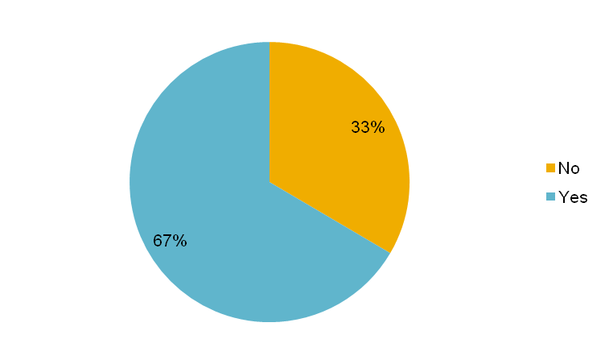

**Figure 1. Distribution of participants according to availability of fortified food around residences**

Figure 1 indicates 67% reported easy access to fortified food in their vicinity, while the remaining 33% stated a lack of availability of fortified food in their residential area.

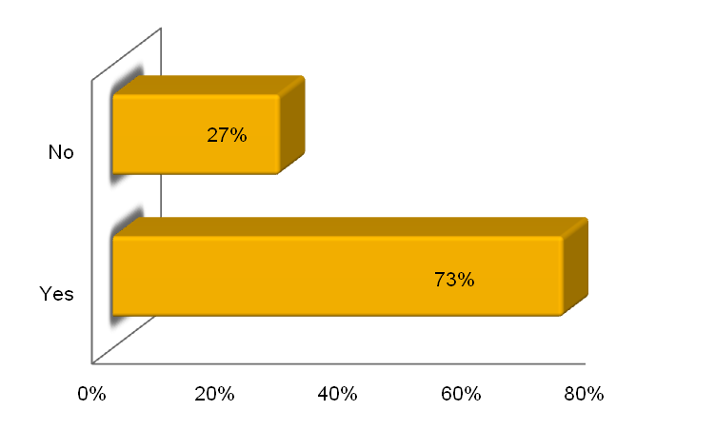

**Figure 2. Distribution of participants according to affordability of fortified food**

Figure 2 illustrates that over half of the participants consider fortified food to be within their

financial means.

**Table 1. Distribution of participants according to consumption of variety of fortified food**

|  |  |
| --- | --- |
| Fortified food | % of consumption |
| +F milk | 46% |
| +F salt | 39% |
| +F rice | 23% |
| +F oil | 18% |
| +F wheat flour | 15% |

Table 1 demonstrates that +F milk is the most consumed fortified food among participants, comprising 46% of the total consumption. In contrast, F+ wheat represents the lowest consumption among all fortified foods reported by the participants.

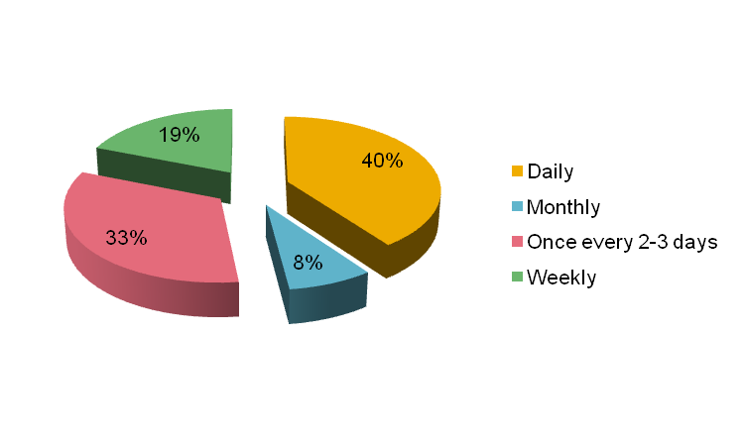

**Figure 3. Distribution of participants according to consumption pattern of fortified food**

Figure 3 illustrates that 40% consume fortified food daily, 33% consume fortified food every 2-3 days, and 19% consume fortified food weekly and 8% consume fortified food monthly.

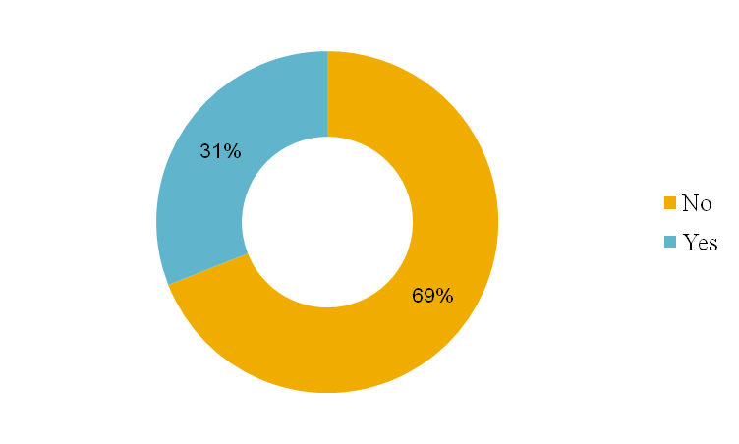

**Figure 4. Distribution of participants according to concerns impacting fortified food acceptance**

Figure 4 it's depicted that out of the participants aware of food fortification, 69% had no misconceptions regarding the safety of fortified food.

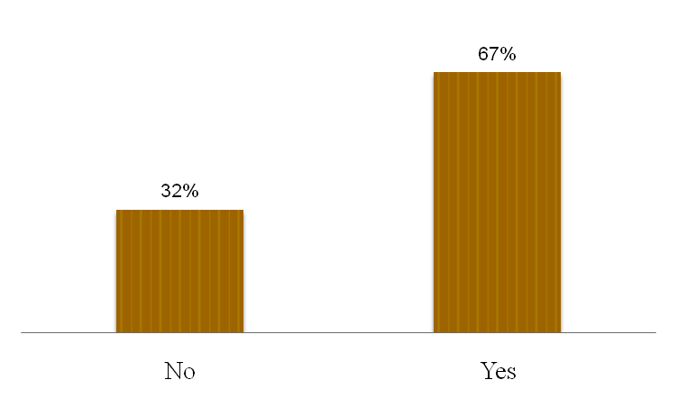

**Figure 5. Distribution of participants according to influence of media on fortified food choices**

Figure 5 illustrates that 67% of participants perceive media as influencing their choices of fortified food, while 32% of participants do not believe media influenced their choices in consuming fortified food.

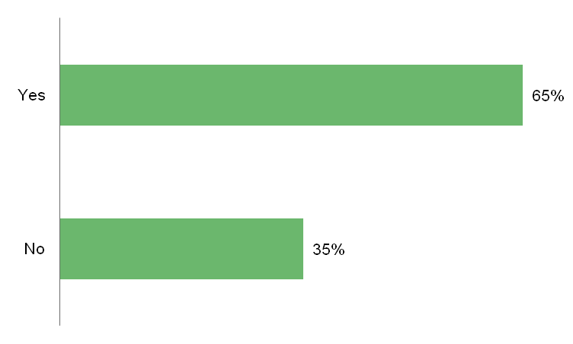

**Figure 6. Distribution of participants according to perceived taste difference of fortified vs. regular food**

Figure 6 illustrates that 65% of participants perceived a difference in the taste of fortified versus regular food.

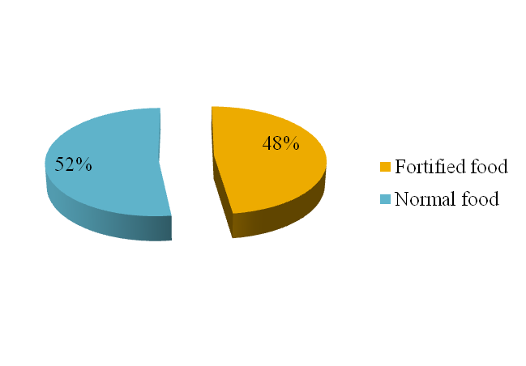

**Figure 7. Distribution of participants according to preferences: fortified food vs. regular food**

Figure 7 shows that 48% of participants, prefer fortified food over normal food. Conversely, 52% prefer normal food over fortified food.

CONCLUSION

The study found that most participants have easy access to fortified foods, with fortified milk being the most consumed, followed by salt, rice, oil, and wheat flour. Fortified foods are commonly included in daily diets. Most participants aware of fortified foods have no safety concerns and hold a positive perception, influenced mainly by media. Taste plays a crucial role, with many noticing a difference between fortified and regular foods. Although a significant number prefer fortified foods, more participants favor regular foods. These findings highlight the need to address concerns, improve taste, and communicate the benefits of fortified foods to increase acceptance and adoption.

REFERENCES

Horton, S., Mannar, V., & Wesley, A. (2008). Best practice paper: food fortification with iron and iodine. Copenhagen Consensus Center, Copenhagen Business School, Denmark.

Bailey, R. L., West, K. P., Jr, & Black, R. E. (2015). The epidemiology of global micronutrient deficiencies. Annals of nutrition & metabolism, 66 Suppl 2, 22–33. <https://doi.org/10.1159/000371618>

Han, X., Ding, S., Lu, J., & Li, Y. (2022). Global, regional, and national burdens of common micronutrient deficiencies from 1990 to 2019: A secondary trend analysis based on the Global Burden of Disease 2019 study. EClinicalMedicine, 44, 101299. <https://doi.org/10.1016/j.eclinm.2022.101299>

Olson, R., Gavin-Smith, B., Ferraboschi, C., & Kraemer, K. (2021). Food Fortification: The Advantages, Disadvantages and Lessons from Sight and Life Programs. Nutrients, 13(4), 1118. <https://doi.org/10.3390/nu13041118>

Ramachandran, P.. (2018). Food Fortification: Public Health Approach to Bridge the Gaps Between Requirement and Intake of Micronutrients. Proceedings of the Indian National Science Academy. 84. 10.16943/ptinsa/2018/49448.

Pingali, P, Aiyar, A., Abraham, M and Rahman, A (2019). Transforming Food Systems for a Rising India. Palgrave Studies in Agricultural Economics and Food Policy, ISBN 978-3-030-14408-1 ISBN 978-3-030-14409-8 (eBook). https://doi.org/10.1007/978-3-030-14409-8

Tiwari BK, Ray I, Malhotra RL. New Delhi: 2006. Policy Guidelines on National Iodine Deficiency Disorders Control Programme-Nutrition and IDD Cell.Directorate of Health Services, Ministry of Health and Family Welfare; pp. 1–22. Government of India.

Food Safety and Standards (Fortification of Foods) Regulations, 2018, published in the Gazette of India, Extraordinary, Part III, Section 4 vide notification number, F. No. 11/03/Reg/Fortification/2014, dated – 21/08/2018, retrieved from: <https://www.fssai.gov.in/upload/uploadfiles/files/Compendium_Food_Fortification_Regulations_30_09_2021.pdf>.