***Original Research Article***

**Morphometric and Reproductive Trends Reveal Near-Equal Sex Ratio, Positive Allometric Growth, and Early Maturity of *Euthynnus affinis* in Southern Philippine Waters**

.

**ABSTRACT**

|  |
| --- |
| Ichthyometric indices and gonadosomatic dynamics provide essential insights for fisheries management and policy development, emphasizing their role in sustainable resource utilization. Our study presents updated information on the sex ratio, length-weight relationship, and length at first maturity of *Euthynnus affinis* in Southern Philippine waters: Celebes Sea, Moro Gulf, Sarangani Bay, and Davao Gulf. We sampled *E. affinis* population which exhibited a near-proportional distribution of sexes, with an overall ratio of 1:0.59. A higher prevalence of males was observed, with a calculated male-to-female ratio of 1:0.59 (p-value > 0.05, χ² = 4.36), indicating significant deviation from an expected 1:1 ratio. The relationship between fork length (FL, cm) and weight (W, g) was expressed as W = 0.0104 FL³.1483 for males and W = 0.0137 FL³.0639 for females. The length-weight analysis revealed a positive allometric growth pattern, indicating that *E. affinis* becomes rotund deeper-bodied as it increases in length. The correlation coefficients (R²) were high, at 0.9760 for males and 0.9577 for females, confirming a strong relationship between length and weight. The b values exceeding 3 further support a positive allometric growth pattern, suggesting that the species grows proportionally more in weight than in length. The length at 50% sexual maturity (Lm50) was estimated at 37.18 cm, while 95% of the population (Lm95) reached maturity at 45.36 cm. For females, Lm50 and Lm95 were 35.19 cm and 41.48 cm, respectively, whereas males reached maturity at 38.43 cm (Lm50) and 49.90 cm (Lm95). We present these findings that highlight early sexual maturation in *E. affinis*, underscoring the need for targeted management strategies to ensure the sustainability of its populations. Our paper reveals the near-equal sex ratio, positive allometric growth, and early maturity of *Euthynnus affinis* highlight the need for science-based fisheries management to sustain population stability. We propose establishing minimum catch size limits above 37.18 cm (Lm50), protecting spawning stocks, and monitoring population trends that can help prevent overfishing and ensure long-term resource availability. Thus, localized management strategies and adaptive policies are essential to account for environmental changes and optimize economic benefits for fishers. |

*Keywords: Length-Weight Relationship, Length at First Maturity, Fisheries Management,* Eastern Little Tuna

**1. INTRODUCTION**

Reproductive biology plays a crucial role in identifying the sexual patterns of commercially exploited fish species by classifying reproductive and spawning behaviors, which serve as key indicators of sexuality throughout an individual's lifespan within a population (Sadovy & Shapiro, 1987; Sadovy & Domeier, 2005; Sadovy de Mitcheson & Liu, 2008). This field also provides valuable insights into fish population dynamics, essential for sustainable fisheries management. Reproductive characteristics, along with growth and mortality-related traits, determine a stock’s regenerative capacity and overall population sustainability (Schaefer, 2001). Several factors, including length-stage data, spawning season, size- and age-at-sexual-maturity, sex ratio, annual or batch fecundity, and gonadosomatic index, are used to assess these reproductive aspects (Zudaire et al., 2010). A thorough understanding of these characteristics, along with precise methods for generating objective estimates, is critical for effective stock management.

The Eastern Little Tuna (*Euthynnus affinis*), along with the Frigate Tuna (*Auxis thazard*) and Bullet Tuna (*Auxis rochei*), remain an underutilized fishery resource on a global scale (Uchida, 1981). Compared to species like Yellowfin, Skipjack, and Bigeye Tuna, research on the reproductive biology of small tuna species is relatively scarce, particularly in the Philippine setting. Studies conducted in other regions highlight the variation in reproductive parameters. For instance, in the Sunda Strait, Indonesia, Eastern Little Tuna have been observed to reach first maturity at smaller sizes, with females maturing between 40.7 and 40.8 cm and males between 43.8 and 44.0 cm (Ardelia et al., 2016). Tunas, being primarily dioecious, do not exhibit sexual dimorphism in their external morphology. As oviparous fish with asynchronous oocyte development, they are classified as multiple or batch spawners, releasing gametes into the ocean for external fertilization.

Historical studies on the reproductive biology of *E. affinis* provide a range of maturity estimates. Wade (1950b) examined tunas captured during exploratory fishing activities in the Philippines, finding the smallest ripe, spawning, and spent female *E. affinis* at 40 cm, 45 cm, and 40 cm, respectively. Williamson (1970) reported a male dominance in larger size classes (50–73 cm) in Hong Kong waters, a pattern also observed in the Philippines, Seychelles, and India. In the Philippines, Buñag (1956) determined maturity based on ova diameters, identifying the smallest mature female at 49.0 cm and the smallest spent female at 47.7 cm. Similarly, Ronquillo (1963) examined 144 *E. affinis* specimens ranging from 33.1 to 65.2 cm and found gonad indices exceeding 3.0 (mature) in females between 38.5 and 65.0 cm. Additional regional studies provide further variations in maturity size. Klinmuang (1978) estimated that *E. affinis* from the Gulf of Thailand and east coast of Peninsular Malaysia reached sexual maturity between 37 and 42 cm. Cheunpan (1984), in a four-year study of 1,010 specimens from the Gulf of Thailand, recorded the smallest mature female at 33.4 cm and found 50% of females mature at approximately 40.0 cm. In Thailand, Yesaki (1982) observed that 93% of maturing (stage-III) females were 43 cm or larger, while in India, Muthiah (1985) estimated the 50% maturity size at 43 cm for females and 44 cm for males. Meanwhile, in Papua New Guinea, Wilson (1981) reported a larger size at maturity, with the smallest fish containing maturing oocytes measuring 48.9 cm in fork length. These studies collectively suggest that *E. affinis* attains maturity at approximately 38–49 cm, depending on the region.

Despite the critical role of ichthyometric indices and gonadosomatic dynamics in fisheries management, there remains a significant gap in region-specific reproductive and growth data for *E. affinis*, particularly in Southern Philippine waters. While previous studies have explored length-weight relationships and maturity sizes in other geographical regions, localized data on sex ratios, growth patterns, and size at first maturity in the Celebes Sea, Moro Gulf, Sarangani Bay, and Davao Gulf are scarce. Existing studies, such as those conducted in the Sunda Strait, Indonesia, report different length-at-maturity estimates, suggesting possible regional variations influenced by environmental conditions and fishing pressures. The limited availability of studies on small tuna species, including Eastern Little Tuna, further highlights the need for updated biological and reproductive assessments to inform effective fisheries policies. Additionally, seasonal variations in catch data underscore the necessity of long-term monitoring to establish comprehensive management strategies. Addressing these gaps is essential for developing adaptive conservation measures that prevent overfishing and ensure the sustainability of *E. affinis* populations in the region.

This study aims to determine the sex ratio, length-weight relationship, and length at first maturity of *E. affinis* in Southern Philippine waters, specifically in the Celebes Sea, Moro Gulf, Sarangani Bay, and Davao Gulf. The research seeks to answer key questions: (1) What is the sex ratio of *E. affinis* in the sampled regions, and does it significantly deviate from a 1:1 ratio? (2) How does the length-weight relationship of *E. affinis* vary between males and females, and what growth pattern does it exhibit? (3) At what fork length does *E. affinis* reach 50% (Lm50) and 95% (Lm95) sexual maturity? (4) What implications do the observed sex ratio, growth pattern, and maturity size have for fisheries management and conservation strategies? To address these questions, the study aims to determine the sex ratio of *E. affinis* and assess whether there is a significant deviation from an expected 1:1 ratio, analyze its length-weight relationship to characterize its growth pattern, estimate the length at first maturity (Lm50 and Lm95) for both males and females, and propose science-based fisheries management recommendations based on the species' reproductive biology and growth dynamics.

**2. material and methods**

**2.1 Study Sampling Sites**

Samples of Eastern Little Tuna *(Euthynnus affinis*) were initially collected through fishery-independent sampling from November 2020 to March 2021 in the primary fishing grounds of Sarangani Bay, Davao Gulf, Moro Gulf, and the Sulawesi Sea. During this phase, sample collection in all four sites was conducted using small-scale municipal fishing boats rented from local fishers in Kiamba, Sarangani Province. Five research staff and six hired fishermen participated in the sampling expeditions. Additionally, samples were obtained from local fish landings, specifically from catches using Fish Aggregating Devices (FADs), locally known as payao, to meet the required sample size.

Sampling was conducted for seven days during each new moon phase to generate data for assessing the gonadosomatic index and determining the species' spawning period, as well as to evaluate size at maturity, fecundity, and gonadal development stages. All collected specimens underwent on-site examination for gross morphological characteristics and morphometric measurements, while gonads, stomachs, and otoliths were extracted for laboratory analysis.

Due to low catch volumes, the study later adopted a fishery-dependent sampling method. The research team collaborated with the SOCSKSARGEN Federation of Fishing & Allied Industries, Inc. (SFFAII), the National Stock Assessment Program (NSAP) of the Department of Agriculture – Bureau of Fisheries and Aquatic Resources (DA-BFAR) in Regions XI and XII, and Davao del Sur State College to secure the required number and size range of specimens. Samples were preserved in insulated boxes with iced seawater and transported to the Ichthyology/Wet Laboratory of the College of Fisheries for preliminary processing. Dissected gonads were further analyzed at the Histopathology Laboratory, Regional Science Research Center, Mindanao State University, Fatima, General Santos City.

**Figure 1: Geographical Distribution of Major Fishing Grounds in the Southern Philippines.** The figure displays a map delineating the study areas encompassing four primary fishing grounds: Sarangani Bay (5.9656° N, 125.1929° E), Davao Gulf (6.813° N, 125.8280° E), Moro Gulf (6.8014° N, 123.4384° E), and Celebes Sea (3.6121° N, 122.2998° E). These locations were focal points for the collection of *E. affinis* samples. The geographical demarcation of these fishing grounds is essential for contextualizing the ecological and environmental factors influencing the observed characteristics of the studied population.

**2.2 Gross Morphological Characterization and Morphometrics**

Detailed morphometric measurements were recorded, and morphological characteristics were assessed to confirm the taxonomic status of the three species. Biological parameters, including standard length (SL), fork length (FL), total length (TL), body girth (BG), and gonad length, were measured using a ruler with a precision of 0.1 mm. Additionally, total body weight (TBW) and gonad weight (GW) were determined using a digital balance scale to ensure accurate data collection.

**2.3 Sex Identification**

Fishes of the family Scombridae, including tunas, mackerels, and bonitos, are sexually dimorphic only at the gonadal level, as they lack externally visible features to differentiate males from females. Sex identification in this family requires dissection and ocular examination of the gonads. Following the general criteria outlined by McBride et al. (2004), male gonads are typically white and smooth, whereas female gonads appear yellow or brown with a granular texture. The paired gonadal lobes are situated within the abdominal cavity along the ventral side of the backbone.

**2.4 Sex Ratio**

The sex ratio was calculated using the formula: total number of males divided by the total number of females (Oliveira, 2012). To determine whether the observed sex ratio significantly deviated from the expected 1:1 ratio, a chi-square test was conducted. The overall sex ratio was statistically analyzed using the chi-square method as described by Sokal (1987), as follows:

$$x_{c}²=\sum{}\frac{{(Oi - Ei)}^{2}}{Ei}$$

Where X2 = Chi-square, c = degrees of freedom, Oi = observed frequency, and Ei = expected frequency, with the null hypothesis that there is no significant difference between the population of male and female fish.

**2.5 Length-Weight Relationship**

The relationship between the weight of the fish in grams and its fork length in centimeters was estimated using the equation defined by Pauly (1984).

$$W=aL^{b}$$

In this equation, W represents the total weight of the fish in grams, while L denotes the fork length in centimeters. The parameter ‘a’ serves as the regression constant or condition factor, and ‘b’ represents the allometric coefficient, indicating the relative growth rate of the fish. By applying a linear regression to the logarithmically transformed equation: log (W) = log (a) + b log (L), the values of a and b were determined, where a corresponds to the intercept and b to the slope of the relationship. The allometric coefficient (b) is crucial in identifying the species' growth pattern. If b equals 3, the growth is considered isometric, meaning the fish maintains proportional body dimensions as it grows. A b value greater than 3 indicates positive allometric growth, where the fish becomes relatively stouter as it increases in size, whereas a b value less than 3 signifies negative allometric growth, suggesting a more elongated form (Dutta et al., 2012).

**2.6 Length at First Maturity (Lm50)**

The fork length at which 50% (Lm50) and 95% (Lm95) of the population attain sexual maturity was determined by plotting the proportion of sexually mature individuals (stage 2A and above) against their fork lengths (ICES WKASMSF Report, 2018). The estimation of Lm50 and Lm95 followed the methods outlined by Stergiou (1999). The Size-at-Maturity (SAM) function, as described by Longenecker et al. (2020), was used to assess the maturity threshold. The analysis incorporated various input data, including fork length (cm), weight (g), gonadal maturity stage (ranging from stage 0 to stage 6), maturity classification (immature or mature), and sex of each collected specimen. A standardized spreadsheet template, following the Standard Operating Procedure (SOP), was utilized to estimate the SAM model parameters in Microsoft Excel 2021.

**2.7 Data and Statistical Analysis**

Inferential data (population characteristics) and statistical analyses (regression analysis, chi-square, confidence interval for length-frequency distribution) were performed with OriginPro Software version 2023, and a significance level of 0.05 was adopted in the study.

**3. results and discussion**

**3.1 Sex Ratio**

A total of 1,314 *Euthynnus affinis* specimens were collected from multiple fishing ports across the four study sites. Of these, 111 individuals (8.45%) were identified as males, 66 (5.02%) as females, while the sex of 1,137 specimens (86.53%) remained undetermined. The fork length (FL) of all collected individuals ranged from 14.00 cm to 64.70 cm, with a mean FL of 25.60 cm (± 6.21 cm). Males exhibited a fork length range of 20.50 cm to 64.70 cm, averaging 34.11 cm (± 8.91 cm), whereas females ranged from 14.00 cm to 56.70 cm, with a mean FL of 35.55 cm (± 9.68 cm). Specimens of undetermined sex had fork lengths between 14.00 cm and 46.90 cm, with an average FL of 24.15 cm (± 4.07 cm). Total body weight (TBW) varied from 343.00 g to 4,632.00 g across all specimens, with an average TBW of 343.00 g (± 380.03 g). Males had a TBW range of 120.00 g to 4,632.00 g, averaging 863.00 g (± 760.36 g), while females ranged from 40.00 g to 3,223.00 g, with a mean TBW of 966.50 g (± 732.95 g). Specimens of undetermined sex (ICES WKASMSF Report, 2018) exhibited TBW values between 40.00 g and 1,910.00 g, averaging 257.00 g (± 153.84 g). The overall sex ratio revealed a higher proportion of females than males in the *E. affinis* population, with a calculated male-to-female ratio of 1:0.59 (p > 0.05, χ² = 4.36). Additionally, minimal to no samples were collected during April, May, June, and August.

Table 1. Sex ratio of *Euthynnus affinis* collected from four study sites, showing the proportion of males, females, and undetermined specimens. The observed male-to-female ratio and statistical analysis (χ² test) indicate significant deviation from the expected 1:1 ratio (p > 0.05).

|  |  |  |  |  |  |
| --- | --- | --- | --- | --- | --- |
| **Month** | **Male** | **Female** | **Undetermined** | **Total** | **Sex Ratio (M:F)** |
| April 2021 | 0 | 0 | 0 | 0 | - |
| May 2021 | 0 | 1 | 35 | 36 | - |
| June 2021 | 0 | 0 | 17 | 17 | - |
| July 2021 | 51 | 0 | 72 | 123 | 1: 0* |
| August 2021 | 0 | 0 | 0 | 0 | - |
| September 2021 | 8 | 14 | 181 | 203 | 1: 1.75* |
| October 2021 | 1 | 7 | 193 | 201 | 1: 7.0* |
| November 2021 | 10 | 8 | 306 | 324 | 1: 0.80 |
| December 2021 | 25 | 22 | 151 | 198 | 1: 0.88 |
| January 2022 | 6 | 7 | 113 | 126 | 1: 1.17 |
| February 2022 | 6 | 6 | 29 | 41 | 1: 1 |
| March 2022 | 4 | 1 | 40 | 45 | 1: 0.25 |
| **Total** | **111** | **66** | **1,137** | **1,314** | **1: 0.59\*** |
| **\* significant** |  |  |  |  |  |

The sex ratio of *Euthynnus affinis* has been a central focus in studies exploring the population dynamics of this species. Globally, research has indicated an overall sex ratio of approximately 1:1, suggesting a balance between males and females within the population (Acevedo et al., 2007; Nikolsky, 1963). However, variations in this ratio have been noted across different length classes. Specifically, males tend to be more abundant within the 28–30 cm LF range and in individuals exceeding 65 cm LF, while females are more frequently observed between 45 and 50 cm LF. Understanding the sex ratio is crucial as it provides insights into the health and sustainability of fish populations. Deviations from an equal ratio may indicate differences in survival rates, selective fishing pressures, or environmental factors influencing growth and reproduction (Lucano-Ramírez et al., 2005; Santamaría-Miranda & Rojas-Herrera, 1997). In the southwest Gulf of Mexico, the relatively balanced sex ratio observed in *Euthynnus affinis* suggests population stability, though the higher prevalence of larger males may imply selective pressures favoring male growth (Alcaráz-García, 2012). Studies have determined that *Euthynnus affinis* reaches first sexual maturity at approximately 34.40 cm LF, which corresponds to an estimated age of two years. This benchmark is particularly important for fisheries management, as it identifies the stage at which individuals contribute to reproduction. Notably, these maturation lengths vary across different geographic regions, emphasizing the role of local environmental conditions in shaping growth and reproductive patterns (Valeiras & Abad, 2006; Rodríguez-Roda, 1966; Diouf, 1981).

**3.2 Length-Weight Relationship**

The relationship between fork lengths in centimeters (FL) and weight in grams (W) in *E. affinis*, both for males and females, can be concisely described by the equations W = 0.0104 FL3.1483 and W = 0.0137 FL3.0639, respectively. This relationship is visually represented in Figure 2 through a linear regression graph. Notably, this species exhibits positive growth allometry, with a strong correlation observed in both sexes. The correlation coefficients (R2) were notably high, reaching 0.9760 for males and 0.9577 for females. The b value obtained denotes a positive allometric growth pattern. in which ‘b’ value is greater than 3 and implies that the fish becomes relatively rotund or deeper-bodied as it grows in length. The analysis of the length-weight relationship in *Euthynnus affinis* demonstrates a positive allometric growth pattern, where the species increases in body depth relative to its length as it grows. This relationship is described mathematically by the equations 𝑊=0.0104𝐹𝐿3.1483 W=0.0104FL 3.1483 for males and 𝑊 = 0.0137 𝐹 𝐿 3.0639 W=0.0137FL 3.0639 for females, indicating that both sexes exhibit similar growth trends. The exponent b in these equations, which exceeds the value of 3, confirms that *E. affinis* does not grow isometrically (where length and weight increase proportionally) but rather gains more weight in relation to length, resulting in a more robust body shape. The high correlation coefficients (R² = 0.9760 for males and R² = 0.9577 for females) suggest a strong predictive relationship between length and weight, meaning that length measurements can reliably estimate the weight of the fish. Positive allometric growth typically reflects efficient energy storage and body condition, which can enhance reproductive success and survival. This pattern may also be influenced by environmental factors such as food availability and habitat conditions, which support the species’ ability to accumulate energy reserves. The study Herath et al. (2019) in Coastal waters of Sri Lanka and Ghosh et al. (2010) in Veraval, India shows similar ‘b’ values of 3.1150 and 3.0558, respectively. The length-weight relationship (LWR) of *Euthynnus affinis* is expressed by the equation 𝑊 = 𝑎𝐿𝑏 W=aLb, where 𝑊 represents weight, 𝐿 denotes length, and 𝑎 a and 𝑏 b are species-specific constants. For *E. affinis*, the LWR has been established as 𝑊 = 0.0254 𝐿2.889 W=0.0254L 2.889 (Deepti & Sujatha, 2012; Ahmed et al., 2015). This equation indicates that weight increases at a non-linear rate relative to length, meaning that as the fish grows longer, its weight increases disproportionately. Studies have shown no significant difference in the LWR between males and females, suggesting that both sexes exhibit similar growth patterns (Ahmed et al., 2015). Understanding the LWR is essential for fisheries management, as it aids in estimating biomass, assessing growth conditions, and evaluating the reproductive potential of the species. Moreover, *E. affinis* has been recorded to reach a maximum length of 579.5 mm, with an average length of approximately 545.05 mm in some populations (Ahmed et al., 2015). These measurements provide critical data for monitoring the health and sustainability of the species within different fishing grounds.

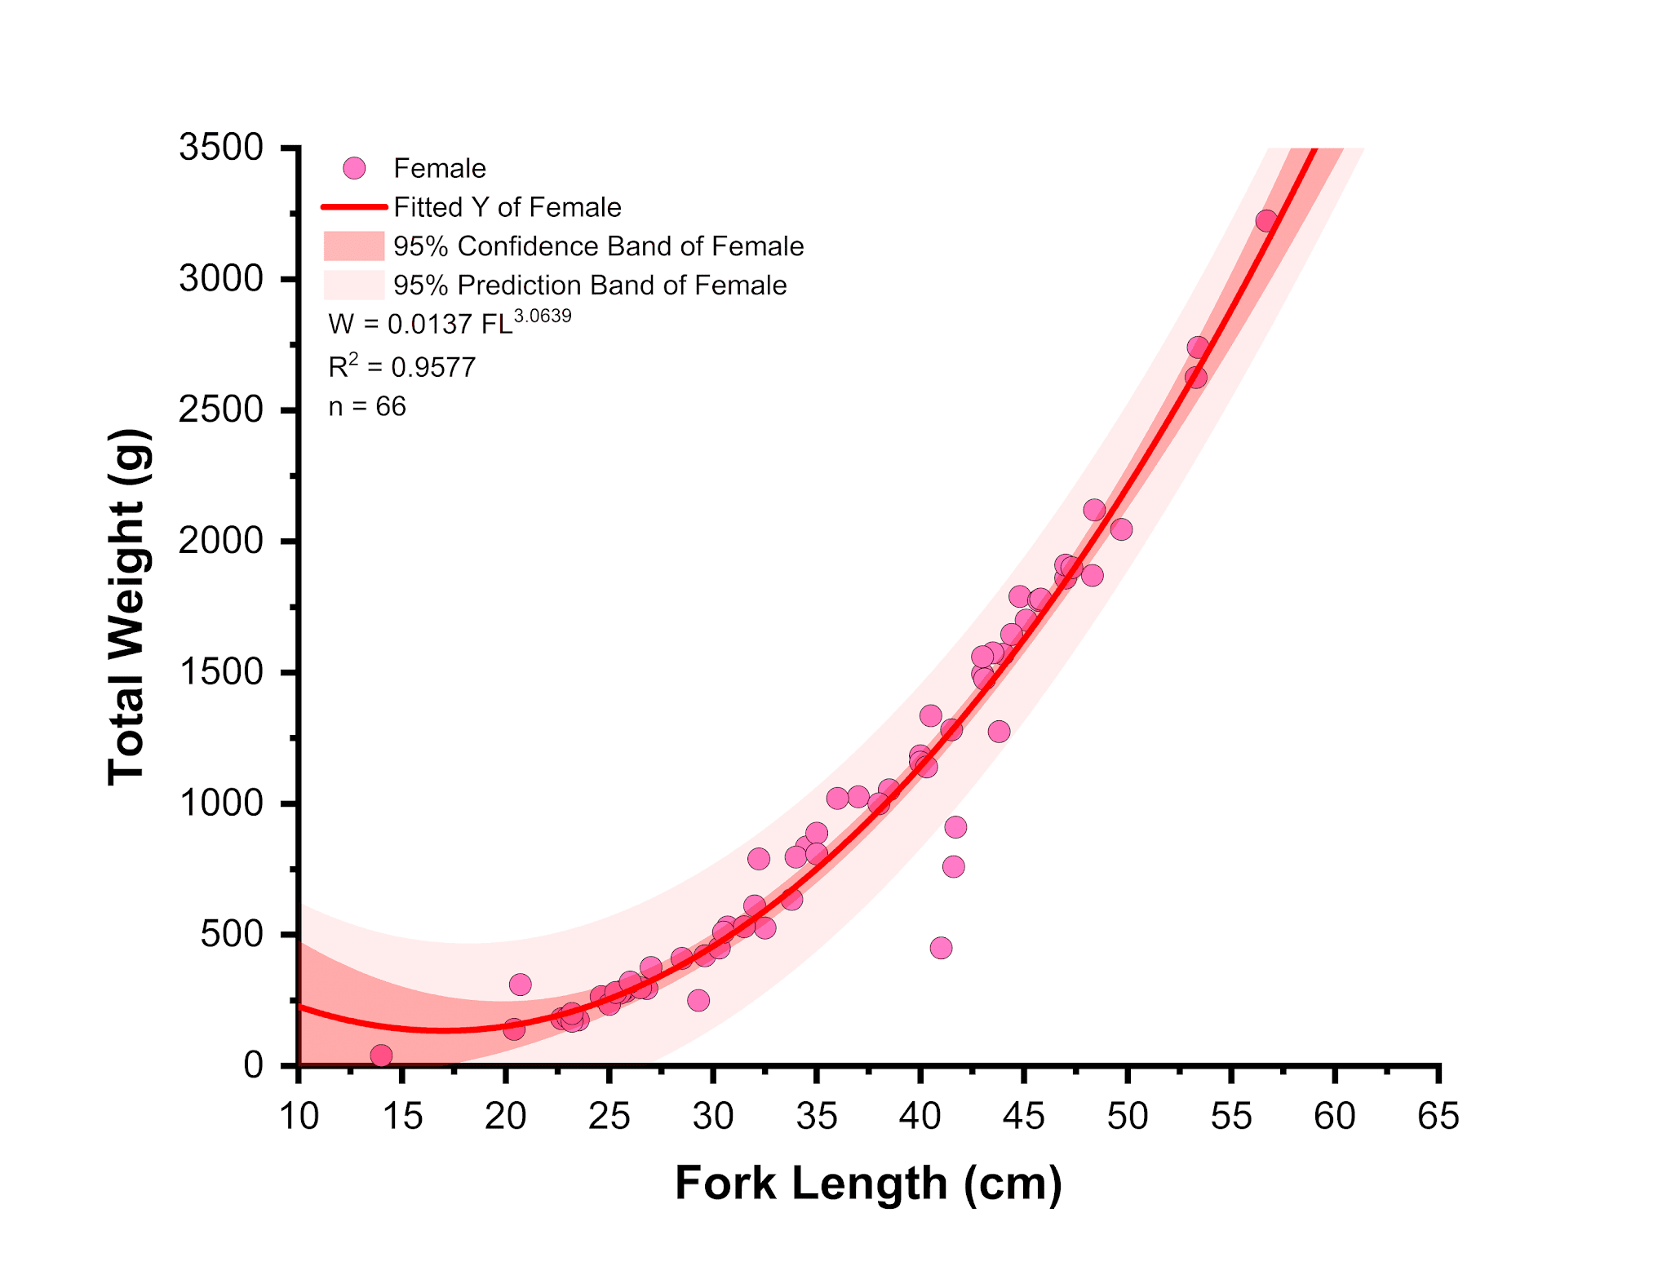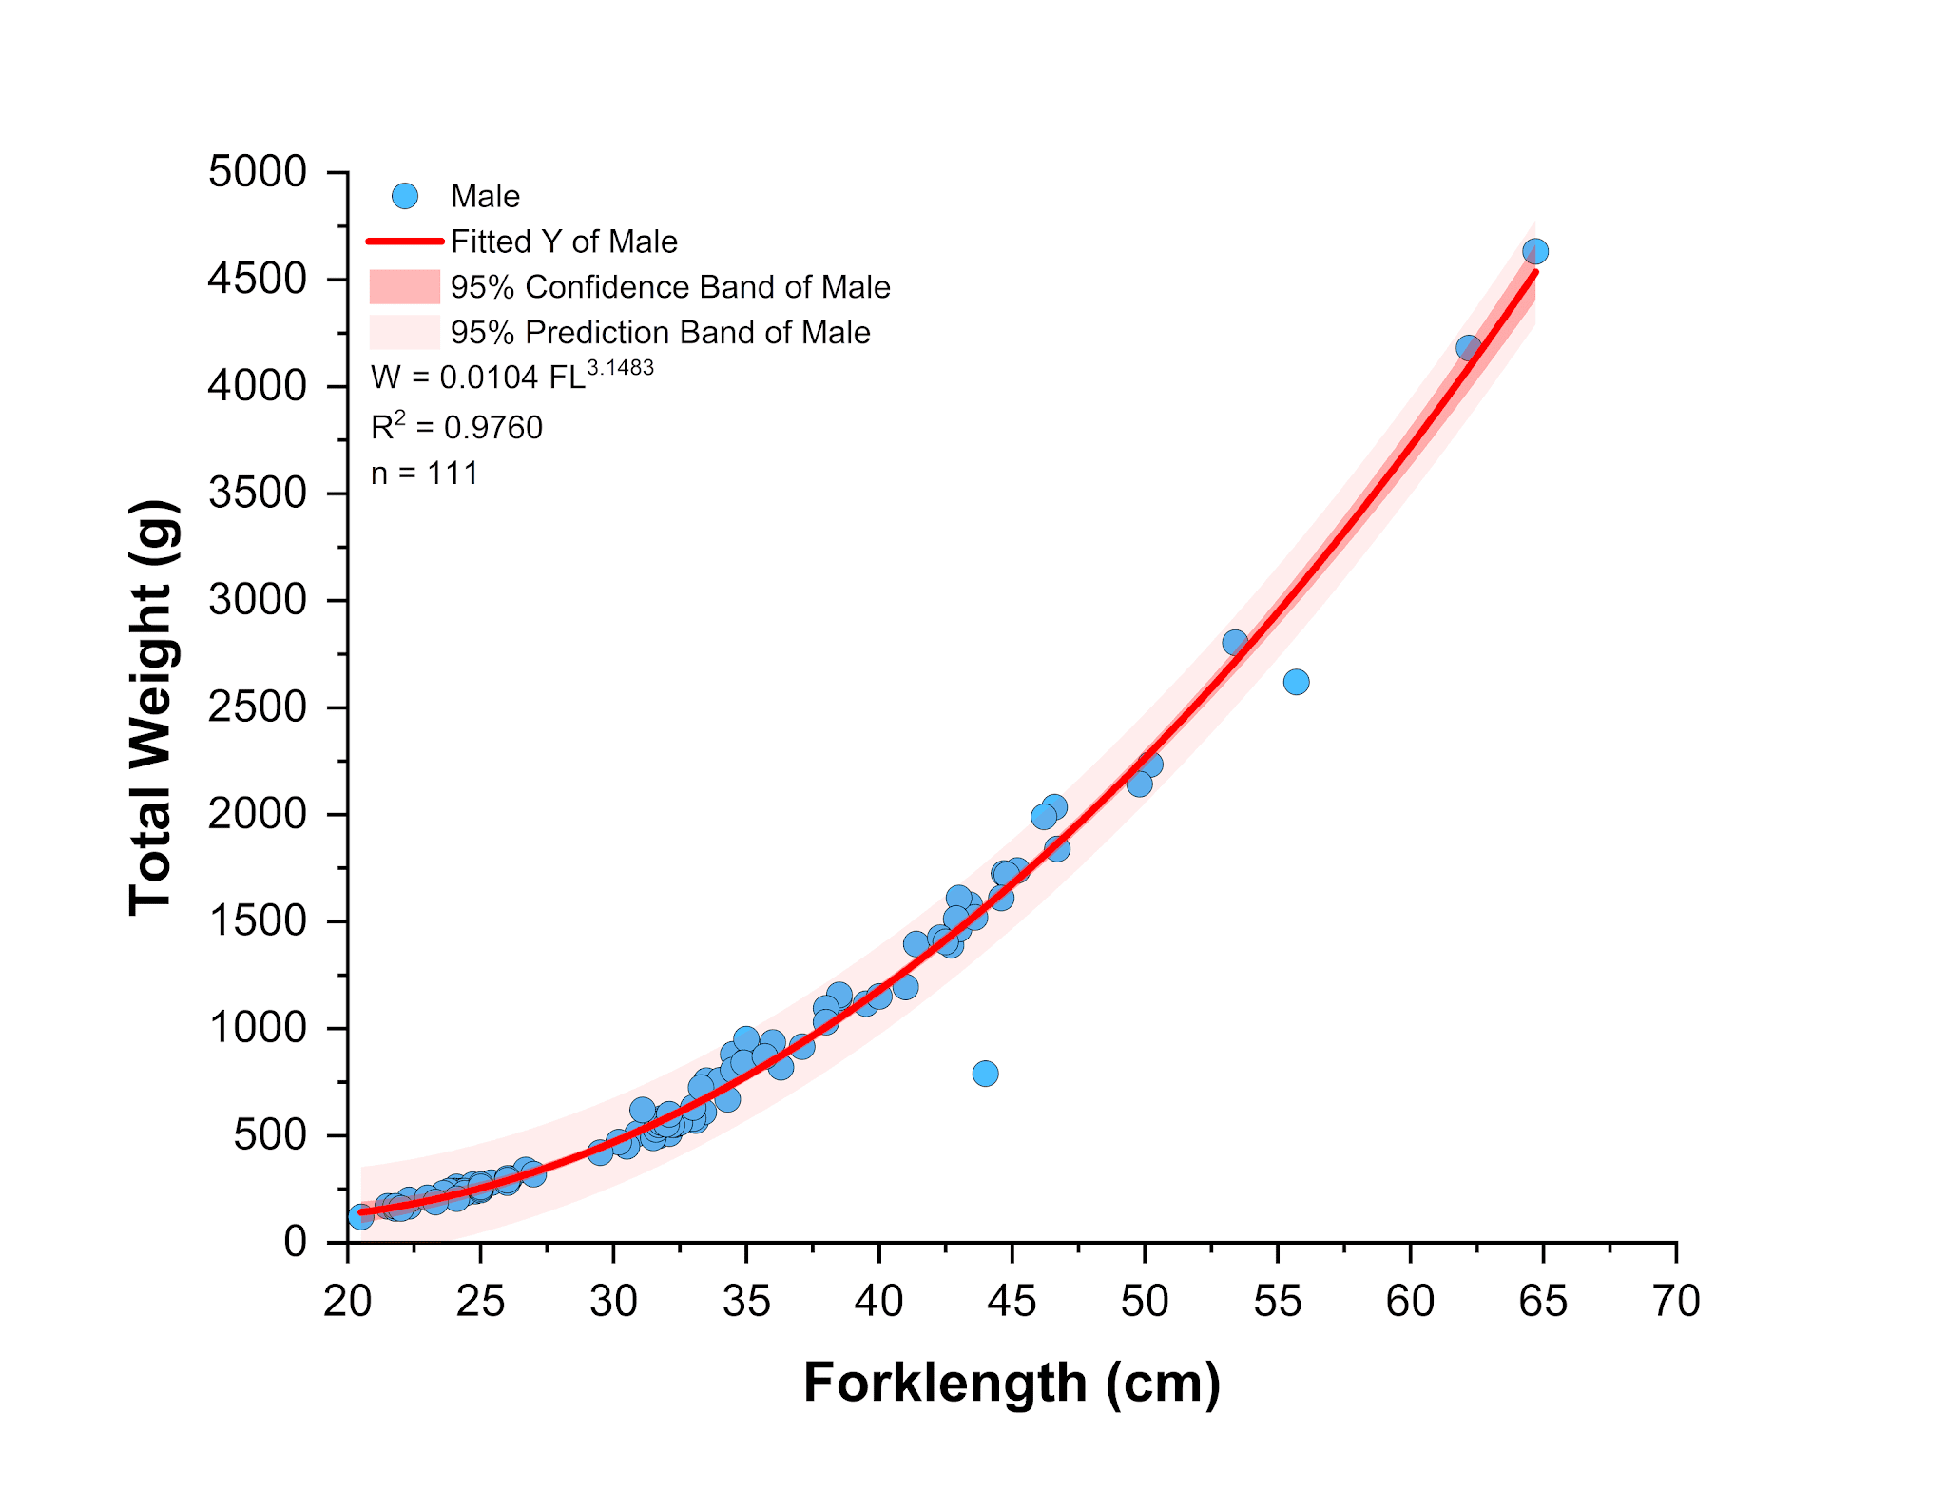

Figure 2. Length-Weight Relationship of *Euthynnus affinis* by Sex Across Four Study Areas. The figure illustrates the length-weight relationship of *Euthynnus affinis* males (left) and females (right) collected from four study sites: Sarangani Bay, Davao Gulf, Moro Gulf, and the Celebes Sea. The analysis was conducted using pooled data from these locations to provide a comprehensive assessment of growth patterns across different marine environments. The plotted regression models depict the positive allometric growth observed in both sexes, where weight increases at a greater rate than length, indicating robust body development influenced by biological and ecological factors.

**3.3 IV. Length Composition and Length at First Maturity (Lm50 and Lm95)**

The *Euthynnus affinis* specimens collected from the four study areas exhibited a wide range of fork lengths (FL), spanning from 14.00 cm to 64.70 cm, with notable variations across regions. In Sarangani Bay, handlines were the primary fishing method, and most of the catch measured between 22.00 and 23.00 cm FL. In Davao Gulf, fish were caught using handlines, purse seines, and ring nets, with size distributions varying by gear type—24.00 to 25.00 cm FL for purse seines and 32.00 to 33.00 cm FL for ring nets. In the Moro Gulf, purse seines and ring nets were the dominant fishing gears, yielding fish sizes of approximately 26.00 to 27.00 cm FL and 24.00 to 25.00 cm FL, respectively. Similarly, in the Celebes Sea, where purse seines and ring nets were also commonly used, the majority of fish caught measured between 26.00 and 27.00 cm FL. Among the different gear types, handlines were the most frequently utilized, followed by purse seines and ring nets. The proportion of sexually mature individuals varied by region, with only 20% in Sarangani Bay, 23% in Davao Gulf, 7% in Moro Gulf, and 8% in the Celebes Sea. The remaining fish, classified as undetermined (stage 0), accounted for more than 86% of the total population across all study areas. The estimated fork length at which 50% of the population (Lm50) reached sexual maturity was 37.18 cm, while 95% (Lm95) attained maturity at 45.36 cm. When analyzed by sex, females reached Lm50 at 35.19 cm and Lm95 at 41.48 cm, whereas males had higher maturity thresholds, with Lm50 at 38.43 cm and Lm95 at 49.90 cm. A detailed graphical representation of the length-frequency distribution and the length at first maturity for each study area is provided in Figure 3.

Figure 3. Length-frequency distribution of *Euthynnus affinis* collected from the Sarangani Bay Protected Seascape (SBPS), Davao Gulf (DG), Moro Gulf (MG), and Celebes Sea (CS) between April 2021 and March 2022 using handlines, purse seines, and ring nets. The pooled data of male and female specimens were utilized to determine and represent the length at which 50% of the population reached sexual maturity (Lm50) and the selection length (SL50) in the graph, providing insights into the population structure and fishing selectivity across the study areas.

Research has shown that the length at which 50% of *Euthynnus affinis* individuals reach sexual maturity (Lm50) is approximately 48.4 cm, while 95% maturity (Lm95) is estimated at around 55.7 cm (Agric4Profits, 2023; Quratulan, 2014). Understanding these maturity thresholds is crucial for evaluating the reproductive sustainability of this species, which is widely distributed in tropical and subtropical waters and holds significant commercial value in global fisheries. *Euthynnus affinis* exhibits considerable variability in growth rates and maturity sizes, influenced by environmental conditions and geographic location. For example, studies indicate that females can reach maturity at sizes as small as 33.4 cm in certain regions, emphasizing the impact of local ecological factors on reproductive development (Ekawaty & Jatmiko, 2018; Yesaki, 1994). This variability underscores the need for region-specific management strategies to ensure the long-term viability of *E. affinis,* particularly as overfishing continues to threaten its populations. Concerns regarding the sustainability of *Euthynnus affinis* fisheries primarily center on the growing fishing pressure and the need for effective conservation measures. Overfishing has been reported in multiple regions, leading to declines in biomass and necessitating urgent regulatory interventions. Studies employing depletion-based stock reduction analysis (DBSRA) have highlighted that current fishing pressures often exceed sustainable limits, calling for improved management frameworks and responsible harvesting practices to safeguard the species' future (Quratulan, 2014).

**4. Conclusion**

Our findings indicate that *Euthynnus affinis* populations in the southern Philippine waters exhibit a nearly balanced sex ratio, suggesting a well-maintained reproductive structure. This balance implies a sustainable population dynamic, where both male and female individuals contribute effectively to the species' reproductive cycle, supporting long-term population stability in the region. The species demonstrates a positive allometric growth pattern, with individuals becoming rotund as they grow, suggesting efficient energy allocation that may enhance reproductive success and survival. The estimated length at first maturity (Lm50) of 37.18 cm highlights early sexual maturation, which could contribute to population resilience despite fishing pressures. However, this also raises concerns about growth-overfishing, as individuals may be harvested before significantly contributing to the spawning stock. Per our data, in ensuring the sustainability of *E. affinis* populations, our findings support the need for science-based fisheries management. We are proposing to establish a minimum catch size limit above 37.18 cm would allow individuals to reach reproductive maturity before being harvested. Protecting key spawning and nursery habitats through marine protected areas (MPAs) or seasonal fishing closures would help sustain reproductive stocks. We suggest the continuous monitoring of population dynamics, including sex ratios, growth patterns, and maturity thresholds as an essential for adaptive management. We also recommend the regulation of fishing practices through controlled catch limits and gear restrictions will aid in preventing overexploitation. We encourage engagement of local fishers, policymakers, and researchers in co-management strategies that will further promote sustainability while optimizing economic benefits. We strongly advise implementing these measures to effectively manage *E. affinis* populations, ensuring long-term resource availability and fisheries stability.

**Ethical approval (where ever applicable)**

The Department of Environment and Natural Resources - Protected Area Management Board (DENR-PAMB) Region XII, the Bureau of Fisheries and Aquatic Resources - National Stock Assessment Program (BFAR-NSAP) Regions XI and XII, the Philippine National Police Maritime Group (PNP-MG) Region XII, the Philippine Coast Guard (PCG) Region XII, and the Local Government Units (LGUs) of General Santos City and the municipalities of Sarangani Province (Alabel, Malapatan, Glan, Maasim, Kiamba, and Maitum) granted approval and established partnerships for the study. The research was conducted in compliance with key institutional and national guidelines, utilizing both independent and dependent sampling techniques.

**References**

Acevedo J, Angulo W, Ramírez M, Zapata LA. 2007. Reproducción del pez Brotula clarkae (Pisces: Ophidiidae) en el Pacífico colombiano. Revista de Biología Tropical 55(3–4):957-967

Agric4Profits. (2023, November 24). How to farm and care for Kawakawa fish (Euthynnus affinis). Agric4Profits. https://agric4profits.com/how-to-farm-and-care-for-kawakawa-fish/ (Retrieved: December 04, 2024)

Ahmed, Q., Yousuf, F., Sarfraz, M., Mohammad Ali, Q., Balkhour, M., Safi, S. Z., & Ashraf, M. A. (2015). Euthynnus affinis (little tuna): fishery, bionomics, seasonal elemental variations, health risk assessment and conservational management. Frontiers in Life Science, 8(1), 71-96.

Alcaráz-García ZTJ. 2012. Edad, Crecimiento y Mortalidad natural del bonito Euthynnus alletteratus (Rafinesque, 1810) en el suroeste del Golfo de México. Boca del río: Universidad Veracruzana, Instituto de Ciencias Marinas y Pesquerías. Tesis de Maestría

Amri, K., Novalina, A., and Setyadji, B. 2019. Some Biological Stock Indicators of Bullet Tuna (Auxis rochei, Risso 1810) from Banda Sea and its adjacent waters. Indonesian Fisheries Research Journal. DOI: http://dx.doi.org/10.15578/ifrj.25.2.2019.103-112

Ardelia V, Y Vitner, & DM Boer. 2016. Reproduction Biology Eastern Tuna Euthynnus affinis in the Sunda Strait. Jurnal Ilmu dan Teknologi Kelautan Tropis 8(2):689-700.

Buñag, D.M. 1956. Spawning habits of some Philippine tuna based on diameter measurements of the ovarian ova. J. Philipp.Fish., 4:145–77.

Cheunpan, A. 1984. Sexual maturity, size at first maturity and spawning season of longtail tuna (T. tonggol), eastern little tuna (E. affinis) and frigate mackerel (T. thazard) in the Gulf of Thailand. Rep.Mar.Fish.Div.Dep.Fish., Bangkok, 43:22 p.

Deepti, V. I., & Sujatha, K. (2012). Fishery and some aspects of reproductive biology of two coastal species of tuna, Auxis thazard(Lacepede, 1800) and Euthynnus affinis(Cantor, 1849) off north Andhra Pradesh, India. Indian Journal of Fisheries, 59(4), 67-76.

Diouf T. 1981. Premieres donnees relatives a l’exploitation et a la biologie de quelques “petits thonidés et especes voisines”: Euthynnus, Sarda, Scomberomorus au Senegal. ICCAT Collective Volume of Scientific Papers 15(2):327-336

Dutta, S., Maity, S., Chanda, A., Akhand, A., & Hazra, S. (2012). Length weight relationship of four commercially important marine fishes of Northern Bay of Bengal, West Bengal, India. Journal of Applied Environmental and Biological Sciences, 2(2), 52-58.

Ekawaty, R., & Jatmiko, I. (2018). Reproductive biology of kawakawa, Euthynnus affinis (Cantor, 1849) in Eastern Indian Ocean. Jurnal Iktiologi Indonesia, 18(3), 199-208. https://doi.org/10.32491/jii.v18i3.313

Ghosh S, Pillai NGK, Dhokia HK. 2010. Fishery, population characteristics and yield estimates of coastal tunas at Veraval. Indian J Fish 57: 7–13.

Herath DR, Perera HACC, Hettiarachchi GHCM. 2019. Some biological aspects and molecular variations in frigate tuna, Auxis thazard of the coastal waters around Sri Lanka. J Natl Sci Found of Sri Lanka 47: 333.

ICES WKASMSF Report (2018) International Council for the Exploration of the Sea: Report of the Workshop for Advancing Sexual Maturity Staging in Fish (WKASMSF).Ecosystem Observation Steering Group. ICESCM/EOSG: 38. REF ACOMAND SCICOM.ICES Headquarters, Copenhagen, Denmark.

Klinmuang, H. 1978. Preliminary studies on the biology of tunas in the west of the Gulf of Thailand and off the east coast of Peninsular Malaysia. Pelagic Fish.Rep.Mar. Fish.Div.Dep.Fish., Bangkok, 5:27 p.

Longenecker, Ken & Langston, Ross & Franklin, Erik. (2020). Standard operating procedure for histology-based rapid reproductive analysis of tropical fishes. 10.13140/RG.2.2.32587.21288/2.

Lucano-Ramírez G, Ruiz-Ramírez S, Rojo-Vázquez JA. 2005. Biología reproductiva de Prionotus ruscarius (Pisces: Triglidae) en las costas de Jalisco y Colima, México. Revista Digital Universitaria 6:1067-1079

Mahmoud HH. 2009. Gonadal maturation and histological observations of Epinephelus areolatus and Lethrinus nebulosus in Halaieb/Shalatien Area Red Sea", Egypt. Glob Vet. 3(5):414 hut423.

McBride SC, Price RJ, Tom PD, Lawrence JM, Lawrence AL. 2004. Comparison of gonad quality factors: color, hardness, and resilience of Strongylocentrotus franciscanus between sea urchins fed prepared feed or algal diets and sea urchins harvested from the Northern California fishery. Aquaculture. 233(1–4):405–422. https://doi.org/10.1016/j.aquaculture.2003.10.014

Muthiah, C. 1985. Maturation and spawning of Euthynnus affinis, Auxis thazard and A. rochei in the Mangalore inshore area during 1979 to 1982. In Tuna fisheries of the exclusive economic zone of India: biology and stock assessment, edited by E. G. Silas. Bull.Cent.Mar.Fish.Res.Inst., Cochin, 36:71–85.

Nikolsky GV. 1963. The ecology of fishes. London: Academic Press. 352 pp

Oliveira, M. R., Costa, E. F. S., Araújo, A. S., Pessoa, E. K. R., Carvalho, M. M., Cavalcante, L. F. M., & Chellappa, S. (2012). Sex ratio and length-weight relationship for five marine fish species from Brazil. Journal of Marine Biology & Oceanography, 1, 2.

Pauly, D. (1984). Fish population dynamics in tropical waters: a manual for use with programmable calculators (Vol. 8). WorldFish.

Quratulan Ahmed, Farzana Yousuf, Maliha Sarfraz, Qadeer Mohammad Ali, Mansour Balkhour, Sher Zaman Safi & Muhammad Aqeel Ashraf (2014): Euthynnus affinis (little tuna): fishery, bionomics, seasonal elemental variations, health risk assessment and conservational management, Frontiers in Life Science, DOI: 10. 1080/ 21553769. 2014. 961617

Rodríguez-Roda J. 1966. Estudio de la Bacoreta, Euthynnus alletteratus (Raf), Bonito, Sarda sarda (Bloch) y melva Auxis thazard (Lac), capturados por las almadrabas españolas. Investigación Pesquero 30:247-292

Ronquillo, I.A. 1963. A contribution to the biology of Philippine tunas. FAO Fish.Rep., 6:1683–752.

Sadovy de Mitcheson, Y, and M Liu. 2008. Functional hermaphroditism in teleosts. Fish and Fisheries 9:1–43.

Sadovy Y, and ML Domeier. 2005. Perplexing problems of sexual patterns in the fish genus Paralabrax (Serranidae, Serraninae). Journal of Zoology 267:121–133.

Sadovy, Y., & Shapiro, D. Y. (1987). Criteria for the diagnosis of hermaphroditism in fishes. Copeia, 136-156.

Santamaría-Miranda A, Rojas-Herrera AA. 1997. Análisis de la variación morfológica del huachinango, Lutjanus peru (Nichols y Murphy, 1922) (Pisces: Lutjanidae) en el litoral de la costa chica de Guerrero, México. Periodo noviembre 1992-diciembre 1994. Sociedad Ictiológica Mexicana.

Schaefer KM. 2001. Reproductive biology of tunas. Fish physiol. 19: 225–270

Schaefer, KM. 2001. Assessment of skipjack tuna (Katsuwonus pelamis) spawning activity inthe eastern Pacific Ocean. Fish. Bull. 99:343-350

Shamsul Hoda, S. M., & Ajazuddin, S. (1992). Some aspects of reproductive biology of two sciaenids, Otolithes cuvieri Trewavas and Johnius elongatus Mohan: maturation, spawning, sex ratio and fecundity.

Sokal, R. R. (1987). FJ Rohlf Introduction to Bio Statistics, WH Freeman & Co. New york.

Stergiou, K. I. (1999). Intraspecific variations in size-and age-at-maturity for red bandfish, Cepola macrophthalma. Environmental Biology of Fishes, 54, 151-160.

Uchida RN. 1981. Synopsis of Biological Data on Frigate Tuna, Auxis thazard, and Bullet Tuna, A. rochei. FAO Fish. Synop. 124 pp.

Valeiras J, Abad E. 2006. Manual de ICCAT, Descripción de la bacoreta.

Wade, C.B. 1950. Observations on the spawning of Philippine tuna. Fish.Bull.U.S.Fish Wildl.Serv., 51:409–23.

Williamson, G.R. 1970. Little tuna Euthynnus affinis in the Hong Kong area. Bull.Jap. Soc.Sci.Fish., (36):9–18.

Wilson, M.A. 1981. Aspects of the biology and production of mackerel tuna in Oceania. In Northern pelagic fish seminar, edited by C.J. Grant and D.G. Walter. Aust.Gov.Publ.Serv., pp. 45–50.

Yesaki, M. (1994). A review of the biology and fisheries for kawakawa (Euthynnus affinis) in the Indo-Pacific Region. Interactions of Pacific tuna fisheries, 2, 3-11. Indo-Pacific Tuna Development and Management Programme, FAO. https://www.fao.org/4/T1817E/T1817E19.htm

Yesaki, M. 1982. Thailand. Biological and environmental observations. A report prepared for the Pole-and-Line Tuna Fishing in Southern Thailand Project. FAO. FI:DP/THA/77/008:46 p.

Zudaire I, H Murua, M Grande, M Korta, H. Arrizabalaga, J Areso, A Delgado-Molina. 2010. Reproductive biology of yellowfin tuna (Thunnus albacares) in the Western and Central Indian Ocean. IOTC-2010-WPTT-48 25 pp.