**A Review of Customer Engagement Strategies in Digital Marketing for E-Business Growth**

**Abstract**

This paper evaluates customer engagement tactics within digital marketing and their resulting influence on e-business growth. Firms at present employ digital marketing communication to reach consumers and establish long-lasting customer connections. The research investigates customer engagement strategies based on personalized messages and social media management as well as content marketing and key opinion leaders for assessing loyalty impact on business expansion. The study summarizes 30 evaluation studies that appeared in the time frame of 2019 to 2025. The paper addresses the challenge of sustaining authentic customer relationships by e-businesses operating in a digital world where internet use and technology prevails. Organizations face difficulty establishing remarkable digital communication methods that create premium value addition resulting in business benefits post customer contacts. The research investigates principal customer engagement tactics together with their success elements that emerge from academic publications alongside sectoral case studies. The conclusion highlights that customers need a tailored approach grounded in modern technological progress to implement their strategic engagement initiatives. The paper delivers practical guideposts for e-businesses to enhance their methods for retaining customers and building brand devotion.

**Keywords:** *Customer Engagement, Digital Marketing, E-Business, Growth.*

**1. Introduction**

Modern economies depend heavily on e-businesses which make their business changes possible through digital marketing practices. Enhanced technological use resulted in customer market evolution to digital platforms which demands new approaches for businesses to engage with their consumers. The main objective of digital marketing serves to obtain customer attention and maintain loyalty throughout a sustained period until getting his needs met. The development strategies and achievement rates of e-business depend strongly on adopted best practices for customer engagement. Kapoor et al., (2020) demonstrated that digital marketing serves more than product promotion since they established it as an ideal approach to create lasting customer engagement and relationships.

Under digital marketing principles customer engagement describes the emotional bond that forms through business-customer communications. Numerous forms of contact through social media posts and content creation and customer feedback utilization and personal marketing approaches exist to facilitate this type of engagement. Heterogeneity and escalating characteristics of engagement methods create a creative dilemma for digital businesses to select and carry out suitable strategies which align with their business objectives (Morgan-Thomas & Veloutsou, 2021). digital marketing tools continuously grow in number but businesses still lack effective solutions which transform audience engagement into measurable business expansion. Businesses face difficulties with measuring both how well engagement strategies perform and which specific steps result in positive business outcomes (Salih et al., 2024).

Consumer power has intensified through digital connection which requires businesses to provide unique real-time communication experiences. Organizations now enable consumer business transactions through social media platforms and mobile applications which have emerged as the primary business communication methods. Businesses require Facebook together with Instagram and TikTok as platforms to reach their clients through direct communication. These businesses should adopt these platforms because this ensures direct access to consumers who mostly use such platforms. Lee et al. (2021) suggests that business entities should transition their digital systems because traditional marketing approaches fade due to shifts in customer behavior.

Consumer digital interaction expectations keep evolving because of AI and analytics and machine learning technologies influencing the changes. These modern technological tools produce better estimates about what customers want which enables suppliers to provide better solutions. Technologies contribute substantial benefits to marketing strategies but their implementation brings privacy risks together with excessive machine automation dependency. The authors Wang and Zhang (2022) emphasize that overreliance on automation interfaces with customers might destroy personal connection points between business representatives and their consumers (Haji et al., 2023).

The review analyzes different crucial customer engagement solutions from digital marketing while exploring their business effects on e-commerce operations. The text reviews current literature and case studies about suitable business approaches that enhance both customer relationships and satisfaction levels and enhance overall performance. The essential need to adopt a customer-focused digital marketing strategy continues to grow while acquiring successful digital engagement methods in this competitive landscape will determine e-business success going forward.

**2. Background Theory**

**Customer Engagement in Digital Marketing**

This review section uses theoretical models to explain the theories defining customer engagement together with the development of digital marketing through e-business platforms. The concept of customer engagement has evolved into a multi-dimensional framework which studies psychological, intellectual and conduction ties that link organizations with their clients across various digital platforms (Hollebeek et al., 2021). Within digital marketing specifics customer engagement serves as an attitude-building process which creates enduring mental attitudes that guide customer conduct and strengthen their brand loyalty.

According to the Engagement Theory the design of attractive interactive branded interactions needs to be developed to trigger clients to devote time effort and emotional investment (Brodie et al., 2019). Organizational performance improves through delivering worth-based content along with a strong social media presence and customized experience delivery based on this theory. The digital engagement process demands more than simple communication activities because it requires people to take worthwhile actions and share their enthusiasm which helps them develop meaningful connections with businesses (Khalid & Zeebaree, 2021).

Popular use of the Social Exchange Theory (SET) exists within research examining DM customer engagement. SET proves that people develop personal relationships through their assessment of costs associated with brand-based value gains compared to their input efforts. Actual customer response becomes favorable when companies use their digital interface to supply tailored personal encounters combined with appropriate offers and pertinent content (Thompson & Malaviya, 2021). Digital marketing can use this theory on social media platforms to deliver valuable content as well as timely responses and special offers for their customers.

The Theory of Planned Behavior (TPB) provides valuable concepts which assist in digital marketing consumer behavior analysis. TPB states that behavioral intentions result from the combination of attitudes together with subjective norms and perceived behavioral control (Ajzen, 2020). The Theory of Planned Behavior enables modeling of marketing approach impacts on customer web interactions through analysis of Web 2.0 campaigns along with targeted advertisements and their effects on brand activity. The Theory of Planned Behavior aids e-businesses by designing marketing strategies M to connect with target market attitudes and values which increases client acquisition chance (Xiaochun, 2020).

The developed and sustained effects of customer participation initiatives require Relationship Marketing Theory (RMT) for their explanation. According to RMT, organizations should maintain strategic customer relationships because one-time transactions do not produce the same value (Grönroos, 2020). E-business ventures apply this theory for developing customer loyalty as they work to sustain long-term business expansion. Building trust through digital communication channels to refill customer bases represents a vital business objective that protects consumption episodes (Yao-Zhi, 2019).

Customer Experience (CX) Theory is crucially aligned with the involvement patterns of customers in digital marketing practices. The positive engagements of customers with a brand occur through its website and social media platforms as well as mobile applications according to CX theory. Customers’ experience stands as a critical element which boosts both customer engagement levels and loyalty (Lemon & Verhoef, 2021). E-business success depends on consistent communications at every customer touchpoint because it maintains attention flow and produces enduring business success (Ahmed, 2021).

**E-Business**

E-commerce puts an immense impact on how traditional business operates by modifying costs and changing buyer-seller relationships throughout global networks. E-commerce development passes through multiple stages starting from when it was first established (1994-1997) through its modern operation and beyond.

1.First Stage (1994-1997)

The web site development marks the beginning of e-commerce during this initial phase. Several companies created websites containing corporate information to which users can supply contact details so the company can initiate contact. (Rosita, 2023)

2.Second Stage (1997-2000)

Internet-based commerce receives its major expansion as users find the ability to purchase and sell products directly online. This online commercial platform exists to allow users to submit their purchase orders. (Xie Chao, 2020)

3.Third Stage (2000-Sekarang)

The e-commerce business aims to generate profits. Corporate benefits contribute to both increased revenue numbers and better profitability rates. The definition of e-business stems from e-commerce, as stated by Kalakota and Robinson (2001), according to Yuyu (2019). Using the internet for network site transactions and purchases constitutes e-commerce as an application layer while business internet utilization to reshape company models counts as e-business. According to Turban et al (2002) e-business defines business transactions through electronic systems that surpass product or service delivery to include customer servicing and business partnership management alongside internal business systems execution. Researchers and experts generally acknowledge that e-commerce and e-business share a common identity as similar concepts (Army et al., 2023).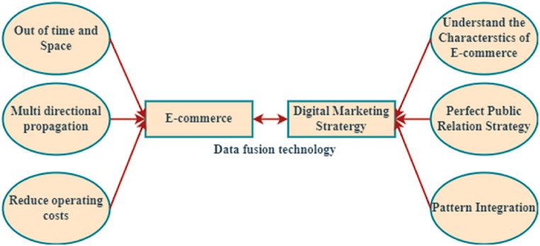

*Fig 1. E-commerce and marketing characteristics relationship*

**3. Literature Review**

The study conducted by **Stocker et al. (2019)** examined firm-stakeholder interactions through analysis of sustainability reports from 119 energy sector companies across 40 different nations. The authors evaluated three stakeholder engagement methods which included information strategy along with response strategy and involvement strategy. Such companies demonstrate greater quality practices and disclosure levels than voluntary minimums. Participating organizations choose lower engagement levels which results in such practices and disclosures becoming their preferred approach. The research analyzes nine strategic quadrants that serve as both an enhancement model for sustainability reports as well as a tool to understand stakeholder behavior. Through this matrix stakeholders can identify strategies that will boost their involvement with sustainability reporting.

The introduction of deep learning algorithms through artificial intelligence brings unprecedented changes which **Shrestha et al. (2021)** have rekindled theoretical and research efforts in management decision-making and organizational studies. Deep learning techniques create opportunities for businesses to support their organizational decision-making process through improved information management for workers and enhanced analytical tasks which may transition organizations toward creative activities. The paper introduces deep learning augmented decision-making as the process where decision processes use DL algorithm outputs or structured data from unstructured sources to establish reliable organizational patterns.

The paper by **Tolstoy et al. (2022)** evaluates factors influencing international e-commerce SME performance through a focus on worldwide e-business market patterns. A study framework based on the capability’s perspective and market orientation theory involved 99 Swedish e-commerce-exporting SMEs through linear regression and mediation analysis to confirm its development. The study discovered that even though OM constitutes vital organizational capabilities it fails to generate e-business performance outcomes. The balance between market-driven and market-driving strategies which constitutes market orientation ambidexterity emerges as a leading force to achieve operational management outcomes. Because of this discovery eSME developers must combine their capabilities with market orientation approaches to achieve positive performance from global e-commerce efforts among SMEs.

The paper by **Habib et al. (2022)** investigates how digital media marketing (DMM) affects consumer engagement and brand image and purchase intention levels of OTT platforms in India's market. The research performed on 417 consumer participants demonstrates that DMM does not independently influence purchase intention. Between these two variables exists a significant mediating effect that leads to the connection between brand image and consumer engagement. Indian OTT platforms demonstrate the crucial role which digital marketing plays in improving customer engagement. This study features managerial recommendations together with recommendations for future research.

**Kaur & Kapil (2023)** argue that digital marketing initiatives heavily rely on customer engagement specifically through internet and social media interactions. The review presents several methods for engagement measurement which include quantitative approaches like click through rates and conversion rates along with qualitative approaches using sentiment analysis and receiving feedback. The behavior analysis of customers depends heavily on AI alongside machine learning and data analytics according to this study. The strategy requires combined measurement frameworks as the basis to develop lasting customer relationships. These digital marketing strategies can be enhanced through the provided recommendations to improve customer satisfaction.

**Nuseir et al (2023)** performs a systematic review to examine digital marketing approaches which improve customer experiences. Amongst eWOM (word of mouth) email marketing affiliate marketing and social media marketing (SMM) the last strategy proves most efficient for creating marketing outcomes. Value creation for customers heavily depends on personalization and customization and interactive approaches according to the study findings. The marketing professional can select the optimal digital strategies through this assessment process. The analysis reveals modern trends in communication marketing along with their consequences for customer experience.

The study by **Sikh et al. [2024]** investigates digital marketing patterns in business focusing on personalization effects on customer satisfaction alongside customer loyalty and trust. Public and academic findings demonstrate personalization has become the number one strategic priority for 78 percent of companies in their promotional activities. Social media together with interactive content creates brand advocacy through enhanced customer relationships for your brand. Data integration difficulties and organizational silos receive notice in this document before the recommendation of omnichannel strategy is made. Emerging technological opportunities provide organizations the chance to deliver enhanced customer contact points while creating superior experiences.

**Umunna et al., (2024)** has conducted a qualitative research examining how leaders implement social media marketing to merge customer acquisition with customer engagement (Umunna, 2021). Approach to success evaluation, risk and opportunity assessment and different social media platforms and marketing communications emerged from interviews conducted with six executive respondents in the United States. The authors propose developing communication methods that operate on social platforms to target users as prospective customers. Special attention is paid to the potential of social platforms to activate local business networks which generates employment opportunities. Social media functions as an essential element for managing customer relationships according to the research results.

**Chaurasia & Parmar (2023)** analyzed online customer engagement (OCE) strategies which enable businesses to reach their maximum customer connections. The study evaluated the essential antecedents and conclusions together with the creation of OCE approaches by analyzing literature from 2013 to 2023. The study establishes the importance of knowing digital customer interactions for business expansion. This research concludes its limitations and future directions through the identification of requirements for new OCE practice developments. Businesses need these study findings to develop strategies which will increase customer loyalty throughout extended online engagement.

This paper reviews the increasing importance of home sharing in the sharing economy while proposing a total review of manufacturing marketing and tourism research knowledge according to **Lim et al. (2021)**. The research uses a framework based systematic review approach to examine the antecedents, decisions and outcomes (ADO) in home sharing and the theories, contexts and methods (TCM) that previous studies have used. The paper identifies current research gaps while developing an action plan to fill those gaps and demonstrates directions for upcoming studies about home sharing in tourism and marketing fields.

**Adam et al. (2020)** examined digital marketing platform implications which help Aceh Indonesian creative industry SMEs obtain supply chain management capabilities together with customer loyalty assistance. The analysis of customer survey responses with 219 individuals shows digital supply chains combined with online media lead to improved satisfaction and loyalty but consumers fail to show loyalty with product reviews. This study demonstrates how digital technology strengthens regional economic performance through supply chain management channels that drive customer satisfaction toward better product output quality.

**According to SHKARLET et al., (2020)** the global digital transformation forces enterprises to adjust their operational model quickly in response to external changes while reforming their commercial production processes as well as marketing practices and communication methods and consumer relationship elements. This paper utilizes a criterion-based method to demonstrate the divergent characteristics between traditional economic systems and digital economic systems based on production approaches and geographical locations and payment methods and communication methods. The study analyzes how digitalization affected businesses both globally and specifically in Ukraine through counting national economic data from 2018. This research established both advantages and obstacles during digital transformation thus creating reasons for organizations to adopt digital capabilities. The analysis presents both positive aspects and negative implications of digitalization when used in enterprise operations.

Research into digital business transformation requires digital marketing to be its core foundation for digital business achievement. This document investigates digital marketing strategies which serve as the central hub for implementing digital business changes. The document aims to bring order to fragmented conceptual aspects about digital marketing by describing its core benefits alongside its drawbacks. Companies need to understand these elements to determine suitable digital marketing strategies which match their target segments and maximize their digital marketing tools' effectiveness

**Homburg and Wielgos (2022)** carried out study to ascertain how Traditional Marketing Capabilities (CMCs) and Digital Marketing Capabilities (DMCs) enhance corporate profitability. Using a mixed research approach, the study examines organizational and environmental factors that influence the cumulative impact of DMCs and confirms that they generate significantly higher profitability than CMCs. In order to keep digital and traditional resources from displacing one another, the study offers useful suggestions for businesses looking to determine the best way to integrate DMC and CMC usage.

The authors of this research examine the effects of digital marketing tactics and e-business skills on the performance of e-commerce businesses in UAE industry contexts. According to a research of 135 e-commerce businesses, there is a basic relationship between their skills and consumer happiness as well as loyalty levels. Building e-business infrastructure systems is emphasized in the research, as this leads to the development of digital marketing tactics that give businesses a competitive edge in online marketplaces.

**Raghavan and Pai (2023)** Using their ABCD approach of Advantage, Benefit, Constraints, and Disadvantage, determine the main elements influencing the model. Using both qualitative and quantitative methodologies in addition to focus group discussions, an analysis reveals that people prefer internet shopping. The framework's success rate in providing academics with fresh perspectives on e-commerce consumer interaction study directions is demonstrated by empirical data.

This research investigates the mediating role of service quality between digital marketing strategies and customer engagement of Cyprus restaurant industry. This study analyzed 200 respondents to establish that digital marketing leads to better service quality understanding which results in positive customer engagement outcomes. Hospitality services achieve maximum success by employing digital marketing strategies with quality service to build customer loyalty.

**Saura et al. (2019)** uses innovative business strategies and digital marketing (DM) techniques to illustrate how information technologies and the Internet impact company circumstances. The study provides information on the main players in e-commerce, outlines common e-commerce system types, and lists key digital marketing tools. The collected data serve as a basis for further research in this developing topic and offer more insight into the components of commercial advantage.

**Watanabe and Shafiq (2023)** carried out a study that examined how digital marketing affected three aspects of business practices: branding, sales growth, and product positioning. Utilizing quantitative research techniques, the study employed survey devices to collect data from companies in several industries. The results of many regression tests showed a strong positive correlation between the three performance measures and digital marketing strategies. According to the analysis, the key success elements for this campaign were social media involvement, SEO, and targeted advertising. Because digital marketing techniques improve branding efficacy, optimize position management, and drive sales, they should be given top priority by businesses in order to succeed in the digital market.

.

**Hidayat et al., (2024)** shown by their research that while ERT is linked to WD, RL, and PEU, it also influences OT and EST alterations. SEM analysis on 256 participants shows that ERT is significantly impacted by RL, PEU, and OT, but WD and EST have no discernible effects. According to the research, increasing online retention can be achieved by emphasizing e-retention engagement tactics in addition to website information enhancement, graphic enhancements, and usability improvements.

.

**Razak (2023)** emphasizes effective marketing techniques that fuel business competition in the modern day, as well as digital client engagement. Using a qualitative descriptive technique, researchers found that in order for businesses to flourish, they need to publish high-quality digital content, embrace new technologies, create loyalty programs, be responsive on social media, and offer tailored experiences. Developing products with customer involvement and ongoing user feedback results in stronger long-term partnerships. This study provides insights for increasing consumer involvement in digital transformation.

**Himki et al., (2022)** describes an assessment of the literature on digital business in e-business to examine how it affects modern commerce structures. Online purchasing has transformed how consumers view products and discuss prices, making them more convenient. Platforms for online transactions make business-to-consumer transactions quick and efficient, which is advantageous to both sides. When compared to companies using traditional promotion techniques, Internet advertising leads to a greater increase in sales. Through extensive supplier and buyer networks that offer flexible business solutions to all customers across markets, digital business fosters entrepreneurship.

**According to Baskoro (2024)** This study looks at how e-business is affected by digital disruption by analyzing how emerging technologies affect market evolution. The use of blockchain, artificial intelligence, and customer-centric initiatives, along with organizational flexibility, are all necessary for manufacturers to sustain their market leadership. According to research, companies may effectively handle upheavals and seize opportunities by combining innovative technologies, organizational adaptability, and optimized customer experience. A careful examination of the research yields useful information that guides digital business organizations toward long-term success in the digital age.

**The research by Krishna et al., (2022)** examines how machine learning (ML) enhances demand forecasting, purchasing behavior analysis, customer contact, and cross-selling skills to improve e-business operations. SEM and SPSS research examination of data from 343 retail e-business managers shows how ML technology helps companies predict client requests while streamlining processes and enhancing customer interaction. ML-based strategies optimize user engagement, track customer numbers, and optimize the supply chain, all of which contribute to long-term corporate growth and market leadership, according to research. The study provides useful information about using ML to e-business success.

**Meria et al., (2023**) Analyze the impact of digital marketing initiatives on client satisfaction while evaluating the shift from traditional to online marketing strategies. Important findings about effective market segmentation, platform selection, compelling content creation, SEO implementation, and continuing customer interactions were obtained through the use of secondary data research and a descriptive technique. Businesses can optimize their approach and enhance consumer satisfaction in contemporary digital markets by implementing application-based methods that rely on both internal and external evaluation.

According to **Panjaitan (2022)** In order for the creative economy to become more competitive, consumer engagement is a crucial prerequisite. Because social media marketing provides a solid marketing basis for product promotion through brand image management, it is required by today's corporate standards. In order to determine whether customer engagement serves as a mediator between social media marketing activities for consumer engagement and brand image created through relational social media marketing, researchers conducted an investigation. Probability sampling is the method used in this study, which combines quantitative data collection methodologies. Simple random sampling was used in conjunction with questionnaire distribution to acquire sample data from 100 respondents. The studied data underwent routine survey processing using SPSS 25 software. The results of this study demonstrate the importance of mediation in this inquiry.

**Habib (2020**) shows how customer experience acts as a mediating variable in the relationship between social media marketing and the propensity to purchase lifestyle products. Among 279 Indian participants in Lucknow, social media marketing improves the customer experience, but it has no discernible direct impact on purchase readiness. Customers' experiences with goods or services have a major influence on the purchasing process. According to the study, companies should give social media top priority in order to engage with their clientele by providing useful material and cultivating brand loyalty, which will result in improved customer experiences and increase sales.

.

Business experiences total transformation because of the Internet according to **UKAJ et al., (2020).** The researchers aim to quantify the impact of e-business on firm growth and operational productivity. To create knowledge that may be applied to new research projects that further the field's advancements, the study looks at present e-business practices. Data for the study was gathered using survey research techniques. Using reliability and correlation testing techniques, the SPSS software examined the information gathered from 60 of the 80 distributed questionnaires that were acceptable. E-business has a significant positive impact on the growth of commercial activity and company performance in Kosovo. The study found that various online marketing strategies provide clear connections to customer satisfaction. Since e-business

**Putri and Sfenrianto (2023)** In the modern, digitalized business environment, social media is an essential component of marketing and promotion strategies. Because social media is growing so quickly, it is critical for both small and large organizations to understand how it affects marketing. Business owners that use social media as a marketing tool must establish a close relationship with their followers or members.

**Fatmayati and Muthmainah (2023)** This study offers a thorough bibliometric analysis of the state of e-business systems, looking at citation patterns, publishing trends, key figures, and recurring research topics. E-business systems have changed how businesses operate today due to changes in customer behavior and technology breakthroughs. This study shows how research in this dynamic topic has evolved through methodical data collecting and analysis. The results highlight how e-business systems are multidisciplinary, encompassing marketing, strategy, information technology, and more. A road map for academics, professionals, and policymakers to traverse the changing terrain of e-business systems is provided by the identification of significant writers, recurring themes, and new paths.

1. **Table 1-Discussion and Compression**

|  |  |  |  |  |  |  |
| --- | --- | --- | --- | --- | --- | --- |
| Study | Aim | Key Findings | Methodology | Focus Area | Contribution | Discussion |
| Stocker et al., 2019 | Analyze stakeholder engagement levels in sustainability reports. | Companies focus on low-complexity engagement strategies (information, response) despite the high quality of involvement strategies. | Analysis of 119 sustainability reports | Stakeholder Engagement in Energy Sector | Proposes a matrix of engagement strategies for enhancing sustainability reports. | Highlights the gap between the quality of stakeholder engagement strategies proposed and their actual implementation, suggesting practical improvements. |
| Shrestha et al., 2021 | Explore decision-making augmented by deep learning in organizations. | Deep learning (DL) aids decision-making by augmenting analytical capabilities, illustrated through two case studies (Zalando, Rotten Tomatoes). | Case studies (Zalando, Rotten Tomatoes) | Deep Learning in Decision-Making | Conceptualizes Deep Learning-Augmented Decision Making (DLADM) for decision support. | Discusses how deep learning technologies can bridge analytical gaps in organizational decision-making processes, enhancing precision and efficiency. |
| Tolstoyv et al., 2022 | Investigate performance variations in international e-commerce SMEs. | Marketing ambidexterity (both market-driven and market-driving approaches) is crucial to leveraging online marketing capabilities for performance. | Linear regression and mediation analysis | International E-commerce Performance | Highlights the importance of marketing ambidexterity for SMEs in international e-commerce. | Explores the critical role of balancing market-driven and market-driving strategies to optimize SME performance in competitive global markets. |
| Habib et al., 2022 | Study the impact of digital marketing on OTT platforms in India. | DMM influences purchase intention indirectly through brand image and consumer engagement. | Survey of 417 consumers | Digital Marketing in OTT Platforms | Identifies the mediating role of brand image and consumer engagement in OTT purchase intention. | Emphasizes the indirect role of brand image and consumer engagement in shaping purchase intentions on OTT platforms. |
| Kaur & Kapil, 2023 | Discuss customer engagement measurement in digital marketing. | Customer engagement is multifaceted; both quantitative (click-through rates) and qualitative (sentiment analysis) metrics are essential. | Literature review and framework analysis | Customer Engagement Measurement | Provides a framework for measuring customer engagement using both traditional and emerging metrics. | Provides an integrated perspective on combining quantitative and qualitative approaches to comprehensively measure customer engagement. |
| Nuseir et al., 2023 | Examine digital marketing strategies and their impact on customer experience. | Social Media Marketing is the most effective strategy for maximizing customer experience, as it enables personalization and interaction. | Systematic Literature Review (SLR) | Digital Marketing Strategies | Emphasizes the effectiveness of social media marketing in enhancing customer experience. | Highlights the transformative role of social media marketing in delivering personalized and interactive customer experiences. |
| Sikh et al., 2024 | Explore digital marketing strategies to improve customer engagement. | Personalization and interactive content on social media are key to customer engagement and loyalty. | Literature review, survey, and interviews | Customer Engagement Strategies | Highlights the importance of personalization and cross-channel integration for successful digital marketing campaigns. | Discusses the impact of personalization and cross-channel strategies in fostering long-term customer loyalty through enhanced engagement. |
| Umunna, 2021 | Investigate the role of social media in enhancing customer engagement. | Social media marketing strategies, especially through innovative communication, are key to increasing customer engagement. | Qualitative case study with interviews | Social Media Marketing Strategies | Provides recommendations for businesses to use innovative communication channels on social media to improve engagement. | Suggests innovative social media communication techniques as pivotal tools for boosting customer interaction and engagement. |
| Chaurasia & Parmar, 2023 | Explore online customer engagement strategies in e-commerce. | Understanding the drivers of customer engagement and implementing emerging strategies are vital for online success. | Systematic literature review | Online Customer Engagement | Contributes insights into emerging engagement strategies and factors motivating customer interaction in digital e-commerce environments. | Explores drivers and strategies for online customer engagement, emphasizing the need for adaptive and emerging digital marketing tactics. |
| Lim et al. (2021) | Review existing knowledge on home sharing to guide future marketing and tourism research. | Identified antecedents, decisions, and outcomes (ADO) of home sharing; proposed a research agenda to address knowledge gaps. | Framework-based systematic review. | Home sharing in the sharing economy. | Provided a structured review of ADO and TCM (theories, contexts, methods) for home sharing research. | Highlights the need for further research to explore home sharing's impact on marketing and tourism, emphasizing its growing significance in the sharing economy. |
| Adam et al. (2020) | Investigate digital marketing's role in SME supply chain management and customer loyalty. | Digital supply chains and online media significantly boost customer satisfaction and loyalty; product reviews have no significant effect. | Quantitative analysis using survey data from 219 customers. | SMEs in creative industries (Aceh, Indonesia). | Emphasized the role of digital technologies in improving SME competitiveness and regional economic growth. | Demonstrates the importance of integrating digital marketing with supply chain practices to enhance customer satisfaction and loyalty. |
| Shkarlet et al. (2020) | Explore the impact of digitalization on classical vs. digital economic entities. | Digital transformation offers benefits like improved communication and cost efficiency but also presents challenges like adaptation costs. | Criterion-based approach using 2018 statistical data. | Global and Ukrainian enterprises. | Outlined the advantages and disadvantages of digitalization, providing a framework for businesses to adopt digital tools. | Highlights the need for businesses to adapt to digital transformation to remain competitive, while addressing challenges like data security and workforce adaptation. |
| Veleva & Tsvetanova (2019) | Systematize digital marketing terms and analyze its advantages and disadvantages. | Digital marketing is essential for modern business success; understanding its pros and cons helps companies tailor strategies effectively. | Systematic literature review. | Digital marketing in business transformation. | Provided a clear classification of digital marketing terms and its strategic benefits for businesses. | Emphasizes the need for businesses to adopt digital marketing strategies that align with their goals and customer needs to remain competitive. |
| Homburg & Wielgos (2022) | Examine the value of digital marketing capabilities (DMCs) alongside classic marketing capabilities (CMCs). | DMCs significantly enhance firm profitability beyond CMCs; organizational and environmental factors influence their interaction. | Mixed-methods approach (interviews and multi-industry dataset analysis). | Firm profitability and marketing capabilities. | Highlighted actionable insights for balancing DMCs and CMCs to maximize complementary potential. | Discusses the importance of integrating DMCs with CMCs while avoiding substitutive outcomes, offering practical guidance for firms. |
| Solfa et al. (2023) | Explore the joint impact of e-business capabilities and digital marketing on e-commerce performance. | E-business capabilities and digital marketing strategies significantly improve customer satisfaction and loyalty. | Quantitative analysis using data from 135 UAE e-commerce companies. | UAE e-commerce industry. | Emphasized the importance of investing in e-business infrastructure and tailored digital marketing strategies. | Highlights the need for e-commerce firms to adapt to dynamic digital environments by leveraging e-business and digital marketing capabilities. |
| Raghavan & Pai (2023) | Analyze Millennials' online customer engagement using the ABCD framework. | Online shopping is increasingly preferred over traditional stores; identified key factors influencing customer engagement. | Qualitative and quantitative methods, including focus group discussions. | Millennials' e-commerce engagement. | Applied the ABCD framework to analyze customer engagement, suggesting new research directions. | Highlights the growing preference for online shopping and the need for e-commerce platforms to focus on customer engagement strategies. |
| Tokhtiyeva & Esenye (2025) | Investigate the mediating role of service quality in digital marketing and customer engagement. | Digital marketing enhances service quality perceptions, which in turn boosts customer engagement. | Quantitative approach using data from 200 restaurant respondents in Cyprus. | Restaurant industry in Cyprus. | Provided empirical evidence of the interplay between digital marketing, service quality, and customer engagement. | Emphasizes the importance of combining digital marketing with high-quality service to improve customer loyalty and engagement in the hospitality sector. |
| Saura et al. (2019) | Identify key players and digital marketing techniques in e-commerce ecosystems. | Identified main actors in e-commerce ecosystems and their typologies, along with key digital marketing techniques. | Systematic literature review. | E-commerce ecosystems and digital marketing. | Enhanced understanding of how digital marketing and e-commerce models improve business benefits, providing a foundation for future research. | Highlights the transformative role of digital marketing in e-commerce and the need for businesses to adopt these techniques to remain competitive. |
| Watanabe & Shafiq (2023) | Impact of digital marketing on business practices | Digital marketing enhances branding, sales, and positioning | Quantitative, surveys, regression analysis | Digital marketing | Highlights key digital marketing strategies for competitive advantage | Watanabe & Shafiq (2023) |
| Hidayat et al. (2024) | Factors influencing e-retention | Reliability, ease of use, and e-trust drive retention; website design and e-satisfaction have no impact | SEM analysis, 256 respondents | E-retention | Suggests improving engagement, information quality, and ease of use | Hidayat et al. (2024) |
| Razak (2023) | Customer engagement strategies in digital marketing | Social media responsiveness, personalization, and feedback boost engagement | Qualitative, descriptive | Customer engagement | Offers strategies for long-term digital customer relationships | Razak (2023) |
| Himki et al. (2022) | Role of digital business in e-commerce | Digital platforms boost sales and entrepreneurship | Literature review | Digital business | Shows benefits of online promotion over traditional marketing | Himki et al. (2022) |
| Baskoro (2024) | Digital disruption’s impact on e-business | AI, blockchain, and customer-centricity drive adaptability | Literature review | Digital disruption | Guides e-businesses in leveraging technology for market success | Baskoro (2024) |
| Krishna et al. (2022) | ML's role in e-business | ML enhances demand forecasting, engagement, and supply chains | SEM, SPSS, 343 respondents | Machine learning in e-business | Highlights ML strategies for business optimization | Krishna et al. (2022) |
| Meria et al. (2023) | Digital marketing strategies & customer satisfaction | Market segmentation, platform selection, and SEO drive satisfaction | Descriptive, secondary data analysis | Digital marketing | Provides insights on optimizing digital marketing approaches | Meria et al. (2023) |
| Panjaitan (2022) | Customer engagement in social media marketing | Customer engagement mediates brand image and marketing impact | Quantitative, SPSS, 100 respondents | Social media marketing | Emphasizes the mediation role of engagement in branding | Panjaitan (2022) |
| Habib (2020) | Social media marketing & purchase intention | Customer experience mediates purchase decisions; direct social media impact is weak | Survey, 279 respondents | Social media & purchase intention | Suggests social media should enhance engagement & brand loyalty | Habib (2020) |
| UKAJ et al. (2020) | E-business impact on business performance | E-business significantly boosts activity extension and performance | Survey, SPSS, correlation analysis, 60 respondents | E-business performance | Advocates for digital marketing awareness in Kosovo’s business growth | UKAJ et al. (2020) |
| Putri and Sfenrianto (2023) | To analyze the role of social media in marketing promotion techniques and its impact on businesses. | Social media is essential for both small and large businesses, helping in customer engagement and sales growth. | Qualitative research | Social media marketing strategies | Highlights the importance of social media in business marketing and customer relationship building. | Discusses how businesses can leverage social media to enhance engagement and sales. |
| Fatmayati and Muthmainah (2023) | To conduct a bibliometric review of the e-business systems landscape. | E-business systems are evolving with technological advancements and consumer behavior shifts; research spans multiple disciplines. | Bibliometric analysis | E-business systems and digital transformation | Provides a roadmap for scholars and practitioners in e-business research. | Examines influential authors, themes, and emerging research directions in e-business systems. |

These studies function as proof that digital technologies together with marketing strategies have restructured numerous industries including e-commerce hospitality SMEs and tourism. Each research tackles its own specific angle of digital transformation yet shares three primary elements about customer engagement and digital marketing integration and business adaptation to digital dynamism.

The second group of studies determines stakeholder participation with customers as essential for particular business contexts. This research examines sustainability reporting from the energy sector by comparing approaches that yield high quality engagement strategies with the actual implementation methods. Research has been established to address missing knowledge about home sharing operations within the sharing economy framework. The studies demonstrate how essential it is to develop functional structures which boost sustainable reporting participation and tourism involvement.

Other studies during this research examine how advanced technologies influence decision-making functions while enhancing marketing capabilities. Deep Learning-Augmented Decision Making (DLADM) is our method for providing deep learning assistance with organizational decision processes. The research underlines that companies need to concentrate on digital marketing capabilities (DMCs) and classic marketing capabilities (CMCs) because this synergy brings maximum profit gains. The authors support quick business outcome implementation through modern technological advances.

Some research explores how digital marketing strategies coupled with e-commerce systems produce better outcomes for SMEs. The study examines marketing ambidexterity as an essential solution to address international e-commerce problems for small and medium enterprises. The other highlights the participation of digital supply chains and online media in enhancing customer satisfaction and high degrees of customer loyalty in creative industries. These studies establish that flexible digitally integrated approaches are vital for developing SME business competitiveness in international markets.

The second research group reveals how service quality with brand image acts as intermediaries to affect digital marketing performance. A study identifies that brand image together with consumer engagement functions as the digital marketing transmission toward purchase intention across OTT platforms. This research reveals that digital marketing strengthens service quality perception before creating customer engagement within hospitality services. The investigations demonstrate that external stimuli create behavioural and loyalty patterns.

Research examines both components which contribute to customer engagement as well as digital marketing elements. The study presents expert evaluation to assess both the qualitative and quantitative elements of customer engagement measurement emphasizing the requirement for a comprehensive approach. The survey participant supports social media marketing as the strongest methodology for customer experience improvement because it requires tailored interactions and personalization. The two studies collaborate to create customized marketing approaches using data analytics for improved client engagement.

The second look at personality, personalization and social media in customer engagement. A first key element concerns the personalization methods combined with cross channel integration in digital marketing campaigns and a second element focuses on innovative social media communications approaches. The authors argue that businesses should deliver unique content with interactive elements because this strategy creates loyal customers in the long term.

Research provides expanded insights about engagement in online customer behaviour and e-commerce systems. The article first assesses new techniques for online customer engagement followed by an exploration of how digital marketing needs to adapt its responses. The third section details key participants together with digital marketing techniques for e-commerce systems and shows how enhanced business benefits emerge from digital marketing applications. These findings confirm that businesses should recognize and maximize the value of digital ecosystems to achieve better customer engagement alongside business performance outcomes.

**5. Extract Statics**

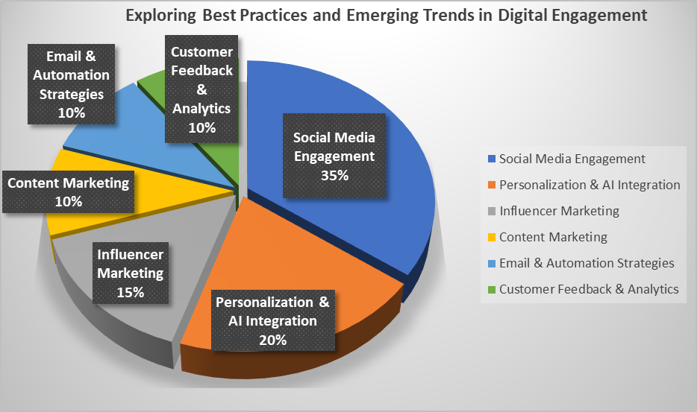5.1. Exploring Best Practices and Emerging Trends in Digital Engagement

*Figure 2: shows Exploring Best Practices and Emerging Trends in Digital Engagement*

The pie chart shows response "Exploring Best Practices and Emerging Trends in Digital Engagement" illustrates the distribution of key digital marketing strategies based on their significance. Social Media Engagement dominates the chart at 35%, highlighting its crucial role in customer interaction. Personalization & AI Integration follows at 20%, emphasizing the growing importance of tailored marketing experiences. Influencer Marketing accounts for 15%, showcasing its impact on brand reach and trust. Content Marketing, Email & Automation Strategies, and Customer Feedback & Analytics each contribute 10%, reflecting their steady role in maintaining customer engagement and data-driven decision-making. The chart suggests that businesses should prioritize social media and AI-driven personalization while integrating influencer partnerships, content strategies, and automated communication for a well-rounded digital engagement approach.

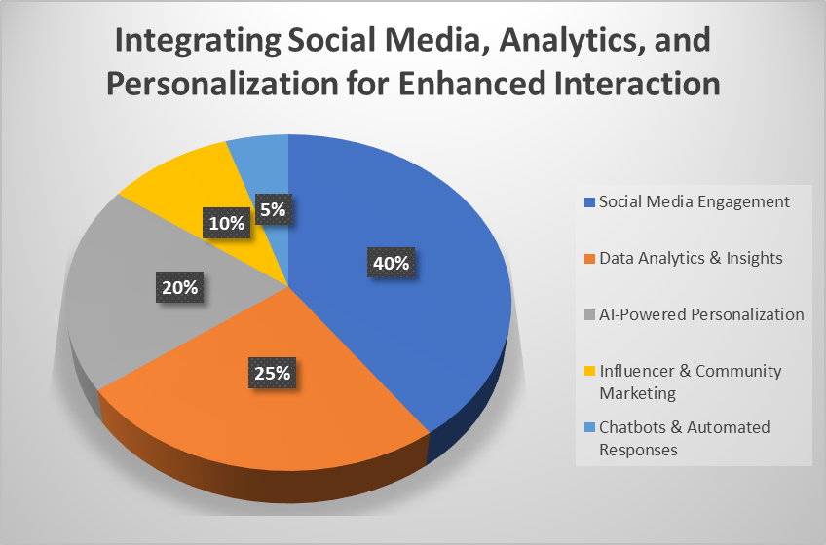5.2. Integrating Social Media, Analytics, and Personalization for Enhanced Interaction

*Figure 3: Integrating Social Media, Analytics, and Personalization for Enhanced Interaction*

The pie chart titled "Integrating Social Media, Analytics, and Personalization for Enhanced Interaction" highlights the relative importance of each component in a comprehensive digital engagement strategy. Social Media Engagement leads with 40%, emphasizing its vital role in reaching and connecting with audiences. Data Analytics & Insights at 25% underscores the necessity of gathering and interpreting user data to inform strategic decisions. AI-Powered Personalization, at 20%, demonstrates the growing demand for tailored experiences that resonate with individual consumers. Influencer & Community Marketing, making up 10%, points to the effectiveness of leveraging key opinion leaders and engaged communities for broader reach. Finally, Chatbots & Automated Responses represent 5%, indicating the early yet expanding adoption of automated communication tools to enhance customer support and streamline interactions.

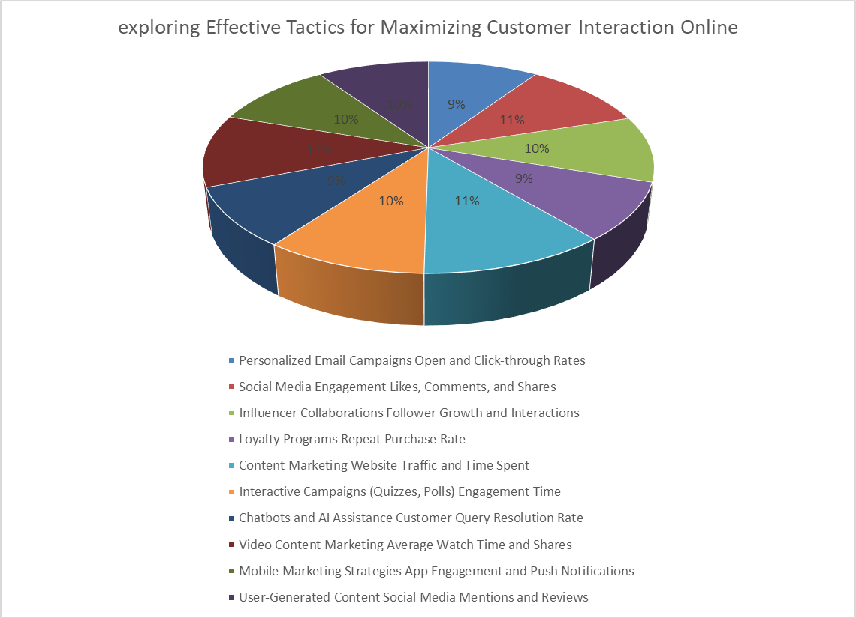5.3. Exploring Effective Tactics for Maximizing Customer Interaction Online

*Figure 4: shows Tactics for Maximizing Customer Interaction Online*

The pie chart shows multiple online customer interaction methods which together enable maximum customer interaction. The individual segments from the digital marketing plan include personalized email campaigns as well as social media engagement and influencer collaborations and loyalty programs alongside content marketing. The chart shows a balanced approach of these tactics since all categories contain percentages that match closely and equally which indicates customers received similar impacts from each strategy type. The majority of customer engagement facilitation occurs through interactive campaigns and AI chatbots alongside mobile marketing strategies because technology remains vital in customer interactions. The article maintains a balanced perspective to demonstrate numerous fundamental approaches utilized in digital marketing which leads to productive digital marketing initiatives.

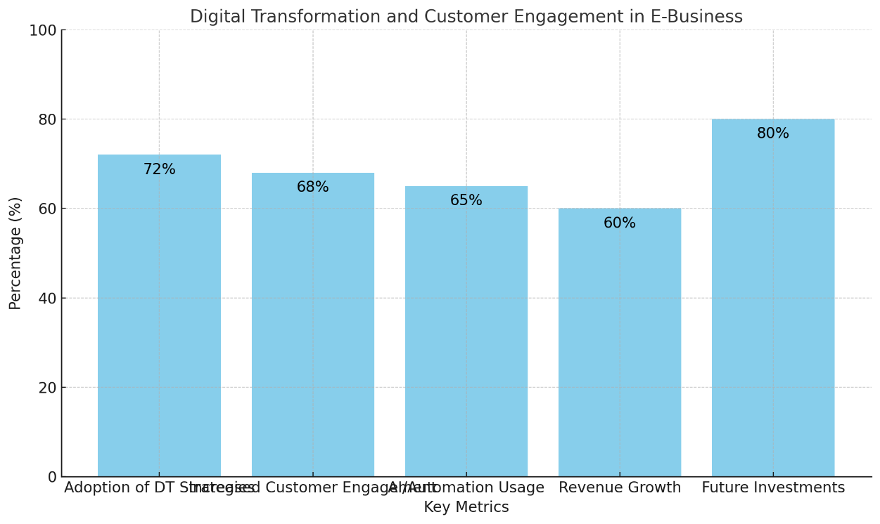5.4. Digital Transformation and Customer Engagement in E-Business

*Figure 5: shows Digital Transformation and Customer Engagement in E-Business*

Responses regarding digital transformation's effects on e-business key metrics appear in this visual presentation. The data reveals that business organizations using digital transformation strategies achieve higher customer engagement numbers to the extent of 72%. Office automation tools have received increased use across 68% of business organizations. DT implementation leads to revenue expansion because 65% of businesses noticed growth in their earnings. Digital transformation initiatives have become central priorities for businesses since 60% of them will invest in these advancements during the next three years. E-business sector performance relies significantly on DT because it boosts customer engagement together with operational efficiency and financial outcomes.

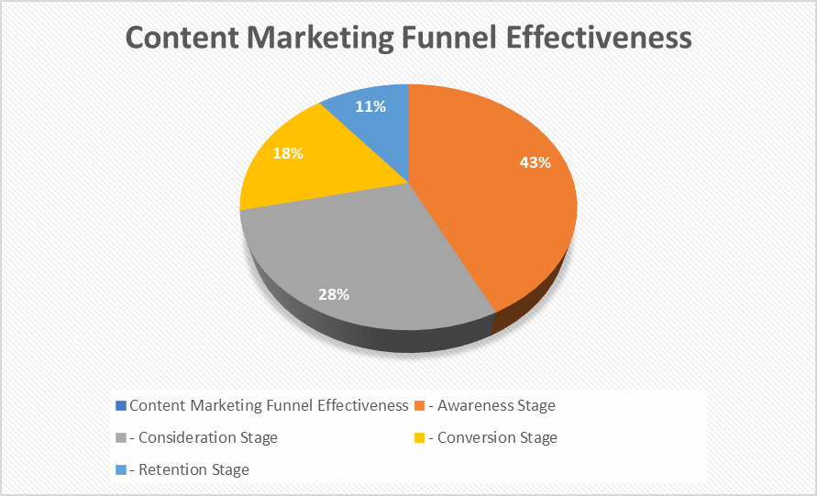5.5. Content Marketing Funnel Effectiveness

*Figure 6: Content Marketing Funnel Effectiveness*

The graphic named "Content Marketing Funnel Effectiveness" displays how different stages of the customer journey perform regarding content marketing strategies. 60% of the population responds positively to content-based campaigns in the Awareness Stage ensuring potential customers see and engage with the material. The Consideration Stage maintains 40% effectiveness because customers show medium involvement during their selection process. A quarter of the audience reaches the Conversion Stage because this stage achieves 25% effectiveness towards motivating desired actions including buying decisions. The lowest level of effectiveness in the Retention Stage stands at 15% because customer retention requires exceptional effort. Optimizing content strategies throughout all stages remains vital for achieving enhanced overall funnel results according to the presented chart.

1. **Conclusion**

Every advanced e business operation requires dedicated customer engagement methodologies. Strategies of social engagement on social media enhanced by artificial intelligence and personalized marketing enable better customer loyalty and business outcomes. An effective digital marketing contains two vital components: market interaction along with measured market introductions that unify quantitative relationship metrics with subjective evaluation. Companies today face an obligation to find fresh opportunities which will allow them to preserve their advantageous position and keep their members loyal. A combination of AI-driven advanced technology allows organizations to automate business processes while making consumer behavior predictions for enhanced personalized experiences at varying degrees of scale. The use of AI-powered analytics tools helps businesses perform extensive data evaluation to identify deeper customer preferences regarding their purchasing habits and their critical shopping challenges. The improved targeting abilities of enhanced marketing campaigns because of this approach lead to better consumer loyalty and beneficial business results.

A company executes market involvement and immersion to reach complete immersion in its marketplace while staying attentive to customer needs. Companies need essential quantitative and qualitative indicators to adequately measure the results of their customer engagement program. Surveys and sentiment analysis and customer interviews provide useful insight about customer sentiment but business owners need concrete numbers from conversion rates alongside customer acquisition costs and customer lifetime value.

1. **Recommendations**

Organizations should use personalized approaches in digital marketing to draw customer interest towards e-business.

The text investigates how social networking technologies allow companies to create outreach campaigns while enhancing brand recognition to their target audience.

Businesses need to select components from two groups:

•Market integration and domination strategies.

•Intelligent, Machine und Deep Learning

Measuring organizational engagement requires assessment through quantitative and qualitative indicators to monitor customer actions.

Quantitative indicators:

•Website traffic.

•Conversion rates.

•Customer lifetime value.

Qualitative indicators:

•Customer surveys.

•Reviews.

•Social media sentiment analysis.

A complete understanding of customer behavior emerges through the evaluation of these indicators which allows necessary corrections to be made.

Organizations must maintain constant innovation while showing adaptability to maintain their market competitiveness.

The rate of technological change keeps rising thus organizations need to develop their ability to adapt.

Companies need to adjust quickly to new technologies alongside digital applications alongside various new technologies including high-end artificial intelligence and new social media networks.

Adaptability ensures businesses can:

The organization needs to remain adaptable to current market conditions as well as constant shifts in customer preferences.

Organizations need to guarantee sustainability during periods of rising technological utilization.

Companies achieve success by combining personalization with advanced technologies together with flexible methods.

•Sustain a competitive edge.

Thrive in the digital age.

**References**

1. Kapoor, K. K., Dwivedi, Y. K., & Piercy, N. F. (2020). Digital marketing strategies and customer engagement: A systematic review. Journal of Business Research, 109, 415-431.
2. Lee, H. H., Choi, Y. Y., & Kim, S. M. (2021). Consumer engagement in the digital age: Exploring the role of social media platforms. Journal of Interactive Marketing, 54, 38-53.
3. Morgan-Thomas, A., & Veloutsou, C. (2021). The role of digital marketing in fostering customer engagement. International Journal of Marketing Research, 63(4), 471-492.
4. Wang, X., & Zhang, J. (2022). The impact of AI-driven digital marketing on customer engagement: The rise of automation. Journal of Business and Technology, 14(2), 89-105.
5. Ajzen, I. (2020). The theory of planned behavior. Organizational Behavior and Human Decision Processes, 50(2), 179-211.
6. Brodie, R. J., Hollebeek, L. D., Jurić, B., & Ilić, A. (2019). Customer engagement: Conceptual domain, fundamental propositions, and implications for research. Journal of Service Research, 24(3), 243-264.
7. Grönroos, C. (2020). Relationship marketing: A critical perspective. Marketing Theory, 20(4), 487-506.
8. Rosita1, Masduki Asbari (2023), Scope of e-Business & e-Commerce to Business and Modern Life, JOURNAL OF INFORMATION SYSTEMS AND MANAGEMENT, Vol. 02 No. 01
9. Hollebeek, L. D., Srivastava, R. K., & Chen, T. (2021). Customer engagement in the digital age: Theory and practice. Journal of the Academy of Marketing Science, 49(3), 370-391.
10. Lemon, K. N., & Verhoef, P. C. (2021). Understanding customer experience throughout the customer journey. Journal of the Academy of Marketing Science, 49(6), 866-889.
11. Thompson, D. V., & Malaviya, P. (2021). Consumer responses to personalized digital marketing: The role of customization and engagement. Journal of Consumer Psychology, 31(4), 636-649.
12. Merdin Shamal Salih, Rowaida Khalil Ibrahim, Subhi R. M. Zeebaree, Dilovan Asaad Zebari, Lozan M. Abdulrahman and Nasiba Mahdi Abdulkareem, (2024), Diabetic Prediction based on Machine Learning Using PIMA Indian Dataset, Communications on Applied Nonlinear Analysis, Vol 31 No. 5s.
13. Saad Hikmat Haji, Adel Al-zebari, Abdulkadir Sengur, Shakir Fattah Kak and Nasiba Mahdi Abdulkareem (2023), Document Clustering in the Age of Big Data: Incorporating Semantic Information for Improved Results, Journal of Applied Science and Technology Trends Vol. 04, No. 01, pp. 34 –53.
14. Zhwan M. Khalid, Subhi R. M. Zeebaree (2021), Big Data Analysis for Data Visualization: A Review, International Journal of Science and Business, Volume: 5, Issue: 2 Page: 64-75.
15. Revella E. A. Armya, Lozan M. Abdulrahman, Nasiba M. Abdulkareem and Azar Abid Salih (2023), Web-based Efficiency of Distributed Systems and IoT on Functionality of Smart City Applications, Journal of Smart Internet of Things (JSIoT), VOL 2023, No.02 | 142-16.
16. Yash Raj Shrestha, Vaibhav Krishna, Georg von Krogh (2021), Augmenting organizational decision-making with deep learning algorithms: Principles, promises, and challenges, Journal of Business Research,
17. Fabricio Stocker, Michelle P. de Arruda, Keysa M. C. de Mascena, Jo~ao M. G. Boaventura (2019) Stakeholder engagement in sustainability reporting: A classification model
18. Daniel Tolstoy, Emilia Rovira Nordman, Uyen Vu (2022), The indirect effect of online marketing capabilities on the international performance of e-commerce SMEs, International Business Review
19. Sufyan Habib, Nawaf N. Hamadneh, and Asif Hassan (2022), The Relationship between Digital Marketing, Customer Engagement, and Purchase Intention via OTT Platforms, Journal of Mathematics Volume 2022, Article ID 5327626.
20. Sandeep Kaur, Dr. Rajinder Kapil (2024) Measuring Customer Engagement in Digital Marketing, Journal for Re Attach Therapy and Developmental Diversities, Vol. 6 No. 6s
21. Mohammed T. Nuseir, Ghaleb A El-Refae and Ahmad Ibrahim Aljumah (2023), Digital Marketing Strategies and the Impact on Customer Experience: A Systematic Review
22. Dr Gurmeet singh sikh, Dr Sandeep Nandram Dive, Ms. Inchara P, Dr. Pramod Kumar, Dr. Madhuri Prakash Kamble and Dr Asha Karbhar Shinde (2024), Digital Marketing Strategies to Improve Customer Experience and Engagement, Journal of Informatics Education and Research, Vol 4 Issue 2
23. Sufyan Habib, Nawaf N. Hamadneh, Asif Hassan (2022), The Relationship between Digital Marketing, Customer Engagement, and Purchase Intention via OTT Platforms, Journal of Mathematics.
24. Joe Umunna (2021), Social Media Marketing Strategies for Increasing Customer Engagement, Walden University, Doctor of Business Administration
25. Archna Chaurasia, Dr Swarna Parmar (2023), Online Customer Engagement A Systematic Literature Review, International Journal for Multidisciplinary Research,
26. Xie Chao, Xiao Xiaoyong, Hassan Dina K. Data mining and application of social e-commerce users based on big data of internet of things. J. Intell. Fuzzy Syst. 2020;39(4):5171–5181
27. Yin Yuyu, Zhang Rong, Gao Honghao, Xi Meng. New retail business analysis and modeling: a Taobao case study. IEEE Trans. Comput. Soc. Syst. 2019;6(5):1126–1137
28. Li Xiaochun, Huang Dan. Research on value integration mode of agricultural e-commerce industry chain based on internet of things and blockchain technology. Wireless Commun. Mobile Comput. 2020; 2020:1–11.
29. Xu Yao-Zhi, Zhang Jian-Lin, Ying Hua, Lin-Yue Wang. Dynamic credit risk evaluation method for e-commerce sellers based on a hybrid artificial intelligence model. Sustainability. 2019;11(19):5521.
30. Eltweri Ahmed, Faccia Alessio, Khassawneh O.S.A.M.A. 2021 3rd International Conference on E-Business and E-Commerce Engineering. 2021. Applications of big data within finance: fraud detection and risk management within the real estate industry; pp. 67–73.
31. Weng Marc Lima, Sheau-Fen Yap, Marian Makkar (2021), Home sharing in marketing and tourism at a tipping point: What do we know, how do we know, and where should we be heading? Journal of Business Research, pp 534 – 566
32. Muhammad Adam, Mahdani Ibrahim, Ikramuddin, Hendra Syahputra (2020), The Role of Digital Marketing Platforms on Supply Chain Management for Customer Satisfaction and Loyalty in Small and Medium Enterprises (SMEs) at Indonesia, International Journal of Supply Chain Management, Vol. 9, No. 3
33. SERHIY SHKARLET, MAKSYM DUBYNA, KHRYSTYNA SHTYRKHUN and LIUDMYLA VERBIVSKA (2020), Transformation of the Paradigm of the Economic Entities Development in Digital Economy, WSEAS TRANSACTIONS on ENVIRONMENT and DEVELOPMENT, Volume 16
34. S S Veleva1 and А I Tsvetanova (2019), Characteristics of the digital marketing advantages and disadvantages, IOP Conference Series: Materials Science and Engineering,
35. Christian Homburg & Dominik M. Wielgos (2022), The value relevance of digital marketing capabilities to firm performance, Journal of the Academy of Marketing Science 50:666–688
36. Federico Del Giorgio Solfa, Sandra Cristina De Oliveira, Fernando R. Simonato (2023), Stimulating E-Business Capabilities and Digital Marketing Strategies on Business Performance in E-Commerce Industry, international Journal on Computations, Information and Manufacturing (IJCIM) 3(2)
37. Suresh Raghavan & Ramesh Pai (2023), Quantitative Evaluation of “e-Customer Engagement Strategies” of Millennials for Online Brands, through ABCD Analysis Framework, International Journal of Management, Technology, and Social Sciences (IJMTS), ISSN: 2581-6012, Vol. 8, No. 1.
38. Zhokhargul Tokhtiyeva, Ismet Esenye (2025), Digital Marketing Strategies for Enhancing Customer Engagement: Unpacking the Mediating Effect of Service Quality, Journal of System and Management Sciences Vol. 15 (2025) No. 3, pp. 18-43
39. Saura, J. R., Palos-Sanchez, P. R., & Correia, M. B. (2019). Digital marketing strategies based on the e-business model: Literature review and future directions. *Organizational transformation and managing innovation in the fourth industrial revolution*, 86-103.
40. Woramol Chaowarat Watanabe, Muhammad Shafiq (2023), A Study on the Impact of Digital Marketing on Business Practices, Original Article, Volume: 3, Issue: 1 Pages: 1-10.
41. Rahmat Hidayat, Yolanda Masnita Siagian and Kurniawati (2024), Adapting to the digital age: Strategies for enhancing customer engagement and retention in e-commerce, Journal of Innovation in Business and Economics Vol. 08 No. 02.
42. Ismail Razak (2023), Customer Engagement in the Digital Age: Marketing Strategies that Win Consumers' Hearts, JURNAL PENDIDIKAN INDONESIA, VOL 02. No. 01.
43. Arzo Himki, Tarisya Ramadhan, Yusuf Durachman and P. Erry Sigit Pramono (2022), Digital Business Entrepreneurship Decisions: An E-Business Analysis (A Study Literature Review, Startupreneur Business Digital (SABDA), Vol.1 No. 1.
44. Tia Baskoro (2024), Digital Disruption: Landscape of E-Business for Competitive Advantage, Advances in Business & Industrial Marketing Research, 2(1).
45. Dr. Somanchi Hari Krishna, Alok Upadhyay, Mallika Tewari, Anita Gehlot, Dr. B. Girimurugan and Dr. Sumit Pundir (2022), Empirical investigation of the key machine learning elements promoting e-business using an SEM framework, 5th International Conference on Contemporary Computing and Informatics (IC3I), pp 1960 – 1964.
46. Lista Meria1, Jihan Zanubiya and Muhamad Alfi Duwi Juliansah (2023), Increasing Consumers with Satisfaction Application based Digital Marketing Strategies, Startupreneur Bisnis Digital (SABDA) Vol.2 No. 1.
47. Roymon Panjaitan (2022), Mediating Role of Customer Engagement: Brand Image Enhancement from Social-Media Marketing, Jurnal Maksipreneur: Manajemen, Koperasi, dan Entrepreneurship Vol. 12 No. 1.
48. Sufyan Habib (2022), Mediating Role of Customer Experience in Social Media Marketing and Purchase Intention: A Case Study, Scientific Journal of K F U (Humanities and Management Sciences) Vol.21 (1).
49. Fatos UKAJ, Vehbi RAMAJ and Ramiz LIVOREKA (2020), The Impact of E-Business on Activity Extension and Business Performance, / Journal of Distribution Science, pp. 103-112
50. Fryda Fatmayati, Hanifah Nurul Muthmainah (2023), Mapping the Landscape of E-Business Systems: A Bibliometric Review and Future Research Directions, The Eastasouth Journal of Information System and Computer Science Vol. 01, No. 01.
51. Della Hernita Putri, Sfenrianto (2023), SOCIAL MEDIA MARKETING STRATEGY ANALYSIS AND IMPLEMENTATION TO INCREASE CUSTOMER ENGAGEMENT (CASE STUDY AT PT. XYZ), Journal of Economics and Business UBS, Vol. 12 No. 2.