**A Review of** **Omni-Channel Strategies in E-Commerce: Integrating Online and Offline Customer Journeys**

ABSTRACT

Omnichannel strategies in e-commerce integrate online and offline channels to create seamless, personalized customer experiences. This approach addresses evolving consumer behavior, characterized by a preference for convenience, flexibility, and cross-platform shopping. By merging platforms like physical stores, mobile apps, and social media, omnichannel retail enhances operational efficiency, customer loyalty, and revenue generation. The integration, however, poses challenges, including data synchronization, legacy system compatibility, and channel conflicts. Emerging technologies such as artificial intelligence, IoT, and big data play a pivotal role in overcoming these challenges by enabling real-time synchronization, predictive analytics, and personalized marketing. Practical implementations include click-and-collect systems, dynamic pricing, and tailored in-store experiences, while theoretical foundations like the cognitive-affective-conative paradigm support strategies that improve consumer satisfaction. Despite significant advancements, high implementation costs and technological complexities remain barriers, emphasizing the need for cost-effective innovations. Future research should focus on augmented reality, blockchain applications, and cross-cultural studies to broaden the scope and applicability of omnichannel strategies. By addressing these challenges and leveraging advanced technologies, businesses can adapt to dynamic market demands, fostering sustainable growth and enhanced customer experiences.

KEYWORDS: Omnichannel strategies, Customer Experience, E-commerce integration, Personalization, Digital transformation, Consumer behavior, Online and offline integration.

1. INTRODUCTION

The fast development of digital technology has drastically changed the retail scene worldwide, e-commerce is now the main force behind change. This change has resulted in the idea of omnichannel retailing, a technique that combines several sales and communication channels to produce a smooth and consistent consumer experience [1]. Unlike conventional multi-channel approaches, which often operate in silos, omnichannel retailing stresses a complete integration of online platforms, brick-and-mortar stores, mobile apps, and social media channels, so enabling customers to easily traverse many touchpoints during their shopping journey [2][3][4].

Omnichannel approaches are a reaction to changing customer behavior rather than only a change in operations. Modern consumers want rapid access to goods and services across channels, flexibility, and personalizing ability. Usually starting on one platform such as searching online they finish their purchase on another, say an in-store visit [5][6]. This linked behavior requires the smooth coordination of inventory, pricing, promotions, and customer assistance across channels [7].

Theoretically, customer journey mapping and expectation-disconfirmation theory help to enable the integration of omnichannel tactics. These points of view underline the need for constant service quality and the removal of friction areas between channels to improve customer satisfaction and loyalty [8][6]. The complexity of adopting omnichannel systems, however, offers major difficulties like the integration of legacy systems, data synchronizing, and keeping operational efficiency across several touchpoints [9].

Still, the strategic advantages of omnichannel shopping are clear-cut. Retailers implementing these techniques may find better brand loyalty, more consumer involvement, and higher sales. Initiatives include click-and-collect systems, dynamic pricing policies, and AI-driven personalizing have practical relevance [10][6][11]. Emphasizing the need for more research on integrated solutions and customer behavior across various markets, firms must also negotiate challenges such as channel conflicts and technology restrictions as they keep using omnichannel methods [12][13].

All things considered, omnichannel commerce is a revolutionary strategy combining digital and physical channels to satisfy current customers. The emphasis should always be on providing flawless client experiences while handling operational and technological complexity as companies keep innovating in this field. Emerging technologies like artificial intelligence and blockchain should be investigated in future studies to help further improve omnichannel methods and provide sustainable value to stakeholders.

The purpose of the review is to examine the evolution and application of omnichannel strategies in e-commerce, focusing on the seamless integration of online and offline channels to enhance customer experience and operational efficiency. It highlights the transformative role of technologies like AI, IoT, and big data while addressing challenges such as data synchronization and high implementation costs. The study aims to identify gaps, suggest innovative solutions, and guide future research to advance omnichannel practices.

We structure the next section of this work as follows: Section 2 provides a brief review of omnichannel strategies in e-commerce, which involve the integration of online and offline channels. Together with the most important conclusions, Section 3 shows the results of the review analysis. Section 4 discusses and compares the review study. Sections 5 and 6 show and discuss some extracted statistics and Recommendations, Section 7 compiles the research findings for future directions and concludes the study.

1. BACKGROUND THEORY

#### **2.1 Omni-Channel Strategies**

Omni-channel strategies represent a transformative evolution in e-commerce, emphasizing seamless integration between online and offline customer touchpoints. Unlike traditional multi-channel approaches, which often operate in isolated silos, omni-channel systems aim to create a unified and consistent customer experience. This strategy caters to the increasingly tech-savvy consumer base that demands flexibility, personalization, and convenience across diverse platforms [14][15].

#### **2.2 Evolution of Omni-Channel Systems**

The concept of omni-channel retailing has evolved through three distinct waves. The first wave of the mid-1990s signaled the emergence of internet channels run under autonomous control from conventional retail stores, therefore creating disparate customer experiences. Emphasizing consumer convenience, the second wave which spans the early 2000s introduced multi-channel integration. Emerging around the middle of the 2010s, the third wave emphasizes complete integration to handle shifting customer expectations and behavior [2]. Technologies such as artificial intelligence, IoT, and big data analytics were widely embraced at this time to enable real-time synchronizing and consumer involvement across channels [16].

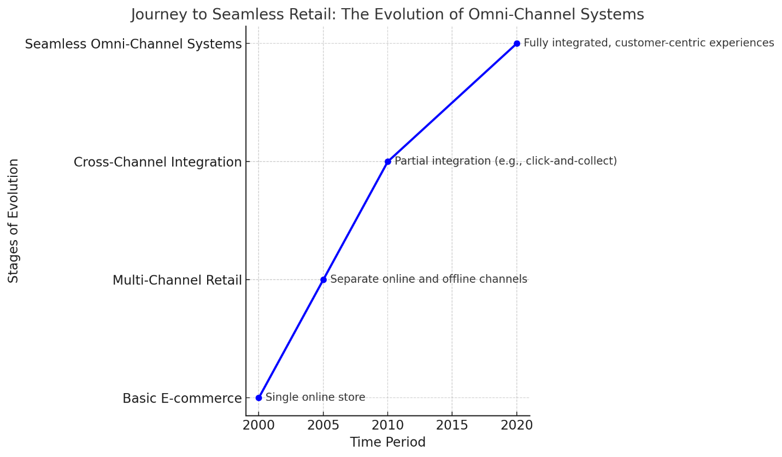

Figure 1: Journey to Seamless Retail: The Evolution of Omni-Channel Systems

#### **2.3 Theoretical Foundations**

Omni-channel techniques have roots in accepted consumer behavior theories. For instance, the cognitive-affective-conative paradigm helps one to understand how consumer decision-making in integrated contexts shapes perceptions, emotions, and intentions [17][18]. Comparably, the idea of planned behavior emphasizes the need for perceived control, attitudes, and subjective standards in steering consumer interactions throughout several touchpoints. Using consistent service delivery, these ideas offer a basis for developing strategies that improve client experiences [14].

#### **2.4 Integration of Online and Offline Channels**

The foundation of omni-channel approaches is precisely combining offline and internet channels. Driven by online data, initiatives such as cross-platform inventory management, buy-online-pick-up-in-store (BOPIS), and tailored in-store experiences show this connection. By removing friction in the shopping trip, these characteristics improve consumer pleasure and convenience [19][20]. Adopting such systems comes with difficulties, too, including data synchronizing complexity, resource-intensive technology adoption, and possible channel cannibalization [21][20].

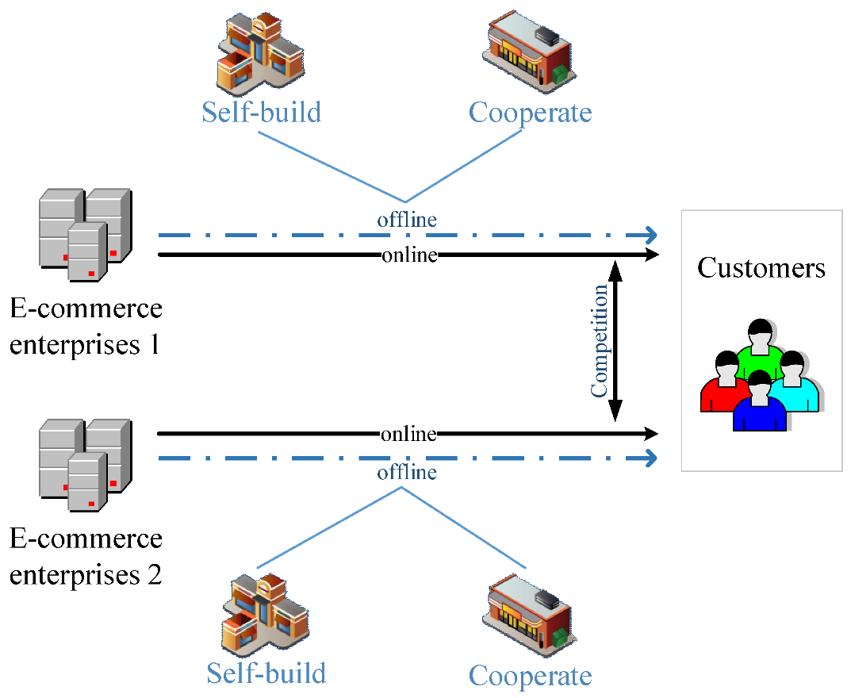

Figure 2: Online and offline integration of omni-channel supply chain [22]

#### **2.5 Practical Implications and Future Directions**

Among the major benefits of Omni-channel approaches are improved operations, more revenue, and more brand loyalty. Companies using real-time data, for example, can customize their marketing campaigns, hence producing more interesting and individualized client experiences [23]. Still, these approaches need constant innovation to solve problems including scalability and economy of cost. Future studies could investigate how newly developed technologies, including augmented reality and blockchain, may improve omni-channel integration while giving sustainability a top priority [16].

Finally, the Omni-channel strategies have redefined the e-commerce landscape by bridging the digital and physical worlds. By focusing on seamless customer experiences, businesses can not only meet evolving consumer expectations but also drive long-term growth. As technology advances, further exploration into its applications will be essential to overcoming existing challenges and unlocking the full potential of omni-channel retailing.

1. LITERATURE REVIEW

There is a lot of writing about omni-channel strategy in e-commerce, which shows how customer trips are becoming more integrated between online and offline channels. This part reviews some important studies that examine how omnichannel methods have changed over time, their main parts, and the problems and chances they create. By putting these results together, this study hopes to find gaps in what is already known and lay the groundwork for more research:

Van Nguyen et al., in 2024 examined omni-channel consumer segmentation from a tailored customer journey standpoint intending to switch behavior in retail electronic products. The study found four segments digital switchers, webroomers, showroomers, and offline switchers each with distinct preferences using a mixed-method approach combining 23 in-depth interviews, focus groups, and a survey of 345 customers. Results underlined that consumer paths are dynamic and influenced by factors including tactile pleasures, economic gains, and convenience as well as motives. Designing segment-specific channel characteristics for better personalizing is recommended with practical consequences. The study focused on Vietnamese electronics alone, future studies advised investigating several sectors and cultural settings for more general relevance [24].

Ismail Razak in 2023 explored how omnichannel marketing crafts a cohesive journey by combining online and physical consumer encounters. Through data integration, customization, and consistent branding, omnichannel tactics improve customer happiness, the study underlined using a qualitative methodology comprising interviews, focus groups, and document analysis. According to the results, current customer expectations are met by cross-channel flexibility including buying online and picking up in-store. While the study underlined the need for customization and channel integration, practical consequences include better consumer engagement and loyalty. Limitations, however, were the specificity of some sectors, implying further study in more general settings and technical developments [25].

Yunita et al. in 2024 looked into how multi-channel integration may help Indonesian department shops use omni-channel plans. The study found important characteristics of integration including marketing, pricing, order fulfillment, and customer service using a qualitative exploratory approach and data from 212 consumers. Results showed that by providing a flawless shopping experience across online and physical outlets, good integration increases consumer happiness and loyalty. Practical consequences draw attention to the need for constant branding and personalizing. One of the limitations was a limited concentration on department shops, implying further study on more general retail sectors and consumer segmentation to grasp different preferences [26].

In 2022, Widjaja et al. investigated omni-channel buying intention and shopper satisfaction in Indonesia's e-commerce sector the effects of utilitarian value, hedonic value, and channel integration quality. The study demonstrated that whereas hedonic value solely affected consumer satisfaction, utilitarian value affected both omni-channel purchase intention and shopper satisfaction using quantitative research using a 250 respondents sample and SEM-PLS analysis. Improved satisfaction came from channel integration; shopping intention was not much changed. The study underlined the need for flawless channel integration to enhance consumer experiences. Limitations included a limited geographic emphasis and sample size, implying future research should take wider settings and take technology effect into account [27].

Tan et al. in 2023 looked at omnichannel integration techniques with an eye toward Buy-Online-and-Pick-up-in- Store (BOPS) and Buy-Online-and-Pick-up-in- Store-and-Return-Online (BORO) models. The paper examined pricing strategies, channel integration, and profit dynamics between e-commerce and offline departments using a game theory method and numerical simulations. Results showed that whereas BORO provides more benefits for physical businesses but lowers online earnings when return rates are high, BOPS improves both channels only at modest distance costs. The study underlined how BORO might improve operational effectiveness and customer happiness. One of the limitations was a simplified consumer behavior model, which suggests additional investigation on multi-channel tactics in various settings with empirical validation [28].

In 2024, Yang and Cai explored using the Stimulus-Organism-Response (SOR) theory how omnichannel customer experiences affect purchase intentions for legal services in China. Using SmartPLS 4.0, the study examined survey responses from 410 participants with an eye on characteristics like connectivity, integration, consistency, flexibility, and personalization. Results showed that personalizing greatly improved flawless experiences, which greatly affected buy intentions. Emphasizing the requirement of customized service delivery and consistent channel integration to raise customer pleasure, practical implications focused on Limitations included the emphasis on legal services in China, implying further study on more general settings and other service sectors [29].

Mishra et al., in 2024 examined the mediating roles of cognitive and emotive consumer experiences in the omnichannel retail environment, therefore investigating the creation of customer value through channel integration. Using structural equation modeling and a quantitative survey of 309 customers, the study revealed that under mediation by cognitive and affective experiences, integrated promotional, product, and pricing strategies notably affected customer value. The results underlined the need for flawless and customized channel integration to raise consumer satisfaction. The study focused on Indian retail and advised future studies on worldwide settings and new technology like augmented reality to further hone omnichannel tactics [30].

Dutta in 2024 studied the revolutionary effects of omnichannel integration on retail efficiency, with an emphasis on big data, cloud computing, IoT, and AI technologies that facilitate smooth consumer interactions. Employing click-and-collect, digital kiosks, and unified inventory systems, the study found advantages including improved customer satisfaction, higher sales, and operational efficiency using secondary research and industry data. High early investments, data management complexity, and organizational alignment were among the difficulties. The study underlined its importance in building a coherent brand experience and recommended future investigation of new technologies and approaches to overcome implementation challenges [31].

Zimmermann et al., in 2022 examined sales-influencing touchpoints in omnichannel retail by use of a multi-method approach comprising Bayesian regression analysis, consumer surveys, and seminars. The research found seven main touchpoint clusters Point of Sale, social media, and Customer Relationship Management that deviate from management impressions. Touchpoints like warranty services improved sales, according to results; others, including digital signs, had negative impacts. The practical consequences emphasized optimizing touchpoints for resource allocation and customer involvement. Limitations included depending on single-retailer data and lack of temporal monitoring; so, future studies might combine enhanced tracking and big data techniques for more general findings [32].

Sumrit and Sowijit in 2023 utilizing the three-factor theory and an integrated importance-performance analysis, analyzed e-commerce omnichannel logistics service quality (OCLQ) in Thailand. Based on 408 consumer responses, the study found 19 OCLQ traits scattered around the purchasing process and divided them into four priority quadrants. Results found notable gaps in areas vital for customer satisfaction, including delivery variances and return policies. Practical consequences advised emphasizing enhancing these qualities while preserving regions of high performance like delivery coverage. One of the limitations was depending just on one merchant; future studies advised larger datasets and use in developing areas [33].

Tagashira in 2022 investigated how warehouse automation may be a signaling system for omnichannel shopping to affect sales. The paper evaluated the influence of automation and its interaction with omnichannel, online, and offline brand attributes using panel data from Japanese retailers and employing a two-way fixed-effects model. Results revealed that, especially in conjunction with omnichannel integration, automation signals favorably affected sales. The research underlined how important visible cues are to improve consumer impressions of operational excellence. Limitations included a concentration on publicly traded companies in Japan, with future studies advised to investigate other markets and include direct customer behavior evaluations [34].

In 2021, Alonso-Garcia et al. explored omnichannel management in B2B settings employing Fuzzy Cognitive Maps (FCM) and a complexity-based methodology to find causal links and replicate "what-if" situations. Data from a Delphi process with thirty worldwide experts underlined as essential for omnichannel management core value repositories including customer-centric offers, channel integration, and customer experience. The results underlined how much more managerial performance is influenced by restrictions such as sales process transformation and technological adoption than by operational elements. Practical consequences included giving constraint mitigating priority above marketing or channel improvements. With suggestions for empirical validations and more general uses in many sectors, limitations included emphasizing expert consensus and simulation-based findings [35].

Gao et al. in 2021, analyzed utilizing the SOR framework and a 434-consumer survey, the effects of channel integration on customer experiences in omnichannel retail. The study separated cognitive from emotive experiences and found that integrated advertising, product price, and transaction data greatly affected cognitive experiences; customer service had more of an impact on affective experiences. Results suggested that flawless channel integration improves consumer experiences, thereby enhancing omnichannel usage intentions. Emphasized in practical consequences is matching integration techniques to consumer expectations. One of the limitations was data from a single Chinese shop, which suggests future research to investigate other settings and longitudinal designs [36].

Cheng et al., in 2023 analyzed online and offline integration using evolutionary game theory, analyzing omni-channel strategies for e-commerce companies The work created a model combining non-cooperative and evolutionary games to assess self-built offline channels against collaboration with physical retailers. Results showed that strategic decisions depended on cost, profit-sharing ratios, consumer loyalty, and competition strategies; no unique equilibrium was discovered. While collaboration was more cost-effective for smaller enterprises, simulation findings underlined that better-perceived customer value and profitability affected businesses to self-build. One of the limitations was the emphasis on theoretical modeling, which implies future studies should include actual data and several market situations [37].

In 2024, Manju Priya et al. examined strategic ways to integrate omni-channel technologies, to improve consumer experiences using consumer preferences, technology developments, and trust issues. Utilizing a mixed-method approach comprising surveys and secondary data analysis, the study revealed online and mobile channels as preferred by younger demographics owing to their ease and flexibility; trust and privacy issues affected technology uptake. Results underlined the need for data security, openness, and tailored services for flawless consumer paths. Emphasized as practical consequences include using technology and fostering consumer trust. A small sample size and regional emphasis were among the limitations, implying further study on worldwide and varied consumer settings [38].

Nofi Wahyuni and Kurniawati, in 2023 investigated the influence of omni-channel capabilities on the retail fashion industry in Indonesia, including customer satisfaction, customer experience, and e-purchase and p-purchase intentions. With 323 survey participants, the study found using structural equation modeling (SEM) that omni-channel capabilities channel consistency, cross-channel synergy, and social media integration positively affected purchase intentions and customer satisfaction. Customer experience turned out to be a main player in between behavioral goals and satisfaction. Emphasized as the need for flawless integration across channels to improve customer satisfaction were practical consequences. With six variables and a focus on the fashion business, the study suggests future research investigate other industries and elements like re-purchase intention and consumer loyalty [39].

Tueanrat et al., in 2021 explored, with an eye on customer co-creation activities, responses, and experience values, the antecedents of customer trip satisfaction in omnichannel shopping. Using an online survey of 425 UK consumers, the study revealed important elements including convenience, financial savings, enjoyment, and human contact in determining satisfaction in the pre-buy, purchase, and post-purchase stages. Results exposed split consumer segments: web-reliant, store-reliant, and omnichannel customers each giving various journey components top priority. Practical consequences underlined the requirement of customizing techniques to meet segment-specific needs for flawless experiences. One of the limitations was depending on a single geographical dataset; additional study is advised for cross-cultural settings and longitudinal studies [40].

Luo et al., in 2020 investigated and discovered, using a randomized field experiment including more than 11,200 consumers, the complementarity and cannibalization impacts of offline-to-online targeting in omnichannel commerce. The study indicated complementarity by showing that encouraging online buying raised overall sales for consumers close to physical businesses by 47%, therefore increasing offline purchases. However offline sales dropped by 5.7% for each extra kilometer for remote consumers, which caused cannibalization. Results underlined the need for customer closeness to maximize omnichannel solutions Among practical consequences were improved targeting to prevent inadvertent sales losses. Limitations included a concentration on one shop, implying future research should include more marketplaces and larger databases [41].

Joshi et al., in 2023 examined facilitators and constraints in omnichannel retailing (OCR) under supply chain interruptions in developing countries, with an eye toward business model reform for consistent consumer experiences. With feedback from eighteen experts, hybrid Multi-Criteria Decision-Making (MCDM) techniques found eleven obstacles including pricing inconsistency and product unavailability, and seven enablers like channel integration and visibility. Results underlined that strong integration and analytics might improve consumer involvement; meanwhile, issues like uneven pricing had to be resolved. Practical consequences emphasized giving seamless channel methods first priority. One of the limitations was depending on expert-based data, which implies future studies should evaluate models in other fields [42].

Gao and Fan in 2021 used expectation-disconfirmation theory to explore, using omni-channel customer experience (in)consistency, how service success fared. Employing a survey of 265 respondents using polynomial regression analysis, they discovered that customer satisfaction is higher when online and offline experiences are consistent; high-quality consistency drives better results than low-quality consistency. While internet encounters impacted repurchase intention and word-of-mouth, offline experiences were more significant in determining satisfaction. Practical consequences included stressing perfect integration and giving offline quality first priority in order to satisfy consumer expectations. Limitations included a single geographical emphasis, implying further study on several cultural and longitudinal angles [43].

Cotarelo et al., in 2021 using quantitative research including 151 online-to-store "Click and Collect" consumers examined by structural equation modeling, explored the effects of omni-channel intensity and shopping value on customer happiness and loyalty in retail. With shopping value having the most direct impact, the study indicated that perceived omni-channel intensity—defined by consistency and seamless integration positively affected shopping value, satisfaction, and loyalty. Practical consequences included the requirement of stores guaranteeing uniformity across channels and emphasizing the improvement of perceived shopping value. Limitations included the emphasis on a specific retail technique and location, implying future studies should cover several industries and omni-channel setups [44].

Prakasa and Wandebori, in 2024 examined, in Uniqlo Indonesia's omni-channel approach, how digital change affected consumer behavior and buying preferences. With a mixed-method approach comprising 201 respondents, the study found differences in online sales success relative to physical stores. This included questionnaires. Results underlined strengthening customer journey consistency, using data-driven tactics, and integrating across touchpoints. Practical consequences included improving internet platforms, enhancing marketing, and attending to environmental issues. One of the limitations was depending on self-reported data and a specific cultural setting. Future studies were advised to investigate several customer categories and cross-cultural viewpoints to improve omni-channel approaches [45].

***Table 1*** in the document summarizes research studies on omnichannel strategies in e-commerce, focusing on the integration of online and offline customer journeys. It highlights key concepts such as consumer segmentation, marketing integration, and channel synchronization, alongside methodologies like qualitative, quantitative, and mixed approaches. The findings emphasize the importance of seamless channel integration, personalization, and real-time synchronization to enhance customer satisfaction and loyalty. Practical implications include improving operational efficiency, aligning marketing strategies, and leveraging emerging technologies like AI and IoT. However, limitations such as sector-specific studies, limited geographic scope, and data complexities suggest the need for cross-cultural studies, broader datasets, and exploration of advanced technologies like blockchain and augmented reality.

1. DISCUSSION AND COMPARISON

**Table 1** Literature Review Summary Table of Research Studies on Omnichannel Strategies in E-Commerce, Integrating Online and Offline Customer Journeys: key concepts, methodology, sample, key finding, practical implication, limitation, and future direction in E-commerce.

|  |  |  |  |  |  |  |  |
| --- | --- | --- | --- | --- | --- | --- | --- |
| Ref. No. Author and Year | Key Concepts/  Theoretical | Methodology | Sample | Key Findings | Practical Implication | Limitation | Future Directions |
| [24] Van Nguyen et al. (2024) | Omni-channel consumer segmentation | Mixed method: 23 interviews, focus groups, 345 survey respondents | Vietnamese electronic retail customers | Four consumer segments were identified, and channel characteristics must be tailored to preferences. | Segment-specific channel designs enhance personalization. | Focus on electronics in Vietnam. | Broader industry and cultural investigations. |
| [25] Ismail Razak (2023) | Omni-channel marketing integration | Qualitative: Interviews, focus groups, document analysis | Sector-specific exploration | Cross-channel flexibility improves engagement and loyalty. | Customization enhances customer loyalty. | Sector-specific, no technical innovations were analyzed. | Extend to other industries and emerging technologies. |
| [26] Yunita et al. (2024) | Multi-channel integration for department stores | Qualitative exploratory | 212 consumers in Indonesian department stores | Integration improves consumer happiness and loyalty. | Branding and personalizing strategies are essential. | Limited to department stores. | Generalize to retail sectors and consumer preferences. |
| [27] Widjaja et al. (2022) | Omni-channel purchase intention and satisfaction | Quantitative: 250 respondents, SEM-PLS analysis | Indonesian e-commerce sector | Utilitarian and hedonic values influence satisfaction, and channel integration boosts satisfaction. | Emphasizes integration to enhance experiences. | Limited geographic scope. | Include larger and more diverse samples. |
| [28] Tan et al. (2023) | BOPS and BORO models in omni-channel | Game theory and numerical simulations | Simulation-based | BORO benefits offline channels more but may lower online profits. | Operational efficiency and customer satisfaction improve with BORO. | Simplified consumer behavior model. | Empirical validation in diverse settings. |
| [29] Yang and Cai (2024) | Omni-channel effects on legal services | Stimulus-Organism-Response theory, SmartPLS 4.0 analysis | 410 participants in China | Personalization improves seamless experiences and positively impacts purchase intentions. | Customized service delivery enhances satisfaction. | Focus on legal services. | Expand to other service sectors. |
| [30] Mishra et al. (2024) | Customer value via channel integration | Quantitative: SEM on 309 survey responses | Indian retail sector | Integrated strategies improve cognitive and affective experiences. | Flawless channel integration boosts satisfaction. | Geographically limited. | Apply worldwide and investigate new technologies. |
| [31] Dutta (2024) | Omni-channel integration revolutionizing retail | Secondary research | Industry data | Technologies (AI, IoT) improve efficiency and satisfaction. | Unified systems enhance experiences. | High upfront costs and data complexities. | Research emerging technologies. |
| [32] Zimmermann et al. (2022) | Sales-influencing touchpoints | Bayesian regression, surveys, and seminars | Multi-method on single retailer data | Touchpoints like warranty services boost sales. | Optimizing touchpoints improves customer engagement. | Single-retailer data. | Use enhanced tracking and big data for broader insights. |
| [33] Sumrit and Sowijit (2023) | Omni-channel logistics service quality | Integrated importance-performance analysis | 408 consumer responses in Thailand | Gaps in customer satisfaction areas were identified. | Improving logistics qualities enhances satisfaction. | Focused on one merchant. | Broaden datasets and explore developing regions. |
| [34] Tagashira (2022) | Warehouse automation signaling | Two-way fixed-effects model | Japanese Retailers panel data | Automation positively affects sales with omnichannel integration. | Operational excellence signals improve customer impressions. | Focus on public companies in Japan. | Include other markets and direct customer behaviors. |
| [35] Alonso-Garcia et al. (2021) | Omni-channel management in B2B | Fuzzy Cognitive Maps, Delphi process | 30 global experts | Managerial performance is impacted by constraints more than operations. | Prioritize constraint mitigation strategies. | Expert-driven findings. | Empirical validation and broader applications. |
| [36] Gao et al. (2021) | Customer experiences in omni-channel | SOR framework, a survey on 434 consumers | Chinese retail sector | Channel integration improves cognitive and affective experiences. | Match integration with consumer expectations. | Single retail dataset. | Explore diverse settings and longitudinal designs. |
| [37] Cheng et al. (2023) | Omni-channel strategies in e-commerce | Evolutionary game theory model | Simulation-based | Self-built channels versus collaboration depend on cost and loyalty. | Cost-effective collaboration for smaller enterprises. | Focus on theoretical modeling. | Incorporate real-world data and market situations. |
| [38] Manju Priya et al. (2024) | Strategic omni-channel integration | Mixed-method: Surveys, secondary analysis | Regional demographics | Trust and data security issues affect technology adoption. | Tailored services and transparency enhance experiences. | Small sample and regional focus. | Research worldwide settings and varied demographics. |
| [39] Nofi Wahyuni and Kurniawati (2023) | Omni-channel in fashion retail | Structural equation modeling | 323 survey participants in Indonesia | Channel consistency improves satisfaction. | Flawless integration enhances satisfaction. | Focus on the fashion sector. | Explore other industries and behavioral aspects. |
| [40] Tueanrat et al. (2021) | Customer satisfaction in omni-channel | Online survey with 425 consumers | UK consumer segments | Convenience and savings drive satisfaction. | Customizing techniques for specific segments enhances satisfaction. | Single dataset focus. | Study cross-cultural and longitudinal factors. |
| [41] Luo et al. (2020) | Offline-to-online targeting | A randomized field experiment on 11,200 consumers | Physical store and online interactions | Proximity increases sales; remote targeting risks cannibalization. | Optimized targeting prevents losses. | Single retailer focus. | Study more marketplaces and larger datasets. |
| [42] Joshi et al. (2023) | Omni-channel retail under disruptions | Hybrid multi-criteria Decision-Making | 18 expert feedback | Channel integration mitigates supply chain disruptions. | Strong integration enhances engagement. | Expert-driven results. | Validate with broader models and datasets. |
| [43] Gao and Fan (2021) | Customer experience consistency | Survey and polynomial regression | 265 respondents | Consistency in quality drives satisfaction. | Focus on offline quality improves outcomes. | Single region dataset. | Expand to longitudinal and multi-region studies. |
| [44] Cotarelo et al. (2021) | Omni-channel shopping value | Structural equation modeling | 151 Click-and-Collect consumers | Omni-channel intensity positively affects satisfaction. | Ensure uniformity across channels. | Single technique and location. | Cover diverse setups and retail methods. |
| [45] Prakasa and Wandebori (2024) | Digital transformation in omni-channel retail (Uniqlo Indonesia) | Mixed-method: Surveys, secondary data analysis | 201 respondents (Uniqlo Indonesia consumers) | Differences in online vs physical store success; emphasized customer journey consistency, data-driven tactics, and integrated touchpoints. | Enhancing online platforms, improving marketing, and addressing environmental considerations. | Reliance on self-reported data and specific cultural settings. | Study broader customer categories and cross-cultural perspectives. |

The literature review shows how omnichannel strategies have changed over time and how they are used in different industries and cultures. The results all agree on one thing: combining online and offline channels should be easy so that customers have a better experience, stay loyal, and businesses run more efficiently. This talk brings together important ideas, compares different approaches, and points out areas that need more research and possible directions for the future.

Through integration and customization, omnichannel strategies have repeatedly proven to increase consumer happiness. Emphasizing the need to customize channel features to personal preferences, Van Nguyen et al. (2024) divided customers into groups including webroomers and showroomers. In line with the results of Mishra et al. (2024), who underlined the need for cognitive and affective experiences in driving satisfaction utilizing integrated marketing and pricing strategies, Gao and Fan (2021) also noted that consistency in online and offline experiences is vital for customer happiness. These developments however show clear limits in regional and sectoral scopes. Research including those by Yunita et al. (2024) and Widjaja et al. (2022) concentrated on particular sectors such as department shops and e-commerce in Indonesia, respectively, therefore highlighting regional insights but lacking more general application. Through cross-cultural and cross-industry research, addressing these constraints might help to offer a more complete knowledge of omnichannel efficacy.

Real-time synchronization and enhanced consumer experiences are made possible in great part by technological developments such as artificial intelligence, IoT, and big data analytics. Dutta (2024) underlined the transforming power of digital kiosks and unified inventory systems in simplifying processes and raising satisfaction. Likewise, Tagashira (2022) found that, especially when combined with an omnichannel strategy, warehouse automation improves consumer views of operational excellence. These developments, however, provide difficulties. As Gao et al. (2021) and Luo et al. (2020) underline, high initial investments, data synchronizing complexity, and possible channel cannibalization remain major obstacles. These difficulties point to the need to study reasonably priced technical solutions and techniques to balance channel synergies and conflicts.

Effective omnichannel plans still revolve mostly around the personalizing of consumer experiences. While Razak (2023) and Wahyuni and Kurniawati (2023) underlined the need for customizing to promote loyalty and satisfaction, Yang and Cai (2024) showed that personalized service delivery considerably influences purchase intentions. These results speak to the need for segment-specific policies found by Van Nguyen et al. (2024). Still, a common restriction in research is depending too much on single-market data or limited demographic samples. As advised by Mishra et al. (2024), increasing research to cover various cultural and behavioral settings will help to create globally applicable strategies.

Though the examined material offers insightful analysis, a few gaps still exist. Future research should look at how newly developed technologies like augmented reality and blockchain could improve omnichannel operations even further. Furthermore, required are longitudinal studies to evaluate how multichannel approaches affect consumer behavior and corporate success across time. Advancing the discipline depends critically on empirical validation of theoretical models as advised by Cheng et al. (2023) and larger datasets to solve regional and sectoral constraints. By filling in these gaps, next studies might offer practical information for companies hoping to implement and hone omnichannel strategies in a market going more and more digital.

Finally, the research emphasizes how omnichannel techniques may bridge digital and physical channels and hence have transforming power. By emphasizing flawless integration, technological innovation, and tailored consumer experiences, businesses may satisfy changing customer expectations and attain sustainable development.

1. EXTRACTED STATISTICS

This section summarizes key findings from omnichannel e-commerce research, emphasizing methodological diversity, sample size distribution, and geographic focus.

***Figure 3*** visualizes the distribution of methodologies in studies of omnichannel e-commerce. The "Mixed Method" is the most frequently used approach, representing 13.6% of the total, followed by "Quantitative" and "Structural Equation Modeling," each at 9.1%. Other methodologies, including "Qualitative," "Game Theory & Simulations," and "Secondary Research," have equal and smaller shares, indicating a diverse but balanced application of research methods. The chart emphasizes the versatility and mixed-method dominance in this research domain.

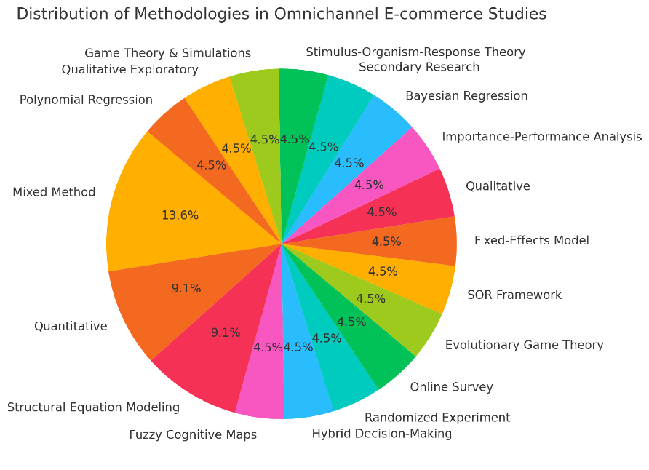

Figure 3: Distribution of Methodologies in Omnichannel E-Commerce Studies

***Figure 4*** presents the sample sizes of omnichannel e-commerce studies, excluding the large outlier of 11,200. It highlights a more balanced distribution of sample sizes, ranging from smaller datasets like 30 to larger ones around 400. This visualization emphasizes the variety in study scales while providing a clearer comparison of methodologies.

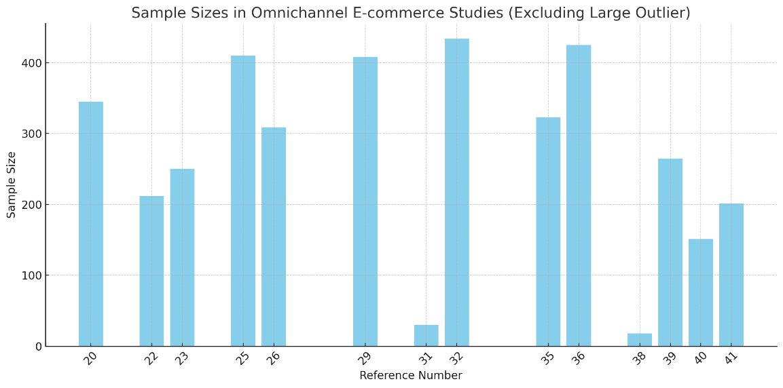

Figure 4: Sample sizes in Omnichannel E-commerce Studies

***Figure 5*** the geographical focus of the studies reveals that Indonesia dominates the research landscape, contributing 16.7% of the studies analyzed, emphasizing its emerging role in omnichannel strategies. Vietnam accounts for 8.3%, reflecting its active exploration of consumer segmentation in retail. China and Thailand each represent 8.3%, focusing on personalization and logistics service quality, respectively. Countries like Japan contribute a smaller fraction (8.3%), emphasizing niche topics such as automation in omnichannel systems. Collectively, other unspecified or simulation-based studies make up 50%, indicating a significant reliance on generalized or non-specific geographic data. This distribution highlights the need for broader global representation and cross-cultural analyses to develop more universally applicable insights into omnichannel strategies.

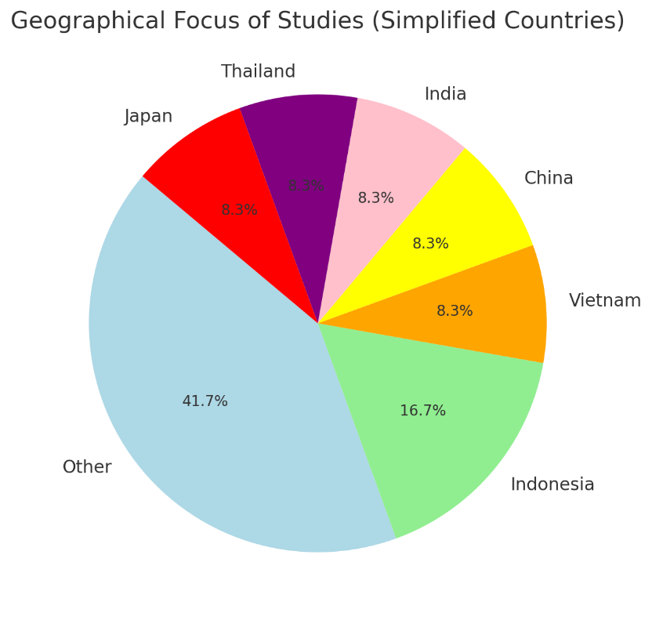

Figure 5 Geographical Focus of Studies (simplified Countries)

***Figure 6*** the Methodologies by Focus Area analysis reveals a balanced reliance on qualitative (33.3%) and quantitative (33.3%) methods in studying omnichannel strategies, emphasizing the importance of both in-depth consumer insights and empirical validation. Though less frequent, mixed methods (16.7%) offer a comprehensive approach by combining these strengths, while game theory and simulations (16.7%) provide unique strategic insights for operational planning. The dominance of qualitative and quantitative methods reflects a dual focus on exploring consumer behavior and validating findings. In contrast, the moderate use of mixed methods and simulations suggests opportunities for further exploration in future studies, particularly for testing complex, technology-driven omnichannel scenarios.

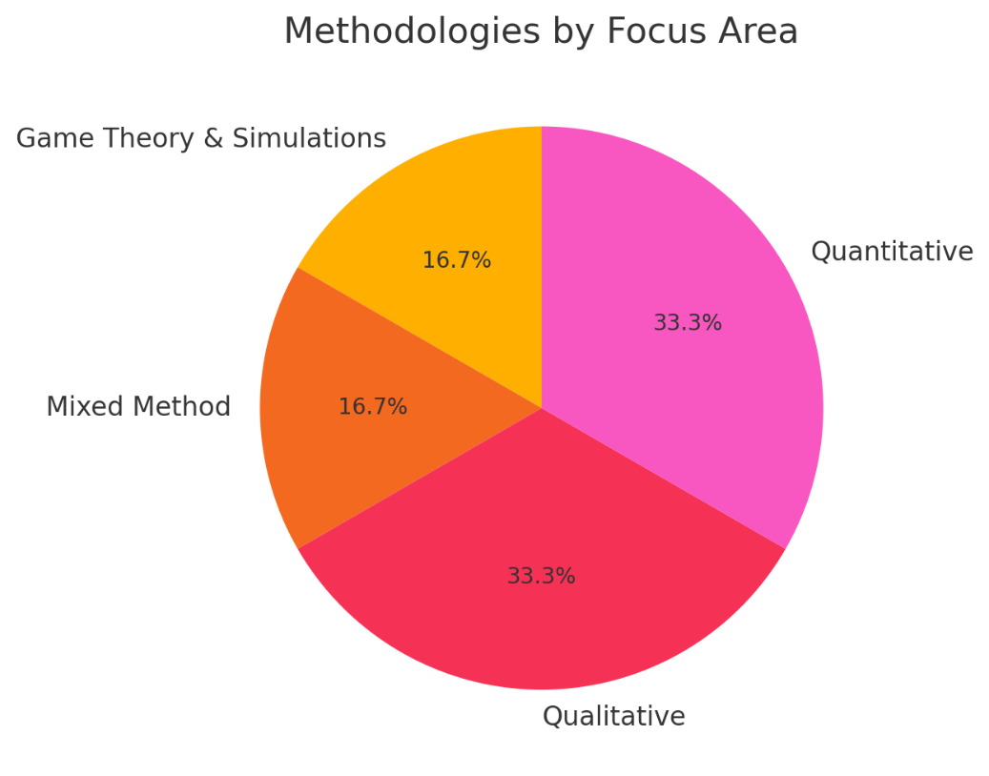

Figure 6 Methodologies by Focus Area

1. RECOMMENDATION
2. **Enhanced Integration of Channels:** Businesses should prioritize seamless integration between online and offline channels to enhance customer experience and satisfaction. Adopting real-time synchronization for inventory, pricing, and promotions can reduce friction during the customer journey.
3. **Technological Innovation:** Emerging technologies like artificial intelligence (AI), the Internet of Things (IoT), and blockchain should be further utilized to optimize operations and provide personalized shopping experiences. Implementing augmented reality (AR) for virtual try-ons and blockchain for supply chain transparency are promising areas.
4. **Personalization Strategies:** Companies must design consumer journeys tailored to specific customer segments, such as showroomers and webroomers, by utilizing advanced data analytics and customer segmentation techniques.
5. **Overcoming Channel Cannibalization:** Effective targeting and pricing strategies are essential to mitigate the risks of channel cannibalization. Techniques such as location-based marketing and channel-specific incentives should be explored.
6. **Operational Efficiency:** Investment in automated processes, such as warehouse management and unified inventory systems, can boost both customer satisfaction and operational performance.

These recommendations aim to address gaps identified in the literature and leverage technological advancements to maximize the benefits of omnichannel strategies in e-commerce.

1. CONCLUSION

The research paper underscores the transformative potential of omnichannel strategies in e-commerce by integrating online and offline channels to create seamless customer experiences. The adoption of technologies like AI, IoT, and big data analytics facilitates real-time synchronization, enhancing operational efficiency and customer satisfaction. Statistical insights highlight the diversity in methodologies, with mixed methods constituting 13.6% of studies, indicating a balanced research approach. Geographic data reveals Indonesia’s dominance in this field, contributing 16.7% of studies, reflecting the importance of emerging markets. Additionally, findings suggest a 47% increase in overall sales from online-to-offline targeting for consumers near physical stores, while distant customers experienced a 5.7% decline due to cannibalization. The emphasis on personalized service delivery and seamless integration across touchpoints consistently demonstrates enhanced customer loyalty and purchase intentions. Despite these advancements, challenges such as data synchronization complexity and high implementation costs persist, necessitating further research into cost-effective solutions. Future studies should explore emerging technologies like blockchain and augmented reality, alongside longitudinal and cross-cultural analyses, to broaden the global applicability of omnichannel practices. By addressing these challenges and leveraging technological innovations, businesses can achieve sustainable growth while meeting evolving consumer demands.

**COMPETING INTERESTS DISCLAIMER:**

Authors have declared that they have no known competing financial interests OR non-financial interests OR personal relationships that could have appeared to influence the work reported in this paper.

1. REFERENCES

[1] H. Min, “Exploring Omni-Channels for Customer-Centric e-Tailing,” *Logistics*, vol. 5, no. 2, 2021, doi: 10.3390/logistics5020031.

[2] C. Gerea, F. Gonzalez-Lopez, and V. Herskovic, “Omnichannel customer experience and management: An integrative review and research agenda,” *Sustain.*, vol. 13, no. 5, pp. 1–24, 2021, doi: 10.3390/su13052824.

[3] S. Iglesias-Pradas and E. Acquila-Natale, “The Future of E-Commerce: Overview and Prospects of Multichannel and Omnichannel Retail,” *J. Theor. Appl. Electron. Commer. Res.*, vol. 18, no. 1, pp. 656–667, 2023, doi: 10.3390/jtaer18010033.

[4] K. Jacksi, S. R. M. Zeebaree, and N. Dimililer, “LOD explorer: Presenting the Web of data,” *Int. J. Adv. Comput. Sci. Appl.*, vol. 9, no. 1, pp. 45–51, 2018, doi: 10.14569/IJACSA.2018.090107.

[5] T. S. G. Furquim, C. P. da Veiga, C. R. P. da Veiga, and W. V. da Silva, “The Different Phases of the Omnichannel Consumer Buying Journey: A Systematic Literature Review and Future Research Directions,” *J. Theor. Appl. Electron. Commer. Res.*, vol. 18, no. 1, pp. 79–104, 2023, doi: 10.3390/jtaer18010005.

[6] J. S. RYU, “Is Consumer Characteristics and Shopping for Fashion in the Omni-channel Retail Environment,” *J. Bus. Econ. Environ. Stud.*, vol. 9, no. 4, pp. 15–22, 2019, doi: 10.13106/jbees.2019.vol9.no4.15.

[7] T. H. A. Bijmolt *et al.*, “Challenges at the marketing–operations interface in omni-channel retail environments,” *J. Bus. Res.*, vol. 122, no. July 2018, pp. 864–874, 2021, doi: 10.1016/j.jbusres.2019.11.034.

[8] D. Schrotenboer, E. Constantinides, C. Herrando, and S. de Vries, “The Effects of Omni-Channel Retailing on Promotional Strategy,” *J. Theor. Appl. Electron. Commer. Res.*, vol. 17, no. 2, pp. 360–374, 2022, doi: 10.3390/jtaer17020019.

[9] V. Belvedere, E. M. Martinelli, and A. Tunisini, “Getting the most from E-commerce in the context of omnichannel strategies,” *Ital. J. Mark.*, vol. 2021, no. 4, pp. 331–349, 2021, doi: 10.1007/s43039-021-00037-6.

[10] Y. Qi, C. Gu, and X. Guo Cui, “Research on Omni-Channel Transformation of Retail Enterprises Under Digital Background,” *Front. Artif. Intell. Appl.*, vol. 367, pp. 280–290, 2023, doi: 10.3233/FAIA230028.

[11] Y. S. Jghef *et al.*, “Bio-Inspired Dynamic Trust and Congestion-Aware Zone-Based Secured Internet of Drone Things (SIoDT),” *Drones*, vol. 6, no. 11, 2022, doi: 10.3390/drones6110337.

[12] R. S. -, S. S. -, and S. F. -, “E-Commerce and Digital Transformation: Trends, Challenges, and Implications,” *Int. J. Multidiscip. Res.*, vol. 5, no. 5, pp. 1–9, 2023, doi: 10.36948/ijfmr.2023.v05i05.7128.

[13] K. A. Utami and G. S. Darma, “Hotel Customer Perspectives Through The Customer Journey On Omnichannel Marketing In 4.0 Era,” *J. Pendidik. Ekon. dan Kewirausahaan)*, vol. 8, no. 1, p. 100, 2024, doi: 10.29408/jpek.v8i1.24372.

[14] A. Rezaei and S. Etemadi, “A Review of Digital Consumer Behavior Models : Insights from Multichannel and Omnichannel Marketing,” pp. 1–13, 2024.

[15] H. P. Maheepala, A. A. M. Jayawardena, and D. G. N. D. Jayarathna, “Factors influencing customer selection of omni-channel supermarket retailing: An empirical study in Sri Lanka,” *J. Sustain. Dev. Transp. Logist.*, vol. 9, no. 1, pp. 85–95, 2024, doi: 10.14254/jsdtl.2024.9-1.7.

[16] M. Simionescu and A.-S. Nicula, “2024 Marketing and Management of Innovations,” *Innovations*, vol. 15, no. 2, p. 2024, 2024, [Online]. Available: https://mmi.sumdu.edu.ua

[17] R. Mishra, R. K. Singh, and B. Koles, “Consumer decision-making in omnichannel retailing: Literature review and future research agenda,” *Int. J. Consum. Stud.*, vol. 45, no. 2, pp. 147–174, 2021, doi: 10.1111/ijcs.12617.

[18] Merdin Shamal Salih, “Diabetic Prediction based on Machine Learning Using PIMA Indian Dataset,” *Commun. Appl. Nonlinear Anal.*, vol. 31, no. 5s, pp. 138–156, 2024, doi: 10.52783/cana.v31.1008.

[19] D. C. Bisaria, “Optimizing Customer Experience Through Omni-Channel Retailing: A Case Study By XYZ Company On Seamless Integration And Increased Sales,” *Educ. Adm. Theory Pract.*, vol. 30, no. 3, pp. 2086–2094, 2024, doi: 10.53555/kuey.v30i4.2264.

[20] Ishika and N. Mittal, “Big Data Analysis for Data VisualizationA Review,” *2021 9th Int. Conf. Reliab. Infocom Technol. Optim. (Trends Futur. Dir. ICRITO 2021*, pp. 64–75, 2021, doi: 10.1109/ICRITO51393.2021.9596423.

[21] A. H. P. K. Putra, “Learning from the Past Bridging Digital and Physical Markets: A Guidelines for Future Research Agenda of Online-to-Offline (O2O) Marketing Strategy,” *Int. Rev. Manag. Mark.*, vol. 14, no. 3, pp. 82–96, 2024, doi: 10.32479/irmm.16145.

[22] Y. Cheng, B. Xie, and K. An, “Analysis of Omni-Channel Evolution Game Strategy for E-Commerce Enterprises in the Context of Online and Offline Integration,” *Systems*, vol. 11, no. 7, p. 321, Jun. 2023, doi: 10.3390/systems11070321.

[23] C. Huang and Y. Wu, “Research on the Integration of Online and Offline Channels in Marketing,” *Highlights Business, Econ. Manag.*, vol. 37, pp. 455–462, 2024, doi: 10.54097/c0hnrg87.

[24] A. T. Van Nguyen, R. McClelland, and N. H. Thuan, “Omni-channel customer segmentation: A personalized customer journey perspective,” *J. Consum. Behav.*, no. December 2023, pp. 1–23, 2024, doi: 10.1002/cb.2401.

[25] Ismail Razak, “Omnichannel Marketing: Connecting Consumer Experiences from Online to Offline,” *J. Ilm. Multidisiplin Indones.*, vol. 2, no. 02, pp. 89–95, 2023, doi: 10.58471/esaprom.v2i02.3999.

[26] S. Patients *et al.*, “We are IntechOpen , the world ’ s leading publisher of Open Access books Built by scientists , for scientists TOP 1 %,” *Intech*, p. 13, 2012, [Online]. Available: http://dx.doi.org/10.1039/C7RA00172J%0Ahttps://www.intechopen.com/books/advanced-biometric-technologies/liveness-detection-in-biometrics%0Ahttp://dx.doi.org/10.1016/j.colsurfa.2011.12.014

[27] Y. G. Widjaja, I. G. So, R. Setiowati, and A. Furinto, “The Influence of Channel Integration Quality on Omni-Channel Shopping Intention and Shopper Satisfaction in the E-commerce Industry in Indonesia,” *J. Distrib. Sci.*, vol. 20, no. 12, pp. 35–42, 2022, doi: 10.15722/jds.20.12.202212.35.

[28] M. Tan, H. Li, P. Yin, and H. Wang, “Omnichannel integration strategy based on BOPS,” *PLoS One*, vol. 18, no. 12 December, pp. 1–19, 2023, doi: 10.1371/journal.pone.0293192.

[29] “HOW DOES OMNI-CHANNEL EXPERIENCE SHAPES PURCHASE INTENTIONS OF LEGAL SERVICES : A STIMULUS-ORGANISM-,” vol. 7, no. August, pp. 190–203, 2024.

[30] S. Mishra, M. Mishra, P. K. Pandey, P. K. Pandey, S. Mahajan, and M. A. Shah, “Formation of customer value through channel integration: Modelling the mediating role of cognitive and affective customer experience in the omni channel retail context,” *Cogent Bus. Manag.*, vol. 11, no. 1, p., 2024, doi: 10.1080/23311975.2024.2349270.

[31] S. S. Dutta, “OMNICHANNEL INTEGRATION : REVOLUTIONIZING RETAIL EFFICIENCY,” vol. 15, no. 5, pp. 592–605, 2024.

[32] R. Zimmermann, W. Weitzl, and A. Auinger, “Identifying Sales-Influencing Touchpoints along the Omnichannel Customer Journey,” *Procedia Comput. Sci.*, vol. 196, no. 2021, pp. 52–60, 2021, doi: 10.1016/j.procs.2021.11.072.

[33] D. Sumrit and K. Sowijit, “Winning customer satisfaction toward omnichannel logistics service quality based on an integrated importance-performance analysis and three-factor theory: Insight from Thailand,” *Asia Pacific Manag. Rev.*, vol. 28, no. 4, pp. 531–543, 2023, doi: 10.1016/j.apmrv.2023.03.003.

[34] T. Tagashira, “Information effects of warehouse automation on sales in omnichannel retailing,” *J. Retail. Consum. Serv.*, vol. 66, p. 102903, 2022, doi: 10.1016/j.jretconser.2021.102903.

[35] J. Alonso-Garcia, F. Pablo-Martí, and E. Nunez-Barriopedro, “Omnichannel Management in B2B. Complexity-based model. Empirical evidence from a panel of experts based on Fuzzy Cognitive Maps,” *Ind. Mark. Manag.*, vol. 95, no. April, pp. 99–113, 2021, doi: 10.1016/j.indmarman.2021.03.009.

[36] W. Gao, H. Fan, W. Li, and H. Wang, “Crafting the customer experience in omnichannel contexts: The role of channel integration,” *J. Bus. Res.*, vol. 126, no. December 2020, pp. 12–22, 2021, doi: 10.1016/j.jbusres.2020.12.056.

[37] Y. Cheng, B. Xie, and K. An, “Analysis of Omni-Channel Evolution Game Strategy for E-Commerce Enterprises in the Context of Online and Offline Integration,” *Systems*, vol. 11, no. 7, 2023, doi: 10.3390/systems11070321.

[38] M. P. R, “OMNI-CHANNEL INTEGRATION FOR ENHANCED EXPERIENCES FROM THE CULTIVATING SEAMLESS CUSTOMER JOURNEYS : STRATEGIC APPROACHES TO OMNI-CHANNEL INTEGRATION FOR ENHANCED EXPERIENCES FROM THE CONSUMER ’ S VIEWPOINT,” no. October, 2024.

[39] N. Wahyuni and K. Kurniawati, “the Effect of Omni-Channel Channels on Customer Satisfaction in Retail Fashion in Indonesia,” *Int. J. Appl. Econ. Bus.*, vol. 1, no. 2, pp. 586–598, 2023, doi: 10.24912/v1i2.586-598.

[40] Y. Tueanrat, S. Papagiannidis, and E. Alamanos, “A conceptual framework of the antecedents of customer journey satisfaction in omnichannel retailing,” *J. Retail. Consum. Serv.*, vol. 61, no. April, p. 102550, 2021, doi: 10.1016/j.jretconser.2021.102550.

[41] X. Luo, Y. Zhang, F. Zeng, and Z. Qu, “Complementarity and cannibalization of offline-TO-ONLINE targeting: A field experiment on omnichannel commerce,” *MIS Q. Manag. Inf. Syst.*, vol. 44, no. 2, pp. 957–982, 2020, doi: 10.25300/MISQ/2020/15630.

[42] S. Joshi, M. Sharma, and P. Chatterjee, “Omni- Channel Retailing for Enhancing Customer Engagement Amidst Supply Chain Disruption: an Emerging Market Perspective,” *Decis. Mak. Appl. Manag. Eng.*, vol. 6, no. 1, pp. 449–473, 2023, doi: 10.31181/dmame0310112022j.

[43] W. Gao and H. Fan, “Omni-channel customer experience (In)consistency and service success: A study based on polynomial regression analysis,” *J. Theor. Appl. Electron. Commer. Res.*, vol. 16, no. 6, pp. 1997–2013, 2021, doi: 10.3390/jtaer16060112.

[44] M. Cotarelo, T. Fayos, H. Calderón, and A. Mollá, “Omni-channel intensity and shopping value as key drivers of customer satisfaction and loyalty,” *Sustain.*, vol. 13, no. 11, 2021, doi: 10.3390/su13115961.

[45] E. G. H. Prakasa and H. Wandebori, “Analysis of Digital Transformation on Consumer Behavior for Shopping in Offline and Online Store (Case Study: UNIQLO Indonesia),” *Int. J. Curr. Sci. Res. Rev.*, vol. 07, no. 01, pp. 20–34, 2024, doi: 10.47191/ijcsrr/v7-i1-03.