***Case report***

**An Unusual Case of Mucosal Prolapse Through a Serosal Defect Mimicking Stoma Prolapse: Diagnostic and Surgical Considerations**

**Abstract**

Stoma creation is frequently performed for conditions like malignancies and bowel obstructions, with potential complications such as prolapse and hernias. Stoma prolapse involves bowel protrusion through the stoma, causing discomfort and cosmetic concerns. This report describes an unusual case of mucosal prolapse from the proximal bowel loop mimicking stoma prolapse. A 16-year-old male with a loop ileostomy presented with protrusion, later identified intraoperatively as mucosa emerging through a serosal defect. Surgical resection and anastomosis led to complete recovery. This case highlights the importance of accurate diagnosis, timely surgical management, and patient education to prevent complications effectively.

**Keywords**

Stoma prolapse, mucosal prolapse, loop ileostomy, surgical complications, ileal perforation

**Introduction**

Stoma creation is a common surgical procedure performed for various gastrointestinal conditions, including malignancies, inflammatory bowel diseases, and bowel obstructions[1]. While stomas significantly improve the quality of life for patients, complications such as prolapse, retraction, and parastomal hernias can arise. Stoma prolapse, defined as the protrusion of the bowel segment through the stoma, may lead to patient discomfort, cosmetic concerns, and functional impairment[2]. Understanding the aetiology, risk factors, and management options is critical for optimal patient care. However, we report a case of an unusual complication of a stoma where mucosal prolapse from the proximal bowel loop mimicked stoma prolapse. This complication may be the first such complication reported to date.

**Case Presentation**

A 16-year-old male underwent exploratory laparotomy for ileal perforation two months prior, with a loop ileostomy created during the procedure. The postoperative period was uneventful, and the patient was discharged on postoperative day five. He presented to the surgical outpatient department with complaints of something protruding from the stoma (Figure 1). The stoma remained functional, and there were no obstructive symptoms. The patient was vitally stable.

On examination, bowel mucosa was protruding from the side of the proximal bowel loop, measuring approximately 12 cm in length, dusky in colour, and oedematous. The exact site of mucosal prolapse could not be ascertained on clinical examination. The patient expressed concerns about discomfort, difficulty managing the stoma, and embarrassment due to the visible protrusion. Stoma reversal was planned after confirming the patency of the distal bowel segment via a distal loopogram.

Intraoperatively, mucosa was found protruding through a serosal defect in the proximal bowel just above the rectus sheath (Figure 2). The diseased ileal segment was resected, and a stapled side-to-side ileo-ileal anastomosis was performed. The postoperative period was uneventful, and the patient was discharged on the seventh postoperative day.

Figure 1 – Showing mucosal prolapse

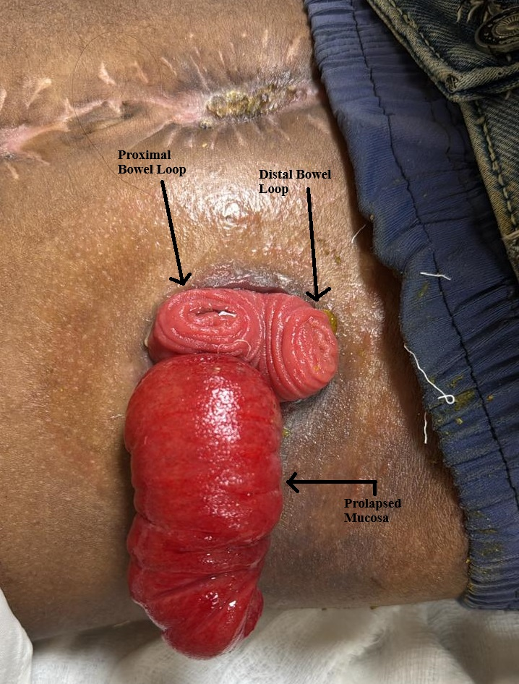

Figure 2 – Showing Intraoperative depiction of mucosal prolapse

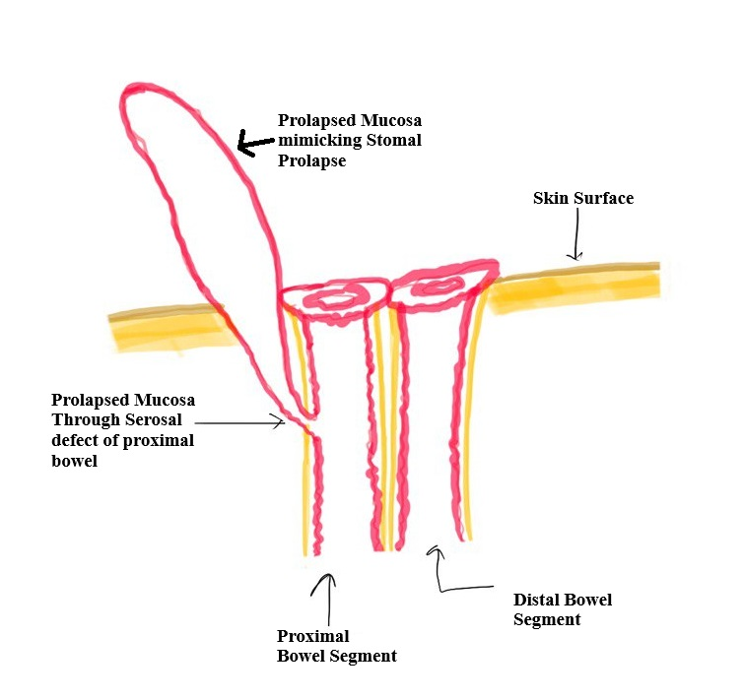

**Discussion**

Stoma prolapse is more common in loop colostomies than in end colostomies, occurring in 2-10% of stoma patients[3]. Risk factors include obesity, chronic cough, increased intra-abdominal pressure, and poor stoma site selection. Loop stomas are prone to prolapse due to their structural design. Prolapse results from weakening of the fascial support around the stoma site, allowing the bowel to telescope outward[4]. Increased intra-abdominal pressure and inadequate fixation of the bowel loop exacerbate the condition. Patients with stoma prolapse may present with visible bowel protrusion, discomfort, bleeding, or difficulty in fitting stoma appliances. Rarely, complications such as ischemia, ulceration, or obstruction may occur[5].

Management of stoma prolapse depends on severity and patient symptoms. Conservative measures include gentle reduction of the prolapsed bowel, use of belts or binders, and dietary modifications to optimize stool consistency[3]. Surgical intervention is indicated for recurrent prolapse, ischemia, or significant patient distress. Options include local stoma revision, resection of the prolapsed segment, or stoma relocation. Laparoscopic approaches have shown favourable outcomes[6].

This case showcases an unusual mucosal prolapse mimicking stoma prolapse, with the site of prolapse only ascertainable intraoperatively. It highlights the importance of patient education, early recognition, and timely intervention.

**Conclusion**

This case underscores the need for awareness of rare complications such as mucosal prolapse through a serosal defect mimicking stoma prolapse. Accurate diagnosis and timely surgical management are pivotal in preventing morbidity. Comprehensive patient education and regular follow-up are vital for managing stoma-related complications effectively.

**References**

1. Maeda K, Maruta M, Utsumi T, Sato H, Masumori K, Aoyama H. Pathophysiology and prevention of loop stomal prolapse in the transverse colon. Tech Coloproctol. 2003 Jul;7(2):108–11.

2. Maeda K. Prolapse of intestinal stoma. Ann Coloproctol. 2022 Oct;38(5):335–42.

3. Tsujinaka S, Tan KY, Miyakura Y, Fukano R, Oshima M, Konishi F, et al. Current Management of Intestinal Stomas and Their Complications. J Anus Rectum Colon. 2020;4(1):25–33.

4. Aubert M, Buscail E, Duchalais E, Cazelles A, Collard M, Charleux-Muller D, et al. Management of adult intestinal stomas: The 2023 French guidelines. J Visc Surg. 2024 Apr;161(2):106–28.

5. Pellegrin A, Pasinato G, Sabbagh C. Stoma prolapse management: Stapler repair. J Visc Surg. 2024 Oct;161(5):317–9.

6. Parini D, Bondurri A, Ferrara F, Rizzo G, Pata F, Veltri M, et al. Surgical management of ostomy complications: a MISSTO-WSES mapping review. World J Emerg Surg. 2023 Oct 10;18(1):48.