Case report

**Unusual co-existence of carcinoma colon & malrotation of gut in elderly female: Literature review & rare case report.**

**ABSTRACT**

**Introduction:** Intestinal malrotation(IM) usually presents as intestinal obstruction or midgut volvulus in childhood but rarely presents in adults either asymptomatically or with abdominal symptoms.Colorectal cancer in adult patients with malrotation is even more rare.

**Study design:** Case report and review of literature.

**Place :** Department of General Surgery . All India Institute Of Medical Sciences , Raebareli , Uttar Pradesh , 229405 , India.

**Case report :** We report a case of gut malrotation with colon cancer causing sub-acute intestinal obstruction(SAIO),who underwent open laparotomy. 60 year-old woman on treatment for suspected bowel TB came with waxing and waning course of intestinal obstruction.Outside colonoscopy/imaging were inconclusive.Institutional computer tomography(CT) scan suggested gut malrotation.Patient underwent an emergency laparotomy with an uneventful postoperative recovery.An intraluminal growth was found in ascending colon along with malrotated bowel. We felt content in heading the distressed patient towards correct therapeutic course.

**Conclusion:** This is 3rd such case documented from India out of 82 cases globally.This report raises awareness about colorectal malignancies in symptomatic adults with IM, though the cause remains uncertain.

**KEYWORDS**

Gut malrotation ,intestinal obstruction ,carcinoma colon ,colorectal cancer ,adult.

**INTRODUCTION**

An uncommon congenital paediatric pathology like intestinal malrotation (IM) resulting from aberrant intestinal rotation and fixation ,generally presents in the first year of life.Very few literature documents its presentation in adulthood which sometimes causes delayed diagnosis and treatment.Colorectal cancers are even rarely reported in adults diagnosed with gut malrotation,therefore while dealing with adult patients with abdominal symptoms, these possibilities should be kept in mind.We are talking about this case here because of its uniqueness as we found only 2 such cases in India reported in the literature.

**CASE REPORT**

A non co-morbid 60-year-old lady presented to Emergency department with acute complaint of abdominal distension with dull aching pain for last 4 days and obstipation for last 2 days.She had persistent mild dull aching dffuse abdominal pain for last 2 years associated with intermittent fever and abdominal distension,and appearance of globular lump over left side of abdomen which gets relieved on episodes of non-bilious vomiting.Her symptoms worsened in last 3 months,with reduction in weight and appetite leading to multiple hospitalizations and blood transfusions for anemia.She was eventually started on empirical ATT for suspected abdominal kochs. On examination,left lower abdominal fullness with mild diffuse tenderness present without any guarding/palpable lump.Lab values(Hb-7.6 g/dl) and peripheral blood smear suggestive of iron deficiency anaemia.CA125, CEA were mildly elevated.Patient had underwent multiple abdominal ultrasounds suggesting varied possibilities like SAIO, kochs abdomen or enterocolitis and also had contrast-enhanced computer tomography(CECT) of the abdomen suggesting kochs abdomen causing closed loop obstruction.Colonoscopy upto hepatic flexure revealed no abnormality.Repeat CECT (Figure 1.a,b) of the abdomen conducted at our institute showed duodenal loops not crossing midline with most of jejunal loops in right hypochondrium and reversal of superior mesenteric vessels relation, (Figure 1.c),suggestive of malrotation with secondarbowel obstruction due to midgut volvulus .

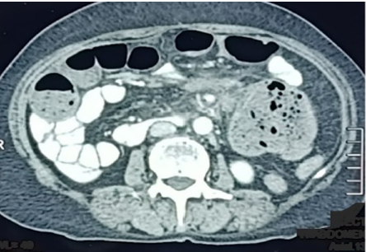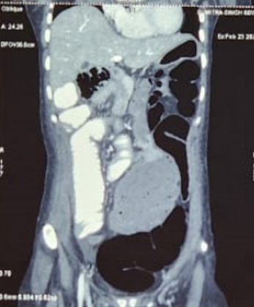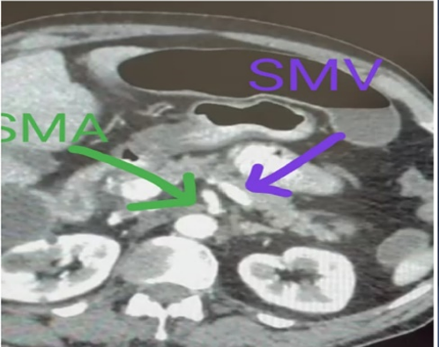

a)

b)

c)

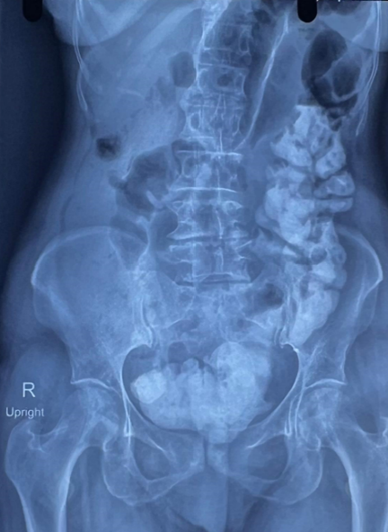

d)

Figure 1.

a,b - CECT Whole abdomen suggestive of heterogenously enhancing lesion ( blue arrowheads ) approx. 15 *7 cm with air foci inside seen on left side in lumber and pelvic area- could be a mass originating from bowel. Whole of the small bowel seen on the right side.

c- SMA (green arrow ) on right side and SMV( purple arrow ) on left side- Inverse relation

d- Upright abdominal radiograph showing clumping of bowel loops on left side

Laparotomy showed duodeno-jejunal flexure on right side with empty right iliac fossa (Figure 2.a).Terminal ileum along with whole of colon was lying in left iliac fossa reflecting non rotation type of malrotation.No volvulus identified.An intraluminal growth was identified in ceacum and part of ascending colon (Figure 2.c). with loops collapsed distal to it.Right hemicolectomy with ileo-transverse anastomosis done.Histopathology (Figure 3),report revealed well differentiated adenocarcinoma colon with 4/17 positive regional lymph nodes(pt2n2mx).Patient is doing well and undergoing adjuvant chemotherapy-CAPOX regimen.

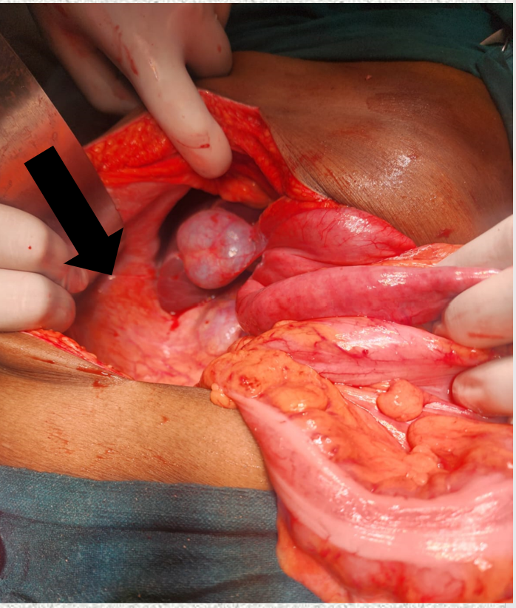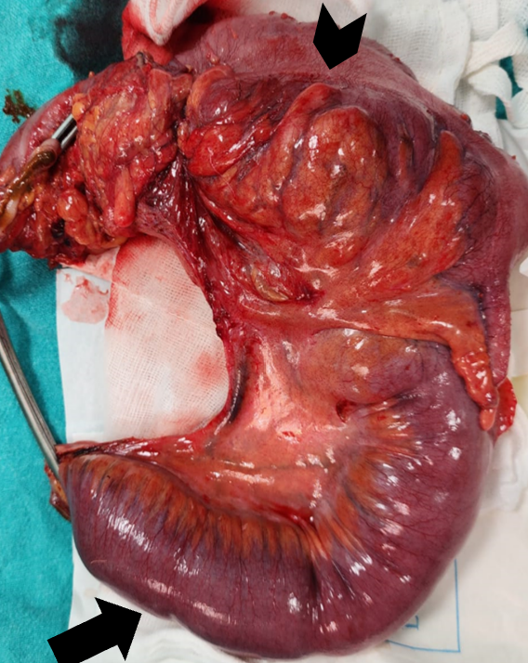

b)

a)

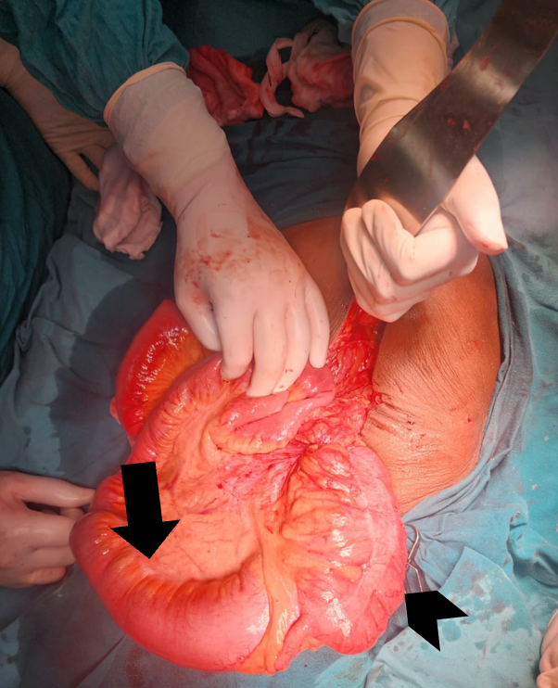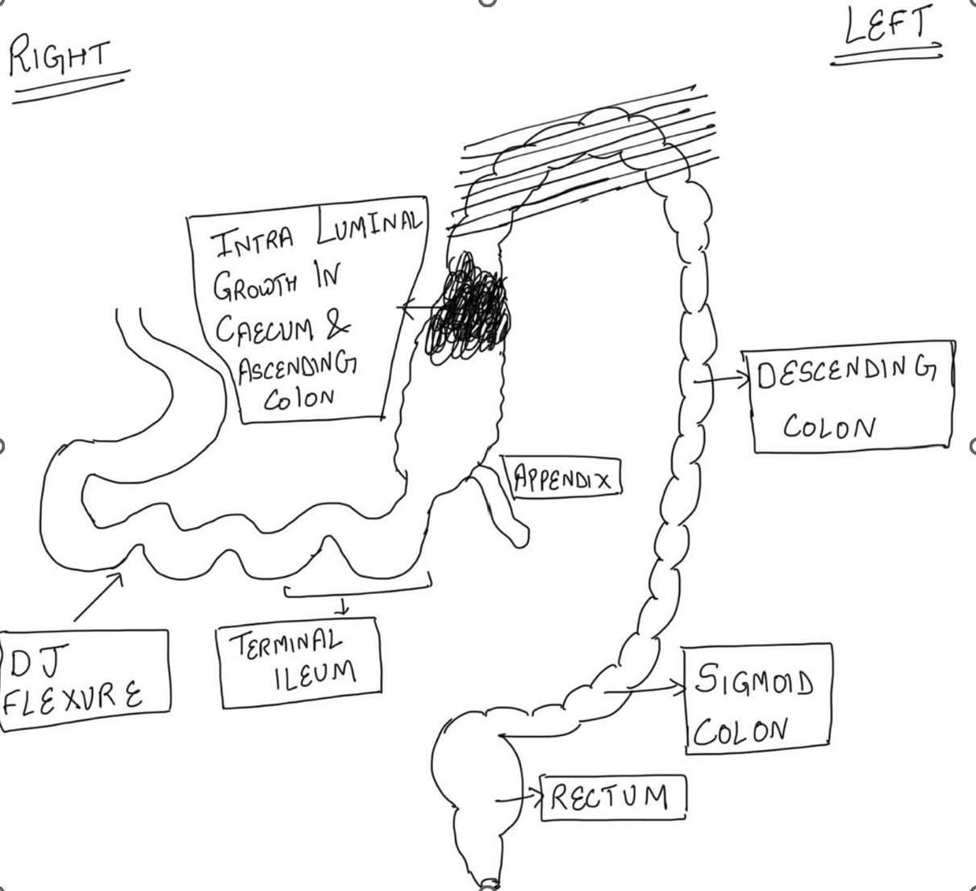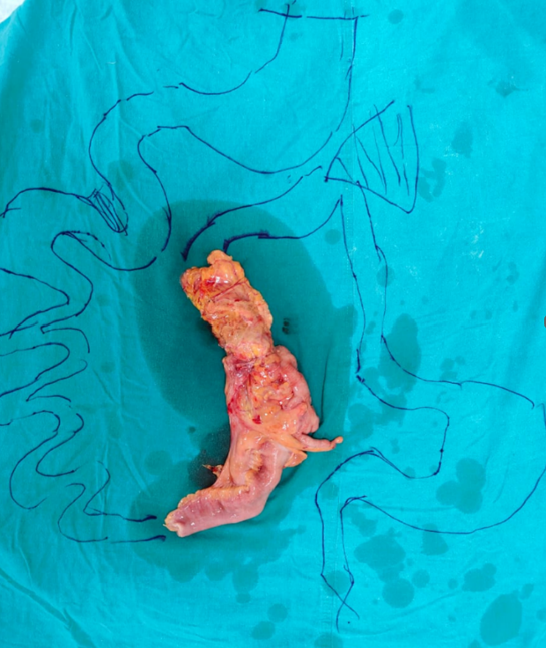

d)

c)

e)

Figure 2.

1. Arrow showing Empty right liac fossa.
2. Specimen sent for histopathology ( arrow showing proximal small bowel, arrowhead showing growth present distally at caecum and part of ascending colon
3. Arrow showing dilated loops proximal to intraluminal growth ( arrowhead)

d - Pictorial representation of patient’s bowel anatomy

e- Arrowhead showing resected bowel segment.

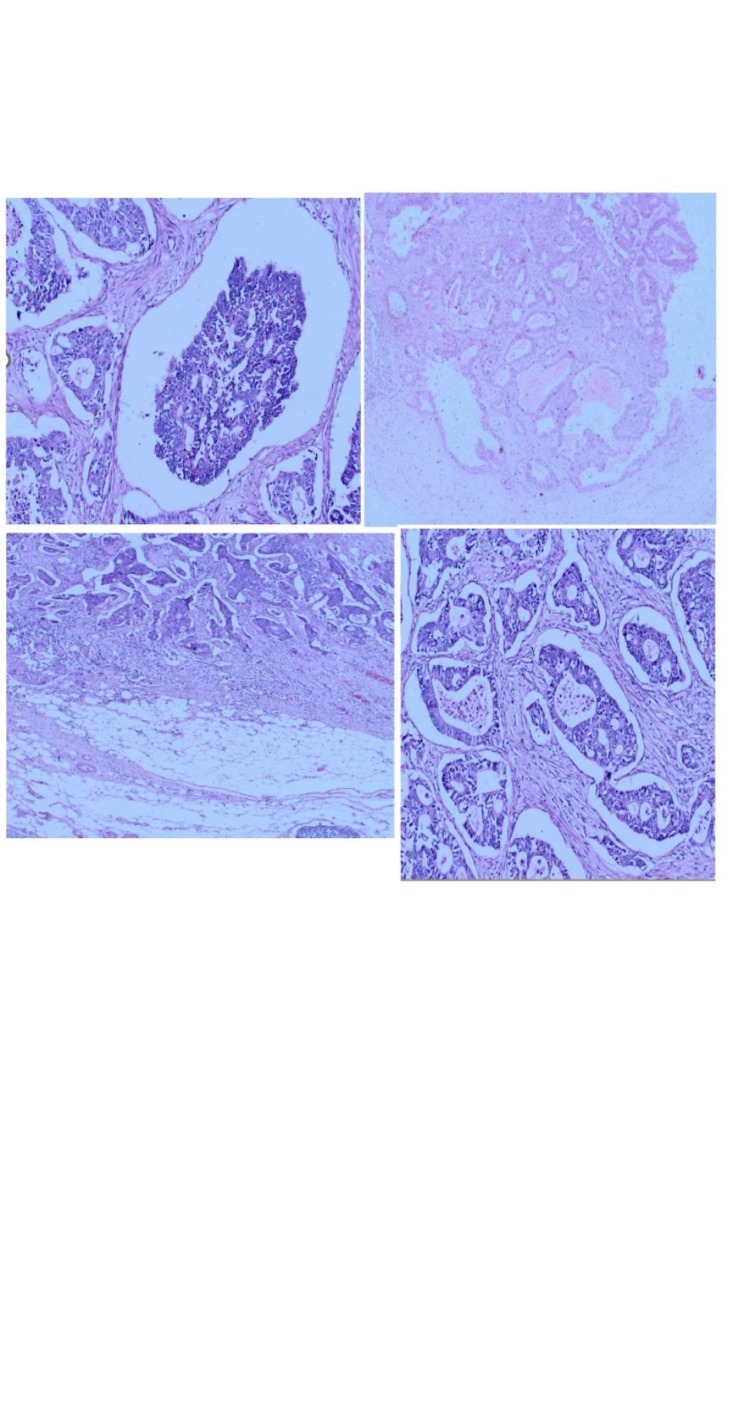

b)

a)

c)

d)

Figure 3.

a- Tumor cells arranged in cribiform pattern

b- Lymph node involvement

c- Tumor is invading the serosa

d- Tumor cells arranged in glandular pattern

**RESULT**

We searched databases such as Pubmed, Google Scholar, MEDLINE with keywords like ‘intestinal malrotation’,‘malrotation of gut’,‘colon cancer’ and ‘malrotation in elderly’.Worldwide reported cases are very few with maximum cases reported from Japan ( Table 1 , 2 ). Since 1970, only 81 cases have been reported citing colorectal cancers in cases of gut malrotation in adults.67 cases are from Japan and 14 from other countries, including 2 from India(2013-West Bengal, 2022 -Karnataka).All adults age betwen 22 to 88 years , with 75 % in range of 50-80 years.Reportedly, ours case is only the 3rd case from India & 82nd worldwide.The location of malignancies and clinical presentation in such patients is shown in ( Table 3 ,4) , and majority cases presented with gastrointestinal bleeding (27%(14/52)) and had cancer arising from right colon including cecum, appendix(58% (47/80)).Only 17%(9/52) presented with intestinal obstruction as in our case.

**TABLE 1– All cases of ‘malrotation with colorectal carcinoma’ reported till date in Japan** (1)**,** (2), (3)

|  |  |  |  |  |
| --- | --- | --- | --- | --- |
| **Author** | **Age/Sex** | **Location Of Malignancy** | **Malrotation Pattern** | **Presentation** |
| Hayashi H,2021 | 78/M | Appendix | Non rotation | Occult bleeding |
| Nakatani K., 2017 | 81/M | Caecum | Non-rotation | Unknown |
| Kimura, 2017 | 54/F | Ascending colon | Paraduodenal hernia | Unknown |
| Nishida, 2017 | 53/M | Sigmoid colon | Non rotation | Pain abdomen |
| Motoki, 2016 | 66/M | Ascending colon | Non rotation | Occult blood |
| Nakayama, 2016 | 63/M | Descending colon | Non rotation | Obstruction |
| Shima, 2016 | 77/M | Sigmoid colon | Reverse rotation | Unknown |
| Oshiro, 2016 | 75/M | Ascending colon, Descending colon | Reverse rotation | Unknown |
| Kubota, 2015 | 82/M | Ascending colon | Malrotation | Unknown |
| Kuwahara, 2015 | 54/F | Transverse colon | Non rotation | Unknown |
| Morioka, 2015 | 65/M | Caecum | Non rotation | Unknown |
| Kuroda, 2014 | 64/F | Transverse colon | Non rotation | Unknown |
| Enomoto, 2014 | 48/M | Transverse colon | Non rotation | Unknown |
| Fuji, 2014 | 73/F | Caecum | Non rotation | Unknown |
| Takahashi, 2014 | 53/F | Ascending colon | Mal rotation | Unknown |
| Hirano, 2013 | 82/F | Ascending colon | Mal rotation | Unknown |
| Maeda, 2013 | 48/M | Transverse colon | Non rotation | Unknown |
| Tatsuma Sakaguchi, 2013 | 78/M | Caecum | Unknown | Unknown |
| Yasuo Sumi , 2013 | 83/M | Transverse colon | Non-rotation | GI bleeding |
| Morimoto M , 2012 | 57/M | Caecum | Reversed rotation | Occult bleeding |
| Hirotaka Tokai , 2012 | 79/M | Transverse colon | Non-rotation | Occult bleeding |
| Kentarou Sekizawa , 2012 | 56/F | Rectosigmoid | Reversed rotation | Anaemia |
| Hiroaki Taiyou, 2012 | 53/F | Sigmoid | Non-rotation | Unknown |
| Kenntarou Kokubo , 2011 | 73/M | Caecum | Reversed rotation | Pain, weight loss, anaemia |
| Yasumitsu Hirano, 2011 | 68/F | Ascending colon | Non-rotation | GI bleeding |
| Minori Ito , 2010 | 67/F | Transverse colon | Non-rotation | Unknown |
| Kenichiro Fukuhara , 2010 | 76/F | Caecum | Non-rotation | Obstruction |
| Hidekazu Takahashi , 2009 | 84/M | Ascending colon | Unknown | Anaemia |
| Yoshio Itatani , 2009 | 61/M | Transverse colon | Malrotation | Obstruction |
| Hironori Kobayashi , 2009 | 60/M | Ascending colon | Non-rotation | Unknown |
| Yoshiyuki Nakasone , 2009 | 71/F | Sigmoid colon | Non-rotation | Anaemia |
| Takashi Seki , 2008 | 88/F | Rectum | Non-rotation | Unknown |
| Sumiya Yamamoto, 2007 | 63/F | Ascending colon | Non-rotation | GI bleeding |
| Takao Kyouzawa , 2007 | 84/M | Descending colon | Non-rotation | Unknown |
| Yushi Fujiwara , 2007 | 53/F | Ascending colon | Non-rotation | GI bleeding |
| Takehide Sasaki , 2006 | 71/M | Transverse colon | Non-rotation | Unknown |
| Yasuyuki Mitani , 2006 | 76/F | Transverse colon | Para duodenal hernia | Obstruction |
| Tomimatsu, 2005 | 81/F | Ascending colon | Non rotation | Unknown |
| Oku Takaomi , 2005 | 56/M | Ascending colon | Non-rotation | Unknown |
| Shigeo Fujita, 2004 | 55/F | Sigmoid colon | Non-rotation | Asymptomatic |
| Uchida H, 2004 | Unknown | Unknown | Unknown | Unknown |
| Keisei Sasaki , 2003 | 71/F | Caecum | Non-rotation | Unknown |
| Takeshi Nagase , 2003 | 60/M | Ascending colon | Non-rotation | Occult bleeding |
| Takanori Goi , 2003 | 72/F | Ascending colon | Non-rotation | Abdominal mass |
| Kaneko Tadashi , 2002 | 52/M | Sigmoid colon | Non-rotation | Anaemia |
| Sato Harunobu , 2001 | 76/F | Appendix | Non-rotation | Acute appendicitis |
| Iwamura T , 2001 | 71/F | Rectum | Non-rotation | bleeding |
| Nobuhisa Akamatsu, 2000 | 81/F | Sigmoid colon | Non-rotation | Unknown |
| Masaya Tamura , 1999 | 55/M | Caecum | Non-rotation | Pain, dyspepsia |
| Katsuyuki Kunieda , 1998 | 57/F | Rectum | Non-rotation | Bleeding per rectum |
| Keisei Sasaki , 2003 | 71/F | Caecum | Non-rotation | Unknown |
| Takeshi Nagase , 2003 | 60/M | Ascending colon | Non-rotation | Occult bleeding |
| Takanori Goi , 2003 | 72/F | Ascending colon | Non-rotation | Abdominal mass |
| Kaneko Tadashi , 2002 | 52/M | Sigmoid colon | Non-rotation | Anaemia |
| Seta, 1996 | 68/M | Ascending colon | Non-rotation | Abdominal mass |
| Shiomi , 1996 | 82/M | Rectum | Non-rotation | Bleeding per rectum |
| Kazuhiko Yokota, 1995 | 66/M | Rectum | Non-rotation | Obstruction |
| Naoki Hashimoto , 1995 | 65/F | Appendix | Malrotation | Unknown |
| Isogai, 1995 | 77/F | Caecum | Non-rotation | GI bleeding |
| Hiroo Ooshita , 1993 | 68/M | Rectum | Non-rotation | Bleeding per rectum |
| Hayashi , 1993 | 72/F | Caecum | Non-rotation | GI bleeding |
| Yoshikata , 1992 | 72/F | Sigmoid colon | Non-rotation | GI bleeding |
| Yokoyama , 1990 | 62/F | Ascending colon | Non-rotation | Abdominal mass |
| Shimanuki , 1988 | 73/M | Caecum | Non-rotation | Obstruction |
| Umaki , 1974 | 43/M | Colon | Non-rotation | GI bleeding |
| Hiratsuka, 1974 | 47/M | Caecum | Non-rotation | Abdominal mass |
| Hiratsuka, 1971 | 52/F | Colon | Non-rotation | Unknown |

**TABLE 2– All cases of ‘malrotation with colorectal carcinoma’ reported till date in rest of world.**

|  |  |  |  |  |
| --- | --- | --- | --- | --- |
| **Author** | **Age/Sex** | **Location Of Malignancy** | **Malrotation Pattern** | **Presentation** |
| Bruna J Czech, 1970 (4) | - | Unknown | Unknown | Unknown |
| Gilbert HW et al. UK, 1990 (5) | 55/M | Descending colon | Incomplete rotation | Obstruction |
| Torreggiani WC Canada, 2001 (6) | 86/F | Caecum | Reverse rotation | Abdominal mass |
| Q J Greene, USA,2007 (7) | 78/M | Ascending colon | Non-rotation | Unknown |
| Ren P T, Lu B C China, 2009 (8) | 45/M | Ascending colon | Incomplete rotation | Abdominal mass |
| Antonio Brillantino, Italy, 2009 (9) | 34/M | Ascending colon | Non-rotation | Abdominal mass, weight loss |
| Michalopoulos A Greece, 2010 (10) | 76 | Ascending colon | Reverse rotation | Unknown |
| Petrou A Greece, 2010 (11) | 59/M | Mucinous adenocarcinoma appendix | Non-rotation | Acute appendicitis |
| Hye Jim Kim, Korea, 2011 (12) | 63/M | Ascending colon | Non-rotation | Obstruction |
| Huh J W, Korea, 2010 (13) | 41/F | Rectum | Non-rotation | Bleeding per rectum |
| Michael Donaire, USA, 2013 (14) | 52/M | Ascending colon | Non-rotation | Anaemia, weight loss |
| Ray D, India, 2013 (1) | 60/F | Caecum | Non-rotation | Anaemia |
| Balachandran G,India,2022 (15) | 72/F | Ascending colon | Incomplete rotation | Anaemia |
| Vieira B,Portugal , 2024 (16) | 63/M | Caecum | Non rotation | Pain abdomen |
| OUR’S CASE | 60/F | Ascending colon | Non rotation | Intestinal obstruction |

**TABLE 3 - Presentation of all the reported cases (Compiled based on data available).**

**[ N=51+1 ]**

|  |  |
| --- | --- |
| Gastrointestinal bleeding | 14 |
| Anaemia | 8 |
| Intestinal Obstruction | 8+1 |
| Abdominal mass | 7 |
| Occult Bleeding | 5 |
| Weight loss | 3 |
| Acute Appendicitis | 2 |
| Pain/Dyspepsia | 3 |
| Asymptomatic | 1 |

**TABLE 4 - Location of malignancy of all the reported cases (Compiled based on data available). [ N=79+1 ]**

|  |  |
| --- | --- |
| Right colon including caecum and appendix | 46+1 |
| Transverse colon | 12 |
| Descending colon including sigmoid colon | 12 |
| Rectum | 9 |

**DISCUSSION**

Malrotation is a group of congenital anomalies caused due to abnormal intestinal rotation and fixation during embryological development.Normal intestinal development happens between 5th to 11th week of gestational life in various stages such as herniation, rotation, retraction and fixation.Non rotation, Incomplete rotation and Reverse rotation are different types of malrotation.Non rotation type is most common form.Most cases of malrotation present in infancy.(17) In neonates,symptomatic malrotation occurs once in 6000 live births.(17) A retrospective study conducted between 1992 and 2009 at Massachusetts General Hospital concluded that intestinal malrotation can occur in patients of any age group in contrast with the old dictum and found that 48% of the patients were adults(>18 years).(18) Early diagnosis and proper management of these patients can be done by increased awareness about this pathology and knowing about its varied clinical presentation in different age groups.Colorectal cancer is an uncommon finding in adults with malrotation and only handful of cases are reported in India.Cases having chronic abdominal symptoms are surgically managed.This literature review and case report aims to raise awareness about IM in adults with abdominal symptoms and

emphasize colorectal malignancies associated in such cases.This association may be due to genetic factors like APC, p53, K-ras, MMR, SMAD4 mutations or due to chronic gut inflammation.(1) The cause for such association is still uncertain and needs to be pondered upon.

**CONCLUSION**

Colorectal malignancy occurring in adult patients with malrotation is extremely rare , hence awareness regarding same and early preoperative recognition will lead to for better surgical planning and management. Also, prolonged follow-up of pediatric patients can confirm about the premalignant potential of malrotation.

**STATEMENTS AND DECLARATIONS**

**Ethical considerations**

Our institution does not require ethical approval for reporting individual cases or case series.

**Consent to participate**

Not applicable.

**Consent for publication**

The participant’s consent was obtained. All authors ensure the patient's anonymity.

**Data availability statement**

Not applicable.

**REFERENCES**

1) Ray D, Morimoto M. Malrotation of the Intestine in Adult and Colorectal Cancer.*Indian J Surg* 2015;77(6):525-31.

2) Nakatani K, Tokuhara K, Sakaguchi T, Yoshioka K, Kon M. Laparoscopic surgery for colon cancer with intestinal malrotation in adults: Two case reports and review of literatures in Japan. *Int J Surg Case Rep* 2017;38:86-90.

3) Hayashi H, Matsuhisa M, Murase Y, Sano H, Nishio K et al. Laparoscopic surgery for appendiceal cancer with intestinal malrotation in an adult: A case report. *Int J Surg Case Rep*  2021;78:342-6.

4) Bruna J. Simultaneous occurrence of nonrotation and intestinal cancer. *Cesk Radiol* 1970;24(2):87-9.

5) Gilbert HW, Armstrong CP, Thompson MH. The presentation of malrotation of the intestine in adults. *Ann R Coll Surg Engl* 1990;72(4):239-42.

6) Torreggiani WC, Thornton F, Lyburn I, Brenner C, Lee MJ. Malrotation of the bowel resulting in a left-sided caecal carcinoma presenting as a palpable intrahernial mass. *Australas Radiol* 2001;45(3):362-4.

7) Greene QJ, Cheadle WG. Ascending colon cancer in a patient with situs inversus. *Am Surg* 2007;73(8):831-2.

8) Ren PT, Lu BC. Intestinal malrotation associated with colon cancer in an adult: report of a case. *Surg Today* 2009;39(7):624-7.

9) Brillantino A, Marano L, Schettino M, Torelli F, Izzo G et al. Report of a rare case of colon cancer complicated by anomalies of intestinal rotation and fixation: a case report. *Cases J* 2009;2:6555.

10) Michalopoulos A, Papadopoulos V, Paramythiotis D, Papavramidis T et al. Colonic cancer in a patient with intestinal malrotation: a case report. *Tech Coloproctol* 2010;14 Suppl 1:S65-6.

11) Petrou A, Papalambros A, Katsoulas N, Bramis K et al. Primary appendiceal mucinous adenocarcinoma alongside with situs inversus totalis: a unique clinical case. *World J Surg Oncol 2*010 ;8:49.

12) Kim HJ, Choi GS, Park JS, Lim KH et al. Laparoscopic right hemicolectomy with D3 lymph node dissection for a patient with situs inversus totalis: report of a case. *Surg Today* 2011;41(11):1538-42.

13) Huh JW, Kim HR, Cho SH, Kim CY, Kim HJ, Joo JK, et al. Laparoscopic total mesorectal excision in a rectal cancer patient with situs inversus totalis. *J Korean Med Sci* 2010;25(5):790-3.

14) Donaire M, Mariadason J, Stephens D, Pillarisetty S, Wallack MK. Carcinoma of the colon in an adult with intestinal malrotation. *Case Rep Surg* 2013;2013:525081.

15) Balachandran G, Bharathy KGS, Sikora SS. Laparoscopic surgery for right colon cancer with intestinal malrotation: A case report and review of the literature. *J Minim Access Surg* 2022;18(4):609-12.

Balachandran G, Bharathy KGS, Sikora SS. Laparoscopic surgery for right colon cancer with intestinal malrotation: A case report and review of the literature. *J Minim Access Surg* 2022;18(4):609-12.

16) Vieira B, Ribeiro A, Sousa P, Leal C, Pinto-de-Sousa J. An Unusual Coexistence: Right-Sided Colon Cancer and Intestinal Malrotation in an Adult. *Cureus* 2024;16(3):e55461.

17) Aboagye J, Goldstein SD, Salazar JH, Papandria D, Okoye MTet al. Age at presentation of common pediatric surgical conditions: Reexamining dogma. *J Pediatr Surg* 2014 ;49(6):995-9.

18) Nehra D, Goldstein AM. Intestinal malrotation: varied clinical presentation from infancy through adulthood. *Surgery* 2011;149(3):386-93.