Research on Furniture Design and Application of Environmentally Friendly Processes under the Concept of Sustainable Development

.

ABSTRACT

|  |
| --- |
| As global environmental issues become more pressing, sustainable development has become a core concept in the advancement of various industries, including the furniture sector. In modern furniture design, the demand for environmental protection and resource conservation has become increasingly significant. This paper aims to explore the integration and application of sustainable development principles in furniture design and eco-friendly processes. First, the basic concept of sustainable development is analyzed, and its specific applications in furniture design are discussed, with a focus on eco-friendly materials, modular design, and ergonomic considerations. Furthermore, the paper delves into the importance of eco-friendly processes in furniture production, particularly in the selection of sustainable materials, energy-saving production techniques, and low-carbon technologies. Through case studies, the paper highlights current green design practices within the furniture industry, underscoring the trends and future direction of sustainable furniture design. Additionally, the paper examines consumer awareness of eco-friendly furniture, market demand shifts, and the role of policies and regulations in promoting green furniture development. Finally, the paper concludes by summarizing the current state and prospects of sustainable furniture design, proposing future research directions, and emphasizing innovations in new eco-friendly materials, digital manufacturing, and furniture recycling. This paper provides both theoretical support and practical guidance for the sustainable development of the furniture design industry and contributes to the advancement of green, eco-friendly furniture. |

*Keywords:* *Sustainable development; furniture design; eco-friendly processes;*

1. INTRODUCTION

With the increasing severity of global environmental issues and the growing scarcity of resources, promoting sustainable development has become an urgent task for industries worldwide. The furniture industry, as a high-consumption and low-recycling sector, has raised growing concerns about its environmental impact[1-4]. Traditional furniture design and manufacturing processes rely heavily on non-renewable resources and often produce large amounts of waste and pollutants during production, which not only harms the natural environment but also affects human health and quality of life. Therefore, integrating sustainable development concepts into furniture design and adopting eco-friendly processes and materials has become an effective approach to addressing the current environmental crisis.In recent years, green design and eco-friendly furniture have become key areas of consumer focus. Green furniture not only reduces the environmental burden but also enhances the market competitiveness of products, driving the sustainable development of the industry. [5] Against this backdrop, this paper aims to explore how sustainable development can be realized in furniture design, analyze the applications of eco-friendly materials, energy-saving processes, and low-carbon production, and showcase the latest practices and achievements in environmental and sustainable design within the furniture industry through case studies. Through in-depth research and analysis, this paper provides a theoretical basis for the sustainable development of the furniture design field and contributes to the transformation of the furniture industry toward greener and more eco-friendly practices[6].

2. Sustainable Development Concepts and Furniture Design

2.1 Basic Concepts of Sustainable Development

Sustainable development refers to meeting the needs of the present without compromising the ability of future generations to meet their own needs[7]. The concept of sustainable development encompasses environmental protection, resource conservation, and social equity. In the context of furniture design, the concept emphasizes reducing resource waste, minimizing negative environmental impacts, and ensuring that products can be recycled or reused at the end of their lifecycle. Specifically, the application of sustainable development in furniture design can be seen in the following areas:Environmental Protection: Designs should aim to minimize the negative impact on the ecosystem by selecting environmentally friendly materials, such as renewable wood, recycled materials, and non-toxic paints.Resource Conservation: Through optimized design and production processes, the amount of raw materials used can be reduced, and resource utilization efficiency can be improved. Modular and standardized designs can minimize waste generation.Social Responsibility: Furniture companies should not only focus on the environmental performance of their products but also on labor conditions, fair trade, and fulfilling social responsibilities such as community development[8].

2.2 Sustainable Development Elements in Furniture Design

Sustainable development elements in furniture design primarily include the selection of eco-friendly materials, modular design, and ergonomic design. Selection of Eco-friendly Materials When choosing materials for furniture, priority should be given to renewable, recyclable, and non-toxic materials. For example:Renewable Wood: Using FSC-certified wood (Forest Stewardship Council) ensures that the wood comes from sustainably managed forests.Recycled Materials: By using recycled materials (such as reclaimed wood, plastic, and metal), reliance on natural resources can be reduced.Low-VOC Paints and Non-toxic Materials: Selecting low volatile organic compound (VOC) paints and coatings can prevent harmful substances in traditional paints from polluting the air[9-12].As shown in Figure 1.

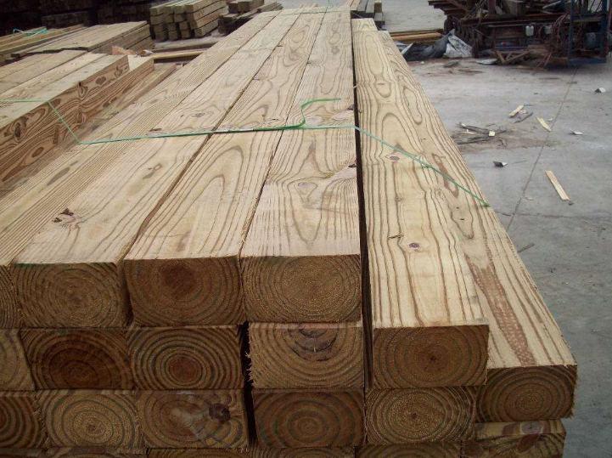  

**Fig.1. Renewable, recyclable and non-toxic materials**

Modular Design：Modular design refers to the design of furniture products that can be disassembled or reassembled, making them easier to transport, store, and update or repair in the future. This design approach effectively extends the product's lifespan and reduces waste generation. With modular design, consumers can replace or upgrade parts of the furniture without discarding the entire piece, enabling resource recycling.Ergonomic Design：Sustainable design should not only consider environmental impacts but also user health. Ergonomic design focuses on product comfort and ease of use, aiming to improve user experience and reduce health issues caused by poor design. For example, ergonomic office chairs can reduce spinal pressure from prolonged sitting, enhancing work efficiency and overall health.

2.3 Green Innovations in Furniture Design

Green design is not only about optimizing materials and processes but also about considering the entire lifecycle of furniture production and consumption. As environmental awareness increases globally, the furniture industry is undergoing a series of green innovations to push design toward more environmentally friendly practices. Product Lifecycle Management：

By considering the entire lifecycle of furniture—from raw material selection to disposal after use—every step should aim to minimize environmental impact. For example, designs should take into account whether products are easy to disassemble, recycle, and reuse, and avoid using materials that are difficult to degrade.Smart Manufacturing and Digital Design：Advances in modern technology have made digital manufacturing and 3D printing increasingly applicable to furniture production. Digital design allows for precise customization based on consumer needs while optimizing production processes to reduce material waste and energy consumption.Green Certifications and Environmental Standards：With the rise of green consumption, an increasing number of furniture products are obtaining green certifications such as EU Ecolabel and Greenguard. These certifications provide consumers with assurance of the environmental and sustainable qualities of the products, encouraging companies to adopt greener practices[13].

**3.1 Application of Eco-friendly Processes in Furniture Design**

**3.1.1 Basic Concept of Eco-friendly Processes**

Eco-friendly processes refer to the use of environmentally friendly technologies, methods, and materials in product design and production to minimize resource consumption, energy waste, and environmental pollution. In furniture production, eco-friendly processes involve not only the selection of materials but also energy utilization, waste management, and pollutant emissions during production. By applying eco-friendly processes, furniture production can achieve resource recycling, reduce the environmental burden of production, and enhance the corporate social responsibility and brand value of companies[14].

Key features of eco-friendly processes include:Resource Conservation: Optimizing designs to reduce the use of raw materials and maximizing resource utilization efficiency.Low Energy Consumption: Implementing energy-saving production technologies to minimize energy consumption.Low Pollution: Improving production processes to reduce waste and pollutant emissions.Recyclability: Designing furniture products to be recyclable or reusable during production and after use[15].

**3.1.2 Selection and Application of Eco-friendly Materials**

One of the core elements of eco-friendly processes is the selection of eco-friendly materials[16]. The use of eco-friendly materials in furniture production can reduce negative environmental impacts and enhance the sustainability of products. Common eco-friendly materials include:Renewable Wood：As a traditional material in furniture, the choice of wood is crucial for environmental protection. Renewable wood, especially FSC-certified wood (Forest Stewardship Council), ensures that the wood comes from sustainably managed forests. This helps to reduce environmental issues caused by deforestation while maintaining ecological balance.Low-formaldehyde Engineered Wood：Traditional engineered wood products often contain harmful substances such as formaldehyde, which release toxic gases and pollute indoor air. Today, low-formaldehyde engineered wood (such as E0 or E1 grade boards) is widely used in furniture design. These materials significantly reduce harmful emissions and ensure indoor air quality.Recycled Materials：Recycled materials, such as reclaimed wood, metal, and plastic, can effectively reduce the demand for raw materials and lower resource consumption. Through recycling, furniture products can minimize environmental burdens while reducing production costs.Natural Fibers and Non-toxic Coatings：In soft furnishings, natural fibers like organic cotton and linen can replace synthetic fibers, reducing the use of chemicals. As for coatings, selecting low-VOC (volatile organic compounds) or non-toxic paints can effectively reduce air pollution and health risks[17].

3.1.3 Energy-saving Production Processes

Energy-saving production processes are an essential aspect of eco-friendly practices in furniture manufacturing. These processes not only reduce production costs but also minimize energy consumption and reduce the carbon footprint of companies. Common energy-saving technologies include: Efficient Energy Use：In furniture production, efficient energy usage can be achieved by employing high-efficiency motors and energy-saving equipment to reduce waste. Additionally, automated production lines can allow for precise energy management and control, avoiding unnecessary energy consumption.Heat Recovery and Reuse：During furniture production, especially in wood drying and surface treatment processes, a significant amount of heat is consumed. Heat recovery systems can capture waste heat and reuse it in other production stages, thus reducing dependence on external energy sources.Water Conservation and Reuse：Furniture surface treatment processes, especially in spraying, often require substantial amounts of water. Implementing water recycling systems can efficiently reclaim and reuse wastewater, reducing water consumption and minimizing wastewater discharge[18].

3.1.4 Case Studies: Application of Eco-friendly Processes in Furniture Production

He following case studies offer practical insights into the application of eco-friendly processes in furniture design and production:Muji is committed to using eco-friendly materials, such as recycled wood and non-toxic coatings, while also promoting energy-saving production processes and packaging material recycling. These efforts have not only improved the environmental sustainability of its products but also helped establish a green brand image in the market.IKEA widely applies eco-friendly processes in furniture production. The company promotes the use of renewable wood and low-formaldehyde boards, along with energy-efficient equipment to reduce energy consumption during production. IKEA also collaborates with recycling organizations to promote the recycling and reuse of furniture products.Herman Miller adheres to strict eco-friendly process standards in the design and production of its furniture products. The iconic Aeron chair is made from recycled plastic and aluminum, and the company has significantly reduced waste emissions during production. Additionally, the product design facilitates easy disassembly and recycling[19]. As shown in Figure 2**.**

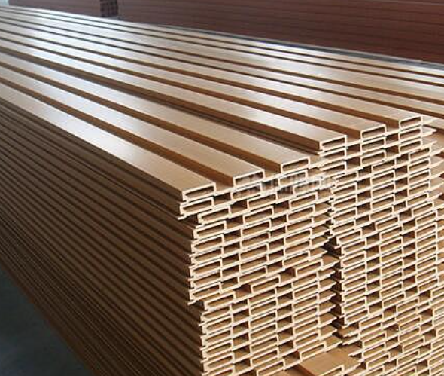 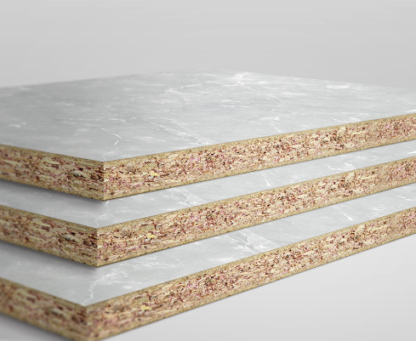 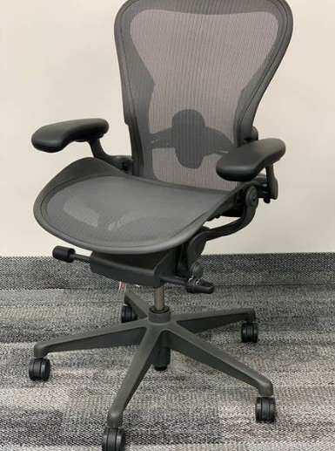

**Fig.2. Environmentally friendly materials**

The application of eco-friendly processes in furniture design and production not only improves production efficiency but also reduces environmental burdens. By selecting eco-friendly materials, adopting energy-saving production processes, and enhancing waste management and recycling, the furniture industry can achieve green production and increase corporate competitiveness. In the future, eco-friendly processes will become a core competitive advantage for the sustainable development of the furniture industry.

4.1 Innovative Technologies and Future Trends in Sustainable Furniture Design

4.1.1 The Role of Innovative Technologies in Sustainable Furniture Design

With the growing awareness of environmental protection and advancements in technology, furniture design is evolving towards a more sustainable and eco-friendly direction. Innovative technologies play a crucial role in promoting sustainability in the furniture industry. By leveraging advanced technologies, not only can the design process be optimized and production efficiency improved, but environmental impacts can also be reduced, achieving green production and sustainable resource use.

3D Printing Technology**：**3D printing technology has started to be applied in furniture design and production. Compared to traditional manufacturing methods, 3D printing offers high customization and precision, enabling the production of parts according to demand. This not only reduces material waste but also allows for the creation of complex-shaped furniture, minimizing dependence on traditional manufacturing tools. Additionally, 3D printing supports the use of recycled materials, such as reclaimed plastic, which effectively reduces resource consumption.

Smart Manufacturing and Automated Production**：**The use of smart manufacturing and automation technologies improves production efficiency while reducing resource waste. For example, through Computer-Aided Design (CAD) and Computer-Aided Manufacturing (CAM) technologies, the production process can be optimized, errors minimized, and precise component manufacturing can be achieved based on demand. Automated production lines can also manage energy and raw materials more efficiently, further reducing waste and carbon emissions.

Digital Design and Virtual Reality (VR)：Digital design and VR technologies allow for more precise and personalized furniture design. Designers can use virtual reality environments to simulate and test designs, enabling them to observe the effects of the furniture in virtual space in real-time. This avoids the production of numerous physical prototypes, saving material costs. Additionally, this technology helps anticipate how furniture will perform in actual use, optimizing designs and reducing the production of defective products[20]. As shown in Figure 3**.**

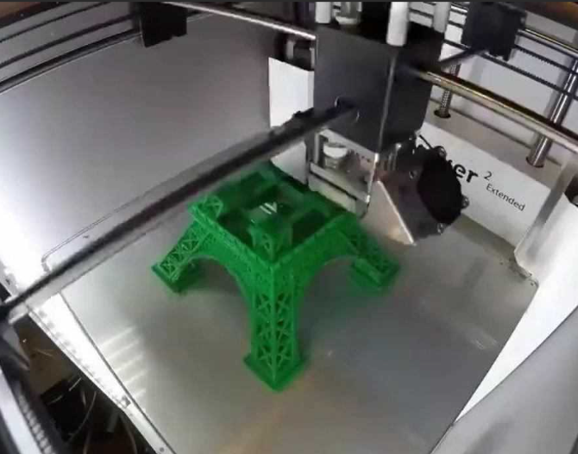  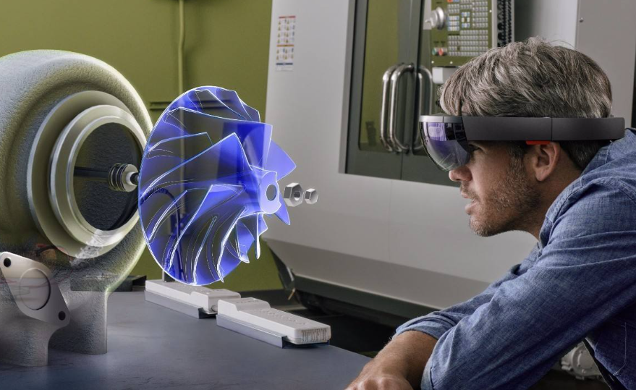

**Fig.3. new technology**

4.1.2 The Innovative Development of Eco-friendly Materials

With the increasing demand for sustainability, the eco-friendly materials used in furniture are continuously evolving. The emergence of new eco-friendly materials provides more options for furniture design.Bio-based Materials：Bio-based materials are made from renewable plant resources (such as bamboo, cotton, hemp, etc.) or biodegradable materials (such as PLA). These materials typically have a lower carbon footprint and can degrade naturally after use, reducing environmental pollution. For example, the use of bio-based plastics can replace traditional petroleum-based plastics, reducing the consumption of fossil resources.Nanotechnology Materials：The application of nanotechnology in the furniture sector is increasing. Nanotechnology can enhance the properties of furniture materials, such as improving durability, water resistance, and antimicrobial properties. For example, nanocoatings can enhance the wear resistance and stain resistance of furniture surfaces, extending the lifespan of products and reducing maintenance frequency, which in turn lowers waste generation.Recycled Materials：In recent years, the use of recycled materials has become more widespread. In furniture production, recycled and reclaimed materials, such as wood, metal, and glass, are increasingly favored by designers. Using these materials not only helps conserve resources but also reduces waste accumulation and environmental pollution[21].

4.1.3 Modular and Demountable Design for Sustainable Furniture

Modular design and demountable design are key strategies for achieving sustainability in furniture. By adopting modular design, furniture production not only reduces material waste during manufacturing but also allows for easy disassembly and reassembly, thereby extending the product's lifecycle.Modular Design：Modular furniture allows consumers to personalize and combine components according to their needs. Modular components are easy to transport and store, and they can be adjusted and upgraded based on usage. Consumers can replace only the damaged parts rather than the entire piece of furniture, thereby extending the product's lifespan and reducing waste.Demountable Design：Demountable design allows furniture to be more easily disassembled and recycled at the end of its life cycle. By simplifying assembly and disassembly processes, energy consumption during production can be reduced, and the disposal of discarded furniture can be made more efficient. For example, some furniture designs use assembly methods that avoid adhesives, relying on clips and screws, making it easier to disassemble and recycle.

4.1.4 The Trend of Smart Furniture in Sustainable Design

With the rise of smart home technology, furniture design is also moving towards smart features. Smart furniture not only enhances the quality of life for users but also contributes to resource savings through smart control, achieving sustainability goals.Smart Home Integration：Smart furniture can be integrated and controlled with other home devices. For example, smart sofas and mattresses can automatically adjust their firmness based on the user's body type and health condition, providing a more comfortable experience. Additionally, smart furniture can monitor usage through wireless sensors and adjust the furniture's functionality based on data, optimizing resource use and promoting energy savings.Energy-saving Smart Features：Some smart furniture products are designed to automatically adjust temperature, humidity, and lighting, thereby optimizing household energy use. For example, smart lighting can adjust its brightness according to the room's light levels, reducing unnecessary energy consumption. Smart air conditioning systems can automatically regulate the temperature based on the environment, promoting energy efficiency.

4.1.5 Future Development Trends in Sustainable Furniture Design

The future trends in sustainable furniture design primarily focus on the following aspects:

Life Cycle Management: Furniture design will increasingly focus on life cycle management, considering every phase of the product's life from raw material procurement to end-of-life disposal, all within the framework of sustainability.Smart and Personalized Design: Smart furniture will become an important trend in the future, with a growing demand for personalized customization.Circular Economy and Resource Sharing: The rental and sharing of furniture will become more popular, helping reduce overconsumption and resource waste through the sharing economy model.Wider Adoption of Green Design Standards: As green certification standards improve, more furniture products will meet sustainable development criteria, driving the industry toward greener, more environmentally friendly practices.

5.1 CONCLUSION

With the promotion of sustainable development, furniture design is moving towards environmental protection, energy efficiency, and resource utilization. By adopting green design, innovative materials, and smart technologies, the furniture industry reduces resource waste, extends product lifespan, and minimizes environmental impact. Modular and demountable designs also provide more opportunities for recycling and reuse, supporting the development of a circular economy.In the future, with technological advancements and increasing consumer awareness, the furniture industry will see more innovations. Smart manufacturing and digital design will make production more efficient and personalized, while eco-friendly materials will be more widely used. Despite challenges in cost and technology, the improvement of green certification systems and policy support will drive the industry toward sustainability.The furniture industry will continue to promote green design, smart production, and resource recycling, moving towards a more sustainable future.

References

1. Yichen Zhang, Shouliang Lai & Renjie Ni. (2025). Simulation of precision machining manufacturing in furniture design visualization process based on environmental thermal modeling: A VR design. Thermal Science and Engineering Progress 103362-103362.

2.Yang Liu. (2025). Interactive design scheme for building indoor thermal cycle and furniture design based on thermal simulation. Thermal Science and Engineering Progress 103360-103360.

3. Yaohui Ji, Yao Sun, Song Qiu &  Xiaojie Geng. (2025). Simultaneous multimodal measures for aesthetic evaluation of furniture color and form.Scientific Reports(1), 2920-2920.

4. Alessandra Rinaldi, Sara Viviani & Daniele Busciantella Ricci. (2025). Urban Furniture Design Strategies to Build Healthy and Inclusive Neighborhoods. Sustainability (3), 859-859.

5. Juan Sádaba, Ylenia Alonso, Itxaro Latasa & Arantzazu Luzarraga. (2024). Towards Resilient and Inclusive Cities: A Framework for Sustainable Street-Level Urban Design. Urban Science (4), 264-264.

6. Wenjia Li, Xinni Zhang, Han Gao, Jingjing Gui, Xiaoyu Yang & Jidong Yang. (2024). Developing positive design with innovative thinking framework: A design pedagogical approach to enhance subjective well-being. Heliyon (23), e39342-e39342.

7. Yuan Tianyue. Application of bamboo pattern elements in furniture design [J]. Footwear Craft and Design, 2025, 5 (01): 81-83.

8. Diana Puspita Sari, Sri Hartini, Faradhina Azzahra, Makhrul Hamdi & Pramudi Arsiwi. (2024). Designing a bedside table of wood furniture waste based on TRIZEE methodology. Production Engineering Archives (4), 551-564.

9. Zoran Vlaović, Tomislav Gržan, Ivica Župčić, Danijela Domljan & Goran Mihulja. (2024). Strength, Durability, and Aesthetics of Corner Joints and Edge Banding in Furniture Design: A Review. Applied Sciences (22), 10285-10285.

10. Xiaojie Xie, Jiangang Zhu, Sheng Ding & Jingjing Chen. (2024). Correction: Xie et al. AHP and GCA Combined Approach to Green Design Evaluation of Kindergarten Furniture. Sustainability 2024, 16, 1. Sustainability (21), 9548-9548.

11. Chen Chen. (2024). Application of support vector machine–based CNC machining in furniture product visual design and production control process.The International Journal of Advanced Manufacturing Technology(prepublish), 1-9.

12. Binglu Chen, Guanyu Chen & Qianqian Hu. (2024). Furniture design based on image color extraction algorithm. Systems and Soft Computing 200123-200123.

13. Chuan Xue & Ling Jin. (2024). Innovative design of wood texture images for indoor furniture based on variable space. Systems and Soft Computing 200114-200114.

14. Abdelmawgoud Mohamed, Koenke Carsten, Baraka Moustafa, El Aziz Ahmed Abd & El Anssary Alaa. (2024). Integration between sustainable construction materials and sustainable furniture design. Innovative Infrastructure Solutions (8).

15. Yang Mao, Bowen Li, Shifan Yin, Zhuohong Han & Qian Liu. (2024). Research on the Application of Tea Culture and Stone in Traditional Furniture Design. Art and Design (5).

16. Jinyu Wang. (2024). Thermal Comfort Simulation in Furniture Design: Integrating Considerations of the Building Thermal Environment. International Journal of Heat and Technology (2).

17. Xinyi Mao. (2024). Research on Emotional Design Intervention in Urban Furniture Design. Landscape Architecture (1).

18. Dongfang Yang & Carlo Vezzoli. (2024). Designing Environmentally Sustainable Furniture Products: Furniture-Specific Life Cycle Design Guidelines and a Toolkit to Promote Environmental Performance. Sustainability (7).

19. Yiwen Zhang, Jiayi Huang, Yiming Gao & Xiang Wang. (2023). Innovative Design for Age-friendly Chair Based on Ming-style Furniture Elements. Journal of Social Science and Humanities (12).

20. Shilin Wu. (2022). Modular Furniture Design by Using Intelligent Platform and Wireless Sensors. Computational Intelligence and Neuroscience 2586711-2586711.

21. (2022). Leading Indian and International Furniture Brands to Showcase Their Latest Concepts and Designs at WOFX - World Furniture Expo. M2 Presswire.