***Original Research Article***

**The Bioactive Compounds in Pure & Ternary Blends of Cocoyam, Soya bean & Bambara groundnut Flour Identified Using Gas Chromatography-Mass Spectrometry (GC-MS) Technique.**

.

ABSTRACT

|  |
| --- |
| **Background**: Bioactive compounds (BACs) are active ingredients responsible for the biological activities of some animal and medicinal plant extracts. Among the plants foods considered as functional foods due to the presence of such BACs compositions, are cocoyam (CY), soya bean (SB) and Bambara groundnut (BGN). The BACs constituents of each of these food plants have been documented but reported BACs in flour blends of such plant foods are scanty, yet various animal experiments involving these and other flour blends are common, while consumption, sometimes on recommendation by experts, of the various plants as food mixtures, abound especially in resource-poor countries, triggering the need for this study to analyze, using Gas-Chromatography-Mass Spectrometry (GC-MS), the BACs of these flour blends. **Methodology:** Cocoyam, soya bean and Bambara groundnut purchased from a local market were processed into fine flour and grouped into pure and ternary flour blends. To ten grams (10 g) of each of the flour blends was added 2.5 L of methanol and allowed to mix for 48 h, following which the solution was filtered using musclin cloth. The filtrate so obtained was extracted for 3 h in a soxhlet apparatus, using an oven at 500C. The extract was analyzed for phytochemical constituents, using GC-MS. **Results and Discussion**: The study revealed the presence of such BACs as Phenols, thiadiazole, monoterpenoids, aziridine, thiourea, stilbenes, amphetamine/phenylethylene, flavonoids, artemisinin, naphthalenes, and 1, 4-diazepanes, in the various CY-SB-BGN flour blend formulations. Each formulation had different family classifications of identified BACs. Some of these BACs have been reported in previous studies in the various pure blends of the plant foods, but blends of the plant food flours revealed additional BACs in the ternary blends. **Conclusion:** Various formulations of CY-SB-BGN flour blends have classes of BACs in both pure and ternary blends, though the classes of BACs in each family varied depending on the formulation. These findings lend credence to the fact that flour mixtures of these plant foods contain BACs that may be useful in disease management and prevention. |

*Keywords: Bioactive compounds, Gas Chromatography Mass spectrometry,* Cocoyam, Bambara groundnut, Soya bean, flour blends.

1. INTRODUCTION

Bioactive compounds (BACs) are present in some plant foods called functional foods and nutraceuticals which are needed in human disease prevention [1] among others. BACs are sourced from plants and animals including cocoyam, shrimps, egg, legumes [2,3,4,5]. BACs bioactivity depends on the chain length, hydrophobicity, molecular charge and the side chain bulkiness of the amino acid residue [6]. The amount of histidine, cysteine, prolne, methionine and aromatic amino acids present in a peptide contribute to its antioxidant activity [7]. One of the key nutritional guide in the use of functional foods, is therefore the consumption of medicinal plant foods [8]. In the list of such food plants are Bambara groundnut (*Vigna subterranean*) Soya Bean (*Glycine max. (L) Merrill*) and cocoyam (*Colocasia esculenta*) all of which have been found to contain adequate nutrients and phytochemicals with bioactivities [9-22].

Cocoyam, together with other tuber crops and starchy foods account for about 40% of the foods consumed by half of the people living in sub Saharan Africa, and a staple food for over one billion people in low income countries [23] and therefore readily available and affordable. Bambara groundnut on its own contains macro- and micro-nutrients [9, 24 – 27], while soya bean, a leguminous crop equally provides excellent nutrition including protein and oil globally [28]. A blend of these flour can produce BACs that could exhibit antagonistic or synergistic effects, with the latter being often the observation. Besides, while one food source may be more potent in anti-inflammatory effect, another may exhibit high antioxidant activity or immune-stimulatory effect, hence the advantage for combination and their exploration in the management of chronic diseases like Type 2 diabetes mellitus whose prognosis in uncontrolled and poorly managed cases are poor with attendant multiple organ damage, high mortality, high morbidity, disability and global endemicity [29], with huge capital expenditure [30].

GC is used for the quantification of metabolites in the blood and urine and that of reaction products in addition to RNA isolation, identification of pollutants, and hazardous compounds in waste dumps (<https://www.omicsonline>), and in the quantitative and qualitative analysis of food components such as carbohydrates and amino acids [31] lipids and associated lipophilic compounds [32, 33] and flavours and aromas.

A combination of GC-MS has been utilized for more efficiency in product analysis. Such combinations gives additional information beside the quantification and identification of a compound [34]. Hence in complex mixtures of geometric isomers, a combination of chromatographic separation and spectroscopic identification is applied in GC-MS [35]. In such cases, the quadrupole spectrometer is used as a common analyzing element. The GC-MS analytic method has been successfully applied in several studies involving medicinal plants such as fermented castor seed (ogiri Igbo) [36], leaves of *gongonema latifolium, petrocarpus mildbraedi* and *piper guineese* plants [37], aqueuous leaf extract of *Gnetum africanum* [38]; *Amaranthus viridis L* (Green leaf [39], and leaf of *Curcurbita pepo L* [40]. Another study equally analyzed the phytochemicals in unripe plantain-millet feed blend using same technique [41].

The aim of this study was to identify the various bioactive compounds in pure and ternary blends of soya bean, cocoyam and Bambara groundnut flour using GC-MS technique, with a view to documenting the compounds possibly responsible for the biological activities of such flour that can be used in chronic diseases management.

2. material and methods

**2.1 Collection of Plant Materials**

Cocoyam, soya bean and Bambara groundnut were purchased from a local market and identified by a plant taxonomist before processing them into flour using standard procedures. The flour of each of the plant foods were stored in airtight containers for future use.

* 1. **Flour Formulations**

The Cocoyam-Soya bean-Bambara groundnut flour were grouped into pure, and ternary blends formulations, based on previous animal experiments involving plant food formulations [41], resulting in eight formulation groups (Table 1).

**Table 1: Cocoyam-Soya Bean-Bambara groundnut Flour Formulations**

|  |  |  |  |  |  |
| --- | --- | --- | --- | --- | --- |
|  | | | | | |
| **Formulations** | **Codes** | **%CY** | **%SB** | **%BGN** | **%RF** |
| 1 | 1C | 16.6 | 16.6 | 16.6 | 50 |
| 2 | 1S | 12.5 | 12.5 | 25 | 50 |
| 3 | 1B | 25 | 12.5 | 12.5 | 50 |
| 4 | 4 | 12.5 | 25 | 12.5 | 50 |
| 5 | O | 0 | 0 | 50 | 50 |
| 6 | CY | 50 | 0 | 0 | 50 |
| 7 | SB | 0 | 50 | 0 | 50 |
| RF | RF | 0 | 0 | 0 | 100 |

RF = Commercial Rat Feed; SB = Soya bean; BGN = Bambara Groundnut; CY = Cocoyam.

* 1. **Plant extraction**

To ten grams (10 g) of each of the flour blends was added 2.5 L of methanol and allowed to mix for 48 h, following which the solution was filtered using musclin cloth. The filtrate so obtained was extracted for 3 h in a soxhlet apparatus, using an oven at 500C. The extract was analyzed for phytochemical constituents, using Gas Chromatography/Mass Spectrometry method.

* + 1. **Phytochemical Analysis**

**2.3.2 Qualitative Analysis Methods**

The qualitative phytochemical screening was conducted following the method described by Shaikh and Patil [42] in which the ground samples were extracted using methanol and water in the ratio of 2:1. Thirty (30 g) gram of each sample was weighed into 150 ml of the solvent contained in 300 ml beaker. This was allowed for 48 hours before filtration using cheese cloth. The filtrate of each sample was used for the phytochemical screening.

1. **Phenols**

To 2ml of the extract that was pipetted into a test tube, 3ml of distilled water was added followed by 3 ml of 10% lead acetate solution. White precipitate formed was a positive sign for phenol

1. **Quinones**

To 2ml of the extract in a test tube was added few drops of concentrated HCl. Green colour which is a positive test was not observed.

1. **Cardiac glycosides**

About 2 ml of the filtrate in a test tube was added few drops of concentrated H2SO4 was shaken and allowed to stand. The appearance of red colour in lower layer indicated phytosterol.

1. **Alkaloid**

A test tube containing 3 ml of the extract was added 3-4 drops of picric acid. Appearance of an orange colour indicated alkaloid.

1. **Anthocyanin**

About 2 ml of the extract in a test tube was added 2 ml of 2N HCl followed by few drops of ammonia, appearance of pink red, which turned blue violet after addition of few drops of ammonia showed the presence of anthocyanin.

1. **Anthraquinones**

To 1 ml of the extract in a test tube, 10 ml 10% ammonia solution was added and shaken vigorously and allowed to stand for 30 sec. A pink, red violet colour indicated presence of anthraquinones.

1. **Saponin**

Five (5) drops of olive oil were added to 3 mls of the sample in a test tube, stirred vigorously and allowed to stand for 30 sec. Emulsification that was observed for this duration indicated the presence of saponins.

1. **Flavonoid**

To 1ml of extract in a test tube was added 2 ml of 2% NaOH solution, the appearance of yellow colour which disappeared upon the addition of few drops of diluted HCl indicated the presence of flavonoid.

1. **Tannin**

To 2 ml of the extract in a test tube was added 3 drops of lead acetate, gelatinous precipitate is a positive test for tannin.

1. **Proteins**

About 5 ml of the extract in a test tube was added 0.1 ml Concentrated HN03. This was heated to a boiling point, the appearance of a colour change to a yellow precipitate which changed to intense yellow following the addition of few drops of ammonium hydroxide. This was a positive test for proteins containing aromatic groups (tyrosine, phenylalanine and tryptophan).

1. **Phytosterol**

To 1ml of the filtrate in a test tube was added few drops of concentrated H2SO4, shaken well and allowed to stand. The presence of red colour in lower layer indicated phytosterol.

* 1. **Quantitative Analysis**

**2.4.1The GC/MS analysis**

Exactly 10 g of the sample was soaked in methanol for 48 hours, and then filtered and concentrated to 0.5 mL. From this, I µl of the concentrated sample was then injected into the GC column for analysis. The GC (Agilent 6890N) and MS (5975B MSD) is equipped with DB-5ms capillary column (30 m x 0.25 mm; film thickness 0.25 µm). The initial temperature was set at 400C which increased to 1500C at the rate of 100C/min. The temperature was again increased to 2300C at the rate of 50C/min. The process continued till the temperature reached 2800C at the rate of 200C/min which was held for 8 minutes. The injector port temperature remained constant at 2800C and detector temperature was 2500C. Helium was used as the carrier gas with a flow rate of 1mL/min. Split ratio and ionization voltage were 110:1 and 70 eV respectively. To identify and quantify the target active compounds present in the extracted sample, their individual mass spectral peak value was compared with the database of National Institute of Science and Technology, 2014; followed by obtaining the percent report from the equipment. The percent report shows the exact amount at which the targeted compounds were present.

Each of the formulation samples analyzed, was reported in a Table (Samples 1- 6 and RF)

3. results and discussion

**3.1 Qualitative Screening Results**

Qualitative screening reveals the possible types of classes of phytochemicals in the plant food materials. Table 2 is the result of the qualitative screening of the phytochemicals in the cocoyam-soya bean-Bambara ground nut formulations.

**Table 2: Result of the Qualitative screening of the phytochemicals in plant food materials**

|  |  |  |  |  |  |  |  |  |  |  |  |  |
| --- | --- | --- | --- | --- | --- | --- | --- | --- | --- | --- | --- | --- |
|  | Formulations | Alkaloid | Flavonoid | Tannin | Phenol | Cardiac Glycosides | Saponin | Proteins | Quinonesi | Anthraquinone | Anthrocyanins | Phytosterol |
|  | 1 | + | + | + | + | + | + | + | - | - | - | + |
|  | 2 | + | + | + | + | + | + | ++ | - | - | - | + |
|  | 3 | + | + | + | + | + | + | + | - | - | - | + |
|  | 4 | + | + | + | + | + | + | + | - | - | - | + |
|  | 5 | + | + | + | + | ++ | + | ++ | - | - | - | + |
|  | 6 | + | + | + | + | + | + | + | - | - | - | + |
|  | 7 | + | + | + | + | + | + | ++ | - | - | - | + |
|  | RF | + | + | + | + | + | + | + | - | - | - | + |

Key: = - absent; + abundant; ++ very abundant

Table 2 showed the qualitative screening test of the selected formulations 1 - 7 and RF. All the formulations contained alkaloids, flavonoids, phenolics, cardiac glycosides, tannins, saponins, proteins and phytosterol.

* 1. **Gas Chromatography –Mass Spectrometry (GC-MS)**

**3.2.1 Commercial Rat Feeds**

|  |  |  |  |  |  |  |  |
| --- | --- | --- | --- | --- | --- | --- | --- |
| To identify the specific bioactive compounds in the commercial rat feeds, the GC-MS, was conducted on the commercial rat feeds (Formulation RF) in Table 3.  **Table 3: Result of the GC-MS Analysis of Formulations RF (0%CY + 0%SB + 0%BGN + 100%RF)** | | | | | | | |
| S/N | Retention Time | Peak Area % | Molecular Formula | Molecular Structure | Molecular Weight | Name of Bioactive Compound | Family Classification |
| 1 | 2.096 | 0.53 | C7H15N |  | 113 | Piperidine, 1,2-dimethyl | Thiadiazol |
| 2 | 2.45 | 0.11 | C3H4N4OS |  | 144 | 1,2,3-Thiadiazole-4-carboxylic acid, hydrazide | Thiadiazole |
| 3 | 2.605 | 0.23 | C8H8O |  | 120 | Phthalan (Isocoumaran) or 1,3-dihydro-2-benzofuran | Phenols |
| 4 | 4.765 | 0.58 | C9H10O2 |  | 150 | 2-Methoxy-4-vinylphenol | Phenols |
| 5 | 5.788 | 0.13 | C8H8O3 |  | 152 | Vanillin | Phenolic aldehyde |
| 6 | 12.286 | 0.66 | C16H22O4 |  | 278 | Dibutyl phthalate | Carboxylic acid |

Table 3 showed the GC-MS report of Formulations RF (0%CY + 0%SB + 0%BN + 100%RF) (The Commercial Rat Feed). It highlighted the molecular structure, molecular formula, % composition, peak flow percentage and retention time of the BACs: piperidine 1,2-dimethyl; 1,2,3-thiadiazole-4-carboxylic acid; phenolic compounds, 1,3-dihydro-2-benzofuran; 2-methoxy-4-vinylphenol, vanillin and a carboxylic acid, dibutylphthalate.

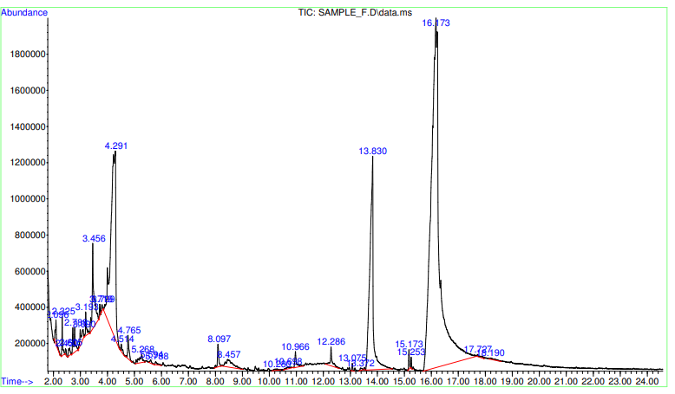

Figure 1: Chromatography of Formulation RF

The chromatography of Formulation RF has been shown in Figure.1, with the various retention time and abundance of the BACs: piperidine 1,2-dimethyl; 1,2,3-thiadiazole-4-carboxylic acid; phenolic compounds, 1,3-dihydro-2-benzofuran; 2-methoxy-4-vinylphenol, vanillin and a carboxylic acid, dibutylphthalate.

CY = Cocoyam, SB = Soya Bean; BGN = Bambara groundnut; RF = Commercial Rat Feed

|  |  |  |  |  |  |  |  |
| --- | --- | --- | --- | --- | --- | --- | --- |
| **3.2.2 Formulation 1 (16.6%CY + 16.6%SB + 16.6%BGN + 50%RF)**  To identify the specific bioactive compounds in the intervention formulations, the GC-MS, was conducted on Formulation 1 in Table 4.  **Table 4: Result of the GC-MS Analysis of Formulation 1 (16.6%CY + 16.6%SB + 16.6%BGN + 50%RF)** | | | | | | | |
| S/N | Retention Time | Peak Area% | Molecular Formula | Molecular Structure | Molecular Weight | Name of Bioactive Compound | Family Classification |
| a | 4.79 | 1.37 | C9H10O2 |  | 150 | 4-Hydroxy-2-methylacetophenone | Phenols (Guaiacol) |
| b | 5.14 | 1.78 | C8H10O3 |  | 154 | Phenol, 2,6-dimethoxy | Phenolics |
| c | 8.07 | 0.37 | C10H12O3 |  | 180 | 4-Methyl-2,5-dimethoxybenzaldehyde | Phenolic Aldehyde |
| d | 12.23 | 0.44 | C16H22O4 |  | 278 | 1,2-Benzenedicarboxylic acid, bis(2-methylpropyl) ester | Carboxylic acid |
| e | 12.94 | 0.28 | C7H13NO3 |  | 159 | N-Isopropoxy-2-carbomethoxyaziridine | Aziridine |

Table 4 showed the GC-MS report of Formulations 1 (16.6%CY + 16.6%SB + 16.6%BGN + 50%RF). It highlighted the molecular structure, molecular formula, % composition, peak flow percentage and retention time of the BACs: 4-Hydroxy-2-methylacetophenone; Phenol, 2,6-dimethoxy; 4-Methyl-2,5-dimethoxybenzaldehyde; 1,2-Benzenedicarboxylic acid, bis(2-methylpropyl) ester and N-Isopropoxy-2-carbomethoxyaziridine

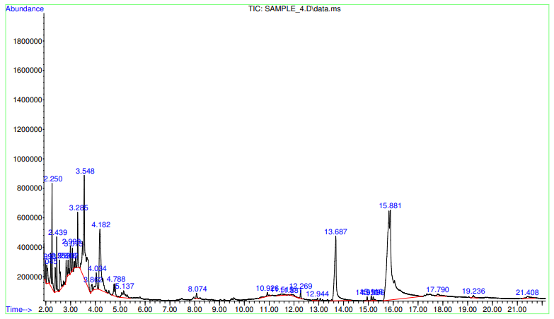

Figure 2: Chromatography of Formulation1

Figure 2 showed the chromatography of Formulation 1 (16.6%CY + 16.6%SB + 16.6%BGN + 50%RF), with the various retention time and abundance of the BACs: 4-Hydroxy-2-methylacetophenone;Phenol, 2,6-dimethoxy; 4-Methyl-2,5-dimethoxybenzaldehyde; 1,2-Benzenedicarboxylic acid, bis (2-methylpropyl) ester and N-Isopropoxy-2-carbomethoxyaziridine

|  |  |  |  |  |  |  |  |
| --- | --- | --- | --- | --- | --- | --- | --- |
| **3.2.3 Formulation 2 (12.5%CY + 12.5%SB + 25%BGN +50%RF)**  To identify the specific bioactive compounds in the intervention formulations, the GC-MS, was conducted on Formulation 2 in Table 5.  **Table 5: Result of GC-MS Analysis of Formulation 2 (12.5%CY + 12.5%SB + 25%BGN +50%RF)** | | | | | | | |
| S/N | Retention Time | Peak Area% | Molecular Formula | Molecular Structure | Molecular Weight | Name of Bioactive Compound | Family Classification |
| a | 1.97 | 0.24 | C9H16N4S |  | 212 | [1,3,4]Thiadiazol, 2-amino-5-(2-piperidin-1-ylethyl)- | Thiadiazol |
| b | 3.999 | 0.30 | C10H5FO3 |  | 192 | p-Fluorophenyl maleic anhydride | Benzene |
| c | 4.765 | 0.32 | C9H10O2 |  | 150 | 2-Methoxy-4-vinylphenol | Phenols |
| d | 5.119 | 0.39 | C8H10O3 |  | 154 | Phenol, 2,6-dimethoxy | Phenols |
| e | 7.063 | 0.09 | C15H11N |  | 205 | Quinoline,2-phenyl | Flavonoids |
| f | 12.298 | 0.58 | C18H26O4 |  | 306 | Phthalic acid, butyl 2-ethylbutyl ester | Carboxylic acid |

Table 5 showed the GC-MS report of Formulation 2 (12.5%CY + 12.5%SB + 25%BGN +50%RF). It highlighted the molecular structure, molecular formula, % composition, peak flow percentage and retention time of the BACs:[1,3,4] Thiadiazol, 2-amino-5-(2-piperidin-1-ylethyl)-; p-Fluorophenyl maleic anhydride; 2-Methoxy-4-vinylphenol; Phenol, 2,6-dimethoxy; Quinoline,2-phenyl and Phthalic acid, butyl 2-ethylbutyl ester.

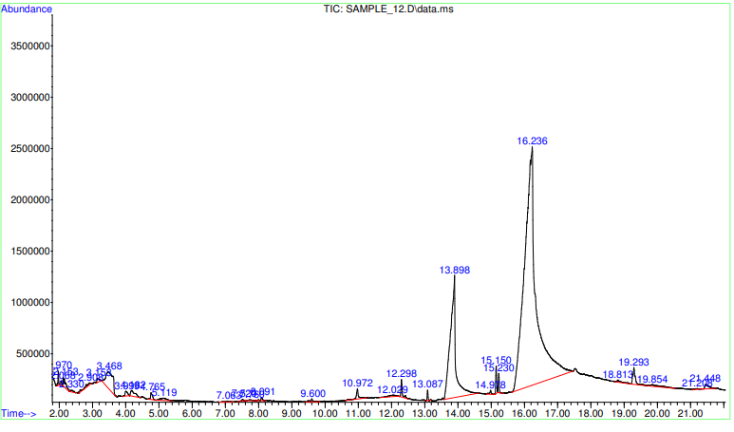

Figure 3: Chromatography of Formulation 2

Figure 3 showed the chromatography of Formulation 2 (12.5%CY + 12.5%SB + 25%BGN + 50%RF), with the various retention time and abundance of the BACs: [1,3,4]Thiadiazol, 2-amino-5-(2-piperidin-1-ylethyl)-; p-Fluorophenyl maleic anhydride; 2-Methoxy-4-vinylphenol; Phenol, 2,6-dimethoxy; Quinoline,2-phenyl and Phthalic acid, butyl 2-ethylbutyl ester.

|  |  |  |  |  |  |  |  |
| --- | --- | --- | --- | --- | --- | --- | --- |
| **3.2.4 Formulation 3 (25%CY + 12.5%SB + 12.5%BGN + 50%RF)**  To identify the specific bioactive compounds in the intervention formulations, the GC-MS, was conducted on Formulation 3 in Table 6.  **Table 6: Result of the GC-MS Analysis of Formulation 3 (25%CY + 12.5%SB + 12.5%BGN + 50%RF)** | | | | | | | |
| S/N | Retention Time | Peak Area% | Molecular Formula | Molecular Structure | Molecular Weight | Name of Bioactive Compound | Family Classification |
| a | 3.422 | 0.134 | C6H5ClO2 |  | 144 | 1,3-Benzenediol, 2-chloro | Phenols |
| b | 4.771 | 0.29 | C9H10O2 |  | 150 | 4-Hydroxy-3-methylacetophenone | Phenols (Guaiacol) |
| c | 5.142 | 0.32 | C8H10OS |  | 154 | Benzene, 1-methoxy-2-(methylthio) | Benzene |
| d | 7.080 | 0.28 | C15H24O |  | 220 | Butylated Hydroxytoluene | Phenol derivative |
| e | 10.440 | 0.09 | C5H10S |  | 102 | Thiophene, tetrahydro-2-methyl | Mono-cyclic heteroarene (Furan) |
| f | 12.298 | 0.16 | C18H26O4 |  | 306 | Phthalic acid, butyl isohexyl ester | Carboxylic acid |

Table 6 showed the GC-MS report of Formulation 3 **(25%CY + 12.5%SB + 12.5%BGN +50%RF)**. It highlighted the molecular structure, molecular formula, % composition, peak flow percentage and retention time of the BACs:1, 3-Benzenediol, 2-chloro; 4-Hydroxy-3-methylacetophenone; Benzene, 1-methoxy-2-(methylthio); Butylated Hydroxytoluene; Thiophene, tetrahydro-2-methyl and Phthalic acid, butyl isohexyl ester.

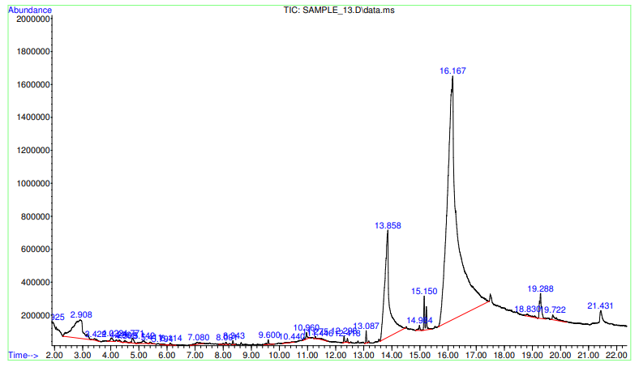

Figure 4: Chromatography of Formulation 3

Figure 4 showed the chromatography of Formulation 3 **(25%CY + 12.5%SB + 12.5%BGN +50%RF),** with the various retention time and abundance of the BACs: 1, 3-Benzenediol, 2-chloro; 4-Hydroxy-3-methylacetophenone; Benzene, 1-methoxy-2-(methylthio); Butylated Hydroxytoluene; Thiophene, tetrahydro-2-methyl and Phthalic acid, butyl isohexyl ester.

**3.2.5 Formulation 4 (12.5%CY + 25%SB + 12.5%BGN + 50%RF)**

To identify the specific bioactive compounds in the intervention formulations, the GC-MS, was conducted on Formulation 4 in Table 7.

|  |  |  |  |  |  |  |  |
| --- | --- | --- | --- | --- | --- | --- | --- |
| **Table 7: Result of the GC-MS Analysis of Formulations 4 (12.5%CY + 25%SB + 12.5%BGN + 50%RF)** | | | | | | | |
| S/N | Retention Time | Peak Area % | Molecular Formula | Molecular Structure | Molecular Weight | Name of Bioactive Compound | Family Classification |
| a | 2.15 | 0.77 | C9H10N4O2S |  | 238 | Hydrazinecarbothioamide (2-[1-(4-nitrophenylethylidene) | Thiourea |
| b | 4.75 | 0.43 | C9H10O2 |  | 150 | 2-Methoxy-4-vinylphenol | Phenols (Guaiacol) |
| c | 12.28 | 0.23 | C14H12 |  | 180 | Stilbene (1,2-diphenylethylene) | Carboxylic acid |

Table 7 showed the GC-MS report of Formulations **4 (12.5%CY + 25%SB + 12.5%BGN + 50%RF).** It highlighted the molecular structure, molecular formula, % composition, peak flow percentage and retention time of the BACs: Hydrazinecarbothioamide (2-[1-(4-nitrophenylethylidene);2-Methoxy-4-vinylphenol and Stilbene (1,2-diphenylethylene)

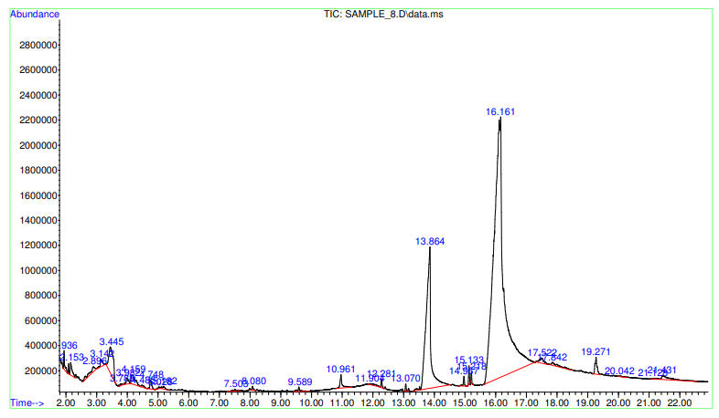

Figure 5: Chromatography of Formulation 4

Figure 5 showed the chromatography of Formulation **4 (12.5%CY + 25%SB + 12.5%BGN + 50%RF),** with the various retention time and abundance of the BACs: Hydrazinecarbothioamide (2-[1-(4-nitrophenylethylidene);2-Methoxy-4-vinylphenol and Stilbene (1,2-diphenylethylene)

|  |  |  |  |  |  |  |  |
| --- | --- | --- | --- | --- | --- | --- | --- |
| **3.2.6 Formulation 5 (0%CY + 0%SB + 50%BGN + 50%RF)**  To identify the specific bioactive compounds in the intervention formulations, the GC-MS, was conducted on Formulation 5 in Table 8.  **Table 8: Result of the GC-MS Analysis of Formulation 5 (0%CY + 0%SB + 50%BGN + 50%RF)** | | | | | | | |
| S/N | Retention Time | Peak Area% | Molecular Formula | Molecular Structure | Molecular Weight | Name of Bioactive Compound | Family Classification |
| a | 5.16 | 1.15 | C8H10O3 |  | 154 | 2,6-dimethoxy phenol | Phenolics |
| b | 5.83 | 0.48 | C8H803 |  | 152 | Vanillin (4-Hydroxy-3-methoxybenzaldehyde) | Phenolic Aldehyde |
| c | 7.90 | 0.13 | C5H12N2 |  | 100 | Homopiperizine (1,4-Diazepanes) | 1,4-Diazepanes |

Table 8 showed the GC-MS report of Formulations **5 (0%CY + 0%SB + 50%BGN + 50%RF)**.It highlighted the molecular structure, molecular formula, % composition, peak flow percentage and retention time of the BACs: 2,6-dimethoxy phenol; Vanillin (4-Hydroxy-3-methoxybenzaldehyde) and Homopiperizine (1,4-Diazepanes).

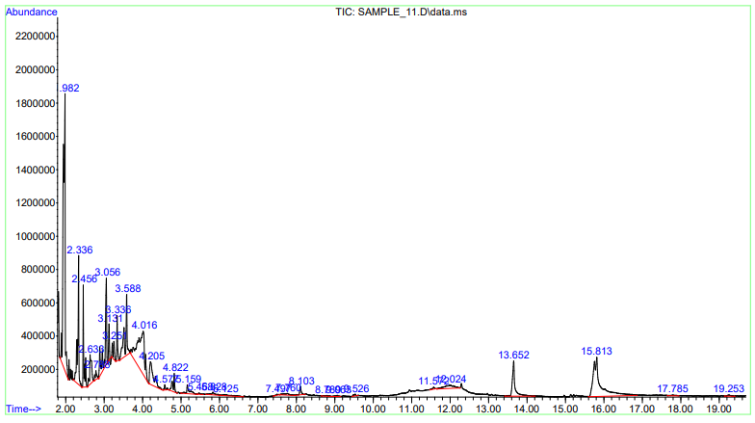

Figure 6: Chromatography of Formulation 5

Figure 6 showed the chromatography of Formulations **5 (0%CY + 0%SB + 50%BGN + 50% RF)**, with the various retention time and abundance of the BACs: 2,6-dimethoxy phenol; Vanillin (4-Hydroxy-3-methoxybenzaldehyde) and Homopiperizine (1,4-Diazepanes).

|  |  |  |  |  |  |  |  |
| --- | --- | --- | --- | --- | --- | --- | --- |
| **3.2.7 Formulation 6 (50%CY + 0%SB + 0%BGN + 50%RF)**  To identify the specific bioactive compounds in the intervention formulations, the GC-MS, was conducted on Formulation 6 in Table 9.  **Table 9: Result of the GC-MS Analysis of Formulation 6 (50%CY + 0%SB + 0%BGN + 50%RF)** | | | | | | | |
| S/N | Retention Time | Peak Area% | Molecular Formula | Molecular Structure | Molecular Weight | Name of Bioactive Compound | Family Classification |
| a | 3.994 | 3.97 | C8H8O |  | 120 | Benzofuran, 2,3-dihydro- | Amphetamine & Phenylethylamine |
| b | 4.754 | 5.24 | C9H10O2 |  | 150 | 2-Methoxy-4-vinylphenol | Phenol |
| c | 5.131 | 1.39 | C8H10O3 |  | 154 | Phenol, 2,6-dimethoxy | Phenol |
| d | 8.023 | 2.21 | C14H12 |  | 180 | (E)-Stilbene | Carboxylic acid |
| e | 11.681 | 0.46 | C16H22O4 |  | 278 | Dibutyl phthalate | Carboxylic acid |
| f | 12.241 | 0.68 | C19H32O6 |  | 356 | Dihydroartemisinin, 10-O-(t-butyloxy)- | Artemisinin |

Table 9 showed the GC-MS report of Formulations **6 (50%CY + 0%SB + 0%BGN + 50%RF)**. It highlighted the molecular structure, molecular formula, % composition, peak flow percentage and retention time of the BACs: Benzofuran, 2,3-dihydro-;2-Methoxy-4-vinylphenol; Phenol, 2,6-dimethoxy; E)-Stilbene; Dibutyl phthalate and Dihydroartemisinin, 10-O-(t-butyloxy)-

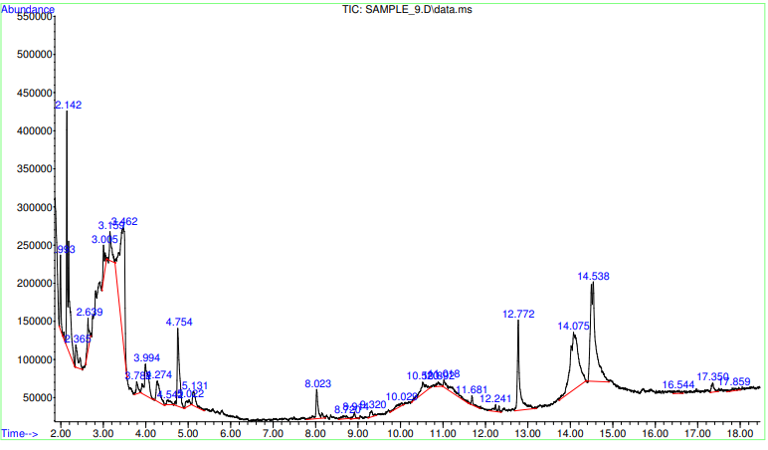

Figure 7: Chromatography of Formulation6

Figure 7 showed the chromatography of Formulations **6 (50%CY + 0%SB + 0%BGN +50%RF),** with the various retention time and abundance of the BACs:Benzofuran, 2,3-dihydro-;2-Methoxy-4-vinylphenol; Phenol, 2,6-dimethoxy; E)-Stilbene; Dibutyl phthalate and Dihydroartemisinin, 10-O-(t-butyloxy)-

**3.2.8 Formulation 7 (0%CY + 50%SB + 0%BGN + 50%RF)**

To identify the specific bioactive compounds in the intervention formulations, the GC-MS, was conducted on Formulation 7 in Table 10.

|  |  |  |  |  |  |  |  |
| --- | --- | --- | --- | --- | --- | --- | --- |
| **Table 10: Result of GC-MS Analysis of Formulation7 (0%CY + 50%SB + 0%BGN + 50%RF)** | | | | | | | |
| S/N | Retention Time | Peak Area% on | Molecular Formula | Molecular Structure | Molecular Weight | Name of Bioactive Compound | Family Classification |
| a | 17.127 | 2.95 | C13H21NO |  | 207 | 4,7,7-Trimethylbicyclo[2.2.1]heptan-2-one O-allyloxime | monoterpenoid |
| b | 21.431 | 2.275 | C14H24O |  | 208 | 2(1H)-Naphthalenone, octahydro-4a-methyl-7-(1-methylethyl)-, (4aα,7β,8aβ) | Naphthalene |

Table 10 showed the GC-MS report of Formulations 7 **(0%CY + 50%SB + 0%BGN + 50%RF).** It highlighted the molecular structure, molecular formula, % composition, peak flow percentage and retention time of the BACs: 4,7,7-Trimethylbicyclo[2.2.1]heptan-2-one O-allyloxime and 2(1H)-Naphthalenone, octahydro-4a-methyl-7-(1-methylethyl)-, (4aα,7β,8aβ).

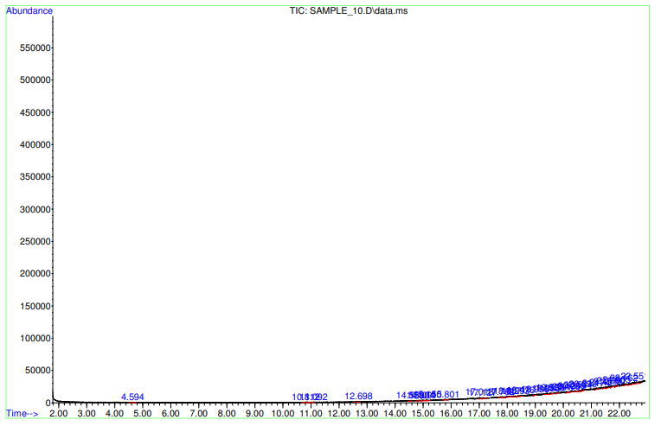

Figure 8: Chromatography of Formulation7

Figure 8 showed the chromatography of Formulations 7 **(0%CY + 50%SB + 0%BGN + 50%RF),** with the various retention time and abundance of the BACs: 4,7,7-Trimethylbicyclo[2.2.1]heptan-2-one O-allyloxime and 2(1H)-Naphthalenone, octahydro-4a-methyl-7-(1-methylethyl)-, (4aα,7β,8aβ).

**DISCUSSIONS**

**The Bioactive Composition of the Flour Samples**

Bioactive compounds (BACs) are sourced from plants and animals including cocoyam, shrimps, egg, legumes [2 -5]. BAC includes bioactive pepetides (BAPs) which contain group of phenolic compounds with antioxidant properties. Among these are flavonoids, phenolic acids and carotenoids.

In this study, the various formulations were documented to contain phenolic compounds, flavonoids and other bioactive substances. The commercial rat feed (formulation RF) contained BACs like **thiadiazol** (Piperidine, 1, 2-dimethyl, 1, 2, 3-Thiadiazole-4-carboxylic acid, hydrazide, **Phenols** (Phthalan (Isocoumaran) or 1, 3-dihydro-2-benzofuran, 2-Methoxy-4-vinylphenol, Vanillin) and **carboxylic acid** (Dibutyl phthalate) (Table 3). Other formulations (1 - 7) equally contain BACs in varying concentrations (Tables 3 – 11). Formulations 1 contained mainly phenolics and carboxylic acids with an additional aziridine compound [N-Isopropoxy-2-carbomethoxyaziridine] while thiourea, phenols and carboxylic acids were the identified BACs in Formulation 4 (Tables 7 and 8). Formulation 6, contained Aphetamine and Phenylethylamine, Phenols, (E)-Stilbene; Dibutyl phthalate and an artemisinin while Formulation 7 had 1,3-Benzenediol, 2-chloro, 4-Hydroxy-3-methylacetophenone, Butylated Hydroxytoluene, 1-methoxy-2-(methylthio), [Thiophene, tetrahydro-2-methyl] and Phthalic acid, butyl isohexyl ester as the bioactive compounds (Table 10). The BACs compounds in formulations 5 were phenolics and diazepanes, and in formulation 2, phenolics and carboxylic acids in addition to thiadiazol (Tables 8 and 5). In Formulations 3, the BACs were 4,7,7-Trimethylbicyclo[2.2.1]heptan-2-one O-allyloxime), and 2(1H)-Naphthalenone, octahydro-4a-methyl-7-(1-methylethyl)-, (4aα,7β,8aβ); (Table 6).

These BACs though present in all the formulations, a critical observations showed that while some formulations contained some of the common BACs, others contained some rare ones like aziridine, artemisinin, and thiadiazol in formulations 1, 2 and 6 respectively. Secondly some of these formulations have different classes of phenolics than others as seen in formulations 1, 2, 3, 4, 5 and 6, with formulation 3 containing an additional phenolic derivative. Thirdly only formulation 2 had Quinoline,2-phenyl, a flavonoid as an identified BAC. Fourthly, the number of different BACs contained in each formulation varied. While Formulations 2, 3, 6 and RF, had six different BACs contained in them, formulations 4 and 5 had three and formulations 1 and 7 had two and five different compounds respectively.

Of the different compounds contained in each formulations, the classes of the compounds were also different. In the commercial rat feed, Formulation RF, the six varied compounds belong to three classes, namely phenolics, carboxylic acids and thiadiazol. In these classes, the phenolics had three different compounds in the family while two compounds, that is, Piperidine, 1, 2-dimethyl and 1, 2, 3-Thiadiazole-4-carboxylic acid, hydrazide (Table 3), are in the family of thiadiazole. In formulation 3, there are four classes with three different compounds in the phenolic family, while in Formulation 2 and 6 there are five and four classes of compounds respectively, with two different phenolic compounds in the phenolic class (Tables 5, 7 and 9).

Among the formulations with three groups of BACs, Formulations 4 and 5, there are two and three classes of compounds respectively, with the former containing two different phenolic compounds and formulation 4 containing only one. Formulation 7 which had two compounds belonging to two different classes had no phenolic compound while formulation 1 with five different compounds in three classes has three different phenolic compounds as constituents of the BACs (Tables 4 and 10).

The findings in this study were in line with discoveries in the analysis of these plant food extracts in previous studies which corroborated the presence of various classes of phenolics, flavonoids and other bioactive substances in soybean, Bambara groundnut and cocoyam. Soya bean was reported by Anderson and his co-researcher, to contain saponins at about 0.5% [43]. Other studies reported the presence of isoflavones, oxalates, phytic acids and bioactive peptides in soybean. The Isoflavones are of three classes, namely the glucosides like daidzein, genistein and glycitin; the acetyl form of glucosides; malonyl glucosides and the unconjugated aglycones [44]. Inositol hexaphosphate (IP6), myo-inositol and inositol phosphate are other BACs in soybean [45]. When Soya bean is processed, the IP6 is dephosphorylated into IP5, IP4, IP3, IP2 and IP1 through the activity of endogenous phytates [46]. Of these, IP6 and IP5 act as anti-nutrient to minerals while IP4 and IP3 can exert antioxidant activities [47].

In cocoyam, the phytochemicals, polyphenolic compounds such as flavonoids, tannin and alkaloids were present in cocoyam and these phytochemicals have hypoglycemic and antioxidant properties [48, 49, 50]. Other bioactive compounds (BAC) contained in cocoyam were 9-octadecenoic acid, a fatty acid followed in terms of concentration by 9,12-octadecadienoyl chloride, a lineleoyl chloride; hexadioic acid, bis (2-ethylhexyl) ester, Octadecanoic acid, and 3-5-di-t-butyl phenol [51].

Bambara groundnut phytochemical contents include phenolics like quercetin, quercitrin, iboquercitrin, kaempterol, rutin, myricetin, luteolin, catechin, epicatechin, caffeic acid, ellagic acid, cholorogenic acid and gallic acid [52]; dietary fibres [53]; fatty acids like PUFA and MUFA [54] and amino acids like arginine, isoleucine, leucine, lysine and glutamic acid [53]. It also contain tocopherols, tocotrienol and phytosterols (Adeyeye *et al.,* 2015). Other BACs are proteins and peptides, [55]. The biological roles of these bioactive compounds have been the basis for their advocate in nutritional therapeutics for various diseases.

These BACs exert various biological activities depending on the particular compound, with such bioactivities ranging from antioxidant activity by single electron transfer [56], antimicrobial [57, 58], anti-inflammatory [59]; hypoglycemic [60], anti-obesity [61] hypocholesterolaemic [62]; slowing of development of insulin resistance [56] and inhibition of endoplasmic reticulum stress [63, 64]. These biological effects are explored in their use for the management of chronic diseases.

4. Conclusion

Pure and ternary blends of Cocoyam-Soya bean-Bambara groundnut flour contains bioactive compounds in various concentrations and forms that are dependent on the ratio formulations of the blend. These bioactive compounds are similar to the ones reported in previous studies whose biological activities supports their use in the management of non-communicable diseases.

Consent (where ever applicable)

No consent was required.

Ethical approval (where ever applicable)

Ethical approval for further

Ethical clearance was sought and obtained from the Faculty of Basic Medical Sciences of the College of Medicine, Rivers State University, Port Harcourt.

References

1. Kris-Etherton PM, Hecker KD, Bonanome A, Coval SM, Binkoski AE, Hilpert KF, Griel AE, Etherton TD.  Bioactive compounds in foods: their role in the prevention of cardiovascular disease and cancer. *Am J Med* 2002., **113**: S71–88.

2. Alemán A, Pérez-Santín E, Bordenave-Juchereau S, Arnaudin I, Gómez-Guillén MC, Montero P.  Squid gelatin hydrolysates with antihypertensive, anticancer and antioxidant activity. *Food Res Int* 2011.,**44**: 1044–51.

3. Ding J-F, Li Y-Y, Xu J-J, Su X-R, Gao X, Yue F-P.  Study on effect of jellyfish collagen hydrolysate on anti-fatigue and anti-oxidation. *Food Hydrocoll* 2011.,**25**: 1350–3.

4. Girgih AT, Udenigwe CC, Li H, Adebiyi AP, Aluko RE.  Kinetics of enzyme inhibition and antihypertensive effects of hemp seed (*Cannabis sativa* L.) protein hydrolysates. *J Am Oil Chem Assoc.* 2011.DOI: [**10.1007/s11746-011-1841-9**](http://dx.doi.org/10.1007/s11746-011-1841-9).

5. Udenigwe CC, Lu Y-L, Han C-H, Hou W-C, Aluko RE.  Flaxseed protein-derived peptide fractions: Antioxidant properties and inhibition of lipopolysaccharide-induced nitric oxide production in murine macrophages. *Food Chem.,* 2009b.,  **116**: 277–84.

6. Pripp AH, Isaksson T, Stepaniak L, Sørhaug T, Ardö Y.  Quantitative structure-activity relationship modelling peptides and proteins as a tool in food science. *Trends Food Sci Technol.,* 2005., **16**: 484–94.

7. Chen HM, Muramoto K, Yamauchi F, Nokihara K.  Antioxidant activity of designed peptides based on the antioxidant peptide isolated from digests of a soybean protein. *J Agric Food Chem.,* 1996., **44**: 2619–23.

8. Piero MN, Njagi JM, Kibiti CM, Ngeranwa JJN, Njagi ENM and Miriti PM. The Role of Vitamins and Mineral Elements in Management of Type 2 Diabetes Mellitus: A Review South As. J. Biol.Sci., 2012., 2(Supp.1):107 –115

9. Arise, A. K., Amonsou, E. O. & Ijabadeniyi, O. A. Influence of extraction methods on functional properties of protein concentrates prepared from South African Bambara groundnut landraces. *International. Journal of Food Science and. Technology.* 2015., 50, 1095–1101. [https,//doi.org/10.1111/ijfs.12746](https://doi.org/10.1111/ijfs.12746).

10. Oyeyinka AT, Pillay K, Siwela M. Full title- in vitro digestibility, amino acid profile and antioxidant activity of cooked Bambara groundnut grain. Food Biosci., 2019, 31:100428. doi: 10.1016/j.fbio.2019.100428

11. Salawu, F. Comparative study of the antioxidant activities of methanolic extract and simulated gastrointestinal enzyme digest of Bambara nut (Vigna subterranean) FUTA J. Res. Sci., 2016., 1: 107-120.

12. Barbieri, R., Coppo, E., Marchese, A., Daglia, M., Sobarz-Sánchez, E., Nabavi, S.F. & Nabavi, S.M. Phytochemicals for human disease: An update on plant-derived compounds antibacterial activity. ***Microbiology Research****,* 2017., 196, 44-68.

13. Saxena, M., Saxena, J., Nema, R., Singh, D. & Gupta, A. Phytochemistry of medicinal plants. ***Journal of Pharmacognosy & Phytochemistry***, 2013, **1**(6), 168–182.

14. Iwai, K., Kim, M., Onodera, A. & Matsue, H. α-Glucosidase Inhibitory and Antihyperglycemic Effects of Polyphenols in the Fruit of *Viburnum dilatatum* Thunb.***Journal of Agricultural and Food Chemistry****,* 2006, *54*(13), 4588-4592

15. Ruzaidi, A., Abbe, M., Amin, L., Nawalyah, A.G., Muhajir, H., Pauliena, M.B. & Muskinah, M.S. Hypoglycemic properties of Malaysia cocoa (Theobromacacao) polyphenols-rich extract. ***Int Food Res. J.***, 2008, 15, 305-312.

16. Merida L.A., Mattos E.B., Correa A.C., Pereira P.R., Paschoalin V.M., Pinho M.F., Vericimo M.A Tarin stimulates granulocyte growth in bone marrow cell cultures and minimizes immunosuppression by cyclo-phosphamide in mice. *PLoS ONE.* 2018., 13:e0206240. doi: 10.1371/journal.pone.0206240

17. Chukwuma C.I., Islam M.S., Amonsou E.O. A comparative study on the physicochemical, anti-oxidative, anti-hyperglycemic and anti-lipidemic properties of amadumbe (Colocasia esculenta) and okra (Abelmoschus esculentus) mucilage. *J. Food Biochem.,*2018., 42:e12601. doi: 10.1111/jfbc.12601

18. Prabhakar, P.K., and Doble, M. A Target Based Therapeutic Approach Towards Diabetes Mellitus Using Medicinal Plants. Current Diabetes Reviews, 2008., 291-308. Bentham Science Publishers Ltd.

19.Kumawat, N.S., Chaudhari, S.P., Wani, N.S., Deshmukh, T.A.,& Patil, V.R.  Antidiabetic activity of ethanol extract of *Colocasia esculenta* leaves in alloxan induced diabetic rats. *International Journal of Pharmaceutical Technique Research,* 2010., 2,1246–1249.

20. Eleazu CO, Iroaganachi M & Eleazu KC Ameliorative potentials of cocoyam (*Colocasia esculenta* L.) and unripe plantain (*Musa paradisiaca* L.) on the relative tissue weights of streptozotocin-induced diabetic rats*. J Diabetes Res*., 2013., 1–8 <https://doi.org/10.1155/2013/160964>

21. Carvalho, A.W., Silva, C.O., Dantas, M.I.S., Natal, D.I.G., Ribeiro, S.M.R., Costa, N.M.B. & Martino, H.S.D. The use hull soybean flour of heat-treated grains does not affect iron bioavailability in rats. ***Archivos Latinoamericanos de Nutrición****,* 2011., 61(2), 135-42

22. Martino, H.S.D., Martin, B.R., Weaver, C.M., Bressan, J., Esteves, E.A. & Costa, N.M.B. Zinc and iron bioavailability of genetically modified soybeans in rats. ***Journal of Food Science****,* 2007., 72(9), 689-695

23. Diouf, J. Dimensions of need, an atlas of food and agriculture. Food and Agriculture Organization of the United Nations, Rome, Italy. 1996., Printed and bound in the UK by the KPC Group, London and Ashford, Kent.

24. Oyeyinka, S.A. & Oyeyinka, A.T. A review on isolation, composition, physicochemical properties and modification of Bambara groundnut starch. ***Food Hydrocolloid****.*, 2018, **75**, 62–71.

25. Oyeyinka, S.A. Tijani, S.T., Oyeyinka, A.T., Arise, A.K., Balogun, M.A., Kolawole, F.L., Obalowu, M.A. & Joseph, J.K Value added snacks produced from Bambara groundnut (*Vigna subterranea*) paste or flour. ***LWT-Food Science & Technology,*** 2018., 88, 126-131.

26. Halimi, R.A., Barkla, B.J., Mayes, S. & King, G.J. The potential of the underutilized pulse bambara groundnut (*Vigna subterranea* (L.) Verdc.) for nutritional food security. ***The Journal of Food Composition and Analysis****,* 2019., 77(2), 47–59.

27. Adeyeye E.I., Olaleye A.A., Adesina A.J. Lipid composition of testa, dehulled seed and whole seed of Bambara groundnut (Vigna subterranea L. Verdc) *Curr. Adv. Plant Sci. Res.*2015;2:1–9.

28. Dukariya, G., Shah, S., Singh, G and Kumar, A. Soybean and Its Products: Nutritional and Health Benefits. Journal of Nutritional Science & Healthy Diets 2020., 1(2): 22-29.Available from: <https://www.researchgate.net/publication/343021410_Soybean_and_Its_Products_Nutritional_and_Health_Benefits> [accessed Jun 03 2024].

29. Sun, H., Saeedi, P., Karuranga, S., Pinkepank, M., Ogurtsova, K., Duncan, B.B., Stein, C., Basit, A., Chan, J.C.N., Mbanya, J.C., Pavkov, M.E., Ramachandaran, A., Wild, S.H., James, S., Herman, W.H., Zhang, P., Bommer, C., Kuo, S., Boyko, E.J., Maqliano, D. J. IDF Diabetes Atlas: Global, Regional and Country-level diabetes prevalence estimates for 2021 and projections for 2045. *Diabetes Research and Clinical Practice*, 2022., 183, 109119. <https://doi.org/10.1016/j.diabres.2021.109119>

30. Van Belle, T.L., Coppieters, K.T. and Von Herrath, M.G. Type 1 diabetes: etiology, immunologyand therapeutic strategies. *Physiological Reviews*, 2011., 91:1.

31. Molnár-Perl, I., Katona, Z.F. GC-MS of amino acids as their trimethylsilyl/*t*-butyldimethylsilyl Derivatives: In model solutions III. *Chromatographia* 2000. **51**, S228–S236 <https://doi.org/10.1007/BF02492811>

32. Lercker G, Rodriguez-Estrada MT. Chromatographic analysis of unsaponifiable compounds of olive oils and fat-containing foods. J Chromatogr A. 2000;881(1-2):105-29. doi: 10.1016/s0021-9673(00)00455-6. PMID: 10905697.

33. Marriott, P., Shellie, R & Cornwell, C. Gas chromatographic technologies for the analysis of essential oils, Journal of Chromatography A. 2001., 936 (1): 1-22.DOI: [10.1016/S0021-9673(01)01314-0](http://dx.doi.org/10.1016/S0021-9673(01)01314-0)

34. Grob, R.L., & Barry, E.F. Modern Practice of Gas Chromatography. Wiley Interscience, 2004; 4th Edition. ISBN-13-978-047187-1576

35. Seppänen-Laakso, T., Laakso, I., and Hiltunen, R. Analysis of fatty acids by gas chromatography, and its relevance to research on health and nutrition, Analytica Chimica Acta, 2002; 465 (1–2): 39-62, ISSN 0003-2670, <https://doi.org/10.1016/S0003-2670(02)00397-5>.

36. Ezekwe, A.S., Ansari, R.A., Rizwan, A.A., Karimah, M.R. & Ewa, O. Qualitative Phytochemical and GC-MS analysis of fermented castor seed (Ogiri Igbo***). GSC Biological and Pharmaceutical Sciences***, 2020a; 13(02), 284-289.

37. Ezekwe, A.S., Ordu, K.S. & Oruamabo, R.S. Phytochemical Screening, GC-MS Analysis and Antioxidant Activity of Three Medicinal Plants from Nigeria. ***Asian Journal of Applied Chemistry Research,*** 2020b; 6(3), 14-26.

38. Ezekwe, A.S., Ugwuezumba, P.C., Nwankpa, P., Egwurugwu, J.N., Ekweogu, C.N., Emengaha, F.C. & Akukwu, D. Qualitative Phytochemical Screening, GC-MS Studies and In-vitro Anti-Oxidative Properties of Aqeuous Leaf Extract of Gnetum Africanum. ***Journal of Drug Delivery and Therapeutics***, 2020c; 10(1), 11-17.

39. Ezekwe, A.S., Wokocha, P.G. & Woha, J.B. Phytochemistry and antioxidant activity of Amaranthus viridis L (Green leaf). ***World Journal of Advanced Research and Reviews***, 2021b; 12(02), 306-314.

40. Ezekwe, A.S., Nwadike, C.N., Wokocha, G.P., George, B.O. Phytochemical Screening, GC-MS Analysis and Antioxidant Activity of Curcurbita pepo L. using Its Leaf Sample. ***Asian Journal of Biology***, 2021a;. 11(4), 33-45.

41. Nnadi, N.N., Ezekwesili, C.N. & Ezeigwe, O.C. Effects of Formulated Unripe Plantain and Millet Dietary Feeds in Alloxan-Induced Diabetic Albino Rats. ***International Journal of Innovative Research and Advanced Studies (IJIRAS)***, 2022; 9(6), 1-10

42. Shaikh, J.R. & Patil, M.K. Qualitative tests for Preliminary Phytochemical screening. ***International Journal of Chemical Studies***, 2020; 8(2), 603-608

43. Anderson R.L., and Wolf, W.J. Compositional changes in trypsin inhibitors, phytic acid, saponins and isoflavones related to soybean processing The Journal of nutrition, 1995; 125 (3):581S-588S. <https://api.semanticscholar.org/CorpusID:19050692>

44. Kao, T. H., Wu, W. M., Hung, C. F., Wu, W. B. & Chen, B. H. Anti-inflammatory Effects of Isoflavone Powder Produced from Soybean Cake. ***Journal of Agricultural and Food Chemistry***, 2007; 55(26),11068-11079.

45. Domínguez, B.M., Gómez, M.V.I. & León, F.R. Acido fítico: Aspectos nutricionales e implicaciones analíticas. ***ALAN Reviews***, 2002; 52(3), 1-12.

46. Chiplonkar, S. & Agte, V. Predicting Bioavailable Zinc from Lower Phytate forms, Folic Acid and their interactions with Zinc in Vegetarian Meals. ***Journal of the American College of Nutrition***, 2005; 25, 26-33.

47. Martino, H.S.D., Martin, B.R., Weaver, C.M., Bressan, J., Esteves, E.A. & Costa, N.M.B. Zinc and iron bioavailability of genetically modified soybeans in rats. ***Journal of Food Science****,* 2007; 72(9), 689-695

48.Kumawat, N.S., Chaudhari, S.P., Wani, N.S., Deshmukh, T.A. & Patil, V.R.  Antidiabetic activity of ethanol extract of *Colocasia esculenta* leaves in alloxan induced diabetic rats. ***International Journal of Pharmaceutical Technique Research****,* 2010; 2, 1246–1249.

49. Karau, G.M., Njagi, E.N.M. Machocho, A.K., Wangai, L.N. & Kamau, P.N. Hypoglycaemic activity of aqueos and ethylaceate leaf and stem bark extracts of Pappea capensis in alloxan-induced diabetic BALB/c mice. ***Brain Journal Pharmacological Toxicology*,** 2012; 3, 251-258.

50. Eleazu, C.O., Iroaganachi, M. & Eleazu, K.C. Ameliorative potentials of cocoyam (*Colocasia esculenta* L.) and unripe plantain (*Musa paradisiaca* L.) on the relative tissue weights of streptozotocin-induced diabetic rats*.* ***Journal of Diabetes Research*,** 2013; 21, 1–8

51. Eleazu, C.O. Characterization of the natural products in cocoyam (*Colocasia esculenta*) using GC‑MS. ***Pharmaceutical Biology***, 2016; 5412, 2880‑2885.

52. Harris, T., Jideani, V., and Le Rose-Hill, M. Flavonoids and tannin composition of Bambara groundnut (*Vigna subterranean*) of Mpumalanga, South Africa. Heliyon, 2018; 4: e00833. Doi: 10.1016/j.heliyon.2018.e00833

53. Yao, D.N., Kouassi, K.N., Erba, D., Scazzina, F., Pellegrini, N. & Casiraghi, M.C. Nutritive Evaluation of the Bambara Groundnut Ci12 Landrace [*Vigna subterranea* (L.) Verdc. (*Fabaceae*)] Produced in Côte d’Ivoire. **International Journal of Molecular Sciences**, 2015; 16(9), 21428-21441.

54. Baptista, A., Pinho, O., Pinto, E., Casal, S., Mota, C. & Ferreira, I.M. Characterization of protein and fat composition of seeds from common beans (phaseolus vulgaris L.), cowpea (Vigna unguiculata L.Walp) and Bambara groundnuts (Vigna subterranean L. Verde) from Mozambique. ***Journal of Food Measument and Characterization****,* 2016; 12, 1-9

55. Carbonaro, M. Role of pulses in nutraceuticals, Eds., In Tiwari, B.K., Gowen, A., McKenna, B., Pulse Foods, ***Academic Press***, 2014; 11, 385-418.

56. Kaleem, M. & Ahmad, A. Flavonoids as nutraceuticals. In: Grumezescu M.A., Holban A.M., ***Therapeutic, Probiotic, and Unconventional Foods****,* 2018; 137–155.

57. Upadhyay, P.K. & Mishra P. Synthesis, antimicrobial and anticancer activities of 5-(4‑substituted phenyl) ‑1,3,4‑thiadiazole‑2‑amines. ***Rasayan Journal of Chemistry****,* 2017; 10 (1),254–262.

58. Njoroge P.W., Opiyo S.A. Antimicrobial activity of root bark extracts of Rhus natalensisa and Rhus ruspolii’. Basic Sci Med., 2019; 8(2): 23-28.

59. Nedeljković, N.; Nikolić, M.; Čanović, P.; Zarić, M.; Živković Zarić, R.; Bošković, J.; Vesović, M.; Bradić, J.; Anđić, M.; Kočović, A.; et al. Synthesis, Characterization, and Investigation of Anti-Inflammatory and Cytotoxic Activities of Novel Thiourea Derivatives of Naproxen. Pharmaceutics, 2024; 16, 1. https://doi.org/10.3390/pharmaceutics16010001

60. Ullah, I., Hassan, M., Khan, K.M., Sajid, M., Umar, M., Hassan, S., Ullah, A., El-Serehy, H.A., Charifi, W. & Yasmin, H. Thiourea derivatives inhibit key diabetes-associated enzymes and advanced glycation end-product formation as a treatment for diabetes mellitus. ***International Union of Biochemistry and Molecular Biology Life***, 2022; 75(2), 161-180.

61. Guo, Y., Fu, W., Xin, Y., Bai, J., Peng, H., Fu, L., Liu, J., Li, L., Ma, Y. & Jiang, H. Antidiabetic and antiobesity effects of artemether in db/db mice. **BioMed Research International**, 2018; 8(6), 39-52.

62. Esteves, E.A., Bressan, J., Costa, N.M.B., Martino, H.S.D., Donkin, S.S. & Story, J.A. Modified soybean affects cholesterol metabolism in rats similarly to a commercial cultivar. ***Journal of Medicinal Food****,* 2011; 14(11), 1363-1369.

63. Wang C, Wang, P., Liu, J-C, Zhao, Z-A, Guo, R., Li, Y-S., Li, S-G., and Zhao, Z-G Interaction of Estradiol and Endoplasmic Reticulum Stress in the Development of Esophageal Carcinoma. Front Endocrinol., 2020; 11:410. Doi: 10.3389/fendo.2020.00410

64. Zhao, Y. , Ran, Z. , Jiang, Q. , Hu, N. , Yu, B. , Zhu, L. , Shen, L. , Zhang, S. , Chen, L., Chen, H. , Jiang, J. , Chen, D. Vitamin D Alleviates Rotavirus Infection through a Microrna‐155‐5p Mediated Regulation of the TBK1/IRF3 Signaling Pathway In Vivo and In Vitro. *International Journal of Molecular Sciences*, 2019; 20(14), 3562. 10.3390/ijms20143562