*Original Research Article*

Development of nectar from snap melon, gac fruit and steviol glycosides: changes in physico-chemical properties, antioxidant potential, sensory and microbial qualities during storage

.

ABSTRACT

|  |
| --- |
| Vegetables in the Cucurbitaceae family have long been known to have health advantages. Snap melon and gac fruit are popular cucurbits commonly cultivated in India. Snap melon is high in dietary fiber, while gac fruit is considered one of the richest natural sources of carotenoids. Snap melon and gac fruit can be utilized to develop functional drinks as they are rich in compounds that benefit human health. Stevia extract can be used to sweeten the blended snap melon and gac fruit juices to formulate a nutraceutical beverage.  **Aims:** The current study aimed to develop low-calorie nectar from snap melon and gac fruit and assess the changes in physicochemical, microbiological, and organoleptic characteristics during storage at ambient (34±2°C) and refrigerated conditions (5±2°C) for a duration of three months.  **Study Design** : The experiment was laid out in a completely randomized design (CRD).  **Place and Duration of Study:** The study was completed at the Department of Postharvest Management, College of Agriculture, Kerala Agricultural University, Thrissur, India, during 2023-2024.  **Methodology:** Based on organoleptic evaluation, the best combinations of snap melon and gac fruit juices were chosen was used to develop low-calorie nectar. The developed low-calorie nectar was distinguished with conventional nectar sweetened with sugar.  **Results:** From the standpoint of microbiology, it seemed safe to store the nectar samples both at room temperature and in cold storage. During storage, it was noted that the nectar's titratable acidity increased, but its physicochemical characteristics, including pH, TSS, viscosity, and colour values, declined. Additionally, the nectar's energy value, antioxidant activity, lycopene, phenols, ascorbic acid, and β carotene all declined over the course of preservation.  **Conclusion:** Addition of stevia extract lowered the energy value of the beverage making it low calorific. Additionally, cultivators may guarantee higher income and prevent post-harvest losses by creating value-added products from these vegetables. |

*Keywords: [Snap melon, gac fruit, bioactives, antioxidant activity, sensory quality, microbial quality}*

1. INTRODUCTION

A recent survey revealed that over one-third of the world's malnourished children reside in India (Singh et al., 2019). Vegetables are key sources of nutraceuticals in a balanced human diet, with those from the Cucurbitaceae family being particularly beneficial. Extensive research has demonstrated that cucurbit vegetables have purgative, anti-inflammatory, anti-diabetic, and antioxidant properties (Rolnik and Olas 2020).

Snap melon (*Cucumis melo* var. *momordica*) is a prominent Cucurbitaceous crop grown worldwide and is crucial for global trade. India, as a secondary center of origin, has not fully exploited this crop, which encompasses almost 40 species. The ripe fruits of snap melon are known for their tendency to split or crack, which leads to high perishability and significant post-harvest losses. Therefore, it is crucial to process them into value-added products to reduce these losses.

*Momordica cochinchinensis* (Spreng.), commonly known as Gac in Vietnam, is a diverse cucurbit species that is widely grown in India. This fruit is nutritionally unique due to its high content of carotenoids, especially lycopene and β-carotene, found in the aril (the flesh surrounding the seeds). Consequently, the food industry may find it advantageous to use Gac fruit in the production of functional beverages.

Stevia is a natural plant-derived sweetener with many functional benefits. Stevia leaves are sweet because they contain steviol glycosides, such as stevioside, rebaudioside (A–F), steviolbioside, and isosteviol. These glycosides are used commercially throughout the world to replace sugar in a variety of foods, drinks, and medications.

Blending gac fruit with snap melon could result in the creation of tasty drink with excellent organoleptic quality along with high nutritional content. Sweetening this drink with steviol glycosides will make the drink low calorie in nature. Hence the objective of the present study was to develop a functional drink rich in bioactive compounds, without synthetic preservatives and to determine the changes in the quality of the product during storage, besides adding diversity to the existing list of functional beverages from fruits and vegetables.

2. material and methods

**2.1 Source of Materials**

Fresh snap melon and gac fruits were purchased in its horticulturally mature stage from the local market. Fresh leaves of stevia for extraction of steviol glycosides were grown in the field maintained by the Department of Postharvest Management, College of Agriculture, Vellanikkara. Steviol glycosides were extracted from stevia fresh leaves which were sorted, and washed with tap water. They were moderately ground without agitation, followed by soaking in hot tap water at 75°C for 20 minutes, at a ratio of 200 g/L for extraction of steviol glycosides, without the use of any additional energy source (Figures 1 &2). The leaves were subsequently strained and filtered (López-Carbón et al., 2019).

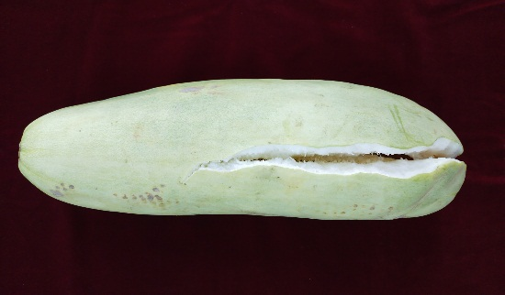 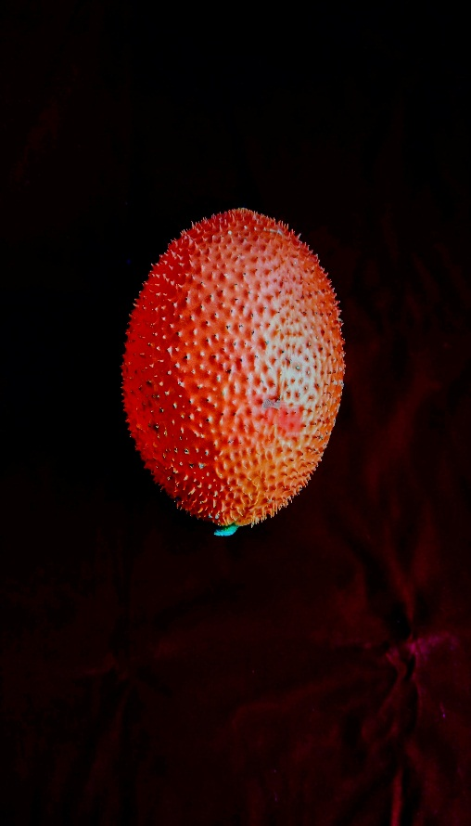

**Snap melon fruit Gac fruit**

**Figure 1. Overview of snap melon and gac fruit**

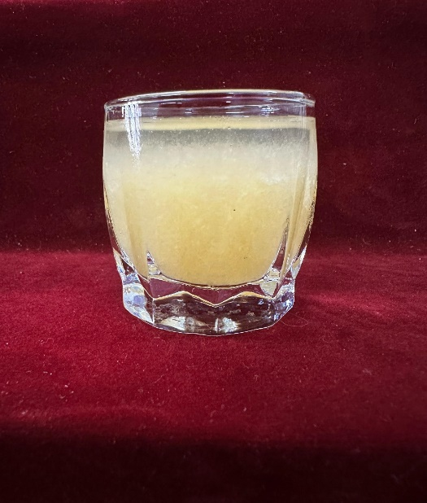 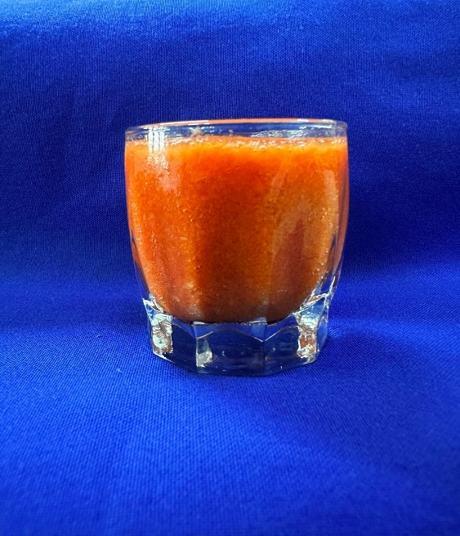 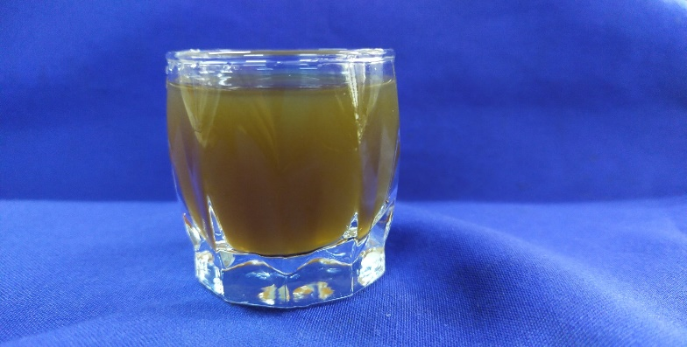

**Snap melon juice Gac fruit aril juice Steviol glycosides extract**

**Figure 2. Juice extracted from snap melon, gac fruit aril and extract of steviol glycosides**

**2.2 Development of nectar from blends of snap melon and gac fruit**

The snap melon juice was substituted with 25%, 50%, and 75% of gac fruit aril juice, followed by addition of steviol glycosides and acid lime juice. The best combination among these was selected based on organoleptic evaluation on 9-point hedonic scale. The combination containing 75% snap melon juice and 25% gac aril juice (75% SM & 25% GF) blend obtained highest overall acceptability scores in preliminary trials and this combination was selected for the preparation of nectar. Three combinations of nectar were prepared. Conventional nectar was developed with 20% juice (75% SM & 25% GF), 15° Brix (sucrose) and 0.25% citric acid (T1). Nectar was also made from pure snap melon juice (20%), with 15° Brix (sucrose) and 0.25% citric acid (T2). For the low-calorie nectar, 20% juice (75% SM and 25% GF) was combined with stevia extract (10%) and acid lime juice (2.5%) (T3). The three formulations of nectar were pasteurized and subsequently stored under ambient (34±2°C) and refrigerated (5±2°C) conditions (Figure 6). The qualitative changes were recorded at monthly intervals for 3 months.

**2.3 Physico-chemical analysis**

**2.3.1 pH, TSS and acidity**

The pH values were measured with a standard digital pH meter. Total soluble solids (TSS) were determined using digital refractometer (Atago, Japan), with results expressed in degree Brix (°Brix). Titratable acidity was assessed using a standard alkali solution (0.1N NaOH) with phenolphthalein as indicator, and the results were presented as a percentage (Ranganna 1986).

**2.3.2 Colour values (L*, a*,b*)**

A Minolta CM-3600D spectrophotometer (Konica Minolta Sensing, Inc., Osaka, Japan) was used to measure the samples' colour in terms of L*, a*, and b*. The light was provided by a D65 lamp as standard. The JAYPAK 4804 application (Quality Control System, Version 1.2) examines the colour values based on the CIELAB colour space. In colour values, L* represents lightness, a* denotes redness/browning, and b* denotes yellowness.

**2.3.3 Viscosity (cP)**

Viscosity is measured by using low-viscosity model viscometer (Ametek Brookfield DVE viscometer, USA) with four spindles and a narrow leg.

Viscosity in cP (mPa*s) = Dial reading x factor

**2.3.4 Ascorbic acid (mg/100g)**

The ascorbic acid content was measured using a titrimetric method with 2,6-dichlorophenol indophenol dye (DCPIP), with the sample extracted with 3% metaphosphoric acid. The endpoint was reached when the excess unreduced dye turned rose pink in the acidic solution (A.O.A.C, 1980).

**2.3.5 Total phenolics (mg/100g)**

The total phenol content was determined using the Folin-Ciocalteu reagent (FCR) following the method described by Asami et al. 2003. In this process, phenols in the sample react with phosphomolybdic acid in an alkaline medium to form a blue-coloured compound. The spectrophotometer was set to 650 nm, and the colour intensity was measured against a blank reagent.

**2.3.6 β carotene and lycopene (mg/100g)**

The β-carotene and lycopene content in the samples were analyzed using the method outlined by Vieira et al.(2019). The sample was mixed with a solvent mixture of acetone and hexane in a 4:6 (v/v) ratio. The mixture was then centrifuged for one minute at 15,000 rpm. To determine the amount of β-carotene and lycopene in the sample, absorbance (A) values at 453 nm and 505 nm were recorded, and the quantification of carotenoids was done by using the following equations.

Cβ-carotene = 4.624 x A453 – 3.091 x A505

CLycopene = 3.956 x A453 – 0.806 x A505

**2.3.7 Antioxidant activity (DPPH) ( ${IC}_{50}$ values)**

The sample's antioxidant activity was estimated using DPPH (2,2-diphenyl-1-picrylhydrazyl) reagent by the method prescribed by Tansku et al*.* (2023). Different volumes of standards and samples were pipetted, followed by the addition of 2.8 ml of methanol and 0.2 ml of DPPH (50µM) reagent to each. The mixture was homogenized and left in the dark for 20 minutes. Absorbance at 517 nm was measured using a UV-Visible 1800 spectrophotometer from Shimadzu, Kyoto, Japan. The antioxidant activity of the sample was evaluated based on its ability to inhibit DPPH radical absorption. The percentage of DPPH inhibition was calculated using the following formula.

Percent inhibition = $\frac{[Absorbance\left(control\right)-Absorbance (sample)}{Absorbance (control)}*100$

**2.3.8 Energy values (kcal)**

The energy value of the sample was determined by multiplying the amounts of protein (Ranganna 1997), fat (Soxhlet extraction), and carbohydrates by factors of 4, 9, and 4, respectively.

Energy (kcal) = (Carbohydrate x 4) + (Fat x 9) + (Protein x 4)

**2.3.9 Microbiological analysis (Bacteria, fungi, yeast)**

Microbiological quality was assessed by counting the total number of microorganisms (CFU). All analyses were performed in triplicate in each of the packaged sample.

Total microbial counts, CFU/ml sample = $\frac{No of colonies X Dilution factor}{Volume of the sample(ml)}X 100$

**2.3.10 Sensory analysis**

A panel of fifty people from different age groups was selected to rate the nectar on a 9-point hedonic scale according to appearance, colour, flavour, taste, aftertaste, body/consistency, aroma, and overall acceptability. A score of 5.5 or higher was considered acceptable (Lawless and Heymann 1999). Panelists scored the samples according to their degree of acceptability using a nine-point hedonic scale in order to assess the sensory qualities.

**2.3.11 Statistical analysis**

For testing each quality parameter, five replications were taken, and the data was expressed on the basis of mean and standard deviation (SD). A two-way analysis of variance (ANOVA) was done using a completely randomized design (CRD).

3. results AND DISCUSSION

**3.1 Physico-chemical analysis**

Snap melon and gac fruit were blended individually and their proximate composition was recorded and presented (Table 1). Snap melon had the highest moisture content and titratable acidity among the fruits. Gac fruit aril recorded highest total soluble solids, pH, ascorbic acid, phenols, β carotene and lycopene. β carotene and lycopene was not detected in snap melon. The radical scavenging activity IC50 value (DPPH) of gac fruit was higher than snap melon.

**Table 1. Physico-chemical characteristics of snap melon and gac fruit**

|  |  |  |
| --- | --- | --- |
| **Parameters** | **Snap melon** | **Gac fruit** |
|  |  |  |
| Moisture content (%) | 95.38 | 90.43 |
| Titratable acidity (%) | 0.64 | 0.25 |
| TSS (°Brix) | 1.2 | 7.5 |
| pH | 4.52 | 5.78 |
| Ascorbic acid (mg/100g) | 26.4 | 44.8 |
| Total phenolics (mg/100g) | 40 | 95 |
| β carotene (mg/100g) | ND* | 1.23 |
| Lycopene (mg/100g) | ND* | 1.63 |
| Anti-oxidant activity (IC50 Values) (μg/mL) | 14.66 | 8.94 |

*\** *ND-Not detected*

**3.1.1 pH, TSS and acidity**

The initial pH values of nectar varied significantly among the treatments (Table 2.). Also, pH values decreased significantly during the storage period. The treatment T3 recorded the highest pH level.T2  had the lowest pH among the treatments. The rate of decrease in pH was more rapid in ambient storage than refrigerated condition. pH has a strong influence on sensory and microbial qualities of the product. The low-calorie nectar exhibited higher pH values compared to nectar sweetened with sucrose, likely due to the higher pH level of stevia extract. Balaswamy et al. (2014) found that the pH of stevia aqueous extract was higher than that of fruit juices. Similar findings were reported by Reale et al. (2020) and Jabeen et al. (2019), noting that beverages sweetened with stevia had higher pH values than those sweetened with sucrose. During storage, a consistent decrease in pH was observed across the treatments of snap melon and gac fruit nectar, a trend also noted by Kausar et al. (2012) and Majumdar et al. (2010) in various cucurbit drinks.

Initial TSS of the different types of nectar varied from 1.45 to 16.78°Brix. The TSS of sucrose-sweetened nectar was significantly higher than stevia-sweetened nectar. The treatment T1 recorded highest TSS of 16.78 °Brix followed by T2 at 16.62 **°**Brix. The treatment T3 which was sweetened with steviol glycosides had significantly lower TSS of 1.45 **°**Brix. TSS values of nectar showed a decreasing trend during storage period (Table 2). The decrease in TSS was more rapid under ambient storage than refrigerated storage. TSS plays a significant role in sensory quality which determines the marketability of the product. A significant difference was noted between the TSS of nectar sweetened with steviol glycosides and the one sweetened with sucrose. The TSS of nectar sweetened with steviol glycosides was lower than that of the sucrose-sweetened nectar, likely because stevioside does not contribute to the total soluble solids (TSS) (Sharma and Tandon 2015). The decrease in TSS during storage could be attributed to the breakdown of carbohydrates, particularly sugars, into acids by microorganisms. Similar reductions in TSS during storage were observed by Singh and Gaikwad (2012) and Habib and Iqbal (2014).

Nectar developed from different combinations had initial titratable acidity values ranging from 0.28 to 0.56%, as indicated in Table 2. Treatment T2 had the highest acidity level of 0.56% followed by T1 of 0.51%. T3 had a significantly lower titratable acidity of 0.28%. The titratable acidity of nectar showed generally an increasing trend during storage (Table 2). A notable difference in acidity levels was observed between nectar sweetened with steviol glycosides and the one sweetened with sucrose. This difference may be attributed to the higher pH of stevia extract. Similar findings were reported by Sharma and Thakur (2017) in their study on low-calorie bitter gourd-aonla blended squash. During storage, an increasing trend in titratable acidity was observed in all treatments of snap melon and gac fruit nectar. This rise in acidity can be linked to the decline in the pH of the product. Similar conclusions were drawn by Gomez et al. (2022) and Kausar et al. (2012). Sabahuddin et al. (2017) found that the increase in acidity during storage was more pronounced when the low-calorie herbal beverage was stored at higher temperatures compared to low-temperature storage.

**Table 2: Changes in physico-chemical characteristics of nectar from snap melon and gac fruit during storage period of 3 months**

|  |  |  |  |  |  |  |  |
| --- | --- | --- | --- | --- | --- | --- | --- |
| **Parameters** | **Storage condition** | **Storage time (months)** | **T1** | **T2** | **T3** | **CD** | **S.Em** |
| pH | Initial | 0 | 2.69b | 2.48b | 4.56a | 0.29 | 0.10 |
| Ambient | 1 | 2.48b | 2.46b | 3.97a | 0.41 | 0.14 |
| Refrigerated | 1 | 2.67b | 2.52b | 4.26a |
| Ambient | 2 | 1.74c | 1.58c | 2.97b | 0.41 | 0.13 |
| Refrigerated | 2 | 1.98c | 1.69c | 3.51a |
| Ambient | 3 | 1.64b | 1.51b | 2.77a | 0.66 | 0.22 |
| Refrigerated | 3 | 1.87b | 1.54b | 3.09a |
| Total soluble solids  (°Brix) | Initial | 0 | 17.18b | 18.11a | 1.45c | 0.45 | 0.15 |
| Ambient | 1 | 16.32c | 16.67bc | 1.22d | 0.49 | 0.16 |
| Refrigerated | 1 | 16.90b | 17.50a | 1.25d |
| Ambient | 2 | 15.75b | 15.20c | 0.95d | 0.42 | 0.14 |
| Refrigerated | 2 | 16.85a | 16.12b | 1.15d |
| Ambient | 3 | 14.15bc | 12.50c | 0.70d | 1.68 | 0.56 |
| Refrigerated | 3 | 15.85a | 15.67a | 1.05d |
| Titratable acidity (%) | Initial | 0 | 0.51a | 0.56a | 0.28b | 0.09 | 0.03 |
| Ambient | 1 | 0.57a | 0.63a | 0.38b | 0.13 | 0.04 |
| Refrigerated | 1 | 0.54a | 0.60a | 0.34b |
| Ambient | 2 | 0.66ab | 0.76a | 0.47bc | 0.19 | 0.06 |
| Refrigerated | 2 | 0.70a | 0.73a | 0.38c |
| Ambient | 3 | 0.76a | 0.82a | 0.54bc | 0.19 | 0.06 |
| Refrigerated | 3 | 0.73ab | 0.75a | 0.51c |
| Ascorbic acid (mg/100g) | Initial | 0 | 27.42b | 19.42b | 41.14a | 8.54 | 2.87 |
| Ambient | 1 | 21.42bc | 16.66c | 30.95a | 9.42 | 3.17 |
| Refrigerated | 1 | 26.18ab | 19.04bc | 33.30a |
| Ambient | 2 | 15.03c | 14.19c | 21.23abc | 7.70 | 2.59 |
| Refrigerated | 2 | 23.00ab | 17.69bc | 26.54a |
| Ambient | 3 | 12.06b | 6.89c | 16.37a | 4.26 | 1.43 |
| Refrigerated | 3 | 18.09a | 15.51ab | 18.95a |
| β-carotene (mg/100g) | Initial | 0 | 0.131a | ND | 0.135a | 0.039 | 0.013 |
| Ambient | 1 | 0.039bc | ND | 0.050bc | 0.020 | 0.007 |
| Refrigerated | 1 | 0.058b | ND | 0.084a |
| Ambient | 2 | 0.032c | ND | 0.043bc | 0.014 | 0.005 |
| Refrigerated | 2 | 0.050ab | ND | 0.062a |
| Ambient | 3 | 0.014b | ND | 0.022ab | 0.010 | 0.003 |
| Refrigerated | 3 | 0.024a | ND | 0.028a |
| Lycopene  (mg/100g) | Initial | 0 | 0.179a | ND | 0.189a | 0.058 | 0.019 |
| Ambient | 1 | 0.065ab | ND | 0.059ab | 0.031 | 0.011 |
| Refrigerated | 1 | 0.077a | ND | 0.089a |
| Ambient | 2 | 0.049c | ND | 0.067bc | 0.023 | 0.008 |
| Refrigerated | 2 | 0.077b | ND | 0.103a |
| Ambient | 3 | 0.021b | ND | 0.034ab | 0.017 | 0.006 |
| Refrigerated | 3 | 0.037a | ND | 0.050a |
| Total phenolics (mg/100g) | Initial | 0 | 45.00a | 26.42b | 57.14a | 12.49 | 4.20 |
| Ambient | 1 | 38.75b | 18.75d | 42.50b | 4.01 | 1.35 |
| Refrigerated | 1 | 42.50b | 26.25c | 47.50a |
| Ambient | 2 | 26.25b | 12.50d | 27.50b | 4.71 | 1.58 |
| Refrigerated | 2 | 33.75a | 21.25c | 37.50a |
| Ambient | 3 | 8.75cd | 6.25d | 12.50bc | 4.37 | 1.47 |
| Refrigerated | 3 | 22.50a | 13.75b | 25.00a |
| Viscosity (cP) | Initial | 0 | 45.38b | 24.70c | 52.68a | 5.40 | 1.81 |
| Ambient | 1 | 39.67c | 22.37d | 48.20a | 3.49 | 1.17 |
| Refrigerated | 1 | 43.32b | 23.75d | 50.97a |
| Ambient | 2 | 35.50c | 20.92d | 44.00ab | 4.27 | 1.43 |
| Refrigerated | 2 | 40.10b | 21.62d | 47.75a |
| Ambient | 3 | 31.25c | 18.07d | 39.00b | 4.59 | 1.54 |
| Refrigerated | 3 | 36.70b | 19.62d | 43.72a |
| Antioxidant activity (${IC}_{50}$ values) (μg/mL) | Initial | 0 | 3.20b | 6.03a | 2.47b | 0.88 | 0.29 |
| Ambient | 1 | 5.29b | 9.94a | 4.33bc | 2.04 | 0.68 |
| Refrigerated | 1 | 3.42bc | 8.95a | 2.46c |
| Ambient | 2 | 6.41b | 11.71a | 4.99bc | 2.17 | 0.73 |
| Refrigerated | 2 | 3.78c | 11.82a | 3.65c |
| Ambient | 3 | 9.76c | 22.75a | 4.80de | 3.58 | 1.18 |
| Refrigerated | 3 | 7.63cd | 16.51b | 3.36e |
| Protein  (gm/100g) | Initial | 0 | 1.32a | 1.01b | 0.55c | 0.29 | 0.10 |
| Ambient | 1 | 0.92 | 0.77 | 0.62 | NS | 0.09 |
| Refrigerated | 1 | 0.92 | 0.90 | 0.57 |
| Ambient | 2 | 0.85b | 0.70bc | 0.55c | 0.25 | 0.08 |
| Refrigerated | 2 | 1.87a | 0.62bc | 0.55c |
| Ambient | 3 | 0.60 | 0.72 | 0.57 | NS | 0.07 |
| Refrigerated | 3 | 0.72 | 0.47 | 0.45 |
| Carbohydrate  (mg/100g) | Initial | 0 | 16.71a | 13.14b | 10.85c | 1.81 | 0.61 |
| Ambient | 1 | 10.00b | 7.50c | 6.75c | 1.78 | 0.60 |
| Refrigerated | 1 | 12.50a | 10.97ab | 7.50c |
| Ambient | 2 | 7.25b | 6.25bc | 5.50c | 1.42 | 0.47 |
| Refrigerated | 2 | 10.50a | 7.00b | 9.50a |
| Ambient | 3 | 6.50bc | 5.25c | 4.50c | 2.15 | 0.72 |
| Refrigerated | 3 | 9.00a | 5.50c | 8.00ab |
| Fat (gm/100g) | Initial | 0 | 4.18a | 1.55b | 0.92c | 0.19 | 0.06 |
| Ambient | 1 | 2.50b | 1.37c | 1.75c | 0.50 | 0.17 |
| Refrigerated | 1 | 3.12a | 1.50c | 2.57b |
| Ambient | 2 | 2.45a | 1.02c | 1.62b | 0.34 | 0.11 |
| Refrigerated | 2 | 2.40a | 1.17c | 1.80b |
| Ambient | 3 | 2.60a | 0.95c | 1.07c | 0.37 | 0.12 |
| Refrigerated | 3 | 2.05b | 1.05c | 1.75b |
| Energy value (kcal) | Initial | 0 | 109.48a | 70.64b | 56.16c | 7.55 | 2.54 |
| Ambient | 1 | 66.20b | 45.47d | 45.25d | 7.86 | 2.64 |
| Refrigerated | 1 | 81.72a | 61.10bc | 55.47c |
| Ambient | 2 | 57.85b | 37.72d | 37.02d | 6.32 | 2.12 |
| Refrigerated | 2 | 68.80a | 56.40b | 46.68c |
| Ambient | 3 | 51.55a | 31.85b | 30.57b | 9.45 | 3.18 |
| Refrigerated | 3 | 57.35a | 49.65a | 39.55b |

*ND* - Not detected NS* – Not significant*

**3.1.2 Colour values (L*, a*,b*)**

Colour values (L*, a*, b*): Instrumental colour values for L*, a* and b* differed between the types of nectars (Table 3). L* value was higher for the nectar made solely from pure snap melon juice (T2), and a* and b* values were higher for the treatment (T3). During the storage period L* values decreased in the nectars. The a* and b* values also varied significantly.

Fruit and vegetable beverages are first judged by the visibility or colour and appearance which plays a crucial role in marketability. The colour values of all treatments varied significantly. The l* value was higher for nectar made from pure snap melon juice, while a* and b* values were higher for nectar containing gac fruit aril and steviol glycosides. The absence of gac fruit aril and stevia extract likely contributed to the higher L* value in nectar made from pure snap melon juice, while their addition likely increased the a* and b* values. These colour values were similar to those found in the study by Wirivutthikorn (2023). During storage, L*, a*, and b* values generally showed a decreasing trend with slight variations. Similar trends were observed in the studies by Eissa et al. (2014) and Cortellino and Rizzolo (2018).

**Table 3. Changes in colour values of nectar from snap melon and gac fruit aril during storage period of 3 months**

|  |  |  |  |  |  |  |  |  |
| --- | --- | --- | --- | --- | --- | --- | --- | --- |
| **Parameters** | | **Storage condition** | **Storage time (months)** | **T1** | **T2** | **T3** | **CD** | **S.Em** |
| Colour values | L* | Initial | 0 | 88.72b | 99.31a | 86.00b | 8.00 | 2.69 |
| Ambient | 1 | 88.44b | 96.35a | 82.63d | 2.64 | 0.89 |
| Refrigerated | 1 | 88.74b | 98.33a | 85.34c |
| Ambient | 2 | 84.58bc | 92.30a | 79.90d | 3.70 | 1.24 |
| Refrigerated | 2 | 85.53b | 94.32a | 81.20cd |
| Ambient | 3 | 81.87bc | 90.19a | 73.54d | 2.67 | 0.90 |
| Refrigerated | 3 | 83.62b | 90.94a | 80.79c |
| a* | Initial | 0 | 1.20a | -0.02b | 0.86a | 0.46 | 0.15 |
| Ambient | 1 | 0.570b | 0.042c | 0.475b | 0.27 | 0.09 |
| Refrigerated | 1 | 0.495b | 0.075c | 1.060a |
| Ambient | 2 | 0.210ab | 0.050b | 0.470a | 0.30 | 0.10 |
| Refrigerated | 2 | 0.400a | 0.065b | 0.420a |
| Ambient | 3 | 0.705ab | 0.055c | 0.905a | 0.61 | 0.20 |
| Refrigerated | 3 | 0.760ab | 0.160bc | 0.920a |
| b* | Initial | 0 | 7.23a | 1.02b | 5.25a | 2.22 | 0.74 |
| Ambient | 1 | 4.17b | 1.71c | 7.24a | 0.77 | 0.26 |
| Refrigerated | 1 | 4.72b | 0.40d | 7.05a |
| Ambient | 2 | 2.25c | 1.02c | 6.14a | 1.50 | 0.50 |
| Refrigerated | 2 | 3.99b | 1.82c | 4.58b |
| Ambient | 3 | 4.48a | 1.62b | 7.11a | 2.64 | 0.88 |
| Refrigerated | 3 | 5.04a | 1.83b | 6.36a |

**3.1.3 Viscosity (cP)**

The viscosity of the nectars ranged from 24.70 cP to 52.68 cP (Table 2). The viscosity of the nectar containing gac fruit aril and sweetened with stevia (T3) was 52.68 cP, which was significantly higher than the 24.70 cP viscosity of the nectar made from pure snap melon (T2). Viscosity of the nectar decreased significantly during the storage period.

Viscosity indicates the consistency of the product which is a direct indication of the dissolved solutes in the drink. Nectars sweetened with steviol glycosides showed higher viscosity than those sweetened with sucrose. The increased viscosity in nectar containing gac fruit aril and stevia extract might be due to reduced water activity. Wirivutthikorn (2023) reached similar conclusions in their study on corn milk beverages with added gac fruit aril, as did Peasura and Sinchaipanit (2022) in their research on guava nectar sweetened with stevia. During storage, the viscosity of nectars decreased. This reduction in viscosity can be linked to the decline in TSS. Similar observations were made by Wojdyło et al. (2014) and Oszmianski et al. (2009).

**3.1.4 Ascorbic acid (mg/100g)**

The ascorbic acid content of all treatments varied significantly. According to Table 2, treatment T3 had significantly higher ascorbic acid content of 41.14 mg/100g which was followed by T1 at 27.42 mg/100g. Treatment T2 developed from pure snap melon had the lowest ascorbic acid content of 19.42 mg/100g. The ascorbic acid content of nectars decreased significantly during the storage period (Table 2). The rate of deterioration of ascorbic acid content was slower under refrigerated conditions than ambient storage.

Ascorbic acid is a strong antioxidant, supplied primarily through diet, of which plant-based products are very important. Evidence suggests that the optimal daily intake of ascorbic acid for humans ranges from 250 mg to significantly higher levels, such as 2000 mg or more. However, the Food and Nutrition Board of the National Academy of sciences-National Research Council has established the recommended dietary allowance (RDA) for ascorbic acid (vitamin C) at 45 mg per day for adults, with specific recommendations of 35 mg for infants, 60 mg for pregnant women, and 80 mg for lactating mothers (Pauling 1974). Nectar sweetened with stevia exhibited higher ascorbic acid content compared to nectar sweetened with sucrose. This increased vitamin C level may result from the combined effect of gac fruit aril and stevia extract, both of which are sources of ascorbic acid. Lemus-Mondaca et al. (2016) noted that fresh stevia leaves contained vitamin C. The reduction in ascorbic acid content during storage could be due to its oxidation into dehydroascorbic acid, and ascorbic acid is also sensitive to heat. The findings were similar to the results reported by Gomez et al. (2022) and Gupta et al. (2022).

**3.1.5 Total phenolics (mg/100g)**

The total phenol content of nectar varied significantly (Table 2). The highest was in treatment T3 which was followed by treatment T1 developed from snap melon and gac fruit aril sweetened with sucrose. T2 developed from pure snap melon juice had the lowest phenol content. Phenolsdecreased during the storage period (Table 2). During storage, nectar stored under refrigerated condition retained phenols better than the samples held under ambient condition.

Phenolics is a group of compounds with strong antioxidant properties. Tannins, catechins, quercetin are some of the phenolic compounds found in fruits and vegetables. The total phenol content was higher in nectar sweetened with steviol glycosides compared to those sweetened with sucrose. Nectar containing both gac fruit aril and stevia extracts had even higher phenol content. Ahmed et al. (2019) noted the presence of phenols in aqueous extract of stevia. During storage, phenol content decreased in all treatments of snap melon and gac fruit nectar. Decline in phenols may be due to oxidative degradation. Similar findings were reported by Sharma et al. (2018) and Palamthodi et al. (2019) in their studies.

**3.1.6 β carotene and lycopene (mg/100g)**

The β carotene content ranged from 0.082 to 0.135 mg/100g and lycopene content ranged from 0.179 to 0.189 mg/100g in the nectar (Table 2). Treatment T3 recorded the highest β carotene and lycopenecontent of 0.135 mg/100g and 0.189 mg/100g respectively. The lowest β carotene and lycopenecontent was recorded in treatment β carotene and lycopenecontent was not detected in nectar prepared from pure snap melon without gac fruit aril (T2). β carotene and lycopenecontent showed a decreasing trend during storage (Table 2). The deterioration of β carotene and lycopene was slower under refrigerated storage than under ambient storage.

β-carotene and lycopene are antioxidants responsible for bright hues of red, orange and yellow colours. The nectar containing gac fruit aril and steviol glycosides had higher levels of β-carotene and lycopene. In their study, Gupta et al. (2015) found that β-carotene was the primary bioactive compound in the leaves of *stevia rebaudiana*. β-carotene and lycopene were not detected in the nectar made solely from snap melon juice without gac fruit aril. The degradation of β-carotene and lycopene during storage could be due to photo-oxidation. Additionally, carotenoids can be converted into isomers during storage, resulting in their degradation. Low-temperature storage resulted in better retention of β-carotene and lycopene. Similar conclusions were reported by Baç et al. (2023) and Nhung et al. (2010).

**3.1.7 Antioxidant activity (DPPH) ( ${IC}_{50}$ values)**

T3 developed from snap melon and gac fruit aril sweetened with steviol glycosides recorded highest radical scavenging activity (DPPH) of 2.47μg/mL, followed by T1 at 3.20 μg/mL. T2 developed from pure snap melon juice recorded the lowest antioxidant activity of 6.03 μg/m. The antioxidant activity of nectar showed a declining trend during storage (Table 2). The reduction in antioxidant capacities was more prominent under ambient storage.

Radical scavenging properties of fruits and vegetables are influenced by the level of bioactive compounds present in them. The nectar containing both gac fruit aril and stevia extract exhibited higher radical scavenging activity (DPPH) compared to other nectars. This increased activity can be attributed to the higher levels of antioxidants from the gac fruit aril and stevia. Similar changes in antioxidant activities were observed by Wirivutthikorn (2023). Ahmed et al*.* (2019) found that aqueous extract of stevia could enhance antioxidant activity. During storage, the antioxidant activity (DPPH radical scavenging activity) decreased in all treatments of snap melon and gac fruit nectar. Similar trends were reported by Gomez et al. (2022) and Sharma et al. (2022).

**3.1.8 Energy values (kcal)**

The energy value varied significantly between the nectar combinations (Table 2). Energy values of nectar sweetened with sucrose (T1, T2) was significantly higher than the nectar sweetened with steviol glycosides (T3). T1 recorded the highest energy value of 109.48 kcal among sugar sweetened nectars. T3 recorded the lowest energy value of 55.88 kcal.

The energy values of nectars showed significant variation. Nectars sweetened with steviol glycosides had notably lower calorific values compared to those sweetened with sucrose. Reduced sweetness and TSS levels in stevia-sweetened nectar could account for lower energy values. Similar findings were reported by Barakat et al. (2016). During storage, the calorific values of nectar decreased, with a more rapid decline observed under ambient storage conditions compared to refrigerated storage. This decrease in energy value during storage could be due to the degradation of carbohydrates and other metabolites by microbes. Additionally, sweetening nectar with stevia led to a reduction in its calorific value. Similar reductions in energy values were observed by Sharma et al. (2022) and Sharma et al. (2021).

**3.1.9 Microbiological analysis (Bacteria, fungi, yeast)**

Variation in microbial population in the nectar was not significant (Table 4). The bacterial population was initially observed in all treatments. The highest bacterial population was observed in treatment T1 (0.36 x 104 CFU/ml). The fungal population was not observed in any of the treatments. Yeast populations were observed in all the treatments with the highest population in treatment T2 (0.36 x 104 CFU/ml). During the storage period bacterial, fungal and yeast populations increased in the nectars. The lowest bacterial, fungal and yeast populations were observed in treatment T3 developed from snap melon and gac fruit aril sweetened with steviol glycosides.

According to FSSAI (Food Safety and Standards Authority of India) regulations in India, the total microbial count must not exceed 25 cfu/ml, total coliform count (TCC) must be absent in 100 ml, and the total yeast count must not exceed 2 cfu/ml. Stevia-sweetened nectar had a lower microbial population than nectar sweetened with sucrose. Stevia's antibacterial properties may be the cause of the lower microbial load in stevia-sweetened nectar. Rodríguez-Rico et al. (2022) in melon (*Cucumis melo* l.) Juice found similar results in their study. The aqueous extract of stevia leaves shows strong antibacterial properties against a range of microorganisms, according to Ibrahem et al. (2020). In the present study during the storage period, there was an increase in the populations of bacteria, fungi, and yeast. In their respective studies, Minh (2019) in cucumber (*Cucumis sativus* var. *Conomon*) juice and Sharma et al. (2020) in low-calorie apple-whey-based RTS beverage noted a comparable rise in the microbial count.

**Table 4. Changes in microbial population of nectar from snap melon and gac fruit aril during storage period of 3 months**

|  |  |  |  |  |  |  |  |  |
| --- | --- | --- | --- | --- | --- | --- | --- | --- |
| **Parameters** | | **Storage condition** | **Storage time (months)** | **T1** | **T2** | **T3** | **CD** | **S.Em** |
| Microbial population | Bacteria  (104 CFU/ml) | Initial | 0 | 0.36 | 0.26 | ND | - | - |
| Ambient | 1 | 4.00 | 8.50 | 4.00 | - | 0.82 |
| Refrigerated | 1 | 4.25 | 3.25 | 2.75 |
| Ambient | 2 | 5.25 | 9.25 | 5.75 | - | 0.71 |
| Refrigerated | 2 | 4.50 | 5.75 | 4.25 |
| Ambient | 3 | 6.00 | 11.00 | 7.25 | - | 0.82 |
| Refrigerated | 3 | 4.00 | 7.75 | 4.50 |
| Fungus  (104 CFU/ml) | Initial | 0 | ND | ND | ND | - | - |
| Ambient | 1 | 2.75 | 3.25 | 1.00 | - | 0.43 |
| Refrigerated | 1 | 1.75 | 3.00 | 0.75 |
| Ambient | 2 | 3.25 | 3.75 | 2.50 | - | 0.22 |
| Refrigerated | 2 | 2.75 | 3.25 | 2.25 |
| Ambient | 3 | 4.25 | 4.50 | 3.50 | - | 0.31 |
| Refrigerated | 3 | 3.00 | 4.00 | 2.50 |
| Yeast  (104 CFU/ml) | Initial | 0 | 0.26 | 0.36 | ND | - | - |
| Ambient | 1 | 4.75 | 3.75 | 2.50 | - | 0.50 |
| Refrigerated | 1 | 3.75 | 2.00 | 1.50 |
| Ambient | 2 | 9.50 | 4.25 | 5.25 | - | 1.03 |
| Refrigerated | 2 | 4.00 | 3.25 | 2.25 |
| Ambient | 3 | 8.50 | 5.00 | 7.00 | - | 0.96 |
| Refrigerated | 3 | 1.75 | 3.75 | 5.00 | - |

*ND* - Not detected NS* – Not significant*

**3.1.10 Sensory analysis**

The sensory evaluation of nectar from snap melon and gac fruit aril revealed that treatment T1 developed from snap melon and gac fruit aril sweetened with sucrose was the most accepted one among the three treatments of nectar, based on organoleptic qualities (Fig. 3, 4 & 5). T1 exhibited the highest levels of acceptance in terms of appearance, colour, flavor, taste, aftertaste, body/consistency, aroma and overall acceptability. T1 obtained an overall acceptability score of 7.7, followed by T2, developed from pure snap melon sweetened with sucrose of 7.5. T3, developed from snap melon and gac fruit aril sweetened with steviol glycosides, had the lowest overall acceptability of 5.5 among the nectars. The nectar treatments sweetened with sucrose obtained the highest overall acceptability scores compared to the nectar sweetened with steviol glycosides. The overall acceptability scores of nectars, along with other parameters, reduced throughout the storage period.

The organoleptic scores of nectars sweetened with sucrose were substantially higher than those of nectars sweetened with stevia. Comparable outcomes were noted by Wafaa et al. (2016) in natural drinks sweetened by stevia. This could be due to the reduction in flavour and colour of the nectar. Additionally, over the course of the three-month storage period, the organoleptic ratings dropped. In their respective investigations, Sharma et al. (2018) on low-calorie aloe vera-aonla blended functional squash and Salaria and Reddy (2022) on RTS beverage from muskmelon C*ucumis melo* l. Variety ‘sarda’) saw a comparable decline in the overall acceptability score during storage. Organoleptic property is directly related to the marketability of the product, of which flavour and colour are the most important criteria.

**Figure 3. Changes in organoleptic qualities of nectar from snap melon and gac fruit aril during storage (1 MAS)**

**Figure 4. Changes in organoleptic qualities of nectar from snap melon and gac fruit aril during storage (2 MAS)**

**Figure 5. Changes in organoleptic qualities of nectar from snap melon and gac fruit aril during storage (3 MAS)**

**A* -Ambient condition C* - Refrigerated condition**

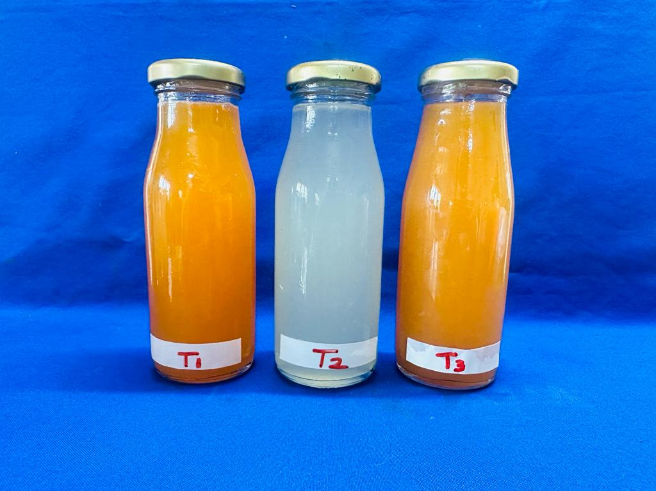

**Figure 6. Types of nectar developed from snap melon, snap melon and gac fruit aril with and without stevia glycosides; T1 - 20% Juice (75% SM and 25% GF) with 15° Brix (sucrose) and 0.25% citric acid, T2 - 20% Juice (75% snap melon and 25% gac fruit aril) with 15° Brix (sucrose) and 0.25% citric acid T3 - 20% Juice (75% SM, 25% GF) with steviol glycosides and acid lime juice**

4. Conclusion

Gac fruit and snap melon work well together to produce value-added products such as nutraceutical nectar. By adding value, farmers can improve their income and ensure that products made from these underappreciated fruits will be available all year round. Even though the combination of nectar sweetened with stevia was high in antioxidant activity, β-carotene, phenolics, ascorbic acid, and lycopene, the nectar sweetened with sucrose had superior overall acceptance scores. During the storage period of nectar, it was noticed that the nectars stored in a refrigerator preserved their phytochemical components better than their counterparts at room temperature. Additionally, stevia extract can be used to sweeten nectar, making it appropriate for usage for diabetic patients. The quality of nectar combinations was judged satisfactory based on a sensory evaluation performed using a 9-point hedonic scale during the duration of the three-month storage period. For up to ninety days, the nectar can be stored at room temperature or in a refrigerator without any synthetic preservatives.

**DISCLAIMER (ARTIFICIAL INTELLIGENCE)**

The authors hereby state that no generative AI tools, including text-to-image generators and large language models (chatgpt, copilot, etc.), were utilized in the authoring or editing of this work.

References

Singh, S., Srivastava, S., & Upadhyay, A. K. (2019). Socio-economic inequality in malnutrition among children in India: an analysis of 640 districts from National Family Health Survey (2015–16). *International journal for equity in health*, *18*, 1-9.

Rolnik, A., & Olas, B. (2020). Vegetables from the Cucurbitaceae family and their products: Positive effect on human health. *Nutrition*, *78*, 110788.

López-Carbón, V., Sayago, A., González-Domínguez, R., & Fernández-Recamales, Á. (2019). Simple and efficient green extraction of steviol glycosides from Stevia rebaudiana leaves. *Foods*, *8*(9), 402.

Ranganna, S. (1986). *Handbook of analysis and quality control for fruit and vegetable products*. Tata McGraw-Hill Publication Co. Ltd., New Delhi, 1997, 634p.

Association of Official Analytical Chemists, & Association of Official Agricultural Chemists (US). (1980). *Official and Tentative Methods of Analysis* (Vol. 13).

Asami, D. K., Hong, Y. J., Barrett, D. M., & Mitchell, A. E. (2003). Comparison of the total phenolic and ascorbic acid content of freeze-dried and air-dried marionberry, strawberry, and corn grown using conventional, organic, and sustainable agricultural practices. *Journal of agricultural and food chemistry*, *51*(5), 1237-1241.

Vieira, D. A. D. P., Caliari, M., SOUZA, E. R. B. D., & Soares Junior, M. S. (2019). Methods for and pigments extration and determination of color in tomato for processing cultivars. *Food science and technology*, *40*, 11-17.

Tansku, S., Rattanacharun, N., & Phanaphitakkul, S. (2023). The effect of edible film on properties and specific sensory attributes of a gac (Momordica cochinchinensis Spreng) aril product. *Songklanakarin Journal of Science & Technology*, *45*(1).

Lawless, H. T., & Heymann, H. (1999). *Sensory evaluation of food: principles and practices*. Springer Science & Business Media.1999:173-207.

Balaswamy, K., Rao, P. P., Rao, G. N., Nagender, A., & Satyanarayana, A. (2014). Production of low calorie ready-to-serve fruit beverages using a natural sweetener, stevia (Stevia rebaudiana L.). *Focusing on Modern Food Industry*, *3*(0), 59.

Reale, A., Di Renzo, T., Russo, A., Niro, S., Ottombrino, A., & Pellicano, M. P. (2020). Production of low‐calorie apricot nectar sweetened with stevia: Impact on qualitative, sensory, and nutritional profiles. *Food Science & Nutrition*, *8*(4), 1837-1847.

Jabeen, F., Wahab, S., Hashmi, M. S., Mehmood, Z., Riaz, A., Ayub, M., & Muneeb, M. (2019). Liquid stevia extract as a substitute of sucrose in the preparation of guava drink. *Fresenius Environmental Bulletin*, *28*(1), 233-243.

Kausar, H., Saeed, S., Ahmad, M. M., & Salam, A. (2012). Studies on the development and storage stability of cucumber-melon functional drink. *J. Agric. Res*, *50*(2), 239-248.

Majumdar, T. K., Vasudish, C. R., Premavalli, K. S., & Bawa, A. S. (2010). Studies on processing and storage stability of ashgourd–mint leaves juice. *Journal of Food Processing and Preservation*, *34*, 549-556.

Sharma, R., & Tandon, D. (2015). Development and evaluation of antioxidant rich low calorie functional bitter gourd (Memordica charantia L) spiced squash. *International Journal of Farm Sciences*, *5*(1), 68-77.

Singh, S., & Gaikwad, K. K. (2012). Studies on the development and storage stability of bitter gourd lemon function RTS beverage. *International Journal of Processing and Post Harvest Technology*, *3*(2), 306-310.

Habib, M. R., & Iqbal, A. (2014). Processing of mixed vegetable juice from tomato, cucumber and pumpkin. *Food Science and Technology*, *2*(6), 83-91.

Sharma, R., & Thakur, A. (2017). Utilization of bitter gourd for developing antioxidant rich low calorie functional beverages through blending and use of alternative sweeteners. *Indian Journal of Ecology*, *6*, 755-760.

Gomez, S., Kuruvila, B., Maneesha, PK., & Joseph, M. (2022) Indian blackberry (*Syzigium cumini* L.) nectar processed without chemical preservatives-changes in physico-chemical properties and bioactive constituents during storage. *Journal of Food Science and Technology, 7*(2):468-78.

Sabahuddin, S., Taur, A. T., & Sawate, A. R. (2017). Studies on process standardization and storage study of low calorie herbal beverage. *Journal of Pharmacognosy and Phytochemistry*, *6*(5), 453-456.

Wirivutthikorn, W. (2023). Effect of Gac Fruit Aril Powder on Product Development of Tofu Milk Supplemented with Gac Fruit Aril Powder. *Burapha Science Journal*, 1504-1521.

Eissa, H. A., Hassanane, M. M., & Sharaf, H. A. (2014). Effect of colorant on cytogenetic, biochemical and histochemical parameters and quality changes during storage of some commercial fruit drinks. *Journal of Nutrition and Food Sciences*, *4*(266), 2.

Cortellino, G., & Rizzolo, A. (2018). Storage stability of novel functional drinks based on ricotta cheese whey and fruit juices. *Beverages*, *4*(3), 67.

Wirivutthikorn, W. (2023). Effect of Gac Fruit Aril Amounts on the Corn Milk Qualities. *Burapha Science Journal*, 517-533.

Peasura, N., & Sinchaipanit, P. (2022). The impact of sweetener type on physicochemical properties, antioxidant activity and rheology of Guava Nectar during storage time. *Beverages*, *8*(2), 24.

Wojdyło, A., Teleszko, M., & Oszmiański, J. (2014). Physicochemical characterisation of quince fruits for industrial use: Yield, turbidity, viscosity and colour properties of juices. *International Journal of Food Science & Technology*, *49*(8), 1818-1824.

Oszmiański, J., Wojdyl̷o, A., & Kolniak, J. (2009). Effect of enzymatic mash treatment and storage on phenolic composition, antioxidant activity, and turbidity of cloudy apple juice. *Journal of Agricultural and Food Chemistry*, *57*(15), 7078-7085.

Pauling, L. (1974). Are recommended daily allowances for vitamin C adequate?. *Proceedings of the National Academy of Sciences*, *71*(11), 4442-4446.

Lemus-Mondaca, R., Ah-Hen, K., Vega-Gálvez, A., Honores, C., & Moraga, N. O. (2016). Stevia rebaudiana leaves: effect of drying process temperature on bioactive components, antioxidant capacity and natural sweeteners. *Plant foods for human nutrition*, *71*, 49-56.

Gupta, S., Sood, M., Bandral, J. D., & Gupta, N. (2022). Effect of blending traditional herbs on physico-chemical changes in bottle gourd nectar*.Journal of Eco-friendly Agriculture*.*17*(2): 413-419.

Ahmad, U., Ahmad, R. S., Imran, A., Mushtaqq, Z., & Hussian, S. M. (2019). Characterization of low calorie ready-to-serve peach beverage using natural sweetener, Stevia (Stevia rebaudiana Bertoni). *Journal of Nutrition and Internal Medicine.* *21*(1), 435-444.

Sharma, R., Sharma, R., & Thakur, A. (2018). Development and evaluation of vitamin C enriched low calorie Aloe veraaonla blended functional squash using stevioside. *Indian Journal of Horticulture*, *75*(02), 289-294.

Palamthodi, Shanooba, Deepak Kadam, and S. S. (2019). Lele. "Physicochemical and functional properties of ash gourd/bottle gourd beverages blended with jamun." *Journal of food science and technology* 56: 473-482.

Gupta, E., Purwar, S., Singh, A., Sundaram, S., Rai, G. K., & Sundaram, S. (2015). Evaluation of nutritional, anti-nutritional and bioactive compounds in juice and powder of stevia rebaudiana. *Indian Journal of Natural Sciences*, *5*(28), 3308-3317.

Baç, H. S., Yemiş, O., & Özkan, M. (2023). Thermal stabilities of lycopene and β-carotene in tomato pulp and pink grapefruit juice. *Journal of Food Engineering*, *337*, 111217.

Nhung, D. T. T., Bung, P. N., Ha, N. T., & Phong, T. K. (2010). Changes in lycopene and beta carotene contents in aril and oil of gac fruit during storage. *Food Chemistry*, *121*(2), 326-331.

Sharma, R., Thakur, A., Kumar, S., & Kumar, V. (2022). Product optimization, storage quality and sensory acceptance of low calorie beverage developed from bitter gourd and kiwifruit. *Brazilian Archives of Biology and Technology*, *65*, e22210371.

Barakat, H., Al-Furaydi, A., Al-Harbi, A., & Al-Shedookhi, A. (2016). Nutritional, chemical and organoleptical characteristics of low-calorie fruit nectars incorporating stevioside as a natural sweetener. *Food and Nutrition Sciences*, *8*(1), 126-140.

Sharma, R., Burang, G., Kumar, S., Sharma, Y. P., & Kumar, V. (2021). Optimization of apricot (Prunus armeniaca L.) blended Aloe vera (Aloe barbadensis M.) based low-calorie beverage functionally enriched with aonla juice (Phyllanthus emblica L.). *Journal of Food Science and Technology*, 1-12.

Rodríguez-Rico, D., Sáenz-Esqueda, M. D. L. Á., Meza-Velázquez, J. A., Martínez-García, J. J., Quezada-Rivera, J. J., Umaña, M. M., & Minjares-Fuentes, R. (2022). High-intensity ultrasound processing enhances the bioactive compounds, antioxidant capacity and microbiological quality of melon (Cucumis melo) juice. *Foods*, *11*(17), 2648.

Ibrahem, E. S., Ragheb, E. M., Yousef, F. M., Abdel-Azizand, M. F., & Alghamdi, B. A. (2020). Nutritional value, cytotoxic and antimicrobial activities of Stevia rebaudiana leaf extracts. *Journal of Biochemical Technology*, *11*(2-2020), 108-115.

Minh, N. P. (2019). Production of cucumber (Cucumis sativus var. conomon) juice. *Research on Crops*, *20*(2), 369-375.

Sharma, R., Choudhary, R., Thakur, N. S., Bishist, R., & Thakur, A. (2020). Optimization of Fructooligosaccharide fortified low calorie apple-whey based RTS beverage and its quality evaluation during storage. *Current Journal of Applied Science and Technology*, *39*(10), 17-28.

Wafaa, K. G., Azza, A. O., & El-Ola, M. M. Z. (2016). Production of natural drinks sweeten with stevia*. AFS-ADVANCES IN FOOD SCIENCES*, 93.

Salaria, M., & Reddy, A. H. (2022). Studies on standardization and quality evaluation of RTS beverage from muskmelon (Cucumis melo L.) variety Sarda. *The Pharma Innovation Journal*, *11*(3), 1952-1956.

Abbreviations

Amb Ambient

AOAC Association of Official Analytical Chemists

CD Critical difference

CFU Colony-forming unit

DCPIP 2,6-dichlorophenol indophenol dye

DPPH 2,2-diphenyl-1-picrylhydrazyl

FCR Folin–Ciocâlteu reagent

IC5O  Half maximal inhibitory concentration

Kcal Kilocalories

MAS Months after storage

Ref Refrigerated

RTS Ready-To-Serve

S.Em Standard error of the mean

SM and GF Snap melon and Gac fruit

TSS Total Soluble Solids