*Original Research Article*

*Russula rajmahalensis*: A new species of Russulaceae from Jharkhand State, India

.

ABSTRACT

|  |
| --- |
| One new species of *Russula*, namely *R. rajmahalensis* belonging to subg. *Heterophyllidiae* sect. *Ingratae* is proposed herein based on its morphological features and nrITS-based phylogenetic inference. A detailed descriptions accompanied with colour photographs of the basidiomata, nrITS-based molecular phylogeny and comprehensive comparisons with similar species are also provided. |

*Keywords: Basidiomycota, Shorea robusta, nrITS, taxonomy*

1. INTRODUCTION

*Russula*, the type genus of the family Russulaceae, is among the most taxonomically diverse groups of mushroom-forming fungi and ranks as the second-largest genus after *Cortinarius* (Pers.) Gray (Kalichman et al., 2020). It is distinguished by its often vividly coloured pileus, a brittle texture due to the abundance of sphaerocytes, the presence of amyloid spore ornamentation, and gloeoplerous elements. However, unlike the genera *Lactarius* and *Lactifluus*, it lacks a branching lactiferous system that terminates in pseudocystidia on the basidiome surface (Buyck et al., 2018). The genus *Russula* exhibits remarkable diversity across the Indian Himalayas, spanning habitats from tropical to subalpine regions, where it associates with both broadleaf and coniferous trees (Adamčík et al., 2019). Buyck et al. (2018) demonstrated that ectomycorrhizal anatomy supports a revised infrageneric classification system of *Russula*, which is followed in this study, based on a new multi-locus phylogenetic analysis.

Species belonging to *Russula* sect. *Ingratae* (Quél.) Maire is typically characterized by a pileus that varies in colour from tawny, ochraceous, or ashy-grey to dark brown, often with a faintly or distinctly tuberculate-striate margin. Their lamellae are equal, sometimes forked, or intermixed with a few lamellulae. These species exhibit a taste ranging from mild to highly acrid, frequently accompanied by an unpleasant smell. They produce white to cream-colored spore prints, with basidiospores featuring a suprahilar area that is either inamyloid or partially amyloid. Additionally, they possess an abundance of gloeoplerous elements throughout their tissues, as well as small, often mucronate, unicellular pileocystidia on the pileus surface, interspersed with branched, short-celled hyphal ends within the pileipellis (Singer, 1986; Sarnari, 1998).

During extensive macrofungal surveys conducted in *Shorea robusta* C.F.Gaertn.-dominated regions of Jharkhand, several noteworthy species from the genus *Russula*, were collected. Detailed morphological examinations and molecular phylogenetic analyses of recent collections revealed one previously undescribed species from subgen. *Heterophyllidiae*, sect. *Ingratae*. This species is introduced here as *Russula rajmahalensis* sp. nov. Comprehensive macro- and micromorphological descriptions of the new species is provided, supported by phylogenetic analysis based on nrITS sequences.

2. material and methods

**2.1 Morphological studies**

Macromorphological characterizations of the collected specimens were done from young to mature basidiomata either in the forest or in the respective basecamps. Images of the fresh basidiomata were captured with Sony DSC-RX100 and Canon Power Shot SX 50 HS. Colour codes and terms were used here mostly after the Methuen Handbook of Colour (Kornerup and Wanscher, 1978). The methods for micromorphological characterizations and SEM work followed the protocols described by Ghosh et al., (2023). Specimens were deposited at the Specimens were deposited at the ASSAM herbarium, Shillong. The subgeneric classification used in this study followed Buyck et al., (2018, 2020). Herbarium acronyms follow Thiers (https://sweetgum.nybg.org/science/ih/).

**2.3 Molecular studies**

**2.3.1 DNA extraction, PCR amplification and sequencing**

The protocols for DNA extraction and sequencing of the ITS region of the nuclear ribosomal DNA (nrDNA) marker followed Ghosh et al., (2023). The final consensus sequences were prepared using Geneious Pro v. 5.1 (Drummond et al., 2010) and deposited at GenBank to procure the accession numbers: PQ438401, PQ438402 for *Russula rajmahalensis* sp. nov.

**2.3.2 Dataset assembly, alignment of the dataset and inferring phylogeny**

To investigate the relationships of the nrITS sequences of the newly identified *Russula rajmahalensis* (ASSAM F015 and ASSAM F016), reference sequences showing the closest matches were retrieved from GenBank (https://www.ncbi.nlm.nih.gov/genbank), the UNITE database (https://unite.ut.ee/), as well as from relevant published phylogenies (Song et al., 2018, Adamčík et al., 2019, Yuan et al., 2019, Chen et al., 2021, Li et al., 2021, Ghosh et al., 2022). A multiple sequence alignment (MSA) of nrITS dataset was built with MAFFT ver. 7 (Katoh et al., 2019) using the L-INS-i algorithm, the 200PAM/k = 2 scoring matrix, a gap open penalty of 1.53 and an offset value of 0.123. The alignment was manually reviewed and trimmed based on conserved motifs using MEGA v. 7 (Kumar et al., 2016). Sites with 90% gaps were removed using trimAl v.1.2 program (Capella-Gutiérrez et al., 2009). Maximum likelihood (ML) analysis was performed using IQ-tree version 2.2.2.6 (Nguyen et al., 2015), with the optimal model for the nrITS locus (GTR+I+G) selected by ModelFinder (Kalyaanamoorthy et al., 2017) based on the Bayesian Information Criterion (BIC). Additionally, ultrafast bootstrap with 1,000 replicates was applied to obtain nodal support values. Maximum likelihood bootstrap (MLbs) values ≥70% are shown in the phylogenetic trees (Fig. 1).

3. results and discussion

**3.1 Phylogenetic inferences**

In our ML phylogenetic analysis, the nrITS data matrix comprised of 98 taxa and 648 nucleotide sites (including gaps). The nrITS dataset contained 437 distinct patterns, 311 parsimony-informative, 70 singleton sites and 267 constant sites. The maximum likelihood (ML) tree obtained from the nrITS alignment with IQ-TREE analysis was constructed with log-likelihood of –7372.051. The rate parameters used were as follows: A-C: 1.50340, A-G: 7.16167, A-T: 1.50340, C-G: 1.00000, C-T: 7.16167 and G-T: 1.00000; base frequencies A: 0.220 C: 0.247 G: 0.228 T: 0.304; gamma distribution shape parameter α = 0.743. Our nrITS based phylogenetic analysis (Fig. 1) showed that two sequences of *Russula rajmahalensis* (GenBank [PQ438401 (Holotype), PQ438402]) were placed in subg. *Heterophyllidiae* sect. *Ingratae*, where it was part of a fully supported clade (MLbs = 94%) comprising of unidentified *Russula* spp., *R*. *ombrophila* and *R*. *fluvialis*. However, our Indian collections are recovered as distinct species within the phylogenetic tree (Fig. 1).

**3.2 Taxonomy**

***Russula rajmahalensis*** A. Ghosh, Hembrom & D. Chakr. sp. nov. Fig. 2

MycoBank: MB 856140

GenBank: PQ438401 (nrITS, Holotype), PQ438402 (nrITS)

Etymology: Referring to the Rajmahal hills of the state Jharkhand (India), the type locality.

Type: India: India: Jharkhand, Rajmahal hills, Sahibganj district, Durgapur Panchayat, Ulghutu area, village of Partee Pahar, 62 m elev., N24°48'06" E87°43'05", September 18, 2022, A. Ghosh, AGJH-037 (ASSAM F015).

Diagnosis: *Russula deodarae* is mainly separated from closely related European *R*. *fluvialis* Taipale, Ruots. & Kälviäinen by combination of occurrence under *Shorea robusta* and nrITS sequence data.

Description: Pileus medium to large sized, 40–100 mm diam., hemispherical when young, then convex, planoconvex to applanate when mature, somewhat depressed at the centre; margin tuberculate striate, decurved to plane with age; cuticle viscid, shiny when moist, hardly peeling, pale yellow to light yellow (4A3–4) to light orange (5A4–5), centrally brown to dark brown (6E–F6–8) with maturity. Pileus context up to 5 mm thick at the disc, thinning towards the margin, chalky white (1–2A1), unchanging after bruising or cutting; turning salmon pink (6A4) with FeSO4 and deep to dark turquoise (24E–F7–8) in guaiacol. Lamellae subdistant to close (7–12/cm at the margin), adnexed, yellowish white (2–3A2), forked near the stipe apex, centre and margin; lamellulae absent; edge even and concolorous. Stipe 37–85 × 15–20 mm, cylindrical or sometimes tapered towards the base; surface dry, smooth, finely longitudinally striate, chalky white (1A1) to yellowish white (1A2) with rusty brownish spots at the. Stipe context stuffed, chambered, chalky white (1–2A1), unchanging after bruising or cutting; chemical reaction same as pileus context. Taste bald. Smell inconspicuous. Spore print not observed.

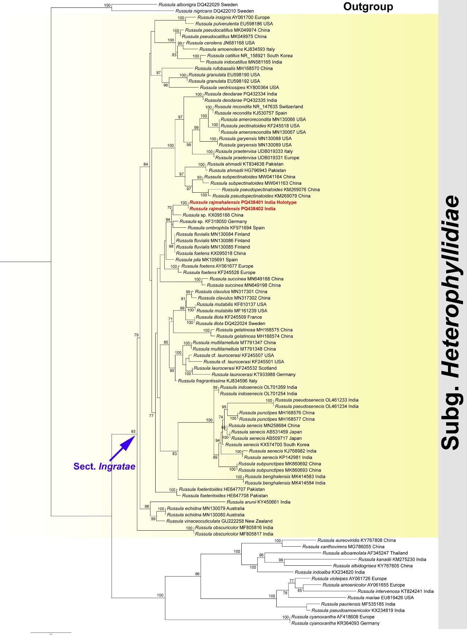

**Fig. 1.** Phylogram generated by means of maximum likelihood analysis based on nrITS sequence data of *Russula* spp. Maximum likelihood bootstrap support ≥70% shown above or below the branches at nodes.

Basidiopores subglobose to broadly ellipsoid, (6.5–)6.8–7.2–7.5(–8.0) × (6.0–)6.2–6.5–6.9(–7.0) μm, [n=40, Q = (1.0–)1.04–1.10–1.16(–1.25); ornamentation composed of amyloid obtuse warts (up to 1.1 μm high), locally subreticulate, rarely isolated, fused in pairs or short chains, connected by occasional, fine, long line connections; apiculi up to 1.5 μm long; suprahilar plage amyloid. Basidia (41–)44–48–52(–55) × (9–)9.5–10.6–11.6(–12.5) μm, clavate, 4-spored; sterigmata up to 5 μm long. Hymenial cystidia near the lamellae face, (45–)50–57–65(–75) × (6.5–)7–8–9(–11.5) μm, subcylindrical, subclavate to clavate, apically rounded, capitate, subcapitate, appendiculate, often originating deep in lamellae context, thin-walled; contents dense granulose, oil droplets present, weakly greying in sulfovanillin (SV); near the lamellae edges smaller, (28–)32–41–49(–55) × (5–)5.5–6.4–7.4(–9) μm, mainly subclavate, rarely clavate, apically mostly obtuse-rounded, rarely subcapiate to capitate, contents dense granulose, oil droplets present. Lamellae edges fertile with basidia. Pileipellis orthochromatic in Cresyl Blue, sharply delimited from the underlying context, 140–220 μm deep, strongly gelatinized, vaguely divided into a 40–70 μm deep suprapellis, composed of branched, suberect to erect, loosely arranged hyphae and 100–150 μm deep subpellis of horizontally oriented densely packed hyphae. Acid-resistant incrustations absent. Hyphal terminations near the pileus margin thin-walled; terminal cells (11–)14–19–25(–34) × (2.5–)3–3.5–4(–4.5) μm, mostly cylindrical, sometimes tapered at the apex, apically mostly obtuse-rounded, sometimes attenuated; subterminal cells mostly cylindrical. Hyphal terminations near the pileus centre more densely arranged, with shorter terminal cells (8–)10–14–18(–21) × (2.5–)2.8–3.1–3.5 μm, usually cylindrical, sometimes tapered at the apex, apically obtuse-rounded and sometimes attenuated. Pileocystidia near the pileus margin frequent, always 1-celled, cylindrical, narrowly fusiform or lanceolate, rarely clavate, thin-walled, (20–)25–35–45(–55) × (3–)3.5–4.3–5(–6) μm, apically mucronate, subcapitate to capitate; contents with dispersed granulose, often with yellowish intracellular pigments, weakly greying in sulfovanillin (SV). Pileocystidia near the pileus centre similar in shape and contents, but in average shorter (15–)22–30–39 × (2–)3–4–4.6 μm, apically mostly mucronate to subcapitate, rarely moniliform. Clamp connections absent from all tissues.

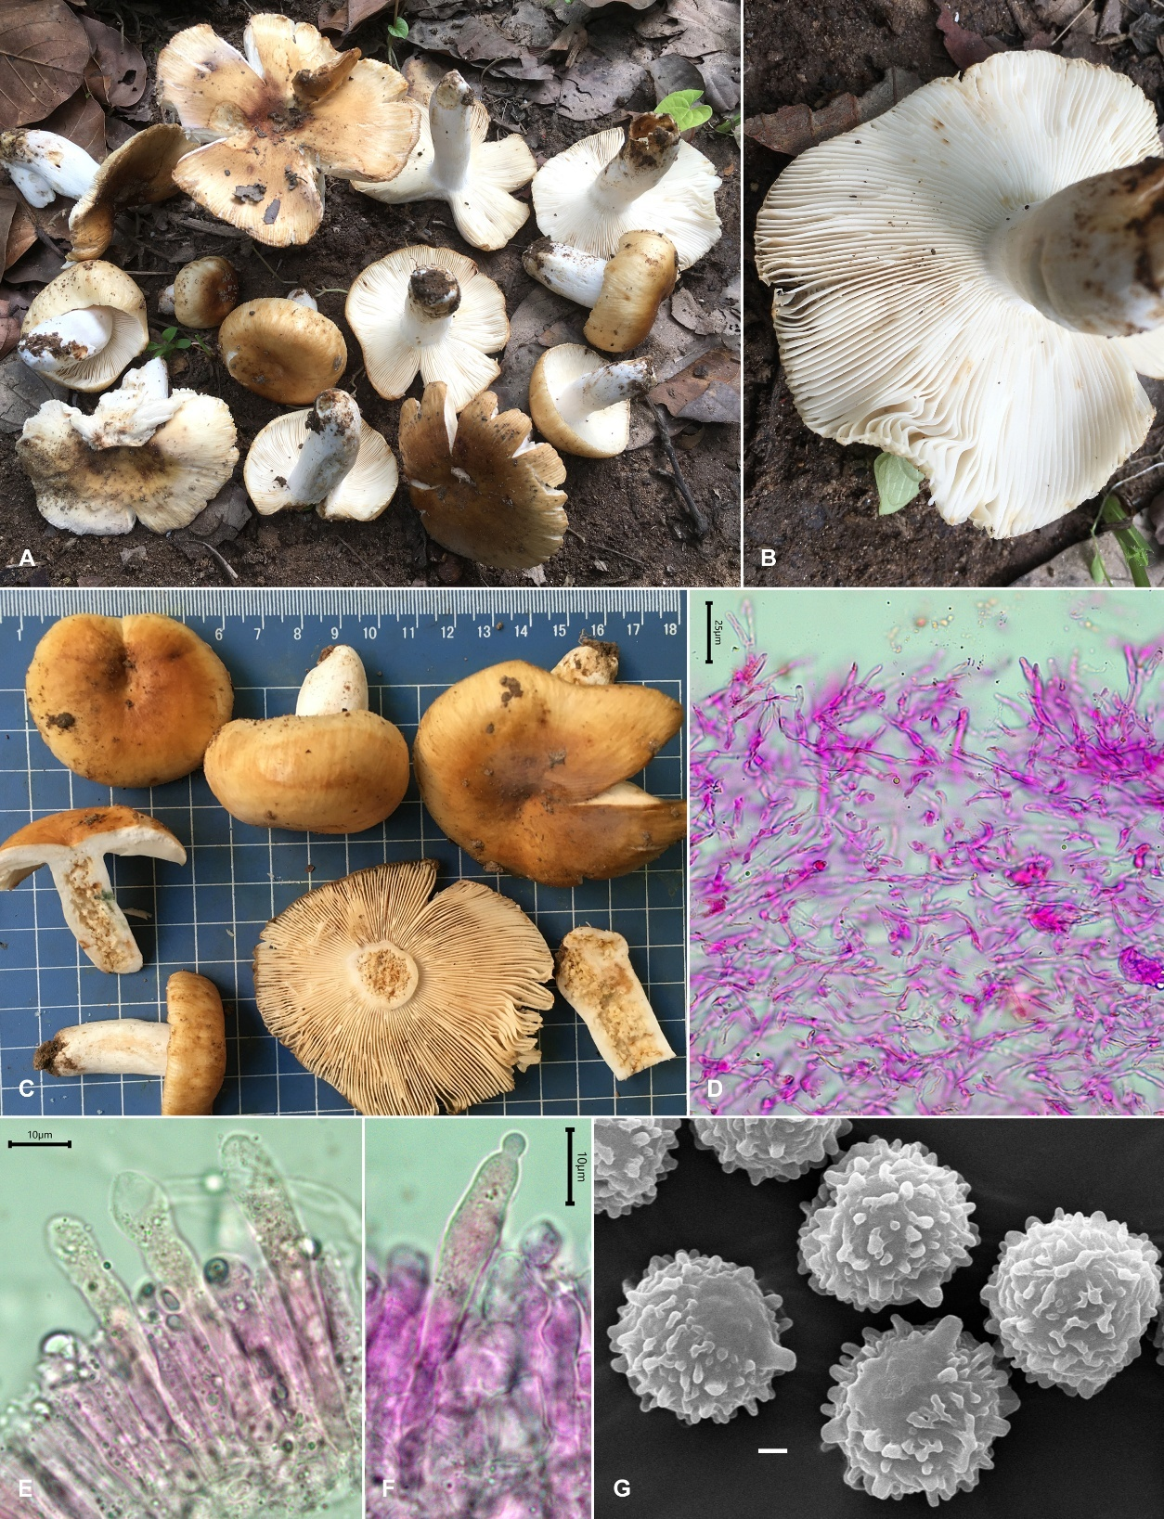

**Fig. 2.** *Russula rajmahalensis*sp. nov. (A, B & C) Fresh basidiomata in the field and basecamp; (d) Transverse section through pileipellis showing elements; (E & F) Transverse section through lamellae showing hymenial cystidia; (G) SEM images of basidiospores. Scale bars: D = 25 μm; E, F = 10 μm; G = 1 μm

Habit and habitat: Solitary or scattered, growing on soil in association with *Shorea robusta* in tropical deciduous forest.

Additional specimen examined: India: Jharkhand, Rajmahal hills, Sahibganj district, Borio block, Dhogada-Paharia burial ground forest, 110 m elev., N 25°02’23.7” E 87°39’35.8”, 62 m elev., September 17, 2022, A. Ghosh, AGJH-032 (ASSAM F016).

Remarks: Considering the similar field appearance and grows in the Sal dominated tropical forests, the present taxon might be close to Indian *Russula* *benghalensis* S. Paloi & K. Acharya and *R*. *pseudosenecis* A. Ghosh, D. Chakr., K. Das & Buyck. However, *R*. *benghalensis* is distinct by the presence of small to medium sized (14–35 mm diam.) pileus, smaller (20–40 × 3–6 mm) stipe and presence of 1–2 tiers lamellulae (Yuan et al., 2020) whereas, *R*. *pseudosenecis* has brownish orange or light brown tinges on the lamellae edges, smaller stipe (20–45 × 9–15 mm), an ixo-palisade type of pileipellis and very long (50–150 μm) single celled pileocystidia (Ghosh et al., 2022).

Our phylogenetic analysis (Fig. 1) places our new species within the well-supported clade (MLbs = 94%) of sect. *Ingratae* (= subg. *Heterophyllidiae*) comprising of *R*. *fluvialis* Taipale, Ruots. & Kälviäinen, *R*. *ombrophila* and unidentified *Russula* sp. However, *R*. *fluvialis* is a common boreal species in Picea-dominated forests, whereas, the spores of *R*. *ombrophila* M.M. Gómez & L.C. Monederohave less crested spines that are rarely connected by line connections and the pileocystidia are wider than 5 μm (Gomez and Monedero 2011, Adamčík et al., 2019).

DISCLAIMER (ARTIFICIAL INTELLIGENCE)

I, Dyutiparna Chakraborty, am hereby declare that NO generative AI technologies such as Large Language Models (ChatGPT, COPILOT, etc.) and text-to-image generators have been used during writing or editing of this manuscript.

References

Adamčík, S., Looney, B., Caboň, M., Jančovičová, S., Adamčíková, K., Avis, P. G., et al. (2019). The quest for a globally comprehensible *Russula* language. Fungal Diversity, 99, 369-449. https://doi.org/10.1007/s13225-019-00437-2

Buyck, B., Hofstetter, V., Eberhardt, U., Verbeken, A., & Kauff, F. (2008). Walking the thin line between *Russula* and *Lactarius*: the dilemma of *Russula* sect. *Ochricompactae*. Fungal Diversity, 28, 15-40.

Buyck, B., Wang, X-H., Adamčíková, K, Caboň, M., Jančovičová, S., Hofstetter, V., et al. (2020.) One step closer to unravelling the origin of *Russula:* subgenus *Glutinosae* subg. nov*.* Mycosphere, 11(1), 285-304. https://doi.org/10.5943/mycosphere/11/1/6

Buyck, B., Zoller, S., & Hofstetter, V. (2018). Walking the thin line… ten years later: The dilemma of above- versus below-ground features to support phylogenies in the Russulaceae (Basidiomycota). Fungal Diversity, 89(1), 267-292. https://doi.org/10.1007/s13225-018-0397-5

Capella-Gutierrez, S., Silla-Martinez, J. M., & Gabaldon, T. (2009). trimAl: a tool for automated alignment trimming in large-scale phylogenetic analyses. Bioinformatics, 25, 1972-1973. https://doi.org/10.1093/bioinformatics/btp348

Chen, B., Song, J., Zhang, J-H., & Liang, J.-F. (2021). Morphology and molecular phylogeny reveal two new species in *Russula* sect. *Ingratae* from China. Phytotaxa, 525(2), 109-123. https://doi.org/10.11646/phytotaxa.525.2.2

Drummond A. J., Ashton B., Buxton S., Cheung M., Cooper A., Heled J., Kearse M., Moir R., Stones-Havas S., Sturrock S., Thierer T., & Wilson A. (2010). Geneious v. 5.1. Available from http://www.geneious.com [accessed 10 January 2025]

Ghosh, A., Buyck, B., Das, K., Bera, I., & Chakraborty, D. (2022). Two new Asian species of *Russula* sect. *Ingratae* with unique basidiospore features for subg. *Heterophyllidiae*. European Journal of Taxonomy, 847, 104-120. https://doi.org/10.5852/ejt.2022.847.1985

Ghosh, A., Buyck, B., Chakraborty, D., Hembrom, M. E., Bera, I., & Das, K. (2023). Three new species of genus *Russula* Pers. from Sal dominated forests of tropical India based on morphotaxonomy and multigene phylogenetic analysis. Cryptogamie, Mycologie 44(3), 27-50. https://doi.org/10.5252/cryptogamie-mycologie2023v44a3

Gomez, M., & Monedero, C. (2011). Una nueva especie para la ciencia: *Russula ombrophila*. Errotari, 8, 14-17.

Kalichman, J., Kirk, P. M., & Matheny, P. B. (2020). A compendium of generic names of agarics and Agaricales. Taxon, 69 (3), 425-447. https://doi.org/10.1002/tax.12240

Kalyaanamoorthy, S., Minh, B. Q., Wong. T. K. F., Heaseler, A. V., & Jermiin, L. S. (2017). ModelFinder: fast model selection for accurate phylogenetic estimates. Nature methods, 14, 587-589. https://doi.org/10.1038/nmeth.4285

Katoh, K., Rozewicki, R., & Yamada, K. D. (2019). MAFFT online service: multiple sequence alignment, interactive sequence choice and visualization. Brief. Bioinformatics, 20(4), 1160-1166. https://doi.org/10.1093/bib/bbx108

Kornerup, A., & Wanscher, J. H. (1978). Methuen handbook of colour (3rd ed.). London: Eyre Methuen Ltd.

Kumar, S., Stecher, G., & Tamura K. (2016). MEGA7: Molecular Evolutionary Genetics Analysis version 7.0 for bigger datasets. Molecular Biology and Evolution, 33, 1870-1874.

Li, G-J., Li, S-M., Buyck, B., Zhao, S-Y., Xie, X-J., Shi, L-Y., et al. (2021). Three new *Russula* species in sect. *Ingratae* (Russulales, Basidiomycota) from southern China. MycoKeys, 84, 103-139. https://doi.org/10.3897/mycokeys.84.68750

Nguyen, L. T., Schmidt, H. A., Von Haeseler, A., & Minh, B. Q. (2015). IQ-TREE: a fast and effective stochastic algorithm for estimating maximum-likelihood phylogenies. Molecular Biology Evolution, 32, 268-274. https://doi.org/10.1093/molbev/msu300

Sarnari, M. (1998). Monografia Illustrata del Genre *Russula* in Europa, Prima Parte. Trento: Associazione Micologica Bresadola.

Singer, R. (1986). The Agaricales in Modern Taxonomy (4th ed.). Koenigstein: Koeltz Scientific Books.

Song, Y., Buyck, B., Li, J. W., Yuan, F., Zhang, Z. W., & Qiu, L. H. (2018). Two novel and a forgotten *Russula* species in sect. *Ingratae* (Russulales) from Dinghushan Biosphere Reserve in southern China. Cryptogamie, Mycologie 39, 341-357. https://doi.org/10.7872/crym/v39.iss3.2018.341

Yuan, F., Song, Y., Buyck, B., Li, J., & Qiu, L. (2019). *Russula viridicinnamomea* F. Yuan & Y. Song, sp. nov. and *R*. *pseudocatillus* F. Yuan & Y. Song, sp. nov., two new species from southern China. Cryptogamie, Mycologie, 40(4), 45-56. https://doi.org/10.5252/cryptogamie-mycologie2019v40a4

Yuan, H.-S., Lu, X., Dai, Y.-C., Hyde, K. D., Kan, Y.-H., Kušan, I., et al., (2020). Fungal diversity notes 1277-1386: taxonomic and phylogenetic contributions to fungal taxa. Fungal Diversity. https://doi.org/10.1007/s13225-020-00461-7