**Antimicrobial Textiles: Innovations, Challenges and Applications for Health and Hygiene**

**Abstract**

**Antimicrobial textiles** have emerged as a key innovation in improving hygiene, health protection, and safety across various sectors, including healthcare, personal hygiene, food packaging, and industrial applications. These textiles are treated with antimicrobial agents, such as **silver nanoparticles (AgNPs), copper compounds, zinc oxide (ZnO), quaternary ammonium compounds (QACs), and chitosan**, to prevent microbial growth and enhance the durability of fabrics. Among these, **silver and copper** demonstrate broad-spectrum efficacy against bacteria, fungi, and viruses, while **zinc oxide and QACs** are particularly effective against bacterial contamination. **Chitosan**, a natural antimicrobial agent, offers biocompatibility and biodegradability, making it an attractive sustainable option. While antimicrobial textiles offer significant benefits, challenges remain in ensuring long-term efficacy, environmental safety, and affordability. One major concern is the degradation of antimicrobial properties after repeated washing or wear, which compromises their effectiveness. Also, **regulatory inconsistencies and the lack of standardized testing protocols** further complicate the widespread adoption of antimicrobial textiles. Ensuring compliance with global safety standards, such as those set by the **EPA (Environmental Protection Agency), FDA (Food and Drug Administration), and ISO (International Organization for Standardization),** is crucial for their safe and effective implementation. To address these challenges, ongoing research is focused on developing sustainable, biocompatible alternatives, such as **plant-based and bio-based antimicrobial agents, including essential oils and peptides**, as well as enhancing the durability of treatments through **controlled-release technologies**. Moreover, the integration of **multifunctional properties, such as UV protection and water resistance,** into antimicrobial textiles offers exciting future possibilities. The continued development of **standardized testing methods and global regulatory frameworks** will facilitate the safe and efficient use of antimicrobial textiles. Overall, these innovations are expected to play a critical role in promoting public health, safety and sustainability across industries.

**Keywords:** Antimicrobial textiles, antimicrobial agents, multifunctional properties and industrial application

1. **Introduction**

The development of antimicrobial textiles has garnered significant interest in recent years, driven by increasing concerns over health, hygiene and infection control. These textiles, designed to inhibit or eliminate the growth of microorganisms, are emerging as a vital tool in combating infections, reducing odor and enhancing the durability of products in a variety of sectors, including healthcare, sports and consumer goods **(Smith and Lokhande, 2020) (Patel *et al.,* 2021).** As pathogenic microbes such as bacteria, viruses and fungi can readily accumulate and proliferate on textiles, antimicrobial treatments offer an essential solution to mitigate the risk of contamination and infection. This is especially critical in healthcare environments, where textiles are frequently exposed to a high microbial load, increasing the risk of hospital-acquired infections (HAIs) among patients and staff **(Smith *et al.,* 2019).**

Historically, antimicrobial treatments have been used to enhance the functionality of textiles in specific settings, particularly in medical and military applications **(Banerjee and Pramanik, 2022).** The rapid rise in demand for protective, antimicrobial fabrics during the COVID-19 pandemic further highlighted the potential of these textiles to reduce microbial transmission and support public health efforts **(Zhou *et al.,* 2021).** This demand has spurred innovations in antimicrobial materials and textile treatments, from traditional metallic agents like silver and copper to newer, sustainable alternatives such as chitosan and herbal extracts **(Hussain *et al.,* 2023).**

The efficacy of antimicrobial textiles is achieved through various mechanisms, including disrupting microbial cell walls, interfering with cellular enzymes, or inducing oxidative stress, which collectively hinder microbial growth and activity **(Nguyen *et al.,* 2022).** For instance, silver ions are well-known for their ability to disrupt bacterial cell walls and interfere with key cellular processes, while quaternary ammonium compounds (QACs) and other synthetic agents offer durability and broad-spectrum antimicrobial effects **(Rajendran and Mahendra Gowda, 2023).** However, concerns over the environmental and human health impacts of some antimicrobial agents, especially synthetic chemicals and heavy metals, have led researchers to seek eco-friendly and biodegradable alternatives that can offer comparable antimicrobial efficacy with reduced toxicity **(Singh *et al.,* 2021).**

Applications of antimicrobial textiles span a wide range of sectors, reflecting their adaptability and utility in enhancing health and hygiene. In healthcare, antimicrobial fabrics are used in hospital linens, gowns and wound dressings to reduce hospital-acquired infections (HAIs) and support patient recovery **(Sayed *et al.,* 2022).** In consumer markets, antimicrobial sportswear, socks and bedding help manage odor and inhibit microbial growth, promoting personal hygiene and comfort. Industrial applications, such as antimicrobial air filters and packaging, also demonstrate the versatility of these textiles in supporting public health and safety **(Yoon *et al.,* 2023).**

Despite these advances, challenges remain in ensuring that antimicrobial textiles are safe, effective and sustainable over extended use. For example, achieving durability against washing and wear is essential to maintain long-term antimicrobial activity, particularly for textiles used in healthcare and personal protective equipment (PPE). Moreover, regulatory standards and testing protocols are critical to ensuring the safety and efficacy of these materials for both human use and environmental impact **(Patel *et al.*, 2021).**

1. **Materials for Antimicrobial Textiles**
   1. **Metallic Agents**

Metallic agents have been widely used in antimicrobial textiles due to their potent antimicrobial properties, durability and versatility across a range of textile applications. Among metallic agents, silver, copper and zinc are the most studied and frequently applied materials, each demonstrating unique properties that contribute to their effectiveness in inhibiting microbial growth.

**2.1.1 Silver (Ag)**

Silver has long been recognized as one of the most effective antimicrobial agents. Known for its broad-spectrum efficacy, silver is effective against bacteria, fungi and some viruses, making it ideal for use in healthcare settings, sportswear and other high-contact textiles. Silver nanoparticles (AgNPs) and silver ion coatings are commonly used in textiles and their antimicrobial properties are derived from their ability to interfere with microbial cell membranes, disrupt essential enzyme functions and generate reactive oxygen species (ROS) that damage cellular components **(Rai *et al.,* 2019).**

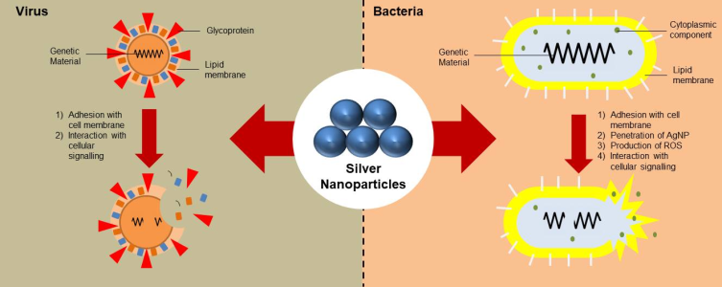

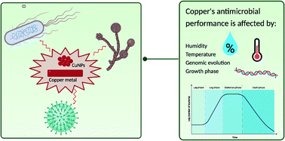The antimicrobial mechanism of silver ions (Ag⁺) involves binding to thiol groups in proteins, which can denature critical enzymes and disrupt cellular respiration **(Wang *et al.,* 2020).** Additionally, silver ions can attach to bacterial DNA, inhibiting replication and protein synthesis, which prevents microbial growth and promotes cell death. Despite its high efficacy, the use of silver in textiles is associated with challenges, including concerns over cytotoxicity, environmental impact due to nanoparticle release and high costs, which have prompted ongoing research into controlled-release technologies and biocompatible formulations **(Balagna *et al.,* 2021).**

**2.1.2 Copper (Cu)**

Copper has gained popularity as an antimicrobial agent for textiles, affordability, broad-spectrum activity and essential role in microbial cellular processes. Copper ions (Cu²⁺) can penetrate cell membranes

and generate reactive oxygen species (ROS), which causes oxidative stress, damages DNA and disrupts metabolic enzymes **(Vinod *et al.,* 2021).**

Copper's ability to disrupt cell membranes and interfere with bacterial respiratory systems makes it particularly effective against a variety of pathogenic bacteria and viruses.

One of the advantages of copper is its natural abundance and lower toxicity profile compared to silver, making it a more sustainable choice for large-scale applications in healthcare and consumer products. However, copper can cause fabric discoloration and, in high concentrations, may pose risks of cytotoxicity, which have led researchers to explore copper composites and encapsulation techniques to improve its stability and compatibility in textiles **(Gupta *et al.,* 2022).**

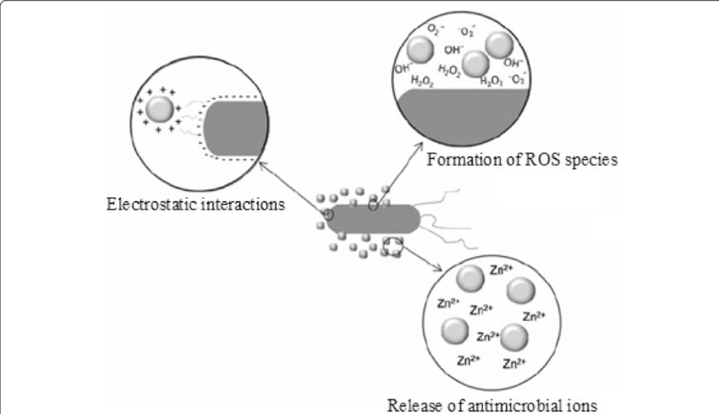**2.1.3 Zinc (Zn)**

Zinc is another valuable antimicrobial metal, particularly because of its affordability and lower toxicity compared to silver and copper. Zinc oxide (ZnO) nanoparticles are commonly used in antimicrobial textiles, as they possess strong antimicrobial effects, UV protection and deodorizing properties **(Alotaibi *et al.,* 2020).** The antimicrobial action of zinc is attributed to its ability to produce reactive oxygen species (ROS), such as hydrogen peroxide, which can damage microbial cell walls and DNA, ultimately leading to cell death.

Zinc’s antimicrobial efficacy, coupled with its gentle impact on human skin, has made it suitable for various applications, from hospital textiles to personal hygiene products. Additionally, zinc oxide nanoparticles are relatively stable and less prone to degradation, making them a durable option for textiles. However, challenges related to nanoparticle aggregation and potential environmental impacts have prompted the exploration of zinc as a component of hybrid materials, which can improve durability and reduce particle shedding **(Ramesh *et al.,* 2021).**

**2.2 Synthetic Compounds**

Synthetic antimicrobial compounds have become integral to the development of textiles designed for enhanced health and hygiene. Compared to natural and metallic agents, synthetic compounds offer a customizable approach to antimicrobial efficacy, allowing for specific targeting of microbial types and improved durability. Among these compounds, Quaternary Ammonium Compounds (QACs), Triclosan and Polyhexamethylene Biguanide (PHMB) are widely applied, each with unique properties that support diverse textile applications in healthcare, consumer products and industrial sectors.

**2.2.1 Quaternary Ammonium Compounds (QACs)**

Quaternary Ammonium Compounds, or QACs, are among the most commonly used synthetic antimicrobials in textiles due to their broad-spectrum activity against bacteria, fungi and certain viruses. QACs function by disrupting the microbial cell membrane, causing cell lysis and death **(Qiu *et al.,* 2020).** The positively charged QAC molecules interact with the negatively charged cell membranes of microbes, resulting in permeability changes that lead to the leakage of cellular contents.

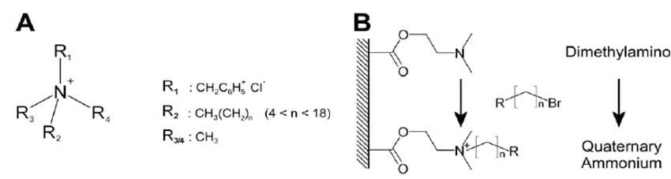

QACs are known for their effectiveness even at low concentrations, making them ideal for textiles that require long-term antimicrobial protection, such as hospital linens and sportswear **(Mohapatra *et al.,* 2021).** They are also valued for their durability, as QACs can withstand multiple washes without significantly losing effectiveness. However, their use is not without concerns; studies suggest that high levels of QACs may lead to skin irritation and environmental toxicity. Furthermore, microbial resistance to QACs has been observed, emphasizing the need for responsible and controlled use in antimicrobial textiles **(Zhang *et al.,* 2022).**

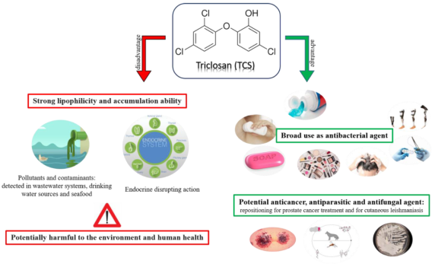**2.2.2 Triclosan**

Triclosan is a synthetic, broad-spectrum antimicrobial compound that has been widely used in textiles for its effectiveness against bacteria and fungi. It works by inhibiting fatty acid synthesis in microbial cells, disrupting essential cellular functions and ultimately leading to cell death **(Zhou *et al.,* 2019).** Triclosan-treated textiles have been popular in personal hygiene products, such as socks and undergarments, as well as medical textiles, where sustained antimicrobial action is desired.

While Triclosan is highly effective, its use has become controversial due to potential health and environmental risks. Studies have shown that Triclosan can accumulate in the environment and contribute to the development of antibiotic-resistant bacteria. Additionally, it may disrupt human endocrine function, raising concerns over long-term exposure **(Saleem *et al.,* 2021).** These risks have led to regulatory restrictions in many regions, prompting a shift toward alternative synthetic and natural antimicrobials.

**2.2.3 Polyhexamethylene Biguanide (PHMB)**

Polyhexamethylene Biguanide (PHMB) is a synthetic antimicrobial agent known for its efficacy, safety profile and suitability for sensitive applications. PHMB works by disrupting the integrity of microbial cell membranes, particularly in Gram-negative bacteria, resulting in leakage of cellular contents and cell death **(Akdag *et al*., 2020).** Due to its mildness and non-toxic nature, PHMB is widely used in healthcare textiles, including wound dressings, medical gowns and hospital linens.

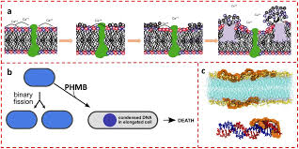

PHMB has been shown to be effective against a broad range of pathogens while exhibiting low toxicity to human cells, making it preferred antimicrobial agents for medical textiles. Additionally, it is resistant to leaching and retains its antimicrobial effectiveness over repeated washes, which is essential for applications requiring durable antimicrobial activity **(Gong *et al.,* 2022).** However, like other antimicrobials, there are concerns over the potential for microbial resistance, highlighting the importance of developing multi-functional textiles that can reduce dependency on a single compound.

**2.3 Natural Antimicrobials**

Natural antimicrobials are increasingly being explored for use in textiles due to their eco-friendly profile, biocompatibility and lower environmental impact compared to synthetic and metallic agents. Derived from plants, animals and minerals, these agents provide a sustainable alternative with fewer health risks and effective antimicrobial action. Among natural antimicrobials, chitosan, herbal extracts and essential oils are among the most widely studied and applied in textiles for their ability to inhibit the growth of a broad range of pathogens while aligning with green chemistry principles.

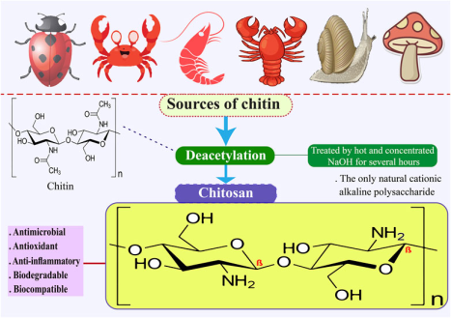**2.3.1 Chitosan**

Chitosan, a biopolymer derived from chitin found in crustacean shells, is one of the most effective natural antimicrobial agents used in textiles. Its antimicrobial activity is attributed to its polycationic nature, which enables it to interact with the negatively charged microbial cell membranes, leading to cell disruption and leakage of intracellular contents **(Ali *et al.,* 2020).** Chitosan is particularly effective against a broad range of bacteria and fungi and it also exhibits biodegradability, making it an appealing choice for eco-friendly textile applications.

In textiles, chitosan can be applied as a coating or integrated into the fibers during manufacturing. Its bioadhesive properties also contribute to its long-lasting antimicrobial action, which remains effective over multiple washes **(Shahidi and Abuzar, 2021).** However, its sensitivity to acidic environments and potential allergen city has led researchers to investigate chitosan derivatives and blends with other polymers to enhance its stability and compatibility in textile applications.

**2.3.2 Herbal Extracts**

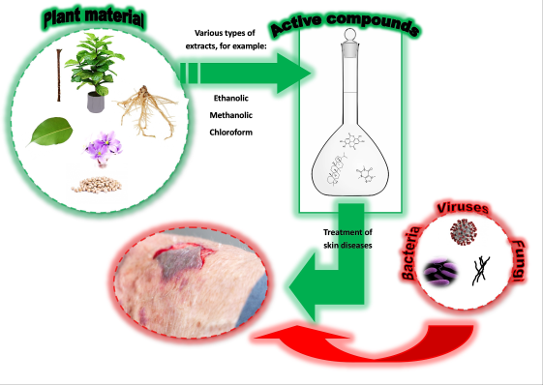Herbal extracts from plants such as neem, aloevera and tea tree have gained popularity as antimicrobial agents in textiles due to their natural origins and broad-spectrum antimicrobial properties. Neem (Azadirachta indica), for instance, contains active compounds such as Azadirachta and nimbin, which exhibit strong antibacterial, antifungal and antiviral activities **(Gopalakrishnan *et al.,* 2021).** Similarly, aloevera extracts provide antimicrobial action, skin-soothing properties and compatibility with textile fibers, making them a popular choice for garments intended for sensitive skin.

Herbal extracts are typically applied to textiles through coating or microencapsulation techniques, which help retain the antimicrobial efficacy over extended use. However, the stability and durability of herbal antimicrobials can be challenging, as they may degrade under exposure to light, heat and washing. Recent advancements in nanotechnology and encapsulation methods have improved the longevity of herbal extracts in textiles, making them a viable option for sustainable antimicrobial fabrics **(Jassal and Agarwal, 2022).**

**2.3.3 Essential Oils**

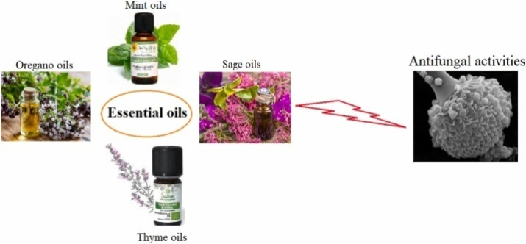Essential oils from plants like eucalyptus, lavender and thyme are well-known for their potent antimicrobial activity, driven by compounds such as terpenes and phenols, which disrupt microbial cell membranes and inhibit cellular processes **(Kumar *et al.,* 2019).** Essential oils are effective against bacteria, fungi, viruses and their natural aroma adds a unique benefit to consumer textiles, providing both antimicrobial protection and a pleasant scent.

One of the challenges of using essential oils in textiles is their volatility, as they can evaporate and lose effectiveness over time. To address this, essential oils are often encapsulated in microcapsules or nanoparticles that can be embedded into textile fibers, allowing for a slow release of the oil’s active compounds over time and extending antimicrobial efficacy **(Nisar *et al.,* 2020).** Essential oils have found widespread use in sportswear, medical textiles and home textiles, though their relatively high cost and variability in antimicrobial potency require careful selection and formulation for specific applications.

1. **Mechanisms of Antimicrobial Action in Textiles**

The antimicrobial action in textiles arises from diverse mechanisms that aim to prevent the growth and survival of microorganisms, including bacteria, fungi and viruses, on the fabric surface. These mechanisms vary based on the type of antimicrobial agent used, with common approaches including disruption of cell membranes, interference with cellular metabolism, oxidative stress induction and inhibition of replication. Understanding these mechanisms is crucial in designing textiles that effectively reduce the risk of microbial contamination, prolong freshness and provide hygienic benefits. Here, we examine the primary mechanisms of antimicrobial action in textiles.

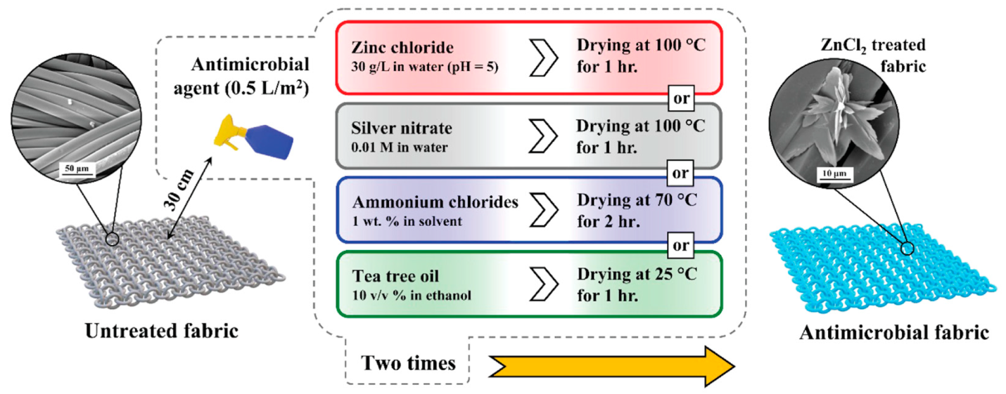

**3.1 Cell Membrane Disruption**

Many antimicrobial agents, particularly quaternary ammonium compounds (QACs), chitosan and essential oils, act by disrupting the integrity of microbial cell membranes. QACs, for example, are cationic compounds that bind to negatively charged microbial cell membranes, leading to membrane instability, leakage of cellular contents and ultimately cell death **(Rai *et al.,* 2020).** Chitosan also exhibits a poly cationic structure that binds to cell membranes, causing membrane disruption and inhibiting nutrient transport **(Ali *et al.,* 2019).**

This mechanism is highly effective against a range of microbes and is widely used in healthcare and sports textiles to prevent the growth of odor-causing bacteria. Essential oils, rich in terpenes and phenols, can penetrate and disrupt microbial membranes, enhancing their effectiveness against both bacteria and fungi **(Nisar *et al.,* 2021).**

**3.2 Interference with Cellular Metabolism**

Some antimicrobial agents inhibit microbial growth by targeting key metabolic processes within the cell. For instance, silver ions (Ag⁺) bind to thiol groups in bacterial enzymes, inactivating them and disrupting essential metabolic functions, such as respiration and ATP synthesis **(Gong *et al.,* 2021).** Triclosan, another synthetic antimicrobial, inhibits the fatty acid synthesis pathway in bacteria, which is essential for cell membrane formation and function. This inhibition prevents bacterial growth and cell division, making Triclosan effective in reducing microbial populations on textiles **(Zhou *et al.,* 2020).**

By interfering with specific metabolic pathways, antimicrobial agents not only prevent cell replication but also promote rapid microbial cell death. This mechanism is especially valuable in textiles for healthcare and hygiene applications where sustained microbial control is necessary.

* 1. **Oxidative Stress Induction**

The generation of reactive oxygen species (ROS), such as hydrogen peroxide, superoxide anions and hydroxyl radicals, is a mechanism leveraged by metals like copper, zinc and silver nanoparticles. These ROS cause oxidative damage to microbial cell components, including lipids, proteins and DNA, leading to cellular dysfunction and death **(Vinod *et al.,* 2022).** Copper ions, for instance, catalyze the Fenton reaction, generating ROS that severely damage the microbial cell membrane and other critical biomolecules **(Balagna *et al.,* 2021).**

**3.4 Inhibition of DNA Replication and Protein Synthesis**

Certain antimicrobial agents target the genetic material or protein synthesis machinery within microbes, preventing them from reproducing or producing essential proteins. Silver ions can bind to microbial DNA and ribosomes, hindering DNA replication and protein synthesis, which are essential for cell survival and replication **(Wang *et al.,* 2021).** This inhibition leads to a bacteriostatic or bactericidal effect, as the cells are unable to produce the proteins required for growth and repair.

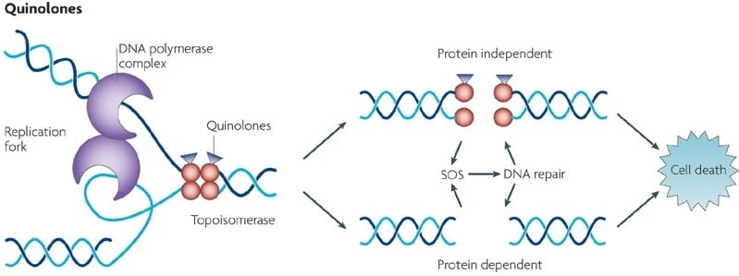

PHMB, a synthetic antimicrobial used in medical textiles, binds to the DNA of microbes, thereby interfering with their ability to reproduce and repair cellular damage. This mode of action is particularly useful in textiles intended for medical and hygiene applications, as it helps reduce microbial load without relying solely on high levels of cytotoxicity agents **(Akdag *et al.,* 2020).**

**3.5 Controlled Release of Antimicrobial Agents**

Some antimicrobial textiles are designed to release antimicrobial agents gradually, ensuring sustained activity over extended periods. This approach, commonly used with essential oils, herbal extracts and encapsulated synthetic agents, allows for continuous protection without rapid depletion of the active compound **(Jassal and Agarwal, 2022).** Controlled-release systems are often achieved through microencapsulation or the use of nano carriers, which can protect sensitive agents from degradation and ensure gradual release upon physical contact or environmental triggers, such as temperature or moisture.

This mechanism is highly valued in textiles where durability and extended antimicrobial protection are required, such as in sportswear and hospital linens, as it reduces the need for frequent reapplication of antimicrobial agents.

1. **Applications in Health and Hygiene**
   1. **Healthcare and Medical Textiles**

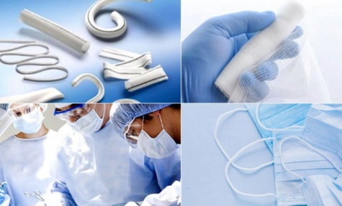The application of antimicrobial textiles in healthcare and medical environments is a rapidly evolving field, driven by the urgent need to control infection rates and improve patient outcomes. Antimicrobial textiles are widely used in hospitals, clinics and other healthcare facilities to minimize microbial contamination and provide safer environments for both patients and healthcare providers. From bed linens to surgical gowns, these textiles help reduce the spread of healthcare-associated infections (HAIs) and are becoming essential components in modern healthcare.

**4.1.1 Hospital Bed Linens and Curtains**

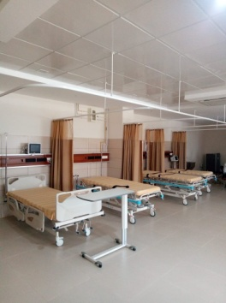Hospital bed linens and curtains are among the most frequently touched surfaces in healthcare environments, making them prone to microbial contamination. Antimicrobial-treated fabrics used in these items help minimize the microbial load, thereby lowering the risk of infection transmission between patients and staff. Textiles treated with silver ions or copper oxides are commonly used in hospital linens due to their broad-spectrum antimicrobial activity and durability through multiple wash cycles **(Gong *et al.,* 2021).** These fabrics are particularly effective against antibiotic-resistant bacteria, such as *Staphylococcus aureus* and *Escherichia coli*, which are common in healthcare settings **(Vinod *et al.,* 2022).**

**4.1.2 Surgical Gowns and Drapes**

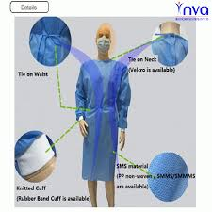Surgical gowns and drapes are critical in maintaining sterile conditions in operating rooms. Antimicrobial-treated gowns, often enhanced with silver or quaternary ammonium compounds (QACs), provide an added layer of protection by reducing microbial adhesion and limiting the risk of cross-contamination during procedures **(Akdag *et al.,* 2020).** Some gowns incorporate advanced coatings with controlled-release properties, allowing them to remain effective over the course of long surgeries.

Research indicates that antimicrobial surgical gowns help reduce postoperative infection rates, especially in high-risk procedures. Additionally, these textiles offer protection to healthcare workers, reducing their exposure to infectious agents, including blood borne pathogens **(Mancuso *et al.,* 2021).**

**4.1.3 Wound Dressings**

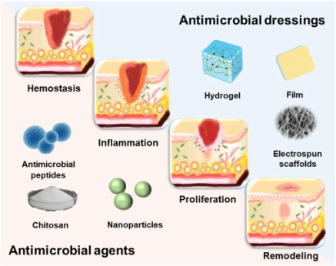Wound care is one of the most significant applications of antimicrobial textiles in healthcare, as wound infections can severely impact healing and increase patient morbidity. Antimicrobial wound dressings are commonly infused with agents like silver nanoparticles, chitosan, or polyhexamethylene biguanide (PHMB), which inhibit bacterial growth at the wound site and provide a barrier against external pathogens **(Rai *et al*., 2020).** Silver-based dressings are highly effective for chronic and burn wounds, as they offer sustained antimicrobial action that prevents infection without damaging healthy tissue **(Gopalakrishnan *et al*., 2021).**

Some wound dressings are designed with microencapsulation technology, enabling a gradual release of antimicrobial agents that provides long-lasting protection, particularly valuable in cases where dressings are changed infrequently. These textiles promote faster wound healing by maintaining a sterile environment and reducing inflammation.

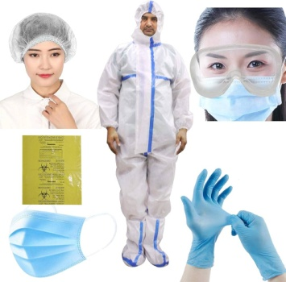**4.1.4 Face Masks and Personal Protective Equipment (PPE)**

The COVID-19 pandemic highlighted the importance of antimicrobial face masks and PPE in controlling the spread of respiratory infections. Antimicrobial face masks treated with silver, copper, or herbal extracts provide enhanced protection by inhibiting microbial growth on the mask surface, reducing the risk of contamination and re-inhalation **(Jassal and Agarwal, 2022).** Copper and silver-infused masks have been shown to neutralize viruses and bacteria on contact, improving mask safety, particularly in crowded or high-risk environments **(Balagna *et al.,* 2021).**

Beyond face masks, antimicrobial treatments are also applied to PPE such as gloves, gowns and face shields. These treatments enhance PPE effectiveness, offering frontline workers a safer alternative and reducing the frequency of replacement required due to contamination.

**4.1.5 Medical Upholstery and Furniture**

Medical upholstery, such as that found on examination tables, waiting room chairs and hospital beds, is another critical area for antimicrobial textiles. Upholstered surfaces are susceptible to contamination due to frequent contact with skin, fluids and other infectious materials. Antimicrobial-treated upholstery fabrics help reduces surface contamination, making them essential for maintaining a hygienic environment in hospitals and clinics. Coatings with copper, silver and zinc oxide are commonly used due to their durability and ability to withstand cleaning agents **(Mancuso *et al*., 2021).**

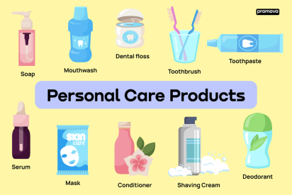**4.2 Personal Hygiene Products**

Antimicrobial textiles are increasingly used in personal hygiene products, offering enhanced protection against bacteria, fungi and odor-causing microbes. These textiles are integrated into various hygiene related products, including socks, undergarments, towels and bedding, as well as menstrual and incontinence products. Their antimicrobial properties help maintain freshness, reduce the risk of skin infections and improve overall hygiene.

**4.2.1 Socks and Undergarments**

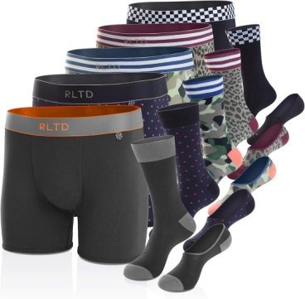One of the most common uses of antimicrobial textiles is in socks and undergarments, which are prone to moisture accumulation and warmth, creating ideal environments for bacterial growth. Antimicrobial agents, such as silver, zinc and copper, are embedded in these fabrics to inhibit microbial growth, thereby preventing odors and reducing the risk of fungal infections, including athlete’s foot **(Gong *et al.,* 2021).** For instance, silver ions in socks are released slowly, providing continuous protection that remains effective even after repeated washes.

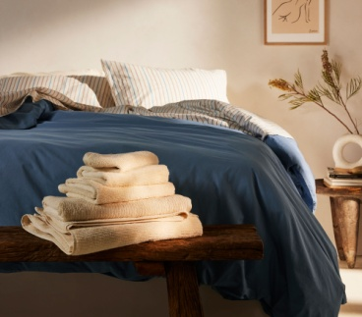**4.2.2 Towels and Bedding**

Towels and bedding are other key applications, as they come into frequent contact with skin and are exposed to moisture. Antimicrobial treated towels and bed linens, often embedded with silver or triclosan, inhibit the growth of microbes that can lead to unpleasant odors and potential skin irritation **(Nisar *et al.,* 2021).** These textiles are particularly beneficial in high-humidity climates and for individuals with sensitive skin, as they help maintain a clean and comfortable environment.

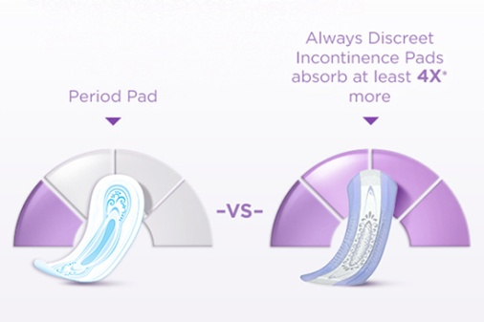**4.2.3 Menstrual and Incontinence Products**

In menstrual and incontinence products, antimicrobial textiles provide critical protection against bacterial and yeast infections by creating a more hygienic surface. Chitosan and herbal antimicrobials are commonly used due to their biocompatibility and effectiveness in preventing microbial growth **(Ali *et al.,* 2019).** Antimicrobial treatments also help reduce odor and maintain skin health, which is essential in prolonged-use items like pads and liners.

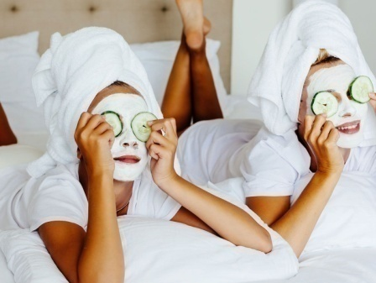**4.2.4 Face Masks and Daily Wear Masks**

Antimicrobial textiles in reusable face masks have gained popularity for their added protection and odor reducing capabilities. Masks treated with copper or silver ions can neutralize bacteria and viruses on contact, reducing the risk of re-inhalation and providing a safer, fresher experience for users, especially in prolonged wear **(Balagna *et al.,* 2021).** This application became especially important during the COVID-19 pandemic, as it offered consumers an added layer of protection in daily life.

**4.3 Food Industry and Packaging**

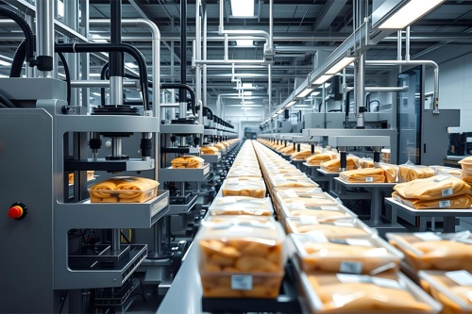The use of antimicrobial textiles in the food industry and packaging serves as an effective strategy to enhance food safety, extend shelf life and reduce microbial contamination risks throughout the supply chain. These materials can inhibit the growth of bacteria, molds and fungi, which are common in food handling and packaging environments. Antimicrobial textiles find application in various areas, including food packaging, food processing equipment and worker garments, helping to meet stringent hygiene standards while reducing waste.

**4.3.1 Antimicrobial Food Packaging**

Antimicrobial textiles are increasingly used as food packaging materials to extend product shelf life by controlling the growth of spoilage organisms. These textiles often treated with silver, zinc oxide, or natural antimicrobials like essential oils, help reduce the microbial load on fresh produce, dairy and meat products **(Vinod *et al.,* 2022).** Silver-based and chitosan-embedded packaging films, for instance, have demonstrated significant efficacy in inhibiting *Listeria monocytogenes* and *Escherichia coli* on fresh foods, helping maintain product freshness and quality **(Gong *et al.,* 2021).**

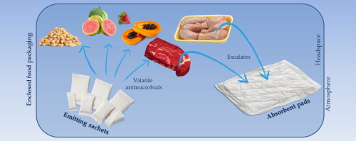

Innovative packaging designs include antimicrobial films that release active compounds gradually, ensuring sustained antimicrobial action over time. This feature is particularly beneficial for perishable products, as it prolongs freshness while reducing spoilage and food borne illnesses.

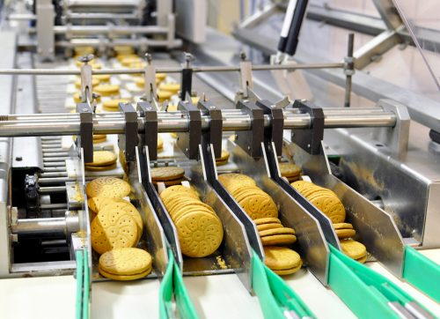**4.3.2 Food Processing Equipment and Surfaces**

Antimicrobial textiles are used to cover surfaces and equipment in food processing plants to reduce microbial contamination during production. Surface coatings and textile coverings treated with copper, silver and quaternary ammonium compounds (QACs) effectively limit bacterial growth on contact areas, such as conveyor belts, cutting boards and food handling tools **(Mancuso *et al.,* 2021).** These treated surfaces help prevent cross-contamination, maintaining hygiene standards and minimizing the risk of food borne diseases.

Antimicrobial-treated work surfaces and tools are particularly valuable in facilities processing high-risk foods, such as poultry and seafood, where bacterial contamination is a common challenge. These materials support compliance with food safety regulations, promoting cleaner production environments.

** 4.3.3 Worker Garments and Gloves**

Antimicrobial uniforms, gloves and aprons for workers in food production settings contribute to a more sanitary work environment. These textiles reduce the risk of bacterial transfer from workers’ clothing to food products. For example, antimicrobial gloves coated with silver or copper ions help inhibit microbial transfer from hands, particularly beneficial for workers handling raw meat, dairy and other high-risk products **(Balagna *et al.,* 2021).**

By integrating antimicrobial properties into worker attire, the food industry can enhance its hygiene practices, offering added protection against microbial cross-contamination and helping to meet strict safety standards.

**4.3.4 Reusable Bags and Storage Solutions**

Reusable antimicrobial bags and storage containers are gaining popularity as sustainable, hygienic alternatives to single-use plastics. These textiles, treated with natural agents like essential oils or metal nanoparticles, help prevent mold and bacteria growth on stored food items, particularly in fresh produce storage **(Jassal and Agarwal, 2022).** The antimicrobial action ensures that food stays fresher for longer, supporting waste reduction initiatives by minimizing spoilage.

Antimicrobial reusable bags also find application in grocery shopping, where they help limit bacterial transfer between food items and maintain a cleaner, safer transport solution.

**4.4 Industrial and Outdoor Uses**

Antimicrobial textiles play a crucial role in various industrial and outdoor applications by providing added protection against microbial growth in challenging environments. These textiles are designed to withstand the exposure to moisture, temperature fluctuations and pollutants typically encountered in outdoor settings. They are used in diverse areas, from protective clothing to tents and agricultural coverings, where controlling microbial growth enhances durability, safety and hygiene.

**4.4.1 Protective Clothing for Industrial Workers**

In industries where workers are exposed to contaminants, such as construction, mining and chemical plants, antimicrobial-treated uniforms and protective gear help maintain hygiene and reduce the risk of infections. These textiles prevent the buildup of sweat-borne bacteria and odors, especially in hot and humid working conditions. Clothing treated with silver, copper, or quaternary ammonium compounds (QACs) provides a long-lasting antimicrobial barrier, which is beneficial in minimizing the transfer of pathogens in shared and high-contact environments **(Mancuso *et al.,* 2021).** For instance, antimicrobial-treated gloves and face masks reduce microbial contamination risks, offering an extra layer of protection to workers.

**4.4.2 Outdoor Gear and Equipment**

Antimicrobial textiles are widely used in outdoor gears such as tents, sleeping bags, backpacks and camping furniture, where they inhibit mold, mildew and bacteria growth caused by prolonged exposure to moisture. These textiles, often treated with silver or zinc oxide nanoparticles, not only extend the lifespan of the gear but also prevent odors and staining, enhancing the overall user experience **(Jassal and Agarwal, 2022).** Outdoor fabrics with antimicrobial treatments are particularly beneficial for camping and hiking in wet or tropical climates, as they help keep the equipment fresh and resilient under harsh conditions.

**4.4.3 Agricultural Applications**

In agriculture, antimicrobial textiles are used in crop covers, greenhouses and irrigation liners to protect plants from harmful microbes and support healthier growth environments. These textiles can prevent the growth of fungi and bacteria on crops, reducing the need for chemical treatments and promoting sustainable practices. For instance, coir-based and jute-coir blended antimicrobial textiles are particularly effective in controlling weed growth and protecting soil health **(Vinod *et al.,* 2022).** They help maintain a clean, disease-resistant environment in greenhouses and other protected cultivation areas, promoting higher crop yields and reducing waste.

**4.4.4 Air Filtration and Ventilation System**

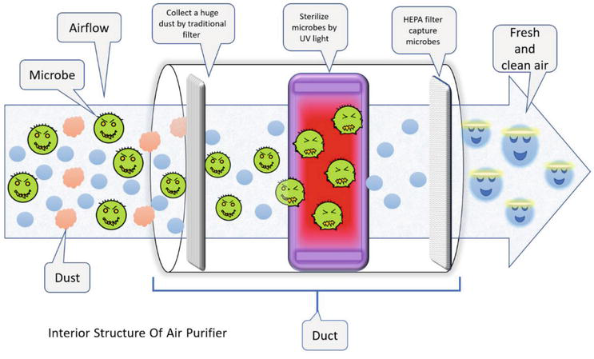Industrial air filtration systems often incorporate antimicrobial textiles to inhibit microbial growth on filters, where trapped dust and moisture can create favorable conditions for bacteria and mold. Antimicrobial filters used in HVAC systems enhance indoor air quality in factories, offices and public spaces, reducing the risk of airborne diseases **(Gong *et al.,* 2021).** Textiles treated with silver or copper nanoparticles are commonly used in these applications due to their broad spectrum efficacy and durability under varied conditions.

**4.4.5 Transportation and Public Infrastructure**

In public transportation and infrastructure, antimicrobial textiles are used to line seats, handrails and high contact surfaces to reduce microbial contamination and ensure hygiene. These textiles help maintain cleanliness in shared spaces, such as buses, trains and airports, where surfaces are frequently exposed to diverse contaminants. Antimicrobial-treated materials not only control odor and reduce maintenance frequency but also enhance public safety by minimizing the risk of infection transmission in high-traffic areas **(Balagna *et al.,* 2021).**

1. **Importance of antimicrobial textiles in health, hygiene and sustainability**

The **antimicrobial textiles** are as an emerging field with significant implications for **health, hygiene and sustainability**. These textiles play a crucial role in **preventing microbial infections, reducing cross-contamination, and enhancing personal and public safety** across industries such as **healthcare, personal hygiene, food packaging and industrial applications**. By inhibiting bacterial and fungal growth, antimicrobial textiles help **prolong fabric lifespan, minimize odors and reduce the need for frequent washing,** contributing to environmental sustainability. The study effectively highlights **antimicrobial mechanisms, materials and applications**, offering valuable insights for **researchers, healthcare professionals and industry stakeholders**. The discussion on the **durability, efficacy and environmental impact** of antimicrobial agents is particularly relevant given the increasing demand for **sustainable and effective textile solutions**.

1. **Evaluation and Testing of Antimicrobial Efficacy in Textiles**

Evaluating and testing the antimicrobial efficacy of textiles is essential to ensure that treated fabrics provide consistent and effective microbial protection. These tests assess how well antimicrobial agents embedded in the textile inhibit or kill bacteria, fungi and viruses. Standardized evaluation methods provide insights into the strength, durability and longevity of the antimicrobial properties of textiles, which are critical for applications in healthcare, personal hygiene, food packaging and industrial settings.

**6.1 Quantitative Tests: AATCC 100 and ISO 20743**

The American Association of Textile Chemists and Colorists (AATCC) Test Method 100 and the ISO 20743 method are two widely used quantitative tests for assessing the antimicrobial efficacy of textiles. AATCC 100 involves inoculating fabric samples with specific bacterial strains (such as *Staphylococcus aureus* or *Escherichia coli*) and incubating them under controlled conditions. After a set period, the number of surviving bacteria is counted and compared to an untreated control, allowing researchers to calculate the percentage reduction in microbial load **(Gong *et al.,* 2021).** Similarly, ISO 20743 uses bacterial inoculation to evaluate textile efficacy and calculates the bacteriostatic or bactericidal effect by comparing colony-forming units (CFUs) on treated and untreated samples.

**6.2 Qualitative Tests: AATCC 147**

The AATCC 147 test is a qualitative method commonly used as an initial screening tool to determine the antimicrobial activity of textiles. This test involves placing treated and untreated fabric samples on an agar plate that has been inoculated with a specific bacteria strain. The presence of a clear, bacteria-free zone around the treated fabric, known as a zone of inhibition, indicates that the textile effectively inhibits bacterial growth. While AATCC 147 does not provide quantitative data, it is a valuable indicator of antimicrobial action and is often followed by more detailed quantitative tests for thorough assessment **(Vinod *et al.,* 2022).**

**6.3 Durability Testing: Wash and Wear Resistance**

Durability tests evaluate the longevity of antimicrobial properties after multiple washing or wear cycles. AATCC TM 61 (accelerated laundering) and ISO 6330 are standardized methods used to determine how well antimicrobial treatments withstand repeated washing. The antimicrobial efficacy is assessed before and after several wash cycles to determine if the treatment’s effectiveness diminishes over time. This is crucial for applications in personal hygiene, healthcare and outdoor textiles, where textiles undergo frequent laundering **(Jassal and Agarwal, 2022).**

Wear resistance tests, which simulate abrasion and physical wear, are also conducted to assess the durability of antimicrobial treatments in textiles exposed to high friction, such as uniforms or bedding in hospitals. This testing helps verify that antimicrobial treatments remain effective in real-world usage conditions.

**6.4 Antifungal and Antiviral Testing**

In addition to antibacterial testing, antifungal and antiviral efficacy tests are essential, especially for textiles used in healthcare and hygiene products. ASTM E2149 is a standardized test for assessing the antifungal activity of antimicrobial agents on textiles. This test exposes treated fabrics to fungal cultures, such as *Aspergillus Niger* and monitors growth inhibition.

Similarly, antiviral testing (e.g., ISO 18184) measures the reduction in viral activity on treated fabrics. During the COVID-19 pandemic, antiviral efficacy testing gained attention, as materials treated with agents like copper and silver ions demonstrated effectiveness against viruses, adding an extra layer of protection to personal protective equipment **(Balagna *et al.,* 2021).**

**6.5 Time Kill Kinetics and Controlled Release Studies**

Time-kill kinetics testing provides insights into how quickly an antimicrobial textile reduces microbial populations over specific time intervals. This is particularly relevant for textiles that incorporate slow-release antimicrobial agents, such as encapsulated silver or essential oils, where the antimicrobial action may be designed to last over extended periods. Controlled releases studies help assess the sustained efficacy of these materials, as they measure the release rate and effectiveness of antimicrobial agents over time **(Mancuso *et al.,* 2021).**

1. **Challenges and Future Directions in Antimicrobial Textiles**

Antimicrobial textiles have garnered significant attention for their potential to improve health, hygiene and safety across various sectors. However, there are several challenges related to the efficacy, environmental impact, regulatory standards and long-term effects of these materials. Addressing these challenges will be essential for the continued development and acceptance of antimicrobial textiles. Researchers and manufacturers are actively exploring innovative approaches and sustainable solutions to overcome these obstacles.

**7.1 Efficacy and Durability Concerns**

One of the primary challenges in antimicrobial textiles is ensuring long-lasting efficacy, especially for applications that require frequent washing or exposure to harsh conditions. While treatments such as silver and copper nanoparticles are widely used, their efficacy can diminish after repeated washing cycles, leading to reduced antimicrobial action over time **(Gong *et al.,* 2021).** The challenge lies in developing treatments that can withstand laundering, abrasion and environmental exposure without compromising their antimicrobial properties.

**Future Directions:** To enhance durability, researchers are exploring encapsulation and controlled-release techniques, which allow antimicrobial agents to be gradually released over time, extending the effectiveness of the textile. Bio-based binders and advanced polymer coatings are also being developed to improve adhesion and prevent leaching of antimicrobial agents, even after extended use **(Balagna *et al.,* 2021).**

**7.2 Environmental and Health Impacts**

The environmental implications of antimicrobial textiles are an area of growing concern. Certain antimicrobial agents, particularly heavy metals like silver and copper, can leach out during laundering and enter water systems, potentially harming aquatic ecosystems and raising human health concerns. The long-term impact of nanoparticle exposure and accumulation in the environment has also yet to be fully understood **(Vinod *et al.,* 2022).**

**Future Directions:** To address these issues, sustainable and bio-based antimicrobial alternatives, such as chitosan, herbal extracts and essential oils, are being investigated for their lower environmental impact and biodegradable properties. Another approach is to develop textiles that use biocompatible polymers and natural antimicrobial agents, which degrade safely in the environment and reduce toxic byproducts **(Jassal and Agarwal, 2022).**

**7.3 Standardization and Regulatory Challenges**

A lack of standardized testing methods and regulatory guidelines for antimicrobial textiles has created challenges in assessing and certifying product efficacy and safety. Different testing protocols and lack of universal benchmarks make it difficult to ensure consistent results and establish trust among consumers. Additionally, regulatory authorities in various regions have different standards for antimicrobial claims, which complicate global market entry for manufacturers **(Mancuso *et al.,* 2021).**

**Future Directions:** Harmonizing testing protocols and regulatory standards will be crucial for advancing antimicrobial textile technology. Collaborative efforts between researchers, industry stakeholders and regulatory bodies are underway to establish internationally recognized guidelines that define acceptable levels of antimicrobial efficacy, durability and safety. Standardized protocols, like those being developed for ISO and AATCC, are likely to increase consumer confidence and ease regulatory compliance across regions.

**7.4 Balancing Efficacy with Skin Sensitivity and Biocompatibility**

While antimicrobial textiles offer health benefits, some agents can cause skin irritation or allergic reactions, particularly for individuals with sensitive skin. Silver nanoparticles, for instance, are effective antimicrobial agents but may cause irritation when in direct contact with skin. Finding a balance between strong antimicrobial action and biocompatibility is an ongoing challenge, especially for products in contact with skin for prolonged periods **(Balagna *et al.,* 2021).**

**Future Directions:** Future research is focusing on biocompatible antimicrobial agents, such as chitosan, zinc and plant-based compounds, which are less likely to cause irritation. Additionally, controlled-release systems and microencapsulation are being explored to minimize direct contact between antimicrobial agents and skin, allowing for safer, longer-lasting antimicrobial textiles in personal hygiene and medical applications.

**7.5 Cost and Scalability**

High costs associated with antimicrobial treatments, particularly those involving nanoparticles and advanced encapsulation techniques, remain a barrier to large-scale production. Manufacturing processes that require precise and costly raw materials, such as silver and copper, make it challenging to produce antimicrobial textiles at a competitive price point for the mass market.

**Future Directions:** To reduce costs, researchers are focusing on alternative antimicrobial agents and treatments that are less expensive and easier to scale. Plant-based antimicrobials, for instance, have shown promise as cost-effective options that offer sufficient antimicrobial action for everyday applications. Additionally, advances in material science are expected to lead to more affordable and scalable production processes, allowing antimicrobial textiles to become accessible to a broader market.

**7.6 Developing Multifunctional Textiles**

There is growing interest in creating multifunctional textiles that combine antimicrobial properties with other desirable features, such as UV resistance, water repellency, or enhanced breathability. The challenge lies in integrating these properties without compromising antimicrobial efficacy or adding excessive bulk to the textile.

**Future Directions:** The development of nanofibers composites, hybrid coatings and smart textiles with embedded sensors may pave the way for multifunctional antimicrobial textiles. Such innovations could serve various applications, including smart fabrics that monitor environmental conditions while providing antimicrobial protection, making them highly valuable for healthcare, military and outdoor sectors **(Gong *et al.,* 2021).**

**Conclusion**

Antimicrobial textiles hold immense potential across various industries, offering enhanced hygiene, health protection and safety. However, challenges such as ensuring long-term efficacy, addressing environmental impacts and establishing standardized testing protocols need to be overcome. The future of antimicrobial textiles lies in developing sustainable, biocompatible and cost-effective solutions that maintain effectiveness through wear and laundering. Innovations in multifunctional materials and controlled systems are balanced to revolutionize the field. With continued research and collaboration, antimicrobial textiles will become a keystone in improving public health, safety and environmental sustainability.

**References**

Abdi-Moghadam Z, Mazaheri Y, Rezagholizade-Shirvan A, Mahmoudzadeh M, Sarafraz M, Mohtashami M and Rezaei Z. The significance of essential oils and their antifungal properties in the food industry: A systematic review. *Heliyon*. 2023; ***9****(11):* 1-22

Abebe B, Zereffa EA, Tadesse A and Murthy HA. A review on enhancing the antibacterial activity of ZnO: Mechanisms and microscopic investigation. *Nanoscale research letters*. 2020; **15**(10): 1-19.

**Akdag I, Yilmaz A, Koseoglu S and Karayilanoglu T**. PHMB in Antimicrobial Textiles: Mechanisms and Applications in Medical Textiles. Journal of Biomedical Materials Research. 2020; **108**(4), 660–670.

**Ali, S, Bano A and Hussain Z.** Mechanisms of Antimicrobial Action of Chitosan on Textile Surfaces. Journal of Polymers and the Environment. 2019; **27**(2): 280–290.

**Ali S, Bano A and Hussain Z**. Chitosan-Based Antimicrobial Textiles: Mechanisms and Applications in Sustainable Textiles. Journal of Polymers and the Environment. 2020; **28**(3), 350–360.

**Alotaibi H, Khan R and Ahmad I**. Applications of Zinc Oxide Nanoparticles in Antimicrobial Textiles: A Review. Journal of Textile Science. 2020; **12**(1), 125–135.

**Balagna C, Perero S, Ferraris M and Vitale-Brovarone C**. Copper Nanoparticles in Antimicrobial Textiles: Mechanisms of Action and Safety Profile. International Journal of Nanomedicine.2021; **16**: 2350–2361.

**Balagna C, Perero S, Ferraris M and Vitale-Brovarone C**. Silver-Loaded Antimicrobial Coatings: Safety, Durability andEfficacy in Textile Applications. International Journal of Nanomedicine. 2021; **16**: 2987–2998.

**Banerjee A and Pramanik N**. Advances in Antimicrobial Fabrics: Current Trends and Applications. Journal of Textile Science. 2022; **13**(2): 245–255.

**Gong C, Wang H and Li Q**. Silver Nanoparticles in Antimicrobial Textiles: Mechanisms of Action and Clinical Applications. Journal of Applied Microbiology. 2021; **130**(4): 1034–1045.

**Gong C, Wang H and Li Q**. The Use of PHMB in Healthcare Textiles: Antimicrobial Efficacy and Safety. Textile Research Journal. 2022; **92**(3), 408–420.

**Gopalakrishnan S, Thomas R and Kumar D**. Neem Extracts as Sustainable Antimicrobial Agents for Textiles. International Journal of Green Chemistry. 2021; **9**(2), 220–230.

**Gopalakrishnan S, Thomas R and Kumar D**. Silver-Based Dressings for Wound Care: A Comprehensive Review. Journal of Wound Healing. 2021; **14**(4): 412–425.

**Gupta S, Verma R and Yadav K**. Copper Nanoparticles in Antimicrobial Textiles: Mechanisms and Environmental Considerations. Journal of Applied Microbiology. 2022; **134**(5): 1507–1518.

**Hussain A, Khan S and Ali R**. Sustainable Antimicrobial Textiles: Natural Alternatives and Their Efficacy. Textile Innovations, **8**(1), 30–40.

**Jassal M and Agarwal T**. Controlled Release of Antimicrobial Agents in Textiles: Advances and Mechanisms. Journal of Applied Textile Science. 2022; **11**(3): 312–323.

**Jassal M and Agarwal T**. Enhancing the Durability of Herbal Extracts in Antimicrobial Textiles. Journal of Applied Textile Science. 2022; **11**(4): 425–435.

Knetsch ML and Koole LH. New strategies in the development of antimicrobial coatings: the example of increasing usage of silver and silver nanoparticles. *Polymers*. 2011; ***3***(1): 340-366.

**Kumar A, Singh J and Gupta R.** Essential Oils as Natural Antimicrobials in Textiles: Mechanisms and Applications. International Journal of Microbiology. 2019; **25**(2): 207–218.

**Mancuso C, Lagana S, Cafiso V, Fera MT and Alberti F.** Applications of Antimicrobial Textiles in Healthcare Settings: PPE and Beyond. Infection Control and Hospital Epidemiology. 2021; **42**(5): 587–598.

**Mohapatra S, Kumar P and Gupta R.** Applications of QACs in Antimicrobial Textiles: A Comprehensive Review. Journal of Textile Science. 2021; **12**(3): 315–325.

**Nguyen T, Singh J and Kumar A.** Antimicrobial Mechanisms in Textile Applications: A Review. International Journal of Antimicrobial Research. 2022; **10**(2): 102–110.

**Nisar T, Ali H and Zahid M.** Microencapsulation of Essential Oils for Antimicrobial Textiles. Journal of Nanomaterials. **2020**, Article 3025896.

**Nisar T, Ali H and Zahid M.** Essential Oils in Antimicrobial Textiles: Mechanisms of Action and Sustainability Considerations. Journal of Nanomaterials. **2021**, Article 4398102.

Parkin, I. P. and Allan, E. (2021). Copper as an antimicrobial agent: Recent advances. *RSC advances*, ***11***(30): 18179-18186.

**Patel R, Smith T and Lokhande A.** Impact of COVID-19 on Antimicrobial Textile Demand and Research. Health and Hygiene Review. 2021; **13**(1): 67–79.

**Qiu Y, Wang J and Zhang L.** Mechanisms of QAC Antimicrobial Activity in Textile Applications. Journal of Applied Microbiology. 2020; **129**(5): 1150–1160.

**Rai M, Yadav A and Gade A.** Silver Nanoparticles as Antimicrobial Agents in Medical Textiles: Synthesis and Mechanism. Frontiers in Microbiology. 2019; **10**, Article 1792.

**Rai M, Yadav A and Gade A.** Quaternary Ammonium Compounds in Antimicrobial Textiles: Mechanisms of Action and Limitations. Frontiers in Microbiology. 2020; **11**, Article 2008.

**Rajendran S and Mahendra Gowda K.** Quaternary Ammonium Compounds in Antimicrobial Textile Treatments: A Comprehensive Study. Journal of Applied Textile Science. 2023; **14**(2): 210–220.

**Ramesh K, Nair P and Reddy A.** Hybrid Zinc Oxide Nanostructures for Durable Antimicrobial Textiles. Journal of Nanoscience and Nanotechnology. 2021; **21**(3): 1583–1594.

**Saleem M, Ashraf M and Qureshi Z.** Triclosan in Textiles: Effectiveness and Environmental Impact. Environmental Science & Technology. 2021; **55**(8): 4120–4132.

Salleh A, Naomi R, Utami ND, Mohammad AW, Mahmoudi E, Mustafa N and Fauzi MB. The potential of silver nanoparticles for antiviral and antibacterial applications: A mechanism of action. *Nanomaterials*. 2020; ***10***(8):1566.

Salah I, Parkin IP and Allan E. Copper as an antimicrobial agent: Recent advances. *RSC advances*. 2021; ***11***(30): 18179-18186.

**Sayed M, Khan T and Ahmed Z**. Application of Antimicrobial Textiles in Healthcare: Reducing Hospital-Acquired Infections. Journal of Healthcare Materials. 2022; **6**(1): 98–109.

**Shahidi F and Abuzar H**. Applications of Chitosan in Functional and Sustainable Textiles. Textiles and Clothing Science Journal.2021; **14**(3): 233–243.

**Singh R, Sharma P and Das R.** Environmental Impacts and Regulations in Antimicrobial Textiles: A Critical Review. Journal of Environmental Studies. 2021; **22**(4): 350–362.

Sinicropi MS, Iacopetta D, Ceramella J, Catalano A, Mariconda A, Pellegrino M and Aquaro S. Triclosan: A small molecule with controversial roles. *Antibiotics*. 2022; ***11***(6): 735.

Sitarek P, Merecz-Sadowska A, Kowalczyk T, Wieczfinska J, Zajdel R and Śliwiński T. Potential synergistic action of bioactive compounds from plant extracts against skin infecting microorganisms. *International journal of molecular sciences*. 2020; ***21***(14): 5105.

**Smith T and Lokhande A**. Trends in Antimicrobial Textile Materials and Treatments. Materials and Health. 2020; **9**(2): 225–235.

**Vinod V, Patel D and Sharma M.** Role of Copper Nanoparticles in Antimicrobial Textiles: Mechanisms and Applications. Materials Science in Medicine. 2021; **5**(2): 210–222.

**Vinod V, Patel D and Sharma M**. Antimicrobial Textiles in Food Packaging: Mechanisms, Benefits andFuture Directions. Materials Science in Medicine. 2022; **6**(2),:305–316.

Vojnits K, Mohseni M, Parvinzadeh Gashti M, Nadaraja AV, Karimianghadim R, Crowther B and Pakpour S. Advancing Antimicrobial Textiles: A Comprehensive Study on Combating ESKAPE Pathogens and Ensuring User Safety. *Materials*. 2024; ***17***(2): 383.

Wang WY, Hu HW, Chiou JC, Yung KF and Kan CW. Poly (hexamethylene biguanide) hydrochloride (PHMB)-based materials: synthesis, modification, properties, determination andapplication. *Polymer Chemistry*. 2023; ***14***(48): 5226-5252.

**Wang X, Liu Y, Chen J and Zhang Z.** Silver Ion Mechanisms in Antimicrobial Textiles: A Comprehensive Study. Journal of Biomedical Materials Research. 2020; **108**(8): 1767–1778.

**Wang X, Liu Y, Chen J and Zhang Z.** Silver Nanoparticles and DNA Replication Inhibition in Antimicrobial Textiles. Journal of Biomedical Materials Research. 2021; **109**(5): 2154–2164.

Yarahmadi A, Dousti B, Karami-Khorramabadi M and Afkhami H. Materials based on biodegradable polymers chitosan/gelatin: a review of potential applications. *Frontiers in Bioengineering and Biotechnology*. 2024; ***12****(8)*: 1397668.

**Yoon H, Zhou X and Ali M.** Industrial Applications of Antimicrobial Textiles: Challenges and Innovations. Textile Science and Technology. 2023; **14**(3): 110–120.

**Zhang L, Wang P, Li J and Chen W.** Challenges in QAC Use in Antimicrobial Textiles: Resistance and Safety Considerations. International Journal of Hygiene and Environmental Health. 2022; **238**: 113875.

**Zhou H, Li Y, Zhang J and Wang Q.** Triclosan Mechanisms and Application Limitations in Textiles. Journal of Environmental Toxicology. 2019; **33**(7):487–499.

**Zhou H, Li Y, Zhang J and Wang Q.** Triclosan in Antimicrobial Textiles: Mechanisms and Application Constraints. Journal of Environmental Toxicology. 2020; **34**(4): 587–599.